‘Hidden Truths: Understanding vulnerability in 21st century Britain’

Friday 8th November 2013

Newman University Birmingham

Building on the publication of Working with Vulnerable Children, Young People and Families (Routledge, 2013), this conference will explore what constitutes vulnerability and how this has been conceptualised by practitioners, theorists and policy makers in relation to an emerging political agenda.

The keynote speakers include Lynsey Hanley, renowned Guardian journalist and critically acclaimed local author of Estates: An Intimate History (Granta, 2007), and Professor Stan Tucker, who is internationally recognised for his research on children and young people’s human rights, social inclusion, risk and the changing nature of childhood.

Conference workshops will focus on an exploration of vulnerability in relation to specific groups including: care leavers; children of prisoners; children with special educational needs and disabilities; young people and the homeless; young people who have sexually harmed others; violence in the context of personal relationships; young people, digital media & risk; and risk in Schools (for further details see draft programme).

The conference will also feature a Panel Discussion where representatives from regional organisations will present their ideas/manifesto for working with vulnerable children & young people followed by an open debate considering the challenges and opportunities in this area. Finally, the conference will launch a new specialist website on vulnerability, with resources for those working in the subject.

Booking Form

Delegate Name:……………………………………………………………………………………………...

Organisation:…………………………………………………………………………………………………

Address:………………………………………………………………………………………………………

Tel No:…………………………….. Email:……………………………………………………………

1st choice for Workshop session one:……………………………………………………………………..

2nd choice for Workshop session one:……………………………………………………………………

1st choice for Workshop session two:……………………………………………………………………..

2nd choice for Workshop session two:…………………………………………………………………….

Delegates will also have the option of signing up for workshops on the day of the conference.

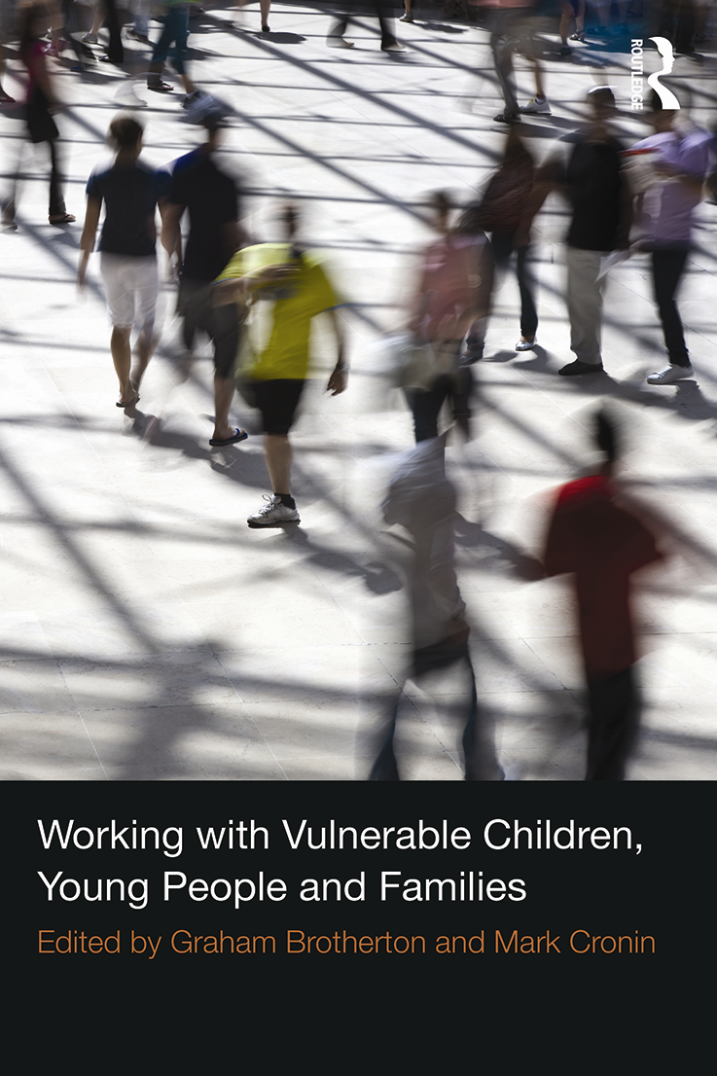
Conference Fee: £50 (£25 NUS/£45 Newman Alumni)
All delegates will receive a free copy of the related book as well as lunch and refreshments.

Payment method: Cheque/Invoice/Cash

Please make cheques payable to ‘Newman University’ and indicate here if the invoice address is different from above.

‘Hidden Truths: Understanding vulnerability in 21st century Britain’

Friday 8th November 2013

Newman University Birmingham

Draft Programme

9:10am – 9:30am Registration
9:30am – 10:30am Key note speakers – Professor Stan Tucker & Lynsey Hanley
10:30am – 11:25am Workshop session one (see summary below)
11:25am – 11:45am morning break/refreshments
11:45am – 12:40pm Workshop session two (see summary below)
12:40pm – 1:50pm Lunch
1:50pm – 3:00pm ‘Finding ways forward‘ - panel of local experts (practitioners and policy-makers) will present their priorities for action and engage in debate with the audience.
3:00pm Conference closes.

Workshop session one options:

Care leavers – This workshop will explore the complexity of issues facing children and young people who have experienced the care system and the challenges they face in terms of leaving care and the design of related support mechanisms.

Children with special educational needs and disabilities – This workshop will explore the experiences of disabled children, from historical traditions of segregation and discrimination to the emergence and development of inclusive education, within the framework of equality and human rights.

Young People who have sexually harmed others – This workshop will briefly introduce the client group and explain some of the challenges in assessing needs, risks and vulnerabilities with these young people. There will be the opportunity to consider the practical application of the holistic model in relation to other young people or service users in different contexts relevant to workshop participants.

Young People, digital media & risk – This workshop will explore the polarised discourses that surround young people's use of digital media, looking at how a predominantly technologically deterministic view can simultaneously see digital media use as both empowering and an activity imbued with risk and potential vulnerability. There will be an opportunity to consider and discuss policy responses that in many ways may have strengthened this polarisation.

Workshop session two options:

Children of prisoners – This workshop will explore why this particular group of children continue to remain invisible in terms of policy and practitioner awareness. It will begin to challenge some myths about the criminal justice system and the potential negative impact on the children of prisoners. It will also to look at ways in which practitioners can work together with families and other agencies to ensure that the rights of these children are upheld.

Housing vulnerability contested - This workshop will make the assertion that homeless people are constructed as being to blame for their predicament, and that young people, particularly working class young people, are made vulnerable through housing policy. Furthermore it will argue that social policy divides homeless people into categories of deserving and undeserving, ignoring structural and personal dimensions. The rest of the time will be given over to a panel of homeless and ex-homeless people who will discuss their first hand experiences of being 'vulnerable’.

Violence in the context of personal relationships – This workshop will seek to explore the evidence around the impact of violence in personal relationships with a particular focus on the impact on children and young people and the adequacy of policy and practice responses to this.

From the pupil perspective: Risk, vulnerability and the conditions for behaviour in schools.– This workshop will report the findings of two studies conducted in schools in Birmingham and the Black Country. This research offers a ‘snapshot’ of both vulnerability and expertise within the pupil lifeworld and the findings of these studies affirm risk as a multi-dimensional and at times complex field of encounter. The studies also highlight the problematic nature of key transition points in the school ‘career trajectories’ of young people.

For further information and return of booking forms please email
Carol Ferran at: c.ferran@newman.ac.uk

