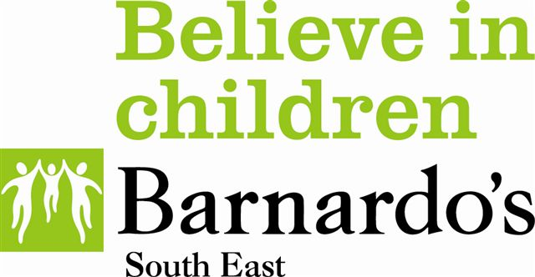

Charter signatory sheet for Organisations/services to support children and families affected by offending behaviour

As an organisation we recognise that children affected by offending behaviour are more likely to experience negative outcomes and we will endeavour to empower these children and families by implementing the aims of the Charter.

Organisation/service name:

Signatory Name:

Signatory Position in Organisation/service:

Signature:

Date:

Would you like copies of previous minutes and information to be sent to you? Yes/No

