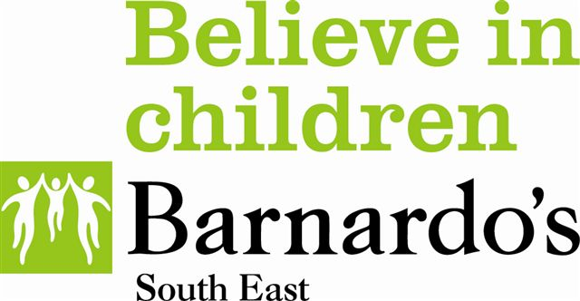

Dear Colleague,

Thank you for believing in children affected by parental imprisonment. By signing up to this Charter you have committed to make a positive difference to children affected by offending behaviour in their family.

In response to you commitment, Community Support for Offenders Families (Isle of Wight) will provide your organisation with the following support:

Hidden Sentence Training – a free one day training programme for your staff. This can be accessed alongside other professionals or we can come to you to deliver bespoke Hidden Sentence Training to meet your organisational needs.

Consultancy Support – telephone access to a Community Support for Offenders Families (CSOF) team member to offer advice and professional guidance in supporting children and young people affected by offending behaviour.

Resource Pack – up to date information on services and resources to support children and families of offenders, including access to i-hop the information hub for professionals.

‘Champion’ for children of offenders – support for the identified individual in your organisation, including quarterly practice updates, training as well as group supervision alongside other Champions.

Community Support for Offenders’ Families
Winchester House
Sandown Road, Shanklin
PO37 6HU Isle of Wight
Phone 01983 865657

