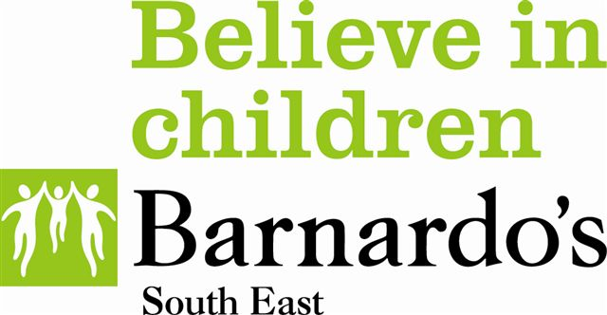

Community Support for Offenders’ Families (Isle of Wight) Steering Group

Terms of reference for Charter to support children and families of offenders’

Background
The families of offenders are one of the most vulnerable groups in society.
“There is a strong association between parental imprisonment and adverse outcomes for children. Children of prisoners have about three times the risk for antisocial-delinquent behaviour, mental health problems and other adverse outcomes compared with their peers.”
(SCIE 2008 Children’s and families resource guide 11: Children of prisoners-maintaining family ties. SCIE, London)

The children of prisoners’ and offenders’ are at risk of failing to meet the Every Child Matters outcomes and are more likely to engage in anti-social and criminal behaviour than their peers. Despite this vulnerability, this group remains hidden, with stigma and fear inhibiting them from accessing support services. Support is required through the offender journey including resettlement (release from a custodial) sentence. When prisoners are released into the community, they and their families are faced with another set of difficulties which help to prevent them accessing universal services e.g. stigma, reintegration into the community, unemployment.

Children of offenders are regarded to be an ‘invisible’ or ‘hidden group’. There is no standard collection of information about who these
children are, where they are, who is looking after them, what their needs are and what support they receive. Research has shown that parental imprisonment can lead to a child experiencing stigma, bullying and isolation. A family member in prison increases the likelihood of the child experiencing poverty as the family may become vulnerable to financial instability, debt and housing disruption. Parental imprisonment might cause a range of adverse outcomes including aggressive behaviour, depression, anxiety, sleeping problems, eating problems, truancy and poor outcomes at school.

Key Facts
- 200,000 children have a parent sent to prison each year.
- Of the 1200 children born each year on the Island 84 will experience the imprisonment of a parent during their school years ( extrapolated from national figures)
- More children are affected by parental imprisonment than by divorce.
- These children have about three times the risk of antisocial2 behaviour and mental health problems2.
- 65% of boys with a convicted parent go on to offend2

Isle of Wight priorities

Children & Young People’s Plan 2014-2017

The vision of the Isle of Wight’s Children’s Trust for 2014-2017:
“Working together to ensure high quality outcomes for all children, young people and their families and to enable them to access sustainable support and services.”

5 specific priorities:

- Securing children and young people’s emotional, mental and
physical health

- Helping children and young people to be safe and feel safe

- Improving education to provide all children and young people with
outstanding learning opportunities

- Inspiring and providing equal opportunities for all children and
young people to achieve their goals and dreams

- 5. Addressing the incidence and reducing the impact of poverty on
the achievement and life chances of children and young people

Evidence suggests that children of prisoners’ and offenders’ are at risk of achieving poor outcomes. Research identifies this group as having high level risk of vulnerability and safeguarding with the potential for future offending behaviour, school exclusion, poor school attendance and attainment. We know that 7% of children will experience a father being in prison at some point during their school years.

Taking these issues into consideration, the Isle of Wight’s Children’s Trust have identified children of offenders’ as a group to be considered under priority 5 of the Children and Young People’s Plan.

Terms of Reference

Purpose
To ensure children and young people affected by a family members’ offending are happy, safe and have the opportunity to achieve their ambitions and realise their potential.

Outcomes:

Children and their carers affected by a family member offending:
- Know who to talk to gain support and information in the organisation.
- Know that they can speak to someone in the organisation that they trust and will understand their situation and not judge them.
- Have access to and information about universal and targeted support, services and resources.

Signatory Organisations:
- Charter signatory has the appropriate authority to instigate change in the organisation e.g. Head teacher
- Ensure policies and procedures reference, protect and promote the wellbeing of children affected by family members offending where appropriate. Where this is not possible, local practice should reflect these principles.
- Ensure a ‘Champion’ is appointed and supported within the organisation to fulfil this role.
- Ensure ‘Champions’ can attend quarterly meetings.
- Enable staff to access appropriate training and up to date information relevant to support children and families affected by offending.
- Work together and with other agencies to make sure they are trained to effectively support children and families affected by offending.
- Aim to develop a culture that recognise and understand the needs of children affected by family members’ offending.

All ‘Champions’ will:
- Attend the 1-day Hidden Sentence training course.
- Be a member of the national i-HOP (information hub on offenders’ families with children for professionals) online service which provides information and advice. Membership is free. .
- Be the identified point of contact for children and families affected by a family member’s offending.
- Be the identified point of contact for staff members who require information, support or guidance in supporting a child/family member affected by a family member’s offending.
- Be the identified point of contact for external agencies to share practice and guidance re: supporting child/family member affected by a family member’s offending.
- Provide non-judgemental, sensitive and informed support and information to children and families affected by a family member’s offending.
- Raise awareness about the needs of children and families affected by a family member’s offending across their organisation where appropriate.
- Attend 3 out of 4 Champion Group meetings per year.
- Be aware of how work with children and families affected by a family member’s offending sits within the overarching behaviour and vulnerability strategies, policies and guidelines of their organisation.
- Provide information for register of expertise to be shared with other Champions

Version 1 March 2015

IOW JSNA 2011-2012, accessed http://www.iwight.com/council/facts_and_figures/jsna.asp 1/9/2012 MOJ Families Do Matter Project Report 2009
MOJ Families Do Matter Project Report 2009
2
2
2
(Shaw, R (1992) Prisoners Children: What are the issues? (Ed)London: Routledge

