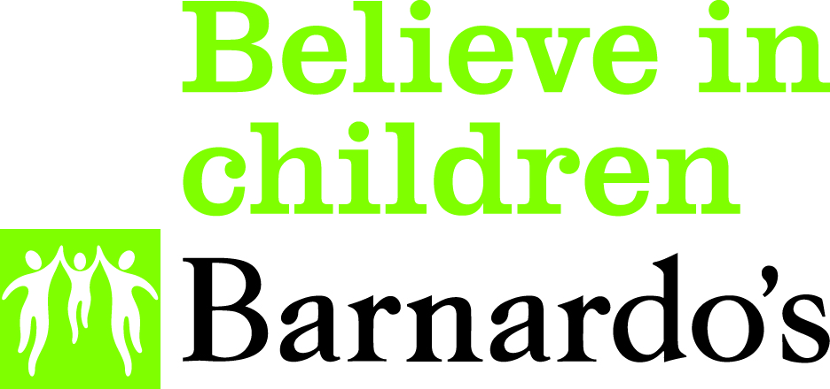 **Charter Process Map**

Expression of interest by Commissioner

Expression of Interest by organisation

CSOF worker call and set up follow up meeting

(5 working days)

Follow up meeting held with CSOF worker & interested organisation/Commissioner.

Charter signature meeting date set & Champion identified where relevant.

Meeting held with Commissioner; COSF agenda to be incorporated within commissioning documents

Charter signature meeting held & Champion introduced to CSOF worker.

KPIs set out with organisation.

(within 3 working weeks)

Charter promoted within organisation. (within another 2 working weeks).

CSOF agenda disseminated through the commissioned services & next steps identified

Staff team booked to receive Hidden Sentence training.

Evidence of children impacted by offending within the family agenda being highlighted & raised within the organisation.

Evidence of CSOF agenda being incorporated into the commissioned services

Evidence of support offered to children impacted by offending within the family and be able to draw on a case study of good practice.

Charter review meeting held with signatory & champion and CSOF worker.

(3months after charter being signed)