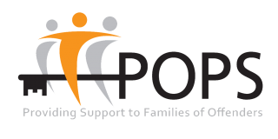

We are very grateful to POPS for organising our guest speakers, Danielle and Debbie, who are offenders’ family members, and have generously agreed to talk about ‘*Why it matters - a Service User perspective’*

POPS (Partners of Prisoners & Families Support Group) is a needs-led organisation, founded 30 years ago by family members experiencing the stigma and distress of supporting a relative through a custodial sentence.

Since that time, POPS’ remit has broadened to provide support services for offenders’ families, offenders and their children at all stages of the Criminal Justice System.

POPS’ unique stand point as a family-led organisation enables us to fully understand the challenges faced by offenders and their families and the importance of giving families a voice and a platform from which to share their experiences. Opening the conference today, family members, supported by POPS, will bring a powerful reminder of the hidden sentence served by so many.