**Christina Hall**

* Director of Operations at Lincolnshire Action Trust.
* Previous roles include: Resettlement Officer, Resettlement Manager, Contract lead for PS Plus, NOMS ESF 1 / 2, CFO3
* Designed and Implemented of a number of innovation projects e.g. SPARC (Supporting People After Remand and Conviction), Departure Lounge at HMP Lincoln
* Previous private sector project management experience for several Blue Chip Companies

**Andy Keen-Downs**

* Chief Executive of Pact since 2005.
* Previous roles include: Deputy Director at Gingerbread (One Parent Families),
* Senior posts with the National Childbirth Trust and with Centrepoint, running the Gatehouse Project in the Hulme & Moss side area of Manchester involving supporting adults with literacy issues and developing a social enterprise community publishing operation.
* In 2015, Andy received the Longford Prize on behalf of Pact

**Polly Wright**

* Children’s Services Manager for Barnardo’s.
* Manages the development of services for children affected by parental offending across the Midlands and South West, as well as the national i-HOP service.
* Worked in children and families’ services for the last 20 years, across the voluntary and statutory sectors, in practice, policy, research and training provision.
* For the past six years she has worked closely with local authorities and the prison service to develop and improve strategic and practice responses to working with the children and families of offenders.

**Lord Michael Farmer**

* Made Conservative Party Life Peer in 2014.
* Chair of Farmer Review on Importance of Strengthening
* Prisoners' Family Ties to Prevent Reoffending and Intergenerational Crime.
* Partner and contributor to the Strengthening Families Manifesto to integrate the importance of family across all government departments.
* Senior Partner at RK Capital Management.
* Sponsor Governor Ark All Saints Camberwell.

**Phil Copple**

* Executive Director, Public Sector Prisons at HMPPS
* Has worked in offender management for over 23 years.
* Previous roles include: Agency board member, NOMS; Director, High Security, NOMS; Director, National Operational Services, NOMS; North East Director, Offender Management, NOMS; Area Manager, North East prisons; Governor, Deerbolt Young Offenders’ Institution and Frankland High Security prison

**Charlotte Weinberg**

* Since 2010, Executive Director at Safe Ground, where she has been responsible for leading the charity through a period of sustained growth and diversification.
* 5 years as a senior residential worker at a hostel supporting young people towards independence.
* Coordinator of the first Saffron Young People’s Project, which worked to influence service provision and policy at local and national level.
* Founding member of the Prisoner Learning Alliance
* Chair of the Centre for Crime and Justice Studies.

**Michael Brown**

**•** A long standing colleague of Safe Ground.

* Founder and Chair of Community Interventions.
* Works with many academics in the field of prison and criminal justice.
* Responsible for a pioneering youth engagement and employment

project for Charlton Athletic Community Trust.



#newboldfamiliesconference



**Corin Morgan-Armstrong**

* + - * Corin has been at HMP Parc for 20 years.
* Established the Family Interventions Unit 2010.
* Designed and established the Invisible Walls Wales project.
* In 2016 the HM Inspectorate stated that the model was ‘innovative and radical and probably the best they had seen in any prison.’
* Corin has designed a simple strategy to engage and work with ex-service men and first-time in custody prisoners, opening a specific residential unit ‘Endeavour’ at HMP Parc in January 2015.

**Carlene Dixon**

**•** Governor of HMP Send for three years.

• Children and families lead for the Women’s Estate.

• Previous roles include: Deputy Governor, HMP Pentonville;

Assistant Private Secretary to Prisons Minister, Ministry of Justice;

Management roles at HMP Wandsworth, HMP Wormwood Scrubs, HMP/YOI Reading, Officer at The Mount

**Lee Stevenson**

* For the last 10 years, Lee has been the Project Director of the Jigsaw Visitors Centre at HMP Leeds.
* Lee has over 18 years experience of working in the voluntary sector, mainly with marginalised groups, offenders and their families.
* Lee has recently expanded the charity and is now also responsible for the family services and interventions at HMP Wealstun.

**Teresa Clarke**



**Developing Effective Practice for Families and Significant Others**

**Speakers**

*[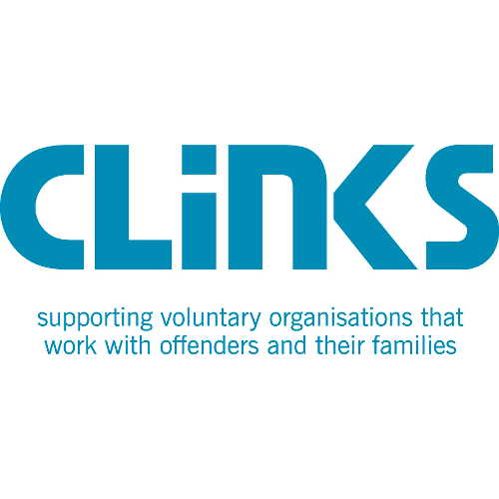](http://www.google.co.uk/url?sa=i&rct=j&q=&esrc=s&source=images&cd=&cad=rja&uact=8&ved=0ahUKEwiUgYnU0PLXAhUhDcAKHQpPARwQjRwIBw&url=http://www.socialfirmsengland.co.uk/supporters/&psig=AOvVaw0cngV7fmRBTr5X94Dmmq2h&ust=1512555012478822)*