HOW CREATIVITY CAN STRENGTHEN THE RELATIONSHIP BETWEEN FATHERS IN PRISON AND THEIR CHILDREN

A multi-award-winning programme is connecting fathers in prison with their children through the power of creativity. Inside Stories, designed and run by Create, the UK’s leading charity empowering lives through the creative arts, gives prisoners the chance to work with professional writers, artists and musicians to write, illustrate and record original stories for their children, which they then set to music. The project culminates in a special family visit at the prison, where the fathers perform their stories and music. The children then receive a storybook and CD, including a personal message from their father. Inside Stories has worked with over 950 prisoners since 2009 at 12 prisons, and been recognised with 60 Koestler Awards.

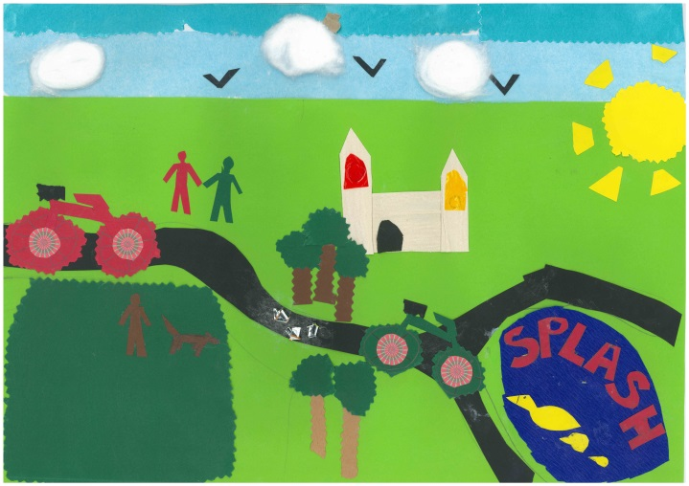
An estimated 200,000 children in the UK have a parent in prison, the majority of these parents being fathers. For these men, maintaining a bond with their children – or creating one with children born since they entered prison – can be difficult. On the outside, their children often struggle with feelings of trauma and uncertainty, including worrying about what their father is experiencing in prison and how much he might have changed when he returns. Furthermore, there is an increasing focus on desistance theory in criminology and the important role that forming and renewing relationships between prisoners and their families play in reducing reoffending rates.

Inside Stories serves as a creative outlet that enables prisoners to learn new skills, develop pride and increased self-esteem and focus these positive outcomes into their role as a parent. It also enables them to develop creative skills - storytelling, collage and music – that they can use to connect with their children on family visits and on release. Carol Topolski, one of Create’s professional writers who works on Inside Stories, wrote an article for the Observer in July 2017 about her experience of empowering the programme’s participants to create their storybooks.

Create’s Patron Erwin James, an author and journalist who served 20 years of a life sentence, has spoken about the impact of Inside Stories, commenting that: “It takes strength, courage and commitment to overcome the limitations that prison culture inflicts on an individual’s capacity to be expressive and creative. I was lucky enough to attend one of Create’s projects and was humbled by the courage and determination they demonstrated.”

Ryan, a prisoner who took part in Inside Stories, found that the project helped him deal with missing his children. He said: “My story is about a village called ‘Musicville’ that has lost all of its music. One of the artists was talking about a dog that had lost its bark and I thought that would be pretty sad – a world without sound or music would be pretty dull. I love music.

The project has given me so many skills, a lot of which I won’t realise until I’m in certain situations. But it’s made me think I’d quite like to go into drama or something creative like that. Maybe some people would turn their noses up at this type of work thinking “why would you want to sit with a bunch of criminals?” But Create hasn’t given up on us and realises that we’re still people, not defined by our crimes.

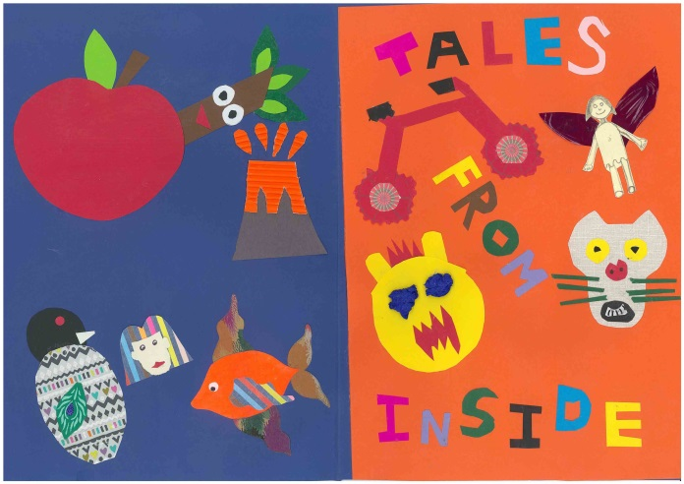
This is one of the only connections guys in here can have with their children. Prison is a volatile place in an enclosed environment and you’re separated from your loved ones. You only get two hours a month to see your family. It’s hard.

There are a lot of people in jail whose kids mean everything to them. You’ll hear a lot of the boys saying their kids are their rocks. You can only make two phone calls a week in here and it’s hard to talk to them because, well, there’s not a lot you can say to children while you’re in prison. Having this book that you can give to them and a CD where they can hear your voice makes you feel good. They can say, “That’s my daddy”. It makes me feel good knowing they can hear my voice whenever they want, just by pressing ‘play’ on a CD player.”

To find out more about Inside Stories and Create’s work, visit createarts.org.uk.

