HMP Lowdham Grange

Children and
Families Strategy

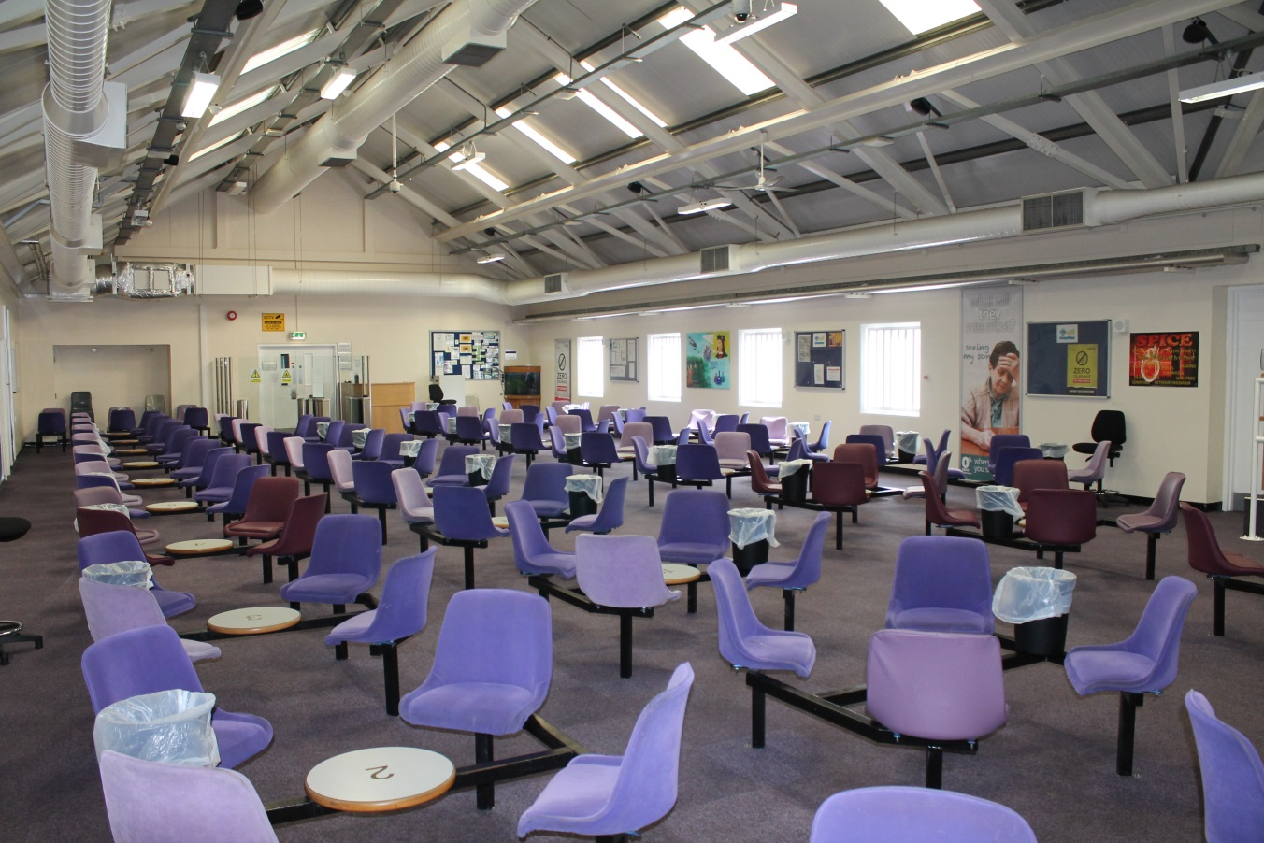

May 2018 – May 2019

Introduction
Maintaining family relationships is paramount in achieving a reduction in re-offending. HMP Lowdham Grange is committed to the fostering of good family relationships and the maintenance of existing relationships, in order to aid the resettlement of prisoners. The prison aims to provide a framework that enables positive outcomes and interactions for children and families with a close family member in our custody. The impact of any custodial sentence is not only felt on the family member but also on the family and friends of the prisoner.
The primary purpose of a prison sentence is to punish the offender by taking them out of society where they can cause harm. However, given practical, financial, social and emotional effects of imprisonment, a prison sentence can also have punitive consequences for families outside prison. Prisoners’ families, particularly their children, are often termed the ‘innocent victims’ of crime (and punishment).
For a long time, prisoners’ families were also referred to as the ‘hidden’ or ‘invisible’ victims of punishment or crime, since the hardships they experienced were not immediately obvious.

What is the impact of imprisonment on prisoners’ families?

Since every family is different (including who is considered to be part of a ‘family’), the impact of imprisonment is different for every family. Yet, research suggests that there are some fairly common experiences.

Over 10 million children in the world have a parent in prison and Action for Prisoners Families estimates that in the United Kingdom approximately 200,000 children have a parent sent to prison each year.
The children of prisoners are 3 times more likely to take part in anti-social and delinquent behavior. Imprisonment can result in reduced family income, home and school moves, disrupted relationships, stigma and decreased social support. Each year in the United Kingdom more children are affected by parental imprisonment than by divorce. It is estimated that 65% of boys who have a father in prison will go onto offend themselves. This research shows that offending can be catastrophic to families and children, who are also being punished along with their parent (Action for Prisoners Families: 2012).
Additionally children from these family groups form a significant number of those entering the Care system.

Specifically:

- Families experience emotional distress even with the temporary loss of a loved one from the family home and/or family life: for example, families miss out on sharing family events such as birthdays and Christmas, or even simple family activities such as meals, with the imprisoned family member.

- Prisoners are stigmatised for their offence, and their families often are too. Families are seen as guilty by association even though they are legally innocent and generally have had no involvement in the offence. This stigma is sometimes referred to as stigma by association. This stigma makes the imprisonment even more difficult for family members, and it can also mean that families are treated negatively by other members of their community, or face negative treatment from colleagues, peers, the media and even friends and family.

- Following the imprisonment of a person, partners of prisoners are often forced to take on multiple roles and responsibilities, particularly where the incarcerated family member has previously had an active role in the household.

- Imprisonment tends to impose financial strain on the families of the prisoners in two ways: by decreasing the family income and by increasing family expenditure, due to costly visits and phone calls, and handing in money for their loved ones in prison. Prison can thus exacerbate existing socio-economic disadvantage

- There are often particular difficulties associated with prison visiting. Visiting often involves great deal of time, effort (both physical and emotional) and expense. Visiting can be quite an emotional experience, with both positive and negative feelings in the mix: for example, families usually enjoy seeing their imprisoned loved one, but due to the brevity of the visit saying ‘goodbye’ comes quickly, which can be distressing.

- Visiting can be particularly difficult for children, with poor facilities that are not ‘child friendly’ and confusing rules restricting how they can interact with their imprisoned family member; families often have to travel long distances to a prison, and are often reliant on public transport; visiting times may not be compatible with tea time and bed time routines, leaving children irritable or tired, which may then impact on school performance the following day.

- Stigma for the children of prisoners can be manifested in being bullied by classmates in school.

- Longer-term, children of prisoners are three times are more likely to engage in anti-social or offending behaviour than their peers who do not have a parent in prison.

- Care Leavers are over-represented in our prisons and 25% of men in prison are likely to be care experienced, potentially double this figure for women.

- Care Leavers constitute one of the most vulnerable groups in our society and those in our prisons are likely to be some of our most complex people, As such it is vitally important that we are able to identify them and have systems in place to ensure they are receiving support, both under statutory obligations for those under 25 but also to understand the impact early childhood trauma and their care experience have on them and their behaviour.

Why focus on Children and Families?
Supportive families are a great resource for prisoners and they often play a vital role in helping an individual move away from crime. A supportive family can also provide effective protective factors for prisoners at risk of suicide and self-harm. Having a stable family to return to on release, can also encourage prisoners to engage in sentence planning interventions and maintain positive behavior whilst in custody, helping their earlier release from custody.
Research on desistance from crime, also suggests that positive family ties can have an encouraging effect on the rehabilitation of offenders. Prisoners who had not received visits whilst in prison were 39% more likely to re-offend, compared to those prisoners who had received visits from family members (Action for Prisoners Families: 2012).
It is therefore important at Lowdham Grange that our staff and our partners/pathways leads encourage positive family relationships, and identify ways of supporting families in order to reduce re-offending.

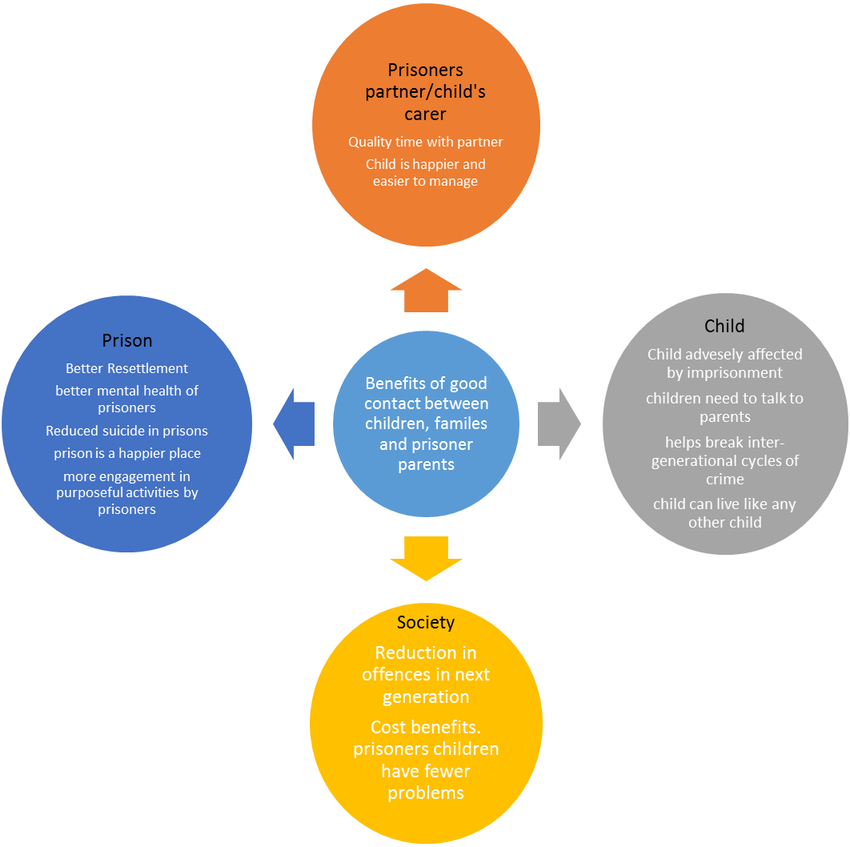
Kids VIP is a children’s charity that looks at improving family links between prisoners and their families. A recent good practice document “Kids VIP” looking at improving the visiting experience, highlighted the following benefits of good contact between prisoners and their families:

In a small number of cases, maintaining family ties may not be appropriate, possibly due to the risk of harm that an offender poses to the family. Safeguarding children and supporting victims should always be a priority. Here at Lowdham Grange this is jointly and carefully managed in the work the National Probation Service and the Public Protection Services do.

At Lowdham Grange the Children and Families Pathway aims to ensure the interests of prisoners and their families are addressed through:

- Helping to maintain family ties, where appropriate.
- Facilitating Family Days
- Providing advice and guidance to families and prisoners.
- Developing a family friendly focus in the prison and through our visitor center.
- Involving the family in Resettlement decisions when appropriate.
- Threading the Children and Families pathway through all of the Resettlement pathways.

Governance and Management of the pathway
In order to ensure that “family” remains the focus of our work towards the rehabilitation of our prisoners, the commitments listed above are monitored through the following processes:

- Reducing Re-offending meeting and related action plan.
- Safer Custody Meeting.
- SMT meetings.

Measuring our success in developing the Children’s and Families pathway

- Prisoner Annual Needs questionnaire
- Family & Friends questionnaire
- HMIP
- Prisoner MQPL
- Prisoner exit questionnaire

Lowdham Grange Reducing Reoffending Pathways – our commitment to prisoners children & families in 2018.

- Attitudes, Thinking and Behavior

We deliver accredited programmes to help prisoners understand their offending, and provide them with tools to help them avoid re-offending in the future.

Current accredited programs include Resolve, TSP and Kaizen

Commitment for 2018
- Ensure we have Managers responsible for the delivery of high intensity programs. This will include responsibility for arranging post program reviews, and inviting attendance/input from the prisoner’s family, where appropriate.
- Continue to work with Commissioners with a view to delivering the accredited programs which address the needs of prisoners who have domestic violence offences.
- Attend the family induction days to provide families with information regarding the interventions available at Lowdham Grange.
- Explore the possibility of mediation between prisoners and families, working closely with the visits team.

- Children and families

At Lowdham Grange we have a multi faith chaplaincy team catering for the diverse pastoral and faith needs of our prison population.

Following notification of a death of a relative of one of our prisoners, the chaplaincy team provide bereavement support for the prisoner through this distressing period.

The Chaplaincy team also arrange on request, marriages for prisoners serving sentences at Lowdham Grange. Regular contact with the bride is necessary to ensure the wedding plans are all in place.

Following a death in custody, the Chaplaincy team are often called on to attend and offer support to the deceased Next of Kin. The Chaplaincy team often take on the role of family liaison, keeping in regular contact with the family and offering continued support.

Commitment for 2018
- Liaise with POP’s alongside the Visits Coordinator to develop and review the family day events, to suit the needs of the families in attendance
- Attend the family induction day and provide families with an overview of the pastoral/faith provisions at Lowdham Grange
- Continue to work with the visits managers to enhance the visits experience for children and families wherever we can.
- Liaise with VIP kids to provide advice to help develop our visits experience for families

- Drugs and Alcohol
Substance Misuse Recovery Service
The service is commissioned by NHS England to deliver services for offenders with a history of, and with current substance misuse problems. The ethos of the Substance Misuse team is to provide an environment where recovery can be achieved. The cycle of recovery is often a difficult one and relapse can be an ongoing feature. The involvement of family can help positively challenge, promote, and support recovery.

Commitment for 2018

- Look at further developing the current delivery of Naloxone training to families in the visitors centre.
- Look at a bespoke wing for prisoners who require more in depth support. ( Drug
- Recovery Wing) and involve family members where practicable.
- Provide advice and guidance to families about substance misuse, and signpost any families to appropriate local community support in their area.
- Involve families in celebrating achievements in recovery, e.g. facilitating involvement in post ‘Foundations of Rehabilitation’ graduations, and provide copies of certificates of achievement for family members if requested.
- Mental and physical health

The healthcare provision at Lowdham Grange is provided by the Nottingham Health Care Trust - NHS England. Prisoners can expect to receive comparable levels of primary and secondary support and treatment, with what they would receive in the community.

The Mental Health Team work with prisoners identified with mental health problems, supporting them towards improved mental health where possible. This can involve contact with family members, where visits have been arranged to help lessen their concerns. Sometimes sight of the person in crisis can bring some semblance of relief to those who otherwise would have limited contact. In-reach also work with, and support prisoners who are at risk of suicide and self-harm, attending their ACCT reviews and actively helping to develop support plans for those prisoners at risk.

Commitment for 2018
- With consent, and taking into account confidentiality issues, we will discuss with a family member diagnosis and treatment plans for a prisoner with a serious medical condition.
- We will liaise with Security to consider, in the case of serious ongoing medical treatment, whether a family member can attend the external hospital
- We will advise the Security department in the event of a serious medical emergency, to consider informing the next of kin and recommend appointing a family liaison officer.
- The healthcare team will attend the family induction day, to encourage families to discuss the healthcare provision at Lowdham Grange.
- We will review all patients currently working with the mental health team, with a view to involving family members in cases where it would be beneficial to treatment and recovery.
- In the event a prisoner is likely to be admitted to a secure hospital under the mental health act, consideration will be given to informing the Next of Kin where capacity is not present. This will be only be completed with the authority of the Security department.

- Education, Training and Employment

This pathway is managed by Lowdham Grange’s bespoke Education and Business Enterprises department and partners, working together to offer opportunities for prisoners to achieve qualifications, enjoy the Arts, and gain real life employment skills.

As part of the curriculum, prisoners can attend and gain a qualification in Family Development which enables them to parent more effectively upon release. There is also access to the Pro-Social Modelling course, which can help encourage and reinforce societal and family norms and behaviours.

The Library service is provided by Lowdham Grange and provides books on parenting and other family related subjects. Prisoners are encouraged to learn to read, and can also take part in ‘Storytime’, making a video story read by them for a child/family member.

There is an extensive gymnasium programme which enables prisoners to stay active and take part in a range of sports. Nutrition and well-being are part of the programme, and some prisoners learn to cook in the kitchens and Bistro. This activity can become a part of their everyday life, and also be learnt and enjoyed by children, partners, and other family members, which encourages a more healthy overall lifestyle.

Commitment for 2018
- To continue to promote qualifications for prisoners enabling them to plan and cook nutritious and balanced meals for themselves and their families on release.
- To encourage prisoners to utilise the Arts facilities to design and draw/paint pictures to send to their children should they choose, and public protection permitting.
- To involve prisoners in the design and creation of art works for display in the visits hall, making the visits hall a brighter more family friendly environment.
- To continue to provide Storytime facilities, and encourage prisoners to take up this valuable opportunity by promoting an understanding of the positive effect felt by a child after receiving a videoed story from their absent family member.
- To continue providing Storytime in the visits hall so children can be a part of the story, and view “Dad” from home.

Other significant teams within Lowdham Grange and their commitment to prisoners Children & Families in 2018.

- Offender Management Unit/ Public Protection
HMP Lowdham Grange recognises that Public Protection is one of the core functions of the prison service, is at the forefront of all that we do, and is the responsibility of all staff regardless of grade or position.
The OMU/ Public Protection Unit cultivate a collaborative, prison-wide approach to public protection, built on clear communication between all departments as well as partner agencies. This enables a prisoners risk to be identified - often this risk may be to children or named adults (who may be from the prisoner’s family). Those who pose the most significant risk will be managed through the MAPPA process.

Safeguarding of children is a priority, and depending on the level of risk a prisoner poses to children, this will determine the level of contact they will be allowed whilst at Lowdham Grange. The management of these restrictions can involve mail and telephone PIN monitoring, and monitoring of contact with children during visits.

The levels of contact a prisoner at risk to children can have is detailed below:

Levels of Restrictions for Child Contact
Level One | Full restrictions apply. No contact with any child permitted All correspondence and telephone calls may be monitored subject to a risk assessment being carried out and regularly reviewed.
Level Two | Contact permitted with named child only via written correspondence. All correspondence and telephone calls may be monitored subject to a risk assessment being carried out and regularly reviewed.
Level Three | Contact permitted with named child only via written correspondence and telephone calls. Correspondence and telephone calls may be monitored subject to a risk assessment being carried out and regularly reviewed.
Level Four | No restrictions necessary, contact permitted with named child only via correspondence, telephone calls and visits. The prisoner may be allowed access to family visits with the permission of the Governing Governor following a further, individual risk assessment. Routine monitoring of correspondence, telephone calls, general observations in the visits area. This level of contact applies only to those children that the prisoner has permission to have contact with. All other children will be subject to Level One restrictions.

Commitment for 2018
DRAFT
- To invite input from families where appropriate, in the sentence planning process. This will be subject to prisoners permissions.

- To attend the family induction day to discuss the work of the OMU/Public Protection Unit at Lowdham Grange.

- The team will continue to arrange on request, family support for prisoners during parole hearings.

- OMU/PPU will continue to develop links with Social Services and raise with them any safeguarding concerns for families of prisoners.

- Safer Custody

For a variety of reasons, there are periods in a prisoner’s sentence when they can become at heightened risk of suicide and self-harm. Involvement by and engagement with the prisoner’s family can be useful in helping to support the prisoner through their crisis period.

At Lowdham Grange the Safer Custody team will, with the prisoners consent, invite contribution/attendance from families at ACCT reviews

The Safer Custody team also manage and monitor the Safeguarding hotline for Lowdham Grange. This provides families/friends with the facility to speak to a member of the Safer Custody team, or leave a message about any prisoner they have safeguarding concerns about. Following receipt of this phone call, the team identify, check on, and provide all necessary support to the prisoner if required.

Commitment for 2018

- To continue to involve prisoners families in the ACCT process, where appropriate and with the prisoners permission.

- To attend the family induction day to discuss with family members the Safer Custody role, and the support provided to prisoners.

- To re-launch and re-advertise the Safeguarding hot line, liaising with POP’s to ensure families are aware of the number and its purpose, and are comfortable in using it.
- Following successful completion of the Buddy training, invite families to attend the award presentation, to encourage them to share in the prisoner’s success.
- As part of the Protected Characteristics strand that sits with Safer Custody, work with our younger population to better understand their needs, especially in the context of families and children, involving them wherever possible.
- As part of the Protected Characteristics strand that sits with Safer Custody, work with the YOT to consider our younger population and their needs.

- Security and Operations

The Security and Operations group manage the visits function, including the visits hall and outside play area, and the processes for both prisoners and families using these.

The team manage the security of the area, with a view to ensuring the safety and security of all those using the visits hall, including families, children, prisoners and staff.

The Security department also manage the pin phone monitoring system, ensuring public protection monitoring takes place in line with the guidelines, to protect the public from unwanted contact from prisoners.

Commitment for 2018
- To continue to provide and improve a tea bar facility for both prisoners and families, so they can access and enjoy refreshments together during their visit.
- To explore the possibility of introducing Friday morning Enhanced visits, providing the best behaved prisoners with the option of additional visits with their families.
- To expand the work that the current crèche workers do, with children and families.
- To attend the family induction day to discuss with family members the function of the Security department, the visits process, and correspondence process.
- To continue to provide advice and assistance to families regarding Assisted Prison Visits.
- To effectively manage the visits hall Photo Booth facility and provide positive memories for children, families and prisoners

Visits team will liaise with POP’s to improve the visits experience for prisoners and families..
- Look into the possibility of utilising POPS to promote and display the child friendly penguin image named Popsicle, which aims to welcome children to the establishment, and sign post them from the visit centre to the visit hall. Popsicle takes the form of acrylic wall art, an accompanying fact sheet, and puzzles for the play area. This has derived from POPS ‘Walk the Walk’ which forms part of the Think Family strategy.

- To further develop the Family Forums, linking families with the various pathway leads.

- To continue to develop the Family days, improving the activities and working with families to make the experience more enjoyable for everyone.

- De Montfort University interior design students have reviewed the visits hall whilst it was occupied by prisoners and their families to understand the acoustics and use of space. Photographs of the facilities have been taken and will be used for a proposal to redesign and improve the visits space.

- Reducing Re-offending

It is the role of the Reducing Re-offending team to co-ordinate and link with all the pathways, and those partners involved in Resettlement/ Rehabilitation.

Moving forward into 2018/2019, the Children and Families pathway needs to be developed significantly. Partners and pathway leads should consider the impact on families and children of any changes/developments they plan to implement.

The Reducing Re-offending team will endeavor to raise the profile of the Children and Family pathway, co-ordinating the development and improvement of this pathway through the Reducing Re-Offending meetings and its related action plan.

Commitment for 2018
- To ensure that each pathway lead in the Reducing Re-Offending meetings discuss their progress against the agreed development objectives in this document.
- To invite prisoners families to attend Prisoner Recognition Ceremonies.
- To complete an annual Prisoner Needs Analysis questionnaire, with a section included on Children and Family’s needs.
- To attend the Family induction day to discuss Reducing Re-offending issues with prisoners families.
- To develop the prisoner exit survey along with the visits team, to incorporate questions relevant to the Children’s and Families pathway.

Annex A

Available support/information for Children and Families, and professionals working with them

- Action for Prisoners’ Families www.prisonersfamilies.org.uk – Action for Prisoners’ Families, works for the benefit of prisoners' and offenders' families by representing the views of families and those who work with them.

- AFFECT – AFFECT provides services for the families of serious offenders and offers support groups to families in the south of England. www.affect.org.uk

- First time in Prison – www.firsttimeinprison.co.uk this website was written by lawyers for individuals (and families) who are facing a first prison sentence.

- Inside Time – www.insidetime.org.uk – this website gives visiting and other advice

- Pact (Prison Advice and Care Trust) – www.prisonadvice.org.uk provides 
Useful information on visiting and how visitors’ centres can help families.

- Prisoners’ Family Voices is a web-based community which gives family members the opportunity to talk to each other.
http://prisonersfamiliesvoices.blogspot.com

- Offenders’ Families Helpline 0808 808 2003 info@prisonersfamilieshelpline.org.uk
www.prisonersfamilieshelpline.org.uk

- Prisoners’ Families and Friends Service 0808 808 3444 info@pffs.org.uk
www.pffs.org.uk

- SHARP (Support Help and Advice for Relatives of Prisoners) 01743 245365 for free

- POP’s
Tel 0161 702 1000

www.partnersofprisoners.co.uk

The local team can be contacted on:
keiths@partnersofprisoners.co.uk and on 01524563556 between 11.45 and 16.45 Wednesday Saturday and Sunday
- NICCO ( Barnado’s ) https://www.nicco.org.uk/
NICCO is a one-stop information and advice service to support all professionals (working with children and families of prisoners) and all families of prisoners, bringing together useful information in one place.

