**Was your dad in HM Armed Forces? Has he been in prison?**

**Are you under 18yrs old?**

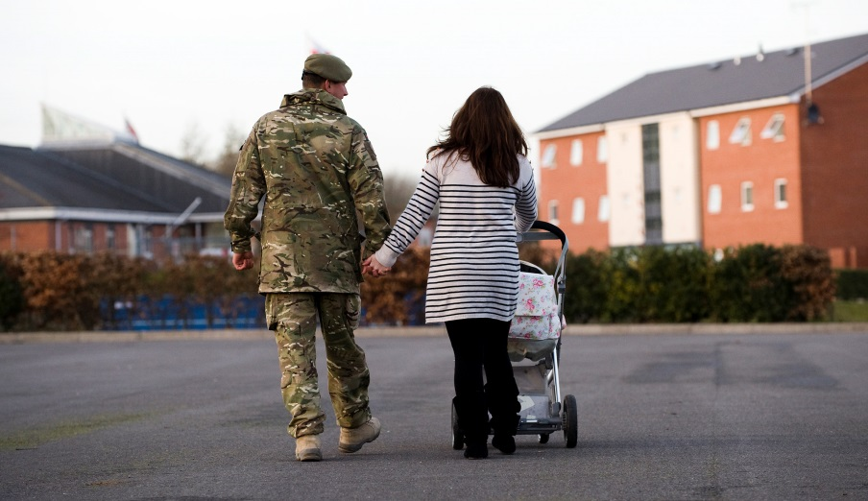



**Have your say and help Barnardo’s find out what support families and children need!**

**Contact us:**

If you would like to participate or have any questions contact us by:

Asking a professional working with you to get in contact e.g. family engagement worker or support worker.

OR

Contact Leonie directly on [leonie.harveyrolfe@barnardos.org.uk](mailto:sara.rattenbury@barnardos.org.uk) / 07702011050

**Interviews can take place:**

 

On the phone Face-to-face



Anonymously online at:

<https://www.surveymonkey.co.uk/r/YPVeteransCJS>

We will need your parent’s permission for you to take part if you are under 16.

We will need your parent’s permission for you to take part if you are under 16.

**We would like to speak to you to find out…**

What **support** do children need when their dad is in prison?

How do dads being in prison **affect** children’s lives?

What helps children to **stay in touch** with their dads in prison?

**Who** can children talk to when their dads have been in prison?

What you tell us will help to make sure services can provide support to children and young people in the future.

  

To answer these questions we will be getting creative

 