**Was your dad in HM Armed Forces? Has he been in prison?**

**Are you under 18yrs old?**

  

**Have your say and help Barnardo’s find out what support families and children need!**

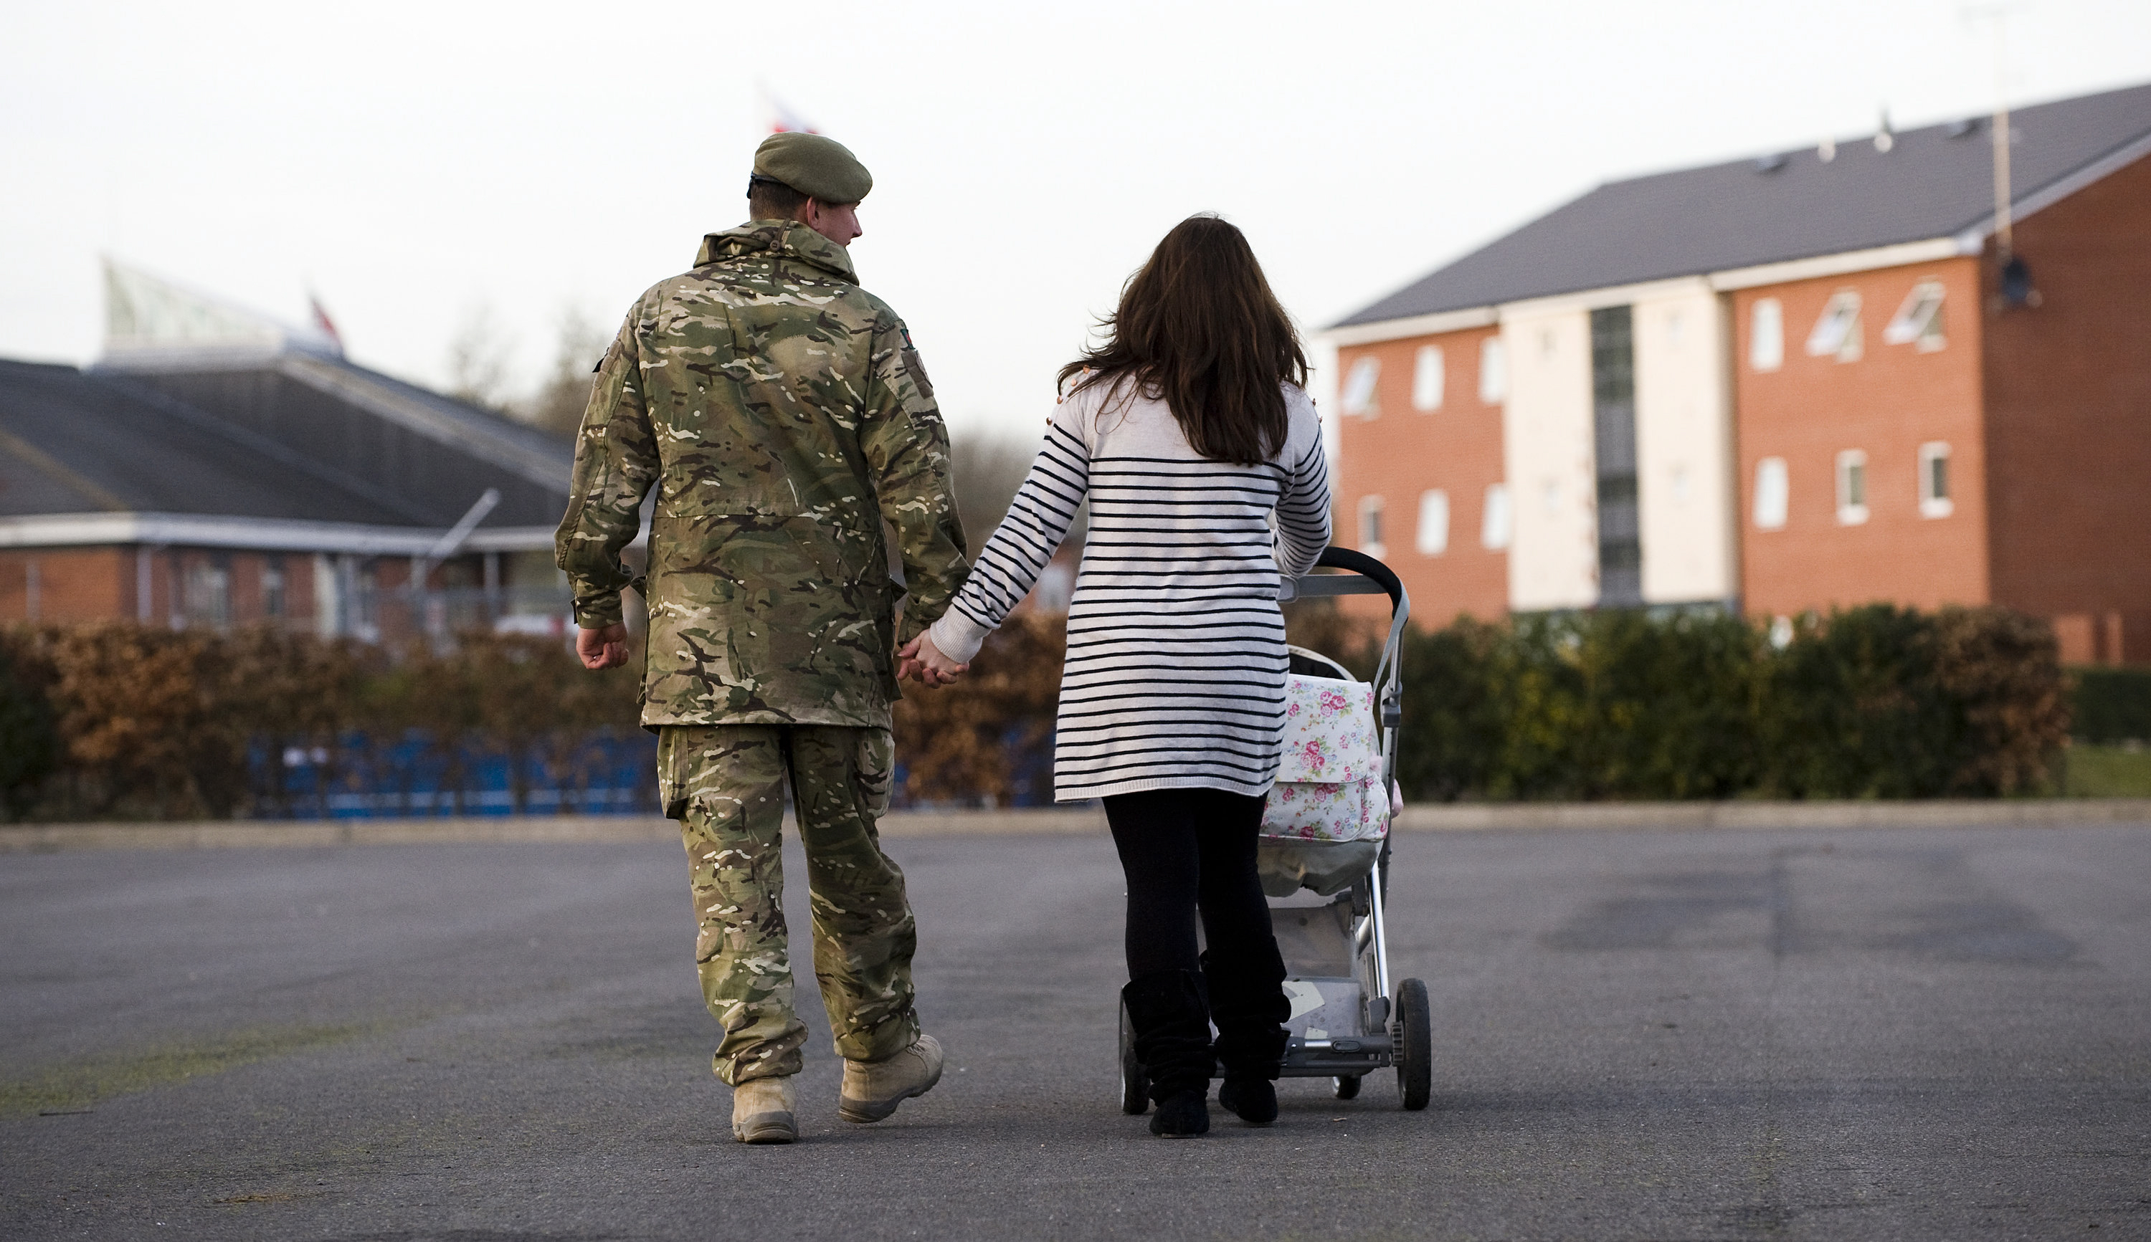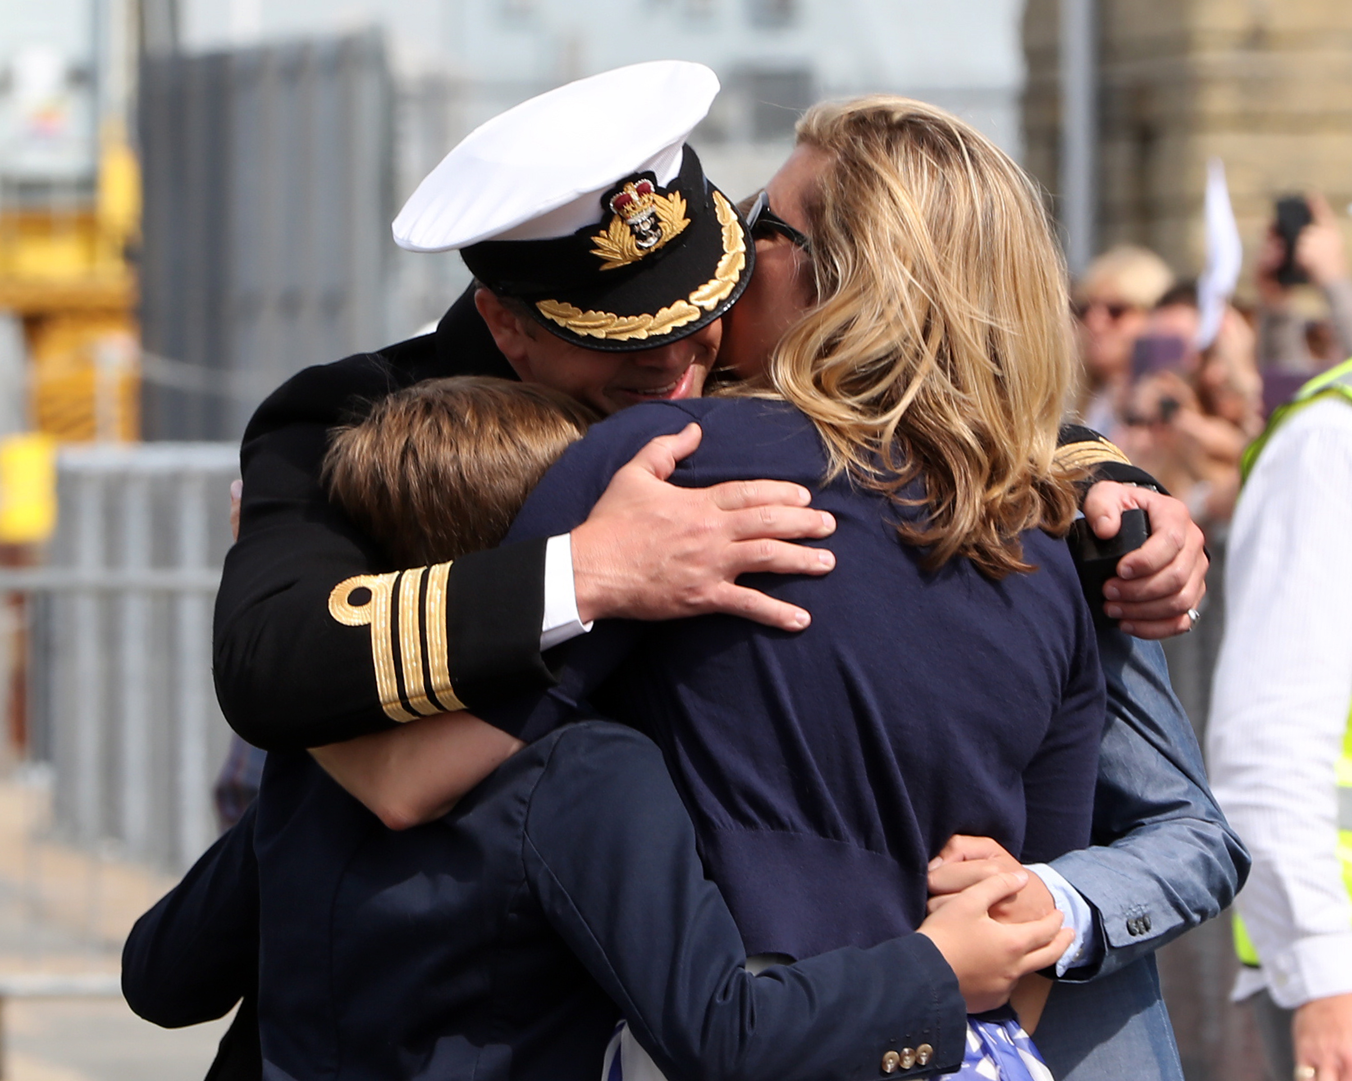



What you tell us will help to make sure future services **provide support to children and young people when they need it**.

If you would like to take part please speak to the family worker at the visit centre/the person who gave you this flyer or contact Leonie directly: [leonie.harveyrolfe@barnardos.org.uk](mailto:leonie@barnardos.org.uk) / 07702011050

We will need your parent’s permission for you to take part if you are under 16.