Have you served in HM Armed Forces?
Do you have experience of being in custody?
Are you a Dad?

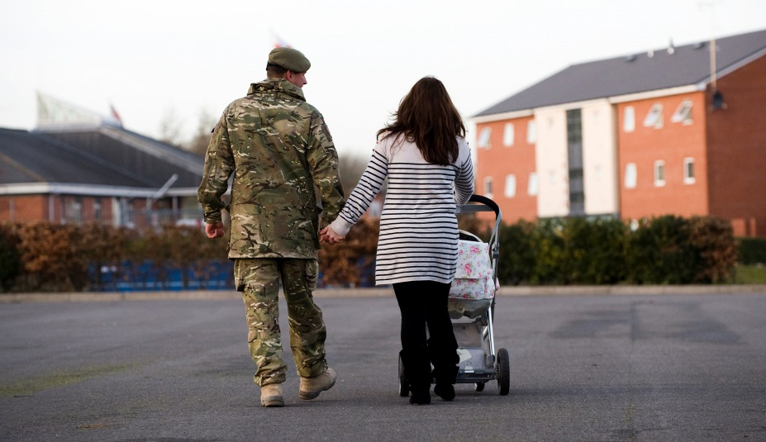
Please help Barnardo’s find out what support
ex-military personnel in custody and their families need!

Contact us:

If you would like to participate or have any questions contact us by:
Asking a professional working with you to get in contact e.g. probation officer or support worker.

OR
Contact Leonie directly on leonie.harveyrolfe@barnardos.org.uk / 07702011050

Interviews can take place:
On the phone Face-to-face
Anonymously online at:
https://www.surveymonkey.co.uk/r/veteransCJS
We also want to talk to your partner/co-parent and children so please let us know if they might be interested.

We will need your parent’s permission for you to take part if you are under 16.

We would like to speak to you to find out…
What support do veterans in custody need during and after their sentence?
How does the experience of custody impact on veterans and their families?
What helps veterans to stay connected to their families while they are in custody?
Who currently provides support to veterans and their families?
The information you share with us will help to shape services of the future to ensure that the support veterans and their families need is available at the time that they need it.
All information shared will be kept in the strictest of confidence
(as long as you do not disclose anything that indicates harm has been caused or will be caused to a person)
All participants will remain anonymous in any reports written.

