Has your partner or co-parent served in HM Armed Forces?
Have they been in custody?
Do you have children aged under 18?

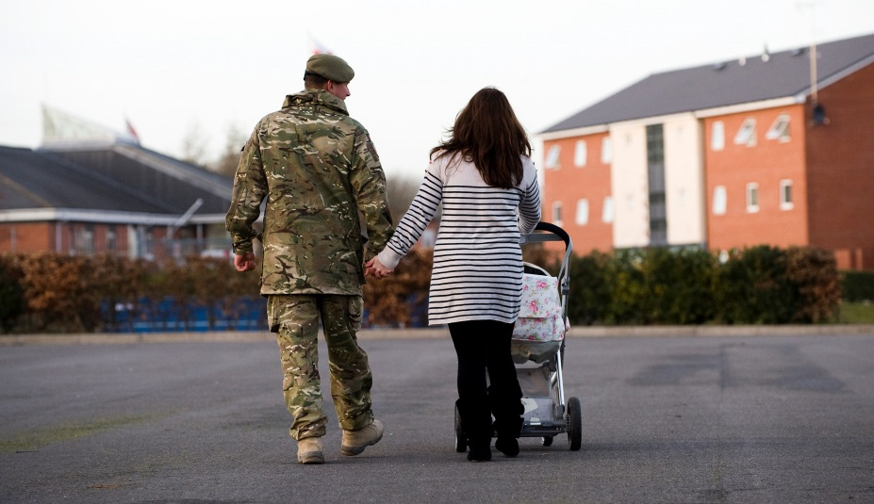

Please help Barnardo’s find out what support families and children need!

Contact us:

If you and/or your children would like to participate or have any questions contact us by:
Asking a professional working with you to get in contact e.g. family engagement worker or support worker.

OR
Contact Leonie directly on leonie.harveyrolfe@barnardos.org.uk / 07702011050

Interviews can take place:

On the phone Face-to-face
Anonymously online at:
https://www.surveymonkey.co.uk/r/familiesveteransCJS

We would like to speak to you to find out…
What support do veterans in custody and their families need during and after their sentence?
How does the experience of custody impact on veterans and their families?
What helps families stay connected to when someone is in custody?
Who currently provides support to veterans and their families?
---
The information you share with us will help to shape services of the future to ensure that the support veterans and their families need is available at the time that they need it.
All information shared will be kept in the strictest of confidence
(as long as you do not disclose anything that indicates harm has been caused or will be caused to a person)
All participants will remain anonymous in any reports written.

