**Are you the partner or co-parent of an HM Armed Forces Veteran? Have they been in custody? Do you have children aged under 18?**

 

**Please help Barnardo’s find out what support**

**ex-military personnel in custody and their families need!**

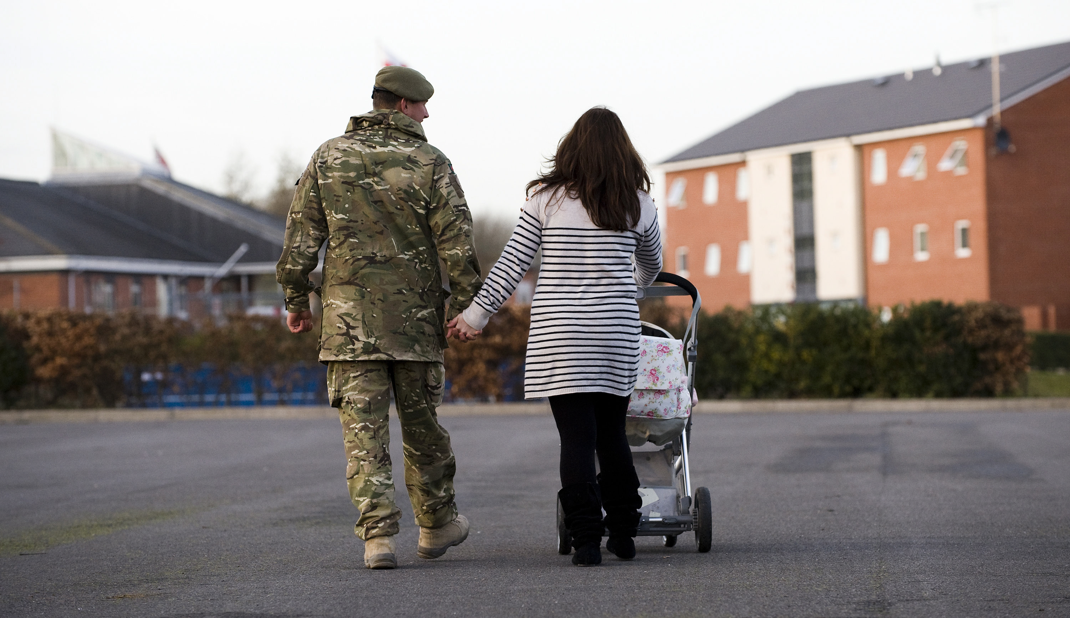 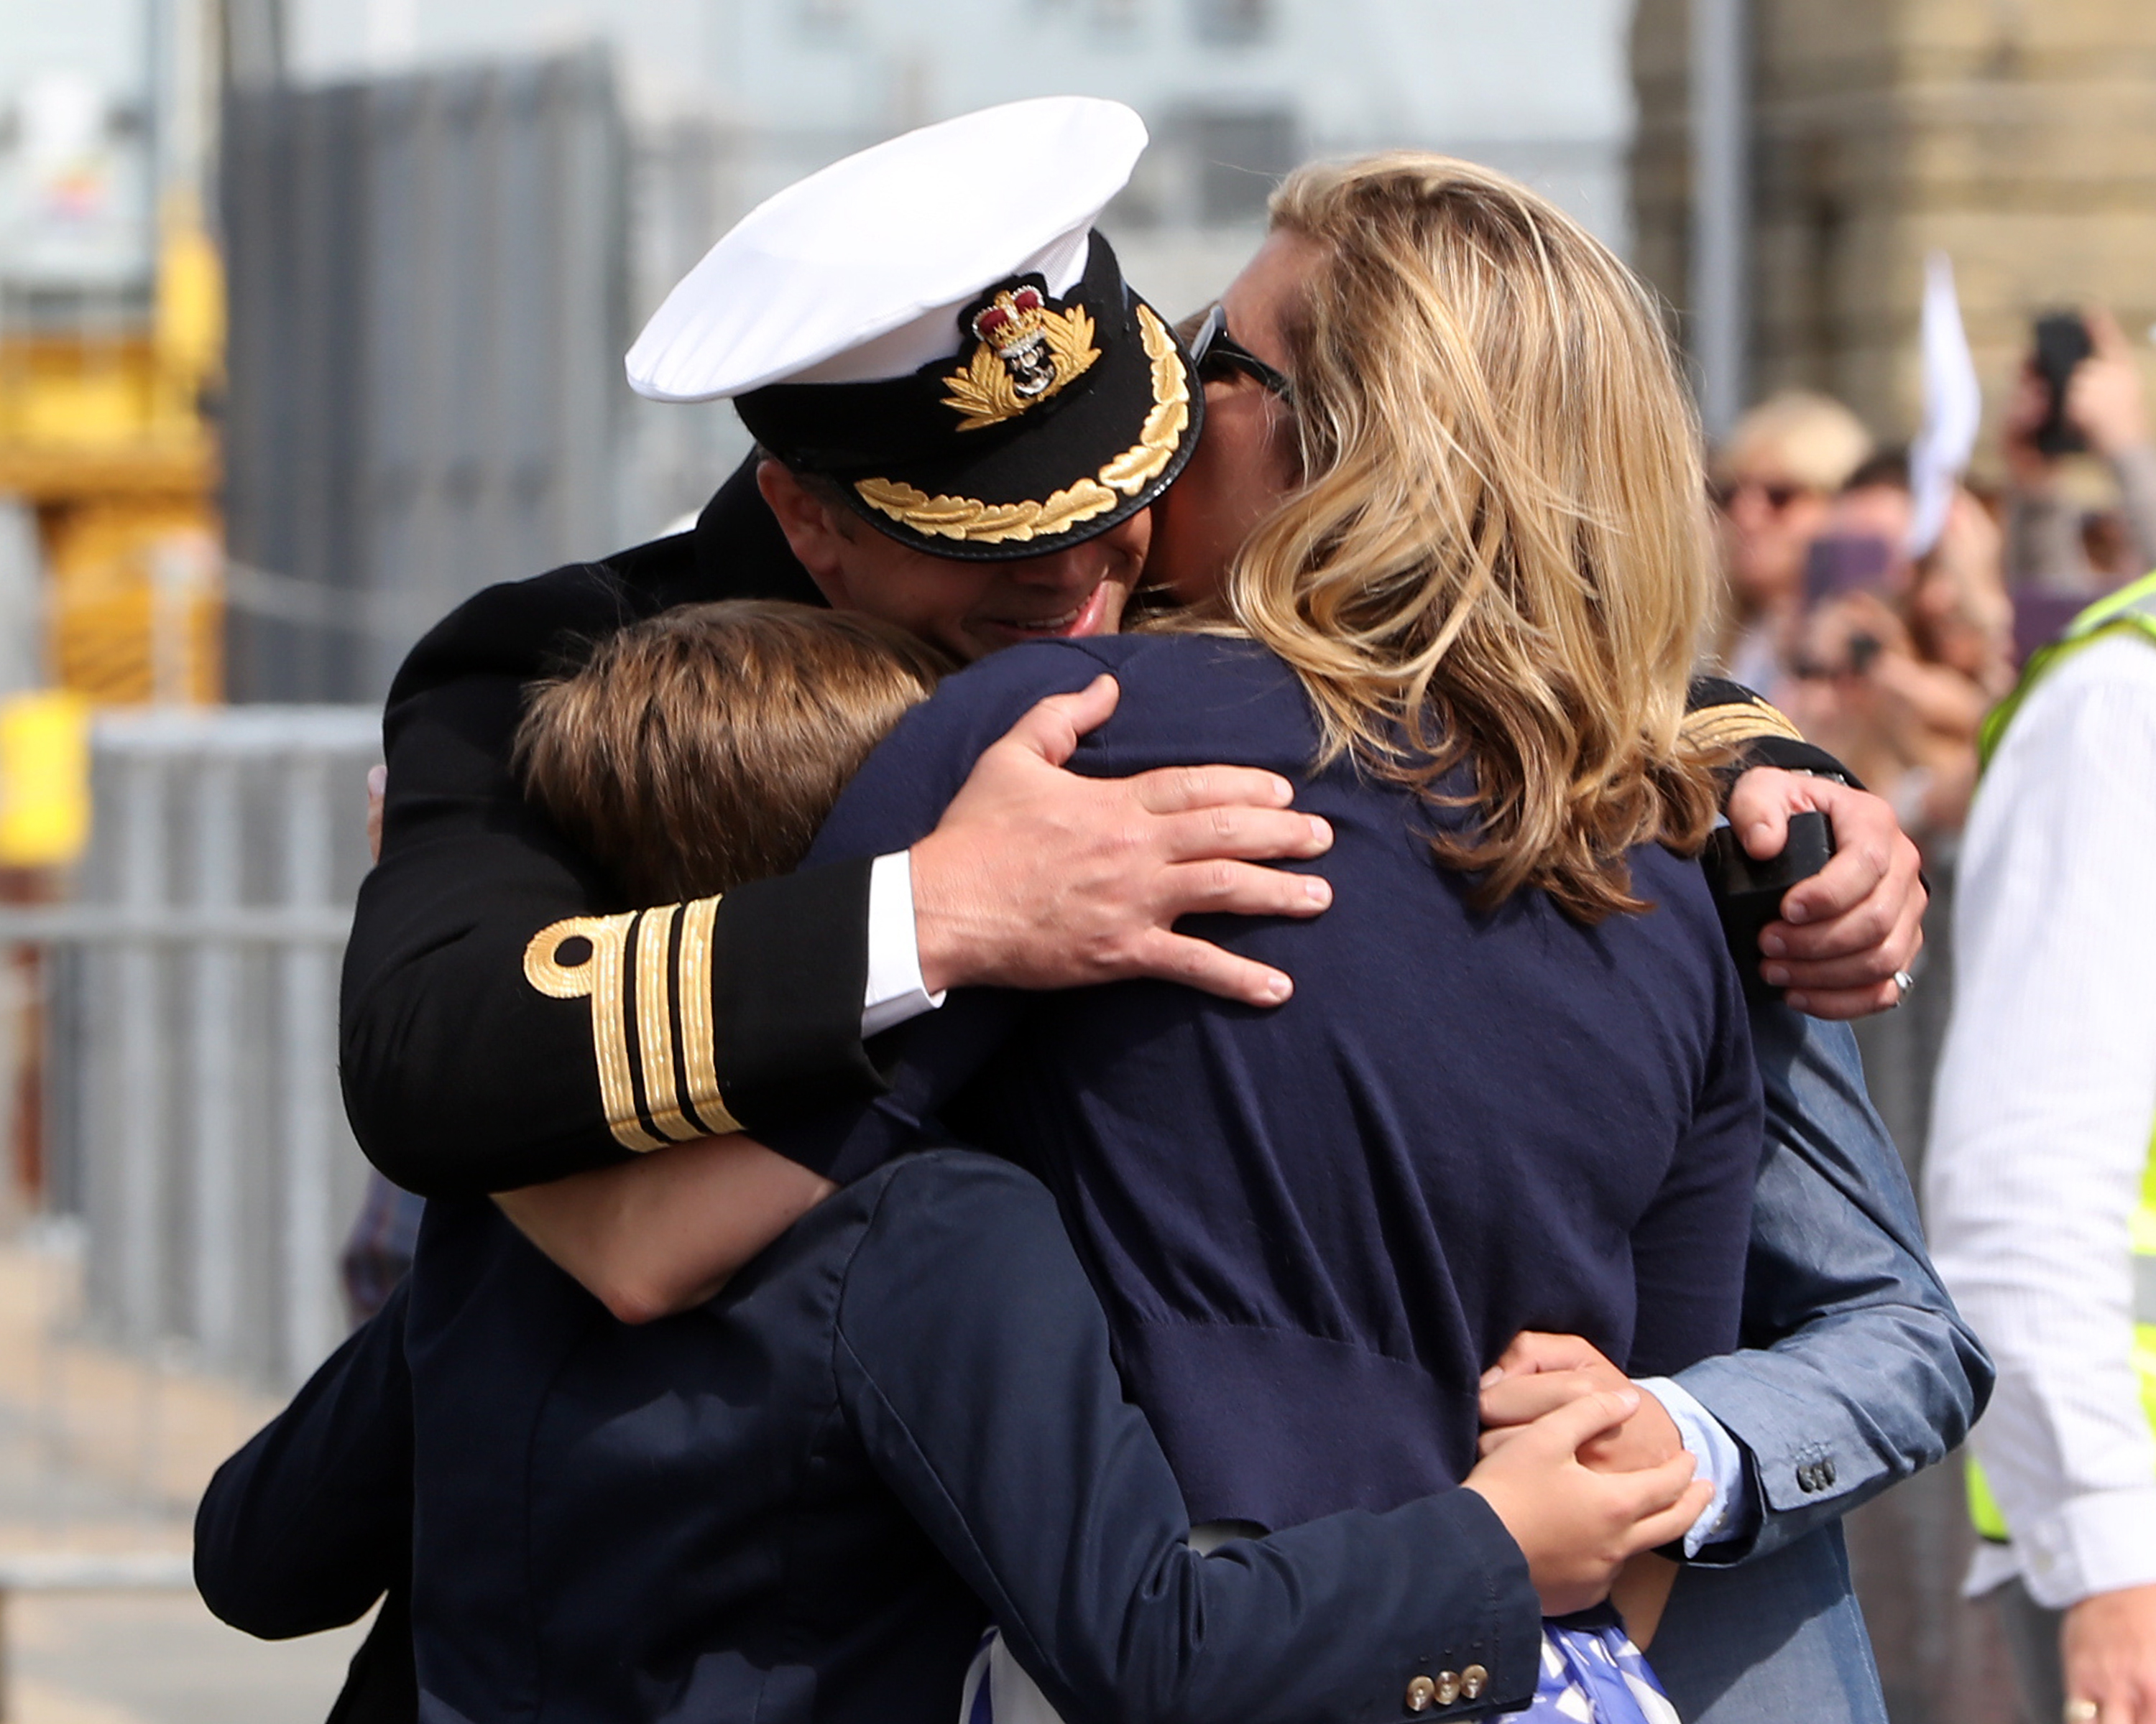

This research will help to shape future services to ensure the **support veterans and their families need is available** at the time that they need it.

All participants will remain anonymous in any reports written.

If you **and/or** your children would like to participate please contact the family worker at the visit centre/the person who gave you this flyer or contact Leonie directly [leonie.harveyrolfe@barnardos.org.uk](mailto:sara.rattenbury@barnardos.org.uk) / 07702011050