Have you served in HM Armed Forces?
Are you a Dad?

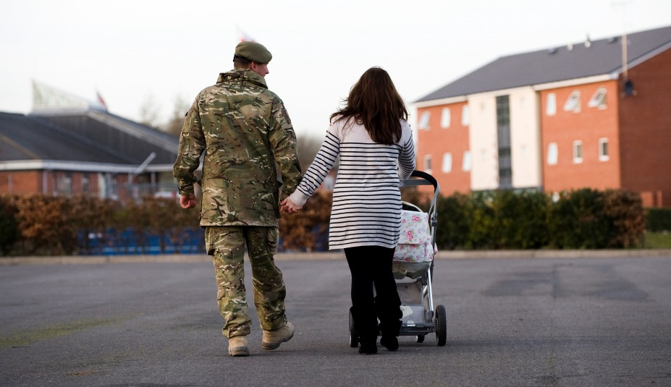
Please help Barnardo’s find out what support
ex-military personnel in custody and their families need!

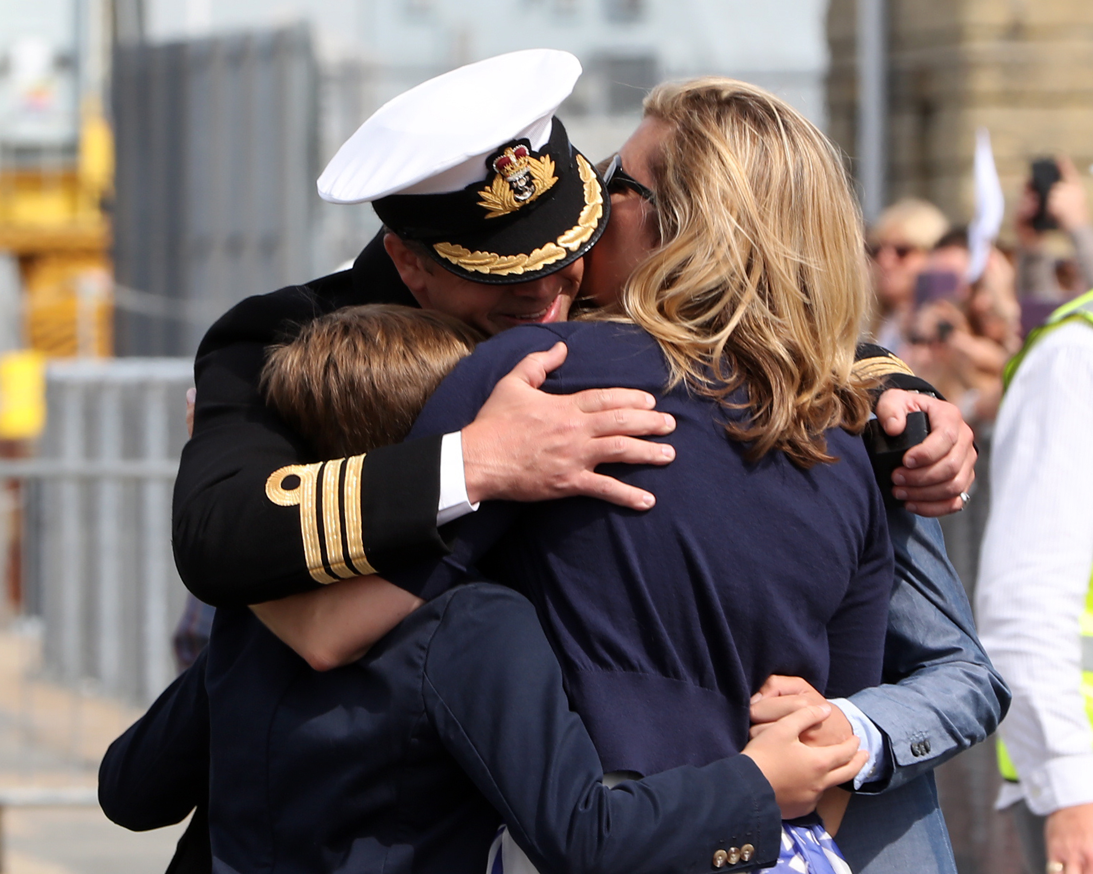

We also want to talk to your partner/co-parent and children, so please let us know if they might be interested.
Alternatively they can contact Leonie directly on leonie.harveyrolfe@barnardos.org.uk 07702011050

Contact us:

If you would like to participate or have any questions contact us by:
Asking a professional working with you to get in contact e.g. VICs lead, offender manager or family engagement worker.

Please note - your status as a veteran will need to be verified if it is not already.

We would like to speak to you to find out…

What support do veterans in custody need during and after their sentence?
How does the experience of custody impact on veterans and their families?
What helps veterans to stay connected to their families while they are in custody?
Who currently provides support to veterans and their families?
The information you share with us will help to shape services of the future to ensure that the support veterans and their families need is available at the time that they need it.
---
All information shared will be kept in the strictest of confidence
(as long as you do not disclose anything that indicates harm has been caused or will be caused to a person).
All participants will remain anonymous in any reports written.

