**Have you served in HM Armed Forces? Are you a Dad?**

**If the answer to both is ‘yes’ we want to hear from you!**



**Please help Barnardo’s find out what support**

**ex-military personnel in custody and their families need!**

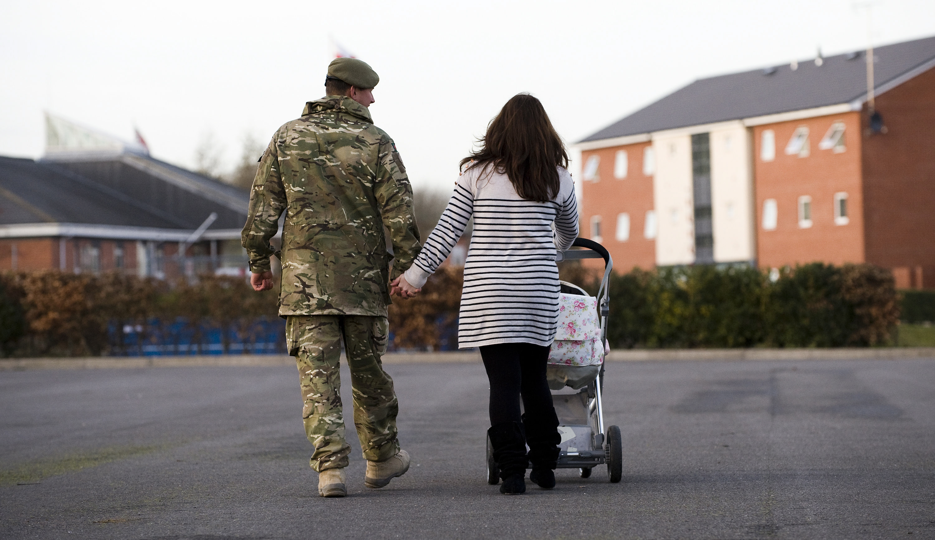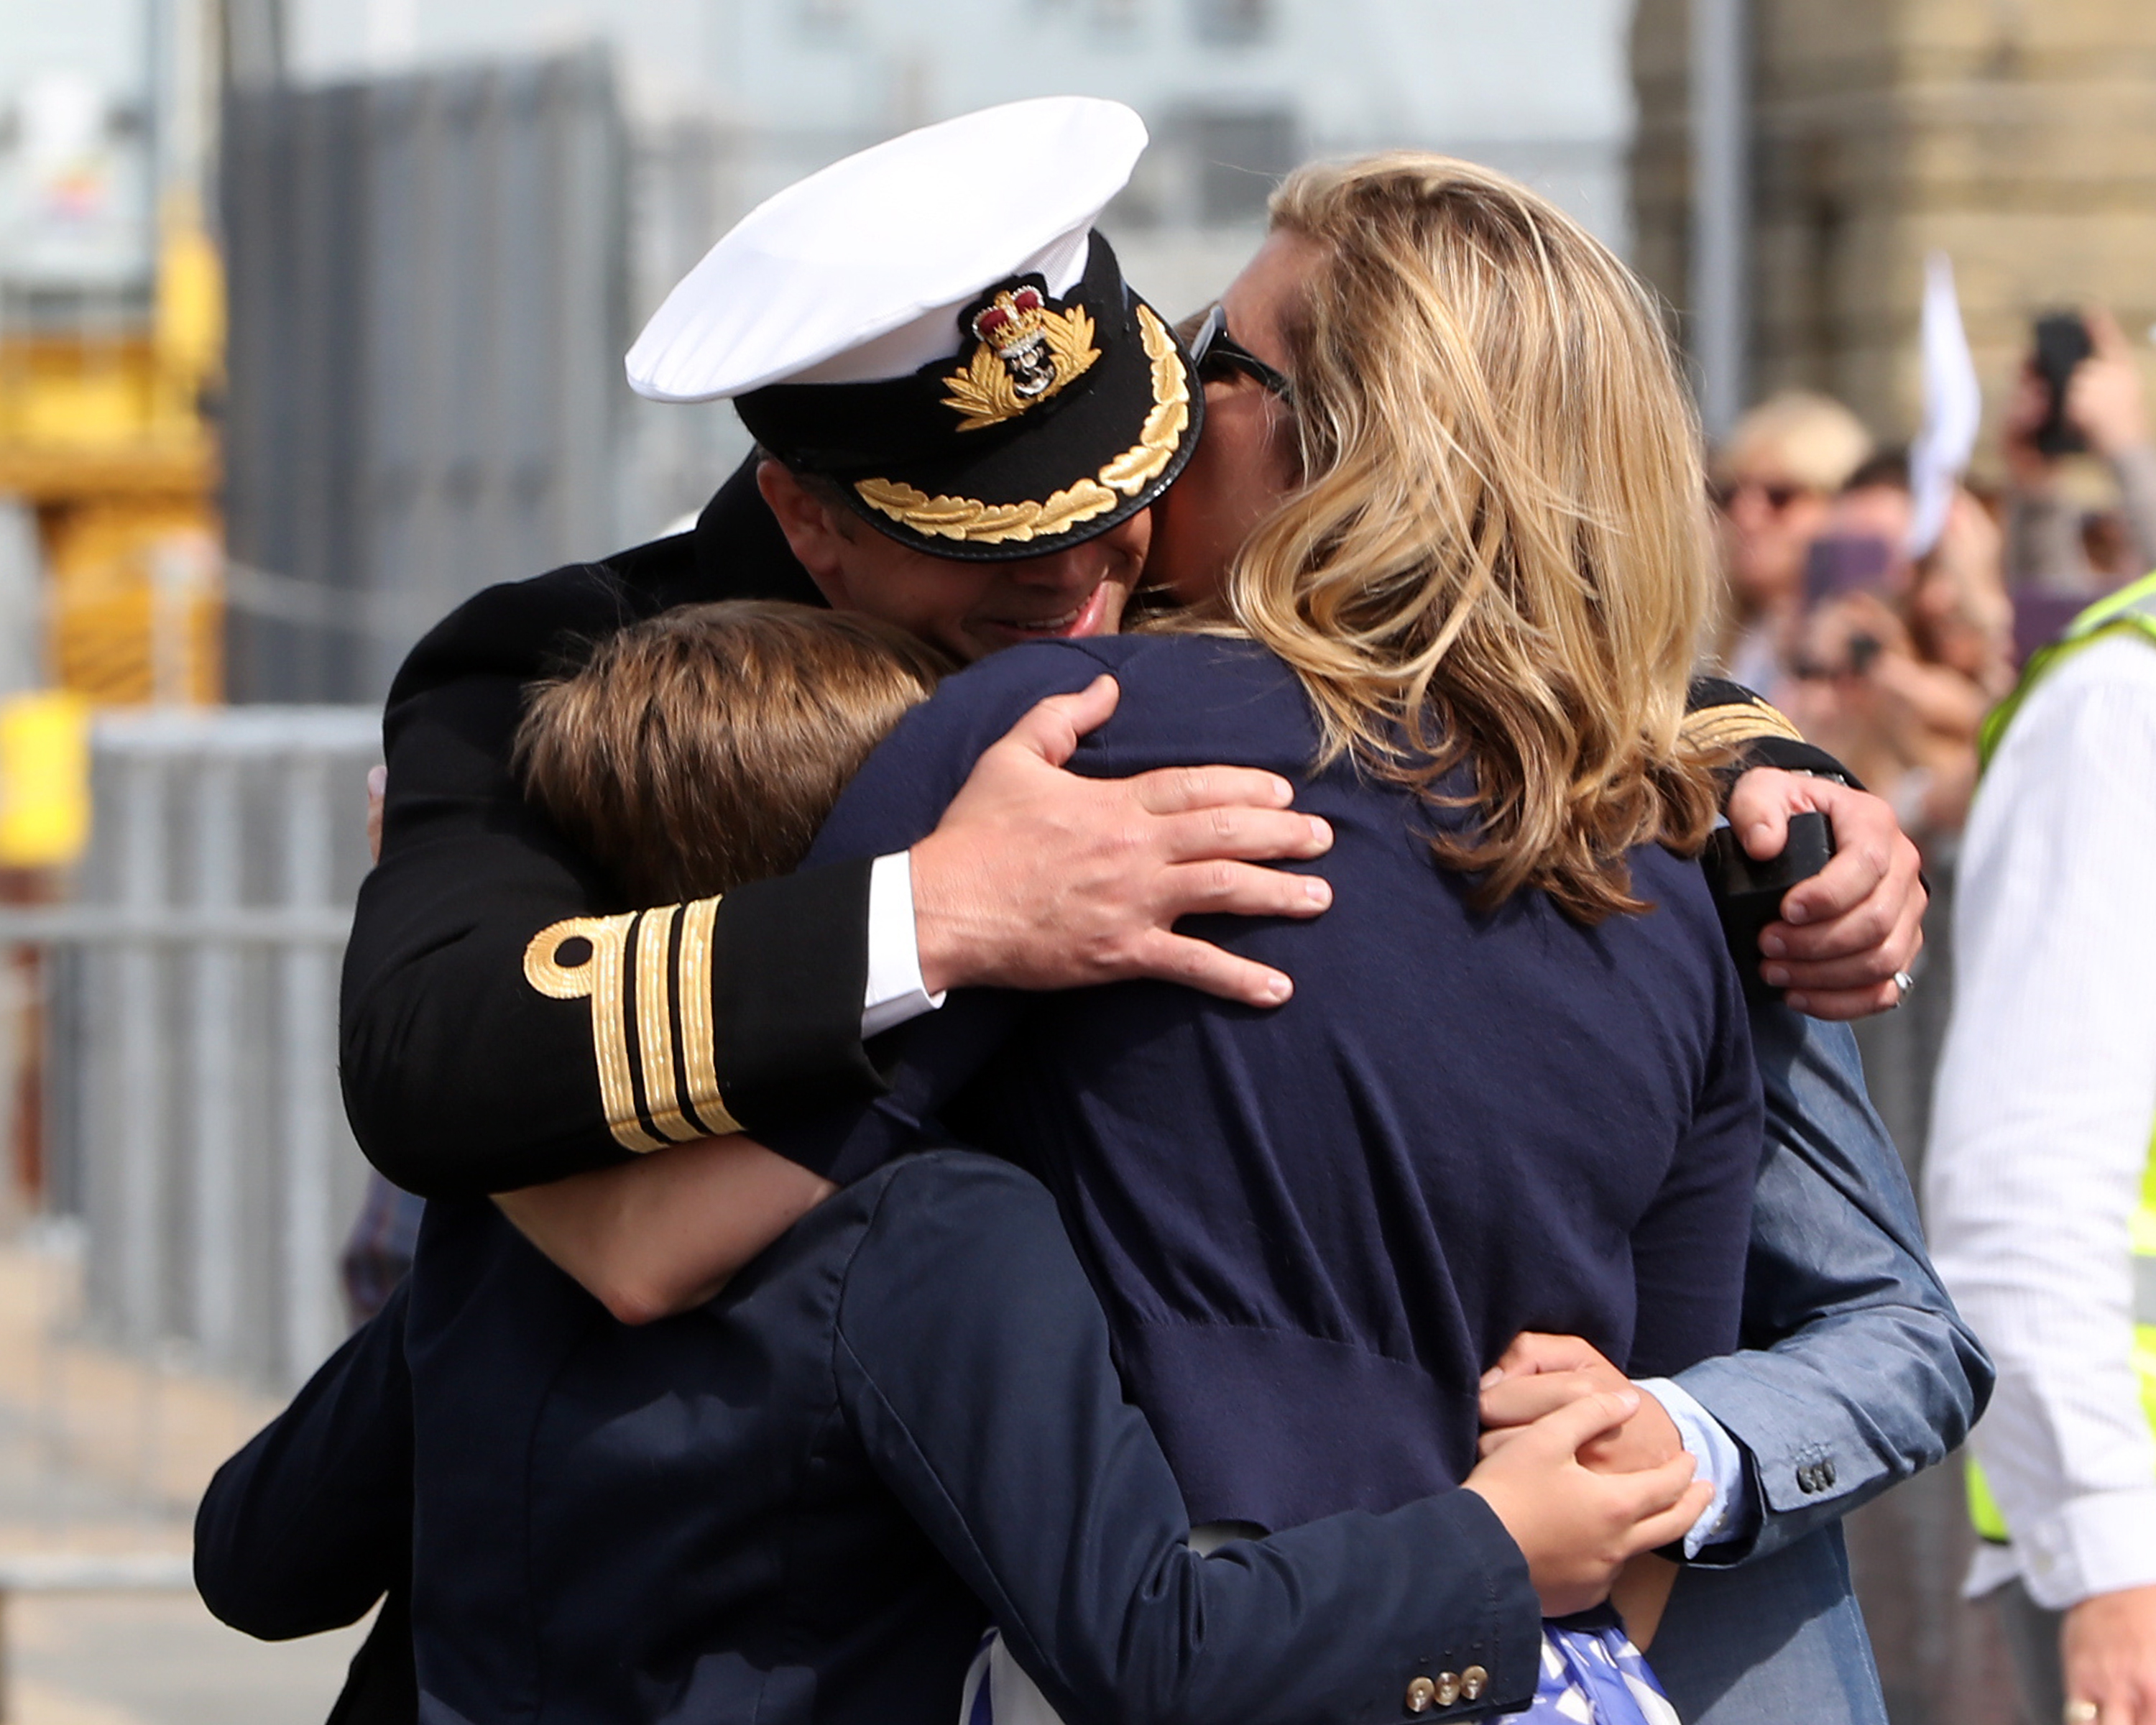

This research will help to shape future services to ensure the **support veterans and their families need is available** at the time that they need it.

All participants will remain anonymous in any reports written.

If you **and/or** your partner and children would like to participate please contact your **ViCs lead**, **Offender Manager** or Barnardo’s/Choices/Pact **Family Engagement Worker**