Children’s Guide to Visiting Guys Marsh

The visit Centre…

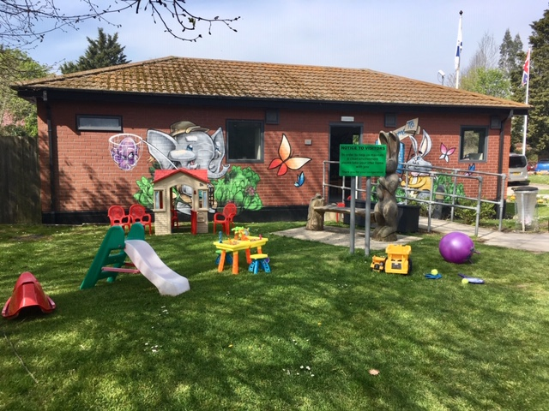

This is the Guys Marsh Visitors centre. This is where you will wait until it is time to see the person you have come to visit. There are some toys and things to draw with in the visit centre.

Going into the Prison…

When it is time for your visit you will go across to the prison. You might see some special prison dogs. They are very friendly and sniff all the people who come into the prison. You will see some of the officers who work at the prison; they wear uniforms and have keys. They have to check everyone who comes into the prison to make sure that they haven’t got things on them that aren’t allowed in the prison. The officer’s job is to look after all the people in the prison. Once your family have been checked you will go into the visit hall.

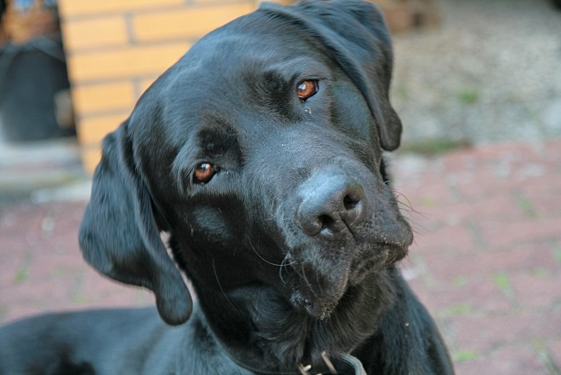

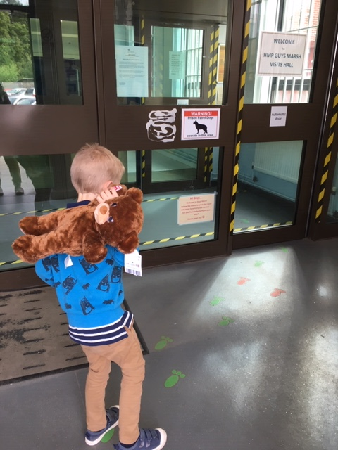

The visit hall…

The Visit hall is where you will see the person you are visiting. It is a big room with lots of tables and chairs in it. When you arrive in the visit hall your family will be told what table you can sit at.

The visit hall at Guys Marsh looks like this…

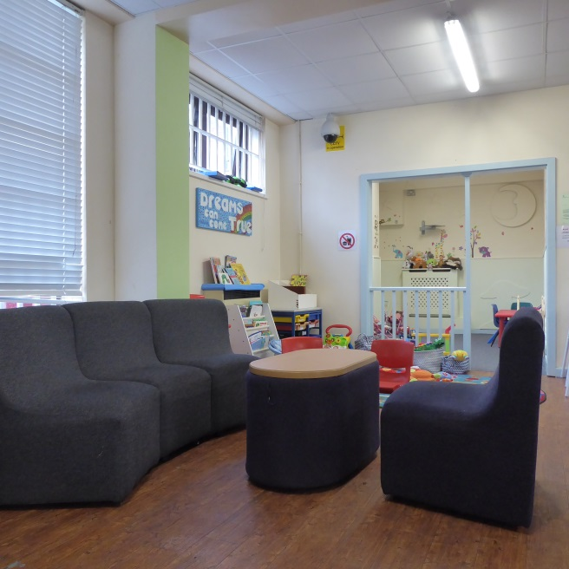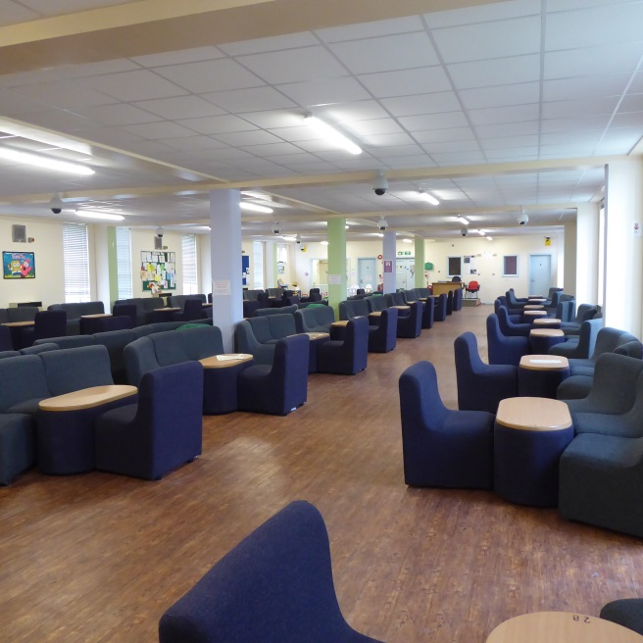

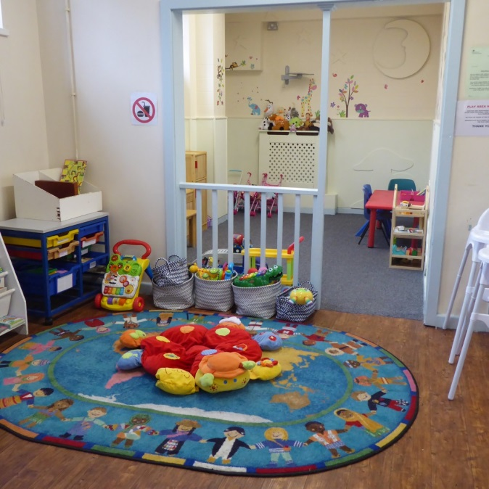The person you are visiting will have to stay sat in their seat but you don’t have to. There is a canteen where you and your family can get food and drink and there are toilets for you to use. There is a play area in the visit hall with toys and games.

The officers will tell you when it is the end of the visit and then you will say goodbye and leave the prison. It’s ok if you feel sad after the visit. Remember that you can always talk to the person you visited by phone or send them a letter. There are letter writing packs in the visit centre that you can take home with you.

Here are some ideas of things you might like to do when you are at home…

* Write a short daily or weekly diary of the things you would like to tell your loved one when you speak to them next. Maybe you heard a funny joke at school you would like to tell them or maybe you got a sticker at school for being helpful.
* Make a memory box. You can fill it with all the things that help you remember your loved one, things like photos or letter from them. Or you
* Write a letter, draw a picture or print a photo to send to your loved one.

Here are some photos of other parts of Guys Marsh

The buildings where the people at Guys Marsh live are sometimes called ‘wings’. Each wing has bedrooms, bathrooms, laundry rooms, and an eating area.

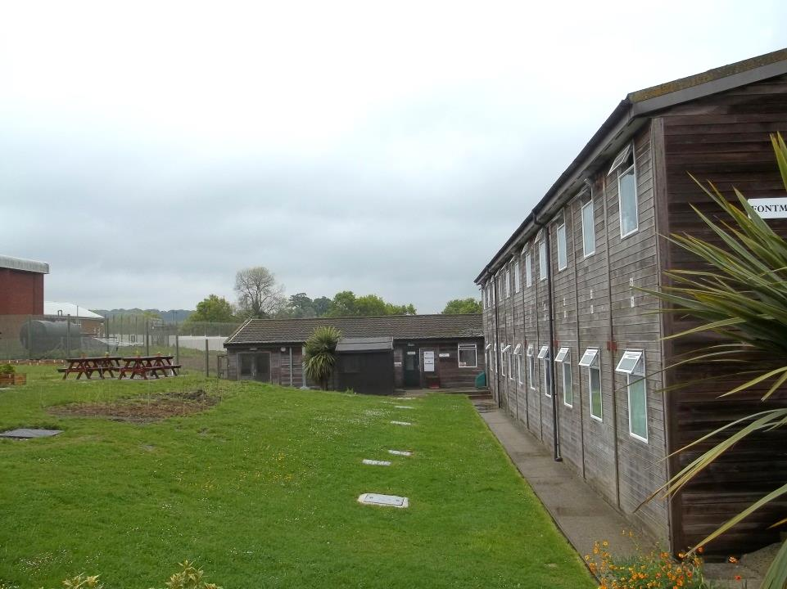

Here is a picture of a wing called Fontmell.

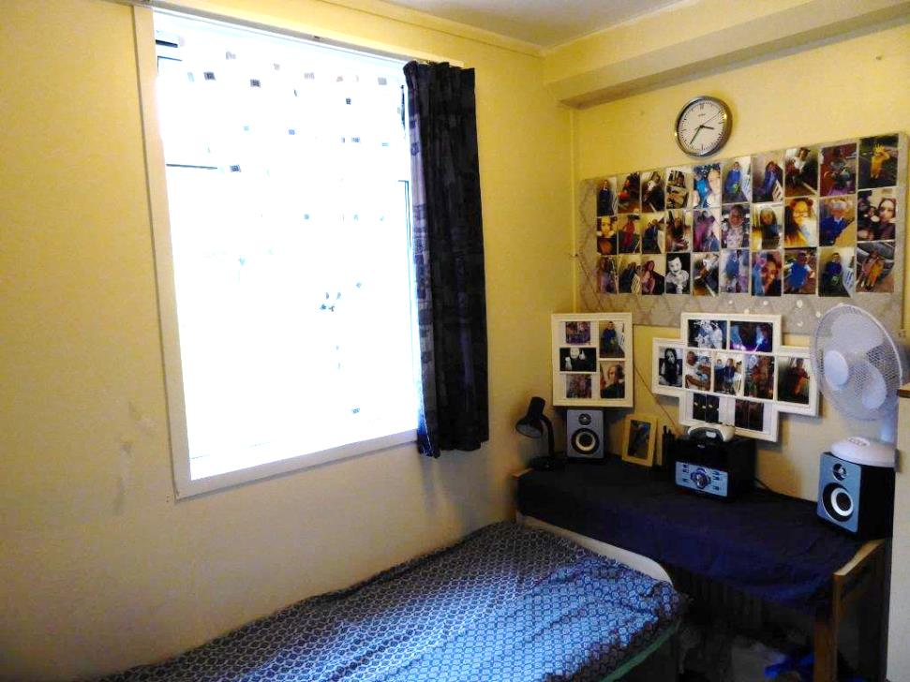

In their bedrooms people can have Tvs, games consoles and books. Lots of the people at Guys Marsh decorate their rooms with pictures of people they love.

People at Guys Marsh have jobs doing things like growing vegetables, looking after animals, fixing TVs and cleaning the buildings. Here are some photos of the Farm area of Guys Marsh where the men who look after the animals and grow vegetables work.

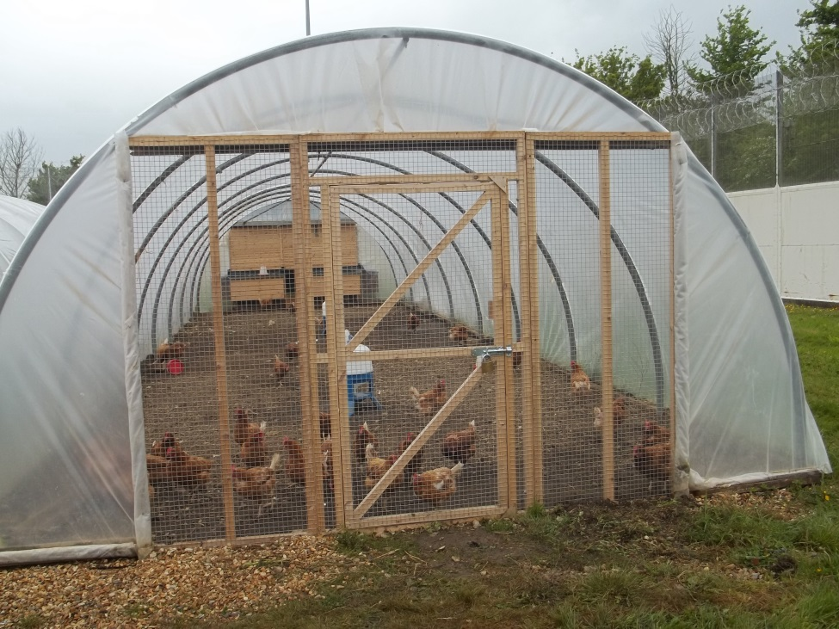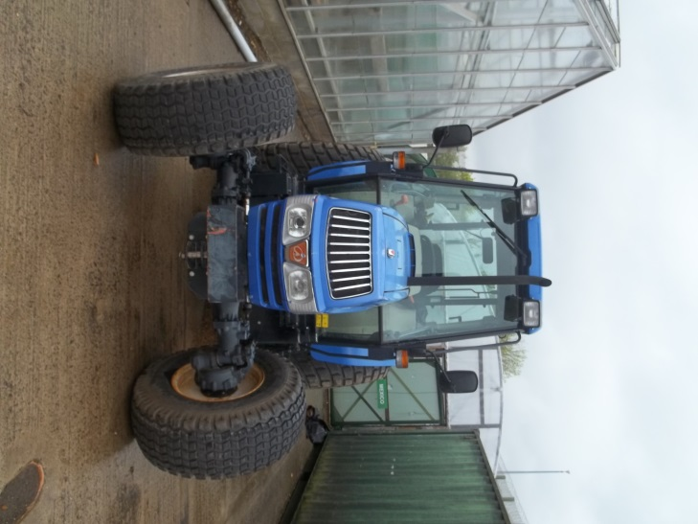

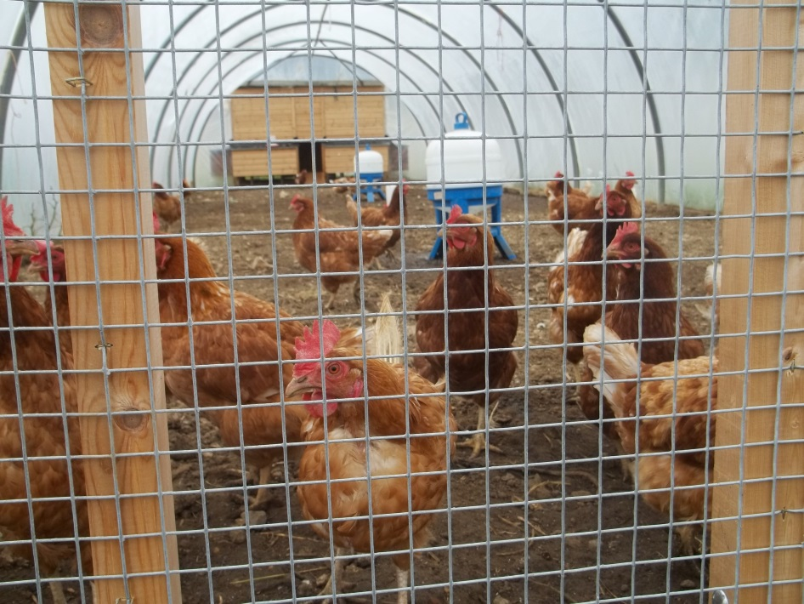

There is an education block at Guys Marsh where people can learn things like maths, English, barbering or Art. There is also a library when men can borrow books, play board games or read the paper.

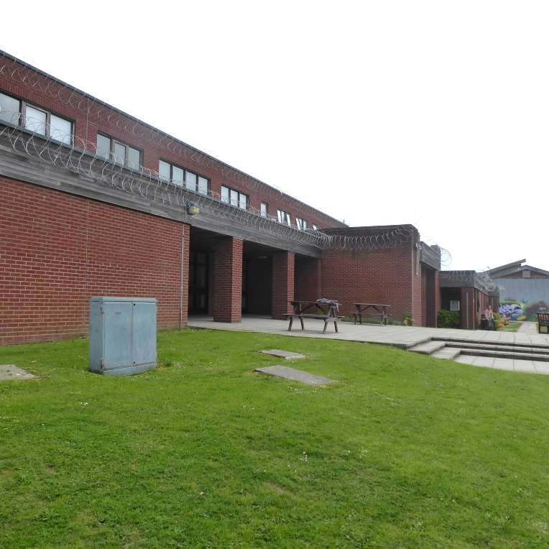

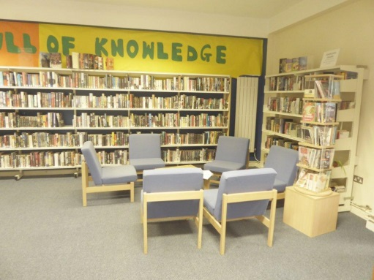

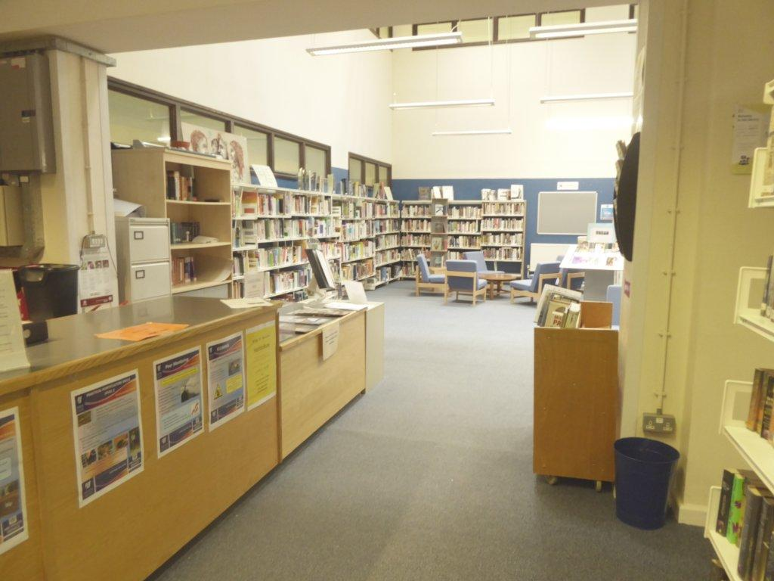

There are lots of other places in Guys Marsh like a hair dressers, a chapel, a Health centre and Dads shack where dads can rcord stories to send to their children.

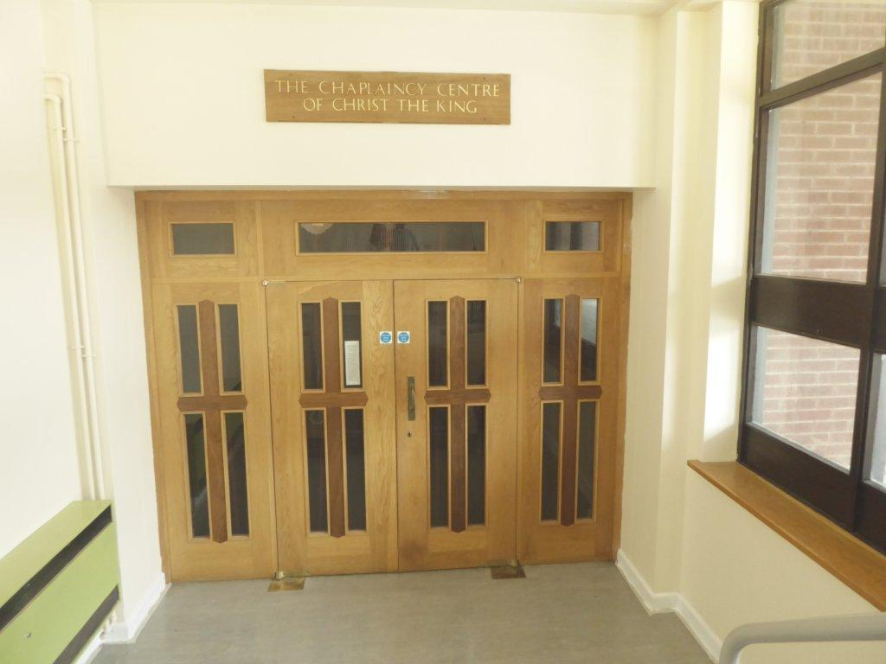

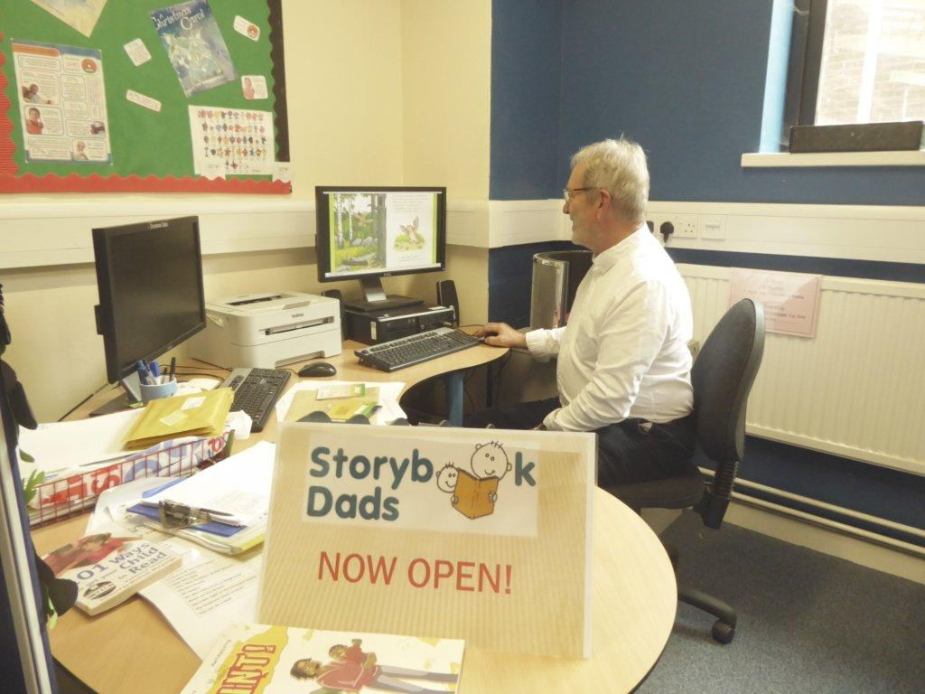

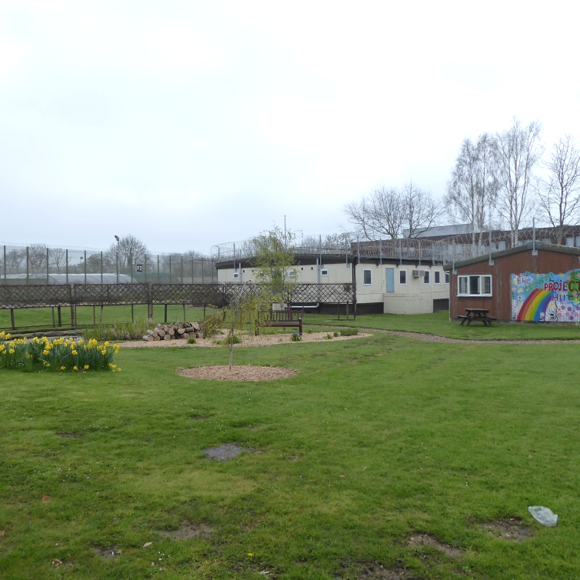

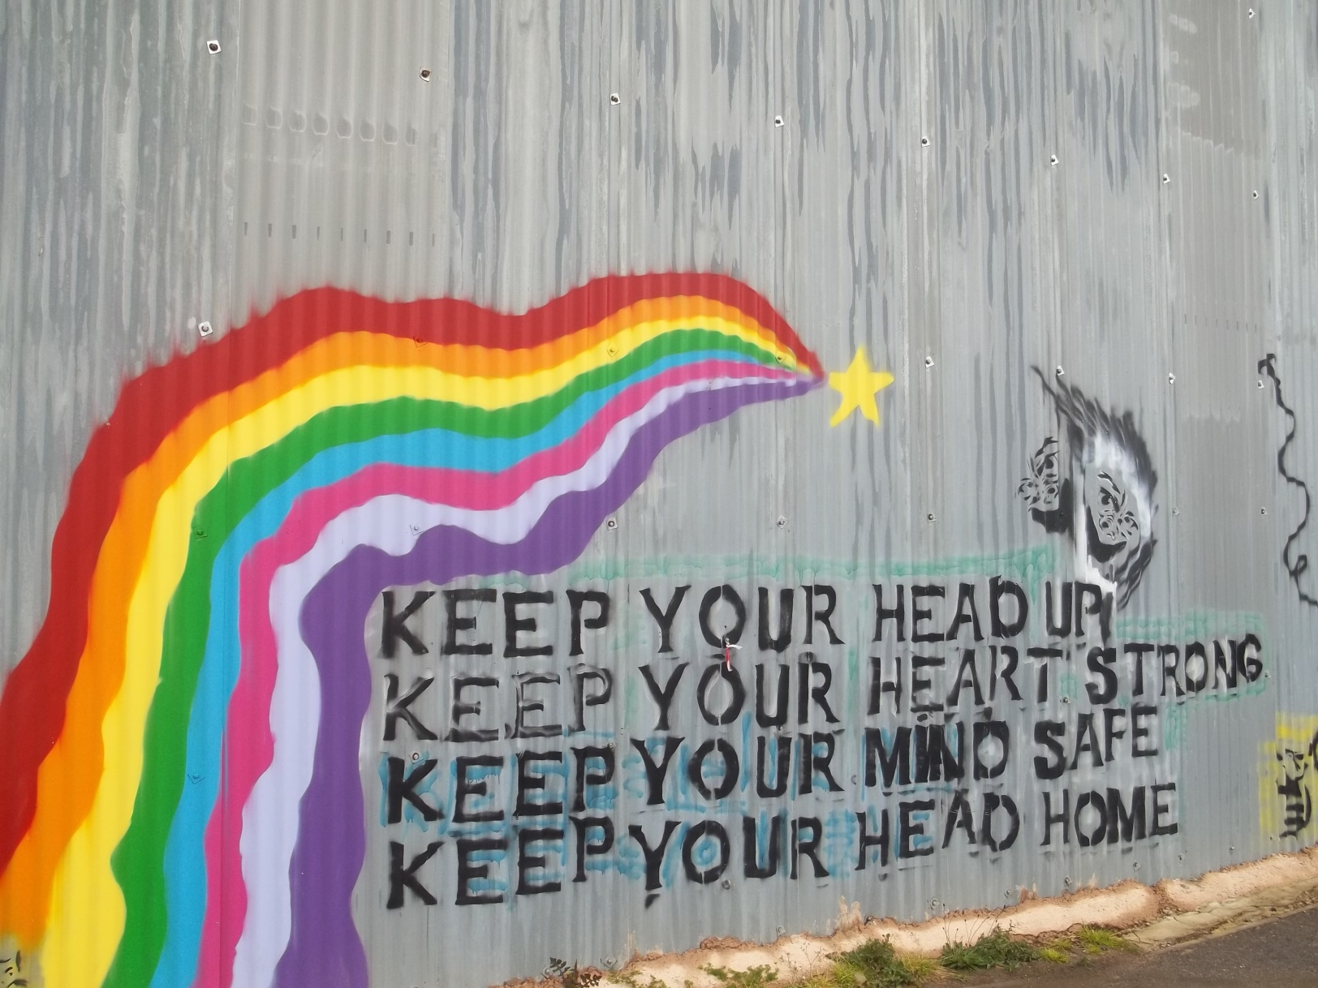

If you have more questions about the visiting process at Guys Marsh please contact the Barnardo’s worker at… [GuysMarshVC@barnardos.org.uk](mailto:GuysMarshVC@barnardos.org.uk)

or email the prison’s family support email address at… [familysupport.guysmarsh@hmps.gsi.gov.uk](mailto:familysupport.guysmarsh@hmps.gsi.gov.uk)