HMP/YOI Downview
Family and Significant Others Strategy 2018

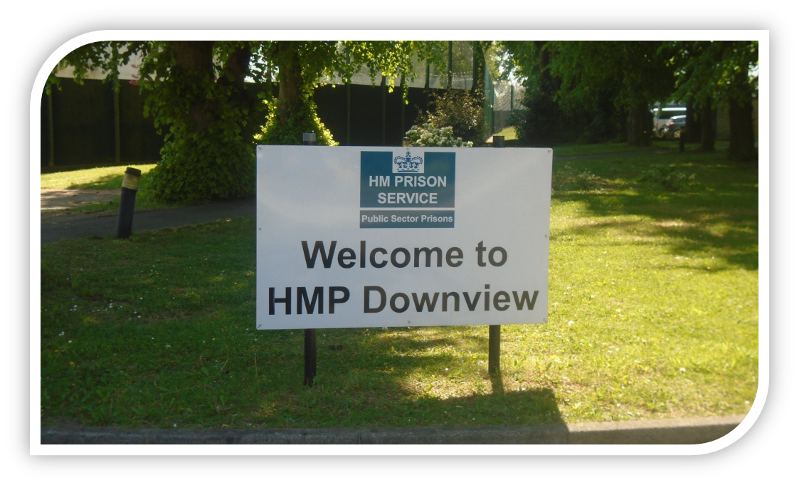

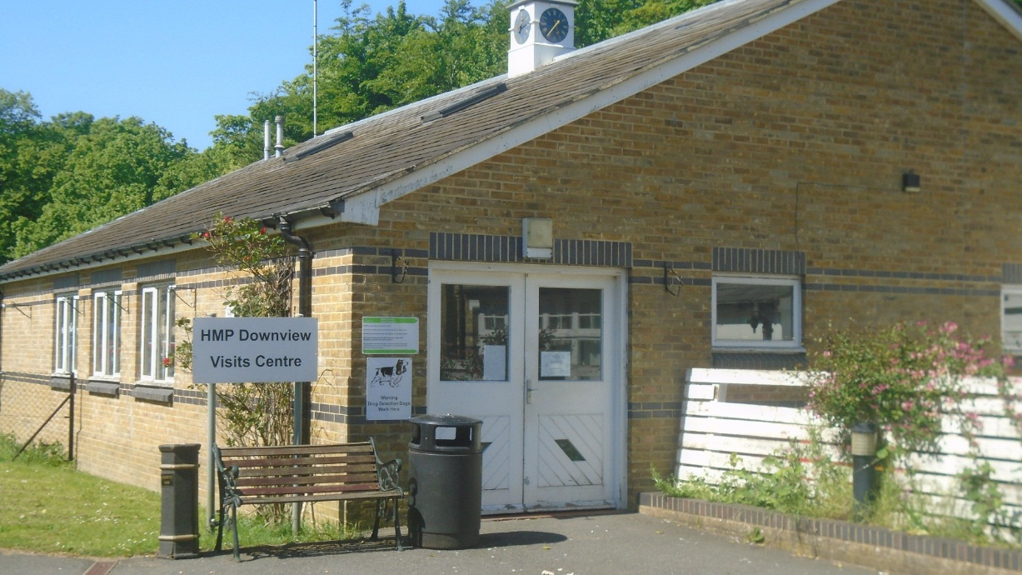

Introduction and Statement of Intent

HMP/YOI Downview aims to provide an environment where its residents are surrounded by others who believe in their potential. Our community needs to be a place where practical support, expertise and opportunities exist. To be successful we must engage groups outside the prison gates who care for and support our residents.

We understand positive ties between family members or any other person who provides support to residents will help to avoid individuals returning to prison and makes HMP/YOI Downview a safer place. We recognise the moral and ethical reasons to develop and implement this policy.
Lord Farmer’s Review was published by the Ministry of Justice in 2017. It highlighted the importance of working with families in reducing crime and the risk of individuals returning to prison. HMP/YOI Downview will work, together with families in a way suitable for our population; this policy explains how we will do this and includes a local action plan.
For the purposes of this policy, we refer to family members however this term extends to anyone deemed to be important to the residents and does not conflict with any safeguarding or public protection concern.

Our aim is to reduce the negative effects a prison sentence has on our residents and those who support them from the wider community. We also aim to offer opportunities to build new, positive relationships with specific consideration to those who have experienced formal care settings or those who do not have existing supportive relationships in their lives.
We take this moral responsibility seriously and work in partnership with PACT (the organisation delivering family services at HMP/YOI Downview) and other relevant organisations to deliver the right services.

Robin Eldridge
Governor
July 2018

Background and consultation
- Her Majesty’s Inspectorate of Prisons
HMP/YOI Downview was inspected by Her Majesty’s Inspectorate of Prisons (HMIP) and their findings stated that Downview had a good range of partners to support the residents however we appreciate further work needs to be done.
The report published in August 2017 states,
“Although work regarding children and families was developing reasonably well, more was required to ensure the needs of all women were met…”
Findings from this recent HMP/YOI Downview Inspection report and the HMIP expectations have informed discussions with our partnership organisations and our local action plan.
- Resident consultation
In order to inform the policy HMP/YOI Downview consulted with their residents in the form of a survey in February 2018. Nearly two thirds (194) of residents took part. This information has been used to understand further how families here help in every aspect of the residents’ lives and what we can do to improve. We are committed to including family members where we can both during the sentence and their journey towards release and through the gate.
Residents have informed us their relationships with other people form an important part of their lives. Our consultation indicates residents can struggle with many emotions in custody such as loneliness, anxiety, depression, shame and anger. Many of these emotions will be experienced by family members and loved ones when someone receives a custodial sentence. Making the visitor experience as easy as possible is a priority for us.
The majority of residents deem a family member or partner as the most important person in their lives and a smaller but significant group recognise a professional/significant other (for example a social worker, foster parent or legal representative) as an important person in their lives. We know contact with others has a significant impact on the well-being of our residents.
Separation is unavoidable however separation can be minimised when we work together to make contact between family members a priority. We aim to make contact as easy as it can be without compromise to our security and safety.
Our residents have reported many aspects of their lives have negatively affected their relationships. These may include factors such as; substance misuse, financial and health concerns before custody. We also recognise in most cases these issues continue to be a factor impacting on their relationships.
The initial experience of prison, for many visitors will be during their loved ones’ current sentence, as the majority of residents reported to us that this is their first prison sentence. The information we provide must not assume a prior level of knowledge therefore, we must prepare visitors with the practical details they need for a smooth visit.
Residents take part in monthly consultations meetings chaired by a Manager and with representatives from the residents themselves. The agenda now includes families.

- Care Experienced/Care Leavers
Care leavers and care experienced residents are those women who have spent any amount of time in the care of a local authority. The national figure indicates that up to at least 25% of women have had some experience of being in care at some point in their lives. The majority of these women will have experienced trauma.
Families support our residents in many practical ways. The survey and information from our partners highlight one in three women return to live with family or friends after release. As Care Leavers are less likely to have family contact we know they are more likely to services around securing accommodation. The Community Rehabilitation Company will work with our Offender Management Unit to identify care leavers and address accommodation needs.
HMP/YOI Downview are undertaking work to identify this group and will run specific focus groups to engage and understand how we can support them. Initiatives included on our action plan aimed at improving services to this group are;
Family days or extended visits for adults where care experienced residents can maintain positive relationships. 18% of residents report regular contact with someone who is not a partner or family member.
The Personal Advisor for Care Leavers can attend all visits sessions, and contact will be made with them to advise them of such following the initial interview process.
Wider promotion aimed at improving awareness of the services available to those residents who do not receive visits. Offer mentoring services and various activities that can continue through the gate and post-release. Criteria and further information on mentoring services are provided by;
Shaw Trust
Pecan
Reflex
St Giles Trust
Hibiscus
The interventions directory in the Visitor Centre and Hall contains further information on mentoring services.

Pact
The Prison Advice and Care Trust (Pact), based at HMP/YOI Downview, is a national charity that provides support to residents, and their families.
In October 2017 Pact were successful in a national bid to provide family services across the female estate. We are centrally working to try and align services in order to provide consistency for visitors/residents and share good practice.
Pact are contracted to deliver the following services;
- Visitor’s centre and refreshment service
- Children’s play workers
- Support on family days
- Case work and individual support
- Courses such as Within My Reach and Building Stronger Families
Have your say
Want to take part in our consultations or have a pressing concern or suggestion? We want to hear from you.
Please complete a form in the Visitors Centre and hand it to a member of staff. You can remain anonymous if you wish.
Alternatively you can complete and post a suggestion/concern form into the box in the visitors centre. We will regularly advertise responses on the “You said, we did” board in the visitors centre.

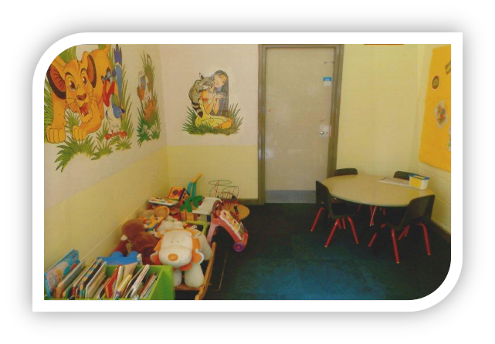Visitors Centre children’s play area

Family Engagement Manager HMP/YOI Downview
Olivia.Cotter@hmps.gsi.gov.uk -Referrals
Pact office- 0208 196 6529
Visitors Centre Enquires-
Downview@prisonadvice.org.uk
Tel- 0208 196 6409
- Families/visitors Consultation
In partnership with Pact we will analyse the results of our recent visitor’s survey and publish the results in August 2018.
This survey will form part of a regular and on-going conversation with families and visitors. Surveys will take place, as a minimum, twice per year. Our action plan will be reviewed and updated on a regular basis. The action plan will be published in the visits centre and visits hall.

Concerned about someone in our care?
Useful numbers

Any Family member or Significant other wishing to raise a concern about a resident in our care please phone our Family Concerns number.
0208 196 6370

Chaplaincy Team - 0208 1964314 (not 24hrs)
E – Mail (not 24hrs)
Safercustody.downview@hmps.gsi.gov.uk
Healthcare services, including Mental Health care are provided by CNWL NHS Foundation Trust. If you have concerns about the health of someone in care, please contact us via Safer Custody. Healthcare services endeavour to involve family members wherever appropriate specifically and where the patient themselves consents to information sharing.

Social Care
Surrey County Council provide social care support to our residents, the eligibility criteria includes
- Those who had involvement from Adult Social Care before custody
- Those with needs as a result of a physical or mental impairment or illness.
To qualify for the support the resident must also be unable to achieve two outcomes related to their independence and well-being including the ability to maintain family or personal relationships.
Referrals forms are available in the visits hall and visits centre or email for more information;
prison.sct@surreycc.gcsx.gov.uk
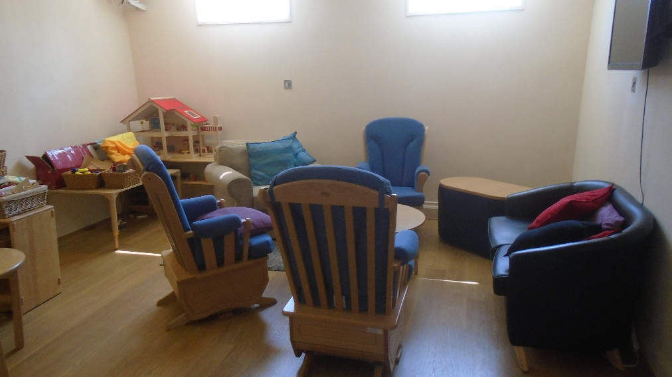
Family Room

Raising the profile
Regular, dedicated meetings with relevant departments have taken place since the beginning of 2018 to inform the action plan, these meetings are chaired by the Deputy Governor. The meetings have resulted in the promotion of family practice within departments and agencies confirming what they do currently to support this pathway. We appreciate further work is needed to
- Advertise more widely and utilise our existing directory of services including mentoring services to staff/residents and visitors
We have considered how we can improve what we do using the proposed headings in Lord Farmers’ Review including;
- Provision Visitor Base/centre and visiting services
- Family Structure to ensure family work is an operational priority
- Extended visits

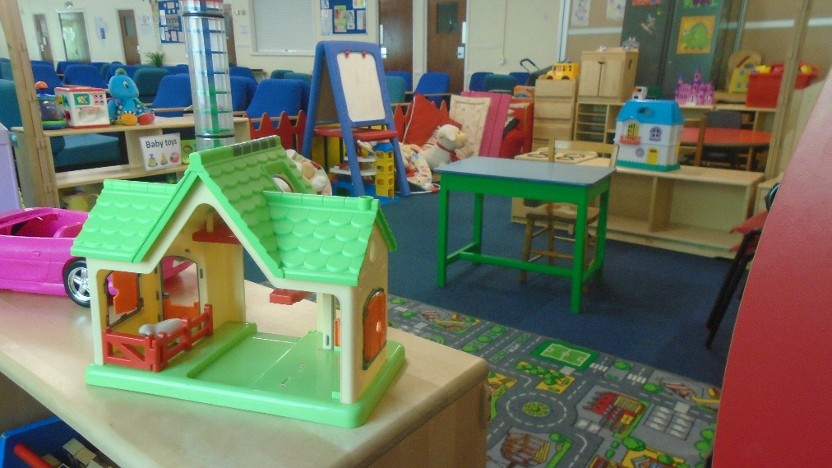
Visits hall Children’s play area

HMP/YOI Downview Family and Significant Others Action Plan

 | Responsible Owner | Progress/  timescales
HMP/YOI Downview will involve families and significant others in key processes where possible. These include sentence planning reviews and where women are receiving additional support to prevent self-harm and suicide. | Head of Safe Guarding/Offender Management (OM) | December 2018
Where possible staffing will be arranged and activities such as graduation events will include families. | Head of Reducing Re-offending  (RRO) | Started and reviewed quarterly
Personal Advisors for Care Leavers are able to visit during domestic visits and the family room is used more frequently and promoted for use by Personal Advisors | Head of Security | July 2018
Volunteer and mentoring services promoted and offered to Care Experienced women and those not receiving regular visits | Head of OM | September 2018
Focus groups with specific groups to address barriers in maintaining and forging positive relationships including Foreign National residents (completed by Hibiscus in May 2018) and Care Experienced women | Head of OM/Safer Custody | November 2018
Host additional family days/extended visits for older children/Care Experienced/parent teacher events and identify staff who are keen to staff these additional event and provide consistency | Head of RRO | First one scheduled in June
Develop a child friendly booklet in partnership with Pact available in the visits centre | Head of RRO | October 2018
Launch a homework club and Story book Mums and review family learning delivered by Novus | Learning and Skills Manager | October  2018
In partnership with Prisoner Advice Service (PAS), launch legal advice sessions on family law issues | Head of RRO | June 2018
All partners delivering debt and finance advice to ensure their services are targeted appropriately to engage Care Experience groups including signposting for visitors | Head of RRO | September 2018
Review and improve how we use Release on Temporary Licence (ROTL) for Care Experienced residents | Head of OM | November 2018
Regular reporting during contract meetings on the promptness of start times for visits | Head of Security | August 2018
Increase and monitor the use of the family room for visits and review the booking system | Head of Security | July 2018
Publish price list for refreshments and opportunity for regular feedback to maintain the quality and range of refreshments | Pact | August 2018
Recruit and retain volunteers to work in the Visits Centre and play area in the visits Hall | Pact | Monitor monthly
Explore and implement mentoring relevant schemes through Chaplaincy | Managing Chaplain | July 2018
Appropriate internal meetings should consider family and significant others as an agenda item and identify ways to work more inclusively with them | Heads of Departments | October 2018
Consult with User Voice and Listeners and gain feedback on we can improve outcomes with families and relationships based on their contact with the residents | Head of RRO | November 2018
Advertise the new Safer Custody contact telephone number once in place | Head of Safer Custody | October  2018

