

**HMP The Verne**

**FAMILIES AND SIGNIFICANT OTHERS STRATEGY**

**2019-2021**

**October 2019**

**INDEX**

INTRODUCTION

CHAPTER 1. VISITOR CENTRE/VISITORS RECEPTION SERVICES

CHAPTER 2. STAFFING STRUCTURE

CHAPTER 3. EXTENDED VISITS

CHAPTER 4. ‘GATEWAY’ COMMUNICATIONS SYSTEM

CHAPTER 5. WORKING IN PARTNERSHIP

ANNEX ‘A’ LOCAL ACTION PLAN

ANNEX ‘B’ DATES OF EXTENDED VISITS 2020

**INTRODUCTION**



I write to give my personal support to this strategy. Maintaining regular and positive contact with families and significant others is of real importance in any custodial environment, especially so for The Verne. These links are so often a key strand to not only providing ongoing strength and support to the individual resident but quality contact and relationships that are enabled to flourish and grow also provide a proven vehicle to reducing the likelihood of future re-offending, with all the benefits for individuals, communities and wider society. Achieving best outcomes from the visiting experience is not straightforward. Custodial domestic visiting environments can be complex and require the skilful blending of many competing requirements.

This strategy sets out a pathway to achieving the required outcomes of the recently published Farmer Report and captures the necessary steps the establishment is taking, and in some cases still needs to take in order to make best provision for all aspects of the visiting experience. This will be achieved by working alongside the Avon and South Dorset Group Reducing Reoffending lead, partnership working with Barnardo’s and Expia, consultation with residents and visitors and by building on the knowledge and research around the needs of the cohort of residents at HMP The Verne.

**David Bourne**

**Governor, HMP The Verne**

For the purpose of this guidance document, ***Family*** is defined as either a blood relative, legal or significant persons that a prisoner identifies as their next of kin. For **care-leavers** this may be someone that provides a statutory service, friend or associate. Many of those in custody will have experienced a non-traditional upbringing, with a range of adults having cared for them, and similarly those in custody with children may have other arrangements outside of a traditional family arrangement. It is important to accommodate all ‘family’ arrangements where they provide a constructive and supportive relationship for the prisoner and their family.



In some cases maintaining family ties may not be appropriate, possibly due to the risk that a resident poses to the family. Safeguarding children and supporting victims should always be a priority in the work at HMP The Verne supported by the National Probation Service and any other statutory authority deemed appropriate.

|  |  |
| --- | --- |
| **Levels of Restrictions for Child Contact** | |
| **Level One** | Full restrictions apply. No contact with any child permitted All correspondence and telephone calls may be monitored subject to a risk assessment being carried out and regularly reviewed. |
| **Level Two** | Contact permitted with named child only via written correspondence. All correspondence and telephone calls may be monitored subject to a risk assessment being carried out and regularly reviewed. |
| **Level Three** | Contact permitted with named child only via written correspondence and telephone calls. Correspondence and telephone calls may be monitored subject to a risk assessment being carried out and regularly reviewed. |
| **Level Four** | No restrictions necessary, contact permitted with named child only via correspondence, telephone calls and visits. The resident may be allowed access to family visits with the permission of the Governing Governor following a further, individual risk assessment.  Routine monitoring of correspondence, telephone calls, general observations in the visits area. This level of contact applies only to those children that the resident has permission to have contact with. All other children will be subject to Level One restrictions. |

At HMP The Verne the **Children and Families Pathway**, aims to ensure the interests of residents and their families are addressed through:

* Helping to maintain family ties, where appropriate.
* Improving parenting skills of residents.
* Provide advice and guidance to families and residents.
* Developing a family friendly focus in prisons and through our visitor centre.
* Involving the family in Resettlement decisions when appropriate

# Lord Farmer Report

**The Importance of Strengthening Prisoners’ Family Ties to Prevent Re-offending and Reduce Intergenerational Crime**

<https://www.gov.uk/government/uploads/system/uploads/attachment_data/file/642244/farmer-review-report.pdf>

In September 2016 Lord Farmer report, The Importance of Strengthening Prisoners Family Ties to Prevent Re-offending and Reduce Intergenerational Crime***[1]*** in partnership with the membership charity Clinks, was commissioned by the Government to investigate how connecting prisoners with their families can improve offender wellbeing, assist in keeping the public safe and reduce reoffending.

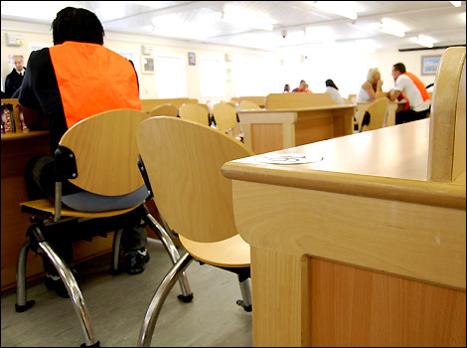

The Farmer report was published on 10 August and made 19 Recommendations that put family and significant others at the heart of prison reform. It supports efforts to improve the relationships between prisoners and their families or significant others and the services that are provided.

According to the Lord Farmer report, ‘Family should be the ‘golden thread’ running through the processes of all prisons, as well as in the implementation of standards presented in the Prison Reform White Paper - Public protection, Safety and Order, Reform and Preparing for life after prison.

Lord Farmer’s report referred to a ‘local family offer’ recommending that all establishments deliver and develop provision in the following areas and that these are reflected in their local strategies which should be a minimum offer:

* Visitor Centre/Visitor Reception Services
* Staffing structure to ensure family work represents as an operational priority
* Extended Visits ned
* Family Learning – to equip prisoners to maintain and improve relationships
* “Gateway” communications system – to demonstrate how the establishment have responsive communication systems in place for families

**CHAPTER 1. VISITOR CENTRE/VISITORS RECEPTION SERVICES**

**Step by step info as to what happens on a social visit**

* **When you arrive at the visitors centre speak to a uniformed member of staff who will give you a booking number.**
* **At 1:30pm a uniformed member of staff will book you in, please have your Visiting order and forms of identity ready.**
* **Male visitors will be given a wristband to wear during the visit.**
* **You will then move to an area where uniformed staff will carry out a search much like you would expect when passing through an airport.**

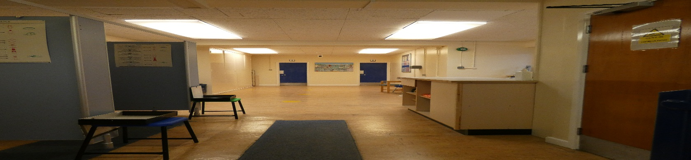

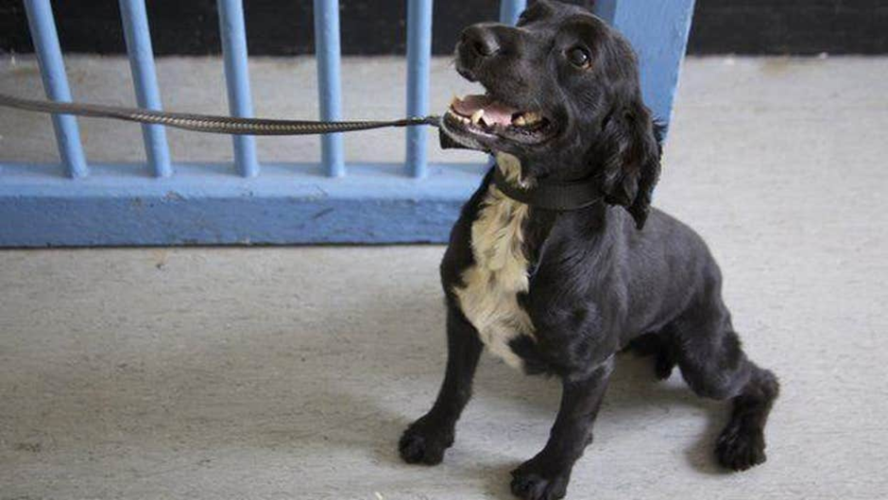

* **Once you have been searched you will move to the visits hall where you will be allocated a table where your visit will take place. Occasionally searching may also include the use of a search dog.**

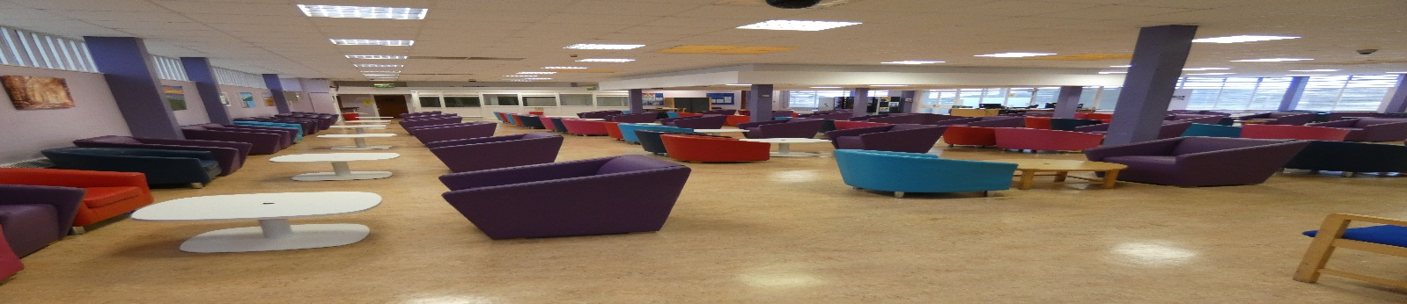

* **At the end of your visit you will exit the prison the same route you came in.**

**CHAPTER 2. STAFFING STRUCTURE**

Governing Governor

Security Governor

Head of reducing reoffending

Visits Custodial Manager

Operations Group

**CHAPTER 3. EXTENDED VISITS**

**We held our first family (Children) visits day mid-December 2019. The day ran from 10am until 4pm, a total of 84 people attended. A wide range of activities were provided. Together with Barnardo’s we funded a buffet for the resident’s and their visitors.**

**The feedback that we received was generally very positive –**

* **“The children have really enjoyed today, their favourite parts were having a family photo and being able to interact via activities”.**
* **“Being able to sit with Daddy”.**
* **“Being able to make cards and crafts with Daddy”.**
* **“Seeing my Husband and children happily having fun”.**
* **“Thank you for arranging the day, we had a great day”.**
* **“Just wanted to say thank you to you and your team for the lovely day. The kids really enjoyed themselves, made such a difference to have all day and be able to move about and eat together. Much more relaxed, they kept saying to me afterwards that it felt like we were a family again”.**

**As laid out in our action plan (annex A) we are exploring which type of extended visits to supply and their frequency. As many of our residents are elderly and will not necessarily have child visitors we need to provide a variety of days to avoid discriminating against any of our population.**

**\*We have now published a list of dates for extended visits (see Annex B).**

**CHAPTER 4. ‘GATEWAY’ COMMUNICATIONS SYSTEM**

To promote the importance of family engagement we have several dedicated telephone numbers that any family friend or significant other is welcome to contact to seek further information, check visits information or raise any concerns or pass on important information.

**Main Prison Operator: 01305 825000**

**Safer Custody: 01305 825005**

**VISITING TIMES**

* **Tuesday’s 0900hrs-1130hrs Legal/Professional visits only**
* **Tuesdays and Wednesdays 1400hrs-1600hrs Social visits and** **Legal/Professional visits**
* **Saturdays and Sundays 1400hrs – 1600hrs Social visits only**

**If you are concerned about the Safety or wellbeing of any Resident held in this establishment you can ring and leave a message on the Safer Communities dedicated line 01305 825005.**

**This line is checked daily by a senior member of staff.**

**If you have a concern that there is an imminent risk of danger to a Resident and you wish to speak to a staff member to raise this concern, then you can call:**

**01305 825056**

**Whilst the staff member answering the phone will not be able to discuss the Resident with you, they can take a message and will immediately pass it onto a senior member of staff for action.**

**Other ways to help families keep in touch**

**Emailaprisoner.com:** Visitors can email direct, at the cost of only a 2nd class stamp. Once the email is received at The Verne an officer will print it off and hand it to the resident. Visitors can also pay the cost for residents to send a letter back via an email.

**Assisted Prison Visiting Unit (APVU):** Visitors can claim back up to two visits a month travel costs through APVU. Terms and conditions apply and booklets and information are available in the Family Pathway Centre, on the website or via telephone.

**Prison Visitors**: Residents who do not have anyone who is able to visit can request to have a volunteer prison visitor who will visit and provide support through phone calls or as a pen pal. This service is offered by the Chaplaincy Department.

**VO’s to phone credit or letters:** Prisoners who do not use all of the Standard Visiting Orders can choose to convert them into extra phone credit or extra letters. This is subject to IEP status and can be done through the visits department.

**Foreign national phone credit and letters:** Foreign national prisoners are entitled to convert their standard visiting orders to phone credit to make calls abroad or airmail letters. For more information, contact a member of Safer Custody.

**Key Workers**

The key worker scheme is a new HMPPS initiative in 2019 whereby Key Workers will meet residents on a regular basis to support their rehabilitation. This might involve engaging and encouraging participation in education, substance recovery programmes and maintaining links with family members. Key workers are actively encouraged to meet with the residents family if available.

**CHAPTER 5. WORKING IN PARTNERSHIP**

**Barnardo’s** have a contract to supply a “Family engagement worker” who works in the visitors reception area and also the visits hall. This is not funded for every visits period.

**Jailhouse café inside and outside** provide food and beverages not only in the visits hall but on midweek visits days visitors are able to visit the café outside of the prison.

**ANNEX ‘A’ Local Action Plan**

|  |  |  |
| --- | --- | --- |
| **Lord Farmer’s Performance Agreement** | **Current Work Implemented** | **Future Targets** |
| **Visitors centre and visiting services (Establishing a Family Strategy):**  • All prisons must provide a dedicated base and services for visitors, given the distances that many have travelled, the practicalities associated with the visit (such as the care of the young or elderly) and the difficult and distressing experience that visiting someone on prison often entails.  • Where public transport links do not serve the prison adequately (so that, for example, taxis are required to complete journeys from rail and bus hubs), the prison should make arrangements with local firms to provide a service.  • Whether it is an external visitor centre or somewhere within the prison walls is not as important as the warmth of the welcome and the standard of what is  provided there. (provided comfortable seating,  toilets, and lockers for personal items, activities for children and the sale of refreshments in a welcoming environment. Access to the facility and services available as soon as people arrive for a visit. Advice, information and assistance (for example, to book in future visits) were also provided, ensuring a smoother visit experience for families and staff inside the secure perimeter.  **Staffing structure to ensure family work is an operational priority (Establishing a Family Strategy):**  • High enough overall level of staffing to enable family work to be carried out.  • Functional head with responsibility for championing this area of prison work, as well as someone at middle management level such as a custodial manager, who can act as a champion to the staff.  • Governor surgeries or means whereby families can routinely access senior members of staff can be an excellent way of ensuring they are drawn in as assets to rehabilitation and know they are recognised as such. | *Currently the visitor reception is the conservatory at the main gate to HMP the Verne.*   * *New visitors lockers ordered/estimated delivery march 2020* * *New seating and tables being ordered Jan 2020* * *Head of Reducing Reoffending* * *Head of Security* * *Visits CM* * *Feedback and suggestion forms are in place in the visits room.* * *SMT member routinely attend every visits session.* | * Visitors reception (Barnardo’s) near to the Jailhouse café (outside). * Appropriate signage for Visitors reception centre * Mother and baby and disabled parking   • Engage with local taxi companies to try and provide a bespoke rate for visitors.   * Information packs * Child friendly info * New info posters and displays * Exploring with Jailhouse café with regard to visitors pre ordering celebration cakes that will be made by the jailhouse café and brought to visits on the day of the visit. * Training by Barnardo’s for dedicated visits team in safe guarding and child protection in prisons, also at a later date Hidden sentence training.   • Meetings   * Residents Forums * Visitor survey |
| **Extended visits (Establishing a Family Strategy & Practice and Innovation):**  • To enable parents to reconnect with their children and supportive relationships with other family members and significant others to flourish. | See annex B |  |
| **Family learning (Practice and Innovation):**  • Evidence-based programmes to enable residents to maintain and improve relationships, implemented with fidelity, reflecting the white paper’s emphasis on improving the use of evidence and data throughout the system. | * Citizenship plan | * PSD Courses * Virtual Campus family learning module? |
| **Gateway’ communication system (Safer Custody):**  • A clear, auditable and responsive communication  system with families and significant others: a dedicated phone line that is listened to and acted upon. Such a ‘gateway’ into the prison will enable  families to share concerns about the resident with staff who will report back appropriately to families about any action taken or support given. | * Safer custody phone line and message service |  |
| **Working in partnership with family services and other providers including Contract Management.** | * Barnardo’s * Jailhouse café | * Prison fellowship – angel tree |
| **Performance and measurement.** | * Resident monthly forum * BGD action plan for visits * Quarterly performance report and meeting with Barnardo’s. |  |
| **Digital and Technology.** | * Pin phone online booking | Improve the information available to visitors (.Gov website & written material) |
| **Practice and Innovation** | December 2019 successfully delivered a Family visits day which ran from 1000hrs until 1600hrs. | * Families champions * Monthly resident art/poetry competition which will be displayed in visits. Visitors can vote for winner. * Noticeboards highlighting the work staff do with residents i.e. keyworking,citizenship scheme, vocational courses and education. |

**Annex ‘B’ Family / Significant others extended Visits dates**

|  |  |
| --- | --- |
| **Date** | **Theme** |
| Thursday 19th March 2020 | Adults only visit |
| Thursday 18th June 2020 | Child visits/Father’s Day |
| Thursday 30th July 2020 | Adults only visit |
| Thursday 13th August 2020 | Child visits/Summer party |
| Thursday 27th August 2020 | Child visits/Summer party |
| Thursday 24rd September 2020 | Adults only visit |
| Thursday 29th October 2020 | Child visits/Halloween party |
| Wednesday 23rd December 2020 | Child visits/Christmas party |
| Thursday 7th January 2021 | Adults only/New year party |

1.