
Barnardo’s
Invisible Lives

Changing Behaviour & Attitudes service
Self & Agency Referral Form

Section 1: Referral Agency details

Please read the referral protocol to ensure we are able to accept a referral from your organisation.

Agency: Date of referral:

Person making this referral - Name(please print):

Signature: Position/role:

Address:

Tel No:
e-mail address:

Section 2 - Parent/carer consent - To be signed by the parent/carer

Data Protection

Personal data and the information recorded in this form will be used to enable staff to offer appropriate support and for monitoring and evaluation purposes, and will be kept in accordance with the Data Protection Act 2018 and GDPR 2018. Data will be stored on the Barnardo’s secure IT systems.

Consent to receiving a service and information sharing (please tick)

I agree to Barnardo’s Invisible Lives contacting me to discuss this referral, should
my child be offered support.

I agree to the recording and sharing of information in line with the Data
Protection Act 2018 and GDPR 2018 above.

Signature: _____________ _ Date: _________

Office Use only: Date received:

Section 3: Parent/Carer to be contacted if referral is accepted

Name:

Date Of Birth:

Home address  Postcode: | Ethnicity:  (as identified by client)  Religion:  (as identified by client)  Disability:  (as identified by client)
Email address:

Home telephone number: | Mobile number:
Position in family/relationship to child/ren: | Parental responsibility?  Yes □ No □
Preferred method of contact:

Section 4: Child/Young person being referred (age 8-19 years)

Full Name | DOB | M/F | Name of Educational Setting | Disability: Y/N  (please give details below) | Ethnicity
If address is different to above parent/carer please write it here:

Section 5: Criteria Assessment

This is a family and child support service. Therefore, the family member must fully engage and consent to receiving support for themselves should this referral be accepted.

The child/young person must have a significant family member or sibling within the CJS* (historical or current) to access the CBA service. Please tick to confirm

If historical, please state when _____________________________________________

Involvement with *Criminal Justice System (CJS) can be from arrest, court, prison, community orders and release from prison. This includes a sibling within Young Offenders Institutes

The child/young person must be exhibiting at least one of the following:-  Aggressive behaviour  Disruptive behaviour  Deceitful  Violation of rules  Significant change in emotional  behaviours  Please elaborate on behaviours indicated above for your referral to be considered: | Please indicate if the following apply:-  Child/young person at risk of school exclusion, excluded or reduced timetable  Child/young person repeatedly involved  in anti-social behaviours but not yet criminalised  Vulnerable to risk taking behaviours  Other factors that may be relevant:
Information regarding the family situation that might be contributing to the child’s adverse behaviour:

- Poor family function
- Boundaries
- Parenting
- Debt and Housing
- Mental Health

Other- please state

Referrer:
Please explain why you would like this child and family to receive support and the outcomes you hope will be achieved

Section 6: Other children/young people within the immediate family

Child’s Full Name | Address (if different from above) | DOB | M/F | Name of Educational Setting | Disability: Y/N  (please give details below) | Ethnicity

Section 7: Other information

Any other support services involved with family? If yes, please list:

Are you aware of any concerns and/or risks that workers should know before making contact or visiting the family/individual?
Please give details:

Any additional background information relevant to this referral?

Do any of the children within the family have a CP/CIN plan? | Y/N | If yes, date of next review:
Are there any other restrictions in place for your or your children’s safety we need to be aware of.  Including Restraining orders, non- molestations, non-contact orders | Y/N | Date completed:
Has there been a Professionals meeting regarding the child/young person being referred? | Y/N | If yes, date of next review:

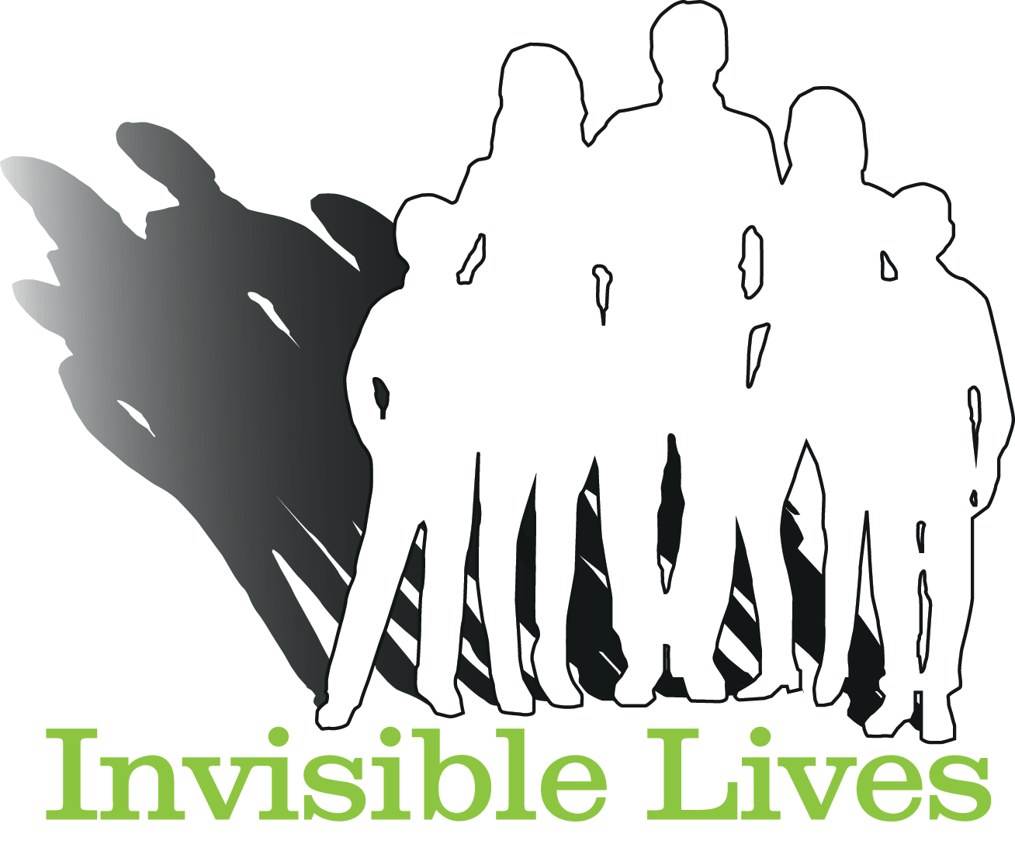

Office use only | Y/N | Comments
Referral accepted as meets all criteria’s
Referral declined or further information required
Incomplete form
Parental/carer consent not signed
Referrer not signed
No family link to CJS
Does not meet criteria
Child Protection Plan in place

Thank you for completing this form.
Please return via email to invisiblelives@barnardos.org.uk or send to: Invisible Lives, Suite 12b Barclays Bank Chambers, High Road, Pitsea, Basildon, Essex, SS13 3AS. Tel: 01268 558448



