|  |
| --- |
|  |
| |  | | --- | | **HMYOI WETHERBY** | | **Family and Significant Others Strategy** | |  |   **September 2020**   |  | | --- | |  |   Head of Reducing Re-offending  Governor Richardson  Family Engagement Manager  CM Padderatz |
|  |

# HMPPS Equality Statement

At HMYOI Wetherby, we are committed to fairness and equality of opportunity for all. We will deliver our services fairly and respond to identified individual needs. Our staff, young people and visitors will display respectful and decent behaviour, and discrimination, harassment and victimisation will not be tolerated. We recognise that such instances can, however, occur and we will ensure that processes are in place for the reporting, monitoring, and appropriate challenge of such incidents in order to take prompt and appropriate action.

**Contents**

|  |  |
| --- | --- |
| **Introduction** | 4 |
| **Family strategy** | 5 |
| **Family and significant others assessment on induction** | 6 |
| **Do you correspond with someone in custody?** | 7 |
| **Directions** | 9 |
| **The Visitors Centre** | 10 |
| **The Visitors Hall** | 11 |
| **Visitor consultation** | 13 |
| **How to book your visit** | 14 |
| **Attending for a visit** | 14 |
| **Purple Visits** | 18 |
| **Safeguards At Risk Hotline** | 21 |
| **Social work team** | 22 |
| **Keppel park run** | 22 |
| **The Resettlement and Offender Management Department** | 23 |
| **The Official Prison Visitors** | 23 |
| **In2Out** | 23 |
| **Psychology and Interventions** | 24 |
| **Family Days** | 24 |
| **Celebration of Achievement** | 24 |
| **Army Cadets Family Days** | 24 |
| **ROTL** | 26 |
| **Child Centred Visits** | 26 |
| **Family Talk** | 28 |
| **Chaplaincy Team** | 29 |
| **Time for Dads** | 30 |
| **Storybook Dads** | 30 |
| **The Youth Council** | 30 |
| **Barnardo’s Advocacy Service** | 31 |
| **CUSP** | 32 |
| **New bridge befriending scheme** | 34 |
| **Covid-19 2020** | 35 |
| **International Day of Families** | 36 |
| **Levels of Restrictions for Child Contact** | 37 |
| **Areas for Development 2020/2021** | 38 |
| **Further reading** | 39/40 |

**Introduction**

HM YOI Wetherby is committed to support the children in our care to develop meaningful and constructive relationships with their families and carers or significant person who is identified as their next of kin, and transforming Wetherby into a place of safety and reform and we recognise the need to provide those in custody with stable environments, as well as opportunities to change their behaviour and turn away from a life of crime. It is vital that family or carers are part of a child’s journey whilst in custody with research showing people in custody who receive visits from a family member, carer or significant other who is a protective factor in their life are less likely to reoffend as they play a key role in this.

Positive family relationships are likely to contribute to good order within an establishment.

Children being separated from their family and friends can be one of the most difficult situations to cope with when in custody and can trigger so many additional emotions and responses making progression whilst in custody onto a successful transition even more challenging. All cells (except for the CSU) have an in cell telephone so that the children can maintain contact with their families, significant other and friends and those children in the CSU have access to a telephone every day on the unit. Letters are issued to the children and they can receive e-mails from their family.

Free Rule 39 letters are issued to those children that require them to write to professional bodies such as councils, social services, solicitors etc.

## Lord Farmer Review 2017

In August 2017, Lord Farmer published a review called ‘The Importance of Strengthening Prisoners’ Family Ties to Prevent Re-offending and Reduce Intergenerational Crime’ otherwise known as The Farmer Review.

Within that report, Lord Farmer writes ‘I do want to hammer home a very simple principle of reform that needs to be a golden thread running through the prison system and the agencies that surround it. That principle is that relationships are fundamentally important if people are to change.’ Lord Farmer also wrote that families ‘need to be seen as a vital resource and the people who visit, and make the often Herculean effort to keep in contact need to be treated as valued allies in the rehabilitation cause.’

**Family Strategy**

Families play a vital role in the successful reintegration of the children back into their communities. Problems arising for individuals in the areas of siblings, children and families are often complex and inter-related. Therefore, it is important that we maintain and develop family relationships and community support to help offenders reduce their likelihood of reoffending. By providing support, encouragement and guidance, these young people will have a higher chance of positive outcomes when resettling into their own community and/or society in general. In September 2016 the Lord Farmer report was commissioned to investigate how connecting those in custody with their families can improve their wellbeing, assist in keeping the public safe and reduce re-offending. The report was published in August 2017 and gave a number of recommendations that put family and significant others at the heart of the prison reform.

Prisoners are stigmatised for their offence, and their families often are too. Families are seen as guilty by association even though they are legally innocent and generally have had no involvement in the offence. This stigma is sometimes referred to as stigma by association. This stigma makes the imprisonment even more difficult for family members, and it can also mean that families are treated negatively by other members of their community, or face negative treatment from colleagues, peers, the media and even friends and family.



**Family and significant others assessment on induction**

The induction team also conduct a family and significant other induction assessment on every person who comes into custody within the first week, to explain the services we provide, including the visits booking process, how the telephones work, receiving and spending money, receiving clothing and property, letter writing, communication with family, and the various family interventions, etc.

**How to contact us:**

**By telephone:**

HMYOI Wetherby 01937- 544200 (Emergency only)

At risk hotline 0800 -4961000 (24hour safeguards answer machine)

**If the matter is deemed as life threatening please call 01937 544200 (this extension is manned 24 hours)**

**By post:**

HMYOI Wetherby

York Road

Wetherby

LS22 5ED

Or at the ministry of justice prison finder website:

<http://www.justice.gov.uk/contacts/prison-finder/wetherby>

**Do you correspond with someone in custody?**

**Email a child in custody at Wetherby**

We know what it’s like to constantly write letters but now you have the option to send your message by email directly from your computer to the prison. Whether from home, work, college or an internet café on the other side of the world – your thoughts can be emailed at a time to suit you. Depending on the time of day you send your message which can now include up to 4 photos, prison staff will print it and pass your message to the young person, hopefully the same or the following day. You can now request a reply by ticking a box when sending your message and your recipient can hand write a reply which will be sent back to you by email.

**How it works.**

Once logged in to our secure website your message will be encrypted then, reformatted by our secure sophisticated software and redirected to the prison of choice. Officers now seal the message (for privacy on the units) and deliver to the recipient, ASAP.

Please be advised our system does not provide a direct email service to your recipient. Our service is simply a different way of delivering.

**Email a Prisoner**

**Working together…**

**Encouraging, Strengthening,**

**Supporting,**

**Family & Community Ties.**

To view our customer comments and/or

Frequently asked questions (FAQ’s)

Please log on to our website:

[**www.emailaprisoner.com**](http://www.emailaprisoner.com)



**Directions**

HMYOI Wetherby (York road, Wetherby, LS22 5ED) is situated approximately 1 mile from Wetherby town Centre. It lies opposite the Racecourse on the B1224 York Road.

**Bus: **

**From Leeds:**

Buses operate on the “First Leeds Bus Company” 98 & 99 Service between City Square Leeds (outside main railway station) and the Centre of Wetherby. Buses run approximately every 30 minutes. From the Centre of Wetherby there is a 1-mile walk, short taxi ride, and/or York bus service.

**From York:**

Buses operate on the “Harrogate & District Bus Company” 79 Service between York Railway Station and Wetherby. There is a bus stop outside the establishment. The buses operate one every hour.

**Train: **

The nearest railway station to Wetherby is either Leeds or York. Both stations are about 14 miles away from the establishment and public transport will be required to get you here.

**Car: **

HMYOI Wetherby lies just off the A1, opposite the Racecourse. When travelling from the north or south if you exit the A1 at the junction sign posted B1224 York, and head towards York. You will find the establishment on the left-hand side.

**The Visitors Centre** at Wetherby provides the first point of contact for friends, families and significant others who are visiting the children in our care. This is an opportunity to provide practical advice on visits information, as well as information, advice and assistance on interventions and services available to those residing in Wetherby. When you arrive at the visitors centre you will be photographed and given an I.D badge which you need to display at all times. A maximum of £10 per adult visitor in coins will be allowed into the establishment which will be carried in a clear plastic bag which we will provide. There is a children’s playground that visitors with young children can supervise their children playing in the fresh air whilst waiting for visits to commence and this will help alleviate any stress that the children may be feeling prior to entering a Prison. We provide parking outside of the visits centre and also some disabled parking bays to assist with ease of access for those who require it.

We provide the following in the visitors centre

* Lockable cabinets
* Contact telephone numbers
* Prayer/contemplation room
* Toilets
* Vending machines

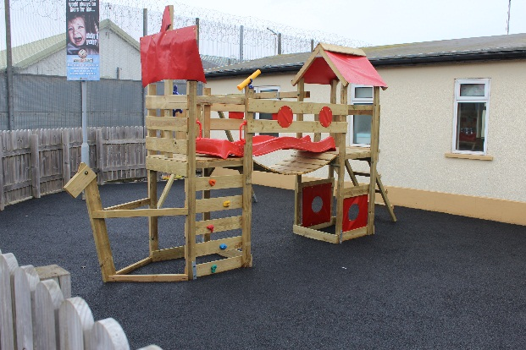

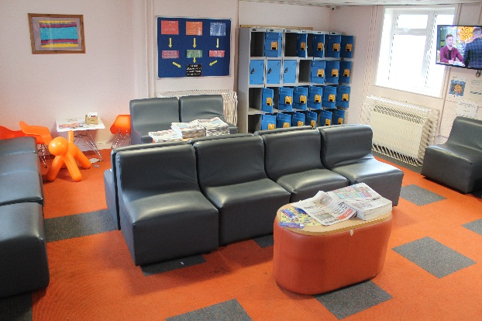

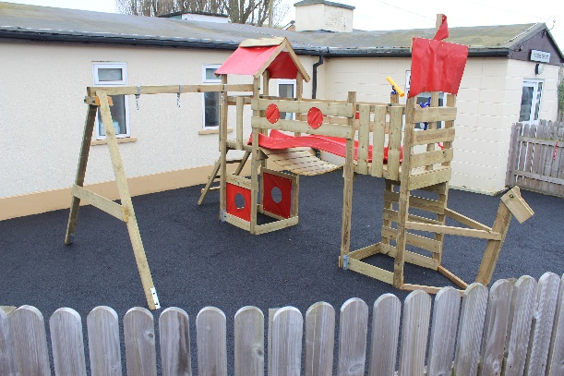

**The Visitors Hall**

The visits hall has just had an overhaul and made to feel more welcoming with new furniture and flooring and a new soft play area so that the visiting experience is more family focussed and friendly. Some of the children’s art work is now displayed in the foyer area of the visits hall.

The visits hall is staffed by Prison Officers who are there to ensure that everyone enjoys their visit and to maintain security and decency. In order for visits to remain a positive environment visitors will be searched prior to visits as perPrison rule and in accordance with the local security strategy (LSS).

Any visitor who is deemed to be abusive or threatening will also have the visit declined or terminated and asked to leave.

We understand that visiting can be particularly difficult for children and confusing rules restricting how they can interact with the imprisoned family member, families often have to travel long distances to a prison and often reliant on public transport, visiting times may not be compatible with tea time and bed time routines, leaving children irritable or tired which may impact on school performance the following day.

There are often particular difficulties associated with prison visiting. Visiting often involves great deal of time, effort (both physical and emotional) and expense. Visiting can be quite an emotional experience, with both positive and negative feelings in the mix: for example, families usually enjoy seeing their imprisoned loved one, but due to the brevity of the visit saying ‘goodbye’ comes quickly, which can be distressing.

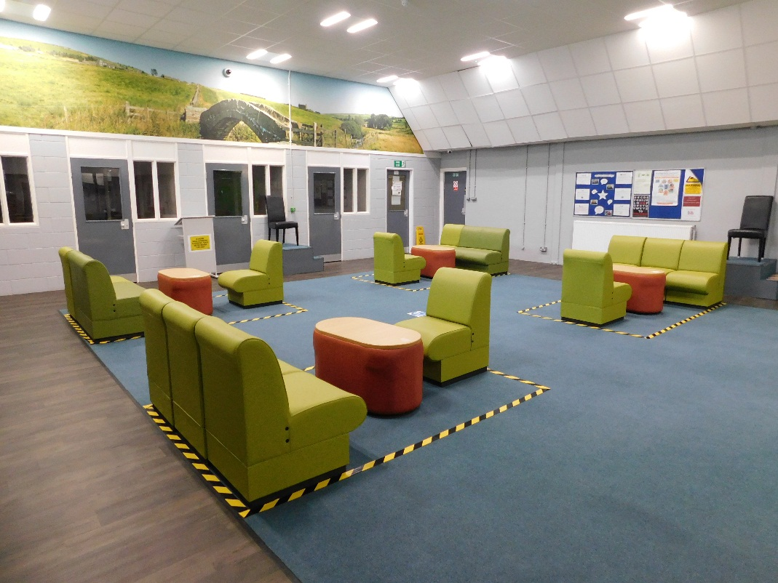

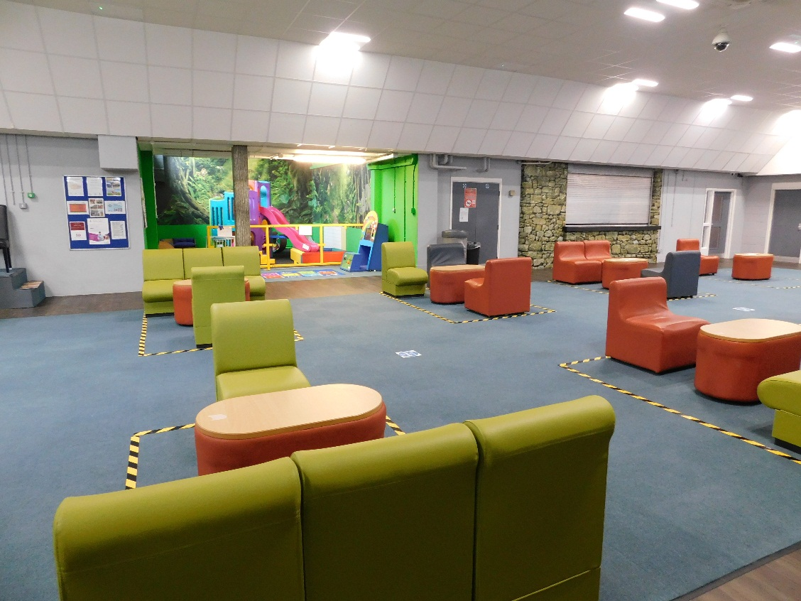

Our facilities include

* Café in the visits hall, serving hot and cold drinks and snacks during most sessions
* Vending machines for alternative refreshments
* Play facilities for young children
* Baby change provision
* Gender neutral, disability compliant toilet facility
* Full disability access to all areas of the visits hall
* Pushchairs
* Mother and baby room for breastfeeding.
* First aid kit
* Baby /toddler snacks

**Visitor consultation**

Every quarter a Governor from either the Residence group, Operations group or Safeguards department holds a **Visitor consultation** event on a Saturday and Sunday in the visits Centre they meet and greet the visiting Families and take notes of any concerns, questions or ideas they may have and these notes are then displayed in the Visitors centre along with the responses where appropriate. Visitors said **“The cleanliness of the toys and facilities available to keep active children engaged were poor”**

We have since installed a new indoor climbing frame and slide in the soft play area.

Visitors said **“Better facilities in the visitor’s centre-TV, reading material as if they arrive early some found it difficult to entertain their children”**

We have since placed a TV in the visitors centre for visitors to watch and have provided some reading material for the visits centre and an outdoor climbing frame for the children to enjoy when the weather permits.

We also have a visitors questionnaire to complete these can be found in the visits hall or the outside visitors centre and your feedback helps us to improve your visiting experience.

**Family visiting times**

|  |  |  |
| --- | --- | --- |
| **Wednesday** | **Evening** | **18:30 – 20.00** |
| **Saturday** | **Morning** | **09:30 – 11:30** |
| **Saturday** | **Afternoon** | **14:30 – 16:30** |
| **Sunday** | **Morning** | **09:30 – 11:30** |
| **Sunday** | **Afternoon** | **14:30 – 16:30** |

Un- sentenced children (Remand) are entitled to one visit per week. Sentenced children are entitled to three visits per month (2 x weekends, 1 x midweek)

Child centred visits to be arranged.

In a small number of cases, maintaining family ties may not be appropriate, possibly due to the risk of harm that a Child in our care poses to the family. Safeguarding children and supporting victims will always be a priority for HMYOI Wetherby

**How to book your visit**

Visits must be booked 48hours in advance (minimum) i.e. For a Saturday visit this must be booked by Wednesday.

For the first reception Visit, there is a maximum of 3 Visitors all must be over the Age of 18

Thereafter only three adults (Including over 10 years old) & three children (Under 10 years of age) can visit.

You can only visit a Young person if they want you to visit them and they have added you to their approved visitors. Your identity will be checked on arrival to make sure you’re on the visitor list.

**Attending for a Visit**

HM Prison & YOI Wetherby provides a Visitors Centre outside of the secure establishment, adjacent to the prison gate. Visitors are required to attend the Visitors’ Centre to book in ahead of the visit. The centre is a facility provided solely for visitor use and opens ahead of visiting times to facilitate visitor arrival. [Visitors must bring the required forms of identification with them to assist with the booking-in process.](../Andy%20Updates/6.7.htm)

Visitors may identify themselves using one of the following:

* passport, including foreign passports, and time expired passports where the photograph is still recognisable;
* C identity card;
* driving licence;
* benefits book;
* senior citizen’s public transport photo pass issued by local authority;
* employer’s or student ID card but only if this clearly shows the name of the visitor and the employer or educational establishment, and has a photograph or signature which can be compared with the visitor’s appearance or signature, and/or the Foreign National’s identity card

If the visitor is unable to produce one of the above, staff may accept combinations of two or more of the following

* birth/marriage certificate;
* cheque book or credit/debit card (counts as one: do not accept as two);
* employer’s pass or ID or student ID card which does not fit the criteria set out above;
* young person’s ‘proof of age’ card;
* trade union or National Students’ Union membership card;
* rent book;
* foreign identity or residents’ card (other than EC ID cards acceptable in their own right);
* expired documents from the above lists that appear satisfactory in other ways;

and :

* ID card from a recognised Prison Visitors’ Organisation
* Citizen Card.

Visitors may be refused entry to the prison for being intoxicated or unruly or for carrying contraband or failing to provide acceptable identification.

Visitors must leave all belongings either within their vehicle or in the lockers which are provided. The visitor must retain the key to the locker for the duration of the visit. Information about custody generally, support services locally or nationally, as well as details and instructions about our local policy and procedures are available in the Visitors’ Centre. Information regarding what to expect and how to raise an issue or complaint is clearly displayed in the Visitors’ Centre; [visitors are asked in particular to raise any concern about the welfare and well-being of any young person in our care](../Andy%20Updates/Child%20Protection%20Policy%20Brian.doc).

Risks or other issues to young people will be addressed by the establishment, in confidence, and always with the young person’s well-being central to these considerations. [A Safeguards hotline number is also displayed for visitors who feel more comfortable in raising these matters while they are away from the establishment.](../Andy%20Updates/Visits%20Notice%20to%20Visitors.doc)

The centre aims to be a friendly and welcoming environment. On arrival at the visits centre, visitors must book in at the desk therein. It is important that visitors

Take note of the fact that they are not permitted to take anything in to the prison for young people.

*It is the prison’s policy to contact the police on every occasion that a visitor attempts to pass an item on to a young person.* ([Referral of Prohibited Items Offences to the Police](../Andy%20Updates/422%20Referral%20to%20police.htm))

When notified, visitors will proceed through to the main prison gate where they will be logged in,

and then on to the visits area where they will be searched in line with the [Domestic Visitors on Entry](../searching/DOMESTIC%20AND%20OFFICIAL%20VISITORS/Searching%20Risk%20Assessment%20DOMESTIC%20VISITORS%20ON%20ENTRY.htm)

risk assessment, before being admitted to the Visits Hall. A refusal by a visitor to be searched will

result in the visit being refused.

Visitors must wear any item of identification that staff request during the entry process and this must

be worn for the duration of the visit without exception.

On entering the visits area, they will identify themselves to the visits staff, who will direct them to a designated table.

Passive drug and mobile phone detection dogs are often used in the visits entry area. These dogs are trained specifically for this role and are entirely safe to be around. Visitors are required to agree to being searched by dogs, a refusal will result in the visit being declined by the prison.

Upon indication of a concern by the dog, the visitor will be required to undergo a [further search](../searching/DOMESTIC%20AND%20OFFICIAL%20VISITORS/Searching%20Risk%20Assessment%20DOMESTIC%20VISITORS%20ON%20ENTRY.htm); any refusal will result in the visit being declined by the prison. A positive indication by a passive search dog will result in an offer of a closed visit or the visitor being refused entry for the visit.

Visits are monitored with the use of [Closed Circuit Television (CCTV)](../Andy%20Updates/120%20CCTV%20Policy.htm) cameras which are operated by a trained member of staff, as well as by officers in the Visits Hall. Visits may be closely observed if there is reason to believe that a security risk exists by the visit taking place or if the camera operator or other member of staff notes unusual or suspicious behaviour. Recordings from this footage will be made available to the police in any prosecution.

[Entry to visits is regarded as acceptance and understanding that monitoring by CCTV will take place](../Andy%20Updates/CCTV%20Notice.doc).

If a visitor arrives without the relevant booking reference (having pre-booked a visit) the Visitors’ Centre staff will contact the Duty Manager who will decide whether or not entry into the Visits Hall will be authorised.

[Failure to bring appropriate identification will jeopardise the visit taking place](../Andy%20Updates/6.7.htm), and failure to bring the booking reference details will certainly delay the start of the visit.

**Online**

To book a visit you can go online to [**http://www.gov.uk/prison-visits**](http://www.gov.uk/prison-visits)You don’t need a Visiting Order (VO) number to request a visit.

You’ll need:

* the child’s prison number
* the child’s date of birth
* the dates of birth for all visitors coming with you
* An email address is required
* A valid contact phone number is required
* Your visit will be confirmed by email within 3 working days. The service is available in England and Wales only

We can still issue claim packs for assisted visits.  All new Applications for assistance should be made online at [www.gov.uk/help-with-prison-visits](http://www.gov.uk/help-with-prison-visits)

Staff in the visits hall can help you with completing the assisted visits paperwork to claim expenses.



**Have a secure video call with a young person in prison**

You can now have a secure video call with young people in prison using your mobile phone or tablet.

This is a new service offered by HM Prison and Probation Service and a private company, Purple Visits.

Secure video calls are free of charge during the Coronavirus outbreak.

Calls last 30 minutes and each young person can have up to 4 people on the call - as long as they are all in the same place, **and on the young person’s approved contact list.**

Video calls will be recorded and monitored by prison staff. Prison staff may be male or female. Secure video calls are limited to 1 a month.

**Who can have a video call?**

Anyone on the young person’s approved contact list can have a video call. The main video caller must be over 18.

People under 18 can be on the call, as long as they are on the young person’s approved contact list.

**What you’ll need to make a video call**

- mobile phone or tablet (it’s not possible to use a laptop or desktop computer)

- passport, driving license or other government-issued ID

- proof of address (if your ID does not include this)

- the young person's name, number and date of birth

- names and dates of birth for everyone who will be on the call

**Download the Purple Visits app**

You need to use an app created by Purple Visits to have a secure video call.

**1. Download and install the app**

You can download the app from Google Play or the Apple App Store. You will need to install the app on your phone or tablet.

**2. Create an account in the app**

This involves taking a picture of your driving license, passport or other government-issued ID. You may also need proof of address if your ID doesn’t include it.   
  
It can take up to 24 hours for your account to be verified.   
  
**3. Add details of everyone who will be on the video call**

You can have up to 4 people on the call. Everyone needs to be registered with the app, and those over 18 will need ID.

**4. Prison staff will book the video call**

You are not able to make a video call request directly. If the young person you usually visit requests a video call with you, prison staff will arrange the date and time of the call.

You will then receive an email with video call details when the call has been scheduled.   
  
You can ask to reschedule the call if you need to.

**5. Get set up for the video call**

So that your video call goes smoothly, please make sure that you have:

* a strong internet connection: Wi-Fi is recommended
* good lighting so that your whole face, and the face of any additional people, can be seen clearly
* a plain background so that the camera can stay focused on your face
* switched off any message notifications or alerts that may disrupt the call
* 

We also have a **Safeguards at Risk Hotline** which allows family and friends of those in our care to express any concerns that they may have, this is monitored on a daily basis and action is taken if required. We also have community concern forms in the visitors centre and the visits hall for families to complete and return to us should they want to raise a concern.

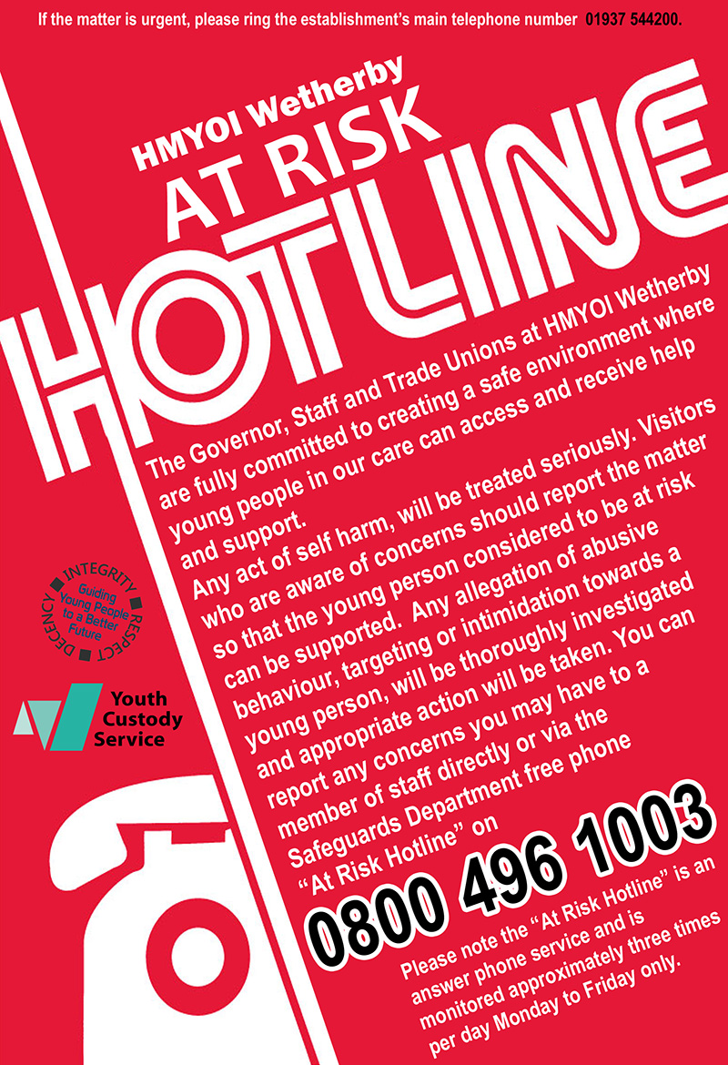

**Wetherby’s Social Work Team** is a fully embedded, integrated service which, in the first instance works side by side with the Offender Management and Safeguarding Departments. Their role is to support the establishment and its functions in identifying initial and ongoing needs of the children which could hamper positive outcomes for them and their families. In addition to this the Social Work team advise and support on Child Protection issues, Leaving Care support and rights, assisting on co-ordinating accommodation needs and escalating if required, between local authorities and Wetherby. If a young person is transferred to the adult estate then they have contact details for their personal advisor, and the receiving establishment is made aware that they are a care leaver. The Social Work team ensure all Looked after Children are identified at their initial screenings and have a support plan to help them achieve the five outcomes as outlined in Every Child Matters and support Local Authorities and the prison in achieving expectations from the LASPOA guidance.

The social work team also offer support for pre-birth assessments or if a social worker is involved in your own child’s life they can link up to your child’s social worker.

CFL signature thumb

Keppel park run takes place every Saturday morning at 9am in the grounds of the Keppel Unit at

HM YOI Wetherby. Young people and staff members can walk, jog, run  a 5Km route or volunteer each week. Once eligible for ROTL young people will be able to attend a local park run to support continuation of this upon release.

We are planning for family members to be allowed to take part with their child by either walking, jogging or running on a Saturday morning when we hold family park run. Families can also interact with the results as they are published on the park run website each week. Family members can also take part in the community at the same time each Saturday as their child at Keppel park run. It offers a shared interest between family members where they can encourage each other to take part.



**The Resettlement and Offender Management Department** offer advice to young people with family related queries. Remand and sentence planning meetings provide the forum to explore individual need and any concerns can be referred to the relevant agencies for support. Resettlement practitioners can also provide family liaison based work for those wanting to establish contact with family members or rebuild previous links. Resettlement practitioners can also liaise with Public Protection colleagues for any Child Protection queries. One of the key roles of the Resettlement practitioners is to identify the influence the relationship between the child and their parent, guardian or carer has on the child’s behaviour. It may be that this relationship needs to be nurtured however at times these relationships can be extremely negative and detrimental on a young person’s responses and behaviour therefore a more complex approach may be needed to achieve positive outcomes for the young person.

**The Official Prison Visitors** (OPVs) provide support to those young people that have little or no family contact. They can also support those that do have family contact but require further support whilst in custody. The OPV volunteers coordinate their visits through the Chaplaincy Team. Any member of staff working with young people can make a referral to the service. The OPV volunteers are a diverse group of individuals with many different skills and attributes that provide great support to those they are visiting.

In addition to the OPV scheme, Wetherby are fortunate enough to have the support of the local charity **In2Out.** This is a service which children self-refer to and provides ongoing practical and emotional support during their time in Wetherby and when transitioning back into the community. The charity offers support in the areas of accommodation, employment, general personal skills in relation to independent living and this support continues well on into resettlement and beyond. This ‘mentoring style’ contact has proven to be very successful in reducing the risk of children’s re-offending when they leave custody. The charity tends to work more with children who do not have any family they can rely on support from however on many occasions, In2Out have helped re-build fractured relationships between children and their families producing positive outcomes for all. In 2019, In2Out supported 100 children in custody and in the community. The life skills challenge is an ASDAN accredited course.

In addition to the resettlement focused mentoring support, since August 2019 In2Out has been successfully running the Life Skills Challenge on the Keppel unit. Life Skills Challenge is a 10-week course tailor-made to the independent living needs of each young person who is about to leave custody and return to their community.

**Psychology and Interventions**

Psychology and Programmes try where possible, to inform children’s families and guardians that they have been selected and will be completing either a 1-1 or group intervention. Facilitators will keep those who wish to be involved, updated in their child’s progress and informed about their completion of interventions. It has proven helpful with children’s motivation and engagement throughout an intervention. On the completion of group interventions, Psychology and Programmes hold a celebration event in which families and guardians are invited to attend to celebrate the success of completers. During this event, children are presented with certificates and encouraged to show their families and guardians of the great work they have completed.

**Family Days** and **Celebration of Achievement** days are another key area in which relationships between young people and their support network can be further enhanced in a way which promotes pride and achievement, self-worth and admiration. Family Days currently take place on Keppel Unit, Benbow Unit, Collingwood Unit and Napier Unit where the children in our care get the opportunity to showcase the work they’ve been doing within Wetherby and their support network gets the chance to interact with the partner agencies supporting their children within Wetherby. This is also an opportunity for the children to spend time with family members in a less formal setting than visits which allows for more intimate and caring interactions as you would expect from this type of relationship.

**Army Cadets Family Day**

To celebrate their achievement after completion of the 12 week Army course there is a family day. This is granted to all the boys regardless of IEP levels. The family’s arrive and are escorted to the event and are met by the boys. There is a short PowerPoint presentation delivered by the course instructors. The families are then invited to play a few games with the boys. At 1200hrs the boys provide a display to the parents on the foot drill which they have learnt which also includes marching. After the drill the boys are presented with a Trophy and a Certificate by a member of the Armed Forces. After the parade the families are invited to a finger buffet and associate with their respective boys.





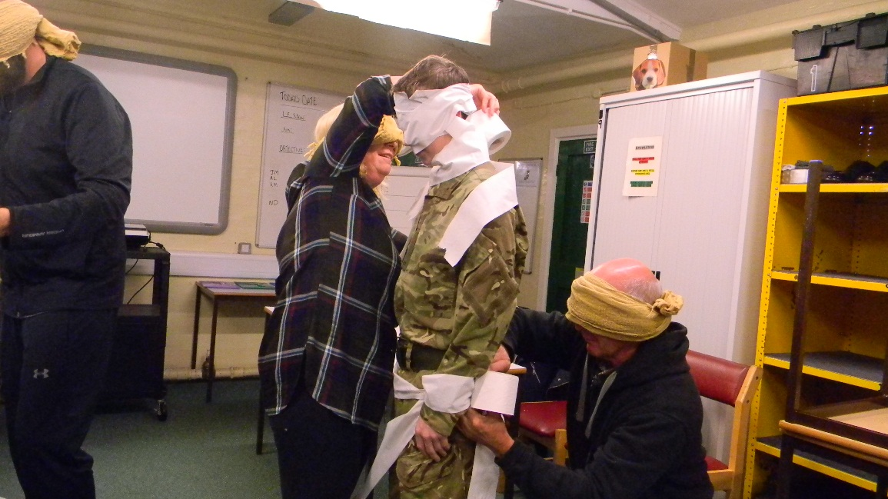

Those eligible in custody are able to apply for a **ROTL** which allows them to spend a day in the community with their family which supports relationships and family ties and enables those who have proven that they are well behaved, trusted and progressing positively. ROTL can be granted based upon risk assessments and eligibility. When a child completes a successful ROTL it also opens other gateways of opportunity like

* Early released
* Home detention curfew
* Parole

We will be introducing **Child Centred Visits** where appropriate which will be for those in our care who have children themselves and have siblings under 5 years old, the aim is to encourage, strengthen and maintain positive relationships whilst in custody as per Lord Farmers report that **“Family should be** **the golden thread”** we will focus on the children and this will be an opportunity to have a photo taken with their child and encourage positive interactions between the dad and their child or young sibling creating memories. The carer will stay during the visit and activities will be provided for the child and their dad/brother to enable the Dad/brother to reconnect with the child and flourish.

All residents have to pass two checks before they are allowed to attend a Children’s Event – one check from Public Protection and one from Security. Anyone who is a risk to children may not attend and neither can those who are on closed visits. When it is a family event, we are happy to consider applications from Basic, Standard and Enhanced children and each will be risk assessed robustly. However, we do believe that any resident who is a ‘family person’ should be aiming to get enhanced status and set a good example for his children/siblings.

We will encourage soft play activities for children under 5 years of age, and aim to support the early physical development of children. Soft play helps to develop physical activity and encourages children to enjoy fun and exciting play with their fathers/ sibling. Research has shown that children who are regularly involved in active play develop well on many levels, including physical, emotional, mental and social. Soft play is for children to use their imagination and get involved in exploratory play. Soft play helps children learn new motor skills and aids development through physical activity. Soft play allows children to use their imagination and get involved in exploratory play. It also aims to support the relationship between father/brother and child.

* Encourage positive interactions between parents/brothers and young children.
* Help parents/brothers to explore ways of playing with, listening and talking to their child/sibling.
* Familiarise with phrases, rhymes and songs.
* Encourage parents/siblings to share books and stories with babies and young children.
* Develop understanding and confidence.
* Photos can be provided for the day, as long as family members and the young person in custody has signed the disclaimer regarding posting photos on social media sites.

To support the maintenance of family relationships offenders can request, during the application process, to have a photograph of them and their visitors taken during the visit. Subject to security approval, this will be facilitated in the visits hall. At the end of the visit the family will sign a disclaimer prohibiting the use of the printed photograph on social media and the family will then receive the single printed photograph as they leave the visits hall.



It is estimated that 200,000 children each year are affected by a parental imprisonment.

We also facilitate when appropriate inter-prison phone calls for children in custody who have parents and family members in custody ensuring that contact is maintained.

At Wetherby we hold several celebration events linked to the Cadets passing out parades, Street Doctors graduation, Education Qualification presentations and Duke of Edinburgh achievements to name but a few. During these events family have the opportunity to see their young person supported in what they have achieved and these events can be extremely emotional due to the success of the children. The families are then able to spend time with their young person, share their experiences and share lunch over the period of several hours.

**Family Talk**

It’s the chance for the boys to talk with their family about things that they think are important alongside a therapist who is good at helping families talk together, it may be that the children want to sort out past arguments or difficulties in their relationships or they might want to talk about the effects of crime or staying out of trouble in future or something else. The children in our care can invite partners, boyfriends or girlfriends, mums and dads, brothers and sisters, grandparents or anyone they think of as your family. One of the best things about it is that it is a safe place to discuss difficulties and sort things out.

[](http://www.yudor.com.tw/archive/image/edcontent5/editor/support.jpg)

The **Chaplaincy Team** 

Offers pastoral support and care to all children throughout their time in custody. Statutory duties performed by Chaplaincy include seeing all new receptions within 24 hours of arrival and visiting the Healthcare and CSU every day to support prisoners who are isolated from the normal regime of the prison. The Chaplaincy Team provide teaching and discussion sessions which cover the beliefs and worship of the different faiths and look at reinforcing appropriate behaviour and thinking. The team offers one to one support, advice and encouragement. The Chaplaincy Team are responsible for verifying and informing a child when news of a bereavement or serious illness of a relative is known, with ongoing support offered where appropriate. Chaplains are responsible for the pastoral care of all children in our care of any faith and none and fulfil the right of all children to observe their religion and participate in corporate worship. Chaplaincy also offers help and advice to staff that may have questions about the principles and sensitivities of a child’s faith. The chaplaincy team also provide through the Mothers Union a bag for new mothers that include baby wipes etc. and these can be handed out on visits by the new dad.



Within this team there also operates the **Time for Dads** course which is an accredited programme under the CARE for the family’s positive parenting programme which promotes the well-being and responsibilities required for our young fathers or fathers-to-be to be successful in sharing the upbringing of their children, this course has a celebration event at the end where family members can come too.

[](https://www.careforthefamily.org.uk/wp-content/uploads/2014/09/Sample-Pages-from-TOFP-Dads-Facilitators-Manual.pdf)



In addition to the Time for Dads course our education provider, Novus, runs the **Storybook Dads** facility within the library. This is an opportunity for young fathers to be able to record themselves reading bedtime stories which can then be played to their child at home and reinforces their presence in the child’s life. More recently the need for this to be extended to young people who have very young siblings at home has been recognised as an additional positive influence on both the young person and their siblings and proves to be a popular service.

**The Youth Council** sits bi-monthly and addresses every aspect of a child’s time within Wetherby. Within this children raise any concerns or make suggestions as to where and how we might be able to improve on current provision in relation to family support and contact. This is then discussed further with the Heads of Functions within Wetherby and an action Plan developed.



For all those young people in Wetherby who feel that perhaps their voice is not being heard clearly enough, **Barnardo’s Advocacy Service** can provide them with an advocate to help them deal with their concerns. Their issue could relate to their stay at Wetherby or it could be an external concern, for example, something to do with their YOT or Social Services, ROTL/Early Release or immigration issues and the service is there to empower the young person in having their feelings and wishes presented in an organised and mature manner.



**CuSP,** (Custody Support Plan) Each child in HMYOI Wetherby will have a dedicated CUSP Officer to support them during their time in custody. CUSP involves a weekly meeting between the child and CUSP Officer. CUSP is about identifying needs and achieving goals that help them move forwards.

Much like a Jenga tower, when the base is wobbly, so is the rest. CUSP is about having the space to identify needs at each level and set goals that strengthen the tower.



**New bridge befriending scheme**



We have introduced a befriending scheme for those in our care who are 17 years and 6 months old and older who will be transitioning into the adult estate and would like to have a friendship with security through letters and eventually visits and phone calls. The support is sometimes more attractive to those who are vulnerable and isolated or have limited or no contact with people in the outside world.

Some young people here don’t have much contact outside but all of us need someone to talk to - someone we can trust, who doesn’t put labels on us, who talks straight, stays in touch and doesn’t make promises they can’t keep. New Bridge befrienders will support the boys while they are here and as they move to adult prison.

The befrienders aren’t attached to Wetherby but to the child and that’s why they can continue to be the child’s volunteer as they move on.

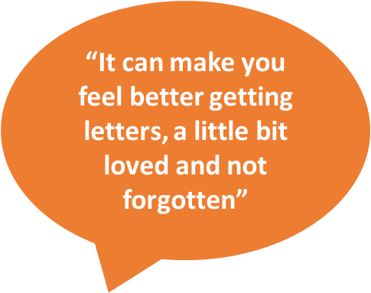

**Covid-19**

During the 2020 covid-19 pandemic we put a lot of support in place for the boys in custody which enabled them to maintain contact with their families and significant others and to look after their mental health during the crisis. We ensured that each boy received £20 of phone credit each week at no extra cost to the boys and provided them with in cell activities to do to keep their minds healthy and alert. Those boys who were dads were able to colour a picture in and have their photo taken with their picture and this was sent to their children to help alleviate any worries that they may have had.

We also introduced Purple Video visits in June to support the children and maintain family contact whilst regular visits are suspended. Each young person will be offered 1 video visit per month up to 30 minutes long this will be a facial recognition software which means that if an unauthorised person is detected on the screen or nudity is seen the image will freeze.

The boys were supported by the staff.

**International Day of Families 15th May 2020** 

International day of families was founded by the United Nations in 1994. The International Day of Families is observed on May 15th every year to celebrate the importance of families, people, societies and cultures around the world.

Family isn’t always blood, it’s the people in your life who want you in theirs, the ones who accept you for who you are, the ones who love you no matter what. So take time to think critically about what family really means to you and how you can get closer to the people that you love.

We celebrated the event by issuing all the boys with a quiz/activity pack for them to complete and we designed a card for them to send to their families or significant others to encourage and maintain contact.

We enclosed a card for the boys to write on what family meant to them which will be displayed for visitors to see.

We also raised £68.55 from a cake sale for staff which has been donated to the Donkey sanctuary so that we adopted a Donkey.

**Safeguarding** of children is a priority and depending on the level of risk level a person in custody poses to children, will determine the level of contact they can have with children whilst in custody. The management of these restrictions can involve mail and telephone PIN monitoring and monitoring of contact with children during visits. This is detailed below.

|  |  |
| --- | --- |
| Levels of Restrictions for Child Contact | |
| Level One | Full restrictions apply. No contact with any child permitted All correspondence and telephone calls may be monitored subject to a risk assessment being carried out and regularly reviewed. |
| Level Two | Contact permitted with named child only via written correspondence. All correspondence and telephone calls may be monitored subject to a risk assessment being carried out and regularly reviewed. |
| Level Three | Contact permitted with named child only via written correspondence and telephone calls. Correspondence and telephone calls may be monitored subject to a risk assessment being carried out and regularly reviewed. |
| Level Four | No restrictions necessary, contact permitted with named child only via correspondence, telephone calls and visits. The prisoner may be allowed access to family visits with the permission of the Governing Governor following a further, individual risk assessment.  Routine monitoring of correspondence, telephone calls, general observations in the visits area. This level of contact applies only to those children that the prisoner has permission to have contact with. All other children will be subject to Level One restrictions. |

**Areas for Development in 2020/21**

HMYOI Wetherby is committed to continuous improvement in how we maintain the ‘golden thread’ of families and significant others in all that we do. In order to achieve that we have identified areas for development throughout 2020/21, which will be reviewed for progress through our Reducing Reoffending Committee on a six-monthly basis and updated annually.

Our commitments for the coming year are as follows;

* Review refreshment service
* Review all messaging within the visits Centre is up to date and family friendly
* Develop this family strategy to incorporate the Lord Farmer recommendations and HMIP recommendations.
* Review the current induction paperwork to ensure that significant other is recorded alongside the next of kin.
* Consider SKYPE and video link opportunities for those struggling to access visits. We have now introduced purple visits.
* Child centered visits to start including those with children and young siblings under 5 years old.
* To consider DVD dads, similar to Story book dads but a DVD option so that the child can see as well as hear the story.
* Improve the outside visits Centre.
* Offer baby food/snacks in visits
* Design a child friendly booklet to alleviate any concerns that a child may have when visiting a prison.
* Family park run events.

**Further Reading**

* [Transforming Rehabilitation: a summary of evidence on reducing reoffending  MoJ](https://www.gov.uk/government/publications/transforming-rehabilitation-a-summary-of-evidence-on-reducing-reoffending) (2013)
* [Prisoners’ childhood and family backgrounds](https://www.gov.uk/government/uploads/system/uploads/attachment_data/file/278837/prisoners-childhood-family-backgrounds.pdf) examines childhood and family background of prisoners, their current family relationships, associations between these characteristics and reoffending, and estimates numbers of children (around 200,000 in 2009) affected by parental imprisonment (2012)
* [NOMS Commissioning Intentions](https://www.gov.uk/government/uploads/system/uploads/attachment_data/file/280924/evidence-segmentation-2014.pdf) Factors linked to reoffending and desistance (2014)
* [Transforming Rehabilitation: a summary of evidence on reducing reoffending  MoJ](https://www.gov.uk/government/publications/transforming-rehabilitation-a-summary-of-evidence-on-reducing-reoffending) (2013)
* [Prison Reform Trust Research](http://www.prisonreformtrust.org.uk/uploads/documents/KEEPING_IN_TOUCH_book4.pdf) looking at the potentially greater impact of imprisonment on children of women prisoners (2005)
* [Evaluation of the Community Support for Offenders' Families service](http://www.barnardos.org.uk/resources/research_and_publications/working-with-offenders-families/publication-view.jsp?pid=PUB-2400)  Emerging learning from a NOMS funded pilot of probation based family support services (2015)
* Emerging learning from a NOMS/Dept. BIS management review about [better targeting of family case work and interventions](http://www.barnardos.org.uk/resources/research_and_publications/working-with-offenders-families/publication-view.jsp?pid=PUB-2400) (2014)
* [i-HOP](https://www.i-hop.org.uk/) Advice and Information for commissioners and professionals working with offender’s families (funded by the Department for Education)

Beyond Youth Custody – <http://www.beyondyouthcustody.net/wp-content/uploads/The-role-of-family-support-in-resettlement-a-practitioners-guide.pdf>

* Action for Prisoners’ Familieswww.prisonersfamilies.org.uk – Action for Prisoners’ Families, works for the benefit of prisoners' and offenders' families by representing the views of families and those who work with them.
* AFFECT– AFFECT provides services for the families of serious offenders and offers support groups to families in the south of England. [www.affect.org.uk](http://www.affect.org.uk)
* First time in Prison **–** www.firsttimeinprison.co.uk this website was written by lawyers for individuals (and families) who are facing a first prison sentence.
* Inside Time **–** www.insidetime.org.uk – this website gives visiting and other advice
* Prisoners’ Family Voicesis a web-based community which gives family members the opportunity to talk to each other.

<http://prisonersfamiliesvoices.blogspot.com>

* Prisoners’ Families and Friends Service 0808 808 3444info@pffs.org.uk

[www.pffs.org.uk](http://www.pffs.org.uk)

* SHARP (Support Help and Advice for Relatives of Prisoners) 01743 245365for free

POP’s

Tel 0161 702 1000

* [www.partnersofprisoners.co.uk](http://www.partnersofprisoners.co.uk/)

The local team can be contacted on:

[keiths@partnersofprisoners.co.uk](mailto:keiths@partnersofprisoners.co.uk) and on 01524563556 between 11.45 and 16.45 Wednesday Saturday and Sunday

* NICCO ( Barnado’s **)** https://www.nicco.org.uk/

NICCO is a one-stop information and advice service to support all professionals (working with children and families of prisoners) and all families of prisoners, bringing together useful information in one place.