Family and Significant Others Newsletter- June 2021
For this month’s newsletter we are sharing some updates surrounding some changes in regards to social visits and also to inform you of how we are running COVID vaccinations of those in custody. Therefore, please see below information provided by both the visits team and Healthcare Department who need your support as Families & Significant Others to encourage your loved ones to get vaccinated if they haven’t already and to follow the current rules of COVID within visits.

VISIT UPDATES
As you are all aware, social visits have been very difficult throughout COVID due to the various restrictions which have been put in place to ensure the safety of visitors, prisoners and staff and to reduce the risk of COVID spreading at Guys Marsh.
However, in line with the community, Prisons have seen some changes recently in some restrictions for visits to take a step forward to make visits a more enjoyable experience for everyone. The changes include:
Visitors from 2 households can visit a person at the same time
Under 11s can receive a hugs from the person they are visiting

THINGS TO BE AWARE OF OR TO REMEMBER…
Under 11s can have contact due to the risk of passing on the virus being much lower in this age group than others | Children can leave their seat but will need to stay in the area marked out during the visit
Everyone on the visit will still need to follow social distancing guidance when arriving or leaving the visit | Visitors are encouraged to access the widely available twice weekly rapid testing in the community - www.nhs.uk/conditions/coronavirus-covid-19/testing/get-tested-for-coronavirus/
The maximum number of visitors allowed will remain the same | Adults & children who are over 11 must continue to social distance from the person they are visiting

VACCINATIONS UPDATE
Hello can I introduce myself, I am Liz the Patient Engagement Lead for Healthcare at HMP Guys Marsh.
Over the last few months we have tirelessly been vaccinating our patients, your loved ones. We started in January when we were giving the Astra Zeneca to the older population and we are now going to start vaccinating the younger population with the Moderna vaccine.
We are disappointed in the uptake of the vaccine and would like to have seen more men take up the offer. We understand that they can have very different reasons for not having it, but I would like to point out that now things are getting back to normal and the men are able to have visits and move around more freely, it is the only way that we can prevent a serious breakout and men having to be hospitalised.
We have been lucky here but we don’t want to push our luck, so please could you encourage your loved ones to have their vaccination, to protect themselves, you their loved ones and others. We can beat it but only if we all work together.

Covid Vaccination Myth Reality
The Covid 19 vaccine is not safe for the BAME communities.
- There is no evidence that any vaccine works any differently within any ethnic group
I cannot have the vaccine because of my religious beliefs.
- The Vaccine does not contain any animal or egg products
The Covid 19 vaccine contains a microchip.
- Out of the 10 ingredients not one of them resembles a microchip
It can cause blood clots
- You are more likely to die of Covid 19 than getting a blood clot from the vaccination
If you have had Covid 19, there is no point in getting the vaccination.
- If you have been sick with Covid 19 you can still benefit from having the vaccination, has it is unclear on how long the anti-bodies offer protection following the illness and you have to consider the different variants that keep popping up.

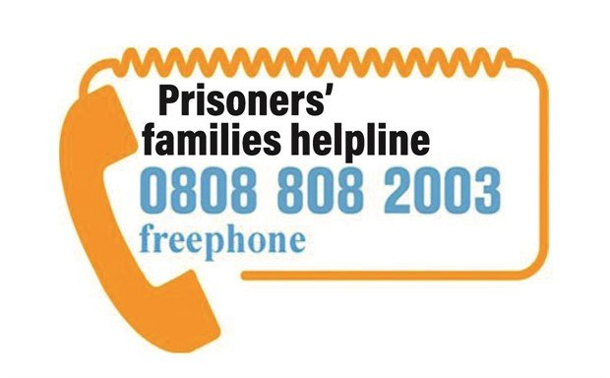
OTHER HELPFUL INFORMATION

- Prisoner’s Families Helpline: Families of prisoners can access advice and support through the Prisoner’s Families Helpline. Follow this link to watch their video for families about what to do if they have a worry or concern for a loved one in prison https://www.prisonersfamilies.org/pages/category/need-urgent-help?Take=24

Please use the below feedback form to let us know how you find our monthly Family Newsletters and what you would like to see on any newsletters- to help us in keeping you up to date with any information you would like to know!

Contact Us
Should you have any concerns about one of the men in Guys Marsh you can contact the safer custody team by email SaferCustodyGuysMarsh@justice.gov.uk or if the matter is urgent call the Safer Custody Hotline on (01747 856457) and the local safer custody team will be made aware of your concerns.
If you have any general queries or questions then feel free to contact the Family Champions Tracy & Mia by email on FamilySupport.GuysMarsh@justice.gov.uk or the Guys Marsh Banardos family worker Aimee on Aimee.Derrick@barnardos.org.uk / GuysMarshVC@barnardos.org.uk
If you need to contact Staff to make them aware of personal matters such as births, deaths etc. then please contact the Chaplaincy by email on Chaplaincy.GuysMarsh@justice.gov.uk
You can also receive regular updates on what is happening at HMP Guys Marsh by following the official twitter account @HMPGuysMarsh
We are aiming to provide you with updates on any changes or new initiatives on a monthly basis. If you would like to sign up to receive the newsletter each month via email, then please contact the Family Support email above and we can add you to a mailing list!
Also, if there is anything you would like to see on the monthly newsletters, then please get in contact and make us aware!
Stay safe and keep well
HMP Guys Marsh

