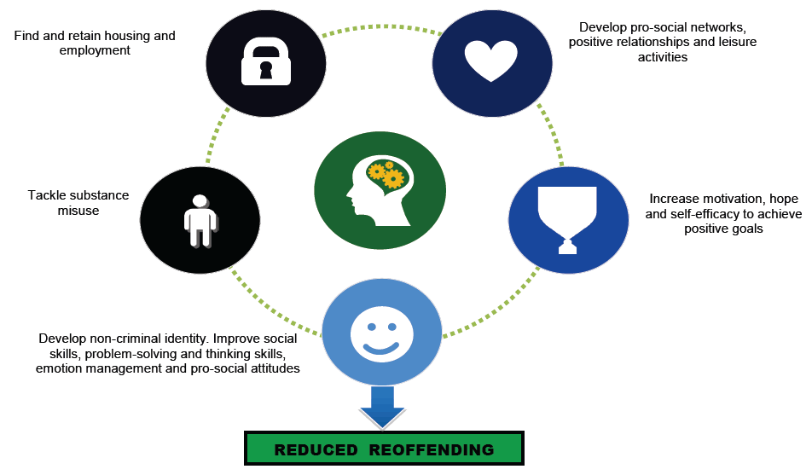**Reducing Reoffending Newsletter - January 2022**

As we move into 2022 areas in our function will be working to bring all our news and information together in one newsletter.

It has been recognised throughout COVID-19 that communication and consistency is valued by staff, people in our care, family and friends.

The newsletter will also support how we work together when regimes are restrictive or access to activity is limited. The pandemic has demonstrated how we have considered alternative options for delivering services such as virtual visits, in-cell education and structured wing activity. This has enabled new ideas to flourish and the introduction of new technology.

We start 2022 in a Stage 3 regime. This means there are restrictions in place such as COVID-19 testing for visitors, indoor activities being in households where unable to safely distance, wearing of face coverings and essential services running. We have supported these exceptional circumstances with additional phone credit, temporary measures pay and by offering vaccinations and testing where applicable.

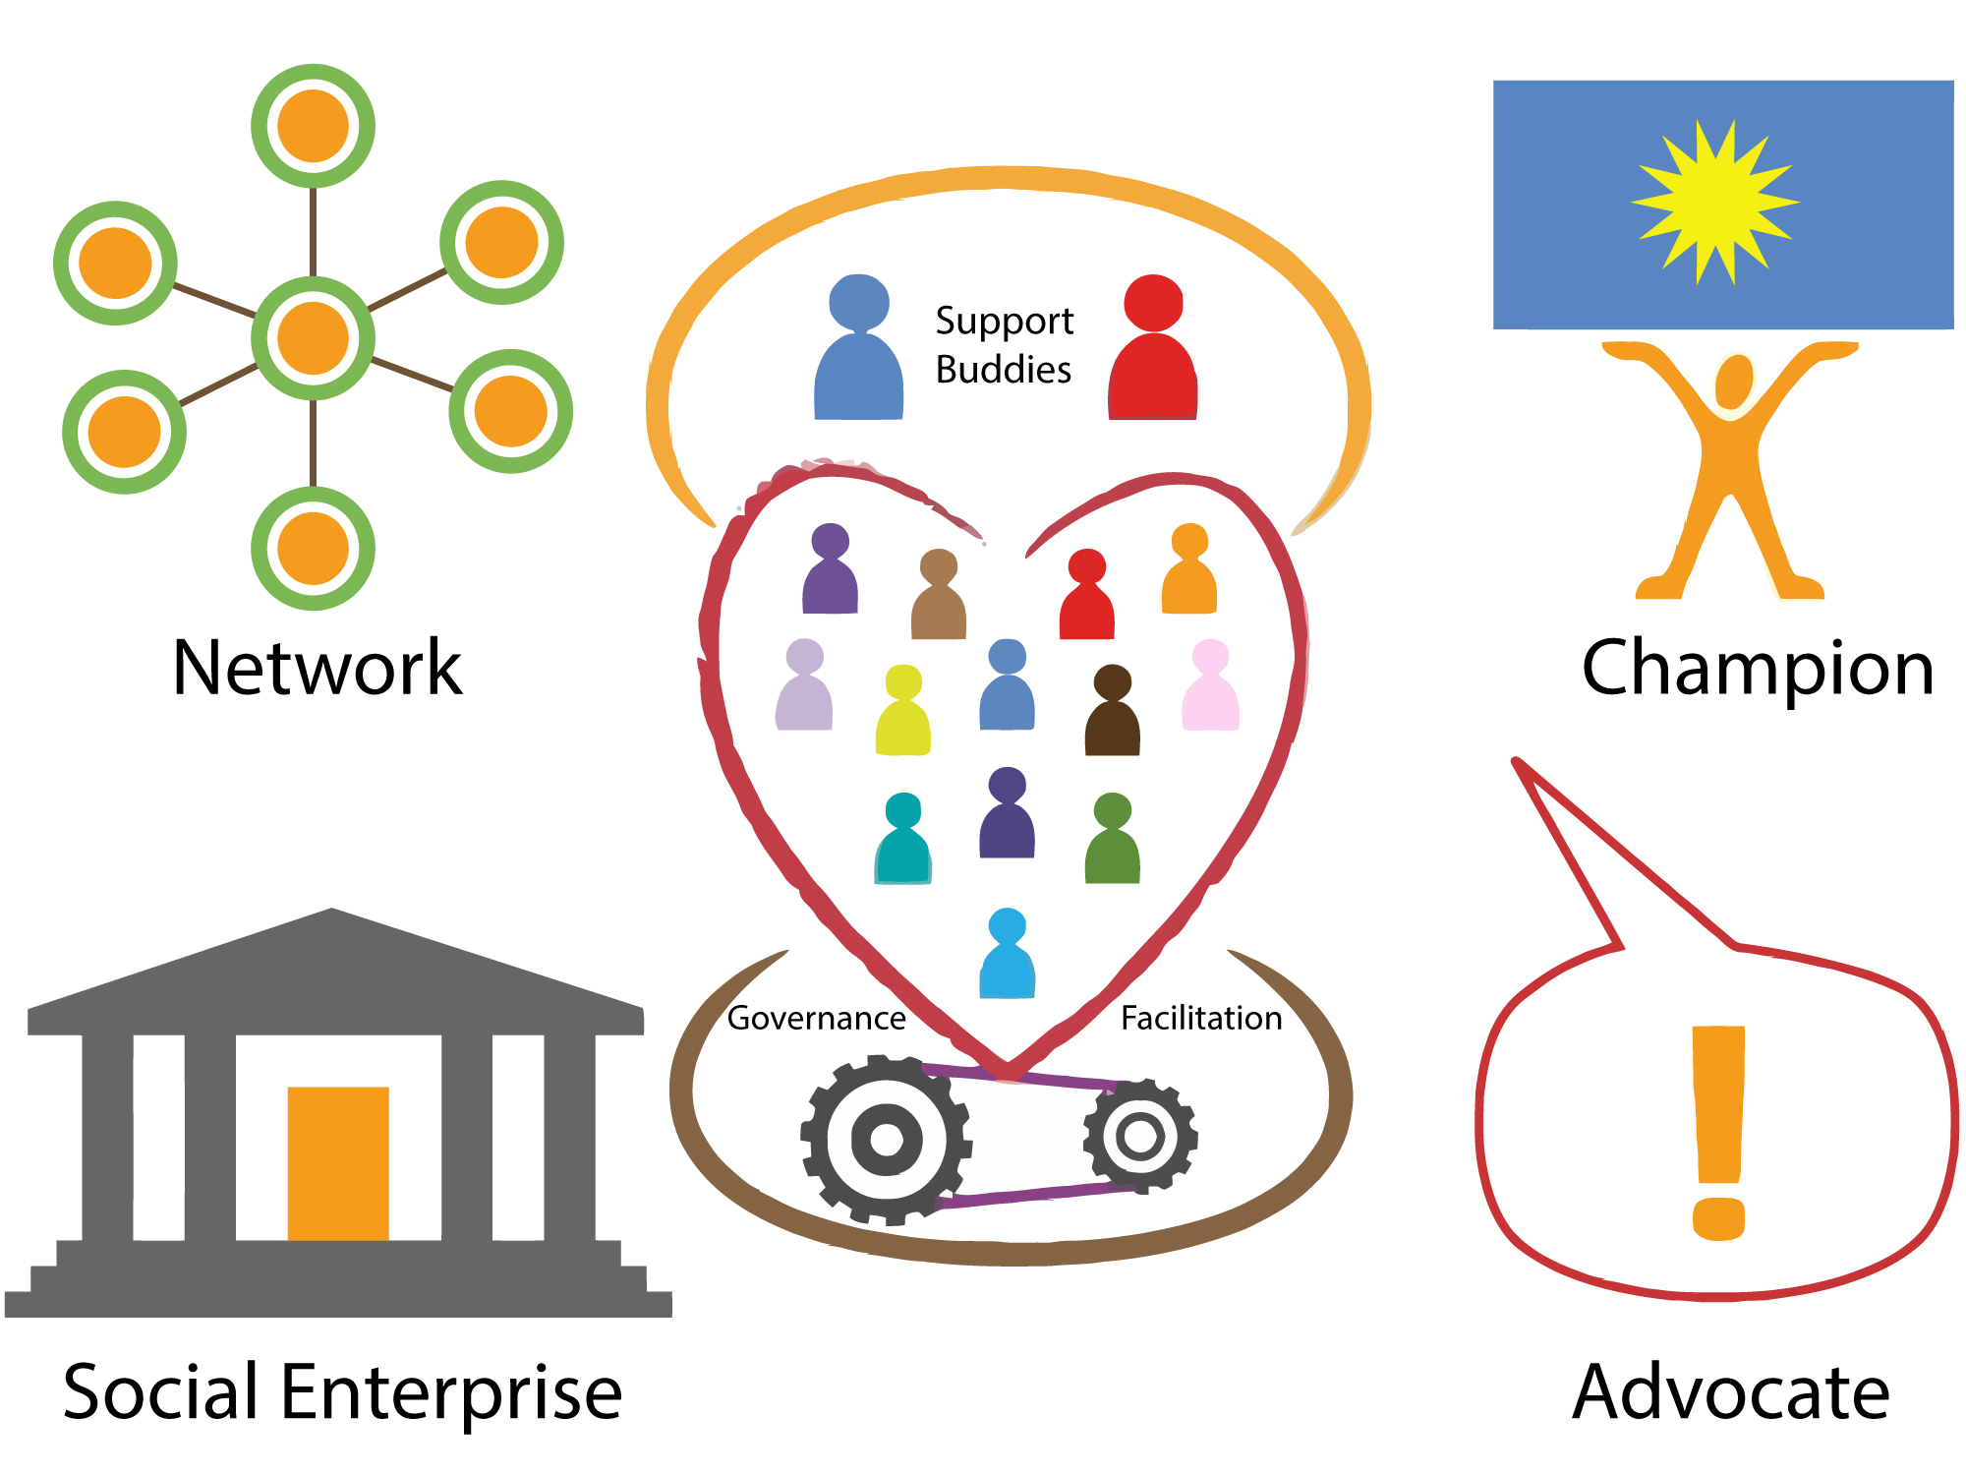We would like to continue to work together this year to provide as much opportunity to develop and progress towards a rehabilitative release as possible. We would welcome your help and ideas to do this.

**3 C’s 2022**

* Continue to promote the PACT (Purpose Achieve Community Transformation) strategy to become more procedurally just in our communications and processes. To actively participate in activities that support change and improvement.
* Be more collaborative in working towards implementing new change and taking on more feedback! 3C’s champions will be seeking feedback about specific topics and opening up opportunity to engage in forums, discussions and projects that are of interest!
* January will look at plans for a “New GM” as we enter a new year and progress towards expansion – 3 C’s champions will be asking what kind of activities and events you would like to see and take part in over the next year so we can start to plan for these (hoping COVID lets us!)
* This month, champions will be discussing the pillars of rehabilitative culture with you and seeing where you think our key developments are so this can form part of our strategy over the next year! Think about our processes, relationships, environment, opportunities and leadership.

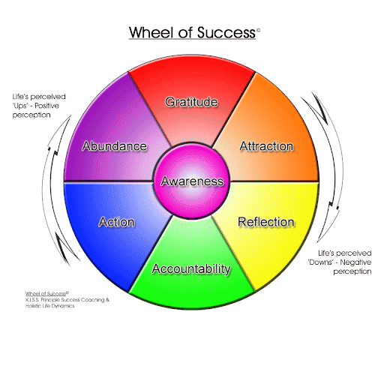**Programmes 2022**

* The start of the year sees a smaller Programmes team, this means that we are limited to what can be delivered at the moment. We are running smaller groups and will be starting this year delivering TSP on a 1-1 basis due to minimal staffing and COVID. We are hoping to have more staff start in the Spring which is fab!
* Prioritisation for programmes remains the same; you will be prioritised if you are within 12 months of a relevant date (parole, release, sentence end) and, within this group, we will prioritise further based on soonest date and risk levels.
* We are working to implement more additional support work including Timewise as a peer mentor model and also Choices and Changes for young adults delivered with keyworker support; watch this space!

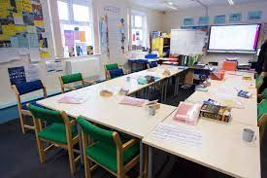**Education 2022**

**Functional Skills- what’s the point……..?**

* Remember in order to achieve in education and employment in the future a good level of Maths and English is needed. We run courses in Maths and English from Entry level up to Level 2. A Level 2 qualification is equivalent to a GCSE pass and is essential for progression on release. If you would like to know more about progressing your English and Maths skills we would like to hear from you.
* Included in our delivery of essential skills for employability and progression is IT. Information Technology moves at a very fast pace so even if you think you are totally computer savvy it may be worth refreshing your IT skills before progressing to the next stage of your rehabilitation. Look out for the posters on the wing advertising the next start dates for the levels you need or put in an app to get yourself on the waiting list. We are now offering IT at Entry level so even if you know nothing about computing there is an option for you to learn from scratch and begin your pathway.
* A good level of Maths and English is also essential for you to join any vocational courses and is a solid foundation for all of your future learning.

**IT – IT Entry Level, Level 1 & 2** are available in the New Year. If you are interested in updating your computer skills or understanding new technology please put in an application. We are expecting additional laptops moving forward to support in cell learning and the IT qualification would benefit.

**Classroom delivery** – Currently classroom delivery is in cohorts and is a blend of Face to Face delivery and in cell work. Face to Face delivery and Library is completed in households.

|  |  |  |  |  |  |  |  |
| --- | --- | --- | --- | --- | --- | --- | --- |
| Monday AM | Monday PM | Tuesday AM | Tuesday PM | Wednesday AM | Wednesday PM | Thursday AM | Thursday PM |
| Gwent | Dorset | Anglia | Mercia | Rainbow | Fontmell | Cambria | Saxon |

There are some exceptions to this where fresh air, social distancing or testing can mitigate full time courses such as CLEA, Industrial Cleaning and Horticulture.

The Education magazine SHOUT OUT can be collected from the Library, the Pop Up Activities desk or ask the Education mentor from your wing.

**Library & Distance Learning 2022**

**Dates for your diaries**

January 17th - Dr Martin Luther King Day

January 25th – Burns Night

January 27th – Holocaust Memorial Day

February – Chinese year of the Tiger

February 14th – Valentine’s Day

There are a wide variety of applicable Films and Activities themed for these events. For more information contact the Library, Activities CM (Colin Soper) or Education.

**Industries 2022**

2022 has seen a return to Stage 3 Covid restrictions. This allows us to run essential and government contracted services only.

This means that we are only opening Kitchens, Waste and Recycling, Decency, Laundry, Farms, Gardens and Livestock where appropriately staffed.

**FARMS** - Dean and his team continue to plan ahead for the coming spring and are readying the green houses and polytunnels to supply us all with fresh produce.

**HYDROPONICS** - There is a plan to open a new workshop when restrictions are lifted which will see the introduction of new technology. There will be a Library information day in the spring for anyone who is interested in becoming part of this work party.

**HYDROPONICS**

Hydroponics is a method of growing plants without the use of soil. The plants get the nutrient from a liquid solution.Plants grow in an inert media. An inert media is a product that may help to support the plant but has no feed for the plant and is open enough for the roots to grow through. This could be any number of different products such as: clay balls, rock wool, coir from coconuts or even floor mats. Water containing nutrients is either pumped over the plants or the roots of the plants hang into the solution. The main advantage of hydroponics is that it uses much less water than conventional growing and it is possible to accurately adjust the quantities of feed and oxygen that the roots have access to. As Hydroponics can be used for vertical growing it means that there are many possibilities for increasing food production where access to land is scarce.

**AEROPONICS**

Aeroponics is a new adaptation of hydroponics. Plants are grown without being planted into any growing media. Water containing all of the nutrients required is sprayed onto the roots at regular intervals. This has been found to be extremely efficient and uses even less water than hydroponics. The requirements to set up an aeroponic unit are more high tech but once established are extremely efficient. There is minimal cleaning down between crops but cleanliness throughout the process is essential to minimise exposure to pests or disease. Many aeroponic systems employ a hydroponic system as a back-up in case of failure of the misting nozzles. This system is considered to be one of the best for the plants as it gives access to oxygen at the roots almost continuously.

**AQUAPONICS**

Aquaponics is the combination of Aquaculture and Hydroponics. It is a system that farms plants as well as fish. This uses all of the skills of hydronic growing as well as those of a fish farmer. The plants take most of their nutrient from the fish waste. By absorbing these nutrients the plants are also filtering the water that makes it safe for the fish. With the correct choice of plant and fish then it is possible to feed the fish with the waste from the plants (such as roots and older leaves from salad crops or the leaves and stems from fruiting plants like tomatoes). The advantage of this system is the protein and vegetables that are produced go a long way towards a balanced diet with minimal inputs. Molluscs, crustaceans, algae and different types of fish can all be added to the mix in order to expand the range of food that can be produced.

**GARDENS -** The Guys Marsh Gardens are being well tended and there is a further opportunity for two ROTL Outside Gardeners coming up. Look out for vacancies from the Activities Hub. The Spring is a busy time for planting, mowing and cutting and we are hoping align this with some additional qualifications through Kingston Maurward college in the New Year.

**LIVESTOCK & PROJECTS –** We are currently under Avian Flu restrictions so you have wondered where our duck, chicken and geese have gone. They are all safely housed in one of the unused polytunnels in order to avoid contact with wild birds who are at risk of spreading the disease unknowingly. Anyone who enters LBA are expected to wash their feet in a footbath to avoid the spread further. Once the risk has subsided we will be welcoming the Ducks and Geese back to the pond area.

**DECENCY WORKSHOP -** The decency workshop continues to run smoothly the workshops main focus is to reduce and control the levels of all items and materials issued out on a weekly bases. This is working very successfully due to the decency team currently working there.

The workshop instructors would just like to remind units the apps have been updated and the items and figures have changed. You can access the NEW apps on the shared drive.

**WING RECYCLING -** The wing recycling is going well but we could be more ecologically efficient, every unit has a designated recycling bin in place, this is checked to ensure it is in operation. If your unit does not have a recycling bin the decency team will ensure one is put in place in order to recycle successfully.In the month of November 427 items were collected by decency workshop and recycled.

**WASTE & RECYCLING** – We are striving to be more sustainable and support a greener environment. We have had three new tables delivered so sorting recyclable items will be much more efficient in the future. We continue to complete daily collections from the wings. Remember the traffic light system **RED** bags for COVID Laundry, **YELLOW** bags for Bio Hazard Waste and **GREEN** for recycling.

**ELECTRICAL REPAIR WORKSHOP -** We continue to refurbishelectrical goods such as TV’s, Kettles, in cell phones in the electrical repair shop in order to ensure there are replacement items available as necessary. If you have any broken items please take them to Workshop 6. There is also a non-accredited electrical awareness workbook and in late Spring prisoners will be able to complete an accredited electrical qualification at Level 1 & 2 and become a registered PAT tester.

**10 Fantastic Recycling Facts**

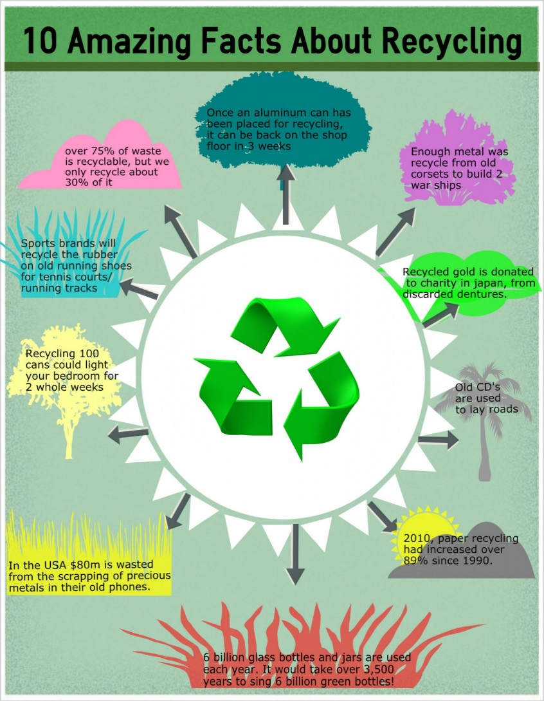

**Fact #1:** If every aluminum can in the United Kingdom was recycled, we would need 14 million fewer dustbins.

**Fact #2:** 275,000 tonnes of plastic are used in the UK every year, roughly 15 million bottles per day.

**Fact #3:** Glass takes 4000 years to decompose, but is 100% recyclable and can be reused again and again.

**Fact #4:** One recycled tin saves the energy it would take to power a television for three hours.

**Fact #5:** One recycled glass bottle saves the energy it would take to power a computer for half an hour.

**Fact #6:** One recycled plastic bottle saves the energy it would take to power a 60 watt light bulb for three hours.

**Fact #7:** 10000 tonnes of waste can create one job if you burn it, 6 jobs at a landfill, but 36 jobs at a recycling plant.

**Fact #8:** In the UK, the average person generates their body weight in rubbish every seven weeks. That’s seven times a person’s body weight per year.

**Fact #9:** Each tonne of paper recycled can save 17 trees, 380 gallons of oil, three cubic yards of landfill space, 4000 KW of energy, and 7000 gallons of water.

**Fact #10:** And with all of this in mind, up to 50% of the contents in the average dustbin can be recycled.

**LAUNDRY** – We urge you all to continue to use the Laundry for all your prison issue kit. We are about to get our Laundry upgraded which will make washing and drying more efficient. Please send any excess kit you may have been storing back to the Laundry in order to be cleaned and redistributed. We are aiming to re-open the clothing exchange service when restrictions lift in order to make collection of kit more accessible.

**TEXTILES** – The new Textiles workshop opens in January. There will be qualifications attached allowing opportunity to move into the textiles industry on release. As we expand we will be offering domestic machine work, mending and specialist stitching for those that would like to learn new skills.

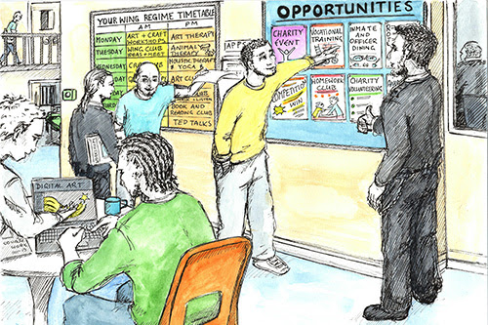**Activities 2022**

For 2022, the Activities Hub’s main priority is to ensure that we are able to offer all those within Guys Marsh the opportunity to engage with purposeful activity during their Sentence. This is to support with your progression in regards to your Sentence Plan, D-Cat Reviews, and Parole, amongst many other things! We are utilising all the spaces we have available in Stage 3 and these will increase as we move back down the restrictions stages!

**In 2021, we were able to:**

* Restart the Attendance Figures to show what our attendance is in regards to those available to work and divided this into wings to show individual wing attendance.
* Reintroduce the weekly Allocations Board where we discuss our capacities, upcoming courses, those who require a job and those who are unemployed.
* Revise the Removal Process to support those with substance misuse in conjunction with Drug Strategy, ISMS & Security.

**In 2022, we plan to:**

* Review the Prisoner Employment & Pay Policy to document new processes, highlight policies of the prison in regards to purposeful activity and ensure that the pay we are offering reflects your hard work and encourages you to gain qualifications in terms of your progression.
* Introduce My Choices Boards for those who are unemployed in conjunction with Officers, POM’s & Keyworkers to discuss where individuals would like to be allocated and seeing if we can deliver!
* Become involved with Activity pop up shops on wings in conjunction with the Activities CM and Education mentors to showcase what we can offer and what opportunities are available at Guys Marsh.

**Families & Significant Others 2022**

**In 2021, we were able to:**

|  |  |
| --- | --- |
| **MONTH** | **WHAT WERE THE HIGHLIGHTS?** |
| JANUARY | Banardos delivered Safeguarding Training to new officers to support in social visits & Key work. This will be rolled out to more staff in the New Year to keep you, your loved ones and your families safe! |
| FEBRUARY | We were able to source ‘Dad Pads’ for new fathers to support them on release. We also increased Purple Visits slots to all wings over each weekend instead of 3 to give more opportunity for contact with families whilst visits were restricted. The Family Champion also created a step by step guide on Purple Visits which was sent out to numerous families! |
| MARCH | Barnardos increased the in cell activities being offered- this included various packs to mark special occasions. Safer Custody also introduced a new Hotline for your Families & loved ones to contact at any point. |
| APRIL | We were happy to announce that Social Visits were being reintroduced. |
| MAY | We led on the ‘Safe & Sound Selfie Project’ where we sent pictures of to your loved ones along with a hand written message. |
| JUNE | A Personal Advisor for someone in our care who is Care Experienced attended their Parole Board. We also reintroduced and promoted the Prisoner Voicemail Service. |
| JULY | We got involved in a photo project with the family of a previous resident to recreate a First Time Visitors booklet for adults & children. |
| AUGUST | Banardos were authorised to begin re-delivering face to face work. |
| SEPTEMBER | We were authorised to begin contact in Social Visits- so you were able to hug your loved ones whilst visiting. This included having photos taken during the visit. |
| OCTOBER | Banardos introduced the Virtual Family Forum. We also led on Care Experienced Week where we had the Regional Operational Care Experienced Lead come in to chair a forum and deliver training to staff. |
| NOVEMBER | We collaborated with the 3 C’s Champions on Families & Significant Others work. We also saw a rise in prisoners requesting to get involved with Story Book Dads and other family groups run by Barnardos! |
| DECEMBER | Christmas Visits have commenced- with goodie bags donated by FOGM. There was also a celebration event for all the prisoners who had engaged with Inside Talking throughout the year. |

**In 2022, we plan to:**

* Reintroduce extended family visit days on a monthly basis when restrictions allow- we already have themes and ideas ready!
* Introduce more family groups run by Barnardos to support with maintaining or re-establishing family ties.
* Continuation of monthly Virtual Family Forums to allow your Families & loved ones to have a safe space to ask questions and raise concerns with our Family Engagement Worker.
* Keep adding Families & Friends to our monthly newsletter list- to keep everyone updated with what is going on at Guys Marsh.
* Encourage you, your Family and any Significant others to get involved with reviews to celebrate your hard work in Education, Programmes, and ISMS etc.
* Focus on supporting those who are Care Experienced in regards to support in the community via their Personal Advisors to ensure they are prepared for release.

**Care Experienced & Young Adults**

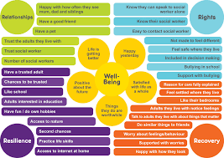We aim to hold more forums and group discussions to highlight the support available to Care Experienced and Young Adults. There are two staff SPOCS in OMU for you to contact if you have been in the Care system and want to contact your personal advisor, you may be eligible for additional benefits on release. The Choices and Change programme will be available through your keyworker as we progress through 2022 and is specifically designed to address behaviours linked to age and impulsivity. The Family Engagement worker can also support in signposting to other support networks.

**Gym 2022**

Although Gym regimes have been limited during COVID restrictions it still has managed to deliver/achieve the following in 2021 during COVID restrictions.

Staff - First Aid at Work (FAAW) x 6, Staff wellbeing day, Sports Massage, 15m Bleep test training sessions to support operation staff to improve fitness for their roles.

Prisoners - Circuits (Astro), Men’s Health – Body MOTs, sessions offered to ‘Tackling Drugs through Sport’

**Proposed for 2022**

Prisoners - AFC Bournemouth/Twinning Project – football/coaching courses awards, FAAW Courses, Level 2 Gym Instructor, Shannon Trust, Summer Athletics Days, Sports Days, Charity Events, Rowing Club/League, Tai Chi/Yoga – Tackling Drugs Through Sport, Rehab- Ultrasound, Park Run

People with learning difficulties and disabilities coming in for a morning working with prisoners

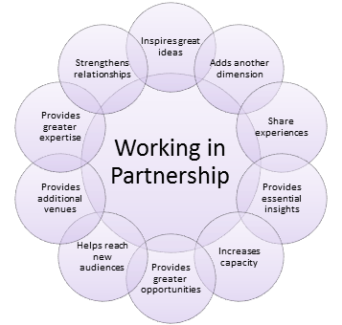Staff - FAAW Courses, Summer Sports Day, Charity Events, Tai Chi/Yoga, Staff Wellbeing, Sports Massage

**Partnerships 2022**

Guys Marsh are always thankful for the relationships we have established with various partners to deliver support, advice and materials to those in our care. Below are some of our main partners that we are looking forward to continue to work with in 2022!

**Inside Talking:**

Inside Talking is a charity which supports fathers in prison. It provides a safe environment for them to talk about anxieties and concerns that are important to them and to then process coping strategies to move forward with difficult relationships and family life. Marika & Tim are enthusiastic about using communication to support in positive family relationships.

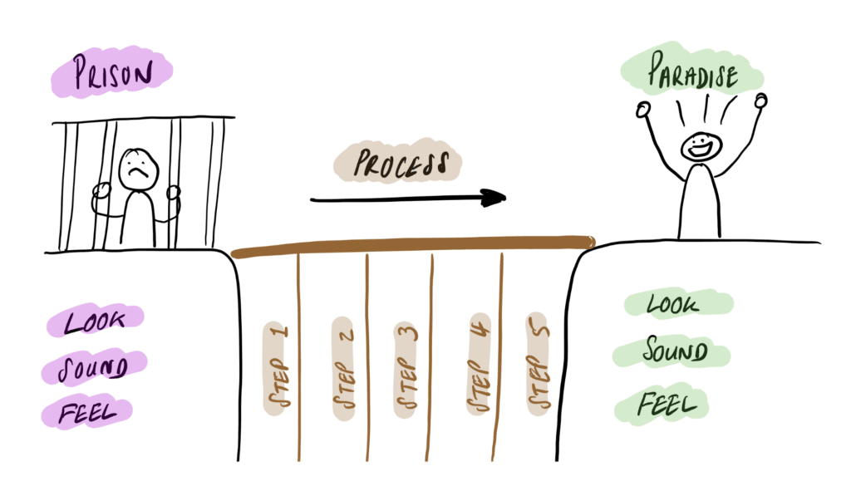Inside Talking runs once a week in a small group for a period of around 6 weeks. If you wish to apply to be considered for a future group, then please submit an application to the Activities Hub.

**Shannon Trust:**

We currently have 4 Shannon Trust Mentors who are supporting various learners with their reading and writing skills. During COVID, it has been difficult to facilitate this service but since mid-2021, the mentors have still managed to support 20 learners - which is a massive achievement!

There is a monthly meeting held with Shannon Trust volunteers in the community, where there is an opportunity to be trained as a mentor. Therefore, if you have your Maths & English Level 1 qualifications, then put in an application to Activities to see if we can get your trained! An Officer is due to be trained in January 2022 as the Shannon Trust Facilitator of Guys Marsh, where more support can be offered to both learners and mentors.

We also welcome applications for referrals to support with your reading & writing at any time, so if you feel this would benefit you, please get in touch.

**Friends of Guys Marsh (FOGM):**

Friends of Guys Marsh Prison (FOGM) is a charity formed in 2004 for the benefit of Guys Marsh prison community and supports in reducing reoffending. This includes supporting men & their families - we supply a Saturday bus for visitors; food for Family Days; materials for in-cell hobbies and help towards clothes for employment on release.

FOGM have recently supported many individuals with leavers bags, clothes for interviews and art materials to support their hobbies. They also provided Christmas goodie bags to visits in both 2020 and 2021 for your children when they visited you over the festive period!

Please put a FOGM Referral form into the Employment Hub if you wish to apply for any support.

**Activities CM & Education Mentors 2022 - Activities Pop up Workshops**

CM Soper is now the Activities CM and will have oversight and support the Education Mentors. There will be regular pop up shops on each of the wings as timetabled below.

**What might you find at the pop up activity shop?**

* A list of all current job/education course vacancies in custody
* Details of how to access learning in the workshops, education and within other activities
* Signposting to additional supports such as Shannon Trust, Storybook Dads, Inside Talking, Barnardos, Themed events, Employment Hub
* List of external vacancies supporting through the gate employment
* Details of how to access higher level learning through PET or OU
* Other course availability such as Tackling Drugs through Sport, ISMS groups, Unlock Drama

|  |  |  |  |  |  |  |
| --- | --- | --- | --- | --- | --- | --- |
| **Monday**  1400-  1450 | **Tuesday**  0900-  0950 | **Tuesday**  1400-1450 | **Wednesday**  1400-  1450 | **Wednesday**  0900-  0950 | **Thursday**  1400-  1450 | **Friday**  0900-  0950 |

**Induction - Induction Week:**

When you first transfer into Guys Marsh, you are automatically put on the Induction Week where you will meet various departments, receive a Directory of Services to showcase what opportunities Guys Marsh have and complete various other tasks to start your journey with us. We have 2 Induction Reps who support your engagement during this week and can offer any additional advice when required.

As part of your induction, you will be involved in the following:

* Meet the Induction Rep, wing mentors and advisors to answer any questions.
* Visit the Library & Employment Hub in the Education building.
* Complete your Maths & English initial assessments to let us know what level you are working at.
* Sit with Prospects to complete a ‘Face to Face’ board to discuss what purposeful activity you want to do here or to discuss any resettlement goals and plans to see how we can support you.
* Meet with OMU and find out who your Prison Offender Manager (POM) is.
* Meet with Programmes to discuss what Offender Behaviour Programmes are available to you and how to refer to them.
* Meet with ISMS on your arrival to be offered support in relation to substance misuse.
* Be seen by Healthcare to discuss any support you may require.
* Have a first night discussion with an officer to discuss any concerns, answer and questions and provide you with everything you need for your first night.
* Attend the Gym to complete your manual handling training and Gym induction.

Due to households currently not being able to mix, the induction week has had to be condensed but we are hoping that once we enter Phase 2 again that we can begin having a predominantly face to face induction with all departments on the induction unit.

**Resettlement 2022 - Employment Hub:**

The Employment Hub is designed to be a one-stop-shop for employability support and external job vacancies. We advertise external jobs across all resettlement areas so anyone actively looking for employment on release will have opportunities to access roles specifically for ex-offenders. Since June 2021, we have managed to secure 11 individuals jobs on release!

The Employment Hub provides:

* Access to job adverts and support with the application process for interview on release.
* Support with improving employability skills, such as CV writing and interview practice.
* Referrals to set up Bank Accounts, ID Cards & for FOGM requests.
* Holds 12 week resettlement groups to discuss any support you require & repeats this process at 4 weeks.

We have 2 Pathways Ambassadors who will be able to advise those in our care on how to develop skills and knowledge while in custody in order to prepare for employment on release. If you wish to have an appointment for the Employment Hub, then please submit an application to the Activities Hub.