**Reducing Reoffending Newsletter - February 2022**

As we move into 2022 areas in our function will be working together to bring all our news and information together in one newsletter.

It has been recognised throughout Covid 19 that communication and consistency is valued by staff, people in our care, family and friends.

Throughout February we have seen wings in Outbreak status. This has led to limited access to activity for some. In some cases Education has been sporadic in order to offer opportunity for everyone to have some face to face delivery. I ask that staff continue to engage with learners and workers. We do have the in cell phone facility and sometimes it is just reassurance that is required. If prisoners would like a call please send an app to the activities hub who will signpost to the relevant teams to make the call.

**Activities**

Both the Head of Reducing Reoffending and Activities Hub Manager have sat down to review the 2022 Prisoner Employment & Pay Policy with the hope that this can come into effect as of April 2022. We will be circulating the new policy within the 3 C’s Meetings and via our Reps & Mentors to receive feedback from residents prior to approval so any amendments can be made. The hope is that this new pay review will provide incentives to elevate our attendance, engagement and progression within purposeful activity.



The Activities Hub are also holding weekly ‘Allocations Boards’ where we discuss with various departments about all our purposeful activity vacancies and upcoming courses. If you are aware of anyone that is struggling to find Activities to engage with then please highlight their name to the Hub to be discussed as part of these boards.

**Families & Significant Others 2022**

On the first Tuesday of each month, the Family Champions lead on a Families & Significant Others meeting. Please see below some updates from this meeting:

* 2 Post Programme Reviews were attended by Family members where positive change was recognised and awarded.
* We supported and arranged 3 compassionate visits for residents.
* We received 4 referrals for support and guidance from Barnardos from just 1 wing in a week.
* A craft group session was held in the Library by Barnardos where memory books and calendars were made from fathers for their children.
* One individual that transferred to D-Cat thanked the Family Champions and Family Engagement Worker with their support since they have been at Guys Marsh to help re-establish contact with their child and for advice received on processes for Family Court.
* Prison Offender Managers (POMs) are regularly trying to involve family members in any sentence progressions or resettlement plans. This is via email or phone calls.
* A Virtual Family Forum is being held by Barnardos on 6th February, where 13 invites have been sent out to families and loved ones to get involved. These forums will be held on a monthly basis, so please get in contact with the Family Mailbox if your families would like to take part.

**NEW IDEAS TO LOOK OUT FOR…**

**Purposeful Activity Photo Project:** This opportunity will be for residents to have a photo taken in their activity area followed by a comment by their supervisor to explain to their loved ones about the work they do, what they have achieved etc. or to receive a copy of their development log.

**Homework Club:** Education are currently looking at the curriculum in schools to then be able to give to residents, so they can support with their children’s homework or general school conversations- this has been given as feedback by residents to help them feel involved in outside life!

Barnardo’s run a monthly virtual family forum for friends and family with loved ones at Guys Marsh.

The next forum is on March 10th at 8pm.

If you are interested in attending or finding out more please email - [guysmarshvc@barnardos.org.uk](mailto:guysmarshvc@barnardos.org.uk) or [FamilySupport.GuysMarsh@justice.gov.uk](mailto:FamilySupport.GuysMarsh@justice.gov.uk)

**PRISONER VOICEMAIL**

**HOW TO SIGN UP**

1. Family/Friends signs up on **‘prisonvoicemail.com’**
2. Prison Voicemail sends voicemail number to Prison
3. Prison adds number to pin and informs prisoner so things can get started!

Also the testimonial from email a prisoner:

*The best thing about ‘Email a Prisoner’ for me is that it is cheaper and faster than the old school letter writing, stamping then posting method.*

*I have used it to keep in contact with my partner and assist her with her studies as well as maintaining important connection with my daughter on a weekly basis. If and when important messages need to get to me, she knows the email will reach me the following day (except for Friday). I am able to see both the date and time it was written which is comforting.*

*It has helped make us closer than ever and we are not afraid to discuss or exchange real questions and responses that we may not discuss in person or over a telephone conversation.*

*Lastly, I also get pictures through email which again comes quicker than traditional mail. It is easier for my partner as this can all be done through her mobile phone (smart phone) wherever she may be.*

**To find out how to connect with loved ones through prisoner voicemail send an application to The Family champion – Mia Florio**

**Care Experienced & Young Adults**

We have had recent conversations to look into recruiting a ‘Care Experienced Champion’ to be able to support Staff with raising awareness for those who are Care Experienced in custody. This should be an exciting new opportunity where we hope to see more positive outcomes for those who are eligible for support.

Please see below feedback that was given back by both our Under 25 and Over 25 Care Experienced residents. This feedback will be analysed and an action plan will be created; led and reviewed by the Family Champion, OMU and the Care Experienced Champion:

|  |  |  |
| --- | --- | --- |
| 70% of responses said they would engage with Activities put on for Care Experienced residents if they were available | 25% said they either had or have a Personal Advisor when they were eligible for support | There is to be more support given surrounding Mental Health & eligibility for support on release. |
| Require support with accessing Social Care Records | Be focused as a priority for Keyworker conversations | Invite organisations in to deliver talks and workshops |

It was ‘Young Adults’ week from Monday 7th Feb to Friday 11th Feb 2022. It was open to all those at Guys Marsh that fit into the 21-25 age range.

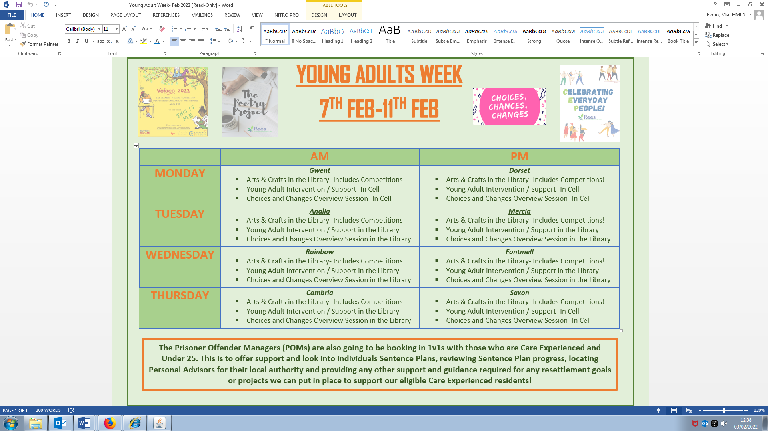Please see below some feedback that was given and the timetable offered

Attendance wasn’t huge to YA sessions with us (kind of expected with the up and down lockdowns!) but please see below some feedback from those who attended:

Points around barriers in custody listed below as these will help us come up with some plans moving forward:

* Being seen as ‘lowest rank’ amongst other peers
* Disrespected by others
* Having to learn to bite your tongue
* Feeling treated like babies by staff and other prisoners
* Not wanting to achieve because of being judged by others (i.e. working hard to get a good job etc can be judged by others)

Some suggestions of how we can improve:

* Set boundaries/opportunities relevant to age
* Focus on the individual and their individual need rather than their age
* Appreciate those working to high standards and boundaries; being aware that one YA high standards may be different to another or our own
* Understand we are human and be more open to making changes
* More regular key work specific to YA’s and having a voice in who their keyworker is i.e. someone they trust and get on with

**Shannon Trust:**

We currently have 4 Shannon Trust Mentors who are supporting various learners with their reading and writing skills. We will gradually be recruiting for more over the upcoming months…

In regards to good news stories we congratulated one mentor in January who has been mentoring for 25 years with Shannon Trust. This dedication and commitment to supporting others in custody with these skills is a massive achievement that does not go unnoticed!

We also welcome applications for referrals to support with your reading & writing at any time, so if you feel this would benefit you, please get in touch.

We currently have **9** active learners and are managing to keep them engaged despite restrictions!



**Friends of Guys Marsh (FOGM):**

Friends of Guys Marsh Prison (FOGM) is a charity formed in 2004 for the benefit of Guys Marsh prison community and supports in reducing reoffending. This includes supporting men & their families - we supply a Saturday bus for visitors; food for Family Days; materials for in-cell hobbies and help towards clothes for employment on release.

In January we had **5** FOGM requests approved to support those who had upcoming releases!

Please put a FOGM Referral form into the Employment Hub if you wish to apply for any support.

**Resettlement 2022 - Employment Hub:**

The Employment Hub is designed to be a one-stop-shop for employability support and external job vacancies. We advertise external jobs across all resettlement areas so anyone actively looking for employment on release will have opportunities to access roles specifically for ex-offenders.

**In January:**

* A total of ***51*** people seen by the Hub
* 4 CVs were sent to New Futures Network for job applications
* 27 CVs are currently being worked on to be able to apply for future jobs
* Guys Marsh is being seen as best practice for their Employment Hub across other establishments, which is a massive achievement!

Sadly, we lost one of our Pathway Ambassadors to D-Cat this month and we wish him all the best! As of 2nd February we are interviewing for a new Ambassador to be able to support and encourage individuals with employment on release!

**Programme News**

**RESOLVE**

As some of you may know, RESOLVE is being rolled down this year

and will no longer be run after December 2022. At Guys Marsh,

we have a new programmes team who are not RESOLVE trained

therefore we will not be delivering any more RESOLVE.

RESOLVE will be replaced with additional TSP groups.

We are working with regional, national and local teams to

re-assess individuals. If you are found not suitable for TSP,

we will look into this further with your POM to identify any other options.



**Timewise Peer Mentoring**

Timewise is a non-accredited intervention to help manage

violence in custody. We will be running a peer mentor model

which means a peer mentor will be delivering this to those

identified participants. People will be identified through Safer

Custody linked to CSIP, Adjudications, IEP warnings etc.

Damien Parker-Stokes on Gwent will be our Timewise Peer Mentor.



**Pets as Therapy**

We will soon be bringing in a weekly Pets as Therapy dog.

We have conducted all local risk assessments and this

is expected to start soon with an aim to reward

individual success and also use as a wellbeing strategy.

If you are interested in engaging in a pets as therapy

session, please send an app to Beccy Archer in Programmes.





**Industries**

**Decency** workshop employees have had to work exceptionally hard these past weeks due to shortages of employees with wings experiencing outbreak and lockdown.

They have still managed to complete all the units’ weekly orders a total 6023 items despite this.

Also big congratulations to the following Decency workers:-

AB has completed and gained an award in practical cleaning skills (bodily fluids, spillages and Hazardous items).

MS has gained an award in IT user skills and warehousing and storage Level 2.

DY is the new workshop mentor and is currently completing his functional skills qualification in English.

LM has worked towards qualifications to enable him to become a QC and has completed English L1 course.

**Activities CM Update**

Hi Everyone,

I’m currently pushing for development logs to be completed. Both Dorset and Anglia are making good progress with this which is reassuring to see. These are important documents as they help to develop those using them and document their progress. I have a question I’d like to ask everyone though: What do you want from me in my role as Activities CM? Are there any particular updates you want to see from me? Have you got any feedback for me (positive or negative)?

I’m focusing at the moment on improving the India (Education Officer) role to ensure we have consistency which is helpful for the education department and means a lot to them. The education mentors are having their role reviewed and we are looking to increase the amount of time they spend in education to improve the links with the wings which have been hit hard by the recent Covid closures. If any men on the units have any in cell work that they need to complete and hand in then I’d like to encourage them to do so or ask for help if they need it. We have some spaces on L1/2 English and Maths functional skills which is important to ensure people can get the best jobs in the prison so I’m encouraging all those that are able to do so to sign up for them! Finally we have some exciting new developments to the popup workshops that we are doing on the units which focus more on the facilities we have to offer and also the curriculum pathways to make things more transparent and to help the men decide how best to direct their educational journey.

CM Soper- Activities CM

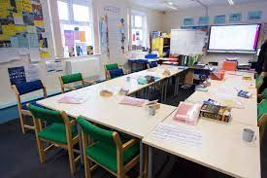**Education 2022**

Functional Skills Maths and English can be accessed in many different ways. To support progression into better paid jobs in custody or more opportunities on release. You can now access by:-

* In cell pack
* Outreach in your work place
* Blended learning
* Face to Face

All residents engaging with FS are automatically invited to “Functional Skills Friday” – A time where you can chat about your experience with other learners over a cup of tea and a biscuit!

The Library is offering a wide variety of activities throughout February:

* Valentine Card making
* Chinese New Year activities
* An invitation to submit Art work as part of an Exhibition through FOGM to be shown at Shaftesbury Art Gallery.

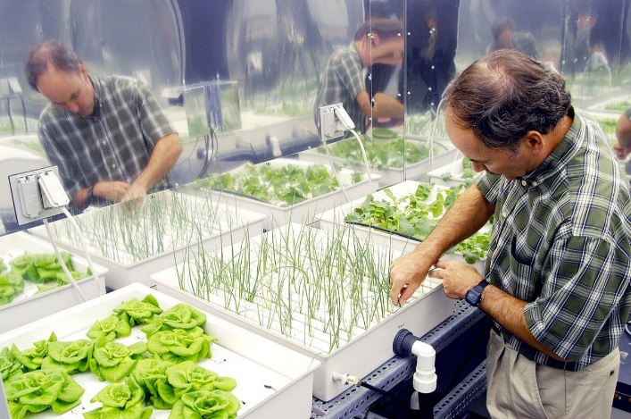A live introductory session to Aquaponics with workbook and activity sheet. If you are interested in working on our pilot programme in Land Based Activities please put in an application to Activities Hub.

**Gym**

Congratulations to PEI Simon on your new Gym qualifications!

Tackling Drugs through Sport is running groups every Tuesday.

If you are interested in monitoring the health benefits in refraining from substance misuse whilst being supported both physically and mentally with Gym and ISMS expertise please put an application into ISMS.

