Families & Significant Others Strategy

HMP/ YOI ROCHESTER

Family and Significant Others Lead(s)
Helen Bicker FASO SMT Lead Date
Paul Barber FASO Champion Date
Yvette Philpott PACT Family services ________________________ Date
Governor of HMP/YOI Rochester
Dean Gardiner (MBE) Date

INDEX
Title: Page:
- Introduction 3

- How to contact us 4

- Your Visit 5

- Visits Facilities 8

- Other ways of Contacting someone here 9

- Visits hall and visitor feedback 10

- Family Visits 12

- Learning and development 13

- Future plans 14

- Additional support for Families 15

- Family Success Pathway 16

Introduction

HMP/YOI Rochester is committed to actively seeking the involvement of families in our work to support individual prisoners and believe we have a responsibility in helping to maintain all positive relationships.
At HMP Rochester we understand that family comes in various forms and for the purpose of this the term family will relate to relatives or significant people in our residents’ lives that provide support and constructive relationships
For the men in our custody supportive families are a great resource that often play a vital role in helping an individual move away from crime. A supportive family can also provide effective protective factors for prisoners at risk of suicide and self-harm. Having a stable family to return to upon release or to support progression to lower category establishment, can also encourage prisoners to engage in sentence planning interventions and maintain positive behaviour whilst in custody.
We understand that Families of those sentenced to prison sentences are impacted by this and recognise that they often serve a ‘hidden’ or ‘invisible’ sentence, as their hardships are not immediately obvious.
We are therefore committed to improving our family offering, making visits less oppressive and making the process better for all involved.

How to contact us

Address:
HMP Rochester, 1 Fort Road, Rochester, Kent, ME1 3QS

Switchboard Phone number:
01634 803 100

Email address for queries, concerns, or complaints:
businesshubrochester@justice.gov.uk

Visits Booking line:
01634 803 237
Booking line opening times: Monday to Friday 8:00am to 12:00pm

Follow us on Twitter @HMPRochester

Safer custody hotline
If you have a non-immediate concern about the safety or wellbeing of a man in Rochester, call the safer custody hotline.
Telephone: 01634 803 268
Leave your name, telephone number, the reason for your call and the name and prisoner number of the man you are worried about. You should be called back within 24 hours.

Your Visit
To visit someone in Rochester you must:
- Be on that person’s visitor list
This has to be requested by the resident on a general application providing the visitors Name, Date of Birth, address and phone number.
- book your visit at least 2 working days in advance
This is the minimum. We recommend booking at least a week in advance as slots book up very quickly.
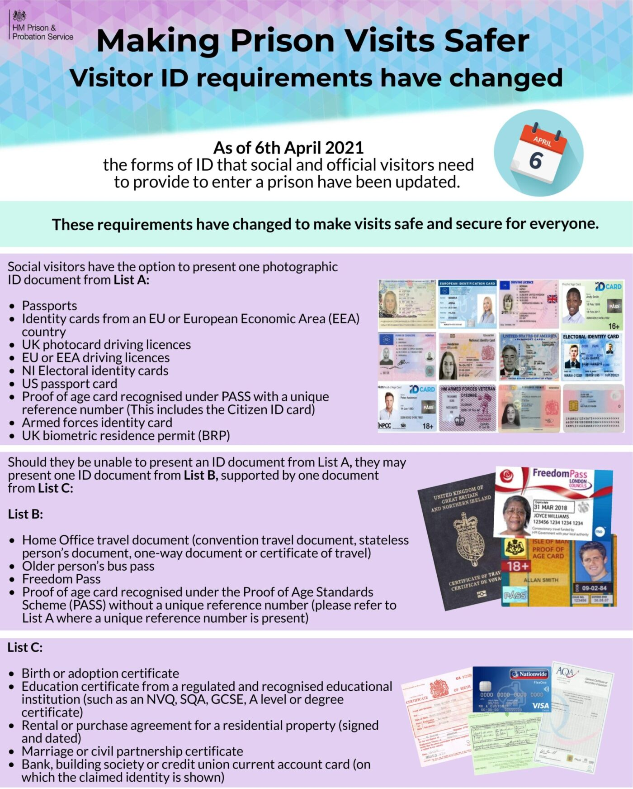
- Have the correct ID with you

At least one visitor must be 18 or older at every visit.
There may be a limit to the number of visits a person can have, and how many visitors at the table. You can check this with by phoning the HMP Rochester booking line.
Please contact HMP Rochester for any questions, comments or queries you have about visiting.

Help with the cost of your visit
If you visit a family member, partner or someone who does not get other visitors you might be able to get help paying for:
- travel to the prison
- overnight accommodation
- meals
You can apply to get help paying for visits that you:
- have made in the last 28 days
- want to make in the next 28 days
You must be getting certain benefits or have a health certificate to get help.
If you take a child with you or someone to help you (for example because you’re disabled) you might also be able to get help paying for their visit.
For more and to apply visit https://www.gov.uk/help-with-prison-visits

How to book family and friends visits
Rochester is running a limited visits schedule. Visits are also happening differently than normal, observing strict guidelines, which must be followed.
You can book your visit by telephone. There is no online booking service available.
Visits booking line: 01634 803 237
Booking line opening times: Monday to Friday 8:00am to 12:00pm excluding bank holidays.

Visiting times:
- Monday to Thursday: 2pm to 3:30pm
- Friday: 9:15am to 10:45am
- Saturday 2pm to 3:30pm
- Sunday 2pm to 3:30pm

Getting to Rochester
Bus:
From Rochester Station -Take the 145 Arriva Bus and ask for the Bridge Wardens public house.
From Chatham Bus Station – Take the 142 Arriva Bus and ask for Cookham wood bus stop.

Cross the road and walk up the alleyway to the Shell petrol station. Cross the road and walk up the hill. Go past HMP YOI Cookham Wood on your left. Rochester prison is on your right. The visitors centre is in the lower car park.

Train:
The journey from London Victoria to Rochester takes around one hour.
The journey from Rochester station can then be completed by Taxi, or a 45 minute walk each way.

Walking routes

TAXI NUMBERS
ABC Taxis - 01634 840840
Ace Taxis - 01634 720500
Computer Cabs – 01634 666666
Vokes Taxis - 01634 222222

Taxis normally sit waiting at the stations
and other companies are available.

Car:
From the M2 exit at Junction 3 and follow the signs to Chatham; at the 3rd roundabout take the first turning on the left signposted Borstal. The prison is approximately 2 miles down Maidstone Road, on the left opposite the Shell garage. From the M20 exit at Junction 6 and follow the signs to Chatham and Rochester on the A229. At the top of Blue Bell Hill keep left and follow the signs to Borstal.
Rochester has a visitor’s car park, including several spaces for Blue Badge holders. You may also park in the general car park as you drive into the prison.

Visiting Facilities
There is a visitor’s centre at Rochester which has toilets, a baby changing area and secure lockers available. It opens at 12:30pm on visiting days (8am on a Friday). This is just before the main gate to the prison and has large signs on the walls. The visitor’s centre is run by PACT and there is a member of the team on hand during every visits session.
Spurgeons say: We are the first people families see when visiting Rochester so we do our very best to make sure we offer the most friendly and welcoming service possible, the team will try there hardest to make the visiting experience the best it can be while always following and promoting the prisons guidelines, we offer a number of different services in the VC from clothing exchange for visitors and we work with a number of outside agencies and charities like the hygiene bank and Baby basics so we are able to support families if they are struggling finically. Toys and activities are always available to children while they wait, making the visitors centre a comfortable place to be.
A uniformed member of staff will check your ID, book you in and provide you with visitors Identification. Unfortunately, if you don’t have the correct ID you will be refused entry.
There is an outside play area with new play equipment.
Light refreshments are sold in the visits centre while you wait for your visit to commence. There is a tea bar in the visits hall for you to buy your loved one some food or drink. The Tea Bar is cash only as we don’t currently accept other forms of payment

Entering Rochester
You will be given a compact to sign explaining the rules to follow during the visit.
If you have not visited Rochester, or a prison before, please ask staff if you have any questions.
Staff will direct you to the main gate once the visits staff are ready for you to enter
All visitors will go through a metal detector portal and will need to be given a rubdown search (similar to that you would receive in an airport), including children. You may also be screened by drug detection dogs.
After your visit
If you have any concerns after your visit, a member of the PACT team will be on hand in the visitor’s centre and will be happy to speak to you. You can report concerns to uniformed staff at any time during your visit. You can also email Rochester with any issues or concerns:
businesshubrochester@justice.gov.uk

Other ways of Contacting someone here
Secure Video Calling: Prisoners are currently entitled to a free video call, once per month. Visitors have to download the “Purple visits” app and follow the instructions in order to register. The Video call is then requested by the prisoner here at Rochester.

Phone calls: Prisoner now have access to in-cell telephony 24hrs a day

Letters: Residents are entitled to 1 x second class letter per week at the prison’s expense. Additional letters may be sent out at resident’s expense.

Email a resident: Visitors can email direct at the cost of only a 2nd class stamp. Once the email is received at Rochester a member of staff will print it off and hand it to the resident. Visitors can also pay the cost for residents to send a letter back via an email.
https://www.emailaprisoner.com/

Prison voicemail: Visitors can download an app on their phones that is linked to the prison telephone system whereby they can record and leave messages that residents can pick up in their cells. Residents are also able to leave a message in return. https://prisonvoicemail.com/

Assisted Prison Visiting Unit (APVU): Visitors can claim back up to two visits a month travel costs through APVU. Terms and conditions apply and booklets and information are available in the Visitors Centre, on the website https://www.gov.uk/help-with-prison-visits

Prison Visitors: Residents who do not have anyone who is able to visit can request to have a volunteer prison visitor who will visit and provide support through phone calls or as a pen pal. This service is offered by the Chaplaincy Department.

Storybook Dads: Residents can create a recording of their voice for children and this will be made into a visual storybook DVD for children to keep and watch as a bedtime story, or through the day. This scheme is run by the Library.

Letters for Children: Spurgeons provide letter writing packs for the visits centre to encourage children to write letters into their relatives; these are provided at no costs to the families.
Foreign national phone credit and letters: Foreign national residents can get a different phone system to provide cheaper calls to abroad and allow them to top up their phone account with more credit.
New Dads: Residents who have children born while in custody can apply to have their photo taken with the new baby. This will be done in a more private room and copies given to the resident.
Visits Hall and visitor feedback
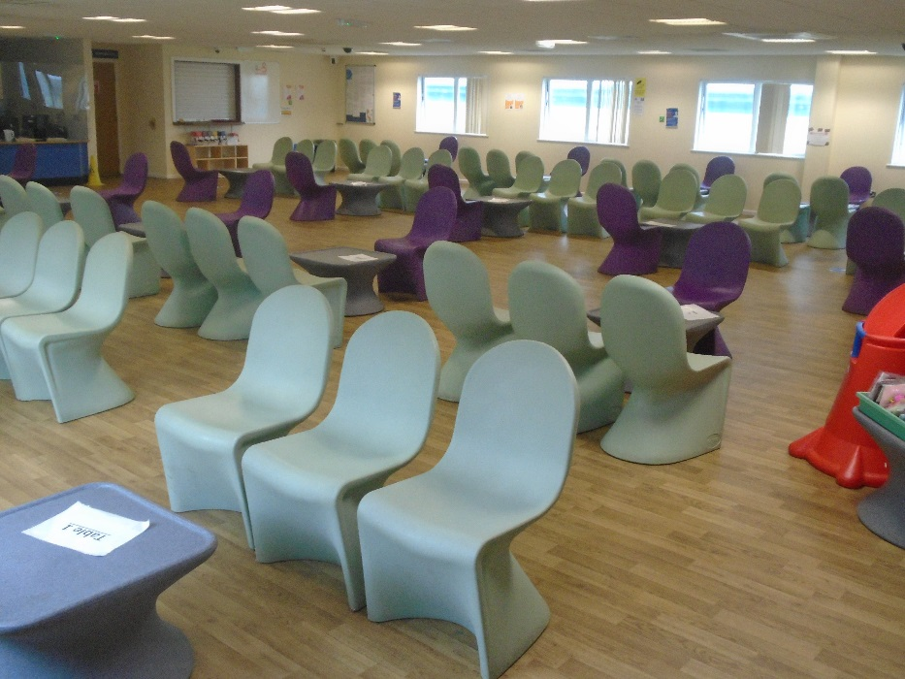
PACT
PACT Family Service team at HMP Rochester offer support to residents, their families and significant others in several different ways:
Currently play sessions aren’t being offered in the Visits Hall but PACT have adapted this by providing children with activity packs and also offering keeping in touch packs for Dads to post home to their children, there are always Children’s books available so they can be read on purple visits and we also regularly post home birthday gifts to the children too.
They will offer a number of additional enrichment activities for example New-born baby visits with photo opportunities, as well as offering Family days up to 12 times a year which will be full of fun activities for the whole family to enjoy together.

What we offer

Rochester offers one visits hall. It is a good sized room which currently has 20 tables with 4 chairs around each. Visitors have access to Baby Changing facilities, toilets and high chairs. The family engagement workers and volunteers wear informal clothing to help with welcoming visitors, especially children.

The toy and book area in the visits hall is currently out of use, however we hope to reuse this area in the near future.

There will be opportunities for the children to do craft activities and make items for their loved ones during the visit (Cards, pictures, etc.)

We are hoping to restart offering Storybook Dad soon. Residents can create a recording of their voice for children and this will be made into a visual storybook DVD for children to keep and watch as a bedtime story, or through the day. This scheme is run by the Library.

Surveys and Feedback

HMP & YOI Rochester encourages feedback about the services we actively seek opportunities for visitors to share their opinions to shape and improve our offering and services provided. Every visitor has the opportunity to complete feedback forms with Spurgeons to give people the opportunity to express any concerns or recommendations, as well as let us know what we are doing well. This information is collected and discussed at our Families and Significant others meeting which is quarterly.
Family Visits

Rochester could not deliver family days due to the COVID 19 pandemic. But we are pleased to be restarting this service in May 2022.
We aim to hold 12 family days per year, 6 for children under aged 5, 6 for children aged 5 and over.
We aim to hold these throughout the year and try our hardest to offer these outside of school times, to ensure the best experience for all. Whilst our vision for the family days is to offer a continually improving offering all will include an opportunity to eat together, games, and other activities and provide themed sessions, for example Easter, Halloween, Christmas and the Creepy Crawlies event.
These will be published to the resident on the wing to allow them to apply for the family day.
These days are open to men who have been cleared through Public Protection and Security; we offer other events, such as the Celebration of Success where nominated residents are encouraged to invite family members to attend. These visits are additional to the standard visiting orders. All residents have to pass security checks before they are allowed to attend a Children’s Event. Anyone who is a risk to children may not attend and neither can those who are on closed visits. When it is a family event, we are happy to consider applications from Basic, Standard and Enhanced residents and each will be risk assessed robustly. However, we do believe that all residents should be aiming to get enhanced status and setting that good example for his children.
Once the resident is accepted for a family day the PACT team will contact the family to explain the details: time, date, dress code etc.

Learning and development
PACT – Coming home
PACT deliver a coming home course for 8 men at a time, this course aims to support men leaving prison to reflect on their expectations and plans about leaving prison, and the kinds of relationships they will have on release.

Time for you and your child
Run by PACT, Time for you and your Child, is intended to support fathers maintain their role in the family while in prison as well as providing them with ideas and information about ensuring healthy child development and behaviour.
Thinking Skills

Some of our residents will be required to complete accredited behavioural change programmes as part of their sentence plans, such as the Thinking Skills Programme or RESOLVE. Approximately 6 weeks after completion of this a post programme progress review meeting is held. The resident is entitled to invite 2 approved visitors, their family or friends, to attend this meeting, which is a fantastic opportunity for their families or significant others to see the good work they have done. The meeting usually lasts around 60 minutes with the Resident and their visitor given time together in our visits hall afterwards. This is on top of their normal visit allowance.
Education
Residents have the opportunity to learn new skills and qualification such as English, Maths, Stonemasonry, Carpentry, Welding, Industrial cleaning, Catering and So much more.

Future Plans
- We are looking at reintroducing celebration events with our education provider to invite families in to celebrate the success of their loved ones, when they've completed courses at HMP Rochester.

- Departure Lounge: this will be an area external to the prison where families can wait for their loved ones on release, staffed by partner agencies to give those released the extra support if needed to start their journey into the community in the best possible way.

The importance of re-integration with family has not gone un-noticed at Rochester and, together with service providers, we believe the facilitation of the departure lounge could be a positive stepping stone to the reducing of re-offending and the golden thread to reform.

Additional support for families
- Action for Prisoners’ Families www.prisonersfamilies.org.uk – Action for Prisoners’ Families, works for the benefit of prisoners' and offenders' families by representing the views of families and those who work with them.

- AFFECT – AFFECT provides services for the families of serious offenders and offers support groups to families in the south of England. www.affect.org.uk

- Inside Time – www.insidetime.org.uk – this website gives visiting and other advice

- Prisoners’ Family Voices is a web-based community which gives family members the opportunity to talk to each other.
http://prisonersfamiliesvoices.blogspot.com

- Offenders’ Families Helpline: 0808 808 2003 info@prisonersfamilieshelpline.org.uk
www.prisonersfamilieshelpline.org.uk

- Prisoners’ Families and Friends Service: 0808 808 3444

info@pffs.org.uk

www.pffs.org.uk

- HMP/YOI Rochester’s Safer custody concern line: 01634 803268

- NICCO (Barnardo’s & HMPPS Partnership) https://www.nicco.org.uk/ - NICCO is a one-stop information and advice service to support all professionals (working with children and families of prisoners) and all families of prisoners, bringing together useful information in one place.

- Assisted Prison Visits scheme – who promote family ties by contributing to the cost of prison visits, for those in receipt of a low income. 0845 3001423
- RELATE offer free couples counselling for Parents who live in Kent and Sussex, that are due for release or have been released during the last year. Referrals to this service can be done by contacting 0300 0030270. Or by speaking to an offender manager who can email a referral.

To ensure families are at the centre of everything we do at HMP Rochester.
A Dedicated Families Team
Offender Management Unit, Probation and CRC

Chaplaincy Team

Prison Officers
Key Workers
Prison Staff

PACT
Prison Library,
Education
Prison Industries
Programmes
Safer Custody
Gym Staff
FAMILIES
SUCCESS PATHWAY
Deliver Coming Home Course.
Residents can purchase a Bike for their loved ones

HMP/YOI
ROCHESTER
PACT
Family
Services
Provide Family services, trained play staff on visits, family related training for our men, ‘ Time for you and your baby’ and advice for visiting families.
Arrange Family day visits

Release on temporary License.
Home detention curfews
Resettlement
Family invited in to post progress reviews of behavioural change programmes.
Story Book Dads, Celebration events for families.
First Night Interviews, daily interactions, Family and significant others information available through key worker. Book visits
Messy Church
Official Prison Visitors Scheme
Involved in family days, advice around healthy lifestyles
01634 803268 Crisis Number
Involve Families in Assessment,
Care in Custody and Teamwork
(ACCT) process.

