

**HMP ELMLEY & Pact**

**FAMILY & SIGNIFICANT OTHER STRATEGY**

**2023**

**Support Families**

**Support Residents**

**Prevent Re-Offending**

**Index**

|  |  |
| --- | --- |
| **Translation Index** | **Page 2** |
| **Overview** | **Page 4** |
| **Family Focus** | **Page 4** |
| **Governance** | **Page 5** |
| **Progress** | **Page 5** |
| **Public Protection and OMU** | **Page 6** |
| **Searching of Children & Children’s guide** | **Page 7** |
| **Complaints** | **Page 7** |
| **Safer Custody** | **Page 7** |
| **Additional support and Pact leaflet** | **Page 7** |
| **Getting to Elmley** | **Page 8** |
| **Contact Points** | **Page 9** |
| **EMERGENCY CONTACT POINT** | **Page 10** |

**Translation**

**Translation Notice**

|  |  |
| --- | --- |
| English | This information can be translated upon request. Please ask a member of staff for assistance. |
| Albanian | Ky informacion mund të përkthehet sipas kërkesës. Ju lutemi kërkoni një anëtar të stafit për ndihmë. |
| Lithuanian | Queste informazioni possono essere tradotte su richiesta.  Si prega di chiedere assistenza a un membro del personale. |
| Russian | Эта информация может быть переведена по запросу. Пожалуйста, обратитесь за помощью к сотруднику |
| French | Ces informations peuvent être traduites sur demande. Veuillez demander de l'aide à un membre du personnel. |
| Romanian | Aceste informații pot fi traduse la cerere. Vă rugăm să cereți ajutor unui membru al personalului. |
| Polish | e informacje mogą zostać przetłumaczone na żądanie. Poproś członka personelu o pomoc |
| Serbian | Ове информације се могу превести на захтев. Замолите члана особља за помоћ. |
| Arabic | يمكن ترجمة هذه المعلومات عند  الطلب. يرجى طلب المساعدة من  أحد أعضاء فريق العمل. |
| Bulgarian | Bu bilgiler talep üzerine tercüme edilebilir. Lütfen bir personelden yardım isteyin. Metni buraya çevirmek için yazın |

**Top 10 preferred language C Nomis October 2022**

**Overview**

The publishing of the Farmer Review in August 2017 highlighted the need for a review of the delivery and embedding of Family Services across the prison estate. The Review investigated how engagement between our residents and their families and significant others in the adult male prison estate across England and Wales could assist in both reducing reoffending and addressing issues around intergenerational crime.

At HMP Elmley we have reviewed our strategies and policies in line with the Review and have made some good progress towards instilling the ‘golden thread’ that Lord Farmer believes should run through all policy and strategy in each establishment.

**Why should we focus on children & families?**

At Elmley we recognise that the family unit is a key factor to reducing reoffending and encouraging positive engagement and stability. We know It can also reduce acts of self-harm and decrease levels of anxiety. Having a strong and positive support network around our residents can greatly reduce the risk of them coming back into custody and create a stable and safe environment for everyone.

We are committed to continually reviewing and improving our Family Services provision along with our current provider Pact.

Feedback from the visitors and prisoners is vitally important to us. We have scheduled focus groups with the residents and the feedback from families, this will help us to reflect on our delivery and we will use this information to inform the choices we make in how we deliver our Family Services going forwards.

We recognise that positive family links are a key element to both emotional wellbeing, reducing anxiety and depression and encouraging positive engagement. We also recognise that strong family relationships can support the stability of the establishment and reduce reoffending on release.

We echo the sentiment of the Farmer Review that Families should be the ‘golden thread’ that runs through all policy frameworks and moving forwards we will be focusing on the implementation of all of our new initiatives and aligning these to both our local strategies and the key recommendations of the Farmer Review.

**Governance & Assurance**

The family pathway sits under the Reducing Reoffending lead, Joe Rook, and is managed through the following forums/meeting structures:

* Senior Leaders Team (SLT)
* Pact Performance meetings
* Reducing Reoffending Meeting
* Quality Improvement Group

**Progress**

To date we have taken some key actions to address the issues raised both locally and in the Farmer Review.

* HMP Elmley’s Visitor Centre is a family friendly environment and is staffed by the Pact Family Workers.
* Storybook Dads is run through our Library provision and is open to all residents in custody at HMP Elmley.
* In the past we have delivered tailored events which allowed residents to design and create stories for their children these were then published into books. These courses were very well received and popular. Using the DPS system we now have the freedom to run courses such as this throughout the coming year.
* We plan to schedule 12 Family Days per year, including visits for wider family for those who do not have children to support family relationships.
* We have integrated our catering with Pact to provide a family friendly service which includes themed days around key events and celebrations.
* We have reviewed the way in which we allocate to family days and recognise that all children have a right to spend time with their parents when they are in custody.
* Secure video visits are now available on application from our residents to help strengthen ties for those who find it difficult to visit in person.
* The Pact team now inform our first night centre induction process, this gives all new receptions access to support, advice and guidance around family contact at this extremely stressful time.
* ‘’You said we did’’ feedback forms will be completed in the visitor’s centre, and this will feed into our reducing reoffending strategy and ensure that the visits experience remains focused on family ties any actions taken will be published in the visitors centre.
* Pact offer a support service to those who are engaging with social services, and with those whose children are going into care, the Pact team can now provide photographs and post-visit support. This is linked to the Safer Custody team so that the welfare of everyone can be monitored and supported. In addition to this Pact now offer a new baby photograph for dads with new families.

**Public Protection & Victim Awareness**

It is our aim at Elmley to facilitate and encourage positive family interventions wherever possible. We work closely with other departments such as the Public Protection Team to ensure that this is done in a safe environment for both the family members and the resident to account for all appropriate factors when supporting family links.

**Offender Management in Custody (OMiC)**

As part of our Officer key work scheme, we ensure that all officers have a comprehensive understanding of the family services available at HMP Elmley, and that the Head of Reducing Reoffending works closely with both Pact and all key workers to ensure that we are supporting positive family relationships.

**Accommodation on release**

Suitable accommodation on release is essential for our residents to give them the best chance of successfully reintegrating back into their communities. We have a responsibility to house Care Leavers aged 18 -24 immediately upon release, and there is also a need to engage with all residents in custody prior to release to ensure they all have suitable housing to go to. Our local Resettlement Manager has co-ordinated meetings with all local authorities and councils to facilitate this within custody and to make sure individual needs are catered for.

**Searching Children & Children’s experiences of prison visits**

All visitors are searched in line with the appropriate policy guidance, and always with respect and dignity. Babies and children are searched sensitively, and only under supervision of a parent or guardian. Appropriate arrangements are also made for any visitor with disabilities, and we deal with any specific needs on an individual basis. Both Pact and prison staff make every effort to minimise any negative experiences during the visits process.



**Complaints**

All visitors are able to make a complaint regarding their visit experience if they so wish, you can ask the visits hall staff or the Pact staff in the visits centre about the process. In addition we also have a feedback book located in the visitors centre and this is checked regularly by managers and ‘’you said we did’’ forms with feedback and comments given for each entry.

**Safer Custody**

We have various hotlines that families can call to express any worries they have about a loved one, whether in relation to bullying, violence, self-harm, or any other issues. This is publicised in the visit’s centre and hall and the numbers are listed on page 3 of this document. Safer custody additionally have a specific strategy that includes Care Leavers



**Signposting & Additional Support**

Prison and Pact staff are aware of the many agencies and support services that are available to residents, and these are well documented in our prison visitor booklet.



**Getting to Elmley**

**By Train**

The nearest railway station is Sheerness, which is approximately seven miles from the prison, from there you can get a bus Eastchurch or a Taxi from outside of the station.

**Bus**

From Sheerness Chalkwell run a service to Eastchurch and the prison 01795 423982.

**By car**

Head for Sheerness from the M2 or M20 take the A249 towards Sheerness, once on the island head towards Eastchurch and follow the signs to the Prisons ME12 4DZ there is free parking available outside the visitor centre.

There is a visitor centre just outside of the prison where you can book in, and a selection of hot and cold food and drink are available as well as a small children’s play area.

**Contact Points**

**Post**

Prisoner Name and prison number,

HMP Elmley, Church Road, Eastchurch Kent ME124DZ

**General Phone Number**

**01795 802000**

**Visits Booking Number**

**0300 060 6605**

**Or**

**By email socialvisits.elmley@justice.gov.uk**

**Residents Family & Significant Other Hotline**

**0808 808 2003 open Monday to Friday 09:00 – 20:00 Sat & Sun 10:00 – 15:00**

**Visits Centre**

**01795 802195**

**Samaritans**

**08457 909090**

**Safety Concern line**

If you are concerned about the safety or wellbeing of any resident at Elmley but there is no imminent threat of danger you can ring this number and leave a message for the safer custody team who will investigate this and feed back to you.

**01795 880921**

**EMERGENCY CONTACT**

If you have a concern that there is an imminent risk of danger to a resident, and you wish to speak to a member of staff in person about this please dial

**01795 802000**

The member of staff answering this call will not be able to talk to you about the resident, but they will immediately pass this information to a senior member of staff for actioning and we will aim to let you know what the outcome is.

**HMP Elmley: Working together to enable positive change**

**Visitor Centre**

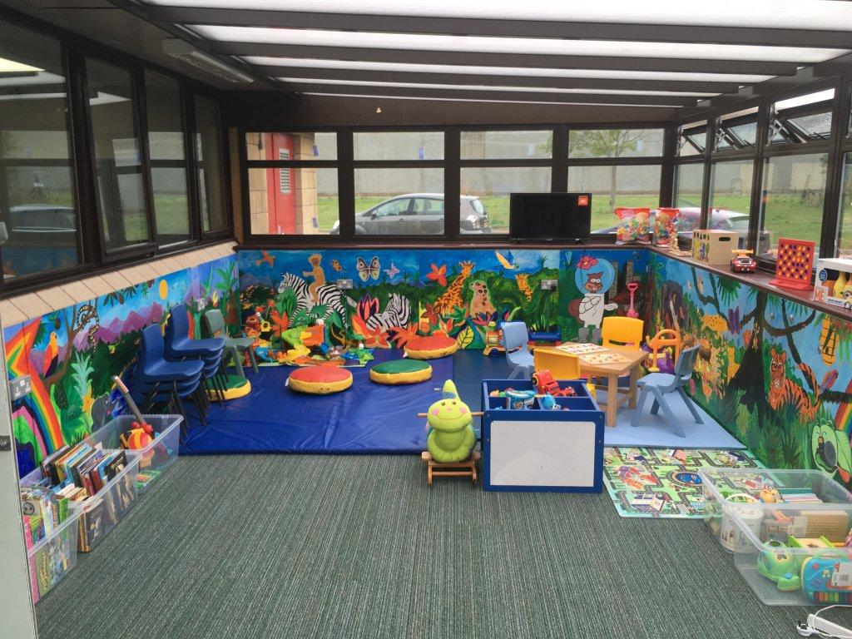

**Visits Hall**

