|  |
| --- |
| ────  **Reducing Reoffending and intergenerational crime**  ──── |
| ────  **Maintaining prisoners`**  **relationships**  ──── |
| ────  **Creating a safer Prison**  ──── |
|  |
| ────  **Working in Partnership**  ──── |



HMPYOI Stoke Heath

**Family and significant others**

**Strategy**

**December 2022**

Contents

Introduction 3

Working in Partnership 4

Partnerships & Stakeholders 4

Family services provision 5

Our Vision 6

Our Challenge 7

Our Approach 8

Equality & Diversity 9

Safer custody 9

Current practice 11**.**

Parenting Course 11**.**

Family Days 11

New Born Visits 11

Story Book/DVD Dads 11

Life Journal **11.**

Angel Tree Project 11

Regular Play Session / Crèche Facilities in Visits 11

Making it Happen - Development Objectives 12

Making it Happen - Residential Group 18

Making it Happen - Prison Communication System for Families and Significant Others 18

Making it Happen - Operations Group 19

Making it Happen - Offender Management Unit 20

Foreign National Prisoners 21

Care Experienced Prisoners 22

Conclusion 22

Further Reading / Documents 23

# Introduction

In recent years, the Government has recognised the importance of improving the support and services available to the children and families of offenders, and the financial, emotional, and physical effects having a parent in prison can have on children.

Maintaining family/significant other relationships can help to prevent ex-prisoners from re-offending and assist them to resettle into the community but many offenders lose contact with their family/significant others as a result of entering prison. Studies have shown, prisoners are less likely to reoffend if family/ significant other relationships are maintained throughout their sentence.

This is reinforced by a thematic findings paper by HMIP 2016 Life in Prison: Contact with Families and Friends[1] which concludes that ’good family contact has an important role to play, not only in supporting prisoners through their sentence, but in supporting their rehabilitation after release.’

To address this fundamental need within our prisons the Government is driving forward the ‘Family and Significant Others’ agenda as it recognises that supporting offenders’ family and significant relationships can help improve prison safety and security, reduce reoffending, support desistance from future offending and the possible likelihood of intergenerational offending.

As Lord Farmer states in his recent report “harnessing the resource of good family relationships must be a golden thread running through the processes of all prisons”.



‘Family ties is a golden thread’

However, it is also recognised that not all family relationships are positive. Sometimes Family members may be the direct or indirect victims of a prisoner’s offence. These individuals have the right to protection from their perpetrator. Family or significant others may be enablers, contributing to their offending behaviour. Prisoners may be subject to harassment or restraining orders, so it is very important we manage these relationships properly to ensure that we prevent inappropriate contact yet provide adequate tailored support to meet the needs of our prisoners and their families.

HMPYOI Stoke Heath therefore has a moral and ethical responsibility to assist any meaningful and constructive relationship in preparation for our prisoner’s release. We are committed to transforming our prison into a place of safety and reform and we recognise the need to provide those in our custody with stable environments, as well as opportunities to change their behaviour and turn away from a life of crime.

# Working in Partnership

It is recognised that Family and significant other work is an operational priority. The importance of family is noted throughout the latest Her Majesty’s Inspectorate of Prisons Expectations, which encourages prisons to have a greater focus on family and significant other relationships to prevent reoffending. Partnership working across all functions continues to be developed at Stoke Heath including other partnerships ranging from family service partners and others including health, substance misuse, learning and skills, key workers, offender management in custody and community supervision.

## Partnerships & Stakeholders

This list is not exhaustive as partnerships take time to become established and will evolve over time-if you want to contact us with ideas to develop our services please e mail [familyandsignificantotherstokeheath@justice.gov.uk](mailto:familyandsignificantotherstokeheath@justice.gov.uk).

**However, for concerns ring the safer custody line number below 01630 638011 and leave a message. These are listened to daily.**

**Any immediate concerns you should ring the switchboard**

**01630 636000 and ask to speak to the orderly officer.**

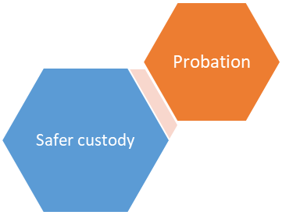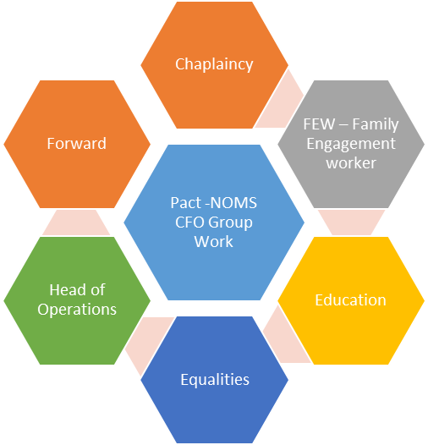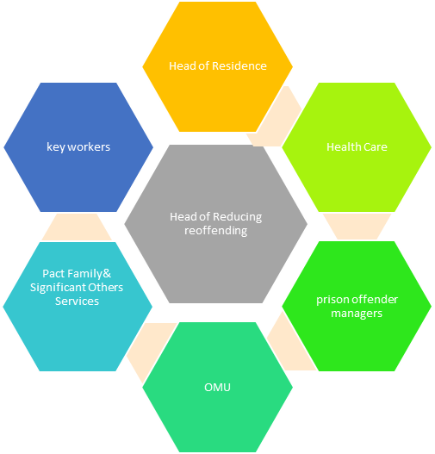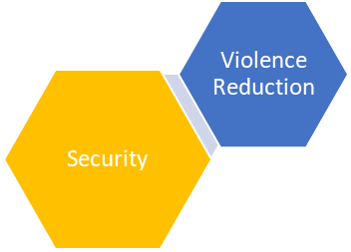

## Family services provision

Pact has responsibility for working to improve services for children, young people and families of offenders. Pact now has significantly more family engagement worker resources with responsibility for working in partnership with Stoke heath to support isolated prisoners who would benefit from befriending services ,including New Bridge and virtual or social visits with Pact volunteers who are amongst the leading pioneers within this field.

It is estimated that:

* 200,000 children are affected by parental imprisonment across England and Wales

Children with a parent in prison are:

* Twice as likely to experience conduct and mental health problems, and less likely to do well at school.
* Three times more likely to be involved in offending. 65% of boys with a convicted father will go on to offend themselves.

# Our Vision

HMPYOI Stoke Heath recognises that healthy, strong, and resilient families/external adult relationships are the fundamental building block of any community life, and a key means by which we can prevent reoffending and reduce the likelihood of intergenerational crime. Additionally, the emotional, social, and economic benefit of strong families/external adult relationships and responsible fathers to Stoke Heath cannot be underestimated.

Our vision for family and significant other services is for earlier and consistent support and stronger family and significant other ties. We want to see a family/significant other-focused Stoke Heath, where:

* Family Support/significant other services are fully integrated and imbedded within the provision and culture of the prison.
* Family and other prisoner Support needs are identified at the earliest opportunity and are prioritised alongside sentence plans, which follows them through their journey of rehabilitation.
* All visitors, especially children and young people who visits Stoke Heath feel safe, supported, and welcomed.
* Every mother, father, care experienced prisoner and those without supportive adult relationships receives the support they need to build, strengthen, maintain and develop their relationships.
* Public services, businesses and voluntary groups all work closely together, accepting that the whole family approach is our focus.

# Our Challenge



In December 2022 we had 92 care experienced offenders residing at HMP Stoke Heath ,which equates to nearly 12% of our population. Prisoners who are due for release within the next 3 months are contacted and either have suitable accommodation arranged post release or are working with the Community offender manager/resettlement team to address this.

As of December 2022, we had 428 prisoners who had received no social visits in the last 6 months .We will carry out further surveys to look at trends over time and assess whether our interventions are working

We have previously trained /briefed our key workers and prisoner health and well-being champions to be able to work with isolated groupS of prisoners to encourage them to establish a meaningful adult relationship, whilst in custody. This work will recommence and will be led by Pact via annual full staff briefings, and internal work to raise awareness of the key worker role and links to reducing reoffending. In addition, there are issues of health and disability, learning , educational, and neuro diversity challenges, as well as social, emotional difficulties. Often, these issues are inter-related and may be historical.

Many children of prisoners are growing up to experience behavioural problems, mental illness, substance misuse, teenage parenthood, and low educational attainment as a result of impaired family life. These problems are often exacerbated by poverty. An up-to-date picture of the challenges we face in improving the lives and raising aspirations of our vulnerable children and their families can be found within the studies of charity organisations.

The key issues we must address are:

* Some offender’s family related problems are allowed to escalate due to lack of responsibility at the early stages of their sentence.
* Sometimes, where issues are identified, departments / staff are sometimes too quick to refer the prisoners on when they could support the prisoners through simple processes
* The array of services available from different departments can be complex and not always well co-ordinated, with different systems and definitions of need. Prisoners and their families often struggle to navigate their way to the support they require.
* We know that a small number of prisoners with complex needs are responsible for a disproportionate amount of the workload – but we sometimes struggle to join up our resources.
* Adults’ and children’s services need to find new ways to work effectively together to ensure that when problems faced by the adults in the family are addressed, the implications for their children are also considered and addressed – a more holistic approach.
* Sometimes there are gaps or weaknesses in service provision.

# Our ApproachImage result for family vision clip art

Our broad aim is to adopt a whole prison approach to support the maintenance and development of prisoners` relationships with family, significant others, and friends, using a range of methods and interventions, and incorporating the recommendations of Lord Farmer into our work

|  |  |
| --- | --- |
| Our priorities for 2022/23are as follows: | |
| 1. Intervening early and preventing problems | We want to identify Prisoner’s and their family needs earlier. Discuss these needs with their families and significant others at the earliest opportunity to prevent problems developing into crisis. Over time, this should reduce the overall workload faced by all departments. |
|  | |
| 2. Family-focused: tailored and unified | When prisoners or their families and significant others use our services, we want to ensure that those services are tailored to their needs, with particular sensitivity to the needs of children and young people. We want to take ownership of each family’s challenges and commit ourselves to finding a solution. Where there are gaps, we will seek effective solutions to meet those needs. This includes joint work between the prison and other partnership stakeholders or services providers to ensure a holistic response |
|  | |
| 3. Accessible and inclusive | The services we provide need be accessible and inclusive to all. There should be “no wrong front door” to family support services. Our services should be available wherever their first point of contact is. We will need to be more pro-active in making our services visible. All interventions to evidence the needs of children and adults with a disability are met. |
|  | |
| 4. Integrating services | It is recognised that a number of different departments and wing staff/key workers/Prison offender managers will contribute to support our prisoners and their families. Good outcomes will be achieved when departments work effectively together with each other. |
|  | |
| 5. Empowering families and significant others to take responsibility | We want to work together with families and significant others, involving them in the decision-making about what is best for them and supporting them to improve the services they want and need most. |
|  | |

## Equality & Diversity

Families come in many different forms, although usually children and young people are raised by their mother(s)/ father(s) as a couple or as a single parent. They may have other significant relationships which may include carers, relatives, and other adults connected with the family or foster carers. Many of those in custody will have experienced a non-traditional upbringing, with a range of adults having cared for them, and similarly those in custody with children may have other arrangements outside of a traditional family arrangement

It is very important that we recognise that family units can be very diverse. All services or provision that we deliver must adhere to the Equality Act 2010 and should reflect inclusivity and diversity that support people with protected characteristics.

The Young (2014) and Lammy (2017) reviews highlight the need to reflect Black, Asian and Minority Ethnic prisoners as part of their recommendations with specific reference to race and faith. Our service providers should be reflective of our service users and all staff should seek to be culturally competent with an understanding of the types of services that should be provided to meet their needs.

## Safer custody

All services or provision that we deliver must adhere to our local Safer Custody policies. Many of the services we aim to provide will support and enhance the main objectives of the Safer Custody team.

This Strategy should support individuals and their family and significant others to cope with the difficult times ahead as they adjust and settle into their sentence. The results of a prisoner feeling vulnerable at this time, can be fatal.[2]

There are four key steps to follow to help you to identify and respond appropriately to possible abuse and/or neglect.

## Safeguarding Process



It may not always be appropriate to go through all four stages sequentially. **If a child is in immediate danger or is at risk of harm, you should refer.** You should record, in writing, all concerns and discussions about a child’s welfare, the decisions made and the reasons for those decisions.

**Being alert to signs of abuse and neglect**

The first step is to be alert to the signs of abuse and neglect, these signs are highlighted in ‘**what to do if you’re worried a child is being abused, Advice for practitioners, March 2015’**.

**Questioning behaviours**

The signs of child abuse might not always be obvious, and a child might not tell anyone what is happening to them. You should therefore question behaviours if something seems unusual and try to speak to the child, if appropriate, to seek further information.

**Asking for help**

If you have concerns about a child, you should ask for help. All concerns should be discussed with Head of Offender management.

**Refer**

All concerns should be followed up in writing to security.

## Current aCTIVITIES AND SERVICES AT sTOKE hEATH

### Group work iNTERVENTIONS

A group work intervention ,Within My Reach, to support development of family ties will be available via PACT CFO3 to all prisoners on their caseload in the last 12 weeks of sentence or earliest release date on HDC/Parole, plus Coming Home, which is a 1 day resettlement programme, which prepares prisoners for their return to the home and/or family

Forward Trust ,who support prisoners with substance misuse interventions , offer a family relationship course to all prisoners on their caseload in the last 12 weeks of sentence or earliest release date on HDC/Parole

### Family Days

We have increased our family days from 8 to 12 per year. The aim of the family days is to prepare our men for release by offering them the opportunity to keep in touch with their families, and perhaps to begin to mend some broken relationships.

They can be particularly helpful for siblings/ children who can be distressed and confused by their brother’s/ father’s absence.

### NEWBORN visits

We offer the opportunity for our men to have a visit at the birth of their new-born child to start them on the journey of parenthood. This also allows us to inform our men about the various other services we provide.

### Story book/dvd Dads

The process is simple. The prisoner chooses a book and is recorded reading the story. The recording is downloaded onto a computer where music and sound effects are added. The finished story is put onto a CD and then sent to the child. This is run in conjunction with HMP Dartmoor. DVD option is available so the child can see as well as hear the story.

### Angel tree project

Angel Tree supports prisoners in their family relationships by providing a way for them to give Christmas presents to their children. Local Prison Fellowship volunteers raise funds and work with churches and prison chaplains to buy and deliver the presents. As long as they are allowed access to their children, prisoners are given the opportunity to apply for a gift to be sent to them.  Each gift is sent as though it is from the parent in prison and is accompanied by a personal message written by the parent for their child.

Angel tree – Mother’s Day – Same as above but for Mother’s Day.

### Regular Play session / crèche facilities in visits

Pact staff support children in the visit centre and the visit hall who are visiting their loved ones by providing a creative, supportive, organised, and structured play for the children encouraging interaction, support and quality time together. The play area facility will be available during all the agreed domestic visiting hours and during half term school holidays.

### Farewell visits

Private visits when a child is being put up for adoption.

Family photos are available if requested by family members

# mAKING IT HAPPEN - Development objectives

Development Objectives for 2021/22-updates

|  |  |
| --- | --- |
| Operations Team to introduce and evidence manager Face to face meeting consultation with visitors and prisoners every 6 months, building on “you said we did “feedback Monitor developments at quarterly performance & quality review meetings. | |
| **Head of Operations** | **Dec 2021 update –** We continue to operate purple visits. Governor Forums and consultation meetings will be set up with visitors. Governor Hands agreed to participate  **March 2022 update –** Coming out of Covid we will then take thisforward.  **June 2022 update –** Family support groups occur virtually via zoomeverymonth and are advertised in monthly newsletter and twitter. The next forum is 20th June This concept will be developed further.  **Sept 2022 update** – family support groups continue virtually via zoom and will be developed further with a new provider |
| **Evidence for quarterly meeting March 2022** |

|  |  |
| --- | --- |
| offering Care experiEnced PRE-RELEASE support in the last 6 months of their sentence and inviting stake holders to an event | |
| **Head of Offender Management** | **Dec 2021 update –** Had first coffee morning where outside agenciesattended and gave advice and support. Head of OMU to update more on next meeting regarding recommendations and development.  **March 2022 update –** No update given  **June 2022 update –** We have been unable to organise any furthercoffee mornings at the present time due to work pressures and staffing issues within the OMU we will look to organise one for possibly August where we will have external agencies attend.  **Sept 2022 update** – one successful event for care experienced prisoners has taken place with new provider to develop additional support going forward |
|  |

|  |  |
| --- | --- |
| Care experience/prisoners who don’t receive visits will be able to apply for an event similar to the prisoner family day, involving befriending agencies and prison staff | |
| **Head of OMU** | **Dec 2021 update –** No update yet. Head of OMU to update fornext meeting.  **March 2022 update –** No update given  **June 2022 update ––** We do not have capacity to do this separately but will look to see if they can be added to the pre-release coffee morning and invite befriending agencies in as well.  **Sept 2022 update** – new provider has additional resources to develop additional support going forward |
| **September 2022** |

|  |  |
| --- | --- |
| Look at the feasibility and funding options to increase the hours for family engagement worker | |
| **Barnardo’s** | **Dec 2021 update –** Barnardo’s now have a regional Family engagementworker who starts December 2021. She will concentrate on black and other prisoner ethnic groups family support across the region and will work with Head of Equalities to see how this can support the establishment.  **March 2022 update –** HORR has completed a specification for increased level of service delivery and additional family engagement worker resources and await result of bid.  **June 2022 update-** HORR anticipates an increase in budget and resources to give more support to the care experienced and significant others, including supporting the needs of black and other prisoner ethnic groups.  **Sept 2022 update –** There has been an uplift in resources for family engagement workers from 1.10.2022 to allow a wider range of support services to be offered as part of new specification and family and significant other strategy for 22/23. Suitable accommodation and IT facilities are in place to support the increase in resources |
| **September 2022** |

|  |  |
| --- | --- |
| Care experience/prisoners who don’t receive visits will given an opportuntiy to apply for a visit with barnardo’s volunteers- befriending service. visits can be taken face to face/purple visit within domestic visits session | |
| **Head of Ops and develop this with Barnardo’s** | **Dec 2021 update -** Systems are in place and supported by Head of Ops. This has now been established through advertising on brochures on wings and around the jail. Therefore, Barnardo’s will continue to run.  **March 2022 update –** Barnardo’s have carried out a total of 13befriending visits using purple visits and Barnardo’s volunteers.  **June 2022 update –** We have moved purple visits into ourmainstreamvisits and presently have a good take up on it, between 3-6 a day. Barnardo’s still have volunteers keen to resume the befriending service and we have cover arrangement to support existing volunteers. Posters have been produced to advertise this on the wings.  **Sept 2022 update** – Head of Operations has made contact with Barnardo’s, who do not have sufficient resources at present to continue to provide befriending service post covid. This will be re-introduced with the new provider, building on our previous success |
| **Update at December meeting** |

|  |  |
| --- | --- |
| To act on feedback from visitors in relation to older children not having enough to do on family day- look at alternative activities | |
| **Barnardo’s/Head of Operations** | **Dec 2021 update –** The TV has now been set up in Visits and Barnardo’s will supply the Wii console and board to be kept for use on family days.  **March 2022 update –** Barnardo’s will liaise with Head of operationsregarding progress and update.  **June 2022 update –** The console is now in place and Barnardo’s havesupplied new toys and material for family days.  **Sept 2022 update –** Currently no negative feedback received regardingthe lack of activities for children. We have piloted separating the two-family days by aiming to have the majority of younger children on one of the days and the older children on the other day. The intent behind this is to ensure that the children are mostly around their own age group and able to socialise together during family day events, and we view this as a positive option |
| **Dec 2021** |

If you have any concerns regarding a loved one at Stoke Heath, please ring the safer custody line 01630 638011 and leave a message. These are listened to daily. Any immediate concerns you should ring the switchboard 01630 636000 and ask to speak to the orderly officer

Development Objectives for 2022/23

|  |  |
| --- | --- |
| Operations Team/Pact to introduce and evidence manager Face to face meeting consultation with visitors and prisoners, building on “you said we did” feedback . | |
| **Head of Operations** | Governor Forums and consultation meetings will be set up by Pact with visitors and relevant Senior managers, including Head of Operations,Head of Reducing Reoffending and Governor.  Family support groups will occur virtually via zoomeverymonth and are advertised in monthly newsletter and twitter. This concept will be developed further with Pact  **Update at quarterly meeting 6.12.2022 No Pact FEW on site - mobilisation of Pact FEW staff commencing Jan 23x 16hrs per week FEM post to be readvertised. Head of Ops/other Functional Heads will support Pact once on site -Pact services manager to update at next quarterly meeting on 2/2/2023** |
| **Evidence for quarterly meetings commencing February 2023** |

|  |  |
| --- | --- |
| 12 family day events including one for indeterminate sentence prisoners will be organised by pact,who will be responsible for coordination of all arrangements for each family day | |
| **PACT Management Lead**  **Evidence for quarterly meetings commencing February 2023** | **Update at quarterly meeting 6.12.2022**  **No FEW/FEM staff on site at present-currently planning for family days on 19/12/22 and 20/12/22 with Pact using FEW from another site to organise and coordinate -there is a high demand from prisoners**  **Request from HORR to Pact for further family day on 20/2/23,as demand remains high**  **Head of Res planning key worker training ,commencing with key work champions when staffing allows. HORR &Head of Res to speak to Business assurance manager re key worker training priority**  **Agreed Newbridge referral system does not need input from OMU and can be carried out directly between prisoner and Newbridge for written befriending support .HORR to chase up New bridge for their response-done 6.12 .2022-further discussion with Head of OMU/HOMD to follow** |

|  |  |
| --- | --- |
| Care experience prisoners will be able to apply for an event similar to the prisoner family day, involving befriending agencies and prison staff including PRE-RELEASE support in the last 6 months of their sentence and inviting stake holders to an event | |
| **Head of Offender Management** | **Update at quarterly meeting 6.12.2022**  OMU will organise a minimum of 2 events similar to the prisoner family days ,involving befriending agencies and prison staff, for care experienced/prisoners who do not receive visits to support, including pre-release support-First event to be organised by end of March 2023, with invitation to external stakeholders / internal resettlement partners, including Pact family engagement workers/FEM |
| **Evidence for quarterly meetings commencing February 2023** |

|  |  |
| --- | --- |
| Ensure INDUCTION PROCESS FULLY COVERS FAMILY&SIGNIFICANT OTHER SUPPORT SERVICES AVAILABLE TO pRISONERS.KEY WORKERS TO BE FULLY AWARE OF HOW THEY CAN SUPPORT PRISONERS | |
| **Pact** | Pact FEW to see all prisoners face to face on induction and refer them for relevant family &significant other services to support them, including Within My Reach ,Story book Dads ,virtual befriending visits, family days etc  Pact to train up induction red band to provide additional updated induction information on the range of support services available to support prisoners. Pact to utilise prisoner laptop in cell technology.  Hawcs(prisoner health &well-being champions) to be trained up by Pact to support prisoners with queries regarding family and significant other services available at Stoke heath |
| **Evidence of completion for quarterly meetings commencing February 2023** |

|  |  |
| --- | --- |
| prisoners who don’t receive visits OVER A 6 MONTH PERIOD will given an opportuntiy to apply for visitS with PACT volunteers- befriending service. visits can be taken face to face OR AS Virtual visit within domestic visits session | |
| **Pact Family engagement worker/FEM to develop with support from Head of Ops** | **Update at quarterly meeting 6.12.2022**  FEW to source data with support from Head of OMU and Head of OPS re virtual visits Monitor take up/feedback from virtual visits for those prisoners who receive no visits and report to next F&SO meeting pm on 2.2.2023 .  FEW/FEM to coordinate visits befriending service with PACT volunteers |
| **Evidence for quarterly meetings commencing February 2023** |

|  |  |
| --- | --- |
| To act on feedback from visitors AND prisoners to improve Family &significant other services | |
| **Family &significant other meeting membership** | Update at quarterly meeting 6.12.2022  HORR has discussed with HAWCS ideas for development in new F&SO strategy and fed back on strategy on a page development objective achievements for 21/22  Head of Res has included F&SO topic as part of monthly prisoner consultation meeting and will bring these to F&S0 meetings  Family day prisoner/visitor feedback is very positive and has been acted on with improvement in family day meals and separate age appropriate family days where possible  No FEW/FEM staff on site at present -FEW/FEM to bring feedback from visitors forum to F&SO meetings |
| **Evidence for quarterly meetings commencing December 2022 to include prisoner consultation meetings ,Hawcs meetings, visitor’s forum, ,family days feedback, Pact Family engagement worker/FEM/staff feedback** |

|  |  |
| --- | --- |
| THE MANAGEMENT INFORMATION ON THE NUMBER OF PRISONERS WHO DO NOT RECEIVE VISITS IS UPDATED AT 6 MONTHLY INTERVALS AND EVIDENCE PROVIDED ON NOMIS CASE NOTES THAT THIS INFORMATION IS DISCUSSED DURING KEY WORKer SESSIONS,WITH SUPPORT/befriending OPTIONS IDENTIFIED to reduce isolation. rES CM qa/ SPO qa to provide feedback to quarterly meetings | |
| **FEW/FEM/Head of OM/Head of Ops/Head of OM-Provide info re prisoners having family days/virtual visits**  **Head of Res -ensure key workers aware of need for support/befriending for those prisoners that are isolated making referral to Pact for New bridge befriending or virtual /face to face visits with Pact befriending volunteers**  **Chaplaincy will offer prison visitors to give support where appropriate**  **Evidence for quarterly meetings commencing February 2023** | **Update at quarterly meeting 6.12.2022**  **No FEW staff on site at present**  **FEW/FEM to collate 6 monthly report July -Dec 2022, with support from Head of OM &Head of Ops re virtual visits for F&SO meetings commencing February 2023**  **Head of Res planning key worker training ,commencing with key work champions when staffing allows. HORR &Head of Res to speak to Business Assurance manager re key worker training priority**  **Agreed Newbridge referral system does not need input from OMU and can be carried out directly between prisoner and Newbridge for written befriending support .HORR to chase up New bridge for their response-done 6.12 .2022--further discussion with Head of OMU/HOMD to follow** |
| Pact to provide awareness training for key workers ,residential staff and all staff in prisoner facing roles with prisoners | |
| **Evidence for quarterly meetings commencing January 2023**  **PACT/Head of Res to jointly produce short bullet point brief for Key workers , to raise awareness of their role in supporting isolated prisoners – final agreement on content of key worker role brief to be agreed at mobilisation meeting with pact on 27/10 -11am**  **Head of Safer /Head of Ops /Head of OM/HORR to support Pact if required re presentation slides for 8/2/2023 to reflect the new range of services /interventions and development objectives for 22/23** | **PACT to provide overview of new expanded service at full staff briefing on 9/11/2022 at 3.30 pm((15 min presentation and publish as nts to raise staff awareness**  **Update at quarterly meeting 6.12.2022**  **-Full staff briefing training cancelled by Pact due to lack of staff-HORR rearranged for 8 Wednesday 8/2/2023 15.30 hrs-**  **-PACT to provide overview of new expanded service at full staff briefing on 8/2/2023 at 3.30 pm((15 min presentation and publish as nts to raise staff awareness)**  **-Head of Res to produce a key worker slide, and other functional leads re key messages for full staff briefing for HORR to share with Pact by end of January 23** |

# mAKING IT HAPPEN - Residential GROUP

All Prisoners on reception are given the opportunity to make a call to notify family that they have arrived at Stoke Heath.  
During Induction and when on the Induction wing it is explained to every prisoner about the methods of communication available here at Stoke Heath. They are asked to list PIN numbers on a phone list of family/friends that they wish to be able to call and this is passed through the OMU team and then to the Business Hub for approved numbers to be listed on their account.  
They have in cell technology and are issued with a Laptop on Induction where the content is explained and how they can use this to access applications, process and check their own cash in account and order canteen and their daily food choices.  
All convicted adults are entitled to a letter every week at public expense Letters are available to issue to prisoners on the wing and they can also use the electronic email a prisoner service.  
Social visits are available and the amount and times explained during induction and families received information which allows them to access a central booking system where slots are available (copy of induction booklet available if required) . Video calls can be booked for those who prefer to video call or where family may live a distance away and transport may be an issue.  
Prisoners can have a face to face video call with family, friends to maintain the family contact.  
Families are notified of the video call facility and they can register and set up an account with verification to enable them to book video calls with the prisoner.  
All methods of communication are explained on Induction and with in cell phones also available at Stoke Heath prisoners can ring from the comfort of their own cell.  
In addition to the visits, video calls and pin phone access Stoke Heath runs regular family days for those eligible to spend valuable time with family and loved ones outside of the normal visits entitlement.

If prisoners are identified as having no visits, they are offered a letter by the key worker for every unused visiting order and befriending correspondence with Newbridge or virtual visits with support from Pact volunteers forms part of our development objectives for 22/23 .information on how prison visitors can apply for assistance with prison visits is available in the visitor’s centre, family & significant other wing notice boards and library

We can arrange inter prison phone calls via application, which are monitored by staff due to the security element.

Accumulated visits applications can be made to OMU to consider if this supports the maintenance of family ties whilst acknowledging that our location can be difficult for those who do not have access to a car for travel.

Compassionate family calls are arranged via our chaplaincy department in order to give appropriate privacy away from a wing office and the pastoral support if required.

I

# mAKING IT HAPPEN - prison communication system for families and significant others

The establishment has effective arrangements for families/significant others to report safety concerns and promotion of their use, which is regularly tested. There are effective arrangements in place to receive and act promptly on information, and to provide feedback to the individual where appropriate

**Dedicated Number: 01630 638011**

We have a dedicated line for families/friends/visitors who believe that their family member is at risk from themselves or others, which listened to daily. If the caller leaves their number, we will always call them back. We will always speak to the prisoner involved even if the caller states they don’t want the prisoner to know they have concerns. We will always find a way for someone to have a conversation to ensure that the prisoner knows what options they have available and that we care.

We will always ask permission from the prisoner to disclose information to the caller. As a safer custody function, we aim to develop this part of the role and hope, to invite concerned family members in, if appropriate, to reassure both them and the prisoner.

Family contact is reviewed individually with prisoners for those on an Assessment, Care in Custody and Teamwork (ACCT) and where appropriate documented in the ACCT/case notes. Families’ concerns about mental and physical health are properly recorded by the relevant departments and action taken, utilising case management systems.

**Bespoke Support Visit**

This will usually be Safer Custody led and can offer a visit requiring a private environment with extra support from staff, in a location to suit the circumstances.

Visits have been accommodated in Healthcare, the Separation and re-integration unit (SRU) and the Chapel. These have been facilitated for men who are physically or mentally unwell or who have been in crisis (suicide attempt or long-term Assessment, Care in Custody and Teamwork (ACCT), etc.) Staff will be briefed and have an awareness of the individual circumstances and can offer support for the family and prisoner both during and after the visit.

**Public protection:**

Family or other supportive relationships also play a role in intelligence gathering regarding a prisoner’s mental health, drug use (prescription and illicit), propensity to violence and risk to self

The children and family court advisory and support services (Cafcass) single point of contact is Head of Offender Management. Cafcass safeguard and promote s the welfare of children in family law proceedings

If you have any concerns regarding a loved one at Stoke Heath please ring the safer custody line 01630 638011 and leave a message. These are listened to daily. Any immediate concerns you should ring the switchboard 01630 636000 and ask to speak to the orderly officer.

# mAKING IT HAPPEN - OPerations GROUP

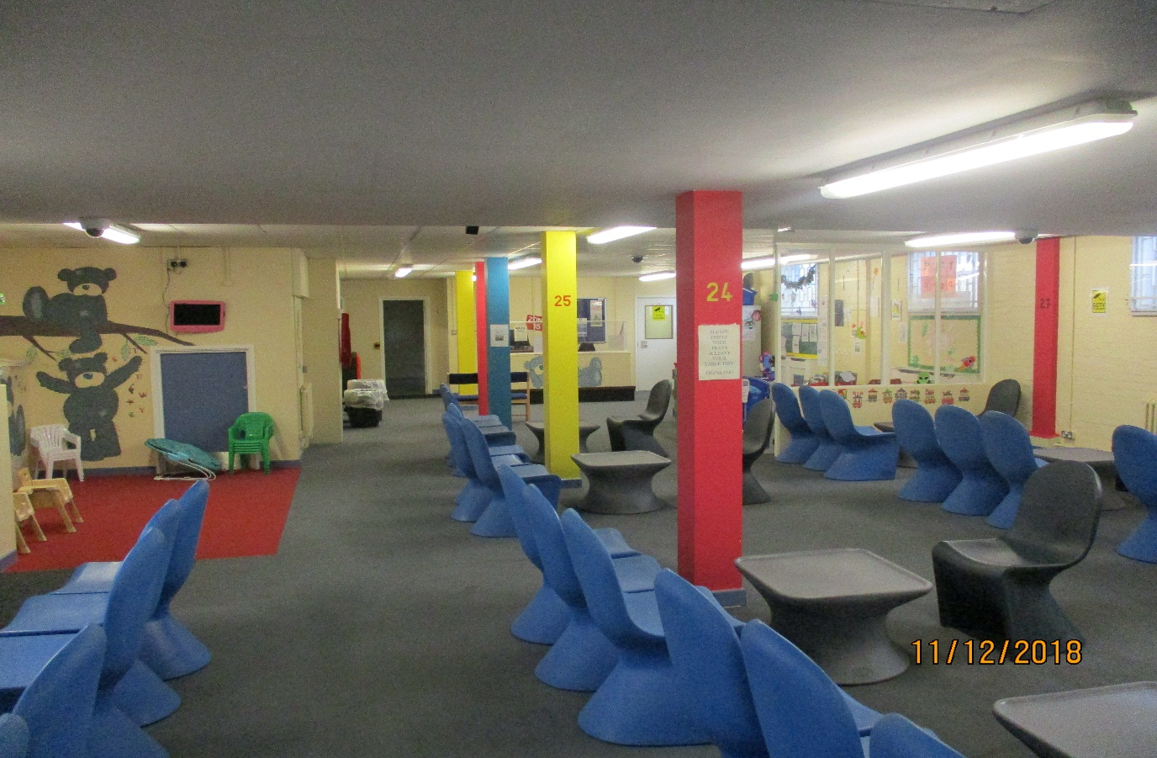

The Operations Team has made reasonable progress regarding what we do to support Family & Significant Others

* We have continued to improve the aesthetics of the visit’s hall, ensuring cleanliness is a priority, and we have cleaned the carpet in the hall and now plan to do this regularly.
* We have continued with the questionnaires & Answers for Visitors and prisoners to have their say in improvements regarding Visits Sessions.
* We continue to promote the First Time Visitors Guide, explaining the process and making the journey more comfortable for visitors and especially First Time Visitors.
* Going forward with the request from the HAWC reps we have agreed to paint the closed visits area, so that it is more welcoming to children.

Virtual visits have been successfully introduced into Stoke Heath; we are able to offer this service to the prisoners. This enables all prisoners to receive a visit during this time. This opportunity allows for prisoners to have a visit from family/friends they may not have previously received one due to distance or transport.

# mAKING IT HAPPEN - OFFENDER MANAGEMENT UNIT

Consideration of family and significant other is included in the Prison Offender Manager risk assessment and planning for the sentence. All Prison Offender Managers address all family issues from the initial interview and throughout sentence. They will promote family links to children in care by aliasing and contacting social services and OMs in the community and where necessary arrange telephone/face to face meetings with families when need. Relevant information and literature is available to Prison Offender Managers about the family agenda.

Health & well-being champion prisoners have been trained/briefed to support prisoners in this area of work and Pact will continue to train Hawc`s in this important work

Preparation for release:

Where appropriate, the family view is considered when looking at:

* + Home Detention Curfew(HDC)
  + Release on temporary licence(ROTL)
  + National probation service (NPS) Engagement
  + Engagement with local authority/leaving care teams etc.

Care experienced prisoners are identified on arrival and logged. LA’s are notified to ensure keyworkers are identified and full support is given to the care lever whilst in custody and in preparation for release.

On induction, Prison Offender Manager will direct key worker to investigate any prisoner identified with no next of kin, to try to identify any significant other relationship, which can be supported and developed as a meaningful and constructive relationship to prevent reoffending and reduce the likelihood of inter-generational crime.

When considering Home Detention Curfew and Release on Temporary licence family links and support are always the first consideration and explored and challenged for prisoners deemed unsuitable by Offender Managers in the community. National probation service engagement is paramount to ensure a seamless approach from custody to community involving families in the transition.

# FOREIGN NATIONAL prisoners

Foreign national offenders with visitors from abroad can save up visiting orders to get more visits during the time their family are in this country. Prisoners may apply for this request to the Head of Operations through the general application process, once this has been authorised and prisoners have been notified their visitors will be able to book their visits through the visits booking line. Visitors from abroad will still be required to produce acceptable forms of ID on arrival at the establishment before any visit is allowed to take place.

**Prison Visitors**

This scheme can be arranged for offenders who do not receive regular visits. Prison visitors are people from the community who give up their own time to visit, listen to and interact with offenders. This facility can be arranged through the Chaplaincy.

**Foreign National phone credit** Prisoners can put an application in for a foreign national pin, on this number they can have up to £50.00 and 20 contact numbers. To apply for credit on this pin it is a separate application to the canteen sheet. Prisoners are able to access their private money to transfer to their spends for credit.

**International Pin credit**

To be eligible for the £5.00 phone credit per calendar month prisoners should apply by application. They must have international numbers on their pin as well as not receive any social visits whilst in custody.

**Language**

At HMP& YOI Stoke Heath access to interpreting and translation services is available through The Big Word. This service is available and accessible across the establishment, including reception, and the Offender Management Unit (OMU) department.

**Immigration**

The immigration system is very complex and subject to legislative change. Immigration Surgeries are provided to prisoners and advice available on Immigration matters from the United Kingdom Border Force (UKBF) who visits the establishment on a quarterly basis. If a foreign national prisoner or detainee wishes to ask for advice or discuss their situation with the Immigration Officer between Surgeries, they should make a request to the Offender Management Unit. United Kingdom Border Force (UKBF) are able to attend the establishment if they are needing to speak to a prisoner. This will be facilitated in legal visits.

If you have any concerns regarding a loved one at Stoke Heath, please ring the safer custody line 01630 638011 and leave a message. These are listened to daily. Any immediate concerns you should ring the switchboard 01630 636000 and ask to speak to the orderly officer.

# Care experienced prisoners

Here at HMP Stoke Heath we are committed to identifying Care experienced prisoners in Custody, to ensure we are able to provide necessary support and guidance, helping them to realise their aspirations.

Our aim is to re-engage the responsible authority and appointed personal advisor with their client to re-establish the close working relationships and assess what individual support is needed.

All prisoners at Stoke Heath are notified of the name of their Prison Offender Manager and Key Worker within 48 hours of their arrival.

A one-to-one introductory meeting will take place with the POM within 14 days of their arrival, and everyone has the opportunity to divulge if they have ever spent time in care, through a questionnaire. Once identified the POM works with the Personal Advisors to devise and develop tailored pathway plans, which is managed throughout the time the prisoner is in custody.

The Care Experienced Leads also works in partnership with The Care Experienced Prisoners Association and Pact to offer support and guidance to the prisoners in regard to their rights, entitlements and re-engagement with both families and significant others.

They also offer guidance to staff in working with care experienced people. This also links with the Key worker role to provide a seamless support network.

# Conclusion

Studies have shown that prisoners are less likely to reoffend if family and significant other relationships are maintained throughout their sentence.

Supporting offenders’ family and significant relationships can help improve prison safety and security, reduce reoffending, support desistance from future offending and the possible likelihood of intergenerational offending.

We will continue to work across all areas at Stoke Heath and in partnership with Pact to develop a whole prison approach to the development of a family and significant other focussed Stoke Heath, as identified in this Strategy and development objectives, and which are responsive to the recommendations of Lord Farmer

# Further Reading / Documents

* Transforming Rehabilitation: a summary of evidence on reducing reoffending MoJ (2013)
* Prisoners’ childhood and family backgrounds examines childhood and family background of prisoners, their current family relationships, associations between these characteristics and reoffending, and estimates numbers of children (around 200,000 in 2009) affected by parental imprisonment (2012)
* NOMS Commissioning Intentions Factors linked to reoffending and desistance (2014)
* Transforming Rehabilitation: a summary of evidence on reducing reoffending MoJ (2013)
* Prisoners’ childhood and family backgrounds examines childhood and family background of prisoners, their current family relationships, associations between these characteristics and reoffending, and estimates numbers of children (around 200,000 in 2009) affected by parental imprisonment (2012)
* Prison Reform Trust Research looking at the potentially greater impact of imprisonment on children of women prisoners (2005)
* Statistics on Women and the Criminal Justice System identifies that women are more likely to experience domestic violence (2013)
* Evaluation of the Community Support for Offenders' Families service Emerging learning from a NOMS funded pilot of probation-based family support services (2015)
* Emerging learning from a NOMS/Dept BIS management review about better targeting of family case work and interventions (2014)
* i-HOP Advice and Information for commissioners and professionals working with offender’s families (funded by the Department for Education)
* Maintaining Family Ties PPO Learning Bulletin relating to maintaining family ties with prisoners (Sep 2014)
* Family Days in Prison, EuroPris summary report comprising answers to a knowledge management system request from member administrations across Europe (March 2016)
* Limerick Prison Family Days additional information supplied by the Irish prison service in response to the EuroPris knowledge management system request (March 2016) Barnardo’s Locked Out -
* Beyond Youth Custody
* Thematic report by HM Inspectorate of Prisons - Race relations in prisons: Responding to adult women from black and minority ethnic backgrounds (March 2009)
* What to do if you’re worried a child is being abused Advice for practitioners March 2015

1.
2.