HMP/YOI Standford Hill

Family Strategy
April 2022 – 2023

Contents

Item Page

Introduction 3
Aim of the Strategy 3 Objectives and Timeline 2018/19 3
Family Centre 4
Family Days 4
Transport Links 4
Working in Partnership 5
Spurgeons 5
Forward Trust 5-6
KCC Libraries 6-7
Performance and Measurement 7
Meeting Structure 7
Spurgeons 7
HMPPS 7-8
Digital and Technology 8
Storybook Dads 8
Email a Prisoner 8-9
Hotline 9
Developing Innovation and Practice 9
Improved Transport Links 9
Child-Centred Activities 9
Children’s Catering Activities (Family Bake Off) 9
Social Inclusion Team 9
Care Leavers 9-10
Assessment Care in Custody Teamwork 10

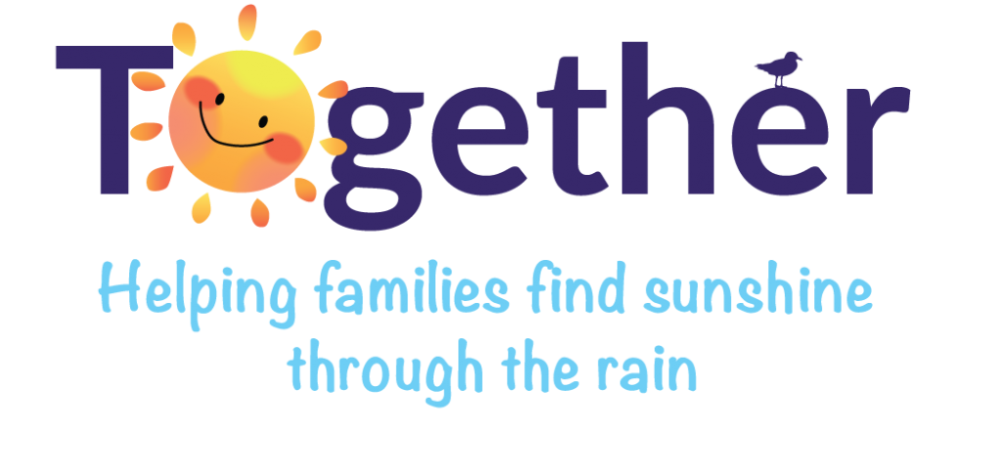
Introduction

‘Family should be the ‘’golden thread’ running
through the processes of all prisons…”
Lord Farmer, Delivering Effective Family Practice

- Head of Reducing Reoffending - Ian Whittle – Member of SLT
- HMPPS Family Co-Ordinator - Sean Wood – Custodial Manager

Aim of the Strategy

HMP Standford Hill greatly recognises the importance of strong family relationships and actively promotes this in numerous ways throughout the prison. HMP Standford Hill believes that maintaining and encouraging positive family relationships can be an important protective factor in helping offenders to break the cycle of crime and desist from future offending and may impact on the prevention of intergenerational crime. This is reinforced by a thematic findings paper by HMIP 2016 Life in Prison: Contact with Families and Friends, which states that ‘good family contact has an important role to play, not only in supporting prisoners through their sentence, but in supporting their rehabilitation after release’.

Standford Hill is committed to facilitating specific family days, as an open prison we are able to make these days as informal and enjoyable as possible. We are assisted by PACT our family charity, as well as many other very willing volunteers within the prison, including The CGL family worker, KCC libraries and some of our peer support workers.

We are committed to transforming HMP Standford Hill into a place of safety and reform. We recognise the need to provide the men in our custody with stable environments, as well as opportunities to change their behaviour and turn away from a life of crime. Relationships with families and significant others play a key role in this.

We use the importance of strengthening prisoners’ family ties to help prevent re-offending and reduce intergenerational crime.

Future objectives & Timeline

- Visitor Survey to be completed by the 31st January 2023.
- Visitor Forums to be completed by the 31st January 2023.
- Coming Home course to be completed by the 31st January 2023.
- Family Bake Off to be completed by the October 2023.
- Family evening meal visits to be completed by October 2023.
- Special family relationship visits to be completed by October 2023.
- Educational share in success day for families – Weston College. – October 2023.

Family Centre – The home of social visits.

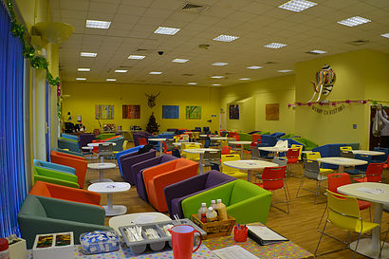
Social Visits are held in our Family Centre and take place on Wednesdays, Thursdays, Saturdays and Sundays, from 13:45 to 15:45. These can be booked by either telephone between the hours of 09:00 and 16:00 Monday to Friday on 0330 0588223 or via email by visiting the website www.gov.uk/prison-visits

Social Visits / Video Visits

The prison runs visits on Wednesday, Thursday, Saturday, and Sunday afternoons between 1345 – 1545. All prisoners have access to visits if their visitors have been previously cleared. There are currently 18 family spaces available on each visits sessions and prisoners are permitted to have four visits per month subject to them having the required visiting orders and subject to availability. We also run video visits alongside our normal visits, with 6 sessions on each visit’s day, totalling 24 per week. This a great alternative to visits, especially for families that live so far away. With the cost-of-living crisis it is also a great service for those who may not be able to afford to visit their family, friends or loved ones.

Family Days

Standford Hill continues to hold regular seasonally themed family days with over 144 families able to benefit from these events throughout the year. There is no charge to the families for these events and we have put on positive family activities such as: Art & Crafts; Summer Sports, Fun tabletop quizzes suitable for the whole family. We also have external providers come into the prison providing other activities such as Face Painting, and Creepy Claws who provide an educational presentation about their creepy creatures and their habitats with hands on experiences. We understand that family memories are important, so we offer free photographs on the day. PACT is also scheduled to run other family events such as Homework clubs and Extended Visits. CGL also provide their own family support worker and will work closely with prisoners and families who require additional help.

The Working out Scheme

The Working Out Scheme at HMP Standford Hill allows prisoners the opportunity to fully engage with their sentence plan, by encouraging them into full-time paid employment within their resettlement area, enabling them to support their families.
The scheme is designed to assist individuals achieve safe reintegration into the community and reduce their risk of reoffending. A comprehensive individual risk assessment is completed prior to anyone taking up their employment placement. This enables individuals to follow a supportive but testing regime whilst allowing them the opportunity to demonstrate that they are ready and safe to return to their community.
In 2021, over 60% of prisoners released went into full time paid employment. During the same period, those engaging with the Working Out Scheme collectively earned over £1.6m! This allowed prisoners to support their families with housing, bills, and general family matters, and paying off historic debts and helping them to save for positive future for themselves and their families.

Transport Links

Bus

Bus services to the prison are irregular, there are services to the village of Eastchurch which is about one mile from the prison. Arriva Buses (0870 608 2608) run services leaving from Sheerness Station and Chalkwell Coach Hire (01795 423982) run services from Sittingbourne and Sheerness stations.

Train

Take a train from London Victoria to Sittingbourne, and then a connecting train to Sheerness.

Car

Via the M20: Exit at Junction 7 and follow A249 (signposted Sittingbourne & Sheerness). After 5 miles pass under M2, staying on A249 to Sittingbourne & Sheerness.
Via the M2: Exit at Junction 5 and follow the A249 (signposted Sittingbourne & Sheerness).
Follow for about 5 miles, over bridge onto the Isle of Sheppey. After 2 miles take a right on the roundabout towards Minster & Eastchurch, continue for 4 miles to the next roundabout which bypasses Eastchurch Village. Take a right and follow signs for the Prison.

Working in Partnership

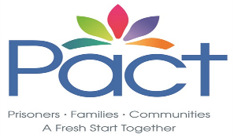
PACT Family Support Services.

PACT Family Services are contracted to provide the Family and Significant Other provision within the establishment. The team consists of a Family Engagement Manager, Lead Family Engagement Worker and a Family Support Worker, all of which hold the relevant qualifications and experience to enable them to work with the children and families that visit.
Within their current service delivery, PACT offer the below services:
One of the team members are present within the Visits Hall from 12:30 to carry out Meet & Greet services. This includes welcoming visitors into the hall, offering support, supervising and ensuring their safety whilst awaiting their visit.

During visits, a member of the team is available to provide purposeful play for the children within the hall. Within our play area we have a dressing up corner, home corner, reading area and various other toys and play equipment. In addition to this, arts and crafts are provided, along with other engaging activities. During the summer months, we also offer outdoor play equipment such as a wendy house and sandpit. Fathers, Grandfathers, Uncles etc are encouraged to engage with the children within the area and they are often seen completing activities with the support of the Family Support Worker.

Family Days and Extended Visits
PACT hold regular Family Days and Extended Visits which alternate monthly. These are events which are held within the Visits Hall and allow 18 families to attend and enjoy a selection of arts, crafts and engaging activities, as well as making use of the entertainment that is provided. Not only do those attending have the opportunity to enjoy a whole day together at no cost to themselves, but they are also provided a lunch free of charge via the prison catering team. These events are usually themed and are often centred around seasons, celebrations and protected characteristics. For example, we have had Summer Sports, Afternoon Tea for The Queens Jubilee and also a date organised for Gypsy, Roma and Traveller Families. In 2023 we will be holding six Family Days and six Extended Visits, six of which will be surrounding protected characteristics.

Homework Club and Baby Bonding
Within the visits enrichment provision, we offer one session of Homework Club and Baby Bonding each week. Each session allows a group of prisoners to attend with their children to engage in a child centred activity to encourage family ties and strengthening of family bonds. This also allows those attending to feel that they are contributing to the child's life, that they have an active role within the child's life and enable them to feel like a positive role model.
Homework Club is aimed at children currently within education that would like to engage with their Father, Grandfather, Uncle etc when completing homework issued by the school or educational worksheets and activities provided within the session.
Baby Bonding is aimed at prisoners with a child from 0 - 2 that would like to experience forming and strengthening their bond. During these sessions activities directed to babies and their development are provided, such as music sessions and messy play. In addition to this, concerns surrounding parenting can be discussed and advice and guidance can be given.

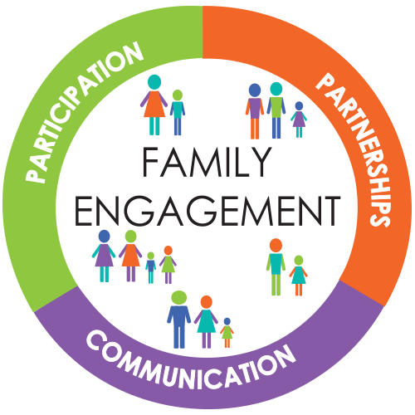
Family Engagement
PACT provides a Lead Family Engagement Worker within the establishment, who is dedicated to completing casework and supporting those currently residing within Standford Hill with various different support services to encourage family engagement.
The LFEW is able to support prisoners to establish or re-establish contact with their families and significant others. For example, they are able to liaise with family members direct or with other agencies such as social services and courts. Part of their role is completing applications such as Child Arrangement Orders, Declaration of Parentages and Help with Fee forms.
In addition to the above, they will also be offering the below structured 1:1 courses:
- Anger & Stress - Explores feelings of anger and how people may show this. It also looks at stress and the impact that these feelings can have on relationships with partners. There is also a focus on strategies to help individuals deal with anger and stress in relationships.
- Confidence and Assertiveness - Explores how we feel about ourselves and how to understand our own strengths and weaknesses. There is also a focus on how to develop good communication, good decision making and assertive responses to certain scenarios.
- Dads Reconnected - For dads who have little or no contact with their children. The structured 1:1 explores parenting skills, how to co-parent or parent from afar as well as identify how to overcome barriers of parenting from afar.
- Family Finance - Reviews the basics of handling your own finances, it starts with a budgeting activity and you can be supported by your case worker and also reviews looking ahead to support you with savings for your financial goals.
- Going Home - Is for service users approaching release and returning to their family. There is a focus on raising awareness of some of the issues individuals and their families might face.
- Good Relationships Part 1 & Part 2 - Two structured 1:1s which aim to provide appropriate communication strategies and how to deal with conflict. There is a focus on how to communicate and how conflict can occur in relationships.
- Managing Your Worry - Explores how stress has an effect on individuals, and the coping mechanisms which can help deal with stress. There is also an exploration of unhealthy responses to stress and how this may lead to negative consequence.
- Moving On - Explores how barriers can affect relationships and ways of life and addresses how to cope with that change.
- My Family Matters - Looks at role models, good support networks and how to communicate those people. There is also a focus on improving family relationships and the importance of respecting family members.
- New Beginnings - Explores how prisons or sentence plans can affect relationships and ways of life, addresses how to cope with that change and became a member of the community again.
- PACT PSHE - Support service users to maintain and improve their own mental wellbeing and increases their ability and resilience to identify and overcome challenges.
- Parenting 0-12 - Helps recognise good parenting, how to support child development and stresses the importance of setting boundaries for children that are positive.
- Parenting Teenagers - Explores how to parent teenagers, provides tips for raising teenagers and offers ways to recognise the skills needed to successfully guide teenagers.

Inductions
To ensure that the team capture the needs of every resident that resides within Standford Hill, a team member attends each induction and triages those that attend to ensure that they are being offered the correct support.
Survey/Feedback
​Surveys will be available during all visits for us to capture the feedback and needs of the prisoners and their visitors. This includes surveys aimed at children to also capture their needs. In addition to this, we send surveys to all prisoners and visitors following attendance at any of our events, such as Family Days and Extended Visits.
As part of our quarterly newsletter, we will be inviting prisoners to send us their feedback to express their views and needs. Focus groups will also be held in partnership with the prison to ensure prisoners are being given a forum to voice their views also. All outcomes will then be discussed during the Family Sub meeting.

CFO3 (PACT)
We offer various courses on Relationships that prisoners can take with us through the programme.
- Relationships- Understanding relationships, healthy and unhealthy relationships, understanding boundaries, understanding co-dependency, effective communication, plan a healthy relationship.

- My Family-To identify positive role models and support network. To understand how to communicate with family. To understand importance of respecting family. To understand how to improve family relationships. To understand how to maintain family relationships.

- Coming Home--Coming Home is a one-day accredited course designed to encourage preparations for release. The course will encourage participants to consider the practical, emotional, and relational issues that are often experienced following a period of custody. The course will enable participants to produce a SMART action plan for their release.

- Within My Reach— Provides strategies to improve communication and conflict resolution skills, and relationship safety/violence prevention. The course is based on the PREP methodology a scientifically based method of teaching relationship education.

- Staying Connected—Contact with you family is an important part of rehabilitation, those that maintain contact are less likely to re-offend, contact is also important for the child’s wellbeing.
This course will increase knowledge of parenting skills as well as giving tips and strategies of how to reconnect or stay connected while in prison.

As a Charity, we also have access to funding that allow us to help families of Prisoners, perhaps with White goods, school uniform, supplies & bedding. We have also been able to help with a food voucher to help families with the cost of living.

CGL employ a Family Worker based within the Substance Misuse Service. It involves developing a package of support for families and carers of those with substance misuse problems, supporting service users, volunteers and staff members to advise and assist families and carers, along with linking in with other agencies within custody, community, and mutual aid groups.

CGL Family worker will.

- Coordinate family and carer Involvement with a recovery orientated substance misuse model.

- Assess and support family and carers by providing advice and information.

- Support in the development of 1-2-1 psycho-social interventions that can support service users, their family and carers.

- Deliver tailor made groups which helps men to explore their family role and work towards rebuilding trust and discovering better ways to communicate with the people close to them, whether that be with parents, siblings, children or any other significant family members.

- Develop links with mutual aid groups to ensure access into services.

- Make onward referrals to appropriate support services.

- Work within a strengths-based approach to ensure that clients wellbeing is supported.

CGL enables people to make the positive changes necessary to lead independent and purposeful lives and create safer, healthier communities.

Standford Hill Library

The library is provided by Kent County Council Library Services and is open 7 days a week, with staffing provided by Kent Library Staff and Library Orderlies.
The library is part of the induction process, and Library Orderlies are encouraged to promote the library to new arrivals.
We have a broad range of stock, including books on parenting and families, as well as books explaining neurodiverse conditions such as autism, or medical conditions such as diabetes, to help support men facing these issues themselves or in their families.
We stock a shelf of children’s books in the Visits area for families to share, and our staff support Families Days.

We work closely with the Shannon Trust volunteer to support the reading programme in the prison and provide follow-on reading for those who finish the programme.
We run Storybook Dads from the library (see ‘Digital and Technology’ below) and offer Storybook Dads SWAPS to men who would like to exchange a range of scrapbook articles about themselves, with their children, increasing their bond as they learn more about each other.

Storybook Dads
By sending a bedtime story disc to their children, men can provide comfort and reduce the trauma caused by the forced separation. Doing something positive and tangible for their child increases their self-esteem and belief in themselves as a valued parent.
As reading to children is the most important thing a parent can do to help with their education, the story disc also gives men the opportunity to make a positive impact on their children’s social and learning outcomes.
For many families, these story discs are a lifeline, helping to heal rifts and enabling imprisoned parents to maintain or build vital relationships with their children. Men that keep in contact with their families are up to 6 times less likely to re-offend.

Performance and Measurement

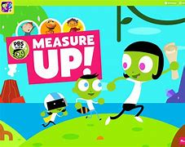

Meeting Structure

A monthly meeting to review the service offered will take place between the following members:

- PACT Service Manager Southeast – Emma Harvey
- Head of Reducing Reoffending - Ian Whittle (Contract Owner)
- HMPPS Family Co-Ordinator - Sean Wood
- PACT Family Engagement Manager – Lauren Sutton.

In addition to this a Family Sub-Committee meeting will take place on the first Tuesday of each month between the following:

- Activities Custodial Manager – Sean Wood.
- Head of Reducing Reoffending – Ian Whittle.
- CGL Family Support worker – Catherine Parry.
- PACT Family Engagement Manager – Lauren Sutton.
- Community Rehabilitation Company Manager
- Independent Monitoring Board Representative

PACT

The following KPI’s are recorded and monitored by PACT:

- Visits room play services operate on 100% of visits sessions
- Eight Family Days are provided in partnership with Standford Hill
- Client satisfaction, to include adult visitors, children and prisoners to achieve 85%. This will be monitored through the visitor forum / visits feedback on Standford Hill website and the Visits Feedback form (Objective 1 – See Appendix A & B)
- Community organisations to have links with the visitor centre
- Ten Participation Forums provided in partnership with Standford Hill
- Attendance at the monthly Standford Hill Family Sub Committee
- Establish a homework club

HMIP - 2019

Her Majesty’s Inspector of Prisons in relation to Family and Contact with the Outside World have the following expectations:

- Prisoners are encouraged to re-establish or maintain relationships with their children and families where it is appropriate and are supported in doing so.
- The prison supports the rights of children visiting their parent in prison, subject to a risk assessment for public protection concerns.
- Prisoners can maintain access to the outside world through regular and easy access to visits. They are aware of the prison procedures and their visits entitlements.
- Prisoners and their visitors can attend visits in a clean, safe and respectful environment which meets their needs.

Our last HMIP inspection in 2019 stated the following.

Work to rehabilitate prisoners and plan for their release continued to be good. The prison, along with the children’s charity Spurgeon’s, offered prisoners a wide range of opportunities to maintain and rebuild their family lives.
The outstanding visitors’ centre was one of the best in the prison estate and was used to host regular and constructive family days. Children and family provision was very good. A wide range of opportunities were available to help prisoners maintain and rebuild relationships with their families.
The impressive family days were innovative and promoted meaningful contact. The visitors’ centre was excellent – it was bright, relaxed, and welcoming. The centre was well equipped and interactions we observed between staff and children were exceptional.

MQPL Surveys from 2019
Out last MAPL report was in November 2019. This was a favourable report with the following findings:

I am able to receive visits often enough in this prison.
(Degree of Positivity: ▲0.89)
(Strongly agreed/Agreed: 74.2% Compared to Typical: ▲0.38)

I am able to maintain meaningful contact with my family whilst I am in this prison.
(Degree of Positivity ▲1.12)
(Strongly agreed/Agreed: 80.8%)

The length of time for each visit is long enough.
(Degree of Positivity ▲0.45)
(Strongly agreed/Agreed 63.5%)

Email a Prisoner

To help family & friends communicate easily and frequently with prisoners you can now send messages to a prisoner via www.emailaprisoner.com. It takes only a few minutes to sign up and the message gets delivered to the prison rapidly.
These sophisticated systems allow you to write an email, press 'send' and sit back in the knowledge the email will be delivered safely, securely & ready for delivery to the prison of your choice. Your message is printed inside the prison and will be included in the daily mail delivery. There is a charge of 40 pence per message by Email a Prisoner for this service.
To access this service, family and friends need to create their own personal account via the website at www.emailaprisoner.com

Hotline

A dedicated telephone line is provided by HMP/YOI Standford Hill to provide families and friends of the men an additional line of contact in the event of an emergency or if any concerns arise. This is monitored daily by staff. If a call is received out of hours, an answer machine service is provided.

The Freephone number for this service is: 0800 6920170.

Other out of hours call line for urgent family and friends calls.

The gate: 01795 884515 - 2000 – 0800 hours

Free monthly phone call for foreign national men (or those with close family abroad)

If you are a Foreign National prisoner or have close family abroad and have not had a social visit in the last month (four weeks) you are entitled to apply for a free five-minute phone call.

National policy guidance clarifies that the last month is interpreted as four weeks prior to an application being made.

Offender Management Unit

Release on Temporary Licence (ROTL)is the foundation of any resettlement plan. ROTL for Maintaining Family Ties is a crucial part of the prisoner resettling back into their community and reintegrating into their family units. Each prisoners’ needs are considered individually and assessed considering the risk of harm to the public, victim, as well as family circumstances. When assessed suitable for MFT ROTL, programmes are planned to enable a managed progression back into the community. These times on ROTL are vital for the prisoners to reconnect with families and children that they may not have interacted with in a community setting for possibly many years, especially with children that were young at the time they entered custody.

As a Resettlement establishment, we strive to create safe programmes of ROTL for all and prisoners generally access at least 2 x periods of Resettlement Day Release and 1 x period of Resettlement Overnight Release per month. Within reason, they can plan the dates of these ROTL periods 6 months in advances, this enables them to be present for family occasions, such as an anniversary or birthday.

We have the capacity to accommodate 464 prisoners and offer a high level of ROTL MFT to those assessed as suitable, for the 12-month period from November 2021 to November 2022, we managed 10480 ROTL MFT events (RDR – 7205 and RoR 3275).

Developing Innovation and Practice

Child-Centred Activities

We will look to introduce Child Centred Activities. These events will be putting the child at the heart of the visit. Activities will include arts and crafts events, family board games, sport events.

Children’s Catering Activities (Family Bake Off)

Once our kitchen is up and running we plan to run ‘Family Bake Off’ style events creating pizzas, cakes and buns (baking & icing), introducing practical family fun whilst also learning together.

Evening Visit – Evening meal.

We aim to open a new café in the old mill area and would like to hold a family visit during the evening whereby the family can sit down together and have a meaningful evening meal.

Social Inclusion

Care Leavers

Our Social Inclusion team will support care leavers by working with them in a pro-social way. In particular we will show optimism that the individual can turn their life around, provide motivation and offer hope for the future.

- A care leaver is someone who has spent time in the care of the local authority.
- Former Relevant Children (under 21) - young adults who have spent at least 13 weeks in the care of a local authority between their 14th and 18th birthdays
- Former Relevant Children Entitled to Extended Support (up to 25) - former relevant children who have notified their local authority that they intend to pursue further education or training
- Persons Qualifying for Advice and Assistance- young adults (under 21) who:
- Were subject to a special guardianship order, or
- At any time after reaching the age of 16, but while still a child were, but are no longer, looked after, accommodated or fostered.

Potential care leavers will be identified on induction and referred to the social inclusion team who will collect all relevant information and liaise with internal and external partners including but not limited to OMU, education, local authority support services and charities. Care leavers will be managed in accordance with the care leaver’s flow chart but with the focus on their personal needs.

The Social Inclusion team will work with the care leaver to identify relevant objectives to set within their sentence plan, with associated actions and activities to address areas of need such as:

- Gaining literacy and numeracy skills
- Gain employment and/or qualifications
- Obtain support with life skills such as cooking, financial management and debt
- Access to mentoring or advocacy services or support groups

Assessment Care in Custody Teamwork

If an individual is subject to an ACCT document whilst in our care and would like information shared with their family this will be done via a supported phone call if appropriate, or a prison visit involving a member of staff to support or advise if needed.

Standford Hills commitment to Public Protection and Safeguarding
Her Majesty’s Prison and Probation Service, of which we are part, are committed to the protection of the public and reducing reoffending by delivering the punishment and orders of the courts and supporting rehabilitation by helping offenders to reform their lives. A crucial component of this commitment is the protection of the public and the safeguarding of the most vulnerable within our society.

HMP & YOI Standford Hill is dedicated to the resettlement and reintegration of the prisoners in our charge, which is underpinned by robust risk assessment and monitoring, adhering to the principles outlined within Public Protection Manual, Multi Agency Public Protection Arrangements (MAPPA) and Prison Service Instructions (PSI).
Public protection and safeguarding is everyone’s responsibility, therefore this policy document is an essential reference to all staff working at HMP & YOI Standford Hill and the processes involved in this critical area of our work.

Gary Price
Governing Governor

Aims
• Maintain and develop public protection procedures to identify and manage high risk and potentially dangerous prisoners.
• Ensure that appropriate action and restrictions are imposed where necessary to safeguard children, victims and to protect the public from the risk presented from identified residents.
• Ensure that systems are maintained for the sharing of relevant information within the establishment for the management and reduction of risk of harm and reoffending.
• Ensure that all necessary information is shared with the multi-agency public protection arrangements as required.
• Ensure that all necessary information is shared within the parole and release process to contribute to the safe release of prisoners and risk management of residents in the community.

