HMP Wandsworth Family & Significant Others Strategy
2022

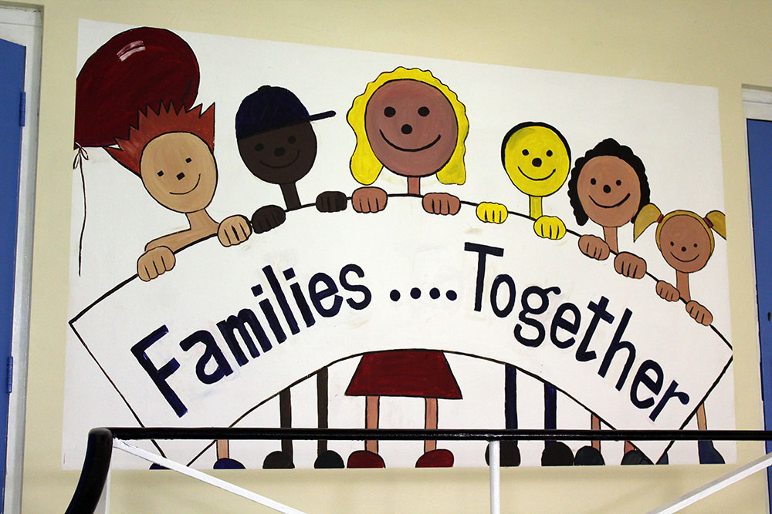

Contents
Families at HMP Wandsworth 2
Current Family Services at HMP Wandsworth 4
Family Days
Social Visits
In cell-phones
E-mail A Prisoner
Assisted Prison Visits Scheme
Letters, Cards and Property
Secure Video Calls
Chaplaincy
PACT
Safer Custody
CGL
BEST
Visitor Experience 8
Improved Engagement 9
Supporting All 9
Partnership Links 10
How we will measure our progress 11
Further Information/Reading 13

Families at HMP Wandsworth

Here at HMP Wandsworth in 2022, five years after the publication of the Farmer Review, we remain as committed as ever to helping maintain, promote and improve our prisoners’ relationships with their families and significant others.
We understand and acknowledge the heavy toll that Covid-19 has taken on family ties in prisons, where restrictions meant long periods without face-to-face visits, and further restrictions around contact once they re-started. We know this has made it an incredibly difficult period both for prisoners and their family members, and we thank everyone involved for their co-operation with us whilst we navigated the challenges associated with the pandemic. In recognition of this, the crux of our family strategy for 2022 is to re-build our visits offer out of the context of the last two years and ensure that adequate opportunities are available for our prisoners to actively maintain face-to-face relationships outside of prison as covid restrictions ease.
We haven’t lost sight of the fact that such relationships are an incredibly important motivating factor in a prisoner’s decision not to re-offend. Focusing on family relationships encourages prisoners to consider the consequences of their actions, focus on their responsibilities, and to try to be good role models for their children. We recognise the powerful role that family and significant others play in helping our people come to terms with their imprisonment and maintain high behaviour standards whilst they are with us.
We also know however, that many of our prisoners, for a variety of reasons, do not necessarily have strong connections outside of prison. We also realise that not all relationships are positive or conducive to moving away from offending and should not be promoted by us. The 2022 strategy therefore has a lot of focus on those who don’t get regular visits or have limited positive family ties because, in the words of Lord Farmer - “If prisons are truly to be places of reform, we cannot ignore the reality that a supportive relationship with at least one person is indispensable for a prisoner’s ability to get through their sentence well and achieve rehabilitation.”

For all these reasons family work remains a critical pillar of our commitment to making HMP Wandsworth a safe and purposeful place as it possibly can be, as well as protecting the public by helping people to live law-abiding and useful lives once they are released.
The purpose of this document is to inform readers of the current family support services and offer for prisoners and families alike here at HMP Wandsworth. We also want to share our future ambitions for how these are improved and evolved over the coming year. We want this to be a document that prisoners, their families and prison staff can all engage with, contribute to and learn from. I hope you will find it useful.
Stacey James
Head of Visits and Family Ties
HMP Wandsworth

Current Family Services at HMP Wandsworth
Family Days
HMP Wandsworth arranges ‘family days’ approximately once a month.
Family days normally have a particular theme, for example Christmas, Easter or Sports day, and give families an opportunity to have longer visiting hours in a more relaxed and fun environment. They typically last all day and are centred around enabling deeper and more meaningful family ties than what might be achieved in a typical 1-hour visit.
Prisoners can apply for family days and the criteria is made available through internal communication services with prisoners. The criteria is generally that prisoners have had visits in the last 6 months with their children and do not have adjudications for things like mobile phones, weapons or drugs when in custody.
Social Visits
Wandsworth usually offers in person social visits Monday – Saturday. The schedule of this does change but time slots are usually readily available.

Visitors have to be added by the person in prison and approved. Visitors can then book slots through the booking line (0300 060 6509).
Times vary from between 1-2 hours.
Refreshments are available to purchase in the hall and there is a play area for children.

Our current visits timetable is as follows:
Monday – Thursday
09:00 – 10:00
10:30 – 11:30
13:30 – 14:30
15:30 – 16:30
Saturday & Sunday
09:00 – 10:00
10:30 – 11:30
13:30 – 14:30
15:30 – 16:30
In cell Phones
All prisoners at Wandsworth have access to in-cell phones which means they can make calls 24 hours a day.
Most are given a PIN on their first night in custody with a limited amount of credit. Within a few days they can upload more credit and add the numbers of those they want to call.
Prisoners can make up to 300 minutes of calls a day, individual calls allowed up to 20 minutes duration, with 1 minute in between each call.

M

E-mail A Prisoner
You can ‘e-mail’ a person in prison through the website https://www.emailaprisoner.com/This service allows family and friends to send an electronic message which is printed off and delivered to a prisoner the next day, and they can then reply to by writing a response. There is a small cost for the service.

Assisted Prison Visits Scheme
HMP Wandsworth partakes in APVS which in some circumstances can contribute money towards the cost of visiting somebody in prison if you are in receipt of certain benefits or have a health certificate to get help. More information is available at: www.gov.uk/help-with-prison-visits
Letters, Cards and Property
Families and Significant others can send unlimited letters and cards to prisoners. These typically take 1-2 days to pass through security and arrive with prisoners once they get to the prison. Prisoners can also send out letters through buying stamps on the canteen.
Families and significant others can hand in property such as clothes. The person in prison has to book an appointment and have it confirmed first, and then property can be handed in at the prison at the agreed time.
Socks and boxers are the only items that can be handed in before a visit without needing an appointment. Similarly, books and games can be purchased directly from Amazon and sent into Wandsworth for prisoners without prior permission.
Secure Video Calls
Secure Video calls are available for prisoners to use at HMP Wandsworth. These are booked via the ‘Prison Video’ app with much more information available online by searching ‘Prison Video’ in your app store. Secure video calls are held Monday – Friday, in the afternoons.
They allow prisoners to have face to face video contact with you through your phone or laptop, similar in many ways to ‘a secure ‘Skype’ call. and are usually half an hour long.
Chaplaincy
The chaplaincy at HMP Wandsworth supports inmates and their families in a variety of ways, perhaps the most significant being ‘major life events’ including illnesses, bereavements, and funeral support, as well as marriages. In the cases of close relatives, the chaplaincy works to ensure that inmates are able to visit their sick family member or attend their funeral, as well as providing pastoral care for other types of life events.
The Official Prison Visitors, a ‘befriending’ service which connects volunteers with prisoners, also operates through the Chaplaincy. This provides a vital companionship opportunity for those with limited family ties.

PACT
HMP Wandsworth contracts out its family provider services. The current provider is PACT (Prisoner Advice and Care Trust). We work closely with PACT to deliver a number of services for families and significant others including:
- A play worker to provide a welcoming space for children which allows them to play safely and maintain attachment with their imprisoned parent or relative during visits.
- Visitors Centre – creating a welcoming environment for visitors, providing useful information and post/pre-visit emotional support for difficult visits.
- An up-to-date website containing information about visiting HMP Wandsworth and prison more generally (www.prisonadvice.org.uk/hmp-wandsworth)
- A full time Family Engagement Worker who provides casework and advocating services, liaising between prisoners, families and other relevant professionals within the prison and community, and signposting to other organisations that can provide specialised advice and support.
- Family Links Visits – A quieter visiting room with supervision from PACT worker for visits with more complex needs between children and their imprisoned parent
- Family Groupwork - delivery of relationship courses to prisoners via in cell packs and family-based courses, including ‘Going home’ and ‘Dads reconnected’.

Safer Custody
Safer Custody at Wandsworth receives information from a variety of sources, including family and friends, about the safety of prisoners. Concerns around welfare, health or violence, drugs and debt should be reported to Safer Custody on 0208 588 4296 or email saferprisonswandsworth@justice.gov.uk who will take action.
If you have a concern that you believe is life threatening, please call 0208 588 4358 and ask for the Orderly Officer. Please note calls to this number will only be actioned if they are thought to be a genuine emergency. All other concerns will be responded to by the Safer Custody team in office hours.
Safer Custody also oversee the ACCT process for those who may be at risk of self-harm or suicide. Families are welcome to join these reviews to improve the care for those subject to them.

CGL
Change Grow Live provide family services as part of their provision for those with substance misuse problems and have a dedicated family liaison officer.
The CGL Family service is designed to support clients who are currently working with the CGL services for their substance misuse. I work in helping clients develop skills that will help them to stay connected to family/significant others whilst in prison. Support is offer through one-to-one key working sessions tailored to an individual’s specific needs and goals pods/programmes exploring issues in a group setting and in cell packs focused on specific skill development in better maintaining relationships.
The Family service can also help with:
- Developing skills to learn how to stay connected to family/significant others (SOs) whilst in prison.
- Developing parental skills and capacity through 1:1
- Support in processing loss & living with separation.
- Support with developing skills for reintegration back into the family pending release.
- Liaise with organisations in the prison cantered on reconnecting families/social networks
- Making referrals to organisations to further support specific needs
The Family service also offers 2 group programmes:
- ‘Keeping In Touch’ group is an opportunity for the clients to get together and make gifts and cards for their loved ones.
- ‘Building Better Relationships’ is a four-day programme designed at looking at family history, past behaviours, anger management and goal setting for relationships.

BEST
The Foreign National Support Services in HMPW (BEST and Catch-22) do work to support Foreign Nationals accessing visiting opportunities. This includes explaining how to book social visits and secure video calls, as well as offering small grants to Foreign National prisoners who have insufficient funds to make calls back home when they come into prison.
BEST train and co-ordinate volunteers to come and visit Foreign Nationals who may not have family ties or friends. There are currently around a dozen volunteers conducting these types of visits at Wandsworth.

Visitor Experience
We want to achieve:
- Visitors can easily and quickly access information about how to visit Wandsworth once a family member or significant other has been sent there
- They can book their desired visit easily
- They find the visiting experience comfortable and as stress-free as possible.

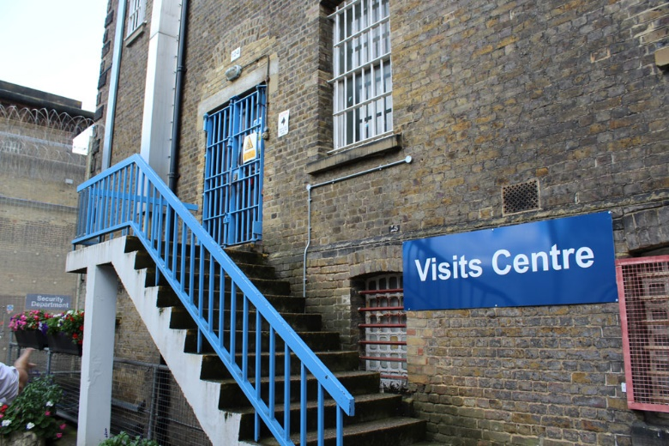
How will we deliver this in 2022:
- Produce a digital platform with all the information needed and made accessible to all the families and significant others who are sent to our custody (by March 2022)
- Work with ‘InsideJob’ to produce a freely available film with information about HMP Wandsworth and what goes on inside for families and significant others to access (by June 2022)

- We will develop a new programme of visits post-co
vid that responds to the needs of our families and significant others. The first priority is re-establishing weekend visits, but we will also look to implement evening video calls (implemented by July 2022)

- We will re-establish a regular programme of monthly Family Days and build on the overwhelmingly positive feedback of previous sessions. We will continue to review our application processes to ensure they are fair, transparent and do not punish children for their parents’ behaviour whilst in prison (ongoing)

- We recognise the importance of weekend visits and the significant impact that suspending these over Covid-19 has had on families. We will re-instate them at the first opportunity.
- We will improve our routine feedback process so visitors can easily log compliments and complaints about the process inside and outside the prison. Any issues that are identified are promptly remedied. We will also conduct 4 x surveys a year with our Family Service Provider (implement by February 2022)
- We will deliver ‘Hidden Sentence' training to visits staff to increase their awareness of the value of Family Ties (by June 2022)

Improved Engagement
What we want to achieve:
- Family members are valued across the prison and involved in the journey of our prisoners
- We create an environment that supports and improves family contact beyond just the provision of social visits
- Families and significant others have the opportunity to feed into our strategy and direction
How we will deliver this in 2022:
- We will work with Safer Custody to review and streamline ways family members can report safety information about their loved ones to the prison (by May 2022)

- We will work with Safer Custody and our Family provider to get families more involved in case work of our prisoners involved in violence or self-harm. We will monitor data around involvement of families in ACCT reviews and CSIP (ongoing)

- We will re-tender our contract with the family service provider to improve the link between the Family Engagement Service and induction. We will use this to assess the needs of every person arriving at Wandsworth, and signpost them to the necessary services and information. As part of this we will implement a peer-to-peer family ties orderly group on induction wing (beginning February, embedded by September 2022)

- We will improve our governance of the Family Provider contract by asking for, and scrutinising quantitative and qualitative data around the usage and impact of the Family Engagement and Support workers (ongoing)

- We will modernise our engagement opportunities, introducing online Q&A sessions bi-monthly with managers in the prison to ask questions and get updates (to begin March 2022)

Supporting All
What we want to achieve:
- Fully understand the reasons why high proportion (approx. 2/3rd) of our demographic does not receive social or purple visits
- We take active steps to reduce social isolation for those who do not receive visits or have strong family ties
- Ensure whole prison, in particular all residential wing staff are actively engaged in improving family ties
How we will deliver this in 2022:
- We will complete a comprehensive data collection exercise to gain a deeper understanding of why it is that so many of our prisoners at HMP Wandsworth do not get visits including: surveys, focus groups and analysis of existing data. We will use this to identify and implement solutions (by April 2022)
- We will continue to improve our family provision for Foreign Nationals by targeting the secure video calls service more towards them. We will work with our booking provider to enable those with relatives abroad or 50+ miles away the opportunity to have additional Purple Visits (implemented by March 2022)

- We will re-tender our Family Services Provider contract and introduce contractual obligations and KPIs to ensure provision is more targeted at those who do not receive visits, including Foreign Nationals (by September 2022)
- We will deliver an up-skilling programme for all OMIC keyworkers to enable them to encourage every prisoner to maintain at least one meaningful contact outside of prison (by September 2022)

- We will implement an easily accessible ‘farewell’ visit service for those who are imminently going to be extradited or deported (by June 2022)

- We will work with our OMU to implement a clearer process for facilitating accumulated visits at other establishments and accommodating them at our own (by May 2022)

Partnership Links
What we want to achieve:
1. develop relationships with new partners and strengthen existing ones to support us delivering meaningful Family Ties at Wandsworth.
How we will deliver this in 2022:
- We will rebuild pre-covid links and develop new ones with organisations such as Family Always Matter, Storybook Dads, Prison Reading Group, Care for the Family and SafeGround (by April 2022)
- We recognise the value of parenting and family-based courses as a useful intervention for our population, particularly those on remand. We will look to continually expand our provision of these courses in partnership with our Family Services provider
- We will have more joined up approach with other internal teams who provide invaluable family services including chaplaincy, CGL and BEST.

- We will develop a bi-monthly collective ‘best practice’ family forum for these services to share their work and best practice (by June 2022)
- We will establish an improved working relationship with Wandsworth Borough Council and other local councils. We will look at ways we can link our family work into the work the borough councils do, including improving the working relationships with local schools who have children with parents at HMP Wandsworth (review by October 2022)
- Our OMU department will establish links with Wandsworth Virtual School to enable passing of information to personal advisors for those who are care leavers or care experienced (ongoing)

How we will measure our progress
- In our 2021 inspection, 17% of our prisoners said a member of staff had encouraged them to keep in contact with a family member or friend. We want to see this at least double by our next full inspection.
- Our data tells us that an average of 66% of prisoners do not receive visits at HMP Wandsworth. We will monitor this weekly. We aim to reduce this by at least 5% on average every 6-month period.
- We monitor the weekly usage of Secure Video Calls and aim to see the usage increase by 10% across the first 6 months of 2022 through implementation of our strategy.
- We know that our take up of social visits is currently very high at an average on 88%. We aim to ensure that we gradually create enough extra to re-instate the ability of our remand and enhanced prisoners to access their visit entitlement without significantly increasing this figure.

- We monitor the caseload of the Family Engagement Worker which is currently around 2% of the population. We aim to see this steadily increase on a bi-monthly basis and ensure that clear, positive outcomes are consistently identified and recorded from this work.

- We aim to see monthly increases in the number of families being involved in ACCT review and/or CSIP management.

- We aim to ensure that there are not instances of repeat complaints raised by visitors about any one issue.

- We aim to find that our focus groups with prisoners are telling us they feel HMP Wandsworth is largely a place which supports family ties well

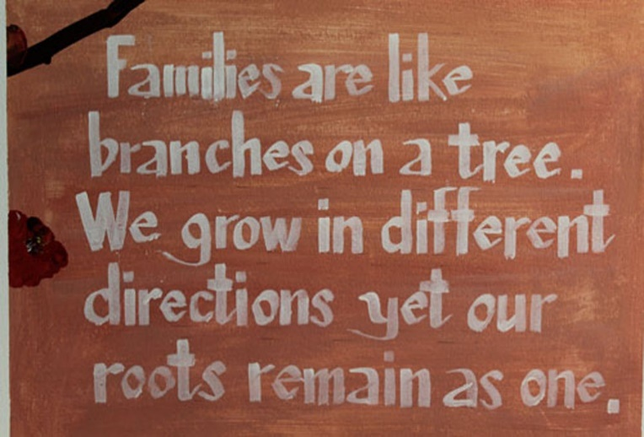

Further Information/Reading

Key Contacts
Custodial Manager Lee Harris – Family and Significant Other Champion

HMP Wandsworth Gov.uk website
Wandsworth Prison - GOV.UK (www.gov.uk)

HMP Wandsworth PACT
HMP Wandsworth | Prison Advice and Care Trust
wandsworth@prisonadvice.org.uk
Visitors Centre: 0208 588 4351 (Monday - Thursday from 8am - 5pm).

Families Helpline
HMP Wandsworth | Prisoners' Families Helpline (prisonersfamilies.org)
Safer Custody Line
If you have a concern about someone in Wandsworth with is urgent but not life threatening call 0208 588 4296 and leave a message
If you have a concern that is life threatening call 0208 588 4358 and ask for the Orderly Officer
HMP Wandsworth Twitter
HMP Wandsworth (@HMP_Wandsworth) / Twitter
HMP Wandsworth 2021 Inspection Report
Report on an unannounced inspection of HMP Wandsworth by HM Chief Inspector of Prisons 13 and 20-24 September 2021 (justiceinspectorates.gov.uk)
HMP Wandsworth Independent Monitoring Board
Home - Independent Monitoring Boards (imb.org.uk)

Lord Farmer Review
6.3664_Farmer Review Report (publishing.service.gov.uk)

