Families and Significant Others Strategy

2018

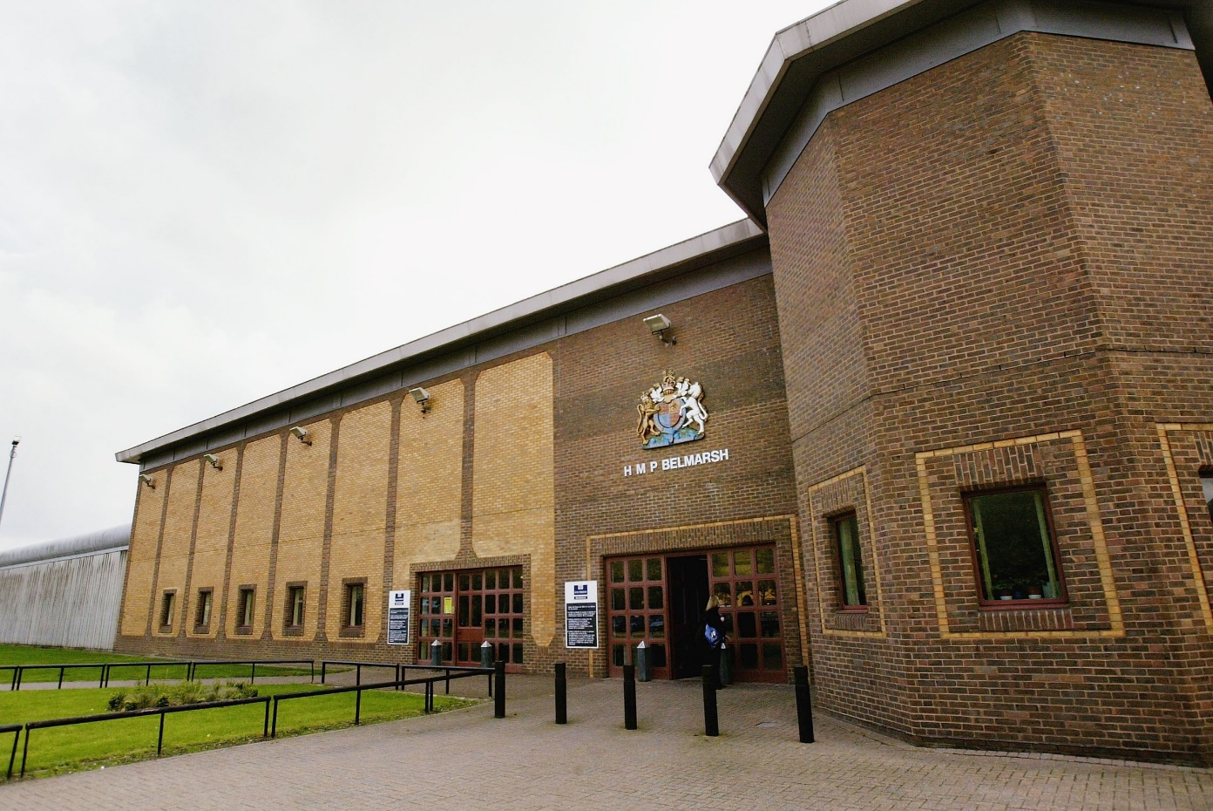
January 2024

HMP Belmarsh
Family and Significant Others Lead: Governor McMonies
Family and Significant Others Champion: Custodial Manager Kemmish.

What is a strategy and why do we need one?
- A strategy is a plan of action which is designed to achieve a long term or overall aim and we need one because without this it would be hard to improve communication, give accountability and ensure that all the team is working towards the same aim.
- At HMP Belmarsh we believe in the report written by Lord Famer and published in August 2017 that having good relationships with either families or significant others is a big part in helping a prisoner to prevent re-offending

HMP Belmarsh became operational on 2 April 1991 and is a high security prison located in the southeast of London which serves the local courts, so we have a diverse mix of prisoners, those on remand and those who are doing short and long sentences until they are transferred to another prison. HMP Belmarsh can hold up to 726 prisoners.

Who are significant others?

Significant others are those individuals who have a close relationship with a prisoner who may be a care leaver or care experienced prisoner:

- Care Leaver – someone who has been in care for a period of 13 weeks or more around their 16th birthday.
- Care experienced refers to anyone who has been in care at any stage of their life, no matter how short a period.

The significant other relationship can positively affect the individual's behavior and attitudes, and significant others could be:

- Friend / Neighbor
- Previous employer
- Previous Teacher
- Spouse or partner

How do I book a visit?

Telephone booking line: 0208 331 4760 or 020 8331 4750
The booking line is open Monday to Friday, 9:30am to 3pm

You can book by email: Belmarsh.visits@justice.gov.uk once we have your email we will endeavor to confirm your booking within 24 hours.

Where do I go when I arrive for my visit?

Below is a picture of the visitor center, this is where you book in and where both the visits’ staff and Prison Advice and Care Trust are available to help answer any questions which you may have.
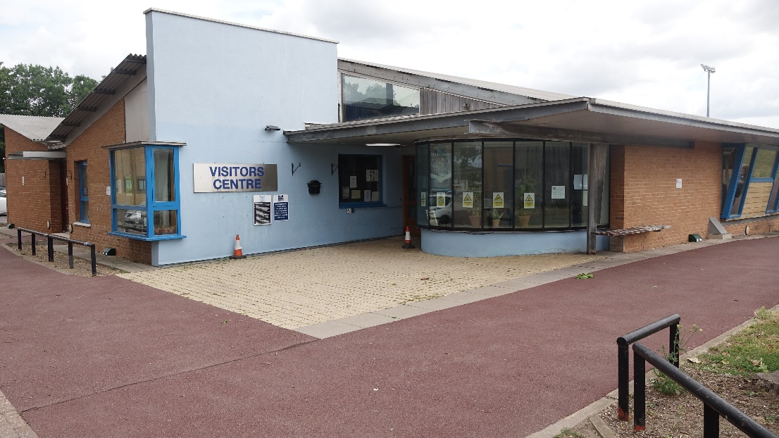
Once you have booked in for your visit, you will then need to proceed to the Visitor Main Search (VMS):

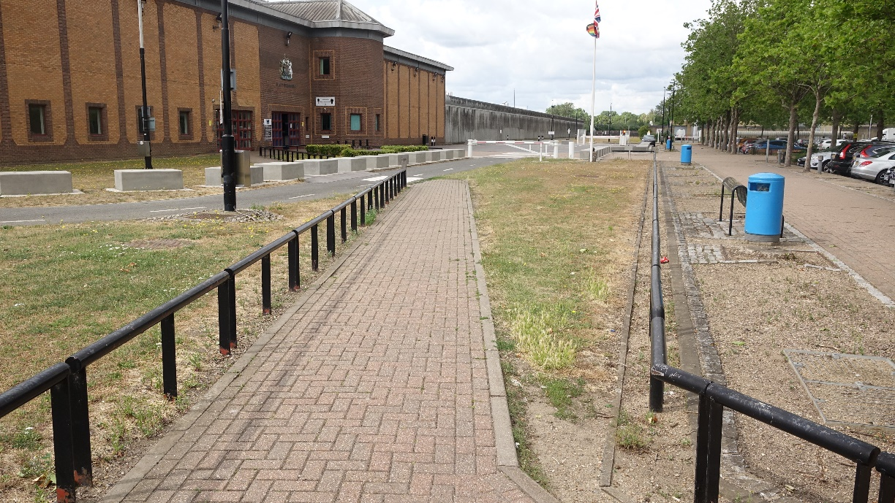

Inside the Visitor Main Search:

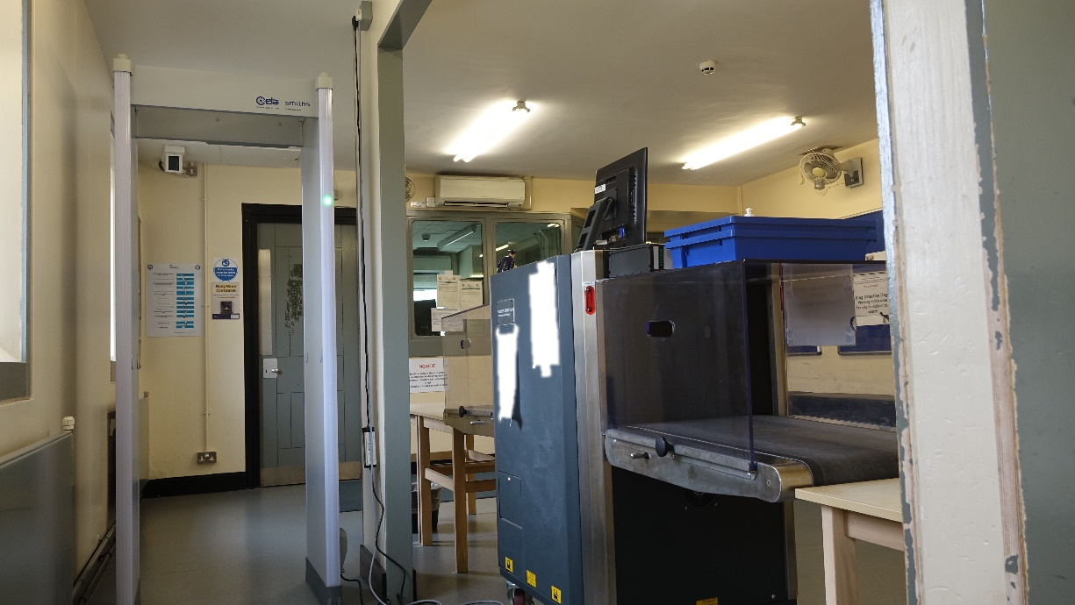

You will then leave the VMS and enter the visits building:

Once you arrive in the visits building, we invite you to take a seat and when called proceed to the visit’s hall, before entering the visits hall you will see passive drug dogs working in this area.

If you are nervous or scared on dogs, when you book in for your visit inform the staff and they will give you a sticker which will alert the dog handlers and staff but please let the dog handler know and they will try and make you feel at ease before and during the search.

You will then proceed to the visits hall where you will remain for your visit:

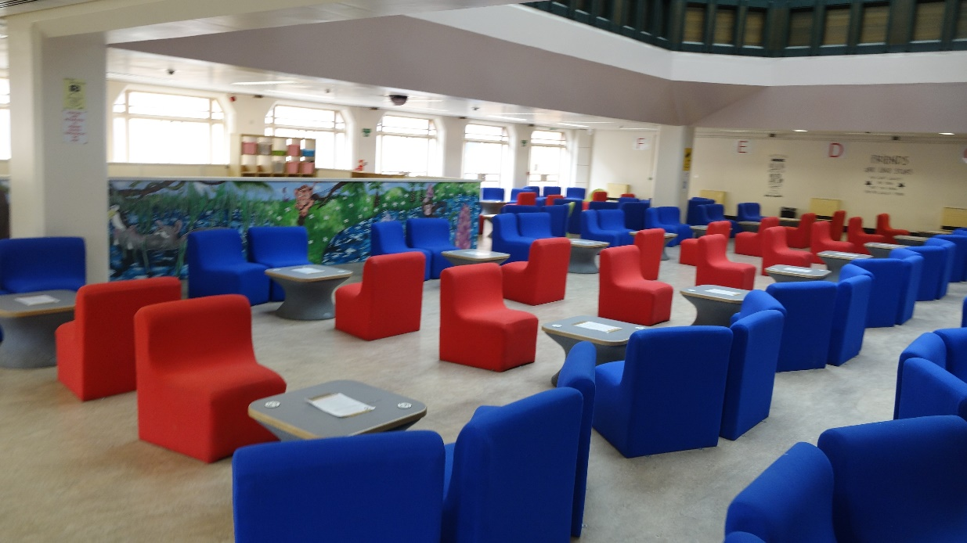

The Creche inside the visit’s hall

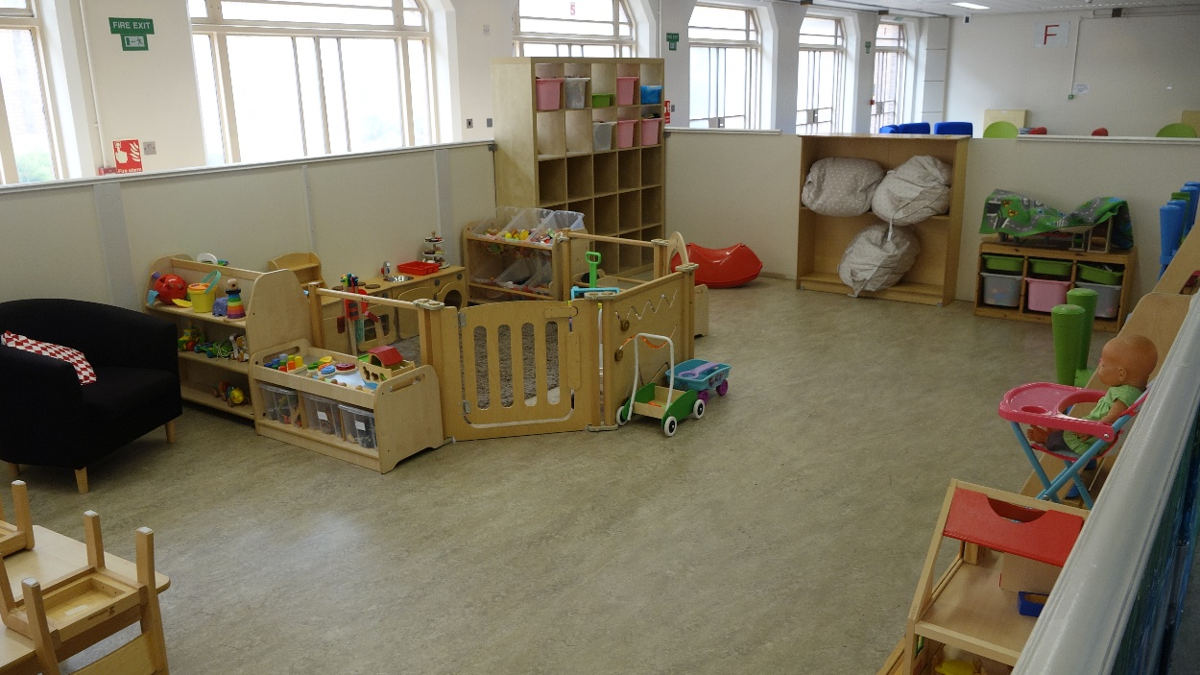

After your visit you will be asked to leave the way which you came into HMP Belmarsh.

Extended Visits

At HMP Belmarsh we have extended visits which are Family Day visits, there are 12 planned for 2023-2024 the family days are different to other visits because you have an all day visit, lunch is provided and the person who you are visiting is encouraged to take part in the organized activities, designed to work together as a team and encourages positive relationships with children and those visiting. These must be applied for by the prisoner in advance.

Additionally, family of listeners are invited for a day and also to attend some graduation ceremonies e.g., upon completion of Listener training or other qualifications.

Prison Video Visits

To have a secure video call with someone in this prison you need to:
- Download the Prison Video app
- Create an account.
- Register all visitors.
- Add the prisoner to your contact list.
How to book a secure video call
You can request a secure video call with someone in this prison via the Prison Video app.
You will receive a notification when your request has been accepted.

Closed Visits

These visits are conducted in a separate area where a large transparent barrier prevents any physical contact.

They are used as a precautionary measure to prevent the smuggling of contraband through Visits.

These are some of the reasons why you will be placed onto closed visits:

- CAT A Prisoners will also be placed on closed visits if their visitors have not been cleared.

- If a pass of contraband has been witnessed during your visit, then you will be placed onto closed visits for a period of three months minimum.

- If the passive dog indicates on the search prior to the main visit’s hall, you will be offered a closed visit if there is room to accommodate and normally you will only be placed onto closed visits for this one visit.

- Security Intelligence

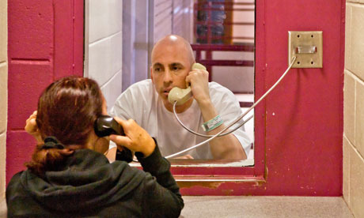

Family Learning & Development

Enrichment activities

if the prisoner applies for them enrichment activities are voluntary activities which will be carried out on your normal visit, in the following room,there is a timetable designed by PACT advertising the activities and once approved you will be taken off your normal visit to complete the enrichment activity on the designated days.

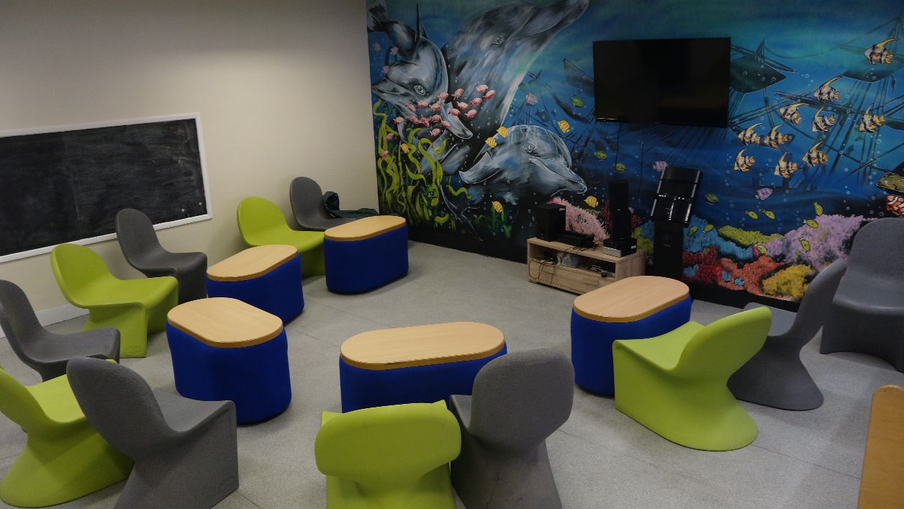

The hope is that taking part in the enrichment activity will strengthen the bond between the prisoner and child. We will publish a timetable every quarter to both visitors and prisoners.

Focus Groups

We also hold focus groups with family members these are chaired by our Visitor Centre Manager and where possible on of the visits management team will also attend. These are held monthly, if you wish to contribute then please contact the visitor center manager in the enrollment center who can advised you further.

Minutes are taken of these meetings and are displayed in the visitor Centre.

Family Service within HMP Belmarsh
Personal Development/1:1
- In-cell workbooks catered to develop skills in maintaining relationships and deal with individual needs
- Providing step by step support planning in achieving goals set through assessment.
- Attend professional meetings and advocate with/or on behalf of the clients on family matters.
Workshops
Group interventions to assist the understanding of family relationships and staying connected. Some examples are:
- “The Book about Dad” and “The Tree of Life” Workshop
- Parenting programs (Family Breakdown/Adverse Childhood Experiences)
- Staying in Touch (SiT) Arts/Crafts/Personalized Items to send home to loved ones.
- Themed seasonal groups around world celebrations/events

Community Family and Significant Others Service
- Family Assessment and 1:1 support
- Signposting to other agencies that could be beneficial for family engagement.
- Family Days and visits hall support
- Parent Groups and Workshops (Pending)

The above is services that are available but are not limited to as all clients are supported around their own circumstances.

What to do if you are worried about a loved one
For a variety of reasons, there are periods in a prisoner’s time in prison when they may become a heightened risk of suicide and self-harm. Involvement and engagement with the prisoner’s family can be useful in helping to support the prisoner through their crisis period.
The Safer Custody team will, with the prisoner’s consent, invite contribution/attendance from families at Assessment in Care Custody and Teamwork reviews, where appropriate.
The Safer Custody team also manage and monitor the Safeguard hotline. This provides families/friends with the ability to speak to a member of the Safer Custody team or leave a message, about any prisoner they have safeguarding concerns about. Following receipt of this phone call, the Safer Custody team will provide all necessary support to the prisoner.
If you have concerns about the safety or wellbeing of a prisoner in Belmarsh, call the safer custody hotline and leave a message. Someone will call you back within 24 hours.
Telephone: 0208 331 4890 the telephone line is checked three times a day to ensure that any concerns are answered at the earliest opportunity.
Email: safercustody-belmarsh@justice.gov.uk
In an emergency, call 0208 331 4781 or 0208 331 4866.

What do we offer for those who do not receive visits?

Each month we run a report from our systems to see who hasn’t received any visits and then we write to them informing them of the support available to them from the

Prison Official Visits scheme: www.naopv.com/

The New Bridge Foundation: www.newbridgefoundation.org.uk/

who both offer a befriending service though visits or pen friends.

Phone calls
Prisoners have phones in their cells but will always have to call you. They have to buy phone credits to do this. The phones are inactive after 10pm, but available at many times during the day.
Prisoners can phone anyone named on their list of friends and family. This list is checked by security when they first arrive so it may take a few days before they are able to call. This can take longer depending on individual cases.
You can also exchange voicemails using the Prison Voicemail service.
Officers may listen to phone calls as a way of preventing crime and helping keep people safe.

Email
You can send emails to someone in Belmarsh using the Email a Prisoner service. You can send messages to your recipient via this website, it takes only a few minutes to sign up and, the message gets delivered to the establishment in the next daily delivery.

Letters
You can write at any time.
Include the person’s name and prisoner number (or date of birth) on the envelope. You must also write your own name and address on the back of the envelope.
All post, apart from legal letters, will be opened and checked by officers.

The Visits Team Managers

Governor McMonies
Functional Head and Families and Significant Others Lead for HMP Belmarsh

Custodial Manager Kemmish
Visits Manager

Supervising Officers M Britton and L Gynn

Kevin Jones
Visitor Centre Manager
Pact

