Family and Significant Others Strategy

HMP/YOI Thorn Cross
Version 1.1 | February 2024



Version Control
Version Author | Karen Griffiths
Version | 1.0
Version Date | 01-02-2024
Final Version Approved By | Robbie Durgan
Date | 06-02-2024

Contents
Our Aim 4
Our Team 4
Our Establishment 5
Our Population demographics at time of writing 03-02-2024 5
Our Strategy 5
Emergency Contact Protocol 6
Contacting Thorn Cross 6
Safeguarding Line 7
Living Here 7
Induction 7
Maintaining Family Ties 8
OMU 9
Visiting Us 10
How to Visit Thorn Cross 11
POPs 13
Getting Help to Visit Thorn Cross 14
Enrichment Activities 14
Family Days 15
Family Forums and Feedback 17
Release on Temporary Licence (RoTL) 18
Vulnerable Groups 20
Resources 22
Glossary 25
Appendix 25

Our Aim
Our aim is to ensure all prisoners in our care who live and work at HMP/YOI Thorn Cross feel safe, and live in a safe, decent and secure community, and whilst at HMP/YOI Thorn Cross they continue to communicate with families and friends.
Thorn Cross aim to put family at the heart of all aspects of life, and the staff and management at HMP/YOI Thorn Cross are dedicated to, and will encourage prisoners to maintain family contact by using the following methods:
- Using the PIN phone system
- Writing to family, friends and loved ones.
- Email-a-prisoner scheme
- Enjoying regular social visits
- Accessing our family days
- By having ROTL
We recognise the importance that maintaining family ties has on reducing reoffending on release, and this principle has informed this strategy. We also recognise how important families are in the improvement of chances and the general wellbeing of the prisoners at Thorn Cross.

Our Team
At Thorn Cross we have a strong, dedicated team to help, including the visits staff who help with booking visits.
HMP/YOI Thorn Cross | FaSO Team
Governing Governor | Robbie Durgan
Functional Lead | Karen Griffiths
Families Champion | CM Austen Smith
Neurodiversity Lead | Andrea Sanderson
Families services | Danielle Upton
Visits Manager | CM Lee Cunliffe

Our Establishment
Our population of prisoners at HMP/YOI Thorn Cross is an eclectic mix of individuals, from a range of different backgrounds and with a diverse range of different needs.
Our Families strategy recognises that Thorn Cross is a group of individuals and that our family offering must reflect this.

Our Population demographics at time of writing 03-02-2024

Population 429
- 7 x Veterans
- 2 x Care Leavers
- 3 x Socially isolated individuals
- 59 x prisoners with a registered disability.
- 1 x prisoner under 21
- 28 x prisoners under 25
- 65 x prisoners are over the age of 50. Our oldest prisoner is aged 70.
- 29 x Prisoners with inderminant sentences
- Our largest age group is 30-39 at 42% of our population
- Our largest group of prisoners are serving between 4-10 years at 58%

Our Strategy
At Thorn Cross we are committed to ensuring that our FaSO strategy is created and informed using appropriate source material and contributing parties.
We therefore commit to working alongside partner agencies to: -
- Review and revise this strategy every 6 months from publication date.
- Additional revisions following recommendations from any future HMIP inspection.
- Survey of prisoners every 6 months
- Survey of visiting families and significant others every 6 months.
- A bi-annual (every 6 months) multi-disciplinary FaSO strategy forum council to inform revised strategies.
Monthly review of strategy to remove any out-of-date information.

Emergency Contact Protocol
There is a secure helpline for family and loved ones to contact the establishment with concerns around self-harm. This is monitored daily and has a voicemail function which is checked throughout the day.
.
There is also an anonymous box in the gate for visitors to raise concerns about self-harm and suicide. This box is checked and emptied daily to ensure that concerns are dealt with promptly. Any applications found will be immediately passed to the duty Orderly Officer in the first instance.
The protocol for contacting a prisoner in an emergency is as follows.

Contacting Thorn Cross
In an emergency or family situation members of the public may contact the establishment and ask to speak with the Orderly Officer. The Orderly Officer is the Duty Manager responsible for managing the prison.
Contact Thorn Cross
01925 805 242

All calls to this number are logged, in order to track progress and ensure accountability and compliance.
As an establishment we will regularly test this line and procedure, to ensure the best experience for families. This will be done monthly.
We have also launched the Online safer custody portal www.prisonersfamilies.org
To support families who have a loved one in custody. Families can raise their concerns to the establishment, and they will receive a response within 72 hours. This does not replace the emergency contact protocol, but non urgent callers will be referred to the portal.

Safeguarding Line
If a family member has concerns about the safety or wellbeing of a prisoner at Thorn Cross, they can either use the portal or call the Safer Custody hotline.
When the Safeguarding line is unstaffed, an answer machine operates which is checked daily by the Orderly Officer.
Safeguarding Line
01925 805 257

Living Here

Induction
Prisoners are welcomed to Thorn Cross in our Reception area by our staff and peer mentors.
Our main aim is to ensure that all men are treated with decency, respect and are encouraged to contact their family to inform them of their location at the earliest opportunity.
All new arrivals will have an induction interview where we will confirm next of kin details, and the prisoner will be advised how to update or add further contact phone numbers to their PIN phone account.
We will also discuss how to book visits at Thorn Cross, and will explain the process to achieving RoTL, should that be something they want to do. Any individual circumstances which mean that extra help and support may be beneficial will be identified at this stage. Foreign national prisoners will receive support to keep in touch with any family and friends abroad. This may include PIN credit in lieu of visits, for example, as well as other support as appropriate.
As part of induction, all men are informed how to access help and support from staff, family, and peer supporters.
The first night for anyone in a new prison can feel strange and difficult, and on some occasions they may feel isolated. The more isolated someone feels, the more difficult their experience of prison is likely to be. For many being separated from their family and friends can be one of the most painful consequences of prison life.
Feeling isolated can also heighten someone’s anxieties or feelings of self-harm, so, having a good network of support is important. Maintaining healthy contact between prisoners and their family and friends is linked both to reducing reoffending and to reducing an individual’s risk of suicide or self-harm.

Maintaining Family Ties
Throughout their time at Thorn Cross prisoners will be encouraged by all staff and our partners to keep in touch with family and friends, and there are lots of way to do this.
Some of our non-discipline departments and partners at Thorn Cross are.
- Chaplaincy Department
- Independent Monitoring Board (IMB)
- Land-based Activities
- Activities team
- Gymnasium
- Healthcare Department.
- NOVUS, our education provider
- Change, Grow, Live – drug and alcohol service provider.
- IAG team
- DWP
- Peer Mentors
Using the PIN Phone System
Telephones are available on the units, and they are available for use on each landing on all of the units between the hours of 07:30 and 22:00.
Instructions for their use are available when the handset is lifted – any problems can be rectified by wing Officers in the first instance.
Writing to family
Mail will be delivered to the establishment each afternoon, Monday to Saturday. The mail is then processed at night to be available to distribute from 07:30.
Outgoing mail should be handed to unit staff throughout the day and will be taken to the Gate each evening. Envelopes should not be sealed; Rule 39 letters should be sealed in the presence of an Officer, and then signed.
Ordinary letters (O/Ls) are available via the wing office; these are free and will be sent 2nd class.
Emailing Family
We also operate an ‘E-mail a Prisoner’ scheme, which now also allows for replies to be sent.
Our Contact Address
If family or friends wish to write to a prisoner here, our address is.

(Prisoner name and prison number)
HMP/YOI Thorn Cross
Arley Road
Appleton Thorn
Warrington
Cheshire
WA4 4RL

OMU
Introductory Induction Meeting
Once the prisoner is settled into their new surroundings, they will be invited to an appointment with their POM in the OMU building. This appointment will be within the first 5 days of arrival at Thorn Cross and during this interview they will discuss their sentence plan. The allocated POM will be available to assist during their stay here, that includes preparing for HDC, ROTL, Parole (if applicable) and being involved in setting license conditions.
As part of sentence planning, prisoners will also be informed of the arrangements for managing the risk of harm they pose to others (including family members), and the avenues available to challenge this in a fair and procedurally just manner.
There are times when families may be asked to support prisoners here at HMPYOI.
Thorn Cross with resettlement planning and this may be on individual invitation or
through one of our many family events. This will be at the request of prisoners through
their Pom or one of the resettlement team.

Visiting Us
Our aim is to ensure all prisoners in our care and who live at HMP/YOI Thorn Cross feel safe, and to continue their rehabilitation through maintaining family ties in a comfortable, welcoming environment.
We will do this by facilitating and overseeing quality family contact in a range of ways that are tailored to meet individual needs and circumstances.
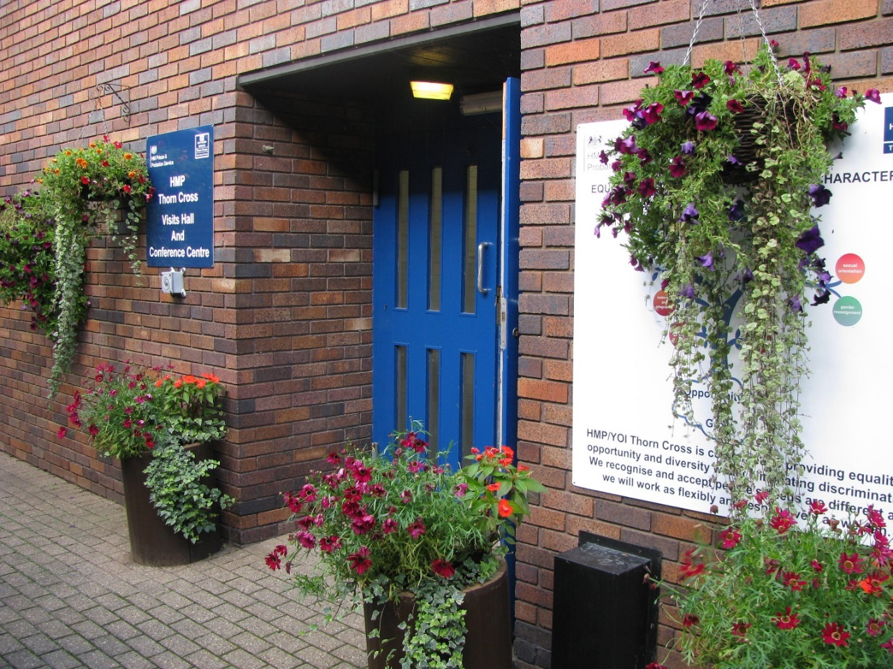

How to Visit Thorn Cross
Visiting times at Thorn Cross are as follows;
Visits Times
Friday afternoon | 13:45hrs to 15:45hrs
Saturday afternoon | 13:45hrs to 15:45hrs
Sunday morning | 09:45hrs to 11:45hrs
Sunday afternoon | 13:45hrs to 15:45hrs

If a prisoner has recently arrived at Thorn Cross, and had visits booked at their last establishment they will be honoured here at Thorn Cross.
We open our facilities to visitors one hour prior to their visit where families can purchase hot and cold refreshments and use toilet facilities.
All visits are facilitated for 2 hours per session.
How Are Visits Booked?
Family can book a visit using the following methods.
By Phone
We have a visits booking line which is open every morning from 830 to 1230 Monday to Friday.
Visits Booking Line
01925 505018

Online
The fastest way to book a visit is using the website below.
Online Booking
www.gov.uk/prison-visits

Larger groups of Families will also be welcomed but will need to be booked in advance.
We have recently developed our visits provision as we are focusing our attention on family time, and we encourage prisoners to get involved with their children’s play therefore we have removed the creche facility and opened a games room which prisoners can access with their children and play together on play stations, pool, and fuse ball tables along with other games that can be played at their own table in visits. We have also opened a garden area with seating that can be accessed when the weather is appropriate, allowing prisoners to book times to be in the sunshine in the garden with their family, they can also purchase a lolly ice. We will continue to review and improve these facilities and we will be introducing an aviary in the spring.
We have also employed our own caterers to provide refreshments during visits that include an array of hot and cold food, drinks, and homemade cakes.

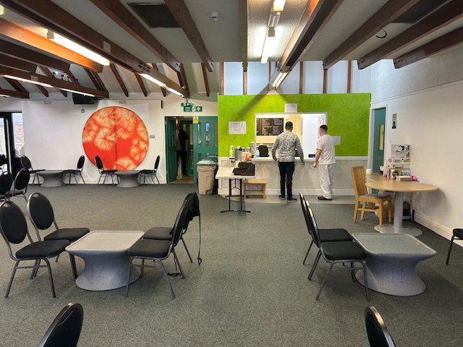

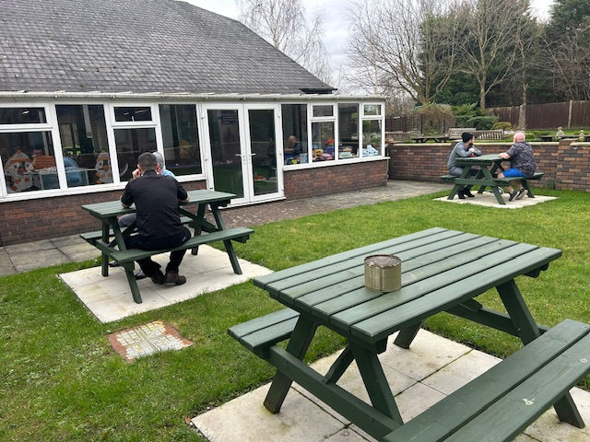

POPs
POPS are our families support provider; they have an appropriately skilled family relationship link worker in place at Thorn Cross. Staff will provide support to men and their families, and develop individual plans as necessary, including for release. The team will also be available for men who are not in contact with their families, or who need support in maintaining relationships with their families. This is advertised around the prison, and OS also refer relevant men to this service.

Our aim is to create a friendly, welcoming environment where together families can meet, laugh and play.

.
We will maintain a well-stocked play area providing a range of age-appropriate toys and activities for children in the visit hall, and we will aim to promote and encourage families to play together.
Visitors should be greeted on arrival to the prison and asked if they require any specific advice or guidance. A meet and greet will be available before visits. Material providing services on advice and support and will be available to meet the needs of many groups irrespective of abilities, languages, and backgrounds.

Getting Help to Visit Thorn Cross
Information regarding Help with Prison Visits scheme (HwPV) enabling families who are struggling financially to maintain contact, is available from the Visits booking team and the staff in POPs. Staff will be on hand and trained to help with any questions or issues that family members may have.

Enrichment Activities
We have improved our enrichment activities to include a range of targeted forums, learning and visiting working with our pops team and our neurodiversity manager, we are moving our quieter Sunday morning visits to include the following enrichment below:
Enrichment Visits/PCV/Purpose themed visits (Sunday AM) –
7th January | Newborn-1Year (Baby) | 7th July | Newborn-1Year (Baby)
14th January | 5-10 PRIMARY | 14th July | 5-10 PRIMARY
21st January | 11-14 HIGH SCHOOL | 21st July | 11-14 HIGH SCHOOL
28th January | TEENS | 28th July | TEENS
4th February | 2-4 YEARS | 4th Aug | 2-4 YEARS
11th February | NEURODIVERSE | 11th Aug | NEURODIVERSE
18th February | HOMEWORK CLUB | 18th Aug | HOMEWORK CLUB
25th February |  | 25th Aug
3rd March | Newborn-1Year (Baby) | 1st Sept | Newborn-1Year (Baby)
10th March | 5-10 PRIMARY | 8th Sept | 5-10 PRIMARY
17th March | 11-14 HIGH SCHOOL | 15th Sept | 11-14 HIGH SCHOOL
24th March | TEENS | 22nd Sept | TEENS
31st March | No Visits Visit | 29th Sept | No Visits Visit
7th April | 2-4 YEARS | 6th October | 2-4 YEARS
14th April | NEURODIVERSE | 13th October | NEURODIVERSE
21st April | HOMEWORK CLUB | 20th October | HOMEWORK CLUB
28th April |  | 27th October
5th May | Newborn-1Year (Baby) | 3rd November | Newborn-1Year (Baby)
12th May | 5-10 PRIMARY | 10th November | 5-10 PRIMARY
19th May | 11-14 HIGH SCHOOL | 17th November | 11-14 HIGH SCHOOL
26th May | TEENS | 24th November | TEENS
2nd June | 2-4 YEARS | 1st December | 2-4 YEARS
9th June | NEURODIVERSE | 8th December | NEURODIVERSE
16th June | HOMEWORK CLUB | 15th December | HOMEWORK CLUB
23rd June |  | 22nd December | XMAS Visit
30th June | Adults Only Visits | 29th December | Adults Only Visits

Prisoners with families who would like to access specified visits are encouraged to inform their families of the facility and book on to the session. There will be less spaces available on the neurodiverse days due to the need for sensory support. The timetable may change to meet the needs of the population, but this will be advertised in advance through our Pops provider.

Family Days
Throughout the year we at Thorn Cross will hold family days, both social and educational. These events will be less formal than social visits we hold a minimum of 6 family days per year, each family day is themed and provides much entertainment for all who take part. We also provide food for the day and often a tour around our beautiful nature trail weather permitting.
Applications to attend these days are sent out by our Pops team
timetable for this year is below.

Family Day Dates (Thursday 10-3)

Date | Events | Themes
15th February 2024 | Valentines | Animals + Children’s mental health week
28th March 2024 | Easter & Eid | Magician + Food
13th June 2024 | Gypsy, Traveller, Roma | Nature + T, G, R + Great big green week + healthy eating week
15th August 2024 | Summer | BBQ + Sports Day + Indian and Pakistan Independence Day
31st October 2024 | Halloween + Black History | Face Painter + BHM
Monday 23rd December 2024 | Christmas | Santa + Christmas + Hanukkah

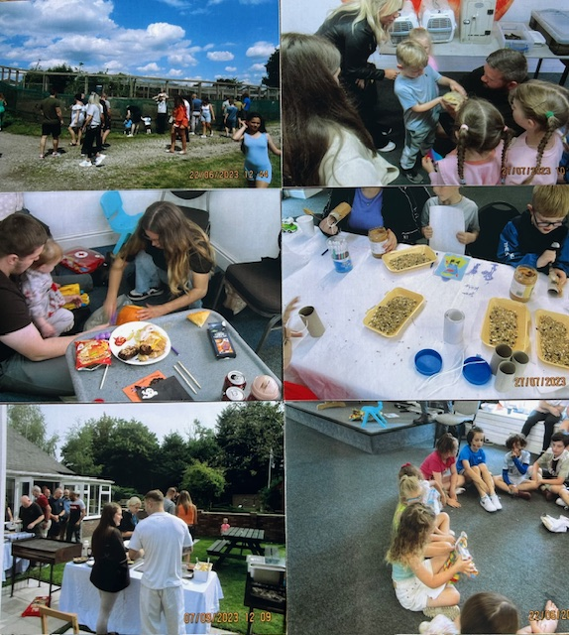

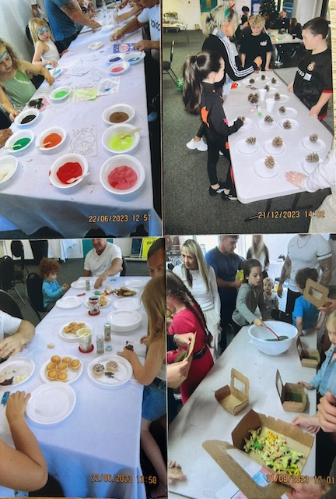

Family Forums and Feedback
Family forums give family visitors, prisoners, and prison managers the opportunity to meet and discuss relevant issues around visiting the prison.
The forums take place bi-monthly and are followed by a tour of the establishment (weather permitting) and a family visit. Family workers will also attend be on site to allow those with children to attend.
We will also ensure that families and significant others unable to stay or attend the establishment are able to join, by conducting Family Forums via online meeting platforms.
Bookings for attendance at the family forums is facilitated by Pops. Every effort will be made for relevant managers or a representative from that department to attend the forums where families have raised concerns to give clarity, support and confidence that we review our processes appropriately.
Surveys will also be produced and sent to visitors and prisoners every 6 months. We will keep minutes from Family Forum events and meetings and create action logs to ensure all learning and feedback is turned into real change and growth.
Family Forum Dates (Friday PM) –
22nd March 2024
17th May 2024
12th July 2024
20th September 2024
15th November 2024

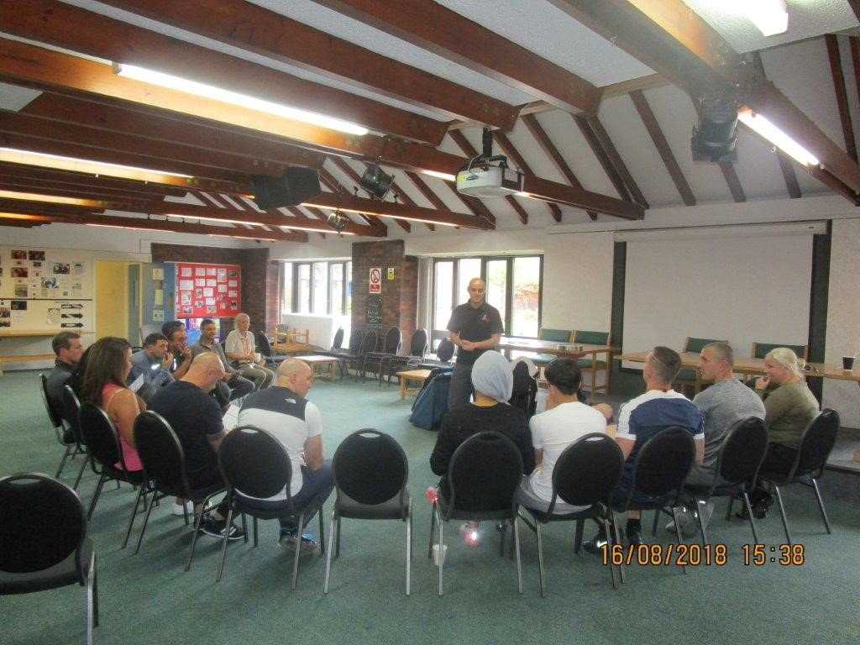

Release on Temporary Licence (RoTL)
All Prisoner who come to Thorn Cross may be subject to receiving RoTL to maintain family ties. These RoTLs will be in the form of Resettlement Day Release (RDR) and Resettlement Overnight Release (ROR).
How Do Prisoners Apply for RoTL?
The prisoner’s POM will advise when they are allowed to apply for ROTL. They then complete an application form called the ‘ROTL-APP’. Before ROTL can be considered an OASys (Offender Assessment System) review must have been completed. For certain men (Restricted ROTL) a report prepared by psychology is required. This was originally called the ‘psychology review report’ and is now called the Enhanced Behaviour Monitoring review (EBM Review). (See Q 3)

It’s very important to fill the application form out as fully as possible giving details of what they will be doing on each day on ROTL and at what time. To apply for ROTL to a home area they will need to provide the name and address of the person requested to stay with and a contact telephone number, so that the Prison can contact the prisoner while they are on Rotl. This should be a mobile number.

How Many RDRs and RORs Do Prisoners Receive?
The Rotl board will decide how many to recommend based on individual risk and need. The ROTL board will consider the length of sentence and how long left to serve before final release date or parole hearing.

The prisoner’s POM will discuss frequency with the prisoner. All RoTL must be linked to sentence plan targets and resettlement goals, and this must be demonstrated when completing the RoTL application form.

Resettlement Day Release (RDR)
Prisoners will progress gradually onto ROTL. This may mean that the first few periods of ROTL may be to the local area and will mean that family will have to come to the local area where ROTL is taken. Most are likely to be straight to your home area for RDR. There will be a gradual increase on frequency, duration, and location of ROTL and this will be decided by the board.

At Thorn Cross all prisoners are treated on an individual basis with regards to RoTL applications, and therefore no two RoTL decisions will be the same - there may be restrictions, exclusion zones and requirements to report to their COM or the police. Nevertheless, we are committed to ensuring we demonstrate our thinking and rationale and will strive to be procedurally just.

Resettlement Overnight Release (ROR)
- When eligible, prisoners will need to provide an address which will be checked by the COM and the Police. In some cases ROR will be taken at a Probation approved premise.
- The first overnight ROTL may only be approved for 2 nights. If this goes well the next ROR may be 2 nights and finally extending to 4 nights. This will be judged on a case by case basis.
- If the prisoner is serving a short sentence they may not have time to progress onto ROR or may only have one two-night ROR.
- All prisoners on ROR will have an evening curfew of 11pm to 6am. In cases where the COM has asked for a longer curfew this will overrule the 11 – 6 curfew. This curfew is part of the ROTL policy and has been added to the license by the policy group.
- The Prison will complete telephone compliance checks whilst on ROTL.
- Failure to respond to a telephone compliance check will result in sanctions, and potentially suspension of ROTL.

Vulnerable Groups
Our aim is to ensure all prisoners in our care who live and work at HMP/YOI Thorn Cross feel safe, and
Men Without Family Support
Some men may not have any family or friends to turn to at difficult times. For those men, alternatives include Prison Visitors and pen pal schemes. Other forms of support if they need someone to talk to include Peer Mentors and the Samaritans (if required).
The establishment will capture and record the number of prisoners who do not receive visits, and do not visit their families via RoTL. The information will be updated every 6 months as a minimum.
These ‘socially isolated’ individuals will be interviewed by a Prison Officer on their wing, who will alert a CM to any concerns. A referral to an outside agency will either be made or discounted, and the reasons for this made.
We will manage and promote family liaison meetings and will help prisoners to re-establish contact with family and friends where it is appropriate to do so, providing support and advice in making initial contact with family and friends. Those who do not get visits at Thorn Cross will be monitored and supported.
We currently have 3 prisoners identified as having no support, they are supported through Pops and our Reducing Reoffending and OMU team.

Care Leavers
HMP/YOI Thorn Cross will provide support, signpost to external groups, and assist with issues faced by prisoners in this group. This will be managed by the Reducing Reoffending department. The Care Leavers lead at HMP YOI Thorn Cross is CM Austen Smith. We have a separate strategy for care leavers, and we currently have 2 prisoners who have confirmed that they are care experienced. We have arrangements in place for their Personal advisor (PA) to visit them when required and this is facilitated in the OMU meeting room or domestic visits, care leavers will not use a visiting order (V.O) for this visit. We also have arrangements in place that allows calls to the PA at the expense of the establishment.
Veterans
HMP/YOI Thorn Cross will provide support, signpost to external groups and assist with issues faced by prisoners in this group. The Safer Living department will work with Residential Units and the Prisoners to provide support to those veterans in our custody who benefit from extra help.

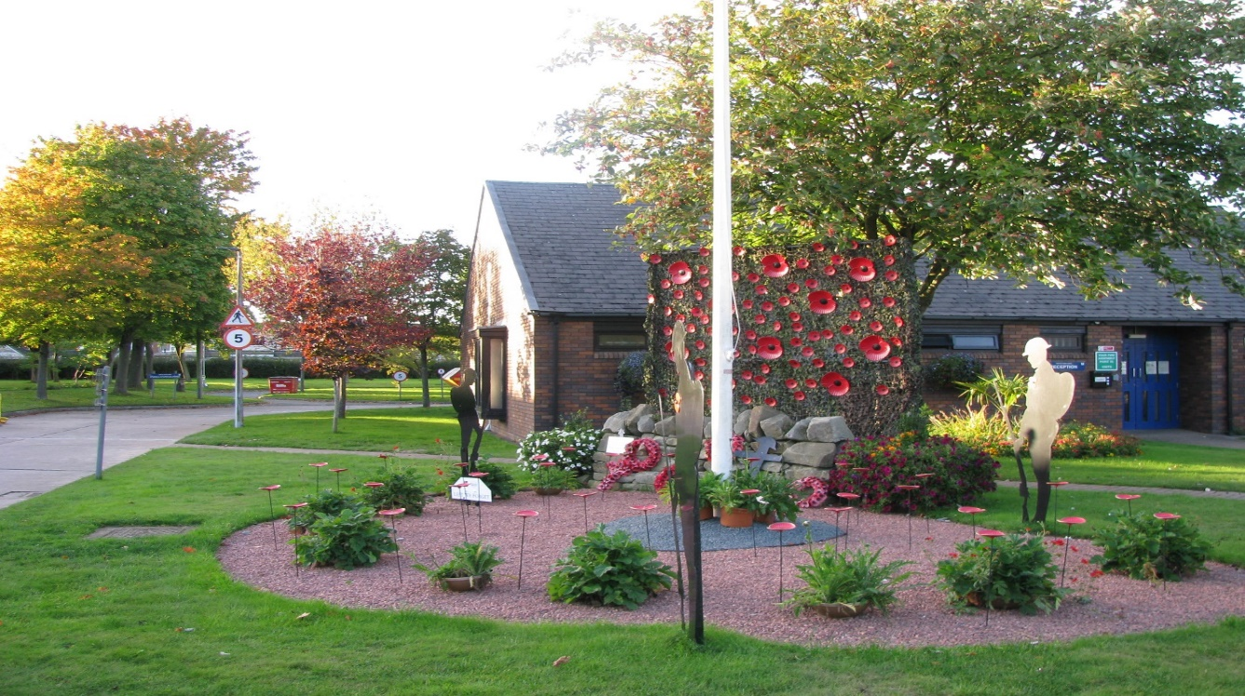
Older Prisoners
HMP/YOI Thorn Cross will provide support, signpost to external groups, and assist with issues faced by prisoners in this group.
Gym sessions should be tailored to meet the needs of older prisoners. Appropriate and suitably tailored accommodation will be sought and provided where this is beneficial to the prisoner.
Protected Characteristics
At Thorn Cross prisoners with protected characteristics have fair and equal access to opportunities to engage with family and significant others. We hold bi-monthly forums for each characteristic and a nominated manager leads on each group. Minutes are kept by safer living team and available to all. IMB are invited and attend frequently.

Resources
Support Available
There are various organisations that can provide support to those in prison, your families and staff.
Organisation Name | Description | Contact
Prisoners’ Family & Friends Service   | Prisoners' Families and Friends Service (PFFS) provides practical help for prisoners' families | 0808 808 3444  http://www.pffs.org.uk/  forwards to https://www.prisonadvice.org.uk/
Offenders Families’ Helpline  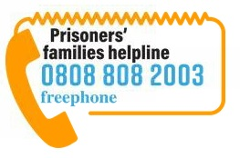 | Provides support to families on all aspects of arrest, court and prison including information and support about visiting family members in custody | 0808 808 2003  http://www.offendersfamilieshelpline.org/  forwards to https://www.prisonersfamilies.org/
PACT | PACT supports people affected by imprisonment. They provide practical and emotional support to prisoners' children and families, and to prisoners themselves. | 0207 735 9535  info@prisonadvice.org.uk  http://www.prisonadvice.org.uk/
Partners of Prisoners (POPS) | POPS provide information and support to the families of prisoners from their earliest contact with the criminal justice system, through to release and beyond. | 0161 702 1000  mail@parnersofprisoners.co.uk  http://www.partnersofprisoners.co.uk/
Prison Reform Trust   | PRF run an advice service for prisoners which can give information on various issues including family contact. The service is for prisoners only. | 0808 802 0060  Prison Reform Trust  FREEPOST ND 6125  London  EC1B 1PN  http://www.prisonreformtrust.org.uk/
Barnardos   | Provides support to the children of prisoners and run IHOP (Information Hub on Offenders’ families with children for Professionals) is a one-stop information and advice service to support all professionals in working with children and families of prisoners, including frontline staff, strategic managers and commissioners. | 0208 550 8822  http://www.barnardos.org.uk/  http://www.i-hop.org.uk/  https://www.nicco.org.uk/
National Association of Official Prison Visitors   | Prison visitors are volunteers who offer friendship and support to prisoners whilst they are in custody. | info@naopv.com  https://www.naopv.com/
Bridging the Gap  Penpal Scheme   | Bridging the Gap offers advice and help to people wishing to write to prisoners and currently oversees over 3,000 penpals | 020 8090 1486  info@btguk.org  http://www.btguk.org/index.php/home
British Penpals   | British Penpals run a scheme for emailing US and UK prisoners | British Penpals  36 The Kings Gap,  Hoylake,  Wirral  CH47 1HF  United Kingdom.  https://www.prisonerspenfriends.org/about
Footsteps 2000 Lt   | Provides emotional support, training and information to the families affect by a loved one’s substance misuse. | info@footstepsforfamilies.org  01925 244524  https://www.footstepsforfamilies.org.uk/footsteps-support-drugs-and-alcohol-abuse

Glossary
Our aim is to ensure all documents are easily understood by all who use them.
We have therefore included this section to help explain some terms used in this document.

Glossary Table
CM | Custodial Manager
IPP | Indeterminate sentence for public protection
OMU | Offender Management Unit
RDR | Resettlement Day Release
ROR | Resettlement Overnight Release
RoTL | Release on Temporary License

Appendix
The following resources and reference materials were consulted or used to inform the writing of this strategy.

Organisation Name | Contact
 | https://www.gov.uk/guidance/thorn-cross-prison
 | https://www.prisonadvice.org.uk/hmp-thorn-cross
 | https://www.doingtime.co.uk/hmp-yoi-thorn-cross/
 | https://www.prisonphone.co.uk/prison-finder/thorn-cross-prison/

HMIP Information
 | https://www.justiceinspectorates.gov.uk/hmiprisons/our-expectations/prison-expectations/rehabilitation-and-release-planning/children-and-families-and-contact-with-the-outside-world/
 | https://www.justiceinspectorates.gov.uk/hmiprisons/goodpractice/?goodpractice-expectation=children-and-families-and-contact-with-the-outside-world

Families and Significant others Action plan 2024-2025
 | Task A Task | Owner | Notes | Dependencies | Deadlines | Rag
1 | Develop family days | K Griffiths | Create schedule | 6 per year | 10-02-24
 | valentines | D Upton  D Daniels | Animals + Children’s mental health week |  | 15th February
 | Easter/Eid | D Upton  D Daniels | Magician + Food |  | 28th March
 | GTR | D Upton | Nature + T, G, R + Great big green week + healthy eating week |  | 13th June
 | Summer holidays | PEIs D Upton | BBQ + Sports Day + Indian and Pakistan Independence Day |  | 15th August
 | Halloween/Black History | D Upton  Alex Smith | Face Painter + BHM |  | 31st October
 | Christmas | D Upton | Santa + Christmas + Hanukkah |  | 23rd December
2 | Enrichment visits | D Upton  A. Sanderson
 | Create schedule | D Upton | Review regularly with population and popularity |  | 10-02-24
 | Hold ND forum | D Upton  A. Sanderson | Held on 30-01-24  Nil attendance, include in next Family Forum |  | 10-02-24
3 | EID | D Daniels/Shoaib |  |  | 28-03-24
 | Plan evening feast with families to celebrate Eid | D Daniels/Shoaib |  | Check staffing and interest at forum
4 | Lifer Day | K Griffiths  S Costello |  |  | 31-10-24
 | Hold Lifer forum to gauge interest | J Grayson
 | Plan event | J Grayson  S Costello |  | Check staffing
5 | Fresh Start | Sinnott
 | Introduce programme | S Sinnott | Planned for 8th March 23 |  | 30-04-24
6 | Literature for visits. | D Upton H Gordon
 | Increase reading provision in visits | D Upton H Gordon | Complete | Review quarterly | 30-04-24
7 | Develop visits Environment | A Smith/K Griffiths
 | Planned Aviary | A Boscarino/ F Ormesher | Area identified planning ongoing |  | 30-04-24
 | Improve seating area  Soften environment | A Smith/  K Griffiths | Additional play area improvements, order projector and gaming area |  | 30-06-24

