

**HMP**

**Whatton**

**Families**

**and Significant Others**

**strategy**

Caroline Vine

Governor

Full

Review

Due

:

October 2025



|  |  |
| --- | --- |
| **Date Effective From:** | October 2023 |
| **Full Review Due:** | October 2025 |
| **Updates Made By:** | Peter Wright Head of Operations |
| **Policy Agreed By:** | Caroline Vine, Governing Governor |
| **Responsible Managers:** | SMT |

**Contents**

**Introduction ..................................................................................................................... 1**

Background ................................................................................................................. 2

Definition of “Family” ................................................................................................... 2

Benefits of “family & significant others” ....................................................................... 2

Lord Farmer report ...................................................................................................... 3

1. **Partnership working………………………………………………………………………… 4**

1. **Understanding and supporting family needs............................................................ 5**

**Maintaining contact**

* 1. written correspondence
  2. Email
  3. Telephones
  4. Visits
  5. Secure video calls
  6. Family visits
  7. Normalisation
  8. Faith and community support

**3.Developing & maintaining positive relationships ................................................... 10**

**4.Breaking down barriers ............................................................................................. 12**

**5. Getting to Whatton NG13 9FQ…………………………………………………………… 14**

Safer custody hotline

What prison life looks like

# Introduction

Providing a safe, Decent and Secure environment, which contributes to Reducing Reoffending by promoting hope and reform by effectively utilising and developing the skills of our people. We provide a rehabilitative regime for resettlement and reception prison, which will encourage those in our care to ‘change their lives, by turning them around’.

**Roles and responsibilities**

The lead for Families and Significant other is **Head of Operations Peter Wright** with **Custodial Manager Gavin West as the Deputy.**

All staff will be responsible for adherence to the Family and Significant Others Strategy. The Senior Management Team and Managers will be responsible for ensuring that it is being followed.

**Head of Operations Peter Wright**

* The Head of Operations is the policy owner and will provide assurance to the Governor.
* To ensure that all aspects of this policy is being followed.
* Ensure that the policy is in place and reviewed when required.
* Discuss monthly family and significant others at the Reducing Reoffending meetings with the relevant people.



* Create and review a live action plan, ensuring progress is made against all objectives.
* To hold consultation groups with prisoners about visits.
* To ensure that children have information about the searching process explained to them in a format they can understand.
* To complete 2 visits needs analysis per year.
* Monitor and amend visits times based on the needs of the population.
* Ensure that visitors of the prison are aware of how to raise a concern about their loved one/report wrongdoing.
* Quarterly testing of the visits booking arrangements to ensure that a weekday visit can be booked in the following week and weekend visits for at least the 2nd weekend after the call.

**The Family Service Provider PACT**

* Provide a service in line with contractual arrangements.
* Complete an annual visitor survey.
* To support prisoners and their families/significant others to have healthy, supportive, and meaningful relationships.
* Support prisoners and their families with a wide range of issues and barriers that are associated with having a parent/family member in custody.
* Provide support for those that don’t receive visits.
* Enrichment days for those in custody that have no contact outside the prison walls.

**Head of OMU Delivery/Services and Head of Residence and Services**

* Ensure that keyworker plans include family and significant others consideration and
* To train keyworkers in the importance of maintaining Family and Significant Other relationships.

To ensure that strategies for Young Adults and Care Leavers consider aspects around Family and Significant Others.

#### Background

Supporting a prisoner to develop meaningful and constructive relationship with his or her family or significant others should be a primary focus for anyone caring for those in custody who hope to achieve positive change and transform lives. Family and significant relationships are considered as a key means by which we can prevent reoffending and reduce the likelihood of intergenerational crime. HMPPS therefore has a moral and ethical responsibility to assist any meaningful and constructive relationship in preparation for their release.

We are committed to transforming prisons into places of safety and reform and we recognise the need to provide those in our custody with stable environments, as well as opportunities to change their behaviour and turn away from a life of crime. Relationships with families and significant others can play a key role in this.

#### Definition of “Family”

For this strategy document, ***Family*** is defined as either a blood relative, legal, or significant persons that a prisoner identifies as their next of kin. For care-leavers this may be someone that provides a statutory service, friend, or associate. Many of those in custody will have experienced a nontraditional upbringing, with a range of adults having cared for them, and similarly those in custody with children may have other arrangements outside of a traditional family arrangement. It is important to accommodate all ‘family’ arrangements where they provide a constructive and supportive relationship for the prisoner and their family.

We recognise that not all family relationships are positive. Family members may sometimes be the direct or indirect victims of a prisoner’s offence such as domestic abuse. These individuals have the right to protection from their perpetrator and in all cases, permission should be sought from the victim and any relevant partner agencies before making contact. This will enable the victim/family unit to be supported in the community. E.g., Victim Liaison Officer or Local Authority Adults Social Care/Children’s Services

Other family or significant others may be enablers, contributing to their offending behaviour. Prisoners may be subject to harassment or restraining orders and the courts take primacy in how we manage familial and other relationships. We must therefore ensure that we prevent inappropriate contact.

#### Benefits of “family & significant others”

Families and significant others can play a vital role in facilitating a safer and calmer atmosphere within the custodial establishment and they play an important role in supporting offenders on community sentences. Prisoners are less likely to reoffend if family relationships are maintained throughout their sentence.

Positive family relationships are also likely to contribute to good order within an establishment. Anecdotal evidence from establishments with positive family engagement programmes indicate reduced incidents of disorder and anti-social behaviour. It is likely that having meaningful and constructive relationships with family and significant others while in custody may reduce anxiety, mitigate the frustration and isolation of imprisonment, and potentially reduce violence. Bringing families closer to a prisoner and encouraging them to be more accountable for their offending and behaviour, and thereby improve reducing reoffending outcomes, but more research is needed in this area.

#### Lord Farmer report

In September 2016 Lord Farmer report, The Importance of Strengthening Prisoners Family Ties to Prevent Re-offending and Reduce Intergenerational Crime***1*** in partnership with the membership charity Clinks, was commissioned by the Government to investigate how connecting prisoners with their families can improve offender wellbeing, assist in keeping the public safe and reduce reoffending.

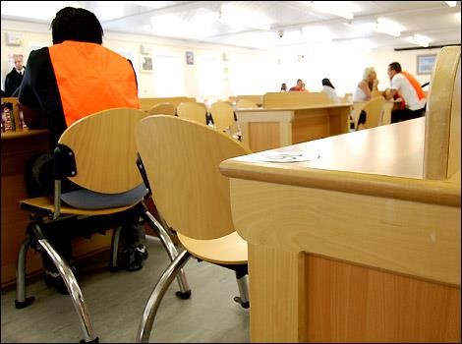

“I do want to hammer home a very simple principle of reform that needs to be a golden thread running through the prison system and the agencies that surround it.



1

[https://www.gov.uk/government/uploads/system/uploads/attachment_data/file/642244/farme](https://www.gov.uk/government/uploads/system/uploads/attachment_data/file/642244/farmer-review-report.pdf)

[r](https://www.gov.uk/government/uploads/system/uploads/attachment_data/file/642244/farmer-review-report.pdf)

[-](https://www.gov.uk/government/uploads/system/uploads/attachment_data/file/642244/farmer-review-report.pdf)

[revie](https://www.gov.uk/government/uploads/system/uploads/attachment_data/file/642244/farmer-review-report.pdf)

[w](https://www.gov.uk/government/uploads/system/uploads/attachment_data/file/642244/farmer-review-report.pdf)

[-](https://www.gov.uk/government/uploads/system/uploads/attachment_data/file/642244/farmer-review-report.pdf)

[report.pd](https://www.gov.uk/government/uploads/system/uploads/attachment_data/file/642244/farmer-review-report.pdf)

[f](https://www.gov.uk/government/uploads/system/uploads/attachment_data/file/642244/farmer-review-report.pdf)

That principle is that relationships are fundamentally important if people are to change. “

*LORD FARMER REVIEW 2017*

# 1. Partnership working

Delivering effective family practice cannot be achieved in isolation and as such we are committed to working in partnership with key local and national stakeholders. Through close working arrangements we can provide a bespoke service that is able to cater to the needs of prisoners and their families during their time in custody and then following on into ongoing support after release.

PACT is the provider for family services at HMP Whatton and as such are key stakeholders, for delivery of this strategy. Quality of outcome will be determined via agreed KPI, which are monitored at regular contract meetings.

### 2. Understanding and supporting family needs

**Maintaining Contact**

There are several ways prisoners can maintain contact with their families including: -

* Written correspondence
* Email
* Telephone
* Social Visits
* Secure Video Calls
* Normalisation
* Chaplaincy and Faith Support

##### 2.1 Written Correspondence

Prisoners are entitled to one letter at the expense of the prison per week. Stamps can be purchased through canteen or sent in by friends and family and there is no limit to the amount of mail that prisoners are permitted to send, provided they are able to fund postage costs.



All mail is subject to searching as per the security arrangements contained in the Local Security Strategy (LSS).

Those subject to Public Protection may have further restrictions on who they can correspond with, but they are advised of this and given additional support if this leaves them socially isolated.

On reception, each person who is new into custody will be asked if they wish to share their significant others email address so information on HMP Whatton can be sent electronically. This information will contain details on how to book visits, what is the regime on offer and other important details about the prison.

##### 2.2 Email

There is a facility for friends and family to send an email and photographs to any prisoner in custody. Messages to prisoners can be sent via the www.emailaprisoner.com website, it takes only a few minutes to sign up and, the message is then printed out and delivered to the prisoner. The cost is 40 pence per message. This method is quicker than sending a letter through the mail the details of this scheme are available on request.

##### 2.3 Telephones

Whilst telephones have been in operation in prisons for several years, HMP Whatton is fortunate to have In Cell Telephony (ICT) in most of its cells. This enables prisoners to contact their families at any time they are locked in their cells (including night-time). Prisoners can purchase phone credit as part of the ‘canteen’ spends, including when under restrictions through IEP or any Discipline awards. If, for some reason they are not working, they still have use of their telephones on the wing landings.

##### 2. 4 Visits

All methods of maintaining contact are of value, however we recognise nothing is as important as the face-to-face interaction of a visit. Our visits areas have recently been refurbished and provides a vibrant opportunity for families and friends to interact. To book a visit, call 01949 803 200, you must have visited at least once by the prisoner prior to being able to book a visit yourself.

We have a facility in the visits for food, this is for all prisoners and families who visit HMP Whatton. Payments for this service are card or cash and is priced to be affordable for all families, a maximum of £25 in coins is also permitted.

##### 2.5 Secure Video Calls

The Secure Video Calls keeps you and your loved one connected with a fully secure and compliant platform used within secure establishments. To use this, you need to download the app. You will need an iOS or Android device to get started. You can download the app from the App Store or Google Play store onto your device. You will then need to register for an account. You will be required to verify the email address you entered when you created an account. Within the verification email you will receive a unique code that confirms your email address. The next step for your new account is to verify your Identity. This process requires you to upload identification and a photo that ensures your information is correct and will help identify you when you are on a video call. Once you have submitted your identification this will be processed and is usually completed within 48 hours. Then you can start adding contacts. A contact is a person that you know in custody who you would like to have a secure video call with. You will need the person's Prison Number to be able to add them to your account.



prison app user guide.odt



Having a Secure Video Call is cost effective, meaning that lack of funds will no longer restrict visual contact.

##### 2.6 Family Visits

Parallel and family visit sessions are run 6 times a year. Prisoners and their families can apply for these special sessions, which allow prisoners to spend quality time interacting with their children/ family in a more relaxed and informal environment.

Approval for these sessions is dependent on the prisoner meeting certain criteria, such as custodial behaviour and whether they are subject to any public protection measures. We do not exclude based on IEP status.

##### 2.7 Normalisation

Whilst acknowledging that prison keeps a boundary between prisoners and the community, we are keen to provide as much normality as possible. This includes utilising partnerships to enhance the regime, including visits by public speakers (local and national), to ensure prisoners can interact and maintain their social skills.

## 2.8 Faith and Community Support

The Chaplaincy Department at HMP Whatton offers pastoral support to our prison community and enable faith and spiritual development. They offer support to all prisoners (regardless of religion) and visit all new arrivals during their early days in custody to identify any pastoral needs or faith issues. They also inform the new arrivals about the faith and pastoral support available and advise them how to contact the team. Where necessary and appropriate they can contact their families to ensure that they know their current location; they also support early days and the safety team who are the central point of communication during that settling in period.

The team provides ongoing pastoral support and will respond appropriately to pastoral need such as family illness or bereavement; The Chaplaincy keeps in contact with families during serious illness and bereavement, they also help prisoners to apply to attend the funerals of a loved one or visit a seriously ill family member in hospital (depending on eligibility criteria). The Faith Centre is a pastorally appropriate space to allow a prisoner to mourn a loved one, light a candle and spend some quiet time away from the pressures of a residential wing.

The Chaplaincy Department also run a Prison Visitors Scheme primarily for people that do not receive social visits from family and friends. They team also hold a busy programme of Faith Activities including services of worship and teaching programmes throughout the week, supporting personal and spiritual wellbeing as well as helping with specific issues relating to a prisoner’s faith journey and practice. The Chaplaincy Department are also happy to provide resettlement support prior to release particularly in relation to providing links to Faith groups within the local community.

Prisoners can contact the team via:

* During pastoral wing visits
* Asking a member of staff on their wing.

There is normally a member of the team available that same day.

##### Understand

To tailor HMP Whatton’s delivery of family practice and ensure its effectiveness we 1st need to understand the needs of the population.

To achieve this, we will conduct regular information gathering exercises from which we can derive key themes.

* Annual establishment needs analysis.
* 2 visitor surveys per year
* Forums with the families and/or significant others of men held in our care.
* Forums with prisoners held at HMP Whatton
* OMiC Key worker and POM feedback sessions linked to sentence plans.
* Commissioned analytical assessment of needs via independent academic bodies.
* National & Regional data sources i.e., Office for national statistics, Nottinghamshire safety board data etc
* MPQL

##### Support

A family member or significant other entering custody often causes significant upheaval to families, particularly children’s & dependents, and as a result it is vital that we stabilise and support the family unit where possible and as soon as possible.

Providing key information and support at the point of arrival for both prisoner’s and their families is critical to maintaining family ties effected or displaced by custody, as is establishing effective avenues of communications allow that information flow and support to continue.



**HMP Whatton will achieve this via:**

Prisoners

1. Screening for issues and concerns during reception process,
2. Screening for issues during the reception & 1st night process. Where issues are identified they are either resolved (where possible) or signposted to the appropriate agencies who can help.
3. Providing effective and practical information to new arrivals to support them maintaining communication with their families and significant others including:
   * PIN phone process and commutation compact
   * Prisons mail system
   * E-mail a prisoner.
   * Prison Voicemail
   * Visiting times and process

Providing effective and practical information to new arrivals to help them adjust to a custodial environment.

1. Providing peer-led advice and support from the point of arrival

Families

1. Providing positive and practical key information to families through documentation and via communication with PACT such as
   * Methods of communication
   * Transport and travel information
   * Location and geographical information
   * Visiting times and process
   * 1st visit induction 1:1 meeting with Pact team

iii. Supporting families who are experiencing difficulties with either emotional support or practical advice.

1. A 24hr safer prison phone line where families can raise concern about loved ones and receive contact from staff in return to address these concerns and fears.
2. Pact runs the national Prisoners' Families Helpline, a free and confidential service which offers practical and emotional support, information, and advice to anyone who is affected by imprisonment, in a straightforward, non-judgemental way. You can reach the Helpline on 0808 808 2003 (freephone - including most mobiles).

The Helpline is open 9am – 8pm Monday to Friday and 10am – 3pm Saturday, Sunday, and bank holidays (excluding Christmas Day & Boxing Day).

You can also email the helpline team on info@prisonersfamilies.org.

To contact PACT Family engagement staff for advice and support call 019498033564

# 3. Developing & maintaining positive relationships

##### Developing relationships

We recognise that not all family relationships are positive. Family members may sometimes be the direct or indirect victims of a prisoner’s offence such as domestic abuse. These individuals have the right to protection from their perpetrator and in all cases, permission should be sought from the victim and any relevant partner agencies before making contact. This will enable the victim/family unit to be supported in the community. E.g., Victim Liaison Officer or Local Authority Social Services.

Other family or significant others may be enablers, contributing to their offending behaviour. Prisoners may be subject to harassment or restraining orders and the courts take primacy in how we manage familial and other relationships. We must therefore ensure that we prevent inappropriate contact.

To ensure that inappropriate contact not achieves safeguarding practices are in place at HMP Whatton from the point of arrival into custody and during their time within the establishment.

First Night contact with family is subject to screening for risk and as such only allowed where no risk is present3. Ongoing contact through written, phone or face to face contact is also subject to similar public protection careening processes.

Where no risk to victim or court orders prevents contact the development of family relationships will be a key element of sentence planning activity and targets set by prison offender managers (POMS) and supported/driven weekly by Key workers.

POMs & Key workers will identify relationship issues where they arise and offer practical solutions and support to empower prisoners to take ownership of and improve relations with their families and significant others. They can draw on several enrichment activities and advice/support services in this area as needed such as4:

* Financial and debt services or education
* “Being Dad” courses.
* “Story book” & “DVD dad” programmes
* Accommodations and housing advice
* Translation services
* Religious and ecumenical support via chaplaincy
* Health or substance misuse interventions and treatment
* Legal phone calls or Rule 39 legal correspondence

##### Maintaining relationships

Maintaining a “normal” relationship with family and significant others can be challenging when in custody in both directions. As such it is important that HMP Whatton offers as wide a range of communication methods as possible to allow for the maintenance of already established relationships and to build developing relationships. Likewise, to support desistance and reduce reoffending risks for prisoners, and to deliver support and reduce the risk of intergenerational criminology for families, it is important that prisoners held at HMP Whatton are encouraged to maintain regular contact with their families and significant others and supported to do so by their key workers and Offender Managers. Key workers and Offender Managers will consider the level of communication during supervision sessions as part of sentence planning target tracking and OASys process.

**“Staying involved”**

To maintain a “Normal” relationship where possible it is important to support the whole family approach to decision making for the family. Too often prisoners are not consulted about or involved in significant, or milestone decisions being made by their families and as such are at risk of becoming detached or separated from the family unit, particularly where long periods of separation occur. Examples of such decisions include.

* Housing location or location moves.
* Financial decisions
* Health matters
* Faith-based milestones or decisions

If we are expecting prisoners to return to a stable pro-social family and protective setting on release it is vital that we encourage the family to include prisoners in significant family decisions to maintain their role within the family. At HMP Whatton we support this via information supply to prisoners and families explaining the importance of this process and OMiC key workers and POM’s encouraging prisoners to keep a clear timeline of when significant decisions need to be made through their regular family communication. Where it is identified that difficult, protracted, or complicated discussions must take place to enable effective decision making for the family then HMP Whatton and PACT Practitioners can facilitate sessions in a suitable environment for this to take place. These sessions can be supported as needed with professional advice linked to the issue i.e.

* Relationship counselling
* Mediators
* Debt advice
* Educational advice
* Psychology
* Health advisors

# 4. Breaking down barriers

The creation, development and maintenance of effective, positive, and meaningful family relationships can often encounter significant barriers or total breakdown for men coming into a custodial environment. There could be several reasons why this is happening so therefore it is critical that as an establishment we are aware of when this occurs at the earliest opportunity, the reasons behind it and where possible find a way to overcome these issues.

Overcome

understand

Awareness

##### Being aware

Being aware of relationship issues or breakdown can be difficult as often prisoners are unwilling to disclose this information or sometimes unaware that any breakdown is happening or has taken place. As such, the relationships, rapport building, and trust developed by key workers and POM’s is vital to ensure that disclosure is achieved. Key workers will track and evaluate family situations during their regular supervision sessions under OMiC and where indicators are found to suggest family issued, explore this with the prisoner. To support this awareness, monthly data checks will be carried out by the safer prison team using NOMIS and the PIN phone system to identify prisoners who appear to be socially isolated (not receiving visits or making phone calls) which could be a sign of relationship breakdown and make relevant key workers aware.

##### Understanding the issue

Once a key worker has identified that a relationship breakdown is occurring, or has occurred, or that there are barriers to effective development/maintenance of a relationship it is incumbent on him/her to explore this fully with the prisoner to gain an understanding of what their view on the issues are. It is important for the key worker to explore what the prisoner feels are the issues as this can often either be incorrect, missing key information or subject to underdeveloped thinking skills.

Once the key worker is in possession of this information, they are required to consider it in consultation with the public protection team and POM so that they are fully aware of any legislative requirements in place to protect victims or official requests for non-contact.

If no barriers to communication exists, then the Key worker or POM will liaise with the PACT Families Team to contact the family of the prisoner to discuss any issues from their viewpoint thereby getting a full 360 view of the current situation which he/she can discuss with the POM to find any effective solutions.

##### Overcoming issues

There are several issues that prisoners could experience that will affect their ability to maintain effective family relationship and contact so as such there cannot be a single fix which can be applied to resolve these. Each issue, or collection of issues require a bespoke solution to be applied by the Key worker, supported by the PACT Team, and prisoner to overcome or improve current issues. Primary to this is ensuring that the prisoner (where possible[1]) is fully aware of all the reasons that are contributing to his difficulties and is supported to develop an effective plan to overcome these with the support of his key worker.

Examples of issues experienced by prisoners include:

* Non-contact requests by partners or family members
* Social stigma of certain offences and families’ reactions to these
* Victims within the family
* Domestic violence
* Ability to visit effective by financial circumstances.
* Relationship or marriage breakdown
* Cultural views
* Language barriers
* Children’s service involvement
* Family absconds.

##### 5. Getting to HMP Whatton

To plan your journey by public transport:

* use [National Rail Enquiries](https://www.nationalrail.co.uk/)
* use [Traveline for local bus times](https://www.traveline.info/)

If you are driving, the postcode is NG13 9FQ.

There is parking to the left of the prison, with Blue Badge parking is at the front and should be requested when booking a visit.

If you have a concern that there is an imminent risk of danger to a Prisoner and you wish to speak to a staff member to raise this concern, then you can call: **01949 803 484**

If you are concerned about the Safety or wellbeing of any Prisoner held in this establishment, you can ring and leave a message on the Safer Custody dedicated line. This line is checked daily by a senior member of staff.

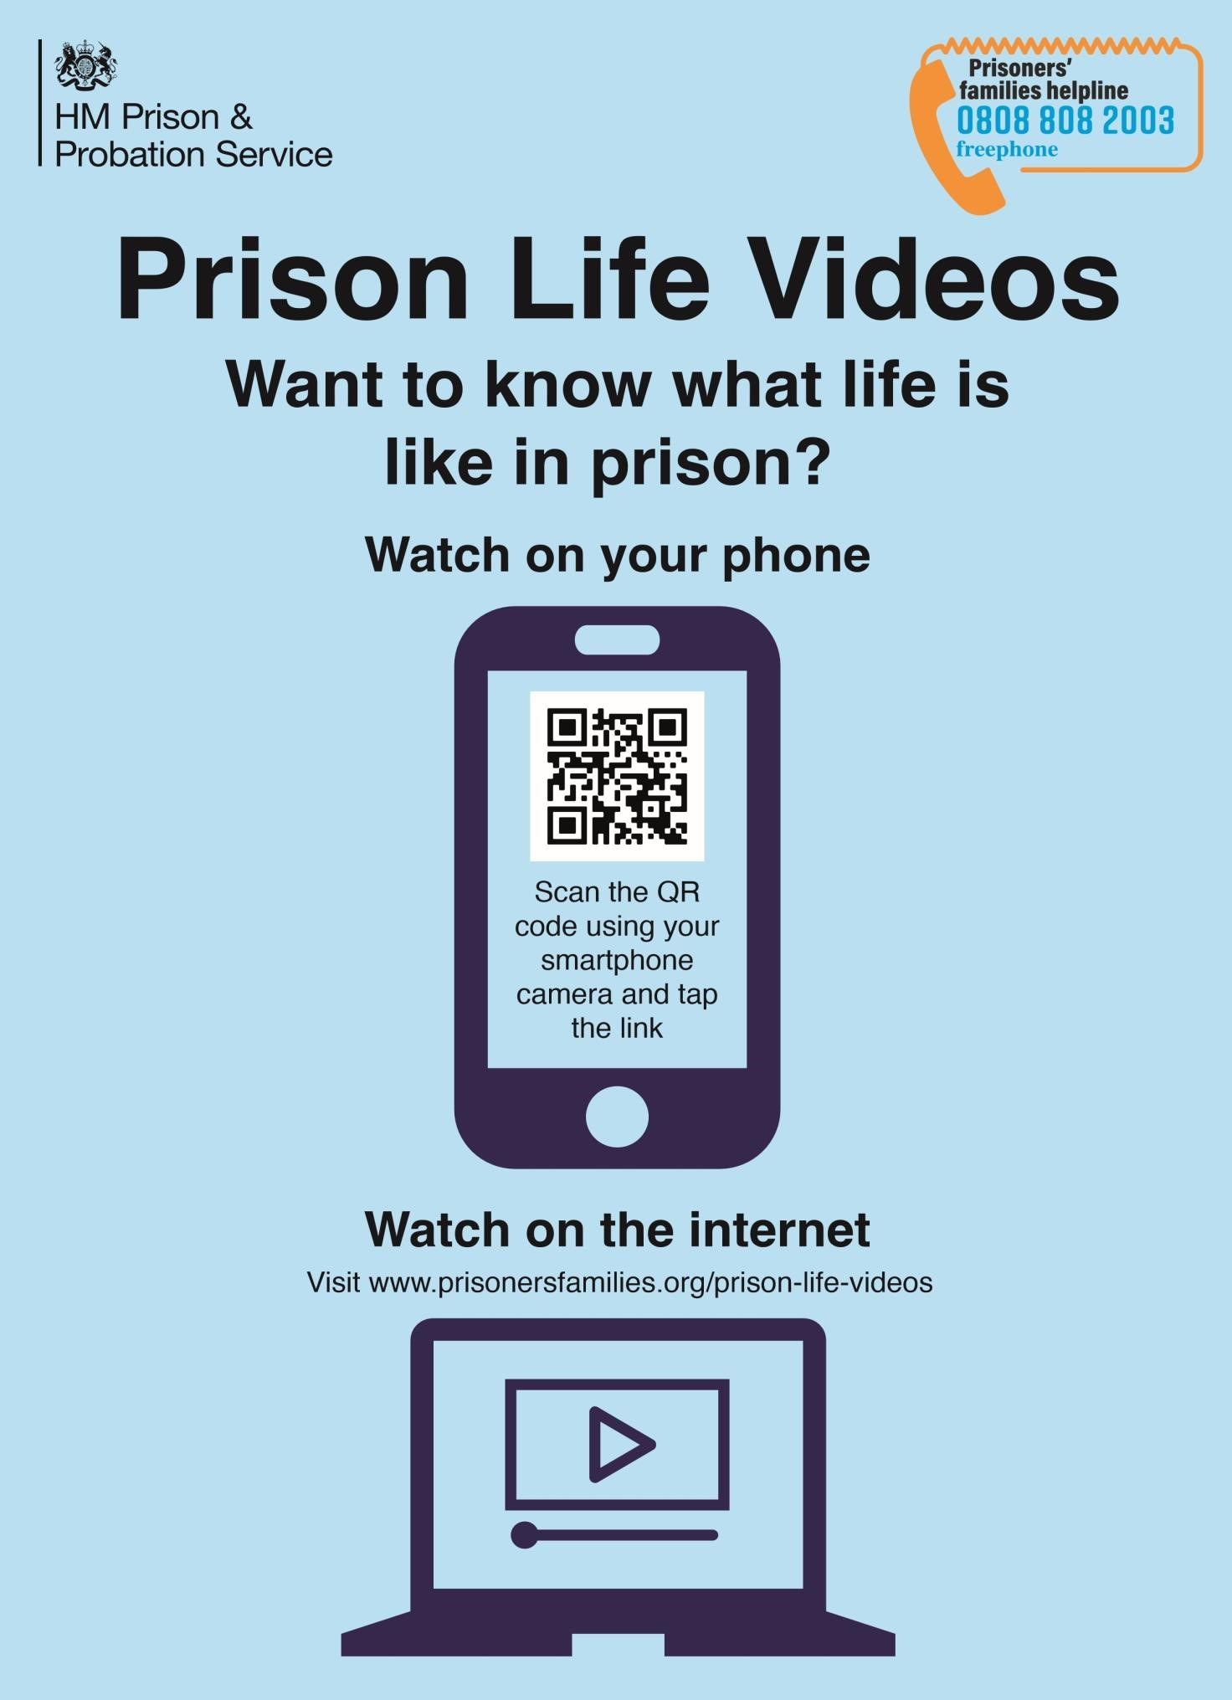

1. Public protection guidelines as per [PSI 2016-18 public protection manual](https://intranet.noms.gsi.gov.uk/policies-and-subjects/probation/public-protection/psi-2016-18) 