

**HMP Featherstone**

**Families and Significant Others Strategy**

**Victoria Smith**

**January 2024**



**Introduction**

HMP Featherstone is a Category C Training and Resettlement prison in Featherstone, Wolverhampton, England. It is operated by Her Majesty’s Prison Service and was opened in 1976.

**HMP Featherstone’s Vision and Strategic Objectives**

HMP Featherstone aims to provide a safe, decent, and secure environment which facilitates the delivery of a progressive regime. Our prisoners will be encouraged to spend their time well; to focus upon progressing through their sentence, reducing their risk of harm and reoffending, and fulfilling their potential. We strive for the purpose that our prisoners will be able to lead a positive and law-abiding life upon their release from custody.

We are committed to embedding a rehabilitative culture that is inclusive, fair, and safe for all. We will adopt a whole prison approach in creating community cohesion where everyone feels respected and people value equality, diversity, and inclusion.

We will provide strong leadership, aspiring to be role models for our colleagues, prisoners, and stakeholders. Our colleagues will be supported to enable them to be at their best, to work collaboratively with each other and partners to support our prisoners on their journey.

* Strategic Objective 1 – Featherstone will be a great place to work
* Strategic Objective 2 – Featherstone will be a safe community
* Strategic Objective 3 – Featherstone will enable a progressive regime

Our prisoners will be encouraged to spend their time well; to focus upon progressing through their sentence, reducing their risk of harm and reoffending, and fulfilling their potential. We strive for the purpose that our prisoners will be able to lead a positive and law-abiding life upon their release from custody. We have a responsibility to help our population to maintain positive relationships as that is key to help aid rehabilitation.

At HMP Featherstone our Families and Significant Others Strategy is overseen by our Head of Reducing Re-Offending who is our local Families and Significant Others lead. This role being within our Senior Leadership team ensures that this work is a priority for the establishment. Their role is to oversee the work of this pathway with an overall focus that prisoners are supported to help maintain positive relationships. They also liaise with all partners involved in supporting this strategy and to ensure that any support offered is in line with our aim for our population.

“I do want to hammer home a very simple principle of reform that needs to be a golden thread running through the prisoner system and the agencies that surround it.

That principle is that relationships are fundamentally important if people are to change”.

Lord Farmer Review 2017

At HMP Featherstone we understand that support and contact doesn’t just include immediate family but extends to friends and can include professionals. In our strategy when we refer to ‘Family’ this means a relative or significant people that our prisoner identifies as providing a constructive and supportive relationship to them.

Our aim is to ensure that our population have as a minimum, someone they can go to for support and who will help them to progress in their sentence. This is why our policy is referred to as Families and Significant Others Strategy as not every prisoner has family, but they may have significant others in their life that are part of their support network, who help them and may visit them. Within this policy we will refer to both parts as ‘family’ for ease.

Our policy will also support those prisoners that are considered care experienced prisoners. At HMP Featherstone we have a Care Experienced Lead who will have their own strategy to support this population. We work alongside them and our teams and partners provide support to them.

Date of Issue: February 2024

Date of Review: February 2025

**Contents**

**How to contact us**

**Staying in touch**

**Visits**

**Our 2022-2023 year**

**Our focus for the 2024-2025 year**

**Visiting Facilities**

**Resources provided to Prisoners and their Families**

**Family Visits**

**Those unable to visit / receive visits**

**Our Future Plans**

**How to contact us**

We are aware that visitors may have queries about visiting HMP Featherstone and should you do so, you are welcome to contact our PACT visits centre team on:

Phone Number: 01902 70 3254. This number is staffed on Tuesday to Thursdays 11 – 4 pm and Saturday to Sunday 11 – 4 pm.

You may also email the team on: [Featherstone@prisonadvice.org.uk](mailto:Featherstone@prisonadvice.org.uk) and they will reply to your email as soon as possible. Please note this inbox is only checked on days the visits centre is open so it can take a day before your email is picked up.

If your query requires them to find out any further information from within the prison this may take a further day or two to reply but they will let you know this.

We also have a visitor’s centre website you can visit on: <http://featherstonevisits.co.uk/>

Should you have any queries about families visits please email: [FamilyVisitsFeatherstone@justice.gov.uk](mailto:FamilyVisitsFeatherstone@justice.gov.uk). Please note this email address is checked during the week but is not monitored regularly throughout the day.

Any matters related to prisoner safety should be raised through the safer custody contact details which are on the next page.

Our Address: HMP Featherstone, New Road, Featherstone, Wolverhampton, WV10 7PU

Phone Number: 01902 70 3000

The Visits Booking Line: 0300 0606502

You can also follow us on Twitter @HMPFeatherstone

**How to contact if you have a concern about a prisoner at HMP Featherstone**

We are aware that sometimes you may have a concern about a prisoner in our custody and you will wish to let the appropriate department know. Currently there are two ways to raise this by either phoning or we now have a digital platform you can contact.

Our digital link is available to search with ‘worried about a loved one in prison’ and the new portal will come up. Alternatively, the link is [www.prisonersfamilies.org/hmp-featherstone](http://www.prisonersfamilies.org/hmp-featherstone)

our phone details are:

**Emergency Contact**

If you have a concern that there is **an imminent risk of danger to a prisoner,** and you wish to speak to a staff member to raise the concern then you can call our switchboard on:

**01902 70 3000**

The member of staff answering the phone will not be able to discuss the prisoner with you, but they will immediately pass your concern onto a senior member of staff to action.

If you are concerned about the safety or wellbeing of any person in our care at HMP Featherstone but there is no immediate threat or danger, then you can leave an answerphone message for the Safer Custody Team on:

**01902 70 3081**

This voicemail service is checked:

1. 07:30 to 09:30
2. 12:30 to 14:30
3. 16:00 to 17:00
4. 19:00 to 21:00

**Who is involved with Families and Significant Others**

Currently within HMP Featherstone we have several partners and agencies that support our Families and Significant Others Strategy. Their support ranges from one-to-one discussions, group work or interventions with families or support agencies. Our partners maintain links with our Offender Management Unit and our Security Department to ensure any work or contact with families is approved for that prisoner.

Our key partner for Families and Significant Others is PACT who hold a 5-year contract for families and significant others work until late 2027.

](https://gbr01.safelinks.protection.outlook.com/?url=https%3A%2F%2Fwww.prisonadvice.org.uk%2F&data=05%7C01%7Ctina.pritchard%40prisonadvice.org.uk%7Cdbb813cefdda42c0dce908da87799b00%7Cd15e482d815445a783bc73d38436e42c%7C0%7C0%7C637971253861451558%7CUnknown%7CTWFpbGZsb3d8eyJWIjoiMC4wLjAwMDAiLCJQIjoiV2luMzIiLCJBTiI6Ik1haWwiLCJXVCI6Mn0%3D%7C3000%7C%7C%7C&sdata=kdxP41GmCXA%2Fhg%2FrXgzm3YLlUKq%2B8wNLfGSvtGaHfAY%3D&reserved=0)

We have a Family Engagement Worker, and their role is to support men with any individual issues they may have regarding contact and communication with their families. They provide one to one emotional and practical parenting support; they support prisoners with maintaining family links and improving breakdown in communication and relationship issues. They provide Family Mediation and support for contact issues with children. They can advocate on behalf of our prisoners and their families and support with signposting to other agencies.

Within HMP Featherstone we have further PACT services through the Shaw Trust and this PACT service provides support to prisoners through one-to-one interventions or courses. All courses are for prisoners who may not be engaging with other departments in the prison, but any prisoner can be referred from staff within the establishment.



Our Library team have a programme of ‘Storybook Dads’ where a prisoner can record a Bedtime story for their children which is then posted to their child. This service can be offered on Family Visit Days for the whole family attending to take part.

Currently due to vacancies within our Library team we have been unable to offer Storybook Dads on Family Visits but when the team is fully recruited, they will recommence this.



Restart are a social enterprise which provide support to prisoners when they are released for cost effective transportation through their shuttle bus to local train and bus links. Their hub has resources to charge mobile phones, contact families and support networks to let them know their time of arrival at their release destination and access toiletries.

Families and those visiting prisoners can access the shuttle bus for collecting from local transportation hubs to HMP Featherstone.



Our Education Provider NOVUS provide ‘parenting skills’ a level 1 course for our prisoners which covers social skills, family relationships, social and emotional development, the principles in listening to children and the changing role and relationships in adolescence.



Himaya Haven CIC is a leading Birmingham based organisation that works with Black, Asian and Minority Ethnic Communities (BAME) and others. The organisation specialises in supporting families of loved ones in custody and prison. We are working with Himaya Haven to begin a pen pal scheme for prisoners who have no support network in the 2024-2025 year.

**Our 2023-2024 year**

Within the 2022-2023 year we are pleased that we have expanded the experience in Family Visits where crafts that are made in the room are able to be sent to the prisoner following the visit. The ability for a parent to have a craft that their child has made and displayed on their wall is a small yet invaluable investment in our population to allow them experiences other parents will have day to day.

PACT recruited our new Family Engagement Worker and following their training they have been providing support to our prison population. Our PACT staff continue to take photos on all family days, and these are emailed to the families. Early 2023 we have run a trial to have a photograph of the family visit day put onto a mug that the family can have posted to them, following the visit.

This trial is on-going and currently we are evaluating the quality of these products to identify if we will continue this offer.

We have used profits made so far to invest in our toy stock for Family Visits and have included children’s dress up clothing including princess and superheroes and new trikes as some examples. One visit had feedback from a prisoner it was the first time he had seen his daughter riding a bike and was overwhelming to him. The toys invested so far have been well received and have continued to uplift the relaxed and engaging atmosphere in every family visit.

Within the new contract food is ordered and managed by HMP Featherstone, not our Families provider. Any profits that are made from the food purchased is invested back into Families and Prisoners through this pathway. In November we used profits to purchase hot food warmers and in December we have re-introduced a hot-food menu which has been well received.

We provide meat options, a halal option and a vegetarian option. These items are sold between £0.40 pence and £0.60 pence and feedback from our visitors is positive on the items and the prices.

In this year we also introduced our first separate family visits for our Safer Custody Department for our prison listeners and this was well received. Prison listeners are voluntary and an invaluable resource for our population and these visits support their family to see the important role they play and show how appreciative we are for the work they carry out.

**Our focus in the 2024 - 2025 year**

Lord Farmers report which, published in 2017, still holds great weight and sets the standards for support in custody, points out that supportive relationships give motivation to all strands of rehabilitation for prisoners and to support their resettlement into the community.

We are currently year 1 of our 5-year current families and significant others contract with PACT and have embedded process to review our performance. We hold monthly meetings with PACT to monitor their performance and any issues or concerns would be managed through this meeting and escalated, if required.

Family Visits are progressing well and feedback from these visits is positive. During a family visit a photograph is taken that can be emailing to the prisoner but due this done through the ‘email a prisoner’ scheme, this is not photo quality and not a full sized photograph. Visitors have asked if they could purchase a photograph to be printed and we are exploring how to take this forward.

We believe purchasing a printer to allow prisoners to have a picture printed is a worthwhile investment. At this time, we are consulting with our prisoner council to identify if a small charge for the prisoner for the for the photograph would be a manageable expense. If this is felt to be acceptable it would be between £0.50 - £1.00. We will consult with our prisoner council for their views and the final decision will be communicated to our population via a community notice.

As an establishment we have asked ourselves what areas within this pathway could we give more focus to and one area we have identified is prisoners who do not receive visits.

When we looked at data on our systems, we identified that on average, 104 prisoners currently at HMP Featherstone have not received a visit during their custodial sentence. It is vital that every prisoner has a support network and has contact with them.

We know that contact may not always be face to face and some prisoners may use secure video calling. We are working to identify prisoners that do not receive visits and who do access secure video calls. We have contacted the Secure Video hub to ask for a report so we can cross-reference but as of late December 2023, no report is available to us.

Our PACT worker has completed focus groups with prisoners to identify any trends in prisoners not receiving visits and as of December 2023 we have yet to identify any. Whilst we have no clear trends why prisoners are not receiving visits; we still believe this is an area to focus on in 2024 and will work with the prison council on this matter.

As of February 2024, we have begun working with Himya Haven who is one of our Families Partners to begin establishing a pen pal scheme for prisoners who do not receive visits. We will begin supporting 5-6 prisoners at a time in the 2024-2025 year and during the year review this scheme to identify how successful this is and how much need there is to identify do we need further support with this.

In the last year we began family forums in our visits centre and held these throughout the year. We feel these are important to have open and honest conversations with families and significant others and therefore this year will be holding these bi-monthly. These will be held with our Head of Reducing Re-Offending who is the Families and Significant others lead and this will allow questions and any issues to be discussed by a member of our Senior Leadership team and any areas to be addressed can then be taken forward. Our PACT staff will take part in these forums, and we will look to record and display in the centre any key questions and trends we are looking into from these focus groups.

We will advertise these forums on our Twitter, on our PACT website and with posters in our visits centre in advance but we are aware that there may be other ways to communicate with our visitors we may not have thought of. If you have any suggestions, please do contact us on [FamilyVisitsFeatherstone@justice.gov.uk](mailto:FamilyVisitsFeatherstone@justice.gov.uk) and we welcome any ideas for how best to communicate with our visitors.

We have also considered how to further enhance our family visits. We have introduced that Enhanced prisoners will be able to have a family visit every 2 months as we believe this acknowledges the progression, they are making in their sentence progression. To further support family visits with the increase for Enhanced prisoners we have increased our limit to maximum 18 spaces in the room per session.

We have also introduced as of December 2023 that family visits are open to prisoners with children, grandchildren, nieces and nephews and cousins under the age of 18 are able to visit. We believe allowing nieces and nephews and cousins in these visits will support prisoners who have strong family ties but may not be parents themselves and wish to utilise these visits to continue to build strong bonds.

We are working with our PACT visits centre staffing to look at our crafts and activities we provide each month in family visits and have made investments in toys and activities. Each month in family visits has a different theme and they range from animals, the beach, superheroes as well as holiday themes of Halloween and Christmas.

Recently we have identified that our visits dress code identified items that are not allowed to be worn but it doesn’t tell our visitors what items they can wear, for example hoodies are not allowed but is a cardigan allowed. Our dress code did not identify what age it applied to and it’s important that our dress code is very clear and doesn’t leave visitors unsure what they can or cannot wear.

The visits dress code is now managed by our Families Lead and we have introduced a new dress code that identifies what restrictions apply to visitors of all ages and what items now apply to those above the age of 10. This will mean that where we mandate the length of shorts for those aged 10 and above a child aged 5 can wear shorts of any length.

Feedback from visitors has been that our dress code is currently applied inconsistently, and on some days, they are allowed in with items that are not allowed but then on other occasions they are not. It's vital that our dress code is applied consistently, and when our new dress code template is live from January 8th, 2024, this will be displayed for all staff and visitors in the gate and the visits centre.

Our Families Lead will support visits staff for a period on the dress code and once staff are familiar with the dress code, they can call on their support if there are any questions.

In 2024 we will utilise profits made to uplift our visits kitchen to upgrade the cabinets and surface area. This investment has been needed for some time and will be a positive use of profits accrued and will greatly benefit visitors. We will also identify if we can train our Orderlies in the visits room in Barista drink making that would be available to purchase. This would also be a large financial investment and may not be able at the time of uplifting the kitchen but will be considered.

Our visits room is dated and not very welcoming and we will be working with our Head of Operations in 2024 to identify how we can uplift this. Simple solutions are painting the room a welcoming colour and we are exploring the option of having a mural painted on the wall.

Uplifting the kitchen and overall visits room will be a focus for our profit’s investment in 2024.

In summary our key aims are:

1. Uplift our visits kitchen.
2. Uplift the visits room.
3. Identify what support is needed for prisoners who do not receive visits.
4. Purchase a printer for pictures to be printed for prisoners to have in possession.
5. Bi-monthly focus groups for families and significant others to attend.

Throughout the year we will continue to report in establishment meetings how this pathway is progressing and review if any further support or work is needed.

In prisons our strategies and aims are linked to the start and end to our financial year which is April to March. At the end of this financial year, we will review how our year has gone and that will help us to think ahead for the next year and what our focus will be for the 2024-2025 year.

**How to stay in touch with a Prisoner**

**Secure Video Calling:** Prisoners are currently entitled to a free video call, once per month which is currently provided by ‘Prison Video’ who have a website you can visit for information [www.prisonvideo.com/](http://www.prisonvideo.com/) There is video instructions on the app you can access which helps explain how to use the service.

To be set up you must:

* Download the app from your mobile phone or tablets app store (they are free to download) – these services are not available using a computer.
* Have appropriate identification which can be a Passport, driving license or another government-issued photo ID available
* The prisoner’s name and prison number
* Names and dates of birth and addresses for everyone who would like to be set-up for calls
* When you register for the service, you must take a photograph and we would recommend ensuring you have good lighting for this picture.

|  |  |
| --- | --- |
| Step 1 | **download and install the app** |
| Step 2 | **Create an account in the app** **and** **add everyone who will be on the call**  To create an account on the app you will need to be over 18 years old and have a picture of your driving license, passport, or other government-issued photo ID.  It can take up to 24 hours for your account to be verified. |
| Step 3: | **Make a video call request**  Once verified, set up the call: You must include the names of everyone who will be on the video call.  Finally, add the name of the person you want to want to have the video call with as a ‘contact’. |
| Step 4: | **Get set up for the video call**  You need a reliable internet connection. Wi-Fi is recommended, but you can also use 3G or 4G mobile data.  You don’t need headphones for the video call, but it may help with the sound quality. |
| Step 5 | **Have the video call**  You should open your app ahead of the scheduled video call time and be ready for the call to start. Call times are fixed and cannot be extended.  Calls will be paused if anyone:   * who is not booked on the call appears on the camera * behaves in a way that would not be appropriate for a social prison visit * tries to record the call or take a screenshot |

**Tips for a successful video call**

* You can use portrait or landscape mode for your call and if you switch between the 2 settings the software will not be affected.
* Try to keep your phone or tablet as still as possible. It may be best to rest it against something, try to rest the phone close to you so the facial recognition software can see you.
* Good lighting is helpful for a call.
* You must have the call in a private place rather than a cafe or public space. Make sure the room is well-lit. Un-even lighting, for example sunlight, can disrupt the way the system recognises faces.
* It is best to sit in front of a plain wall. Pictures or patterns in the background may affect the camera being able to stay focused on your face.
* Please try to stay in one room during the call as this could affect the call.
* If the call pauses, please make sure when it comes back make sure that your whole face – and the faces of any additional people – can be seen clearly.

**Phone calls:** Prisoners now have access to in-cell telephony 24hrs a day

**Letters:** Prisoners are entitled to 1 x second class letter per week at the prison’s expense. Additional letters may be sent out at prisoner’s expense.

**Email a Prisoner:** where family can email direct, at the cost of £0.40 pence per message. Once the email is received a member of staff will print it off and hand it to the prisoner. We offer the option to pay an additional £0.25 pence cost for the prisoner to reply back via an email.

You will need to sign up to the service on the website [**www.emailaprisoner.com**](http://www.emailaprisoner.com)and activate your account. Once you are signed up you can buy credit to start using this service.

**Assisted Prison Visiting Unit (APVU):** Visitors who are in receipt of certain benefits or have a health certificate may be able to claim for help with the cost of visiting. A form is available for you to fill in when you arrive at the visitors centre and please ask the staff to stamp it for you. Information is available at <https://www.gov.uk/help-with-prison-visits>

You can also contact:

Help with Prison Visits: [HelpwithPrisonVisits@justice.gov.uk](mailto:HelpwithPrisonVisits@justice.gov.uk)

Telephone: 0300 063 2100

Monday to Friday, 9am to 5pm

Help with Prison Visits

PO Box 17594

Birmingham, B2 2QP

**Storybook Dads:** Prisoners can create a recording of their voice for children and this will be made into a visual storybook DVD for children to keep and watch as a bedtime story, or through the day. This scheme is run by the Library.

**Letters for Children:** PACT provide letter writing packs for the visits centre to encourage children to write letters into their relatives; these are provided at no costs to the families.

**Foreign national phone credit and letters:** Foreign national Prisoners are entitled to convert their standard visiting orders to phone credit to make calls abroad or airmail letters.

**Visits**

**To visit a prisoner in HMP Featherstone you must**:

* Be on that prisoner’s visitors list
* Book your visit at least 2 working days in advance
* Have the required ID with you for your visit.
* Adhere to the dress-code, details of which are below.

At HMP Featherstone prisoners can have a maximum of three adults visiting at one time, children are also available to visit on top of this allowance but must be accompanied by a visitor who is aged 18 or older.

There is no limit on how many children can visit, but there are only 3 seats available in total for each group, and therefore please consider this prior to booking more than 3 people.

Prisoners may receive two visits per month.

Please contact our visitors centre if you have any questions about visiting.

Visits Booking Line: 0300 0606502

Visits Booking Email: [visitsbooking.westmidlands@noms.gsi.gov.uk](mailto:visitsbooking.westmidlands@noms.gsi.gov.uk)

**When are visits available:**

At HMP Featherstone our visits times are Tuesday, Wednesday, Thursday, Saturday and Sunday and all sessions are from 2 pm to 4 pm.

Visits are required to be one hour minimum and at HMP Featherstone we provide two-hour sessions to allow prisoners as much time as we can provide with their families and significant others.

**Getting to HMP Featherstone**

HMP Featherstone has a visitor’s car park which includes several paces for Blue Badge Holders and Step Free Access to the visitors’ centre.

 **Car:** From Wolverhampton take the A449 northbound – there is a visitor’s car parking facility at the prison.

 **Bus:** Take number 70 from Stand AC to Cannock. Depart the bus at Honeysuckle Drive, Featherstone. Then walk along New Road towards the Prison (approx. 25 minutes). The Visitors’ Centre is well signposted.

 **Train**: The Nearest Railway Station is 6 miles away in Wolverhampton and you can complete the rest of journey by bus or taxi.

**Shuttle Bus**: A low-cost shuttle bus service is available 7 days a week.

To learn more about this regular service, speak to a member of staff by calling: 01902 799787, or email: [shuttle@restartenterprise.com](mailto:shuttle@restartenterprise.com)

 **Local Taxi Companies:**

Westerfield Taxis – 01902 305333

Go Carz – 01902 717273

Black Cabs – 01902 420420

Cannock Road Cars – 01902 280487

Amber Travel – 01902 724040

**Visiting Facilities**

HMP Featherstone’s Visitors’ Centre was built in 1996 by The John Sandy Trust, using money given to it by The Tudor Trust. The centre is opposite the main gate to the Prison and is clearly signposted.

](https://gbr01.safelinks.protection.outlook.com/?url=https%3A%2F%2Fwww.prisonadvice.org.uk%2F&data=05%7C01%7Ctina.pritchard%40prisonadvice.org.uk%7Cdbb813cefdda42c0dce908da87799b00%7Cd15e482d815445a783bc73d38436e42c%7C0%7C0%7C637971253861451558%7CUnknown%7CTWFpbGZsb3d8eyJWIjoiMC4wLjAwMDAiLCJQIjoiV2luMzIiLCJBTiI6Ik1haWwiLCJXVCI6Mn0%3D%7C3000%7C%7C%7C&sdata=kdxP41GmCXA%2Fhg%2FrXgzm3YLlUKq%2B8wNLfGSvtGaHfAY%3D&reserved=0) with staff on hand during every visit’s session.

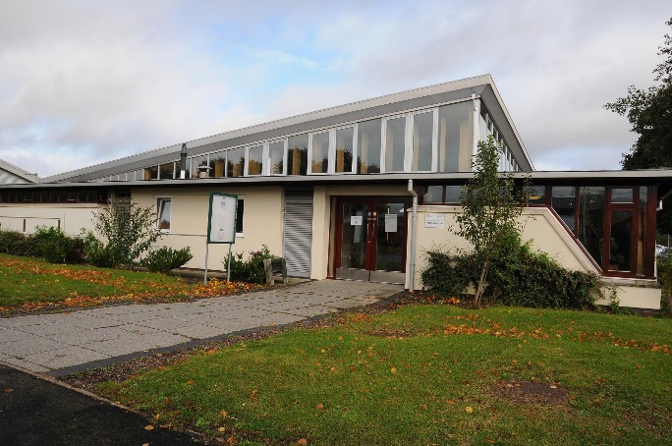The Visitors Centre offers the following services:

* Booking in of families and significant others
* Giving information about visits
* All first-time visitors are given one to one time in which the staff explain the whole process, put them at ease and talk them through the process of going on a visit. They also can ask any questions they may have.

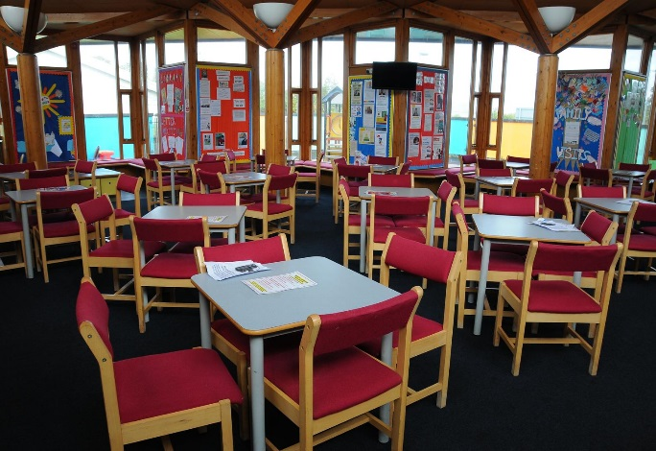

* Within the Centre we have an information corner providing information on a range of services to support the visitors. These include debt advice, children’s services, housing, substance misuse, health and wellbeing. These are signposted through leaflets, literature, poster, IT, Support, and staff distribute up to date prison information as and when required.

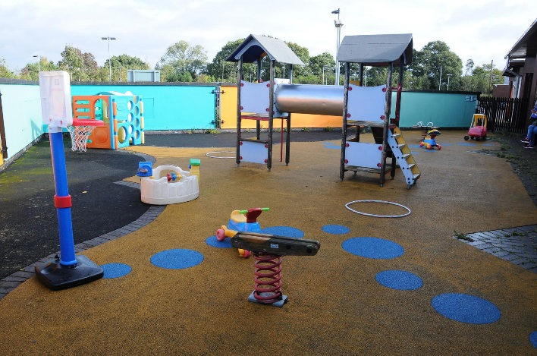

* We have a dedicated play area for children.
* Visitors can purchase refreshments in the center and have time to relax before going into the prison.

**Family Visits**

HMP Featherstone holds 12 family visits a year that prisoners may apply for. These visits are of a more relaxed nature where prisoner and visitors are able to engage in crafts and structured play together. Family Visits are held on a Friday once a month from 10 am until 2 pm in our visits room. These days include lunch provided by HMP Featherstone and craft activities run by PACT for all to share together.

Following our new contract, we continue to find many items we previously provided are not available through the food provider we are contracted to use. We are working with colleagues in Headquarters to request further food items we know our visitors would like to purchase to be added to our food catalogue that we can order. At the time of writing this policy these items are still not available, but we will continue to focus on this to ensure we can provide more food items.

**Those Unable to Receive a Visit**

Prisoners who do not have anyone who is able to visit can request to have a volunteer prison visitor who will visit and provide support through meeting them. This service is offered by the Chaplaincy Department.

Currently this is a focus for us as an establishment and our PACT Family Engagement Worker is currently focusing on this area to identify prisoners who do not receive visits, of any kind. Depending on how many prisoners we identify that don’t receive any type of visit will help us to understand how much support we need to focus in this area.

**Feedback**

We will continue to evaluate the needs of our population and welcome any feedback from visitors about what they would find beneficial on a visit or families visit. You are welcome to email [FamilyVisitsFeatherstone@justice.gov.uk](mailto:FamilyVisitsFeatherstone@justice.gov.uk) with any suggestions or ideas.

**Our Partners**



 

