|  |
| --- |
|  |
| Children & Families Strategy 2024  HMP Send |
|  |
| HMP Send  February 2024 |

Contents

Introduction , Statement of Intent , How to contact in an emergency……… Pages 2 & 3

What we do at HMP Send:

* First Impressions- Visitors Centre…………………………………………Pages 3 & 4
* The Visiting Experience…………………………………………………… Pages 4 & 5
* Children & Families Communication………………………………………Page 6
* Prisoners & Families Feedback……………………………………………Page 6
* Family Days………………………………………………………………….Page 7
* Care Experienced/ Care Leavers………………………………………….Page 8

Stakeholder Engagement…………………………………………………………..Page 9

Action Plan…………………………………………………………………………….Page 10

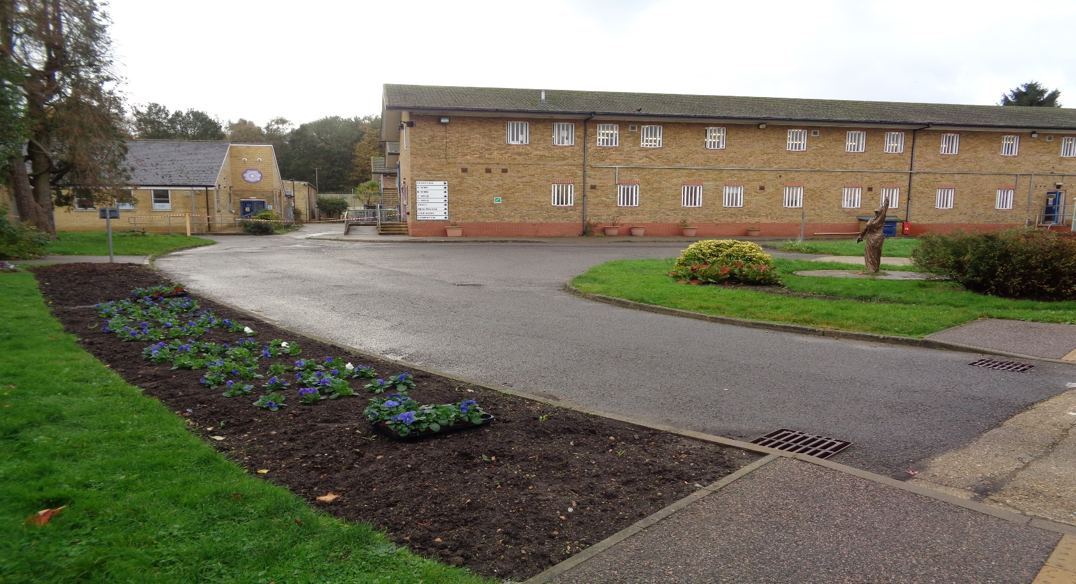

**Introduction & Statement of Intent**

HMP Send is proud to announce that it has a new function dedicated to Children and Families. This includes Governor Liss-Pickering as the head of Function, CM Rhiannon MacDougall as the Custodial Manager and a Children, Families & Equalities Officer.

The goal is to ensure that the impact on a prisoner in our care, their children and family is positive and as stress free as possible.

It is also based on the approach that seeks to contribute to three key areas of ongoing concern and which in themselves represent our Terms of Reference for the strategy.

1. Reducing the likelihood of reoffending
2. Reducing the risk of self-harm
3. Offering information to our residents and families.

HMP Send is committed to delivering the best possible family service to those in our custody and those families in their lives. We do not pretend to always get this right. We make mistakes. But we are honest about that and always strive to learn from things that do not go according to plan, or that we have missed completely. As such we welcome regular feedback from all involved and conduct a series of customer surveys throughout the year, to try and capture the 360 degree experiences of everyone involved.

We understand positive ties between family members or any other person who provides support to residents will help to avoid individuals returning to prison and makes HMP Send a safer place. We recognise the moral and ethical reasons to develop and implement this policy.

Fundamentally we acknowledge that we have both a professional and a moral obligation to support, guide, and help everyone in our custody with regard to their family, parenting, and relationship situation where it is safe and appropriate to do so, and likewise, that what we do in this regard can have significant positive impacts to children and families in the community.

Our Family Intervention strategy and model is built upon official research findings from respected British academics, charities, the Prison Service, Ministry of Justice, and other Governmental bodies, as well as numerous similar publications from international organisations and partners.

We are closely aligned with:

* The 19 recommendations of the Lord Farmer Review – 2017.
* The HMPPS Delivering Effective Family Practice – 2018.
* HMP Send Reducing Reoffending Strategy – Annual.
* Numerous local evaluation and research.
* HMP HMIP and MQPL inspection feedback.
* Internal audit and compliance reports.

HMP Send closely follows the HMPPS Guidance notes regarding what ‘family’ represents, as well as the precautions and safeguards we need to enforce, as such the following 3 points are endorsed by us directly from the HMPPS Guidance notes:

A. ‘*Family’*is defined as either a blood relative, legal or significant persons that a prisoner identifies as their next of kin. For care-leavers this may be someone that provides a statutory service, friend, or associate. Many of those in custody will have experienced a non-traditional upbringing, with a range of adults having cared for them, and similarly those in custody with children may have other arrangements outside of a traditional family arrangement. It is important to accommodate all ‘family’ arrangements where they provide a constructive and supportive relationship for the prisoner and their family.

B. ‘We recognise that not all family relationships are positive. Family members may sometimes be the direct or indirect victims of a prisoner’s offence such as domestic abuse. These individuals have the right to protection from their perpetrator and in all cases; permission should be sought from the victim and any relevant partner agencies before making contact. This will enable the victim/family unit to be supported in the community. To do this we work closely with agencies such as the Local Authority Social Services, and the Police and Victim Liaison Officers.

C. ‘Other family or significant others may be enablers, contributing to their offending behaviour.

Prisoners may be subject to harassment or restraining orders and the courts take primacy in how we manage familial and other relationships.

We must therefore ensure that we prevent inappropriate contact.

**How to contact in the event of emergency:**

* Call 01483 471000 if you think a prisoner is at immediate risk of harm or have important family related information to pass on.

Ask for the Orderly Officer and explain that your concern is an emergency.

They will then carry out welfare checks and support the prisoner with the information.

* Further information can be found on our website [Send Prison - GOV.UK (www.gov.uk)](https://www.gov.uk/guidance/send-prison).

**What we do at HMP Send**

* **First Impressions- Visitors Centre**

At HMP Send we understand the importance of first impressions for those visiting our prison.

The first point of contact for families is at the visitor centre situated outside the prison entrance, this is operated in partnership with PACT who have been working alongside us for 5 years.

We recognise some visitors may have financial difficulties travelling to HMP Send so we offer a free shuttle bus service from Woking train station to assist with this travel families make, especially considering those using public transport with children, babies, the elderly, or those with disabilities.

For those using their own method of transport we recognise that we may have visitors with limited mobility or disabilities therefore we have provided several designated access parking bays which are located directly outside the visitor centre to assist with the ease of access. We also aim to support those using their own method of transport via the Assisted Visits Scheme which if successful on application a contribution will be paid towards visitors travel.

Visiting a prison for the first time can be a daunting experience for families and significant others, we feel that PACT have the specialist skills and staff best suited to working in this environment. Our PACT team take care of all the booking in arrangements, along with being there to explain the visiting process in a child friendly manner, calm nerves, and help with any questions or anxieties, and we are proud to say that our most recent data capture evidenced 77% of the total establishment population as receiving visits from family and significant others, against the Prison Service national average of 48%.

We offer a calming environment here which include the following services:

* Café facility offering hot/cold drinks and snacks before each visit’s session.
* Toilet and baby changing facilities - with disabled access.
* Internal and external play area.
* Lockable possession cabinets.
* Contact telephone number.
* A range of gifts to buy.

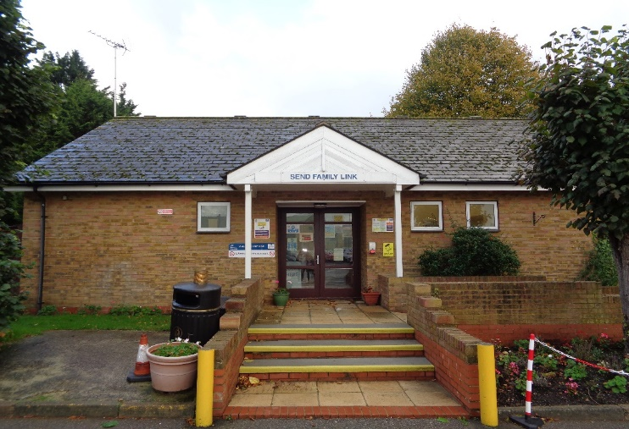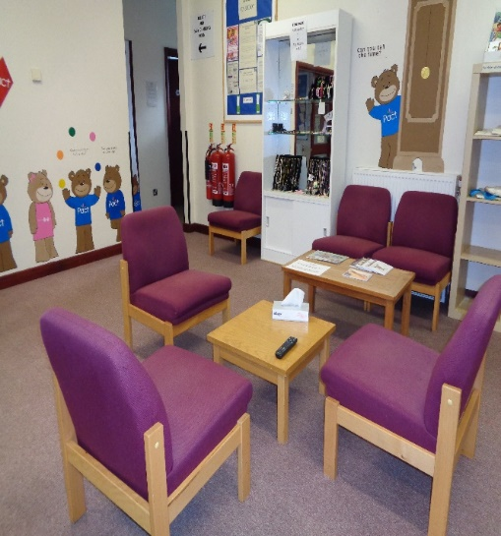

* **The Visiting Experience**

We understand that visitsare very important in maintaining family ties but can also be a difficult time for all involved. Prior to entering the visits hall there are of course security procedures to be adhered to. All visitors will be searched prior to entering the hall by our passive search dog. All residents will also be subject to a search prior to entering the hall. This enables us to ensure that all those who visit and live in HMP Send are kept safe. These procedures are calmly and thoroughly to all visiting taking into consideration individual needs.

HMP Send has made conscious efforts to make the visits experience the best it can be. With a colourful and clean visits hall we feel that the visiting experience at Send is very relaxing.

There is a play area for the younger children to enjoy, and a family room where prisoners can have a quieter visit with their family away from the busy visit’s hall.

The use of this family room has been published via notice to prisoners and is encouraged by all staff during key work sessions and welfare checks.

There is a refreshments counter where visitors can purchase food and drink to enjoy on their visit and we have recently installed a new barista machine which our prisoner orderlies are trained in the use of.

Throughout the year there are also several “family days”. These are a more relaxed visit where visitors will be allowed to go to the food hall and enjoy a meal with their loved ones. These are listed around the prison for prisoners to take note of the dates and apply.

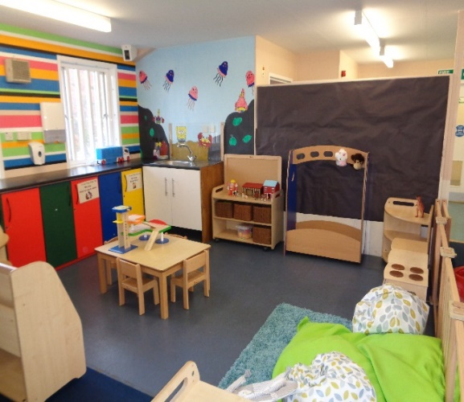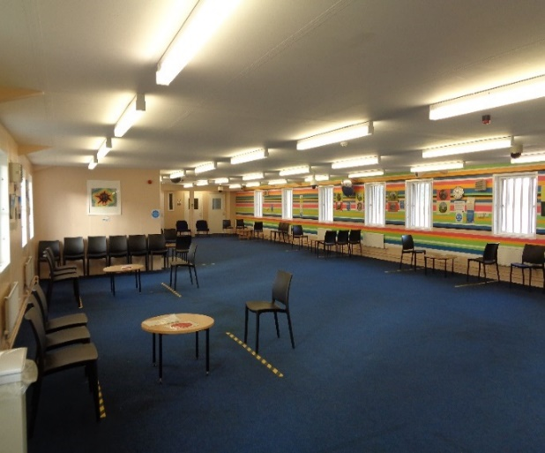

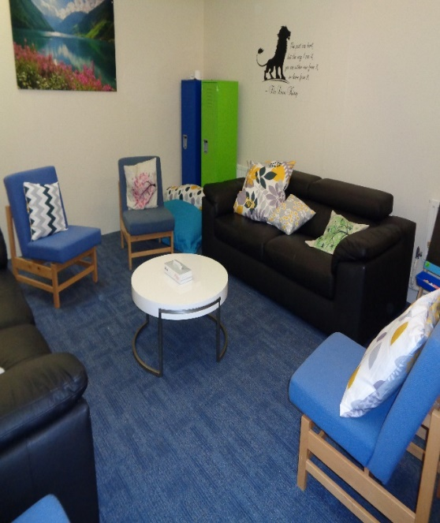

* **Children & Family Communication**

HMP Send has taken huge steps in ensuring that relationships are the best they can be during such a difficult time.

To improve Family Ties whilst in custody we have reviewed and implemented several services which were recommended during the latest Lord Farmer Review. These include but are not limited to installing in cell telephony for ease of access to speak on the phone with families, designed a new application process for the use of the Family Room in visits for a more intimate setting, employing a social worker another family engagement worker within the PACT team and reintroducing the Homework Club for families.

* **Prisoners & Families Feedback**

Here at HMP Send we encourage and appreciate feedback on our services from both prisoners and their families. To assist us with our efforts to stay in tune with what prisoners, their family, children, and Significant others are experiencing within our interventions and service delivery, as well as enabling us to remain responsive to matters relating to diversity and equality, we have developed several methods to capture client feedback, these include:

* Frequent focus groups held with prisoners to understand how we can improve and increase visits uptake.
* Family, children, and significant other feedback on the visiting experience via feedback cards held in the visit’s hall.
* Visits centre helpline- direct feedback logged.
* Written/ email feedback logged.
* Formal request and complaints from prisoners.
* Formal public correspondence complaints.
* Various research and data capture throughout the year.
* **Family Days**

PACT facilitate fifteen family days per year (including Children’s Days, Adult Days, Extended Family Days, TC days and Lifer days) providing arts and crafts, nail painting, face painting and sometimes entertainment for the children and families. The entertainment in the past has included a drumming workshop, magician, a face painter, a clown, an artist, and balloon modelling. At Christmas time every child visiting receives a present and Father Christmas visits us. Similarly, at Easter, we have supplied children with Easter Eggs in the past.

The family days are happy days for the prisoners to maintain family ties and build stronger relationships with.

We try to accommodate all ages, as well as adults, so activities available can include bracelet making, board games, quizzes, bingo, dress up, cake decorating as well as a play area for very young children, with a baby area.

We are in the process of imputing a TV and Wii for older children that may want to play video games with each other or their parents.

* **Care Experienced / Care Leavers**

Care leavers and care experienced residents are those women who have spent any amount of time in the care of a local authority. The national figure indicates that up to at least 25% of women have had some experience of being in care at some point in their lives. Most of these women will have experienced trauma.

Families support our residents in many practical ways. The survey and information from our partners highlight one in three women return to live with family or friends after release. As Care Leavers are less likely to have family contact, we know they are more likely to services around securing accommodation. The Community Rehabilitation Company will work with our Offender Management Unit to identify care leavers and address accommodation needs.

HMP Send are undertaking work to identify this group and will run specific focus groups to engage and understand how we can support them.

Initiatives included on our action plan aimed at improving services to this group are;

Family days or extended visits for adults where care experienced residents can maintain positive relationships.

The Personal Advisor for Care Leavers can attend all visits sessions, and contact will be made with them to advise them of such following the initial interview process.

**Stakeholder Engagement**

We work alongside several partnership agencies both internally and externally at HMP Send and we are extremely proud to have built such a great rapport and reputation with these agencies meaning we are able to improve our family ties.

All the services and interventions detailed in this strategy involve either directly or indirectly, partnership working. This includes formal contractual Service Level Agreements as well as informal arrangements built on mutually beneficial working relationships. This model enables us to develop and offer a broad, safe, and effective service delivery.

A quarterly meeting is held involving all these agencies including internal prison departments to discuss provisions, issues presented and ways of improving the services we have, notes are taken during this meeting and clear action plans are drawn up for review at the next meeting.

* Prison Advice Care Trust
* Social Service/ Children Services
* Friends & Families of Prisoners
* Prison Visitors
* Independent Monitoring Board
* EmailAPrisoner.com
* Prison Voicemail
* CLINK
* Not Beyond Redemption
* Forward Trust



**Action Plan**

|  |  |  |
| --- | --- | --- |
| **What we plan to do** | **Why we’re doing it** | **Target date** |
| Refurbish Visits Hall & Family Room | To enhance visitor’s experience and provide better facilities | May 2024 |
| Conduct visitor’s experience exercise | To ensure our processes, facilitates and information is effective and meets the needs of all visitors | Completed Annually |
| Provide improved feedback in the form of ‘you said, we did’ notices | To improve communication and evidence action taken in response to feedback received from visitors | Ongoing |
| Provide accommodation for families to use on CRL’s | To encourage and improve family relationships and prepare prisoners for outside life. | Ongoing |