**HMP PORTLAND**

Families & Significant Others Strategy

*"Strengthening Portland Family Ties"*

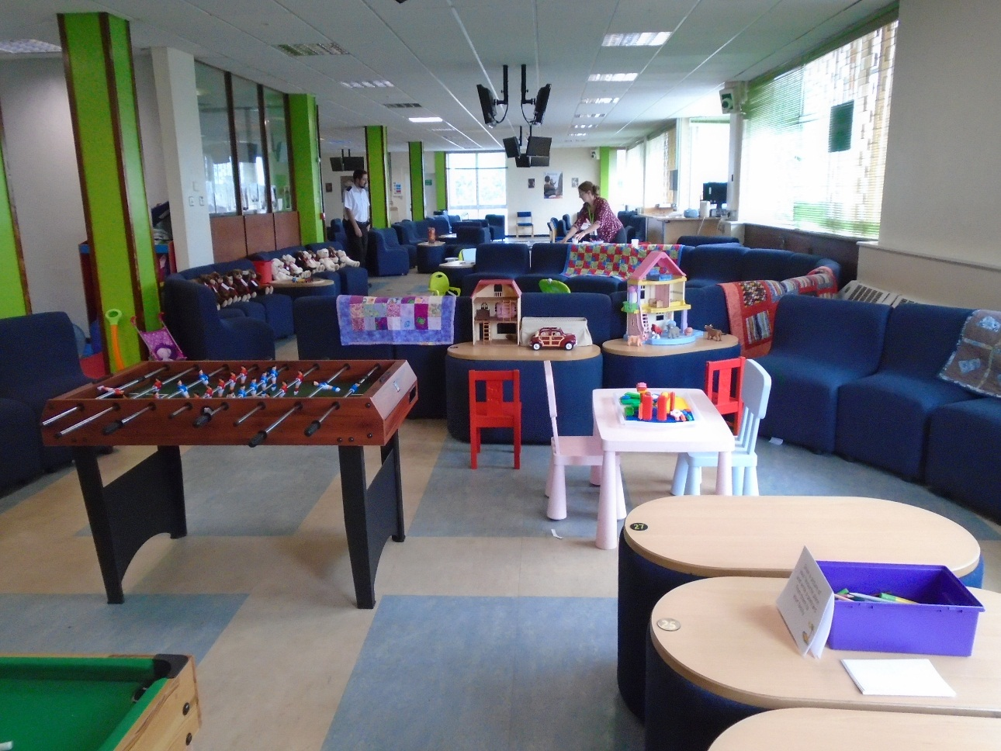

**Our Visit Room**

**Family and significant other paths leads**

Head of reducing reoffending Date 12/12/2023

Family and significant other champion Paula Moate

**Governor of HMP Portland**

Gov Lewis Date 01/07/2023

# 

**CONTENT**

1. Introduction
2. How to contact us?
3. Your visit
4. Visiting the facilities
5. Stay connected
6. Visit
7. Family visits
8. For those who cannot visit/receive visits
9. Learning and development
10. Planning for the future
11. Recruitment of employees

# Introduction

It has long been recognised that positive relationships are at the heart of prison life. Good relationships between staff and prisoners can be pivotal, and prisoners' relationships with their families and other significant people in their lives can be the social bond that supports reintegration on release.

We believe HMP Portland has a responsibility to help maintain all positive relationships.

Supporting the prisoner in developing meaningful and constructive relationships with family or significant others is important work here, especially given the distance that some families may have to visit.

For the purposes of these guidelines, a ***family*** is defined as a relative or significant people that the prisoner identifies as providing a constructive and supportive relationship.

At HMP Portland, we want visits to be less disruptive, more child-friendly and stimulating for everyone who participates by following safety protocols.

HMP Portland is committed to developing new initiatives and support for those who do not have family or visits to help build or repair relationships or create new networks to get support during and after release.

This strategy was written in consultation with various partners, including documents such as HMIP.

**HM Portland Prison** is an based at The Grove on the island of Portland in Dorset, England. It is operated by Her Majesty's Prison Service. The prison was originally opened in 1848 as an institution for adult convicts before becoming Borstal in 1921 and YOI in 1988. In 2011, it became an mixed prison for adult/YO.

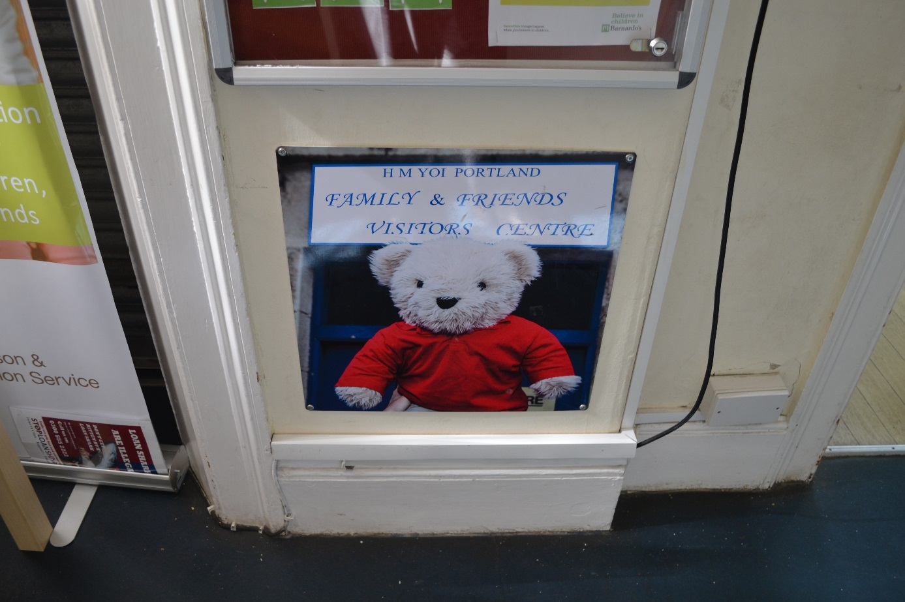

At **HMP Portland**, we strive to **inspire, motivate and guide** inmates to become the best they can. We focus on reducing recidivism and preventing future victims or crimes by preparing offenders for their release through accredited intervention programs, skills, and professional training and education in a supportive environment.

1. **Contact Us**

Address:

**HMP Portland, 104 Grove Road, Portland, Dorset DT5 1DL**

General phone number:

**01305 715600**

**General information**

Gov.uk site will give you all the information regarding HMP Portland.

**Follow us on Twitter @HMPYOI_Portland**

**Emergency contact**

**If you have concerns that there is an imminent risk** to a **prisoner and want to speak to a staff member to report this concern, you can call the switchboard:**

**01305 715600**

**The employee answering the phone will not be able to discuss the prisoner** **with you**, **but will immediately pass your concerns on to a senior staff member for action. We try to immediately resolve any issues raised in this way and let you know what the outcome is.**

**If you are concerned about the safety or well-being of any inmate in Portland, you can call:**

**01305 715666**

**and leave a message/talk to a member of the Safer Care Team and someone will contact you regarding your concerns.**

**Prisoners’ families helpline: call for support and information.**

**0808 808 2003**

**Monday-Friday 9am-8pm**

**Saturday and Sunday 10am-3pm**

1. **Your visit**

**To visit someone in Portland, you must:**

* be on that person's guest list.
* Book your appointment at least 2 days in advance.
* carry the required ID document when travelling.

At least one visitor must be at least 18 years of age on each visit.

There may be a limit to the number of visits a person can have. You can check it out in Portland.

Please contact HMP Portland if you have any questions.

### **Assistance in covering the cost of the visit.**

If you receive certain benefits or have an NHS health certificate, you can get help with your visit, including:

* Travel to Portland
* Where to stay overnight
* Meals

### **How to book visits from family and friends**

Portland has a limited number of schedule visits.

Appointments can be booked online using the booking service available.

Helpline: **01305 715 775** Monday to Friday, from 9.00 to 12:00

**Visiting hours:**

* Friday, Saturday, and Sunday: between 14:00 to 16:00

### **How to get to Portland**

Find Portland on the Google maps.

The nearest train station is Weymouth. From there, you can take a bus to Portland Island, stopping at Grove Corner. The prison is marked from the end of Grove Road and is located approx. 15 minutes’ walk. There is also a taxi rank at the station. A taxi costs about £15 one way

To plan your trip by public transport:

* use National Rail inquiries.
* use Travel line to your bus schedule.

Portland has parking for visitors, including several spaces for Blue Badge owners. You can also park on the main road surrounding the prison.

### **Visiting the facilities**

Portland has a visitor center that has restrooms, a baby changing room, and secure lockers. Opening at 12:30 on visiting days. It is located opposite the main gate to the prison and is clearly marked. The visitor center is run by PACT, and a team member is on hand during each visit session.

The visitor center offers the following services:

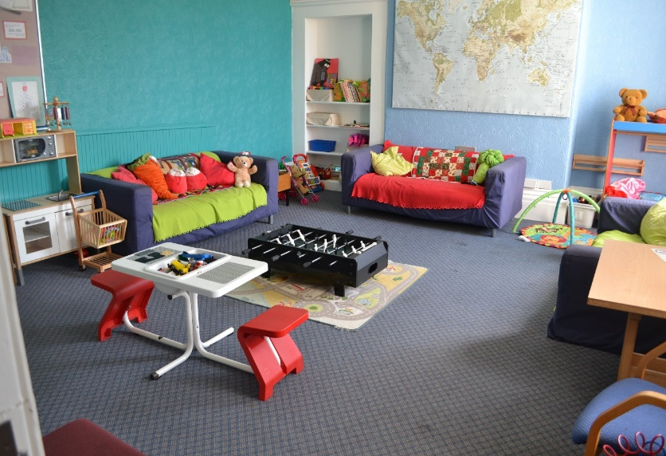

* We provide information, guidance and signpost services on issues such as alcohol and substance abuse, domestic violence, etc.
* We provide advice and support in the field of prison procedures.
* We provide someone to talk to in confidence if support is needed.
* We provide facilities to assist visitors, such as having a stairlift accessible for disabled people on site.
* We offer all visitors the opportunity to give feedback to improve the visiting experience.
* Upon arrival at the Visitor Centre, the staff will guide you through the booking process.
* We provide family support staff available both within and within HMP Portland, for inmates, families, friends and other prominent individuals.
* We provide an integrated substance abuse officer to support the families of these inmates with substance abuse and alcohol.

**Partnership protection**.

Local security arrangements are led by three security partners: the local authority, the Chief of Police and the clinical trial commissioning group. These partners work together to maintain protective practices and implement on-premises security. All PACT employees are committed to child protection and have been trained in accordance with the protection policy. Staff during visits are trained and continuous training is to be conducted.

**Portland's safety leaders are Gov Beckett and Martin Pete, Gov Sheppard.**

### **Entry to Portland**

The staff will direct you to the main gate when the staff is ready to enter.

All visitors, 16 years of age or older, must prove their identity before entering the prison.

All visitors will have to be searched (similar to what you would receive at the airport), including children. You may also be searched by drug-detecting dogs.

The rules of your visit will be explained to you by the officer upon entering the visit area. If you haven't been to Portland or a prison before, ask the staff if you have any questions.

Portland does have a strict dress code to ensure decency for all.

**After the visit**

If you have any concerns after your visit, a member of the PACT team will be on hand at the visitor center and will be happy to talk to you. You can raise concerns with the unified staff at any time during your visit.

1. **Stay connected.**

**Secure video calls:** Prisoners are now entitled to a free video call once a month. They can be ordered through the "Purple Visits" app, which visitors must download and follow the instructions to register. If anyone does not receive social visits, they can have more than one video call.

**Phone calls:** Prisoners now have access to a phone 24 hours a day.

**Letters:** Prisoners are entitled to 1 x second-class letter per week at prison's expense. Additional letters may be sent at the prisoner's expense.

**Prisoner** Email**.com:** Visitors can send an email directly, for the price of only a 2nd class stamp. Upon receipt of the email in Portland, a staff member will print it out and give it to the inmate. Visitors can also cover the cost of sending the letter by the prisoner via email.

**Prison voicemail:** Visitors can download an app to their phones that is connected to the prison phone system so they can record and leave messages that inmates can pick up in their cells. Prisoners can also leave a message in return.

**Assisted Prison Visiting Unit (APVU):** Visitors can claim reimbursement of travel expenses of up to two visits per month through APVU. Terms and conditions apply, and brochures and information are available from the Visitor Centre, website or telephone.

**Care experience people:** Our visit protocol enables flexibility for these visits which encourages allowing Personal Advisors to visit as a domestic visitor as well as a professional visitor and for the use of video call for maintaining contact.

**Prison visitors**: Prisoners who have no one to visit can request a volunteer prison visitor to visit and provide support through phone calls or as a friend of the pen. This service is offered by the Pastoral Department.

**Storybook Dads:** Prisoners can create a recording of their children's voice that will be turned into a visual DVD for children to preserve and watch as a bedtime story or throughout the day. This program is run by the library.

**Children's Letters:** PACT provides letter writing packages for the visitor center to encourage children to write letters to their relatives; these are provided to families free of charge, these are for them to send in not hand out.

**VO for phone credit or letters:** Prisoners who do not use all standard visiting commands may convert them into additional phone credit or letters. This depends on your IEP status and can be done through the visits department.

**Telephone credit and lists of foreigners:** Foreign prisoners are entitled to convert their standard visitation orders into telephone credit for making calls abroad or air mail letters.

**New fathers:** Prisoners who have pregnant partners can apply to give their new baby a quilt. The Linus UK project is a voluntary organization. Their aim is to provide a sense of security and comfort to sick and traumatized infants, children and teenagers by providing new homemade patchwork quilts and knitted ones, as well as giving volunteers across the UK the opportunity to contribute to their local community. These blankets may also be provided for prisoners whose children are adopted.

Prisoners who have a newborn photo will be taken for both parents to take back.

**ROTLS**

HMP Portland is committed to helping our prisoners resettle by offering a wide range of ROTL (Release on Temporary License) including RDR (Day release for resettlement purposes) and ROR (home leave overnight). We have a range of positions available for employment in voluntary and paid positions in the community. All ROTLs are subject to the permission of the probation officer and the police.

**Keywork.**

Keywork is an activity is a constant support throughout the prisoner’s time in the establishment, they will coach and support individuals to identify and resolve issues and concerns for themselves, so they feel settled safe and calm enabling them to engage with their rehabilitation and progress through their sentence.

1. **Visit**

**PACT**

PACTS are a key element in the success of our visits. They provide support and guidance to both inmates and their families/significant others during all visits and ensure that our family visits are fun and engaging for families. They also provide 1:1 support for inmates' contact with children and programs such as the Family Links Parenting Course.

A Family Engagement employee participates in weekday visits and family visits. They also work with other actors such as social services, probation officers and schools to ensure that everyone is properly supported. PACT also continues to build a full team of dedicated volunteers and play workers, which are discussed later in this strategy.

**What we offer**

Portland offers one visiting room that has been recently renovated. Large room with softly furnished tables and chairs. Visitors have access to breastfeeding/baby changing facilities. Special family events are also organized. Everyone can apply for different family events. Guests also have access to highchairs and a toy area. Family engagement staff and volunteers wear informal clothing to help greet guests, especially children.

As requested, there are now information books for older young people, as well as magazines. The favorite among teenagers must be card games and Lego. Further sourcing ideas include interactive games such as "Bop It" and older board and card games, we have also provided a Nintendo WII

Children have the opportunity to join in with craft activities and make items for their loved ones during the visit (cards, photos, etc.)

Sensory bags are also available for people with additional needs, and hearing protectors have been used by several children to cope with noisy environments.

During visits, Storybook Dad is promoted, along with other services such as prison voicemail and assisted visits program.

**Surveys and statistics**

HMP Portland encourages feedback on the services we actively seek for visitors to share their opinions in order to shape and improve HMP Portland's vision. Each visitor can fill out feedback forms from PACT to give people the opportunity to express any concerns or recommendations, as well as let us know what we are doing well. This information is collected and discussed with the governor at a quarterly meeting.

Forums with prisoners are carried out to find out how we can improve and what we do well here at Portland.

We are proud to say that we are working hard to develop the center after visitor feedback. An example below:

Pact supply us with the feedback sheet they collect, and we collaborate the finding.

|  |  |
| --- | --- |
| **Said...** | **Done...** |
| ***Can we have fact books for older children?*** | Now available in the Visit Center and Visitor Room |
| ***You said the visit hall was far too hot,*** | Large fans are now in place. |
| ***You said we needed more baby changing facilities,*** | We have provided a range of nappy sizes and wipes. |
| ***We would like to see more physically active games release steam during visits and more game for older children*** | Purchased a Nintendo WII for sports games and a magnetic dart board for family days. |
| ***We would like more activities*** | A better variety of games and crafts and cake decoration and sandwich making. |

**Helping children in the visitation process**

We have pictures of our Portland bear going through the visit process to support and help children understand, as well as images that make the whole area more welcoming.

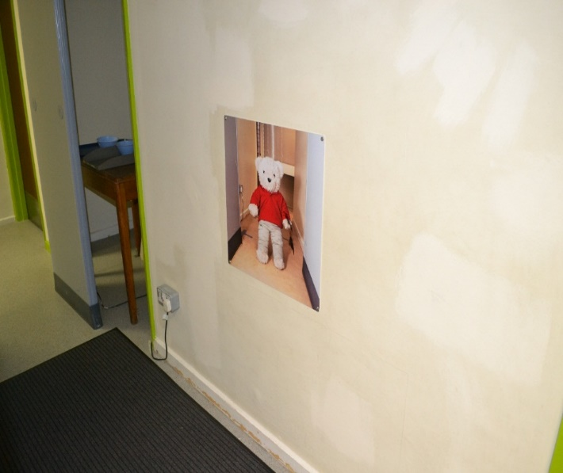

1. **Family visits**

**Enabling relationships to flourish**

HMP Portland organizes numerous family visits throughout the year, including monthly days for children and family, as well as extra days during school holidays.

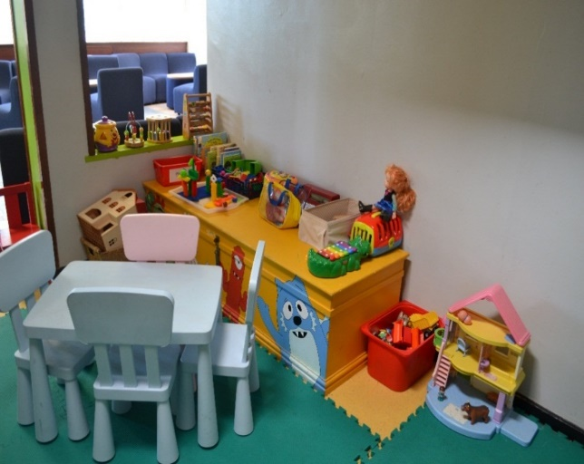**Family visits with children:** These take place in the afternoon every month and are as long as possible; we also offer days during the school holidays throughout the year so that school attendance is not affected. These days include having lunch together, games and quizzes and provide themed sessions such as Easter, Halloween, Christmas and the Creepy Crawlies event. Families have the opportunity to have a family photo taken as both parties can have copies of these.

These days are open to men who have been exonerated by Public Protection and Security; we offer other events, such as the Celebration of Success, where nominated prisoners are encouraged to invite family members to participate. These visits are in addition to standard visit requests.

All prisoners must pass security checks before they can attend a children's event. Anyone who poses a danger to children is not allowed to attend, nor can those who are on closed visits. If it is a family event, we are happy to consider applications from basic, standard and extended prisoners, and each will undergo a robust risk assessment. However, we believe that any prisoner who is a "family man" should strive for a higher status and set a good example for his children.

**If anyone has older children or family members who wish to spend a longer period can also apply for an adult family visit.**

We are very fortunate to cooperate with Expia Ltd, which provides a tea bar where refreshments ca be purchased, which is positively evaluated. **Expia** Ltd is **a charity** company that aims to reduce recidivism by

providing employment and supporting the education and training of risk-assessed prisoners in cafes and prison gardens.

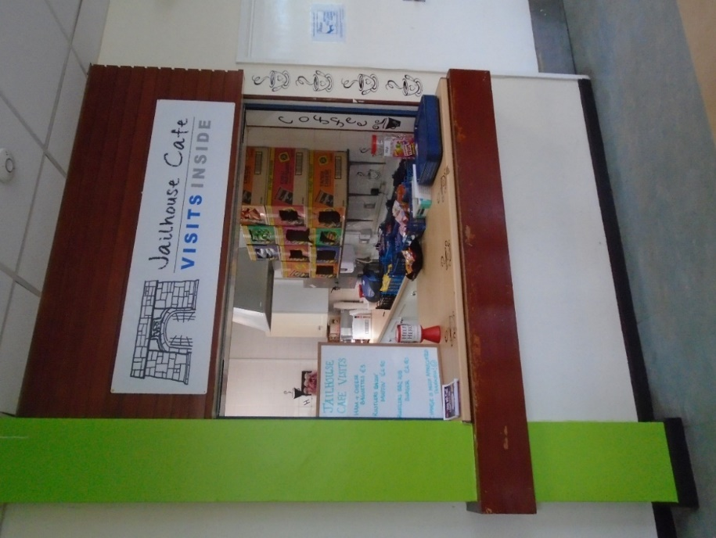

**8.For those who cannot visit/receive visits.**

**Prisoners who don’t have any family visits can apply for a games afternoon where they can have some time off the wing in the visit hall.**

**Prison visitors**: Prisoners who have no one to visit can request a volunteer prison visitor to visit and provide support through phone calls or as a friend of the pen. This service is offered by the Pastoral Department.

**VO for phone credit or letters:** Prisoners who do not use all standard visiting commands may convert them into additional phone credit or letters. This depends on your IEP status and can be done through the visits department.

**Telephone credit and lists of foreigners:** Foreign prisoners are entitled to convert their standard visitation orders into telephone credit for making calls abroad or air mail letters.

**Secure video calls:** Prisoners are now entitled to a free video call once a month. They can be ordered through the "Purple Visits" app, which visitors must download and follow the instructions to register. Extra sessions can be applied for anyone not receiving social visits.

**Prisoner** Email**.com:** Visitors can send an email directly, for the price of only a 2nd class stamp. Upon receipt of the email in Portland, a staff member will print it out and give it to the inmate. Visitors can also cover the cost of sending the letter by the prisoner via email.

1. **Family learning and development**

**PACT**

**Positive Relationship Course** – This is a 6-week programmed delivered with personal advisers from Dorset Local Authority. It is offered to inmates who leave care until the age of 25 and is a small group to provide prisoners with a sense of comfort. During the course, participants will learn communication skills and benefit from ideas on how to take care of themselves that will build their self-confidence.

**Parenting Course** - Taught by two staff and gives inmates the opportunity to develop parenting skills.

The pact will also offer short-term 1:1 interventions, such as connecting to children's services and fostering contacts between prisoners and their children.

**ISMS – Integrated Services in the Field of Substance Abuse**

ISMS offers support, advocacy, education and guidance to clients who engage with the ISMS service and their families/interested others. The ISMS Family Service recognizes that having a loved one in custody can be a traumatic experience, as a service that our goal is to improve communication and support the family member/interested in receiving another.

The service offers support to families in accessing community support services (ADFAM, family services, debt management, housing, etc.), improving family/interested relationships – which have often fallen apart due to broken trust, financial, imprisonment, crime, etc.

ISMS works with internal and external agencies to ensure the best possible outcomes for families, often this is done by a child welfare social worker working with an agreed family plan.

A key partner supporting the work we do in Portland for the Families and Significant Others is EDP. EDP stands for Exeter Drug and Alcohol Services, which provide the employee with family support.

A family support worker engages with partners and children of prisoners in Portland. They run family groups, Healthy Relationships and Family Relationships, which have a chance to reflect on the impact of substance abuse on the family. EDP recognizes that the link between domestic violence and substance abuse is complex and therefore offers support in this regard by working with social services in relation to the child assessment framework.

1. **Future plans**

**Our commitment to visitors and prisoners in 2024 and beyond**

We're looking at ways to further improve our visitor offerings for families and significant others in Portland, with plans to develop more theme days.

We have different ideas on how to improve the situation of children outside, subject to funding and safety issues, and we welcome ideas and initiatives from all prisoners and their families.

We want our Visitor Center to be the best it can be, which is why we are committed to implementing our comprehensive action plan.

**How will we measure our success?**

* By the variety of family visits, friends, and significant visits offered, including those that do not have visits
* According to the number of seats/participants available for each visit
* According to collected statistics on ethnicity, race and cultural attendance at family events
* By the number of prisoners in a family unit from different ethnicities, races and cultures
* Listening to prisoners and their families through regular forums and recording and sharing comments and opinions
* By event feedback forms and family comment book
* Through the adoption by staff of additional training, e.g. security, Family Links, Solihull approach, etc.
* By number of completed courses for parents / families
* By number of school interventions offered to young people

1. **Employment structure**

In Portland, management fully supports the work done in visiting inmates and their families; which is led by the Family and Significant Others' Pathway Lead (Head of Operations and Health, Gov Nantes) and prioritized at the quarterly pathway meeting.

**Amendment sheet**

|  |  |  |  |  |
| --- | --- | --- | --- | --- |
| **Date updated** | **Page amended** | **amendment** | **By whom** | **Version control** |
| **11/9/2023** | **10** | **Keyworker** | **SO Moate** | **V1**  **V1**  **V1** |
| **9** | **Care experience** | **So Moate** |
| **13** | **Pictures** | **So Moate** |
| **12/12/23** | **front** | **name** | **So moate** | **V2** |
| **06/02/2024** | **12** | **Pictures** | **So Moate** | **V3** |
|  |  |  |  |  |
|  |  |  |  |  |
|  |  |  |  |  |
|  |  |  |  |  |
|  |  |  |  |  |
|  |  |  |  |  |
|  |  |  |  |  |
|  |  |  |  |  |
|  |  |  |  |  |
|  |  |  |  |  |