

Family and Significant Others Strategy

HMP Stocken

Keeley Moore Jamie Robinson
Head of Reducing Reoffending Head of Operations

February 2024

Contents

Introduction  - HMP Stocken statement of intent  - The role of Family and significant others in reducing reoffending - Lord Farmer report | 3
1. Partnership working – Meet the team | 5
2. Understanding and supporting family and prisoner needs | 9
3. Developing and maintaining positive relationships | 11
4. Coming in 2023 | 13
5. How to get in touch and useful contacts | 14

HMP STOCKEN – Statement of Intent

Families and pro-social relationships can play a significant role in supporting a prisoner to make and sustain the changes which reduce reoffending. The Lord Farmer review identified that having family ties in prison can reduce the likelihood of reoffending by 39 per cent.

This document aims to bring together findings from HMP Stocken’s 2023 HMIP inspection report, needs analysis, prisoner survey and bring together the different services and initiatives which aim to enhance family ties and relationships whilst in custody and beyond.
Our strategy is based on the risks, needs and responsivity principles and our vision statement;
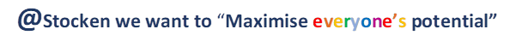

As part of our drive to make family the “golden thread running through the processes of all prisons” (Lord Farmer, 2017), our strategy aims to promote a whole prison approach to families and significant others, by embedding support services and initiatives across all Reducing Reoffending pathways and working closely with internal and external partners both in custody and through the gate to community.
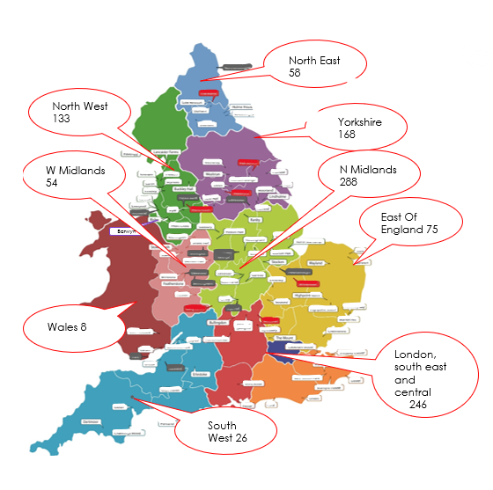
As a national resource, HMP Stocken houses prisoners from all over the Country and so creating opportunities for prisoners to develop and maintain meaningful family ties will be a key part of our strategy. Consideration will be given to families (and significant others) unable to travel regularly to HMP Stocken for visits, by promoting and utilising the technologies available to us and expanding our offer of social visits in 2024.

HMP Stocken aims to build family ties through the delivery of social visits, video visits, family days and other initiatives like story book dads and parenting courses. We aim to equip prisoners with the skills needed to manage anti-social relationships through targeted interventions such as TSP, sentence plan targets like Personal Social Development and also other initiatives such as the positive role model programme delivered via the gym and through active citizenship/mentoring roles.

Russ Truman Keeley Moore/Jamie Robinson Dawn Warren
Governor Family Services leads Lincolnshire Action Trust
The role of Family and significant others in reducing reoffending - Lord Farmer report

The Lord Farmer Review on the importance of family and other relational ties was commissioned as part of the Government's plans to overhaul the delivery within prisons, which at the time was found to have “unacceptable inconsistency of respect for the role families can play in boosting rehabilitation and assisting in resettlement across the prison estate”.
The Review was asked to consider evidence of what works well to help families and prisoners maintain and even improve family ties, what could be learnt about what works to help those prisoners who do not have family connections and how this learning could be translated into policy and commissioning for change.
In the review ‘Importance of strengthening prisoners’ family ties to prevent reoffending and reduce intergenerational crime’ published (10 August 2017) Lord Farmer identified family as the “golden thread” running through the reforms across the prison estate.
Research shows that prisoners who receive visits from a family member are 39% less likely to reoffend, and that maintaining close ties with key family members can significantly reduce the risk of reoffending.
The Prisons Reform White Paper outlined that family members may encourage prisoners to take responsibility for their offending, and the impact it has on their lives and the lives of those around them.
The report acknowledged that innovative schemes and partnerships are also vital vehicles for preparing prisoners for release, and there are already proven partnerships in this area such as Storybook Dads, who help fathers keep in contact with their children, and Partners of Prisoners, who work with prisons to deliver more welcoming visitor environments.
The review concludes that quality family services will help people turn away from crime and it will support families to cope. Voluntary organisations have pioneered best practice for decades and now is the time to spread it far and wide.
The Farmer report made key recommendations that put family at the heart of prison reform. It supports efforts to improve the relationships between prisoners and their families or significant others and the services that are provided. HMP Stocken’s family (and significant others) strategy will aim to incorporate these recommendations along with 2023 HMIP feedback and ultimately enhance the delivery of this pathway.

Partnership working – Meet the team

As part of HMP Stockens drive to embed a whole prison approach to families and pro-social ties. The delivery of this strategy spans across all of the Reducing Reoffending pathway teams.
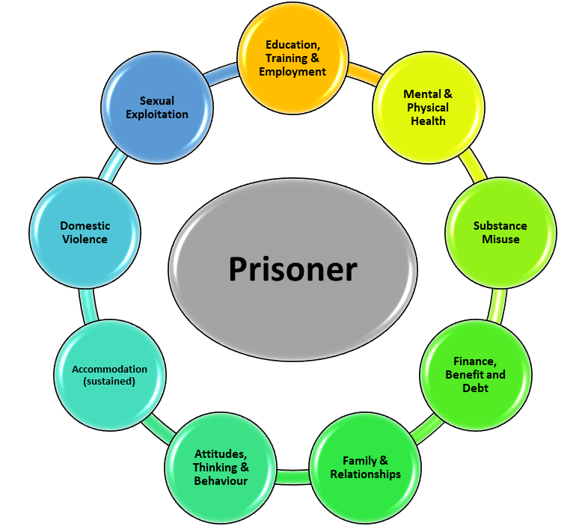

Lincolnshire Action Trust

Lincolnshire Action Trust (LAT) staff are an embedded and crucial partner that drive the importance and effectiveness of prisoners in both improving and maintaining family ties. They continue work to support and signpost prisoners and their families/loved ones. They have proven to be a very dedicated and important partner in helping with anything relating to family matters. The LAT staff have been involved with many families and helped to improve family relationships
Some of the services offered via LAT include;
- Meet and greet service (first time visitor? Don’t worry, we are on hand to support)
- Visitor inductions
- Visits play
- Signposting to other support services including employment, debt advice, children’s services, women’s services, housing etc
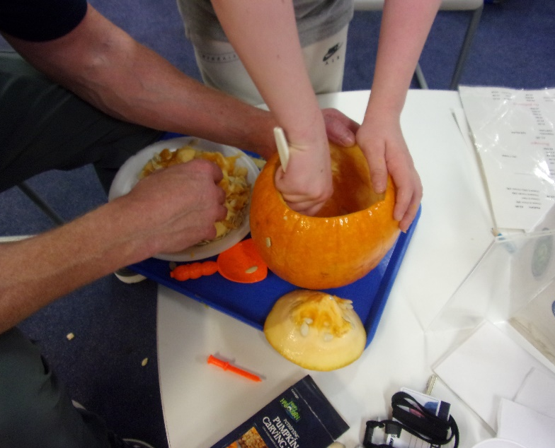
- Monthly Family days and visits enrichment activity
- Being Dad parenting course - NEW
- ‘Far from Home’ monthly prisoner support group - NEW



Rutland County Council – Library team
The library staff have previously been recognised by the CEO of Storybook Dads for their
‘sterling work and commitment (which) has brought a lot of joy and comfort to hundreds of children and will have had a big impact on family ties’. They have continued to run the Storybook Dads initiative as a way to support prisoners in maintaining family ties. In addition to this, the library staff provide a number of children’s books within the video visits hub as a way to support prisoners in reading their children stories.
Stocken’s community gym team

The gym team have developed a programme called ‘the positive role model scheme’ as a way to support prisoners in developing pro-social relationships in prison. The team were recognized at the 2022 POOTY awards for their innovative work in this area.
Not only this, but the team have been supporting prisoners in completing first aid courses with an addition focus pediatric first aid for infants and children.
The gym team are also often a familiar face at family days, often delivering a range of activities such as football and frisby golf.

The Programmes Team
Through the delivery of accredited interventions, the programmes teams place emphasis on teaching prisoner’s valuable skills to help them to develop and maintain pro-social relationships.
Within the delivery of TSP, prisoners complete the ‘positive relationships’ module which sees them develop skills in perspective taking as well as encourage them to think about what relationships they have (or could have) to support their desistance from crime.
Kaizen IPV is a programme which aims to reduce risk in relation to intimate partner violence, by exposing prisoners to a variety of skills designed to enhance self-control, emotion management, to challenge unhelpful attitudes and behaviours within relationships and reduce the likelihood of aggressive and controlling behaviours.
At the end of the programme, prisoner’s family/friends (where appropriate) are encouraged to attend post programme reviews as a supportive measure for the prisoner and to celebrate their success.

The College Team
Within the college, partners deliver short courses and initiatives to support family (and significant others) ties. Notably the ‘positive social development’ (PSD) course made up of the following modules;
- Understanding family relationships
- Personal and interpersonal conflict
- Assertiveness and decision making


Prisoner families are also invited to celebrate success when prisoners reach certain education, training and employment milestones, for example when graduating with the open university.
This year we are working to link family ties with some of the training areas within the prison and are re-launching the birthday cake service via the VT catering workshop to enable families to celebrate birthdays on social visits.

For 2024 we would like to also link our family services strategy with other education skills and work areas by introducing an initiative where prisoners building a bike in Workshop1 (to achieve qualifications), can do so for their children/families – by giving families/prisoners the opportunity to purchase the bike that’s been built.
The Chaplaincy team
Chaplains liaise with families over bereavements and unwell relatives and organise visits where appropriate. They can liaise with families concerning the pastoral and spiritual care given to prisoners but also be a point of contact for family members who have not had a telephone call from a prisoner for some time, and so have understandable concerns about them. Chaplains will then visit to investigate, after which they will contact the relative, with permission of the prisoner, to talk about anything going on for them.
They are also the bearers of positive news such as births and can liaise with families regarding marriage in prison.
Chaplains will attend some of the visit sessions to welcome and introduce themselves to families, so keep an eye out for them and come say hello!

Offender Management unit
The safety of our prisoners and their families is paramount, and our Offender Management Unit support us in ensuring that safety through Public Protection and risk management meetings.
The OMiC model also includes the role of keyworker. One of the jobs for the key workers is to make sure they have an understanding of the family services role, the care leavers system and the impact of not having well developed family ties, so they can help the men to re-connect and sign post the right services.
Please also see page 14 of this strategy about what to do if you are getting unwanted contact from a prisoner.
A whole prison approach
It’s not just the pathway teams who support the delivery of this strategy, conversations about families and the importance of these feature within keywork sessions and with staff on the wings.
Our kitchens team are always on hand to provide refreshments during visits and family days.
Our engagement and equalities team have worked to embed a yearly toyshop for prisoners wishing to purchase and wrap a toy for their loved ones, this has become a huge hit!
Our OSG and officer group work to support families and friends every week during social visits and family days, whether that be within the visits centre or within the main visits hall itself. Some of these staff have been key in making some of the suggestions within this strategy about how we improve our family and significant others offer.
For the year ahead we want to work with staff, prisoners and families (and significant others) to get their views, we want to focus on the needs of different prisoner cohorts, including our care leavers to make sure their views are represented and listened to, and we want to engage more with outside partners.
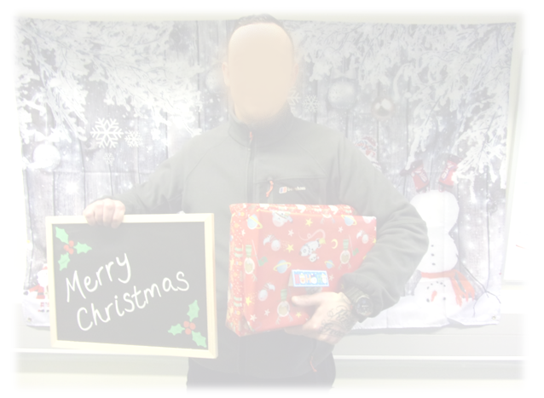

Understanding and supporting family and prisoner needs

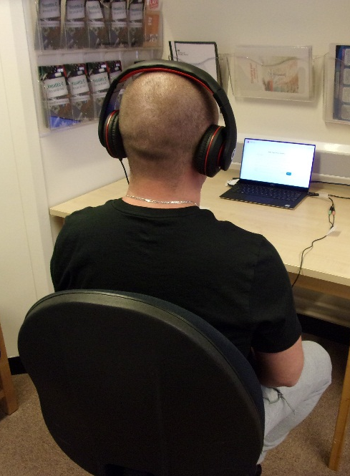
Segmentation data highlights that 89% of prisoners have needs in relation to their lifestyle and associates whilst 72% have needs in relation to their relationships (an increase from 67% the year previous) . This is somewhat comparable to OASys data which highlights 59% have criminogenic needs in relation to their relationships and 87% have needs in relation to their lifestyle and associates. On NOMIS, 66 prisoners have alerts for care experienced, 42 prisoners have gang member alerts, 56 have alerts for conflict with other prisoners and 299 have active Domestic Violence markers which is a significant increase on last year (216) highlighted a need for more initiatives designed to reduce risks in this area.

In terms of pathway needs, this tells us that families and relationships should form an integral part of HMP Stocken’s Reducing Reoffending offer.

Key Summary of the 2023/2024 needs analysis
- 50% of prisoners who responded stated that they had children under the age of 18. When asked who was now caring for them, the majority (84%) stated they now live with their other parent, 8% stated they had gone into care and 8% stated they now lived with other family members

- When asked what support they felt could be helpful in developing their parenting skills, 54% didn’t feel they needed additional support, but 33% stated they would complete parenting classes

- Answering about their relationship status, 38% said they had a partner before coming to prison, but was now single. Followed by 32% who said they were still together. 17% said they were single prior to prison and were still single at the time of the survey. This shows that a large number of relationships with partners had broken down following the prisoners coming into prison.

- When asked about problems in their relationships, before and after coming into prison, respondents reported more problems with children under the age of 18 after coming into custody

- Family arguments was the most common problem reported (27%) followed by problems managing emotion, problems with trust, coping with imprisonment and problems explaining why I am not home (14% for all). When asked what they felt would be helpful in supporting their relationships, most common answers related to distance from home, more visits, cheaper calls and support with family contact

- When asked who they were currently in contact with, “other family members” was the highest (39%), followed by “friends” (27%), then “children” (18%) and “partner” (16%).

- 37% of prisoners had used digital visits whilst at HMP Stocken, whilst 63% had not used this facility. When asked if they would recommend digital visits, 66% stated they would. Of the reasons why not, poor signal quality was among the most frequent answer. When asked how we could improve the service, better quality signal and more access were among the most frequent.

- 57% of those who answered the question stated they had had a social visit whilst at HMP Stocken. When asked about barrier to visits, “distance to travel” account for most of them.

- 37% of prisoners rated the children’s play facilities as either good or very good. They felt these facilities could be improved by better toys, more activities and initiatives like family photos

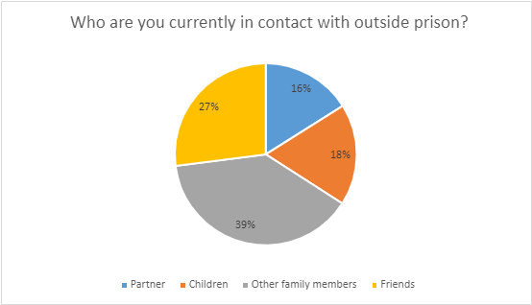
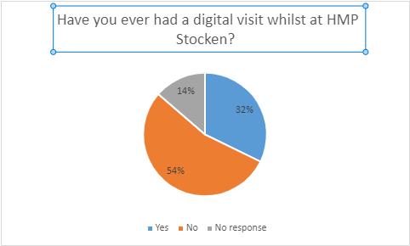

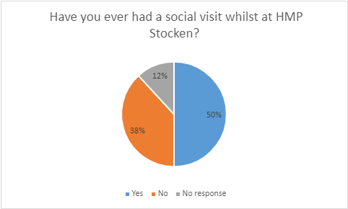

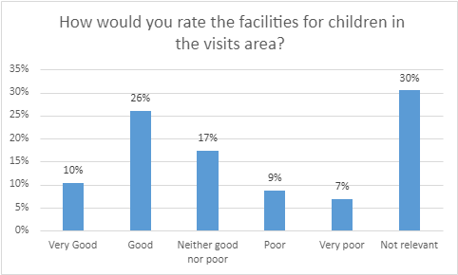

Children and families and contact with the outside world – HMIP feedback 2023
• Many prisoners were located far from home which made it difficult for their friends and family to visit. There were waiting lists for weekend visits. Prisoners told us of their frustration that visits of around an hour were too short
• Despite availability of video calls, prisoners and families told us of technical and procedural difficulties which made them reluctant to use the facility
• Families we spoke to were appreciative of the support provided in the visitor centre by Lincolnshire Action Trust (LAT). They also delivered tailored support to prisoners to maintain contact with their families
• Only 63% of prisoners said they could make a phone call every day, far lower than at comparator prisons. There had been long standing technical issues with the telephones on some wings.
From the findings of the prisoner survey and recent HMIP feedback, the following changes have been made, and recommendations will form part of the family services action plan;

Recommendations
- Visits booking line has returned to an online service in addition to over the phone to speed up visits requests
- The prison has now moved back to offering 2 VO’s a month for all prisoners and enhance PVO’s
- The family services provider has started delivering a parenting course called ‘Being Dad’
- Improve access and connectivity of video visits by ensuring laptops are maintained and available for long distance visits. Escalate issues to the digital team and develop a central hub
- Technical support for families and prisoners has been introduced within the family services contract
- A series of prisoners and family focus groups have been held to better explore the barriers to contact

Developing and maintaining positive relationships
We are working in partnership with other departments and agencies to offer a worthwhile service for the prisoners at Stocken, their families, children and friends.
The following methods of communication are available currently;
- Social visits Our visits hall has a well-stocked play area and a dedicated family support worker when required. All information relating to visits is published on the following website https://www.justice.gov.uk/contacts/prison-finder/stocken/visiting-information
- Prison Video are a great way to support prisoners whose family/friends live across the country or even overseas. All information relating to prison video is published here; Prison Video
- Family Days scheduled in school holidays are extended (4 hours) and often themed family visits, contact LAT for the family day schedule for 2023
- The ‘Email a Prisoner’ and ‘Email a Prisoner reply service’: family and friends can email to a functional email box and the prisoners can send a hand written reply which is scanned in and emailed back
- The library staff are committed to the Storybook dad projects. Prisoners can sound record a story for their children which is sent out. So far this year 50 DVDs have been recorded for prisoners and their loved ones
- Stocken R’ Us the hugely popular Christmas pop-up toyshop, where prisoners can attend and pick, wrap and post a toy/gift to their loved ones!
- Angel Tree: Prisoners can order Christmas presents for their children. The chaplaincy liaises with volunteers to buy, wrap and deliver the presents as long as prisoners are allowed access to their children (our Offender Management Unit is involved also). Each gift is dispatched as though it is from the parent accompanied with a personal message
- We are aware that there are prisoners who do not receive visits in person. The prisoners can exchange a Visiting Order for £1 phone credit. As long as they have not received any visits in a 4 month period, they can submit an application to their Custodial Manager, who will arrange for prisoners monies to give phone credit.
- Prison visits scheme – We appreciate that travelling to see loved ones in prison can be costly, we will promote and support people in getting help with the cost of prison visits, including travel and meals. For more information visit Get help with the cost of prison visits - GOV.UK (www.gov.uk)
- Penfriends is helpful for people who feel lonely or just want to reach out to someone who isn’t a friend or family

Coming in 2024…..
- We want to get families and significant others involved in prisoners training/development. We will start doing this by promoting an initiative where families can purchase the bikes that prisoners refurbish in the bicycle repair workshop (including children’s bikes)

- Similarly we want to support prisoners in getting involved with their children’s education/development by building relationships with schools and supporting prisoners in being involved in things like parents evenings

- Homework club! This year we will be running more homework clubs and story clubs for prisoners to complete via digital visits with their younger loved ones, whether that be children, nieces, nephews etc.

- Birthday cake service, the prisoners can order cakes via VT Catering for special occasions. These can be ordered 2 weeks in advance and shared on the social visit.

- We want to work with those prisoners who do not receive visits or may not have an immediate support network in place. The chaplaincy department have started to establish an Official Visitor scheme. A number of volunteers have been vetted to visit prisoners without families or significant others

- Prisoners with experience of the care system have got a right to be supported by a personal advisor/local authority. We have appointed a dedicated cohort lead who will review the support systems in place for care leavers and enhance these in line with prisoner feedback. Prison leaders have acknowledged barriers to reporting and will work to break these down by introducing a peer support network. Any prisoner who wants support can speak to their key worker or our dedicated cohort lead. They also can ask for support from the Care Leavers Association http://www.careleavers.com/.

- Being Dad parenting course. Based on feedback from the needs analysis and the first pilot course which has taken place, this year we will work with our family provider to introduce the ‘Being Dad’ parenting course on a regular basis as a way to support prisoners in developing valuable parenting skills

- First time Dad family days with sessions on changing nappies and pediatric first aid

- We will embed our month Far from home prisoner support group for prisoners who do not receive visits

- We will increase the uptake of Digital visit support services as we move into a digital age, the use of video calls has become common place in society

- Homework club! This year we will be running more homework clubs and story clubs for prisoners to complete via digital visits with their younger loved ones, whether that be children, nieces, nephews etc.

How to get in touch;
We understand that families or others may want to get in contact for a variety of reasons. Families phone because they are concerned about a loved one, they have news to share or it may be because a prisoner may be at outside hospital and want to know how to visit etc.
Our family services provider is also on hand to support, please get in touch;
Lincolnshire Action Trust; Call: 01780 795261 http://latcharity.org.uk/
Email: latfamililes.hmpstocken@justice.gov.uk
Families and significant others can also call the Chaplaincy department. They answer calls and have a voicemail which is checked several times a day.
Chaplaincy: 01780 795161
Safer Custody also have a dedicated 24 hour telephone line which is checked daily, so families/friends can raise concerns:
Safer Custody Hotline: 01780 795213
Any concerns about the mental or physical well-being of the prisoners at Stocken will be recorded and acted on. Safer Custody will work with the dedicated key workers to ensure that any concerns can be resolved. Where appropriate the Safer Custody team will also inform families when a prisoner is placed on a support plan (ACCT) and can involve families on interventions.

In an emergency
Call 01780 795 100 if you think a prisoner is at immediate risk of harm. Ask for the Orderly Officer and explain that your concern is an emergency.

Useful links and contacts;
This series of short videos has been developed in partnership with prisoners and their families. It explores the different aspects of prison life and the support your loved one can access during their time in custody. Prison Life Videos | Prisoners' Families Helpline (prisonersfamilies.org)
Stocken Prison Visiting Information https://www.justice.gov.uk/contacts/prison-finder/stocken/visiting-information
Help with prison visits scheme; Get help with the cost of prison visits - GOV.UK (www.gov.uk)
The Care Leavers Association http://www.careleavers.com/
National Information Centre on Children of Offenders https://www.nicco.org.uk/
Clinks http://www.clinks.org/
Family Lives http://www.familylives.org.uk/
Pact https://www.prisonadvice.org.uk/
POPS, providing support to families of offenders http://www.partnersofprisoners.co.uk/
Prisoners families helpline; Contact our Helpline Team | Prisoners' Families Helpline (prisonersfamilies.org)

What to do if you are getting unwanted contact from a prisoner?
The Unwanted Prisoner Contact (formerly Victims Helpline) is a national service that prevents victims, or any member of the public, receiving unwanted contact from prisoners.

The service is available to any member of the public (including all victims of crime), with a strong focus on protecting victims of Domestic Abuse and Stalking. It can be used by anyone who wishes to stop contact from prisoners. This includes
    - stopping unwanted letters
    - blocking phone calls
    - texts
    - messages from a prisoner

Run by HMPPS this is a service that anyone can use irrespective if they are for example:
- a member of the public (including all victims of crime)
- the police
- probation practitioner/ victim liaison officer acting on behalf of the victim
- a family member or friend acting on behalf of the victim
- or an organisation working on behalf of the victim to block the contact i.e., solicitors, victim and/or domestic abuse charities

A victim can also contact the service if they are worried about someone being released from prison. For enquiries of this nature please contact the service via telephone: 0300 060 6699, open Monday to Friday, 9am to 4pm: www.gov.uk/stop-prisoner-contact

