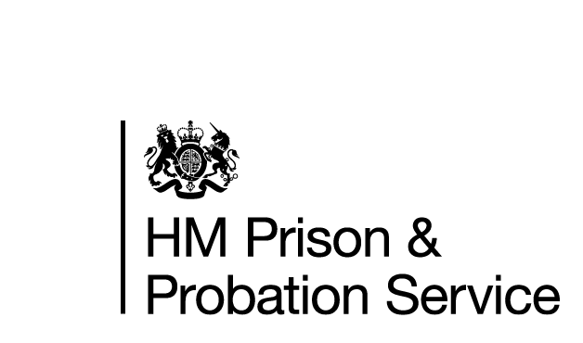



**FAMILY AND SIGNIFICANT OTHERS**

**STRATEGY**

Andy Mielczarski

Head of Reducing Reoffending & Family Strategy

HMP Buckley Hall

March 2024

V.2

**Contents**

Introduction…………………………………………………………………………. Page 1

Contact Us…………………………………………………………………………….Page 2

Your Visit……...………………………………………………………………………Page 3

Partners of Prisoners Support ………………………………………………Page 7

Staying in Touch….………………………………………………………………..Page 9

Future Planning…………………………………………………………………….Page 11

Measuring Success………………………………………………………….…….Page 12

Staffing Structure………………………………………………………………….Page 12

The following document is aimed at what HMP Buckley Hall intends to offer for both Families/Significant others and the people in our care. We are constantly reviewing what services we can offer when it is safe for staff, prisoners and their loved ones

**Introduction**

At HMP Buckley Hall we all have a responsibility to help maintain positive relationships.

Supporting a person in our care to develop meaningful and constructive relationships with their family or significant others is vitally important, especially considering the distance some families may have to travel to visit their loved ones.

At HMP Buckley Hall we want to make visits less daunting, more child friendly and stimulating for all that attend whilst adhering to all security procedures.

HMP Buckley Hall is committed to developing new ideas and supporting those who do not have visits to help build or repair relationships or to gain support during and after release.

For the purpose of this document, ‘Family’ is defined as either a blood relative or other significant people that men in our care identify as providing them with a constructive and supportive relationship.

**History**

HMP Buckley Hall is a male Category C prison in the town of Rochdale, Greater Manchester. It is operated by Her Majesty’s Prison Service. It opened in 1994, today it houses long term cat C prisoners with sentences of sixteen months or more.

**Getting to Buckley Hall**

By Car- Our postcode is OL12 9DP. We are situated 1 mile from Rochdale Town Centre. If using the Motorway network, exit the M62 Junction 21 signposted 'Milnrow and Shaw'. At the Roundabout take the A640 Elizabethan Way, signposted Rochdale. At the first major junction turn right onto A664 Albert Royds Street, signposted Littleborough. At the roundabout turn left onto Halifax Road towards Rochdale Town Centre. Take the second right onto Red Lane, then first right onto Buckley Road. At the roundabout take the second exit. The Visitor’s Car Park is on the left with the Visitors Centre housed in the timber building.

By Train- The nearest train stations are Rochdale and Littleborough. You can catch a train to Rochdale from Manchester Victoria station or from Leeds.

By Bus- From Rochdale Bus Station take any bus from Bus-Stand B. Look out for the Fire Station on Halifax Road and alight at Hamer Post Office. Walk along Red Lane. Follow signs for the prison, which is approximately 10 min walk from the Bus Stop. Any buses travelling to Rochdale from Littleborough will stop on Halifax Road. Alight opposite Red Lane and follow the directions.

**Accessibility**

If you have a disability, please inform the booking clerk when you initially book your visit, so that any special arrangements can be made. Wheelchairs, their users, adults accompanying them, and assistance dogs may need to be searched. Staff who carry out the searches will do so with professionalism and sensitivity. Visitors who need physical assistance during their visit must whenever possible be accompanied by another adult. The establishment’s staff cannot always offer personal assistance.

There is disabled parking at the gate and no steps from the allocated parking up to the main gate. The Visits Hall is on the ground floor and disabled toilets are available.

If you have difficulty visiting the establishment because of a disability you can discuss this in confidence with the Visitors Centre staff on 01706 514 357.



EMERGENCY CONTACT

**Contact Us**

**Address:**

If you have a concern that there is **an imminent risk of danger to a person in our care** and you wish to speak to a member of staff to raise this concern, then you can call the switchboard: **01706 514 300**

The member of staff answering the phone will not be able to discuss the person in our care with you, but they will immediately pass your concern onto a senior member of staff to action. We aim to address any issues raised on the call immediately and will let you know what the outcome is.

If you are concerned about the safety or wellbeing of any person in our care at Buckley Hall but there is no immediate threat or danger, then you can leave an answerphone message for the Safer Custody Team on:

**01706 514304**

This voicemail service is checked regularly throughout the day.

HMP Buckley Hall   
Buckley Hall Road   
Rochdale   
Lancashire   
OL12 9DP

General Phone Number:

01706 514 300 (24 hours)

Fax: 01706 514 399

**Visits Booking Line:**

01706 514 350

**Postal Orders**

Money can be sent in by postal order, made payable to ‘HM Prison Service’. On the back of the postal order write the sender’s name and address and the prisoner’s name and prison number. Post to:

HMP Buckley Hall, Buckley Road, Rochdale, Lancashire, OL12 9DP

You can also send money using your debit card or by bank transfer:

1. Make sure you have their prisoner number and date of birth

2. visit the web page: www.gov.uk/send-prisoner-money and complete the online form.

3. Money should reach the prisoner in 1-3 working days.

**Clothing Parcel**

Prisoners are authorised to receive a clothing parcel which must be sent in within the first 28 days of their sentence. Prisoners can subsequently have a parcel sent in yearly, during the month of their birthday. They can also purchase items from approved prison catalogues.

**Your Visit**





Whenever possible, all prisoners can receive a visit upon arrival at the establishment, prisoners need to add visitors to their ‘approved’ list through the kiosk or through an application. They will require the full name, address and date of birth of each visitor. Once this has been done, visitors can ring up or book online. When you book your visit you’ll be given a booking reference number which you should make a note of. You need to book your visit with the establishment at least 24 hours before the desired visit date. If you turn up without having booked a visit you will be turned away.

**Visiting someone at HMP Buckley Hall:**

You will need to bring one of the following forms of identification with you:

-Passport

-Driving Licence

-EC Identity Card

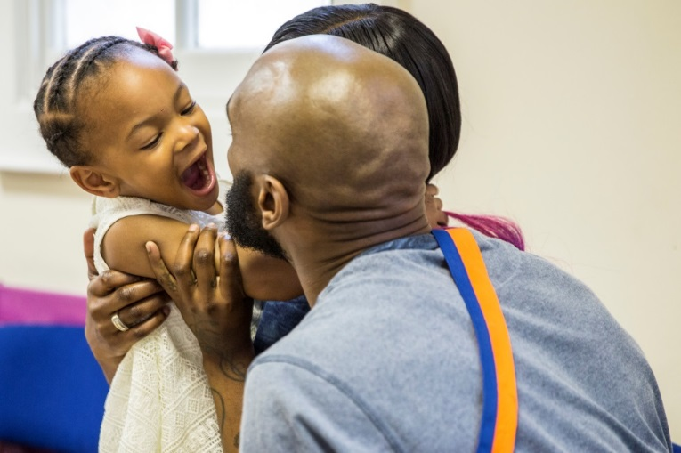-Employers/Student ID Card

-Bus Pass with photograph

-Red Maternity Book (ID option for children).

If you are unable to produce one of the above,

staff may accept combinations of

three or more of the following:

-Birth/Marriage Certificate

-Bus/Rail Pass with Photograph

-Bank Credit/Debit Card

-Young Persons proof of age card

-NUS Card

-Rent book/utility bill

-Library Card.

**Help with the cost of your visit**

Financial Assistance with Visiting: If you receive benefits you may qualify for support with your finances such as travel costs through the ‘Assisted Prison Visits Scheme’. As part of your application, you will need to get a secondary form stamped by prison staff on the day of the visit in order to prove your visit took place. You can request a copy of this form at the Visitors Centre.

**Visiting Hours**

HMP Buckley Hall provides visits at the following times:

Monday to Thursday 14:00 to 16:00

Saturday 09.30 to 11.30, 1400-1600

Sunday 09.30 to 11.30 (Parental Contact Visits only), 1400-1600

The Visitor’s Centre is open Monday to Thursday & weekends, this is where family, friends and legal representatives check in for their pre-booked visits.

**How to book a visit**

A family can book a visit using the following methods:

Call the Visits booking line Monday to Friday 09.30 – 1130, or Monday, Wed and Friday 13.00 -1600 on 01706 514350

Online by email, website www.gov.uk/prison-visits

When booking a visit you will be asked for the following:

-Name and prison number of the prisoner you wish to visit.

-Your own name, address and date of birth.

-The date you wish to visit.

-The number of people visiting – their names, addresses and dates of birth.

-The relation to the prisoner of anyone under the age of 18 years.

The prisoner is allowed up to 5 visitors per visit (this can include a maximum of 3 adults).

Please be aware that you need to be over the age of 18 to visit a prisoner. If a child is visiting then they need to be accompanied by an adult.

We ask that all visitors come on their visit clothed modestly i.e. not too revealing/no offensive or inappropriate slogans or logos.

**Entering the Prison**

You may only take money up to the value of £40 into the establishment for the purpose of purchasing drinks, food, and snacks (no £20 notes permitted). This sum of money is between all visitors on the visit, not per person. ID and car keys cannot be taken to the establishment. Both items can be taken up to the gate where they will be stored in a small locker. On arriving at the gate, you will be required to show your identification. If a visitor does not bring appropriate identification, they will not be allowed to enter the establishment. On your first visit, your details will be entered onto the establishment system (you will be required to have your photograph and fingerprint taken). This makes the process easier and quicker for future visits. All visitors are searched, which will involve passing through a metal detector and a rub-down search. All searches will be carried out sensitively, with respect and courtesy to all individuals. Children are searched by female staff in front of their parents. All visitors' religious beliefs will be respected. There is a private room available should religious headwear need to be removed as part of the search.

**Drugs and prohibited items**

The smuggling of drugs or other prohibited items into a prison is a serious offence and therefore will be treated as such. This includes illegal and prescription drugs. If anyone is suspected of smuggling drugs, they will either:

-Be subject to a more thorough rub down search.

-Be placed on a closed, supervised visit.

-Be subject to a full search (formerly – strip search) if agreed to.

A full search would take place without the visitors consent if they were suspected of smuggling class A, B or C drugs. If any visitor is found to be in possession of an illegal substance or prohibited item, they may face additional security measures as well as be referred to the police for potential prosecution with the maximum penalty being upto 10 years imprisonment.

If you are worried about drugs or are being placed under pressure to smuggle drugs please speak to an appropriate member of staff or contact the establishment by telephone.

Before entering the establishment, you may encounter a dog which is trained to pick up the scent of drugs. If a person is identified as being in possession of drugs or any other prohibited item, they may be subject to visiting ban and the police will be informed.

**In the Visits Hall**

The prisoner will be waiting in the visits hall when you arrive. Normally the prisoner and his visitor(s) sit at a table in an open room, with the other prisoners and their visitors.

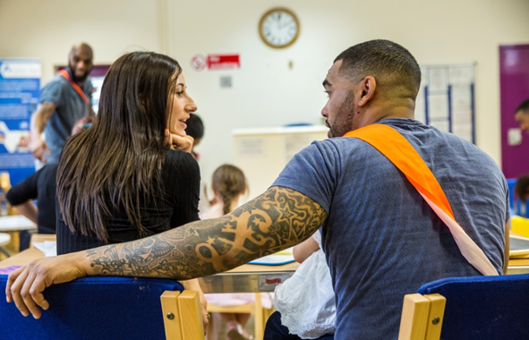Physical contact between the prisoner and visitors is usually allowed briefly at the beginning and end of the visit. The person you are visiting will need to remain seated throughout the visit.

Visitors are able to get up from the seating area to obtain drinks and snacks from the tea bar or to use the toilet. The toilet is situated outside of the visit’s hall, therefore you may be required to be searched again before re-entering the room.

A visit may be held under ‘closed’ conditions if there are concerns that the visit may be a risk to establishment security, or if there is a risk of unacceptable or illegal activity taking place during the visit. During a closed visit, the prisoner and visitors will talk to each other whilst seated either side of a glass panel.

**Children**

All visitors under the age of 18 years are regarded as children and must be accompanied on a visit by an adult. This is a requirement of the establishment’s child protection policy. Children must not be separated from the adult who has brought them to the visit at any time during the visit whilst on the establishment premises, including the Visitor Centre and the car park. Prams and pushchairs can be taken into the prison. A feeding bottle and spare nappies and wipes can also be taken on visits but no changing bag, you can ask for a clear plastic bag from a member of staff if needed. Access to baby change is available.

There are baby changing facilities and a play area (children must be supervised by a parent or guardian). A disabled toilet is also available. Lockers are also available which require a £1 deposit. You will be allocated a specific time slot by the visitor centre staff when it is time to go the main establishment for your visit, you must not approach the main prison area until this time. If you are going to be late for a visit, please contact the Visitors Centre on 01706 514357, as soon as you can. The last entry into the establishment is 30 minutes after the visit start time.

**POPS Family Services**



**Who we are?**

POPS (Partners of Prisoners and Families Support) was founded in 1988 by Farida Anderson MBE for families of prisoners. POPS provide support services to families of offenders at various establishments in the region. POPS recognise supporting a loved one during a prison sentence or a period of remand can be a very difficult time for family and friends. Practically and emotionally, there are many challenges to overcome. POPS strive to provide advice and support for all visitors on a range of issues. They also offer one to one support at times to suit families.

The POPS staff will guide you the whole way into your visit, when you arrive for your visit you will ‘book in’ at the Visitor Centre which is situated in the car park. Here they will ask you to give the name of the prisoner you are visiting and the booking reference number. Names of all visitors will be checked along with ages of visitors under the age of 18 years old.

The Visitor Centre opens 45 minutes prior to visits commencing. At the visitors centre you can buy tea, coffee or snacks, access information and advice and discuss any worries or concerns you may have in confidence. There is a play area for visitors’ children to enjoy whilst on a visit. There is a POPS staff member in the play area to provide play and craft activities for the children, however the parent or adult who brought the child(ren) remains responsible for all children for the duration of the visit. A parent or guardian must sign the child(ren) into the play area at the beginning of the session and sign them out again at the end. The play area is open for children ages 2-12, although children under 2 years may use the play area providing an adult stays with them.

**More Support**

Family Forums:

Family Forums are a great way to get your views heard and speak to other families. The forums are a platform for visitors to voice suggestions that can lead to improvements being made around the visit experience. Members of the Senior Management Team will be available to answer questions and listen to concerns so that the overall visits experience can be improved. The family forums will be advertised in advance using social media and displays in the visits area. As a way of thanking you for attending the in-person forum we will provide a ‘free’ visit on the day of the forum (one that doesn’t require use of a ‘Visiting Order (VO). If you do not wish to attend our family forum but have some feedback, please feel free to write it down and place in the box provided. Speak to a member of POPS’ staff to find out when and where the next forum is taking place.

Family Days: POPS deliver 10 Family Days per year. Family Days are a great opportunity for prisoners and their families to engage in activities and spend quality time as a family unit. Prisoners can apply for a place by putting in an application but must meet certain criteria.

Parental Contact Visits (PCV): These visits take place on the first four Sundays of every month, 9.30am-11.30am. The aim of these visits is to enable fathers to enhance and consolidate their parenting skills and spend quality time with their children. We also offer a supported visit on alternate Sundays to facilitate children with specific emotional/sensory needs. These visits run with reduced numbers creating a quieter and less overwhelming experience.

To apply, prisoners must:

-Have been adjudication free for the last 6 months

-Have not provided a positive MDT (Mandatory Drug Test) within the last 6 months

-Any application received from a prisoner on Basic IEP will be reviewed on a case by case basis but is not automatically precluded from attending a PCV.

All applications will also have to be passed by the Security Department. Once approved,

they will be allocated a week in the month and week 5 is open visits for all prisoners. They are only removed from these visits if their behaviour comes into question.

If you require any additional support or information, please contact POPS’ Head Office on:

**0161 702 1000**

Alternatively, you can email:

[mail@partnersofprisoners.co.uk](mailto:mail@partnersofprisoners.co.uk) or [buckleyhallvc@partnersofprisoners.co.uk](mailto:buckleyhallvc@partnersofprisoners.co.uk)

Or visit their website [www.partnersofprisoners.co.uk](http://www.partnersofprisoners.co.uk)

**Staying In Touch**



[](http://emailaprisoner.com/)

**Email a prisoner**

If you have access to email, it is possible to keep in contact using www.emailaprisoner.com. HMP Buckley Hall operates the ‘email a prisoner’ scheme, but are currently only able to receive in-coming e-mails from family and friends which are printed out and delivered to the prisoner. Email a prisoner enables a family member or friend, anywhere in the world, to send a message to prisoners in the UK from any computer for 40 pence per message. The message is delivered to the prison within seconds so that it can be delivered to the prisoner by prison staff usually the next day. This service allows families to maintain contact via email and provide a faster and alternative method to letters.

[logo small](http://www.prisonvoicemail.com/)**Prison Voicemail**

Prison Voicemail allows friends and family to contact the prison and leave a voicemail message for a prisoner who can then pick the message up using an individual voicemail pin number, this allows families to leave messages at a convenient time for them without worrying about missing a call. For more information check out www.prisonvoicemail.com.

**By Letter**

To send a prisoner a letter, please write his name and number on the front of the envelope and a return name and address on the back in case there are any issues and/or it needs to be returned.

**Penfriends Scheme**



HMP Buckley Hall currently works with the Prisoners’ Penfriends scheme to encourage those prisoners how do not receive visits or have limited contact. Working alongside the Prison Fellowship, HMP Buckley Hall enables prisoners to write to volunteers, these schemes are being coordinated by the Chaplaincy department.

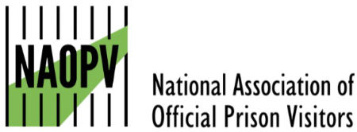**Official Prison Visitors (OPV)**

People in our care who do not have anyone who is able to visit can request to have a volunteer prison visitor called an ‘Official Prison Visitor (OPV) who will visit and provide support. This service is offered through our Chaplaincy department.

**Care Leavers**

People who identify as being care leavers are over-represented in the prison population (27% of those in prisons are thought to have care experience) in comparison to the general population. This is likely to be an underestimate due to reliance on self-disclosure.

At Buckley Hall we will identify any prisoner as a care leaver as:

Any individual who has experience of residing in care for a period of 2 weeks or more.

Although national policy is primarily aimed at those up to the age of 25 for whom local authorities still have statutory responsibility for, we will support those with care experience in prison regardless of their age or status.

Emerging evidence is suggesting that, due to their experiences, this group needs greater support both during their prison sentence and when preparing for and after release. The reasons for this are complex and varied, but as corporate parents it is essential that together we recognise this and address it by providing the best support available to ensure these people can cope with their prison sentence and prepare them for release.

**Young Adults**

HMP Buckley Hall is committed to supporting all young adults in our custody and has a separate Young Adult strategy setting out our commitment and action plan to support men in our care under the age of 25.

**Future Planning**



**Our commitment to visitors and people in our care in 2024 and beyond**

In-Cell telephones were installed in 2022 allowing prisoners and relatives to communicate at more convenient times for all concerned and we are proud that this introduction has further improved family and significant others relationships with their loved ones currently in our care.

We have a designated member of our Senior Management Team to take the lead on our Family Strategy whose role is to improve the link between families/significant others and the people in our care.

We also have a Family strategy champion who works on a daily basis supporting and driving forward our family strategy, meeting families and prisoners as well as supporting our FASO provider.

We will host a series of advertised and scheduled Family forums where families can meet with senior leaders to raise concerns and support the prison in improving its family provision.

We have installed large TV screens in the Visits Centre for up-to-date information, traffic reports, as well as utilising TV’s in the Visits Hall for video consoles.

We are looking at ways to continue to improve our facilities for children, subject to funding and security clearance and will use our virtual digital forums to influence this provision.

We will continue to conduct regular focussed huge prison and visitor surveys where we will be able to greater identify the needs of the people in our care and what we can do to improve their time at HMP Buckley Hall and how to involve their significant others in this journey.

We will host a number of specific family day events to celebrate key events such as Valentine’s Day, Mother’s Day & Father’s Day as well as holding child focussed events around Easter, Halloween and Christmas where the opportunity for the men in our care to spend quality time with their children is allowed to take place in a more informal setting. We will also host an annual celebration event to champion the success of the people in our care. We will invite families/significant others to the ceremonies after significant course/qualifications have been achieved to be able to celebrate success together.

**How We Measure Our Success**

We will measure our success by:

Maximising the number of spaces/attendees available for each visit

By ensuring our focussed family day events are diverse and meet the needs of the men in our care

By listening to and acting on the ideas and comments from both prisoners and families through our regularly advertised forums

By reviewing the feedback in the family comments book and functional mailbox.

**Staffing Structure**

**Our staffing structure ensures that our Families and Significant Others strategy is seen as an operational priority**

**GOVERNOR**

**DEPUTY**

**GOVERNOR**

**HEAD OF SECURITY**

**HEAD OF OMU &**

**PUBLIC PROTECTION**

**HEAD OF REDUCING REOFFENDING**

**&**

**HEAD OF FAMILY STRATEGY**

**HEAD OF RES**

**POPS Manager**

**HMPPS Family Champion**

**Operational Band 5 CM with responsibility for FASO**

**Support worker**

**Play worker**

**Family Engagement worker**

**Band 4 Supervising Officers**