





**HMP ONLEY**

**Family, Significant Others Strategy**

**2024 - 2025**

|  |  |
| --- | --- |
|  |  |
| **Contents**  Introduction | 4 |
| Roles and Responsibilities  Definition of ‘family’ | 5  6 |
| Impact of imprisonment on prisoners’ families | 7 |
| Care leavers | 8 |
| Why focus on children and families | 9 |
| Lord Farmer report | 10 |
| HMP Onley Strategy | 11 |
| Visits | 11 |
| Family Visits | 12 |
| Family Services | 13 |
| Assisted Prison Visits | 13 |
| Official Prison Visitors | 14 |
| Letters | 14 |
| Email a prisoner | 15 |
| Telephone  Prison Voicemail | 15  16 |
| Prisoner Penfriends | 16 |
| Prisoners without a visit history | 17 |
| Foreign national prisoners | 17 |
| Forward Trust Family Support Worker | 18 |
| Safer Custody | 20 |
| Celebrations | 21 |
| Partnership Working | 21 |
| Interventions and Courses | 22 |
| Reducing Re-Offending and Family Learning | 22 |
| Action Plan | Annex A |
|  |  |
|  |  |

**Introduction**

Maintaining family relationships is paramount in achieving a reduction in re-offending. Family and significant relationships are considered as a key means by which we can prevent reoffending and reduce the likelihood of intergenerational crime. Here at HMP Onley we aim to support our prisoners to develop meaningful and constructive relationships with their family or significant others and hope to assist in achieving positive change and transforming lives.

The impact of any custodial sentence is not only felt on the family member but also on the family and friends of the prisoner. HMP Onley aims to provide a framework that enables positive outcomes and interactions for children and families with a close family member in our custody. The primary purpose of a prison sentence is to punish the prisoner by taking them out of society where they can cause harm. However, given practical, financial, social, and emotional effects of imprisonment, a prison sentence can also have punitive consequences for families outside prison. Prisoners’ families, particularly their children, are often termed the ‘innocent victims’ of crime (and punishment). For a long time, prisoners’ families were also referred to as the ‘hidden’ or ‘invisible’ victims of punishment or crime, since the hardships they experienced were not immediately obvious.

We are committed to transforming prisons into places of safety and reform and we recognise the need to provide those in our care with stable environments, as well as opportunities to change their behaviour and turn away from a life of crime. Relationships with families and significant others can play a key role in this.

**Roles and Responsibilities**

The lead of the Families and Significant Others is **Head of Reducing Reoffending – Izu Ndefo**

All staff will be responsible for the adherence to the Family and Significant Others Strategy. The Senior Management Team and Managers will be responsible for ensuring that is being followed.

**Head of Reducing Reoffending – Izu Ndefo**

* The Head 0f Reducing Reoffending is the policy owner and will provide assurance to the Governor.
* To ensure that all aspects of this strategy is being followed.
* To ensure that the strategy is in place and reviewed when required.
* Discuss bi-monthly and significant others at the Reducing Reoffending meetings with the relevant people.
* Create and review a line of action plan, ensuring progress is made against all objectives.

**Head of Operations – Lisa Taylor**

* To hold consultation groups with prisoners about visits.
* To ensure that children have information about the searching process explained to them in a format they can understand.
* To complete 2 visits needs analysis per year.
* Monitor and amend visits times based on the needs of the population.
* Ensure that visitors of the prison are aware of how to raise a concern about their loved one/report wrongdoing.
* Quarterly testing of the visits booking arrangements to ensure that a weekday visit can be booked in the following week and weekend visits for at least the 2nd weekend after the call.

**Families and Significant Others Champion - CM Scott**

* Manage social, legal, and official visits sessions including searching of prisoners’ and visitors ensuring it is carried out in line with National Security Framework (NSF)/Local Security Strategy (LSS) standards.
* Manage the relationship between the establishment and local key agencies supporting legal, social visits and family visits.
* **The Family Service Provider**
* Provide a service in line with contractual arrangements.
* Complete an annual visitor survey.
* To support prisoners and their families/significant others to have healthy, supportive, and meaningful relationships.
* Support prisoners and their families with a wide range of issues and barriers that are associated with having a parent/family member in custody.

**Head of OMU Delivery/Services and Head of Residence and Services**

* To ensure that strategies for Young Adults and Care Leavers consider aspects around Family and Significant Others.

**Head of Residential**

* Ensure that keyworker plans include family and significant others consideration and engagement.
* To train keyworkers in the importance of maintaining Family and Significant Other relationships.

**Definition of ‘Family’**

For this document, ***Family*** is defined as either a blood relative, legal or significant persons that a resident identifies as their next of kin and for care-leavers this may be someone that provides a statutory service. Many of those in custody will have experienced a non-traditional upbringing, with a range of adults having cared for them, and similarly those in custody with children may have other arrangements outside of a traditional family arrangement. It is important to accommodate all ‘family’ arrangements where they provide a constructive and supportive relationship for the resident and their family.

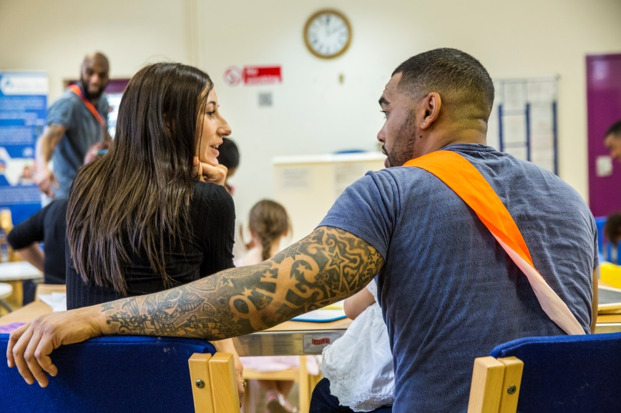

We recognise that not all family relationships are positive, and some family members may even be the direct or indirect victims of a resident’s offence. Other family members can be enablers & contribute towards our prisoners offending behaviour – with this in mind we must ensure that we prevent inappropriate contact.

**The impact of imprisonment on prisoners’ families**

Since every family is different (including who is part of a ‘family’), the impact of imprisonment is different for every family. Yet, research suggests that there are some common experiences.

According to Keeping Children Safe in Education, **200,000 children** have a parent sent to prison every year. Many more have a sibling or close family member in prison.

The National Information Centre on Children of Prisoners (NICCO) estimates the figure is closer to 310,000 and report that 10,000 children visit public prisons every week.

The children of prisoners are 3 times more likely to take part in anti-social and delinquent behavior. Imprisonment can result in reduced family income, home, and school moves, disrupted relationships, stigma and decreased social support. Each year in the United Kingdom more children are affected by parental imprisonment than by divorce. It is estimated that 65% of boys who have a father in prison will go onto offend themselves. This research shows that offending can be catastrophic to families and children, who are also being punished along with their parent.

Additionally, children from these family groups form a significant number of those entering the Care system.

Families experience emotional distress even with the temporary loss of a loved one from the family home and/or family life: for example, families miss out on sharing family events such as birthdays and Christmas, or even simple family activities such as meals, with the imprisoned family member.

Prisoners are stigmatised for their offence, and their families often are too. Families are seen as *guilty by association* even though they are legally innocent and generally were not involved in the offence. This stigma is sometimes referred to as *stigma by association*. This stigma makes the imprisonment even more difficult for family members, and it can also mean that families are treated negatively by other members of their community, or face negative treatment from colleagues, peers, the media and even friends and family.

Following the imprisonment of a person, partners of prisoners are often forced to take on multiple roles and responsibilities, particularly where the incarcerated family member has previously had an active role in the household.

Imprisonment tends to impose financial strain on the families of the prisoners in two ways: by decreasing the family income and by increasing family expenditure, due to costly visits and phone calls, and transferring money for their loved ones in prison. There can also be significant issues if prisoners get into debt and pressurise family to pay to get them out of it. Prison can thus exacerbate existing socio-economic disadvantage.

There are often particular difficulties associated with prison visiting. Visiting often involves a great deal of time, effort (both physical and emotional) and expense. Visiting can be quite an emotional experience, with both positive and negative feelings in the mix: for example, families usually enjoy seeing their imprisoned loved one, but due to the brevity of the visit saying ‘goodbye’ comes quickly, which can be distressing.

Visiting can be particularly difficult for children, with poor facilities that are not ‘child friendly’ and confusing rules restricting how they can interact with their imprisoned family member; families often have to travel long distances to a prison, and are often reliant on public transport; visiting times may not be compatible with tea time and bed time routines, leaving children irritable or tired, which may then impact on school performance the following day. Stigma for the children of prisoners can be manifested in being bullied by classmates in school.

**Care Leavers**

Care Leavers are over-represented in our prisons and 25% of men constitute one of the most vulnerable groups in our society and those in our prisons are likely to be some of our most complex people. As such it is vitally important that we can identify them and have systems in place to ensure they are receiving support, both under statutory obligations for those under 25 but also to understand the impact early childhood trauma and their care experience have on them and their behaviour.

We will aim to deliver activities to develop and enhance prisoners’ relationships with at least one external significant person.

We will aim to Identify whether the prisoner is socially isolated and engaging in the regime. The Operations function will work with prisoner Supervisors, within the Prisoner Management in Custody framework. Also, Key Workers, family engagement workers, Samaritans, and other support provision. Chaplaincy provides invaluable support regardless of the imprisoned person’s faith and seeks to engage with those that are isolated. One approach is the Official Prison Visitors Scheme which the Chaplaincy co-ordinate at Onley.

**Why focus on Children and families?**

Supportive families are a great resource for prisoners, and they often play a vital role in helping an individual move away from crime. A supportive family can also provide effective protective factors for prisoners at risk of suicide and self-harm. Having a stable family to return to on release, can also encourage prisoners to engage in sentence planning interventions and maintain positive behavior whilst in custody, helping their earlier release from custody.

It is therefore important at Onley that our staff and our partners/pathways leads encourage positive family relationships, and identify ways of supporting families in order to reduce re-offending.

Benefits of good contact between children, families, and prisoner parents:

* Prisoners’ partner/child’s carer
  + Quality time with partner
  + Child happier and easier to manage.
* Prison
  + Better resettlement
  + Better mental health of prisoners
  + Reduced suicide in prisons
  + Prison is a happier place.
  + More engagement in purposeful activity by prisoners
* Child
  + Child adversely affected by imprisonment.
  + Children need to talk to parents.
  + Helps break inter-generational cycles of crime.
  + Child can live like any other child.
* Society
  + Reduction in offences in the next generation
  + Cost benefits
  + Prisoners’ children have fewer problems.

**Lord Farmer Report**

Research has shown close ties between prisoners and key family members can significantly reduce the risk of reoffending.

In a landmark review, Importance of strengthening prisoners’ family ties to prevent reoffending and reduce intergenerational crime, published in August 2017, Lord Farmer has identified family as the “golden thread” running through the reforms across the prison estate.

In September 2016 Lord Farmer, in partnership with the membership charity Clinks, was commissioned by the government to investigate how connecting prisoners with their families can improve prisoner wellbeing, assist in keeping the public safe and reduce reoffending.

Lord Farmer said:

My report is not sentimental about prisoners’ families, as if they can, simply by their presence, alchemise a disposition to commit crime into one that is law abiding. However, I do want to hammer home a very simple principle of reform that needs to be a golden thread running through the prison system and the agencies that surround it. That principle is that relationships are fundamentally important if people are to change.



[*https://www.google.co.uk/search?q=lord+farmer+prison+review&oq=lord+farmer+&aqs=chrome.2.0j69i57j0l4.8964j0j4&sourceid=chrome&ie=UTF-8*](https://www.google.co.uk/search?q=lord+farmer+prison+review&oq=lord+farmer+&aqs=chrome.2.0j69i57j0l4.8964j0j4&sourceid=chrome&ie=UTF-8)

**HMP Onley Family Strategy**

The primary aim of HMP Onley’s children and family provision is to actively support friends and families in maintaining positive links with friends and relatives who are in custody. The strategic aim is to reduce reoffending and intergenerational offending by supporting and enabling strong family community ties with prisoners. This will be led by the Head of Reducing Reoffending.

To assist in supporting the families & significant others of prisoners in our care as well as the prisoners themselves, we will work with several partnership agencies to offer the following services:

**Visits**

Prisoners receive visits in compliance with Prison Rule 35 on personal visits and are permitted to receive visits twice every 4 weeks. Visits can be booked via email and by telephone.

HMP Onley will provide information to visitors about support services; signposting to specialist services; information about Assisted Prison Visits Scheme and information to meet needs of people with protected characteristics (e.g. BAME, Women, Children, Non-English-speaking visitors, complaints procedure). We will provide support for prisoners and visitors with neurodiverse needs.

The visits room play area provides an opportunity for children visiting prisoners to engage in play in sight of their parents, or appropriate accompanying adult, and under the care of suitable staff and/or volunteers. We will provide a play worker for domestic visits and family day, who will provide structured play, activities and learning for children of all ages that is engaging and stimulating. The play area facility is available during all the agreed domestic visiting hours and will be stocked with toys and equipment that will be maintained, cleaned, and replenished by our family services provider.

Enrichment activity will be delivered that engages and links to already established provision and in partnership with other agencies.

The visits room will provide a hot and cold food and beverage service. There will also be a service in the Visitors Centre.

The Visitors Centre will be opened at appropriate times and will have equipment and staff to offer suitable support and activities for children of all ages and promote a positive and safe experience.

There will be a range of information on support services such as, but not limited to, debt advice, employment and skills, children’s services, drug / alcohol support, women’s services, housing, health, and wellbeing. Information will be to reflect the needs of BAME visitors, women, children, carers, non-English speaking visitors, protected characteristics of individuals and learning difficulties.

Visits are delivered:

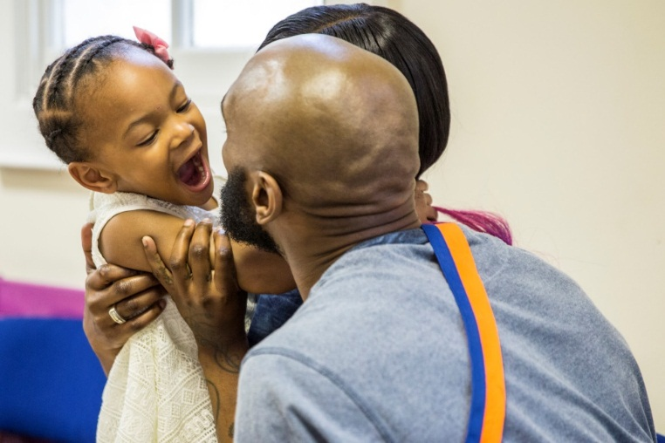

Monday: No visits

Tuesday: 14:00 – 16:00

Wednesday: No visits

Thursday: 14:00 – 16:00

Friday: 14:30 – 16:00

Saturday: 14:00 – 16:00

Sunday: 14:00 – 16:00

To ensure we are providing a service that meets the needs of visitors we will undertake a visitor’s survey in 6 monthly intervals and act on feedback.

**Family Visits**

Family Visits are facilitated once a month, in conjunction (currently) with PACT. These are visits that last from 1100 – 1500 and enable the family to interact in a more ‘relaxed’ environment, with the aim of providing quality time for prisoners and their children under supervision but apart from carers and other visitors. This is a structured day which includes learning opportunities for parents and children working together and will provide a range to cater for different age groups. Other activities can include:

* Craft activity sessions.
* Playing games or doing puzzles
* Reading to children and families
* Interacting with prisoners and their families
* PE activities in the Sports Hall

**Family Services**

Family services will be provided by the Prisoner Advice and Care Trust (PACT). They will promote the Children and Families pathway and actively seek engagement and support of the family for the prisoner’s journey.

**Assisted Prison Visits**

If someone visits a family member, partner or someone who doesn’t get other visitors they might be able to get help paying for:

* travel to the prison.
* somewhere to stay overnight
* meals

They must be getting certain benefits or have a health certificate to get help.

If they are taking a child with them or someone to help them (for example because they’re disabled) they might also be able to get help paying for their visit.

The scheme, including posters, leaflets and application forms is promoted through the Visitors Centre.

Further information can be found at: [*www.gov.uk/help-with-prison-visits*](http://www.gov.uk/help-with-prison-visits)

**Official Prison Visitors**

Official Prison Visitors (OPVs) are a group of people who volunteer to befriend prisoners, at their request, whilst they are in custody. OPVs come from all sections of the wider community willing to visit those prisoners who, particularly do not get regular domestic visits, and would appreciate someone to come and offer some common sense; compassion; interesting conversation and a bit of a sense of humour.

By accessing a positive experience through OPV’s, the prisoner may gain more confidence to approach those possibly estranged, such as partners or children, to visit.

**Letters**

Prisoners can communicate and maintain ties with family and friends, by sending and receiving mail, and communicate confidentially with legal advisers and some other organisations in a manner which does not compromise safety. The process meets minimum statutory requirements and ensures that the security and good order of the prison is maintained.

Prisoners are entitled to once weekly letters at public expense.

Prisoners are also allowed stamps and envelopes to be posted in, or they may purchase them from the family shop. They can also access writing pads from the prison shop. There is no limit on the number of letters prisoners can send out at their own expense.

**Shannon Trust – Turning Pages**

Shannon Trust is a small charity with a big impact. Each year over 4,000 people in prison learn to read with the help of the Shannon Trust Reading Plan and a specially trained prisoner peer mentor. The results are life changing.

Since its introduction in June 2015, Shannon Trust has been welcomed by people in prison, prison staff and literacy experts.

Turning Pages is a fresh, easy way for adults to learn to read, at their own pace, one to one with a friend, family member or other mentor regardless of age, gender, or ethnicity.

All sorts of adults’ struggle with reading and Turning Pages can help them. Learning to read isn’t just a brilliant thing,

* It helps people change.
* It’s a gateway to new possibilities.
* It helps create and nurture relationships.
* It’s a joy.

At Onley, Shannon is co-ordinated through A staff member with a small team of full-time mentors and volunteers supporting men through the prison at work, education and on their wings.

<https://www.shannontrust.org.uk/>

**Email a Prisoner**

Family and friends can send messages via the email a prisoner website. The message is delivered in a daily batch. The message is printed within the establishment and provides a more ‘real time’ element to communication.

 **Telephone**

On first reception into prison, prisoners often need to make an early telephone call to family and friends to let them know their whereabouts. These calls are allowed when prisoners arrive on the Induction wing. The establishment credits each prisoner with £1 to make this call.

Our prisoners can buy telephone credits from their weekly ‘canteen’ spends, including when under restrictions through IEP or any disciplinary awards. The limit is £50 weekly. Foreign National prisoners are not subject to this limit.

Where prisoners have either close relatives or partners detained in different prisons an inter-prison phone call can be facilitated to ensure regular contact. An agreement is made with the other establishment that one prisoner can receive a call on an official telephone at a time convenient for both prisons. The calls are at the discretion of an Operational Manager.

In-cell telephony has been installed to support family contacts.

Prisoners in the general population are allowed to exchange visiting orders to pin phone credit if they have not received a domestic visit in the previous six months. This should be equivalent to a 20-minute call. Once the qualifying period is met, this can be claimed monthly.

**Prison Voicemail**

This prison offers the Prison Voicemail service, which lets prisoners exchange voicemails to their approved family or friends via the Pinphone system. They can also talk directly through the service if the contact is available.

Prison Voicemail gives you cheaper calls and is fully HMP-approved and is available in this establishment.

The service is especially useful for prisoners who:

* Have difficulty reaching family on the phone during association time.
* Have family overseas.
* Have children or elderly relatives they want to communicate with

Family or friends can create accounts at prisonvoicemail.com <https://prisonvoicemail.com/>

**Prisoner Penfriends**



Prisoner Penfriends is a scheme which makes it possible for a prisoner to get to know a new person through the post and is used in prisons nationally. The scheme finds the prisoner someone to write to and this person will write letters to them care of Prisoners’ Penfriends address and they will send the letter on to the prisoner. The system can have the effect of giving prisoners more confidence to write letters and may lead to instigating communication to family or friends that they haven’t previously contacted. Prisoners get in touch at Penfriends, PO Box 33460, London, SW18 5YB. <https://www.prisonerspenfriends.org/>

**Prisoners Without Visits History**

HMP Onley provides a monthly list to Key Workers of those prisoners with no visit history. The Key Worker should encourage and support the prisoners to establish at least one external contact. They will also promote schemes such as Assisted Prison Visits and the exchange of Visiting Orders for Pin Phone credit.

Key Workers should encourage and assist prisoners to establish and maintain relationships with agencies or charities with the assistance of the family services provider (family support worker).

Prisoners found to have no next of kin details on the P: Nomis system are encouraged to do so. These data gaps are checked on a weekly basis and provide valuable information for Key Workers, who may also be exploring the reasons for some prisoners not receiving visits.

**Foreign National Prisoners**

Foreign national prisoners represent the second biggest cohort of prisoners housed in the general estate and has its own distinct estate. HMP Onley generally holds a reasonably small cohort of prisoners who identify as having a nationality other than British.

The OMU department assist in facilitating contact with family who reside overseas as they can suffer from isolation from families and cultures. Access to appropriate international support agencies should be signposted where possible whilst in custody. Assistance in communicating with families is given through the mail and phone entitlements described in the Foreign Nationals Policy.

Foreign national prisoners with visitors from abroad can access the Accumulated Visits process, saving up visiting orders to get more visits during the time their family are in this country.

As previously stated, foreign national prisoners do not have a limit of the pin phone credit they can purchase.

Translation services are available that can be accessed on demand at any time.

There should not be an assumption that because a prisoner is a foreign national and subject to deportation that they do not have family resident in the UK who can visit.

PACT is the current provider running the Visitors Centre and a Cafe inside the prison during visiting sessions and work with family members, partners, friends of prisoners as well as children who visit. They also facilitate family visits.

This is aimed at trying to maintain and strengthen family bonds during sentence so that fewer prisoners are released into an unsettled family life and are therefore less likely to reoffend.



**Level 1** - Meet and greet all visitors to the Visitors Centre and issue Welcome Packs as appropriate.

**Level 2** - General information and advice

**Level 3** - Specific Issue Information and Support – 1 to 1

**Level 4** **-** Family Intervention Work including Family Needs Assessments, direct support.

The services provided by PACT is managed through the national Family and Significant Other Framework.

**Forward Trust Family Worker**

The substance recovery service is provided by Forward Trust who also provide a Family Support Worker.

The Family Support Worker will be in Visitors Centre, working with visitors, staff, and other services to identify and prioritise referrals. They will case manage clients and provide pre and post release specialist advice, support, and onward referral to families most at risk. They manage a drop in appointment system, one to one and group-based support.

The Forward Trust are our substance misuse service provider who work with all prisoners who have a substance misuse history, either currently or in recovery.

The attached video clip shows you about their service:



You can refer to the Forward Trust in the following ways:

* Completing the attached form (also on the Shared Drive in the folder “Forward Trust – SMS) and returning it to the following functional mailbox: [forwardtrustonley@justice.gov.uk](mailto:forwardtrustonley@justice.gov.uk)
* Contacting the Forward Trust using the functional mailbox email address shown above
* Contacting the Forward Trust via phone on extensions: 3563 & 3567

You should always complete a Forward Trust referral in the following situations:

* When a prisoner is found under the influence
* When a prisoner is found in possession of hooch
* When a prisoner is asking for help with substance misuse issues
* When a prisoner says they are in debt due to drug use
* When a prisoner is found with drug paraphernalia in their cell or on their person
* Via an adjudication for a positive MDT

Prisoner can also refer themselves by contacting the Forward Trust via their in-cell phone. They need to dial 01788 523563 and enter PIN Number: 91726755

**Safer Custody**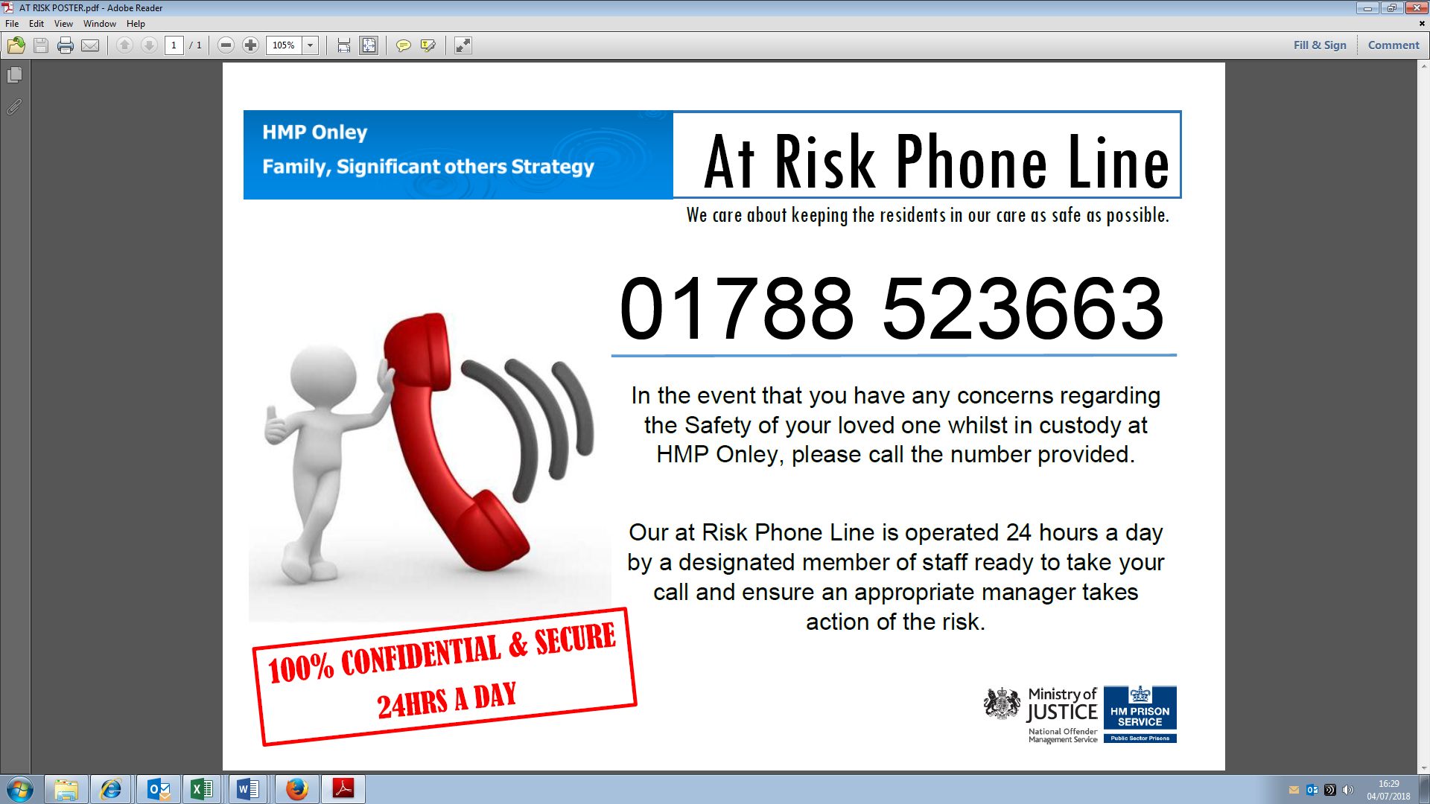

The At-Risk Phone Lines allows family and friends to report concerns about a loved one. Despite our best efforts there are sometimes occasions when we are caring for prisoners who are exceptionally complex with a range of difficulties and challenges. In the most extreme cases we may contact their family members for help or advice on what has helped the individual in the past. We sometimes also ask them if they are willing to come into the prison to take part in the regular reviews of their family members. Their knowledge and experience are very valuable in these cases.

**Celebrations**

Celebrating success is key to incentivising prisoners to engage in rehabilitative activities and those activities that support the work of the prison. It is up to us to develop family involvement in these processes. Listeners graduating from the Samaritans’ based training is celebrated and this is held in Visits Hall. Families are invited to celebrate what is a considerable achievement in helping the establishment to support vulnerable prisoners and those in crisis.



**Partnership working**

Delivering effective family practice cannot be achieved in isolation and as such we are committed to working in partnership with key local and national stakeholders. Through close working arrangements we can provide a bespoke service that is able to cater to the needs of prisoners and their families during their time in custody and then following on into ongoing support after release. Some of our current partners are outlined above and include.

   

**Interventions and Courses**

Suitable interventions and courses will be facilitated, based on needs identified. This may include educational or behaviour management accredited intervention programmes that help prisoners and their families work together to build links and positive relationships. Courses may include parenting and family relationship courses, family learning such as overseeing children’s homework and so on. Family relationship course / interventions may involve other departments including Chaplaincy, OMU, Safer Custody, Security, Through the Gate providers.

**Reducing Reoffending and Family Learning**

Families are influential in supporting men in custody and once released. Having children can be a life changing experience for men in custody and lead them to law abiding lives.

Currently we offer limited opportunities for engagement in education or resettlement activities. Our strategy aims to put families at the heart of reducing reoffending, allowing men to be supported by their families as well as supporting their own children in their development and education.

The library co-ordinates the Lily Pad book service. Lily Pad is a social enterprise that was started by prisoners at HMP Gartree and can provide a range of personalised books for prisoners to send to their children. Also, the Library provides support with Story Book Dads, giving fathers the opportunity to record stories and send to their children.

A new Children’s and Families forum will be established which will be held on a quarterly basis. This will bring together stakeholders to co-ordinate all activity through this pathway. It will also monitor progress, outcomes and agree new initiatives to be explored. It will include prisoner representation, and if possible, families as well.

Our new education and library provider, People Plus, have been commissioned to increase the amount of family learning and engagement. The prison’s DPS funding and freedoms will also be utilised to enhance services where current providers cannot.

These providers will have a greater involvement in the design and delivery of family days, working with other partners and staff, to offer a fun, interactive experience for our men and their families.

We aim to be able to offer family days away from the visits hall environment and will explore the potential use of the Lock Inn (catering academy), PE facilities and other areas of the prison to do so and bring a diverse range of activity.

We are going to implement a homework club style workshop for our men to support their children and how we can join community learning to the prison. Our geographic location is a significant challenge due to approx... 85% of our prisoner population coming from the London and Southeast region, will require us to give some thought on how to best achieve this.

Name: Mark Allen

Date: 9th of April 2024

Action Plan: [HMP Onley Family and Significant Others Policy Action Plans.docx](https://justiceuk-my.sharepoint.com/:w:/r/personal/izuchukwu_ndefo_justice_gov_uk/Documents/Desktop/Family%20and%20Significant%20Others/FaSO%20Measure%202024/HMP%20Onley%20Family%20and%20Significant%20Others%20Policy%20Action%20Plans.docx?d=w064e969c21124102aeb572b090a5de68&csf=1&web=1&e=m3hkaS)