

**HMP**

**Brixton**

**Family & Significant**

**Other Strategy 2024**

**SSS. BrooksD.**

**ve**

**Children**

**and**

**Families**

**Pathway**

**Lead: J Agyepong**

**Head of Operations**

g

cid:image011.png@01D5B4B7.D3F79290

**Reviewed April 2024**



**CONTENTS**

**Introduction**

**Purpose**

**Emergency info & contacts**

**Key Roles & Support-** Prison Staff

**Family Services** -PACT & Routes 2 Change

**Visits** -Social, Family and Secure Video Calls

**Maintaining Family Contact -**other means of communication

**Family Learning Opportunities**

**A Visitors Journey at HMP Brixton**

**How to get to HMP Brixton**

**Beyond visits**

**Prison Life**

**Our Plans**

**INTRODUCTION**

Opened in 1819, HMP Brixton London prison currently serving as Cat C Men’s resettlement prison holding prisoners with less than 2 years to serve.

It is proven that prisoners who maintain positive family ties whilst in custody are much less likely to reoffend.

## *“Family should be the ‘golden thread’ running through the processes of all prisons’*

Lord Farmer Report

# PURPOSE

# Whether directly employed by Her Majesty’s Prisons and Probation Service (HMPPS), or by a Partner Agency working with the prison, this policy is relevant to all prisoners and every member of staff who works here. We all have a part to play in helping those in our custody build a positive relationship with their Families and Significant Others.

# This policy outlines the Children and Family Services we offer prisoners in our custody, and how these services are delivered and managed.

Our Services will be delivered in line with Lord Farmer’s recommendations from his Report. Link above. What we deliver to prisoners will be measured against set criteria from The Farmer Report.

**EMERGENCY INFO & CONTACTS**

If you have any immediate concerns about the safety of your loved ones in our custody please contact the safer custody hotline on: 0208 588 6156

In an emergency please call the switchboard: 020 8588 6000

For assistance from our family service provider please contact: [brixton@prisonadvice.org.uk](mailto:brixton@prisonadvice.org.uk)

Prisoner family helpline: 08088082003

Tweet @HMP_Brixton

Write to the Family and significant others lead/ champion at:

HMP Brixton

Jebb Avenue

SW2 5XF

**KEY ROLES & SUPPORT**

**Family & Significant others (FaSO) Lead: Head of Operations**

* To take the lead on supporting the Families & Significant Others provision at Senior Management Tea level.
* To ensure that the establishment meets HMiP expectations for Children and families and contact with the outside world. In particular –
* Ensures the prison promotes and supports prisoners’ contact with their families and friends. Programmes aimed at developing parenting and relationship skills are facilitated by the prison. Prisoners not receiving visits are supported in other ways to establish or maintain family support.
* To act as the Single point of contact for and oversight of the establishments Family Offer, in relation to –
* Visitor base/centre and visiting services
* Staffing structure
* Extended visits
* Family learning.

•    Responsible for ensuring the establishments FaSO Strategy is fit for purpose.

•    Local lead for completion of the FaSO performance measure.

•    Provide contract oversight for family service providers

**Family & Significant others: Operations Custodial Manager**

* To support the FaSO lead in delivering the above targets
* To work with internal and external agencies to create an atmosphere of ‘Family Friendly Visits, reduce barriers to visiting, provide advice and support to prisoners & families, develop and support interventions designed to promote a healthy relationship between prisoners and their families such as child centred visits, homework clubs, family days, family courses and other family development opportunities.
* To promote the importance of FaSO across the establishment and contribute to training of other staff in this area
* To ensure safeguarding and public protection procedures are in place
* To support family service providers with the referral process and assist with their delivery

**Visits staff**

We have a core group of staff who regularly work in visits to maintain consistency and promote better relationships with families. This group was expanded in 2023 so the staff on duty will be more consistent, better informed, and more familiar to visitors.

We aim to ensure that all staff working in visits have a better understanding of the key role children and families play in the prisoner’s custodial journey, whilst taking into consideration maintaining security, safeguarding and public protection procedure.

**Keywork**

All prisoners will be allocated a designated officer keyworker within the first 2 weeks of arriving at HMP Brixton. Key workers are trained to support prisoners in working towards release which includes helping to maintain positive relationships and family ties. As well as wing staff they will be able to assist and sign post prisoners in resolving general queries.

cid:image011.png@01D5B4B7.D3F79290

The current contract was issued to PACT in September 2022

**PACT (Prison Advice and Care Trust)** works in partnership with HMP Brixton to deliver children’s and family services and to improve and expand the provisions in line with the needs of the population.

The team consists of a services manager, family engagement manager, family support worker and additional casual and volunteer staff who a predominantly based in the visits centre.

Some of the work PACT deliver is:

* Greeting visitors in the visits centre
* Staffing a family friendly visitors centre with information and advice for visitors.
* Signposting family members and prisoners to other relevant organisations for support
* Identifying and contacting all new visitors to answer any queries or concerns prior to their first visit
* Pairing family and significant others who require support with a community befriender volunteer
* Delivering Children and families orientated workshops for both prisoners and staff.
* Play worker sessions during visits, children and sibling play sessions, therapeutic play and family links visits.
* Facilitating extended family visits, teen days, homework clubs and other activities

**Routes2Change** is managed by PACT and offers support to every prisoner and family from induction to up to 6 months post release. The team consists of a team leader, 3 specialist family engagement practitioners and a play coordinator who contact all new arrivals to discuss their family dynamic and other close social bonds. Every prisoner is offered the opportunity to join the programme, which then involves working together to develop a Family Care Plan.

Familyin this context can either be a blood relative or a significant person whom a prisoner may consider to be their Next of Kin (N.O.K), they can also assist in family legal matters and provide support to those without family engagement. Most importantly the relationships need to be a constructive and supportive.

**VISITS**

## Social Visits

|  |  |  |  |  |  |
| --- | --- | --- | --- | --- | --- |
|  | **AM 1** | **AM 2** | **PM 1** | **PM 2** | |
| **MONDAY** |  |  | 14:15  A-D WING | 16:00  A-D WING | |
| **TUESDAY** |  |  | 14:15  G-WING | 16:00  G-WING | |
| **WEDNESDAY** |  |  | 14:15  A-D WING | 16:00  G-WING | |
| **THURSDAY** |  |  | 14:15  A-D WING | 16:00  A-D WING | |
| **FRIDAY** | LEGAL VISITS ONLY | | | | |
| **SATURDAY** | 09:15  A-D WING | 10:45  A-D WING | 14:15  A-D WING | | 15:45  G-WING |
| **SUNDAY** | 09:15  A-D WING | 10:45  A-D WING | 14:15-16:15  A-D WING ENH | |  |

Book online via: [Visit someone in prison - GOV.UK (www.gov.uk)](https://www.gov.uk/prison-visits)

Book Via phone: 02086781433 Monday *to Thursday: 1:15pm to 4pm Friday: 9am to 11:45am*

Email any queries to: [Socialvisits.brixton@justice.gov.uk](mailto:Socialvisits.brixton@justice.gov.uk)

## Secure Video Calls

<https://www.prisonersfamilies.org/change-of-video-call-service>

The introduction of video visits for families and significant others was used to maintain these important relationships during the pandemic. It can be downloaded on any android or apple device form the app store. We are able to facilitate almost 300 video calls per week, the calls are for half an hour. Only people aged 18 or over can register. You will need to provide your name, address, and date of birth, and upload photos of your ID and face. You will also need to add details of any other people who wish to take part in the video calls with you, such as children, and upload a clear photo of each participant’s face.

|  |  |  |  |  |  |  |  |
| --- | --- | --- | --- | --- | --- | --- | --- |
| MONDAY | C- WING  08:45 | C - WING  09:45 | C- WING  10:45 | C - WING  11:45 | C- WING  14:00 | C- WING  15:00 | C- WING  16:00 |
| TUESDAY | G - WING  08:45 | G - WING  09:45 | G -WING  10:45 | G - WING  11:45 | G - WING  14:00 | G - WING  15:00 | G - WING  16:00 |
| WEDNESDAY | D - WING  08:45 | A - WING  09:45 | A- WING  10:45 | A - WING  11:45 | D - WING  14:00 | A- WING  15:00 | A - WING  16:00 |
| THURSDAY | LPU - WING  08:45 | B – WING  09:45 | B - WING  10:45 | B -WING  11:45 | LPU - WING  14:00 | B - WING  15:00 | B - WING  16:00 |
| FRIDAY | N/A | N/A | N/A | N/A | N/A | N/A | N/A |
| SATURDAY | A - WING  09:30 | B - WING  10:30 | C -WING  11:30 | N/A | D - WING  14:00 | G - WING  15:00 | LPU - WING  16:00 |
| SUNDAY | D - WING  09:30 | G - WING  10:30 | LPU – WING  11:30 | N/A | A – WING  14:00 | B - WING  15:00 | C - WING  16:00 |

## Family Visits

Dates will be advertised to prisoners on the wing and to families in the visits centre.  These will be scheduled for:

May 2024 half term: x1 family day & 1x G wing extended fun visit

August 2024 Summer Holiday: x2 family day & 1x G wing extended fun visit

October 2024 half term: x1 family day & 1x G wing extended fun visit

December 2024 Christmas Holiday: x2 family day & 1x G wing extended fun visit

February 2025 half term: x1 family day & 1x G wing extended fun visit

April 2024 Easter Holiday: x1 family day & 1x G wing extended fun visit

*Please note dates may vary depending on school catchment area, dates will be based on local catchment area to HMP Brixton and confirmed 1-2 months prior to each session*

There may also be additional family visits linked to family learning courses, which be advertised to prisoners on the wing and to families via our family service provider in their monthly newsletter.

The family links room also may be available by referral from PACT to deliver family bonding through play sessions or to accommodate reasonable adjustments for adults or children with disabilities, new-borns and families facing difficulties.

Prisoners that are not receiving social visits are eligible to apply to be a part of the **visitors scheme**, this is where they are matched with a Pact visitor based on their interests and needs. Once a Pact Visitor is appointed, they are expected to visit and spend quality time with the prisoner with whom they are matched, approximately once a month for a minimum of one year, ideally until the end of their sentence. Face to face visits come to an end on the day of release and telephone support may be offered for up to 6-weeks post release. These visits take place in the visits hall and are not promoted as a Pact Visit amongst the other prisoners and staff facilitating the visit, so it is up to the prisoner if they share that the visitor is a friend or a volunteer.

Pact also offer enrichment activities to those who do not receive social visits. These are on the wing, and are based on creative activities and positive discussions.

## MAINTAINING FAMILY CONTACT

Prison Voicemail: Family members or friends sign up online and are given a unique landline phone number which they can call at any time to leave messages. The prisoner dials the same number from within the prison to listen and reply.

Inter Prison Visits (IPV): This allows prisoners to have contact with other imprisoned family members. It is operated through a phone call or video links in legal visits room.

In cell telephony: Is now installed in every cell in HMP Brixton after upgrade was completed in Summer 2022

Email a prisoner:   [EmailaPrisoner.com](http://www.emailaprisoner.com/)

Family and friends can send a message which is printed out and delivered by hand. You must buy a minimum of £5 credit in order to use the service, which runs at a cost of 40p per email and at no charge to the recipient.

# FAMILY LEARNING OPPORTUNITIES

|  |  |  |  |
| --- | --- | --- | --- |
| Course/Intervention. | Date. | Number of Participants. | Population. |
| Storybook Dads | Ongoing | 50 opportunities designated for 2024 | All wings. |
| Family Ties Workshops (Forward Trust) | Weekly | Unlimited | A-D Wing (G-Wing can cover content in 1-1s) |
| Family Link Visits | On-going. | As and when required | All prisoners by PACT Referral |
| Bonding Through Play sessions | On-going. | As and when required | All prisoners by PACT Referral |

**FAMILY DAYS: What is it?** Family Days are here to help you improve family contact, bond with your children and do fun activities! **Where?** Visits Hall **Criteria:** Security and Public protection Risk Assessment. **How to book?** Specific Family Day Application, or to Visits Booking.

**FAMILY LINK VISITS: What is it?** A chance to have a supervised visit in our family link room with PACT. Primarily aimed at new-born baby bonding sessions, working with disabled children and families working through issues. **Where:** Upstairs in visits **Criteria:** Risk assessed **How to book?** Application via PACT.

**BONDING THROUGH PLAY What is it?** A chance to ease family issues and rebuild positive relationships through play in the family link room with PACT. Aimed at families with children, disabled children and families working through issues. **Where:** Family link room/Video link **Criteria:** Risk assessed **How to book?** Application via PACT.

### FORWARD TRUST FAMILY TIES WORKSHOPS: What is it? A workshop exploring the notion of roles and that helps you think about some of the responsibilities and feelings that come with them – both good and bad. This workshop looks at stages of change and helps you and your family in your recovery journey. By focusing on topics such as family, addiction, communication and treatment, prisoners have had positive outcomes in their lives. Where? D wing health and wellbeing unit or via in cell pack– How? Group sessions: two sessions per week over a 3-week period. The sessions will take place in the C Wing Porta Cabin 1 during afternoons. For D Wing sessions, it will be run on the wing with a weekly session. Criteria: A-D Wing only (G Wing can work on content on a one-to-one basis with case worker). How to book? Clients will need to be on the Forward Trust and referred by their case managers

**STORYBOOK DADS (PACT):** Get the chance of recording a CD for your child or children to listen to.The goal of Storybook Dads is to bond with your children and to establish a contact by reading to them. **Where:** Family links room **How?** It is a one-hour session supervised by the Route to Change play co-ordinator. **Criteria:** the other parent must agree to it, and you shall not have any restrictions against their children (Level 4 only). **How to book?** Application to PACT staff.

.

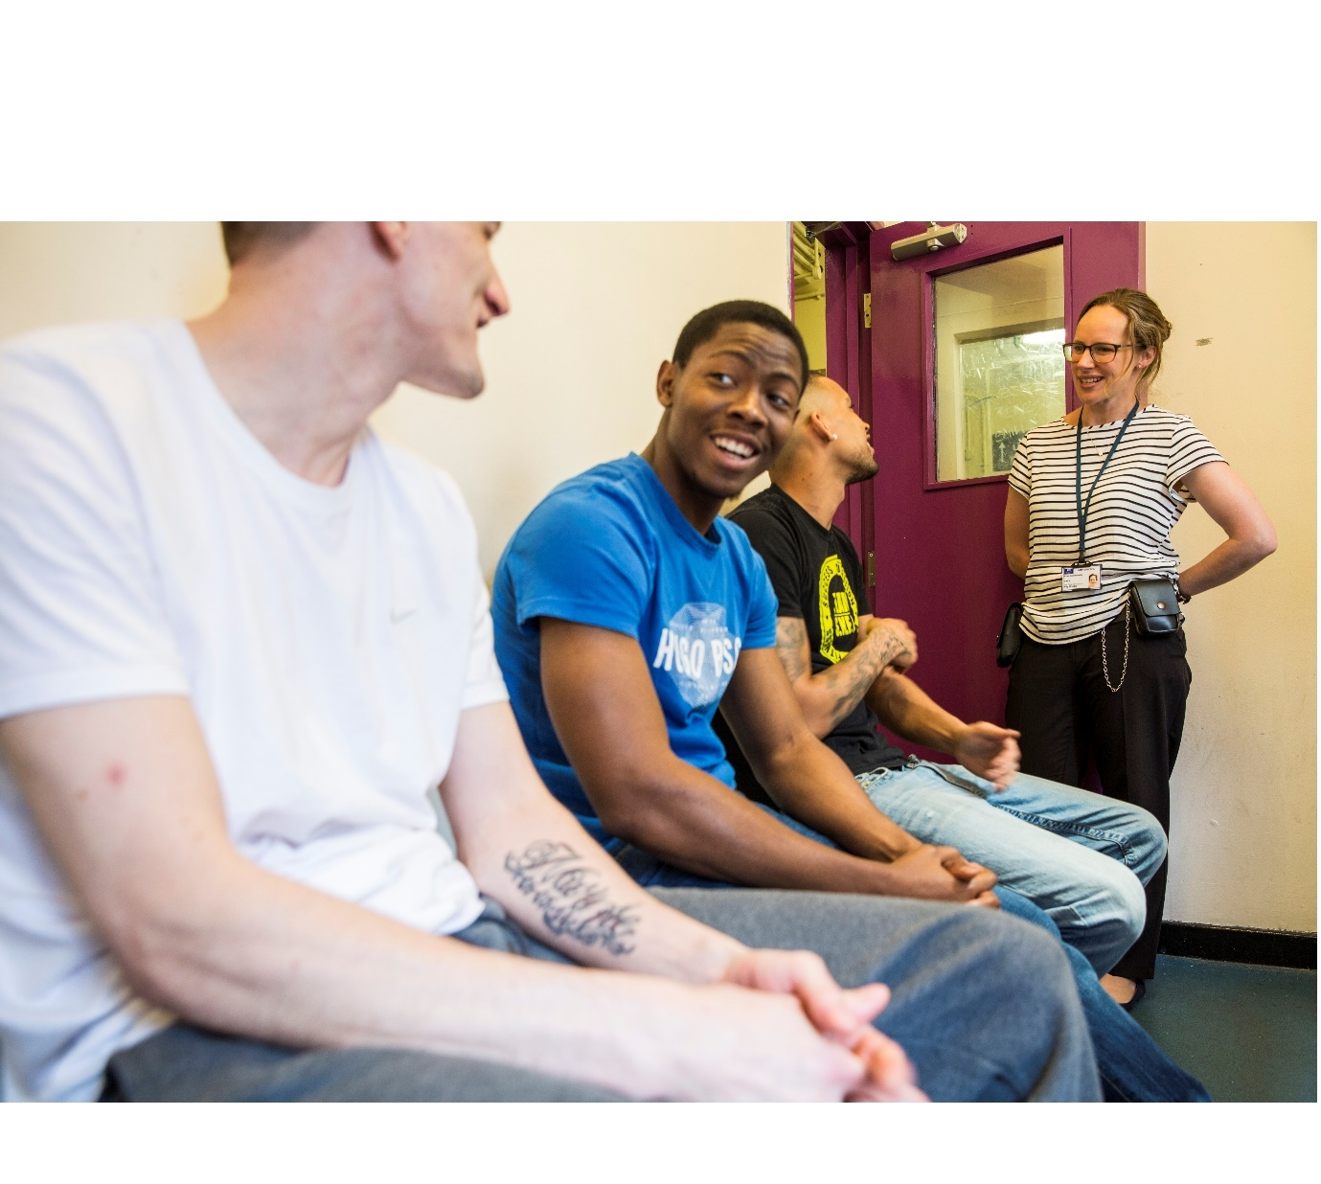

**A VISITORS JOURNEY AT HMP BRIXTON**

Ensure your loved one has your full contact details, d.o.b and address to add to their contacts list.

You will receive digital confirmation from email and online bookings, please bring that with you.

You will be asked to arrive 30 minutes ahead of your visit booking to allow time for processing

Check which ID to bring and familiarise yourself with the dress code and illicit items policy before arriving. Details available:

[Brixton Prison - GOV.UK (www.gov.uk)](https://www.gov.uk/guidance/brixton-prison)

[HMP Brixton | Prison Advice and Care Trust](https://www.prisonadvice.org.uk/hmp-brixton)

When you arrive follow signs for the visits centre at the far end of the car park and past the main entrance

PACT staff will great you and help you book in here, there are lockers for your belongings (we have limited space so try not to bring too much with you as you are not permitted to take anything into the visits hall) except £20 in coins to make purchases for refreshments at the tea bar.

Staff will then direct you to the prison entrance where you will go through 2 sliding doors to security checks, your fingerprint will be taken first.

There is a metal detector and bag search process which will soon include an X-ray machine

Search dogs will often be present. They are not vicious, do not worry.

You will be rub down searched by a member of prison staff. If you require privacy due to cultural, religious, or other reasons the search can be facilitated in a private room just ask.

You will then be shown into the visits hall where you will see a desk on your left. Show your visit order to the officer here and they will tell you which table to go to.

There are pegs for your coat if you don’t need to wear it, please hang it hear. Loose items of clothing are not permitted at the visit’s tables.

The visits hall seats 15 prisoner at a time, the chairs are colourful but weighted, you will be warned by staff not to move them. There is a tea bar and artist painted child friendly murals on the walls.

When seated the prisoners will be allowed to enter the room. You may great with a respectful hug or handshake, please make sure physical contact is decent and kept to a minimum.

You will then have your visit.

Staff will be patrolling throughout.

It is important security procedures and staff instruction are adhered to. This is for the safety of you and your loved ones.

Please do not move the chairs or tables.

Staff will give you a warning prior to the end of your visit so you can prepare to say goodbye and then you will exit via the same entry route. You will be asked to register your fingerprint again to book you out.

You may then head back to the visits centre in the car park to collect your belongings.

Staff are available to assist if you need anything throughout your visit.

**GETTING TO HMP BRIXTON**

There is no parking on site or in any side roads, so it is best to use public transport. The prison is also located in the ULEZ

Finds us on your map: HMP Brixton, Jebb Avenue, SW2 5XF

Brixton tube station is a 15-minute walk away, turn left out of the station up the hill.

There are frequent busses that will take you to the Jebb Avenue/ Brixton prison bus stop- No. s 59, 109, 159 & 250

You can check eligibility and apply for assistance with transport and visiting costs here:

[Get help with the cost of prison visits - GOV.UK (www.gov.uk)](https://www.gov.uk/help-with-prison-visits)

### BEYOND VISITS

If you wish to explore the monitoring around prison standards and family provision you can read her majesty’s inspectorate of prisons expectations here:

[Our Expectations (justiceinspectorates.gov.uk)](https://www.justiceinspectorates.gov.uk/hmiprisons/our-expectations/)

And the full Farmer report here:

[The Farmer Report | Prison Advice and Care Trust](https://www.prisonadvice.org.uk/the-lord-farmer-review)

Other audits also take place such as OSAG which tests safety, IPCO which checks investigatory powers such as mail and phone monitoring for security purposes and MQPL survey which assesses the quality of prison life for all who live and work there.

### PRISON LIFE

PACT – Routes to Change offer a befriending service for any friends or family struggling with having a loved one in prison. This service can help fill in some of the uncertainty about custodial life and prison processes.

Food:

Prisoners receive 3 meals a day. A breakfast pack is provided the evening before and consists of bread/ toast, cereal, milk carton, tea coffee and sugar. Lunch and dinners are chosen weekly by the prison from range of dietary and religious options available on the menu sheet.

Healthcare:

There is a medical room on the ground floor of every wing. Here prisoners will find a healthcare assistant who will be able to help them and healthcare applications and complaints to book an appointment or raise a query.

Canteen:

Prisoners get to choose a selection of items to buy from the canteen every weekend. The delivery is made each Friday which consists of snacks, food, vapes and phone credit.

Gym:

Every wing has a varied gym schedule which will be available from the wing staff or from the prisoner information desk

Prisoner information desk:

Prisoner reps found in a designated office on each wing to assist with general queries, prisoner notices and complaints

Prisoner reps:

Most areas employ a prisoner on each wing from education, distance learning, violence reduction, prison listeners and more. They can be located by their T-shirts or by the signs on their cell doors.

Money:

You can send money to your loved one here. Access to what can be spent each week is between £5 and £40 depending on incentive behaviour level

[Before you continue – Send money to someone in prison – GOV.UK (send-money-to-prisoner.service.gov.uk)](https://send-money-to-prisoner.service.gov.uk/en-gb/)

Education, training, and employment:

Most prisoners at HMP Brixton will be required to engage in purposeful activity from education, creative courses, in cell work or work around the prison.

**OUR PLANS**

|  |  |  |  |
| --- | --- | --- | --- |
| **Action for developing pathway.** | **Process.** | **Person responsible + Completion Date.** | **Progress.** |
| **Review, publish and Implement**  **Children’s Family**  **Strategy.** | Stakeholder consultation and regular updates  Collate work done within  Brixton.    Children and Family Strategy to be made widely available  Conduct monthly contract meetings with PACT | Head of  Operations    April 2025 | * Consultation from prisoners’ family and significant others to be sought on 2024/5 strategy and updates made accordingly * Work will be collated to evidence support of our family pathways throughout the year * Strategy to be available in the visits centre, sent to families via service provider, available on residential units and cited websites. * Contract meetings now fully embedded as well as family pathways meeting |
| **Maintain the number of Family Days**. | Agree family dates for next 12 Months.  Update posters and information for prisoners/visitors.  Maintain PACT Peer supporter numbers.  Maintain the number of family days in its current format. | Operations  Custodial  Manager and  PACT    2024/5 | -Dates to be confirmed but will take place each school holiday  -Posters are on display, information is on display in the visits centre  -Number of family days is maintained  -Any additional funding will be spent on family days |
| **Improve Training provided to staff.** | Change of circumstance training and monitoring  Child safeguarding training.  Security/drug awareness Training for partner agencies  Upskill keyworkers in family pathways provision and importance | Head of operations  August 2024/5 | Change of circumstance monitoring is now in place with assurance process to monitor  Safeguarding training needs completing but staff are aware of public protection and how to raise safeguarding concerns  Service providers are halfway through a wing tour upskilling staff in ad hoc briefings |
| **Improve feedback and monitoring routes for prisoners and their significant others** | Implement monthly meet a Governor session for families  Hold focus groups x2 per year  Implement feedback boxes on wings and in visits centre  Email all families the information booklet when their loved one arrives at Brixton | Head of operations & CM Operations  PACT  FASO Lead & Champion in conjunction with service provider | Ongoing  Monthly ongoing  Completed  Ongoing |
| **Improve visits experience for family and significant others** | Provide ‘back up’ clothing and footwear for those arriving unprepared  Explore opportunity to offer hot refreshments  Consider reintroduce Thursday evening visits for ‘homework club’ | FASO LEAD/Head of Operations CM, PACT  FASO LEAD/PACT | Completed  Profit from snack bar can be redistributed to purchase these things  Planned reprofile July 2024 |
| **Consider Raising Readers project** | Discussion in progress regarding working with the project to enable prisoners to select a book to send to their child. Books are then posted out. Dads read with children via the in cell phone. Discussions about the books take place during visits sessions. | CM Operations | Planned to be introduced summer 2024 |
| **Consider Books for Families** | Discussion in progress regarding working with the charity to enable books to be delivered to the prison for prisoners to choose to send to their F&SO for reading together opportunities. | Head of Operational Leading | Planned to be introduced summer 2024 |
| **Focus on support for those without family or significant others** | Assist chaplaincy to promote the prison visitor scheme  Assist PACT in piloting their own Prison visitor scheme  Monitor data of those not receiving visits to establish how support for this group can be better targeted  Monitor at risk groups such as those vulnerable or care experienced to target further support | FASO Champion/PACT  Completed March 2024  PACT Routes to Change | Ongoing  Completed and ongoing  PACT scheme is due to pilot in Feb 2023  Data has started to be analysed more closely from Jan 2023  HMP Brixton is in conversation with service providers to identify individuals who may require support. |