

**HMP Hatfield**

**Family and Significant Others Strategy**

Local Policy Document

June 2024

Review Due: June 2025

Governor Mick Mills





**Introduction**

HMP Hatfield is committed to helping our prisoners and their families to keep in contact with each other. Families in relation to this document includes blood relatives and legal or significant persons that are identified as a next of kin (for care-leavers this may be someone that provides a statutory service).

In 2017 Lord Farmer published his review highlighting the importance of working with families in reducing crime and the risk of individuals returning to prison. HMP Hatfield is committed to working to implement all of the key recommendations from this review along with any recommendations for Children and Families from other sources such as MQPL, HMIP, IMB etc.

Our FaSO lead is Steve Laud (HoRR) and our FaSO ‘Champion’ is Custodial Manager John Howarth. Responsibility for ensuring that we do what we say we will do ultimately rests with the FaSO lead. The job descriptions for both the FaSO ‘Lead’ and the FaSO ‘Champion’ can be see at Annex A & Annex B.If you have any suggestions or comments please contact us via email [hatfield@prisonadvice.org.uk](mailto:hatfield@prisonadvice.org.uk) or [Outwork.Hatfield@justice.gov.uk](mailto:Outwork.Hatfield@justice.gov.uk)

**Why is this important to us?**

**Background**

There is a wide acceptance of the need for family and significant other services for our prisoners and their families from the following;

* The Farmer report, ‘The Importance of Strengthening Prisoners Family Ties to Prevent Re-offending and Reduce Intergenerational Crime’ was published in 2017. The report recommended family should be the “golden thread” running through all prison processes.
* ‘Delivering Effective Family Practice Guidance for HMPPS 2017’
* Her Majesty’s Inspectorate of Prisons (HMIP) Expectations identifies 46 recommendations in relation to children and families.
* The HMPPS ‘Good industry Practice Measures’ 2019 for Prison family strategy.

HMP Hatfield appreciates that a family member or significant other may also feel the effect of the imprisonment of someone close to them. It is usual for those left at home to be worried about that person in prison and be confused about how to:

* Help them get through their sentence.
* Keep them in contact with their children, siblings, and other family members.
* Help them succeed in substance misuse rehabilitation.
* Help them with mental or physical health difficulties.
* Prepare them for release and integration back into their family groups.

We also understand that families can play a huge part in helping our prisoners through their time in prison and to contribute positively to supporting them to remain offence free in the future.

We also recognise that not all family relationships are positive. Family members may sometimes be the direct or indirect victims of a prisoner’s offence such as domestic abuse and substance addiction.

We know that family relationships in these circumstances can be strained and in some cases have been severely damaged.

At HMP Hatfield we have a multi-agency family team who meet on a quarterly basis to ensure that our services are consistently improving and meeting the needs of our prisoners and their families. The multi-agency team include:

Children and Families Pathway Lead (HMPPS)- Head of Reducing Reoffending

Safer Custody representative (HMPPS)

Family Engagement Manager (PACT)

Healthcare Liaison (Practice Plus UK)

Prison Offender Manager (Probation officer /HMPPS)

Education Manager (HMPPS)

Outwork / Activities manager (HMPPS)

**Understanding the needs of families and significant others**

We will review and understand the needs of families and significant others and will do this by holding Visitors Needs Surveys each year.

HMP Hatfield is a split site that will do all we can to ensure that visits are a pleasurable experience and to keep families in touch with their loved ones held in custody with us.

To help in developing the services at both the Main and Lakes sites, the Families and Children Lead welcomes your views on this matter through our visitor surveys. You can also send in your thoughts and views by writing to the “Head of Reducing Reoffending” at; HMP Hatfield, Thorne Road, Hatfield, Doncaster, DN7 6EL.

To gain further insight, as part of our regular reviews we also analyse the data around prisoner and visitor participation in our visits sessions, inviting contributions from the Independent Monitoring Board (IMB), Security and Offender Management departments, as well as other external stakeholders.

**What we offer**

HMP Hatfield is based across two sites with the main prison located just outside Thorne and Hatfield and the Lakes site approximately 3.5 miles away and next door to HMP Lindholme.

New Receptions are received at the Lakes site for a period of assessment prior to moving to the Main site.

Both locations have a variety of services and initiatives that have been put in place to support our prisoners and their families or significant others.

* **Letters**

There are no restrictions on the number of letters our prisoners can receive and we actively encourage them to write letters to maintain family contact.

Our prisoners can apply for 1 free letter per week plus additional free letters for each child that they have under 18.

On request, free letters can also be provided for specific purposes such as arranging housing, employment, legal proceedings etc. Prisoners can purchase writing materials from the prison canteen and we also provide education classes for those wishing to improve their writing skills.



Our postal address is:

HMP Hatfield

Thorne Road

Hatfield

Doncaster

DN7 6EL

* **Email a prisoner**

Families and friends can also make contact through the ‘Email a Prisoner’ process. This method is quicker and cheaper than sending letters through the post and our prisoners usually receive their email the day after it has been sent.

When emailing, please state if you would like your family member or significant other to be able to reply to your email as this is something that they can do free of charge

For more information please go to:

https://www.emailaprisoner.com/

* **Telephone calls**

**Personal Identification Number (PIN) Telephone Calls**

At present, our prisoners are allowed to have a maximum of 20 cleared domestic numbers that they can call using a prison PIN phone.

Phone credit can be purchased by our prisoners via prisoner earnings and/or monies sent in to them (private cash). Calls can be made 7 days a week between the hours of 08:30 and 22:00.

**Incoming Call Line**

If you have concerns about the safety or wellbeing of anyone at HMP Hatfield, you can call the 24-hour safer custody hotline on 01405 746 509. This line is open 7 days a week 24 hours a day and we will deal with any concerns within a short period after your call.

Please be aware that all telephone calls made from our PIN phones are recorded and may also be live monitored. This is to ensure that we are fulfilling our obligations regarding public protection and the security of the prison.

Our monitoring systems are regularly inspected by the relevant authority to ensure that we are complying with the strict laws that are applied in this area.

**In an emergency**

Call 01405 746500 if you think a prisoner is at immediate risk of harm. Ask for the Orderly Officer and explain that your concern is an emergency.

* **ROTL**

Release on Temporary Licence (ROTL) is used extensively at HMP Hatfield to maintain and build family links. The types of ROTL licences that are available are:

Resettlement Leave, Day and Overnight release and Special Purpose License.

ROTL can only be granted following the completion of a successful risk assessment and eligibility process and once approved, prisoners can access one day release and one period of overnight release a month. At HMP Hatfield on average prisoners collectively complete more than 5,500 social ROTL’s per year successfully.

Prisoners who are eligible apply for access to their ROTLS by submitting an application to their Prison Offender Manager (POM).

The primary focus of ROTLs is always around resettlement and the maintaining of family ties and in their application to take ROTL, our prisoners have to provide a schedule of activities while on ROTL that shows how they are best using this time with their family or significant other to maximum benefit and effect.

Our Offender Management Unit (OMU) take the lead on the risk assessment process for ROTL in conjunction with external Community Offender Managers (COM).

* **Family Days**

Family days at HMP Hatfield are designed to be both welcoming and supportive. Across these days there are activities for prisoners and their families / significant others to join in with as well as dedicated time and space to sit and relax together and the opportunity to enjoy a meal together.

We aim to hold 4 differently themed family day events throughout the year, usually in line with school holidays. These are very popular and the feedback from them from both visitors and prisoners has been very positive, both in terms of quality family time and fun.

Access to Family Days is made by prisoners via the internal application process.

Families are also invited into the establishment to take part in Employment Celebration events. Held in the visits room, these are run by our Outworks team and involve employers awarding prisoners who have been recognised for attaining success and achievements while working out of the prison.

This gives families and significant others the opportunity to celebrate these accomplishments together with employers and the Outwork team.

* **Visits**

We currently have visits sessions available at both sites on the following days;

Hatfield site; Saturday and Sunday – afternoons between 2 and 4pm

Lakes site; Friday, Saturday and Sunday – afternoons between 2 and 4pm.

There is plenty of room for cars at the Main Hatfield site however unfortunately, parking space is very limited at the Lakes site. Visitors can use the Lindholme visitors car park if there are no spaces available at the Lakes site.

Social visits can be booked by any family member already on an approved list of visitors supplied to us by our prisoners. We can host a maximum of three adult visitors (plus children) per prisoner in each visits session. A visit can be booked either through the prison visits booking number (01405 746611 – Monday to Friday 9am to 1pm) or online at: socialvisitshatfield@justice.gov.uk

When booking a visit you will need the following information:

* prisoners number
* prisoner’s date of birth
* dates of birth for all visitors coming with you
* whether any visitors have any disabilities (including hidden disabilities) that we need to be aware of so that we can make reasonable adjustments

The visitor must already be on their prisoners approved visitor list before a visit can be booked. Unfortunately, we cannot book visits directly via the main telephone phone number.

* **The Visits Rooms**

The visits rooms at both sites are large and open spaced with seating arranged so that prisoners can enjoy their visiting times comfortably.

At both the Main and Lakes site, we actively encourage prisoners to play and interact with their children. There are play areas at both sites as well as other toys and board games available for this.

Both visits room contain a dedicated Tea Bar facility where snacks and drinks can be purchased (cash only). These tea bars are operated by trained prisoners while the visits rooms are staffed by Prison Officers who are there to ensure that everyone enjoys their visit while maintaining safety, security and decency.

Both visits’ rooms have facilities for those who wish to ‘breast feed’ in private so they can do so comfortably.

We acknowledge how difficult a prison environment can be especially in a visits hall where it can be very noisy and intimidating. To help support neurodiverse children & adults we have dedicated rooms in both visits halls that provide a range of sensory aids and distraction packs. This helps to stimulate the five senses and helps reduce anxiety.

We also encourage visitors who have disclosed they have a hidden disability to wear a sunflower lanyard. This helps staff on site to identify and offer additional support and assistance.  It’s important to us that we create an inclusive environment for all. We will make every effort to accommodate individual needs as we want every visitor to have a positive experience when visiting us.

In order for visits to remain a positive environment, although routine searching prior to visits is not usually required, there are circumstances relating to everyone’s safety and security where you may be asked to comply with a search.

Any visitor who is deemed to be abusive, threatening or unfit to visit could, in some cases have their visit declined or terminated, including being asked to leave.

For those Prisoners that don’t receive visits, we can offer additional support from the relevant agency that can be provided on a one-to-one basis if required.

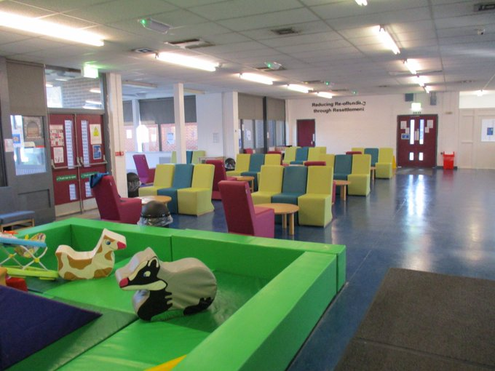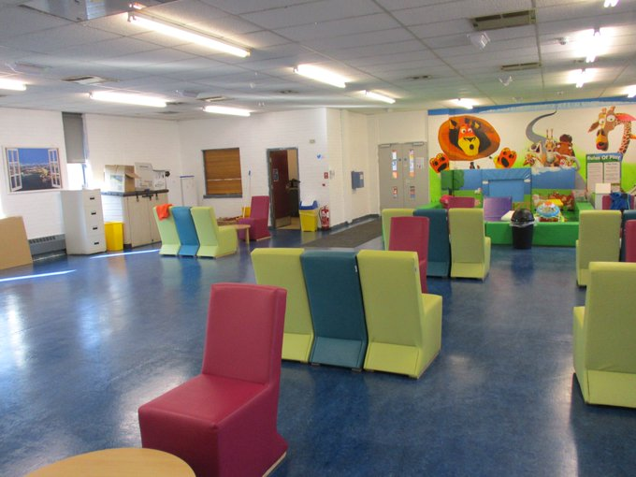

* **Family Engagement Manager**

In order to support prisoners and their families or significant others we have a part-time Family Engagement Manager who is employed by PACT.

PACT can be contacted on 01405 746583 or via email at [Carra.Grayson@prisonadvice.org.uk](mailto:Carra.Grayson@prisonadvice.org.uk)

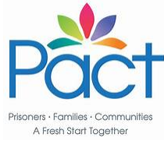

The Family Engagement Manager works with families and significant others to try and maintain good communication links and to help in cases where the relationships have broken down.

They can provide support on a one to one basis with our prisoners to assist them with child related problems and will refer on cases where additional work is needed.

The Family Engagement Manager can provide support in contacting school, social care, family court and other agencies who may be involved with prisoners and their families or significant others.

PACT will also run workshops and in cell support books across the year for prisoners identified in need of this.

You can find more out about PACT at: <https://www.prisonadvice.org.uk/>

* **Cafcass**

The specific point of contact at HMP Hatfield for all matters regarding Cafcass is Pact Family Engagement Manager Carra Grayson on 01405 746583 or [Carra.Grayson@prisonadvice.org.uk](mailto:Carra.Grayson@prisonadvice.org.uk)

* **Story Book Dads**

Our prisoners have the facility to record themselves reading a book that they can send to their child. This is done through our library provider and is really useful in strengthening the bond between them and their child.

* **Care Leaver Support**

The assessment of Care Leaver status forms part of POM induction interview. POM’s will work with our prisoners on an individual basis to ensure that care leavers rights are obtained. They can facilitate talks by the Care Leavers Associations as well as peer support groups for prisoners who are Care Leavers themselves.

* **Prisoners in Crisis**

There are times when our prisoners require additional support both from prison staff as well as from their family and significant others.

Where appropriate and with the prisoners permission, those recorded as family/significant others will be informed and/or invited to attend/contribute to support meetings.

Family members and significant others will be asked to attend due to their knowledge and experience, as in times of crisis this can be invaluable.

* **Young Adult Strategy**

The Young Adult Strategy (YAS) provides a clear vision for improving outcomes and experiences for young adults (18-25 inclusive) in custody and around 10% of the population at HMP Hatfield would normally meet these criteria.

It’s important that we measure and support this specific cohort of prisoners and that outcomes are comparable with our other age profiles and groups. It’s also noteworthy that there is significant crossover between young adults and experience in care.

The YAS also helps to support the rehabilitative culture which HMP Hatfield has long had established. The FSO strategy will work in conjunction with the YAS strategy and Care leavers support to ensure that we deliver on our stated aims.

Young adults are a standing agenda item on the FSO meetings and the Young Adult lead is invited to attend.

* **Safeguarding Strategy**

In order to support our prisoners and to ensure that we protect the public from abuse and neglect, we operate within the national Safeguarding framework. The strategy is jointly owned by the Head of Residence and OMU Senior Leadership team.

Where concerns are evidenced there is a clear duty to investigate and escalate the concerns so that they can be fully addressed.

* **Communication Gateway**

Keeping our prisoners as safe as possible in prison is our top priory. In the event that a family member/ significant other has any concerns regarding the Safety of their loved one whilst in custody at HMP Hatfield, they can ring the gate telephone number on **01405 746 509**. The gate is staffed 24hrs per day.

Calls where possible should include the full name of the prisoner that they have concerns about as well as a contact number so that we can call them back to update them.

**Working in Partnership**

**HMP Hatfield is committed to working in partnership with a variety of organisations to ensure that the needs of our prisoners are being met.**

**We recognise that helping to understand the needs of a prisoners family or significant other can increase that understanding and offers of support for those in question.**

**Areas for improvement and development, how are we developing our FaSO provision?**

Our establishment prides itself on continuing to learn from our experiences.

**Feedback to prisoners, staff and visitors on progress from the development objectives?**

**Employment celebration events** - Prisoner Forum feedback –‘*stage 2 paid employment was a great benefit to supporting Family ties. The shift patterns of 4 on 4 off, made it simple to arrange home leave and family time with a rolling rota. Additionally, they had money in the bank to be able to treat their children and families when they went on home leave.’*

Its clear that the strategy of supporting paid employment directly contributes to better FaSO outcomes for prisoners. Further employment celebration events are scheduled for 2025.

**Staff training objective-** PACT have introduced and rolled out two separate training courses, covering both safeguarding and the FaSO provision. All operational staff have completed this training.

**Annex A**

**HMP Hatfield FaSO Lead Job Description (Agreed 13/09/2023- reviewed 20/06/2024)**

As noted in the recent Family and Significant others terafeature from HMPPS, ‘*Families and Significant Others**play a critical role in supporting prisoners; positive relationships have been identified as a protective factor in the desistance from crime’*

As a Category D, resettlement Prison HMP Hatfield rightly recognises the key importance of ensuring that our prisoners build and then maintain good family ties.

The Functional Head responsible for Reducing Reoffending (HoRR) shall be the establishments FaSO lead. Their responsibilities are as follows:

* *Maintain oversight of the FaSO strand and chair the regular FaSO meetings which take place here at HMP Hatfield*
* *Ensure that, together with the FaSO Champion (activities Custodial Manager) they are a single point of contact for and oversight of the establishments Family Offer*
* *Ensuring the establishments FaSO Strategy is fit for purpose*
* *Local lead for completion of the FaSO performance measure*
* *Contract management for family service providers (currently PACT)*
* *Ensure that the FaSO strategy is kept up to date and aligned to the desired outcomes*
* *Embed the FaSO strategy throughout the establishment*
* *Ensure appropriate communications are maintained with families*

**Annex B**

**HMP Hatfield FaSO Champion Job Description (Agreed 13/09/2023- reviewed 20/06/2024)**

As noted in the recent Family and Significant others terafeature from HMPPS, ‘*Families and Significant Others**play a critical role in supporting prisoners; positive relationships have been identified as a protective factor in the desistance from crime’*

As a Category D, resettlement Prison HMP Hatfield rightly recognises the key importance of ensuring that our prisoners build and then maintain good family ties.

The Functional Head responsible for Reducing Reoffending (HoRR) shall be the establishments FaSO lead. However this role cannot be completed in isolation and requires a who prison approach to ensure that FaSO’s are the golden thread which run throughout both reducing reoffending and the establishment as a whole.

Their responsibilities are as follows:

* *In the absence of the HoRR chair the regular FaSO meetings which take place here at HMP Hatfield*
* *Monitor and assure the regular checks completed within the FaSO strand (including telephone checks on the safer custody & visits lines)*
* *Ensure that, together with the FaSO lead they are a single point of contact for and oversight of the establishments Family Offer*
* *Ensuring the establishments FaSO Strategy is fit for purpose*
* *Local lead for completion of the FaSO performance measure*
* *Ensure that the FaSO strategy is kept up to date and aligned to the desired outcomes*