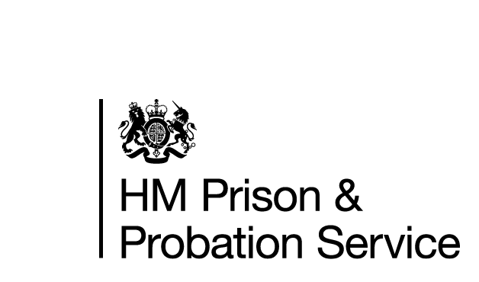



**FAMILY AND SIGNIFICANT OTHERS**

**STRATEGY**

Toni Lamb / Thomas Benson & Carl Jones

Visits Manager & Visits SO

January 2025

**Contents**

Introduction…………………………………………………………………………. Page 1

Contact Us…………………………………………………………………………….Page 2

Your Visit……...………………………………………………………………………Page 4

Barnardos………………………………………..……………………………………Page 8

Staying in Touch….………………………………………………………………..Page 12

Future Planning…………………………………………………………………….Page 14

Measuring Success………………………………………………………….…….Page 15

Berwyn Strategy……………………………………………………………………Page 16

Safeguarding…………………………………………………………………………Page 17

The following document is designed at what HMP Berwyn aims to offer for both Families/Significant others and the people in our care.. We are constantly reviewing what services we can offer for staff, prisoners, and their loved ones

**Introduction**

At HMP Berwyn we all have a responsibility to help maintain positive relationships.

Supporting a person in our care to develop meaningful and constructive relationships with their family or significant others is vitally important, especially considering the distance some families may have to travel to visit their loved ones.

At HMP Berwyn we want to make visits less daunting, more child friendly and stimulating for all that attend whilst adhering to all security procedures.

HMP Berwyn is committed to developing new ideas and supporting those who do not have visits to help build or repair relationships or to gain support during and after release.

For the purpose of this document, ‘Family’ is defined as either a relative or significant people that a person in our care identifies as providing a constructive and supportive relationship.

**History**

HMP Berwyn is the largest prison in the country and is in the town of Wrexham, North Wales. It is operated by His Majesty’s Prison Service. It opened in 2017 and houses men on remand, VPs and PCOSO’s, Young Offenders and Category C prisoners

**Getting to Berwyn**

Berwyn is located on Wrexham Industrial Estate and google maps is the easiest way to find the prison using the postcode LL13 9QE.

Berwyn is not the easiest prison to get to by public transport, however there are two train station (Wrexham General and Wrexham Central) both stations are about 4 miles away and Taxis are available at the stations, (both in Wrexham), or book in advance on:

Apollo taxis 01978 262626

Wrexham Prestige taxis 01978 357777

Speedie Cars 01978 262829

Station Cars (which is located outside Wrexham General railway station) 01978 363661.

Cresta Cabs 01978 353500

Visitors are also able to order a taxi for free from the prison for their return journey using a direct line situated in the visitors’ centre.

There are several local buses from Wrexham town centre which pass the prison.

There is also parking at the prison, including spaces for Blue Badge holders.

If you have a disability, there is disabled parking at the front of the establishment, and we have disabled toilets available in the Visitor Centre and the Visits Hall. The Visits Hall is located on the top floor, however there is a lift available for those people who struggle with stairs.

Wheelchairs, their users, adults accompanying them, and assistance dogs may need to be searched. Staff who conduct the searches will do so with sensitivity. Visitors who need physical assistance during their visit must be accompanied by another adult. The establishment’s staff cannot offer personal assistance.

If you have difficulty visiting the establishment because of a disability you can discuss this in confidence with the Visitors Centre staff on 01978 523000**.**

EMERGENCY CONTACT

**Contact Us**

**Address:**

If you have a concern that there is **an imminent risk of danger to a person in our care** and you wish to speak to a member of staff to raise this concern, then you can call the switchboard: **01978 523000**

The member of staff answering the phone will not be able to discuss the person in our care with you, but they will immediately pass your concern onto a senior member of staff to action. We aim to address any issues raised on the call immediately and will let you know what the outcome is.

If you are concerned about the safety or wellbeing of any person in our care at Berwyn but there is no immediate threat or danger, then you can leave an answerphone message for the Safer Custody Team on:

**01978 523772**

This voicemail service is checked numerous times a day.

HMP Berwyn   
Bridge Road

Wrexham Ind. Est

Wrexham

LL13 9QE

General Phone Number:

01978 523000 (24 hours)

**Visits Booking**

Prisoners now book their

Own visit.

**Sending Money to a Prisoner**

You can no longer send money by bank transfer, cheque, postal order or send cash by post to any prison. You’ll need to send money through the Money to Prisoners Portal using a debit card instead.

The Money to Prisoners Portal service is free, secure, and available in all prisons in England and Wales.

To get started on the Portal you will need the prisoner's date of birth and prisoner number.

If you cannot use the online service, you may be able to apply for an exemption - for example if you:

are unable to use a computer, a smart phone, or the internet

do not have a debit card

**You cannot give money to the prisoner during a visit.**

**Clothing Parcels**

Prisoners are authorised to receive a clothing parcel which must be sent in within the first 28 days of their sentence or unless they are on remand and then it would be dependent on volumetric control.

**Your Visit**





All prisoners can receive a visit upon arrival at the establishment, prisoners need to add visitors to their ‘approved’ list through the kiosk or through an application to the visits booking team. They will require the full name, address, and date of birth of each visitor. Once this has been done, prisoners are able to book their own visits. If you turn up without having booked a visit you will be turned away.

**To visit someone in HMP Berwyn:**

You will need to bring one of the following forms of identification with you:

-Passport

-Driving Licence

-EC Identity Card

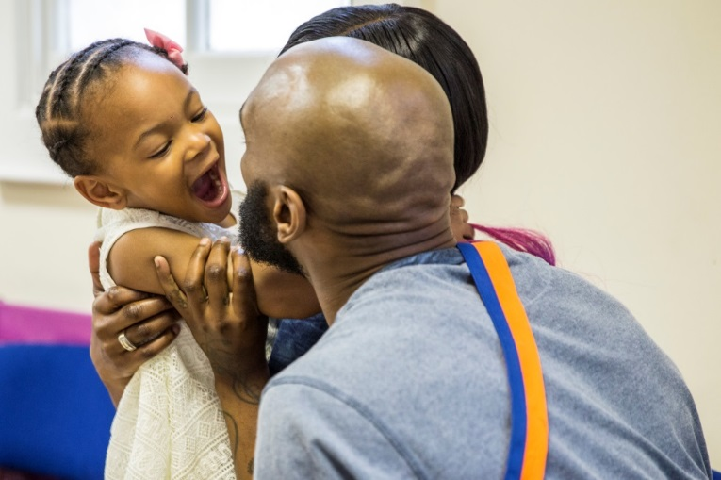-Employers/Student ID Card

-Bus Pass with photograph

-Red Maternity Book (ID option for children).

If you are unable to produce one of the above,

staff may accept combinations of

three or more of the following:

-Birth/Marriage Certificate

-Bus/Rail Pass with Photograph

-Bank Credit/Debit Card

-Young Persons proof of age card

-NUS Card

-Rent book/utility bill

-Library Card.

**Help with the cost of your visit**

Financial Assistance with Visiting: If you qualify to receive help with your finances such as benefits, you may be able to recoup all or part of the cost of your travel expenses through the ‘Assisted Prison Visits Scheme’. As part of your application, you will need to get a secondary form stamped by prison staff to prove your visit took place. You can request a copy of this form at the Visitors Centre.

**Visiting Hours**

HMP Berwyn provides visits at the following times:

|  |  |  |  |  |  |  |  |
| --- | --- | --- | --- | --- | --- | --- | --- |
|  | **MONDAY** | **TUESDAY** | **WEDNESDAY** | **THURSDAY** | **FRIDAY** | **SATURDAY** | **SUNDAY** |
| 0845 0945 | **PCOSO/VP** | **GEN POP** | **GEN POP** | **PCOSO/VP** | **ENHANED**  **GEN POP / PCOSO/VP/ NOT A VISIT VISIT** | **GEN POP** | **GEN POP** |
| 1030 1130 | **GEN POP** | **PCOSO/VP AND GEN POP** | **GEN POP** | **GEN POP** | **PCOSO/VP AND GEN POP** | **GEN POP** |
| **LUNCH** | | | | | | | |
| 1400 1500 | **GEN POP** | **ENHANCED GEN POP** | **GEN POP** | **ENHANCED PCOSO/VP AND GEN POP** |  | **GEN POP** | **GEN POP** |
| 1545 1645 | **PCOSO/VP AND GEN POP** | **PCOSO/VP AND GEN POP** |  | **GEN POP** | **PCOSO/VP** |

|  |  |
| --- | --- |
|  | PCOSO and VP visits only |
|  | PCOSO and general population visits  Not a visit visit |
|  | General population visits. |
|  | No Visits |

The Visitor’s Centre is open all week and this is where family, friends and legal representatives are checked in for pre-booked visits.

**How to book a visit**

All prisoners at Berwyn book their own social and video visits. Prisoner’s book visits through the Uni Link System, however all visitors will need to be on the approved visitors list for a visit to be booked. The prisoner will put in a request via Uni-link to Visits Booking, who will then make the relevant checks and once satisfied, you will go on the prisoner’s approved list.

The prisoner is allowed up to 5 visitors per visit (this can include a maximum of 3 adults).

Please be aware that you need to be over the age of 18 to visit a prisoner. If a child is visiting, then they need to be accompanied by an adult over the age of 18.

We ask that all visitors come on their visit clothed modestly i.e., not too revealing/no offensive or inappropriate slogans or logos, ripped jeans or hoodies, please see the clothing policy in the Visit Centre, if you are unsure, please contact the Visit Centre prior to attending. Anyone not dressed in accordance with the policy will be refused entry.

**Entering the Prison**

We now operate a card payment system and as such we will soon be working towards no money being brought into the establishment, currently you are only allowed up to £30 in coins for the purpose of purchasing drinks, food, and snacks. This sum of money is between all visitors on the visit, not per person. No liquids or car keys are allowed to be taken in the establishment. These items can be taken up to the gate where they will be stored in a small locker. You will need a pound coin to operate the locker which is returned to you when belongings have been retrieved. On arriving at the gate, you will be required to show your identification. If a visitor does not bring appropriate identification, you may not be allowed to enter the establishment. On your first visit, your details will be entered onto the establishment system (you will be required to have your photograph and fingerprint taken). This makes the process easier and quicker for future visits. All visitors are searched, which will involve passing through a metal detector and a pat-down search. All searches will be carried out sensitively, with respect and courtesy to all individuals. Children are patted down by female staff in front of their parents. All visitors' religious beliefs are respected. There is a private room available should religious headwear need to be removed as part of the search.

**Drugs**

The smuggling of drugs is a serious offence and therefore will be treated as such. This includes illegal and prescription drugs. If anyone is suspected of smuggling drugs, they will either:

-Be subject to a more thorough rub down search.

-Be placed on a closed, supervised visit.

Any visitor is found to be in possession of an illegal substances, the police will be contacted, and the visitor arrested.

If you are worried about drugs or are being placed under pressure to smuggle drugs, please speak to an appropriate member of staff, or contact the establishment by telephone.

Before entering the establishment, you may encounter a dog which is trained to pick up the scent of drugs. If a person is identified as being in possession of drugs or any other prohibited item, they may be subject to closed visits, visiting ban and the police will be informed.

**In the Visits Hall**

The prisoner will be waiting in the visits hall when you arrive. Normally the prisoner and his visitor(s) sit at a table in an open room, with the other prisoners and their visitors.

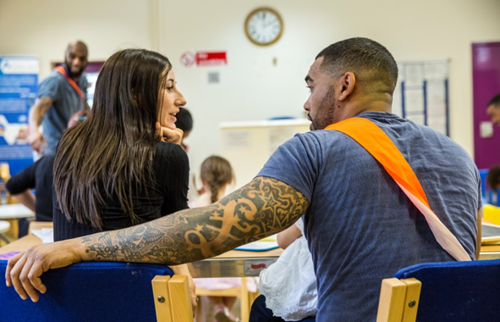Brief contact between the prisoner and visitors is usually allowed at the beginning and end of the visit. The person you are visiting is to remain seated throughout the visit.

Drinks and snacks are available from the tea bar by completing an order form which is on the table where you are seated. Once completed you will take your order to the Orderly, with a payment card and your food and drink will be brought to your table. You are permitted to use the toilet. The toilet is situated outside of the visit’s hall; therefore, you will be required to be searched again before re-entering the room.

A visit may be held under ‘closed’ conditions if there are concerns that the visit may be a risk to establishment’s security, or if there is a risk of unacceptable or illegal activity taking place during the visit. During a closed visit, the prisoner and visitors will talk to each other whilst seated either side of a glass panel. The visitor will be allowed to purchase refreshments but the prisoner will not be able to have any refreshments.

**Children**

All visitors under the age of 18 years are regarded as children and must be accompanied on a visit by an adult. This is a requirement of the establishment’s child protection policy. Children must not be left alone anywhere, at any time on the establishment premises, including in the Visitor Centre or in the car park. Prams, pushchairs and car seats are not allowed to be taken into the prison. A feeding bottle can be taken in on a visit with a sealed pre made formula but no open liquid or changing bags are permitted. Nappies and wipes are provided.

Breastfeeding is permitted in the hall with support from Barnardo’s and the BCUHB Public Health Team who will support mums to breastfeed during their visit. A mum who needs to breastfeed during a visit can remain in her seat and will be provided with a muslin cloth by the Barnardo’s team members to use. We support baby lead feeding and for those who don’t want to feed in the hall we have a designated feeding room.

There are baby changing facilities, and a disabled toilet is also available. You will be informed by visitor’s centre staff when it is time to go the main establishment for your visit.

If you are going to be late for a visit, please contact the Visitors Centre on 01978 523307, as soon as you can. The last entry into the establishment is 20 minutes after the visit start time.

**HMPPS BERWYN PRISONER, FAMILIES AND SIGNIFICANT OTHER SERVICE**

**Who are we?**

Barnardo's is a British charity founded by Thomas John Barnardo in 1866, to care for vulnerable children. As of 2013, it raised and spent around £200 million each year running around 900 local services, aimed at helping these same groups. It is the UK's largest children's charity, in terms of charitable expenditure.

**What we do?**

Barnardo’s will deliver safe and welcoming visitor services to support prisoners, their families, and significant others, thereby supporting positive family ties and relationships external to HMP Berwyn.

Barnardo’s staff will guide you the whole way into your visit, when you arrive for your visit you will ‘book in’ at the Visitor Centre which is situated in the car park. Here they will ask you to give the name of the prisoner you are visiting. Names of all visitors will be checked along with ages of visitors under the age of 18 years old.

The Visitor Centre opens at 0700 hours Monday to Friday. At the visitors centre you can buy refreshments from the machines located in the Centre. You can also access information and advice and discuss any worries or concerns you may have in confidence. There is a Bernardo’s staff member in the Visitor Centre to provide play and craft activities for the children, however the parent or adult who brought the child(ren) remains responsible for all children for the duration of the visit.

**More Support**

**Family Forums**: Barnardo’s Family Forums are a great way to get your views heard and speak to other families. The forums are a platform for visitors to voice suggestions that can lead to improvements being made around the visit experience. If you do not wish to attend our family forum but have some feedback, please feel free to write it down and place in the box provided. Speak to a member of Bernardo’s staff to find out when and where the next forum is taking place.

**Family Days:** Bernardo’s deliver Family Afternoons throughout the year. These will be themed to meet with our diverse community. Family Days are a great opportunity for prisoners and their families to engage in activities and spend quality time as a family unit. Prisoners can apply for a place by putting in an application but must meet certain criteria.

-Be on either standard or enhanced regime

-Have been adjudication free for the last 6 months

-Have not provided a positive MDT (Mandatory Drug Test) within the last 6 months

All applications will also have to be passed by the Security Department. Once approved, they will be allocated a place on the Family Day. Prisoners are only removed from these visits if their behaviour comes into question, and they drop down to basic regime.

**Not a visit visits**: Barnardo’s also hold monthly visits for all prisoners that do not get social visits, there are 50 spaces available on each session and prisoners are personally invited by Bernardo’s. This gives prisoners the opportunity to build new relationships and supports reintegration into society and by creating a social environment, it also provides them with time away from the community. Prisoners are provided with board games a quiz and donated refreshments.

**Support:** Bernardo’s family support will be available by telephone – 01978 523004 - it would also be helpful if you could let us know whether we are able to leave a message if there is no answer - and we will aim to get back to you as soon as we possibly can.

We can support prisoners and their family with:

* Family that may struggle with the cost of visits
* PPRC
* Family Breakdowns
* Social Services
* Adoption

What ever issue you have let us know, if we cannot help you, we will put you in touch with someone who can. Dates for all available sessions are displayed on all houseblocks and notice boards around the establishment.

If you have urgent concerns about the welfare of your loved one in prison, please call the prison Safer Custody line directly.

**Prisoners’ Families Helpline**

You can also contact the Prisoners’ Families Helpline for advice and support on all aspects of the criminal justice system:

Call 0808 808 2003 (9am – 8pm Monday to Friday and 10am – 3pm Saturday and Sunday)

Email the team on [info@prisonersfamilies.org](mailto:info@prisonersfamilies.org)

If your query is urgent please email [Berwyn@barnardos.org.uk](mailto:Berwyn@barnardos.org.uk)

Fill in a contact form and request a call back at prisonersfamilies.org

**Safer Custody Team**

If you are worried about your loved one while they are a resident at this prison, you can contact the Safer Custody team on 01978 523 772.

You may be asked to leave a voicemail. Please make sure you include:

Your name.

The reason that you are calling.

The name of your family member/friend (and their prison number if you know it).

Please wait at least 24 hours for a call back before contacting the prison again.

If your concerns are immediate or life-threatening, please call the prison switchboard on 01978 523 000.



**Staying In Touch**



[](http://emailaprisoner.com/)

**Email a prisoner**

This prison uses EmailaPrisoner.com. Through this service, family and friends can send a message which is printed out and delivered by prison staff by hand. Once you have signed up, you will receive an activation link via email which you must click on to activate your account and send a message. You must buy a minimum of £5 credit to use the service, which runs at a cost of 40p per email and at no charge to the recipient.

[logo small](http://www.prisonvoicemail.com/)**Prison Voicemail**

Family members and friends can sign up to PrisonVoicemail.com, a service which allows social contacts to exchange voicemails with prisoners.

On signing up, you will be given a unique local landline number you can call at any time to leave a message; this message will be instantly available for your loved one to listen to. Prisoners can check their messages by dialling the same unique number from any phone in the prison and may leave a reply. When the message has been heard, the family member receives an instant text notification, signalling they may leave another message.

To access messages, the prisoner pays the cost of a landline call, but the cost of the service itself is paid by the family or friend.

Plans start from £5 per month.

**By Letter**

Letters to prisoners should be addressed to:

Wrexham Industrial Estate, Bridge Rd N, Wrexham LL13 9QE

(Prisoner’s name and prison number)

You must write your own name and address on the back of the envelope, or it will not be delivered to the prisoner.

If you do not know the prisoners’ prison number, please address the envelope as above with the prisoner’s date of birth next to his name.

**Secure Video Calls**

This prison offers Video Visits which is secure video calls that helps you stay in touch with people in prison.

A user guide and other information is available on the Prisoners’ Families Helpline website.

Only people aged 18 or over can register for an account with Prison Video.

You will need to provide your name, address, and date of birth, and upload photos of your ID and face. You will also need to add details of any other people who wish to take part in the video calls with you, such as children, and upload a clear photo of each participant’s face.

You will need to upload ID for people over the age of 18 only, unless the prison specifically asks for anything else.

During the call, the system will continually check the identities of the people present to make sure that only people who have been approved by the prison are on the call. It will also check for signs of inappropriate clothing or nudity. If the system detects any of these things, the call will be paused automatically.

In most cases the secure video call will then resume automatically.

You will need to download and install the free Prison Video app from the Apple App Store or Google Play Store (or equivalent app stores outside the UK) on your phone or tablet device and then create an account. Only people aged 18 or over can register for an account with Prison Video.

You will need to provide your name, address, and date of birth, and upload photos of your ID and face. You will also need to add details of any other people who wish to take part in the video calls with you, such as children, and upload a clear photo of each participant’s face.

You will need to upload ID for people over the age of 18 only, unless the prison specifically asks for anything else.

Children can join a call if they are registered and approved as extra participants in your Prison Video account. This means you will need to add details of the children who wish to take part in the video calls, and a clear photo of each child’s face. No other ID is required for children unless requested by the prison.

Only people who have been added and approved as participants will be allowed on the call.

• Just like phone calls, all video calls are recorded for security purposes, and staff may watch or listen to them

• No screenshots, photographs or screen recording is allowed

• Wear appropriate clothing

• Only approved contacts can be on the call

• The account holder must always be present during the call

You’ll need to follow the usual prison rules around what to wear and how to behave. The call can be paused or ended if prison rules are not followed.

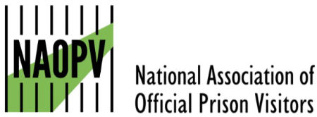**Official Prison Visitors (OPV)**

People in our care who do not have anyone who is able to visit can request to have a volunteer prison visitor called an ‘Official Prison Visitor (OPV) who will visit and provide support. This service is offered through the Chaplaincy department.



**Its Story Time and Shout Out**

Offering opportunities for prisoners to record visual and audio stories for their children, and to keep in touch at special times, anniversaries, birthdays and festivals.

**Care Leavers**

Following the Children & Social Work Act 2017 (C&SWA 2017), all young adults defined as Care Leavers can be offered support until the age of 25. The Care Leavers Lead is Janine Smith based in the Offender Management Unit. Support can consist of:

Relationships & Keeping Safe

Accommodation

Leisure and Participation

Money, Health and wellbeing

Education, Employment and Training

There are posters on each community to advertise monthly forums and well as a Uni-Link inbox which has been created so that any care leaver can send and receive applications to one mailbox. We recognise that sometimes men are embarrassed to admit that they are a care leaver when they arrive in Reception. Therefore, we have a Peer Support Representative on Induction who is working with prisoners to encourage the prisoners in confirming if they have been in care, so that we can offer the relevant support.

**Our Future Plan**

**Our commitment to visitors and people in our care in 2025 and beyond**

* All rooms have in-cell phones and laptops.
* We plan to add a functional email account where families / significant others can email with any ideas / suggestions to improve the experience of visiting HMP Berwyn, this will be done through Barnardo’s.
* We are working closely with Barnardo’s and our sole purpose is to improve the link between families / significant others and the people in our care.
* We are aiming to work with Barnardo’s to put together a friends/family council, where we will regularly meet with friends and family to discuss up-to-date improvements and any areas of concern/improvement. Any feedback from the meetings will be discussed internally within our family/significant other staffing structure.
* We have a Neurodiverse Room in the visit’s hall used on a needs basis.
* We are looking at ways to continue to improve our facilities for children, subject to funding and security clearance. Any ideas would be welcome.
* We have now started to hold Visits for those in our care that do not get visits.
* We have a Families and Significant Other Strategy.
* We have a monthly themed Family Visit.
* We have a breakfast / homework club every Sunday.
* We hold a monthly Veterans Breakfast Club.
* We are looking at holding several days where we celebrate the success of the people in our care. We will be inviting families / significant others to the ceremonies after significant course / qualifications have been achieved to be able to celebrate success together.

**Measuring Success**

-By the number of spaces/attendees available for each visit.

-By listening to prisoners and families through regular forums, recording and sharing comments and feedback.

-By reviewing the feedback in the family comment book and functional mailbox.

-By the variety of family, friends and significant others visits offered.

-By collating important data from the people in our care and acting on the information gained.

**Berwyn’s Strategy**

* The Functional Head Lead for Families & Significant Others provision is Governor Lyndsey Cheeseman and Toni Lamb is Families and Significant Other Champion to staff.
* HMP Berwyn log all calls made to the establishment in case of an emergency and Barnardo’s provide additional family support.
* HMP Berwyn provide details of our Visitor Base, visiting services, staffing structures, family learning and extended visits.
* The establishment records wider more detailed information about outcomes around visits.
* The establishment links effective contract management and partnership work with its Families & Significant Others provision.
* The establishments Families & Significant Others provision link with work being done at the establishment with: Care leavers, looked after children (where appropriate). Prisoners who do not receive visits. Prisoners with protected characteristics.
* The establishments’ Offender Management strategy ensures that staff working with prisoners are aware of the importance of the Families and Significant Other agenda. Keyworkers have not yet been identified.
* The establishment can evidence that HMIP, MQPL and other reports or information is discussed and contributes to developments and plans around their Families & Significant Others provision.
* The establishment links issues around Public Protection with its Families & Significant Others provision and works closely with OMU, POMS and Social Services.
* The establishment links preparation for release with its Families & Significant Others provision.
* The establishment ensures that the information published on their MoJ Prison Finder/GOV.UK listing is accurate and up to date.
* HMP Berwyn have a Families & Significant Others Strategy Document.

**Safeguarding**

Safeguarding in Prisons is about keeping visitors and the people in our care safe. We have a statutory duty of care as both an organization and as individuals working in a custodial environment to keep people safe from Abuse and Neglect. At Berwyn this means we have a responsibility as an individual to take appropriate action protect individuals.

**Abuse** is any act, or failure to act, which results in a significant breach of a prisoner’s human rights, civil liberties, bodily integrity, dignity or general wellbeing, whether intended or inadvertent; including sexual relationships or financial transactions to which a person has not or cannot validly consent, or which are deliberately exploitative.

**Neglect** is simply to fail to care for someone properly. It leads to mistreatment due to a lack of attention. It can also be active neglect, which is intentional, or passive neglect, which is from a lack of experience, information, or ability. Physical neglect is failing to attend to someone’s medical, hygienic, or nutritional needs. Emotional neglect involves ignoring and isolation.

**How to raise a Safeguarding concern at Berwyn**

Visitors have several established ways of raising concerns of neglect or abuse.

* Directly to a member of staff.
* The Complaints.
* Discrimination Incident Reporting Form, (DIRF).
* Speak or write to Barnardo’s.
* Safer Custody Hotline.
* Directly to North Wales Police.
* Confidential box in the Visit Centre.

It is important that all reports of suspected abuse or neglect are treated seriously. There are various processes that it may be appropriate to follow with the aims of:

• Preventing further abuse or neglect.

• Supporting and protecting victims, witnesses and reporters.

• Investigating whether the suspected abuse or neglect took place.

**What to do if you’re worried a child or vulnerable adult is being abused**

Concerns about a child or vulnerable adults welfare can vary greatly in terms of their nature and seriousness, how they have been identified and over what duration they have arisen. If you have concerns about a child or adult, you should ask for help.

You should discuss your concerns with staff in the Visits Hall or Barnardo’s.

If, at any time, you believe that a child or vulnerable adult may be a in need, or that a child or vulnerable adult is being harmed or is likely to be, you should refer immediately to local authority children / adults social care. This referral can be made by any practitioner. If you see further signs of potential abuse and neglect, report and refer again.

**External Links**

HMP Berwyn will strive to maintain positive links with partner agencies including Nort Wales & Northwest Police forces, Social Services, Child Safeguarding agencies.

**HMIP Expectations**

Expected outcomes: The prison supports prisoners’ contact with their families and friends. Programmes aimed at developing parenting and relationship skills are facilitated by the prison. Prisoners not receiving visits are supported in other ways to establish or maintain family support.

Barnardo’s family services provided excellent support to prisoners with family concerns and broader resettlement needs. Prisoners were helped to rebuild and maintain family relationships and children were given excellent support with play during visits. It was particularly impressive that prisoners with children of school age who wished to engage in their child’s education were supported to do so. Barnardo’s had contacted a few schools and arranged parents’ evenings through video calls.

The visits hall was a spacious, welcoming, and relaxed environment. A designated tea bar is available to buy refreshments. Sentenced prisoners can have up to five hours per month dependent upon their IEP (Incentive and Earned Privileges) and remand prisoners up to three visits a week.