

**HMP Askham Grange**

**Family and Significant Others Strategy**

Local Policy Document

February 2025

Review Due: January 2026

Governor Julia Spence



**Introduction**

HMP Askham Grange is committed to helping our Prisoners and their families to keep in contact with each other. When we speak about families in this document this includes: blood relatives, legal or significant persons that a prisoner identifies as their next of kin and for care-leavers this may be someone that provides a statutory service. In 2017 Lord Farmer published his review highlighting the importance of working with families in reducing crime and the risk of individuals returning to prison. In 2019 Lord Famer published ‘Farmer 2’ which is specific to the needs of female offenders and their families. HMP Askham Grange has been working to implement all of the key recommendations from this publication, along with any recommendations for Children and Families from other sources such as MQPL, HMIP, IMB etc.

**Why is this important to us?**

HMP Askham Grange appreciates that family member’s will also feel the effects of the imprisonment of someone close to them. It is usual for those left at home to be worried about the person in prison, be confused about how to:

* Help them get through their sentence
* Keep them in contact with their children, siblings and other family members
* Help them succeed in substance misuse rehabilitation
* Help them with mental or physical health difficulties
* Prepare them for release and integration back into their family groups

We also understand that families can play a huge part in helping our Prisoners through their time in prison and contribute positively to supporting them to remain offence free in the future. We also recognise that not all family relationships are positive. Family members may sometimes be the direct or indirect victims of a prisoner’s offence such as domestic abuse and substance addiction. We know that family relationships in these circumstances can be strained and in some cases have been severely damaged.

At HMP Askham Grange we have a dedicated multi-agency family team who meet weekly to ensure that our services are consistently improving and meeting the needs of our women and their families. The multi-agency family team include:

Children and Families Pathway Lead (HMPPS)- Head of Reducing Reoffending/OMU *Loren Sell*

Head of Res, Safety, Equalities and MBU (HMPPS) – *Governor Cooper*

Mother and Baby Custodial Manager and FaSO champion (HMPPS) *Siobhan Martin Mills*

Safer Custody Custodial Manager (HMPPS) *Becky Conyers*

Family Engagement Manager (PACT) *Claire Malarkey*

Family Engagament Worker (PACT) *Sophie Boocock*

Nursery Manager (Action For Children) *Hannah McNally*

Prison Offender Manager (Probation officer /HMPPS) *Paul Hobart*

MBU Officers (HMPPS)

**Understanding the needs of families and significant others**

We continually strive to understand the needs of families and significant others. In part we will do this via a regular Visitors Needs Surveys. Askham is keen to do all we can to ensure that visits are a pleasurable experience and to keep families in touch with their loved ones whilst they are with us. To help in developing the services at Askham the lead of Families and Children welcomes your views on this matter. They can be contacted by writing to the Head of Reducing Reoffending at the address below.

**What we offer**

HMP Askham Grange has a variety of services and initiatives that have been put in place to support our women and their families and significant others.

* **Family Induction Booklet**

When women arrive at HMP Askham Grange they are asked if they wish their next of kin/significant other to be sent a ‘Family Induction Booklet’. The booklet contains all of the information that a family member/significant other will need to know about the establishment, its services, how to raise concerns and how they can support their family member whilst they are in custody.

* **Letters**

There are no restrictions on the number of letters Prisoners can receive. Prisoners are actively encouraged to write letters to maintain family contact. They can apply for 1 free letter per week plus additional free letters for each child under 18. On request, a free letter can be provided for specific purposes such as arranging housing, employment, legal proceedings etc. Prisoners can purchase writing materials from the prison shop and Askham provides education classes for those wishing to improve their writing skills.

Our postal address is:



[Prisoners name and prison number}

HMP/YOI Askham Grange

Askham Richard

York,

YO23 3FT

* **Email a prisoner**

Families and friends can email a family member through the ‘Email a Prisoner’ process. This method is quicker and cheaper than sending letters through the post. Our women usually receive the email the day after it has been sent. When emailing if you state you would like a Prisoner to be able to reply to your e mail, they can (this is free of charge!)

For more information please go to:

https://www.emailaprisoner.com/

* **Telephone calls**

***Personal Identification Number (PIN) Telephone Calls***

Presently Prisoners are allowed to have 20 cleared numbers they are allowed to call using the prisons PIN phones. Credits are purchased via prisoner earnings and/or monies sent to them (private cash). Calls can be made 7 days a week between the hours of 08:30 and 22:00.

All telephone calls made from a Prisoner are recorded and may be live monitored. This is to ensure that we are fulfilling our obligations regarding public protection and the security of the prison. Our monitoring systems are regularly inspected by the relevant authority to ensure that we are complying with the strict laws that are applied in this area.

* **ROTL**

Release on Temporary Licence is used extensively at Askham to maintain and build family links. ROTL can be granted based upon risk assessments and eligibility. Types of licences used are: Childcare Resettlement Leave, Day and Overnight release and Special Purpose Licenses. Prisoners are eligible to apply for access to the above ROTLS via application to their Prison Offender Managers. The primary focus of ROTLs is always resettlement and maintaining family ties. Prisoners are expected to provide a schedule of activities that will show how they are using this time to maximum effect.

Offender Management Unit lead on the risk assessment process in conjunction with external Offender Managers.

* **Family Days**

Family days at Askham are designed to be both welcoming and supportive. Across the day there are plenty of activities to join in with, dedicated time and space for families to sit and relax together, as well as the opportunity to sit and enjoy a meal together.

A number of themed family day events are held throughout the year, usually in line with school holidays. These are very popular, with feedback always being very positive both in terms of quality family time and fun. These events are advertised internally to our Prisoners who can apply for a space at the event.

* **Visits**

We currently have visits available on Saturday and Sunday afternoons. The times of the visits are usually from 1.45pm and are finished by 3.45pm.

Visits can be booked by family members who are included in a list of visitors supplied to us by the Prisoner. We can hold a maximum of three adult visitors plus children in each visits session. A visit can be booked either through the prison visits booking number (0300 0606515) or on line at: <https://www.gov.uk/prison-visits>

When booking a visit the visitor will need the:

* prisoner number
* prisoner’s date of birth
* dates of birth for all visitors coming with you

The Prisoner must add the visitor to their visitor list before the visitor can book a visit.

Unfortunately, the prison cannot book visits directly via the main telephone phone numberalthough Prisoners can request to book a visit by contacting the Business Hub.

* **The Visits Hall**

The visits hall is a large and open space that has seating arranged so that visitors can enjoy time with their family member. At Askham it is actively encouraged that Prisoners play/interact with their children. There is a soft play area where Prisoners can interact with their children as well as the option of using one of our board games, or using one of the ‘Bored and Busted’ bags which can be collected from the tea bar for use during the visit.

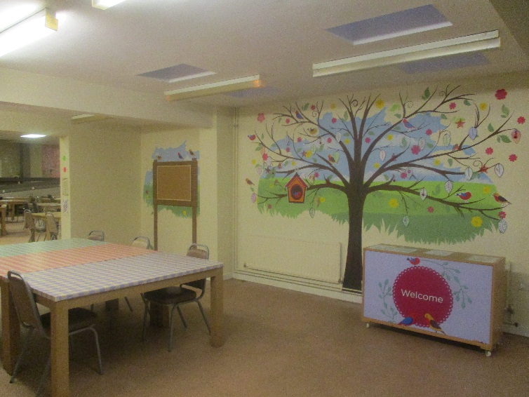Within the hall there is a dedicated Tea Bar ran by our Prisoners for purchasing drinks and snacks. This area is staffed by Prison Officers who are there to ensure that everyone enjoys their visit and to maintain security and decency. In order for visits to remain a positive environment, although routine searching prior to visits is not usually required, there are circumstances relating to safety and security where you may be asked to comply with a search. Any visitor who is deemed to be abusive or threatening will also have the visit declined or terminated and also be asked to leave.

For those Prisoners who don’t receive visits are offered additional support that can be provided on a one to one basis.

* **Acorn House**

Acorn House is a furnished house that provides extended day visits for Prisoners with their families or significant others. This is an additional service to the usual visiting arrangements. Prisoners can apply for a visit at Acorn House via application to the Custodial Manager of MBU/Res. All requests are considered on an individual basis and a decision is made at the weekly Family Team meeting.

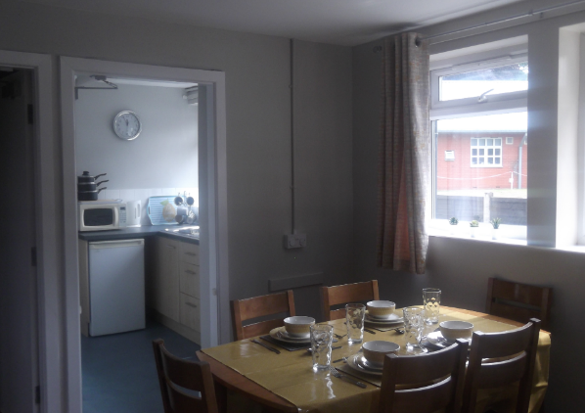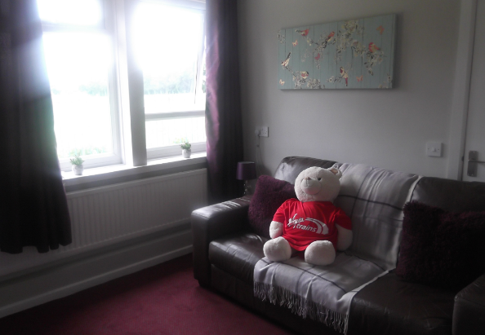

* **Mother and Baby Unit**

Pregnant mothers or those with children under 18 months can apply to have their child with them on special mother and baby accommodation. The Mother and Baby Unit is a specialist unit separate to the main building located next to the nursery which is ran by the Action For Children team. Applications are considered on an individual basis taking into account the best interests of the child.

* **Key Worker**

The introduction of the key worker is an opportunity to help us to achieve positive relationships and cultivate a healthy culture in which prisoners can feel confident in developing themselves; along with staff increasing their understanding about the impact they can have on helping them make these changes progress. Key workers will work with individuals to get them to be more responsive and make the right choices for themselves. Working with the women the key worker must demonstrate their enabling attitudes and skills, along with having an understanding of what they are trying to achieve and, the change they are encouraging the prisoner to make. It is important that staff have a belief that this change can happen.

Key workers will work collaboratively with the individual, colleagues and other agencies to develop a rehabilitate culture with a focus on personal development through the building of strong working relationships. There is good evidence that getting prisoners to work on their personal development has a positive impact on reducing suicide, self-harm, violence, anger and alienation and improve good order which benefits everyone.

Key workers have been allocated an average of 45 minutes each week for one to one contact with the individuals allocated on their case load.

* **Prison Offender Managers**

Every prisoner at HMP Askham Grange is allocated a Prison Offender Manager previously known at Offender Supervisor). Prison Offender Managers (POMS) work within the Offender Management Unit and work alongside the prisoner to ensure sentence plan progression and risk elements are addressed during their time with us. POMS link up with a Community Offender Manager to ensure resettlement plans are in place. POMS see prisoners on their assessed complexity of need.

* **Pregnancy, Mother & Baby Liaison Officer (PMBLO**)

The PMBLO acts as a source of information and liaison between professionals and women in the following cohorts:

* Pregnancy, birth, the post-natal period, and other pregnancy outcomes – within 12 months of entering prison or during a sentence.
* Mother and Baby Units (MBUs) – Mothers and child rearing individuals applying for and spending time on MBUs with their children
* Maternal Separation from children up to the age of two – Mothers, child rearing individuals and adoptive parents separated from children up to the age of two years old in the 12 months prior to entering prison, as a result of imprisonment, or following time on an MBU

The PMBLO completes the early identification of needs, early contact and information sharing, and effective partnerships between prison staff and key agencies, to ultimately improve outcomes for women and their children.

* **Family Engagement Manager**

In order to support Prisoners and families we have a full time Family Engagement Manager and a part time Family Engagement Worker who are employed by PACT. They work Monday to Friday and can be contacted on: 01904 772016 or via email at

[claire.malarkey@prisonadvice.org.uk](mailto:claire.malarkey@prisonadvice.org.uk) or [sophie.boocock@prisonadvice.org.uk](mailto:sophie.boocock@prisonadvice.org.uk)

The Pact team work with families to try and maintain good communication links and to help in cases where the relationships in the family have broken down. They provide support on a one to one basis with Prisoners to help them with child related problems and will refer on cases where additional work is needed.

The Pact workers can provide support in contacting school, social care, family court and other agencies who may be involved with Prisoners and their families.

PACT also run interventions across the year for our Prisoners. Workshops include ‘Building Stronger Relationships’ and ‘Preparing To Go Home’.

You can find more out about PACT at: <https://www.prisonadvice.org.uk/>

* **Cafcass**

Cafcass (the Children and Family Court Advisory and Support Service) represents children in family law proceedings. The majority of work is in private law divorce and separation cases.

To fulfil private law safeguarding role we have a duty to, wherever possible, undertake telephone risk identification interviews with the adult parties before the first court hearing The first hearing is scheduled to occur within six weeks of the application and Cafcass must file the safeguarding letter, reporting the outcome of calls with the adult parties, within 17 working days of receiving the application.

Cafcass arrange these phone calls by writing to the adult parties with an appointment time. The party is then called by one of their Family Court Advisers at the agreed time.

The specific point of contact for Askham Grange for all matters regarding Cafcass is Pact Family Engagement Manager Claire Malarkey on 01904 772016 claire.malarkey@prisonadvice.org.uk

* **Story Book Mums**

Prisoners have the facility to record themselves reading a book for sending to a child relative. This is done through our library provider and is useful in strengthening the

bond between adult and child.

* **Care Leaver Support**

The assessment of Care Leaver status forms part of POMS induction interview. POMS will work with Prisoners on an individual basis to ensure that care leavers rights are obtained. The champions facilitate talks by the Care Leavers Associations as well as peer support groups for Prisoners who are Care Leavers.

**Prisoners in Crisis**

There are times when Prisoners require addition support both from prison staff but also from family and significant others. Where appropriate and with the Prisoners permission those individuals recorded as family/significant others will be informed and/or invited to attend/contribute to support meetings. Family members and significant others will be asked to attend due to their knowledge and experience, as in times of crisis this can be invaluable.

**Communication Gateway**

Keeping our Prisoners as safe as possible in prison is our top priory. In the event that a family member/ significant other has any concerns regarding the Safety of their loved one whilst in custody at HMP & YOI Askham Grange, they can ring the Safer Custody telephone number. The Safer Custody Line is a recorded message line which is checked regularly by our staff.

**The 24 hour Safer Custody Telephone line number is 01904 772026. This number should only be used if there are concerns about the safety or wellbeing of a Prisoner**.

If you get through to the answer phone family members/ significant others should leave a brief message of their concern and include the full name of the Prisoners along with a contact number so the family member/ significant other can be updated. The answer phone is checked hourly.

**If the matter is deemed as life threatening please call 01904 772013 (this extension is manned 24 hours)**

**Adult and Child Safeguarding**

This policy should be read in conjunction with both the Adult Safeguarding and Child Safeguarding policy’s. The main contacts are:

**Child Protection Manager (CPM)** – Governor Dannielle Cooper

[danielle.cooper@justice.gov.uk](mailto:danielle.cooper@justice.gov.uk) Tel 01904 772 000 ext. 2007

**Child Protection coordinator (CPC**) – CM Becky Conyers

[rebecca.conyers@justice.gov.uk](mailto:rebecca.conyers@justice.gov.uk) Tel 01904 772 000 ext. 2110

**Nursery Manager** – Hannah McNally

[hannah.mcnally@justice.gov.uk](mailto:hannah.mcnally@justice.gov.uk) Tel 01904 772 000 ext. 2078

**Family Engagement Manager** – Claire Malarkey

[claire.Malarkey@justice.gov.uk](mailto:claire.Malarkey@justice.gov.uk) Tel 01904 772 000 ext. 2016

**M&B Manager** CM Siobhan Martin-Mills

[siobhan.martin-mills@justice.gov.uk](mailto:siobhan.martin-mills@justice.gov.uk) Tel 01904 772 000 ext. 2132

**Communication, Engagement and Improvement**

The FaSO team are committed to ensure that effective communication and engagement with key stakeholders aids improvements to the FaSO service we offer. We do this by:

* There is a live FaSO action plan to drive improvements.
* The FaSO team holds two specific ‘Family and Significant Others’ focus groups with prisoners every year.
* The CM of Operations holds two specific ‘Visits’ focus groups with prisoners every year.
* FaSO team holds an annual FaSO conference at HMP Askham Grange
* FaSOs are surveyed about the FaSO provision yearly
* FaSOs are surveyed about the Visits provision every six months.
* FaSO team holds regular awareness sessions with the staffing group.

**Working in Partnership**

HMP Askham Grange is committed to work in partnership with a variety of organisations to ensure that the needs of our Prisoners are being met. We do this successfully with PACT, Action For Children, Care Leavers Association etc. We recognise that educating others to understand the needs of offender’s families can increase understanding and offers of support for those in question.

Over the last two years we have worked in close partnership with a national rail company who have been highly supportive of our Family and Significant others agenda by donating both time and funds to refurbish areas used by our women and their families and by donating a vehicle to enable more families to visit the establishment.

**Live Action Plan**

**(INSERT)**

**Jargon buster**

**Acorn House** – a furnished house on prison land used for by families for contact and visits outside of domestic visiting arrangements

**Action For Children** – charity contracted to provide nursery care for mother and babies and family learning

**C&F** – children and families lead, the manager responsible for ensuring the care and support of families

**CRS-** Community rehabilitation services

**JCP** – job centre plus, staff from the job centre assist Prisoners with applications for benefits  
**LCSB** – local safeguarding children’s board, the multi-agency board designated to support children’s services in North Yorkshire

**MBU** – mother and baby unit, accommodates 10 mums with their babies under 18 months.

**NOVUS** – the education provider who deliver some employability training

**PACT** – Prison Advice Care Trust, charity contracted to provide a family engagement manager to support families

**POM** – Prison Offender Manager – staff designated to case manage and support Prisoners through their sentence

**Safer custody** – a team of staff to ensure Prisoners and visitors are safe from risk of harm

**TWP** – Together Women Project, a charity contracted to provide support regarding abuse

**Annex A Interventions/Services**

|  |  |  |
| --- | --- | --- |
| Interventions/process/tasks | Measure | Stakeholders |
| Mother and baby unit (MBU) | Consider the best interests of the child in managing the MBU | MBU manager |
| MBU social care assessments | Support local authorities in carrying out social care assessments | Local authorities, PACT, Action 4 Children, MBU manager |
| Multi-agency team | Meet weekly as a multi-agency team to support all of those being cared for by the team | Probation, MBU manager, C&F lead, PACT, Action 4 Children, |
| Safeguarding children Policy | There is a safeguarding children policy to ensure all children and visitors are protected and reported effectively | C&F lead |
| Health visitor and midwifery | Ensure all mothers have access to ante-natal and post-natal care | MBU manager |
| Local safeguarding children’s board | Attend the LSCB meetings | C&F lead |
| Acorn House | Ensure access to Acorn House is available Prisoners for day/overnight visits and to local authorities and care professionals Ensure all overnight visits are managed and supported | Multi agency team |
| Nurturing course family learning | Support women engaging in the Nurturing course | Action 4 Children, |
| Family Law advocacy | Provide free family law advice with local solicitors | PACT |
| Finance and benefits | Provide finance and benefit support during custody and to prepare for release | CRS, Novus |
| Domestic visits | Visits are accessible to all Prisoners and take place on Sat and Sun afternoons |  |
| Visits survey | Regular visitors surveys will take place | Operations staff, PACT |
| Visits play area | Visits play area will be maintained and available to all visitors | Operations staff |
| Release on temporary licence | Support women applying for ROTL | OMU |
| CCRL | Ensure those eligible can access CCRL every 8 weeks | OMU |
| ROR | Ensure those eligible can access ROR every 4 weeks | OMU |
| RDR | Ensure those eligible for RDR can access release dependent on IEP level | OMU |
| SPL | Consider applications for special purpose release where appropriate | OMU |
| Story book mums | Mothers can record story book mums for those eligible | Library |
| Family days | There will be at least 4 family days per year | Action 4 Children,, PACT, C&F lead |
| Outgoing calls | All Prisoners have access to outgoing telephones | Prisoner staff |
| Safe custody line | A help line is available to all families | Operations staff |
| Nursery provision | Nursery provision is available to all those on the MBU and can be used for supervised contacts | Action For Children |
| Care leavers | Support is given to care leavers together with local authorities | HMPPS, PACT, local authorities |
| IPP & Lifers | IPP and Life sentenced Prisoners are support in maintaining, developing family ties | Multi agency team |
| Academic review | Acorn House systems are evaluated by an Academic review | C&F lead Huddersfield Uni |
| Internet access | Prisoners can access the internet via their smart phones and ROTL to local library | Operations staff |
| Chaplaincy | The chaplaincy provide pastoral support for families including bereavement | Chaplaincy |
| Relationship advice | Independent advice is available for relationship issues | PACT, TWP |

