HMP Rye Hill
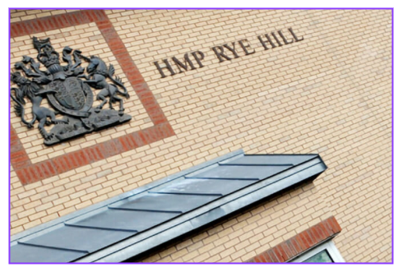


Family and Significant Others Strategy 2025



Contents

Pg No
3 | Strategy Introduction
5 | Related Strategies, Policies and Procedures
6 | Contacting Rye Hill
8 | Getting to Rye Hill
9 | Your Visit at Rye Hill
15 | Additional Support
17 | Assisted Prison Visits
18 | Ways to Stay in Touch
21 | Listening to Feedback

Strategy Introduction

HMP Rye Hill is committed to working with prisoners, families and significant others to help improve their relationships, improve prisoner wellbeing and assist in keeping the public safe by reducing reoffending rates.
This document has been developed to take into consideration the Lord Farmer review into the importance of strengthening prisoner’s family ties, HMPPS strengthening prisoner’s family ties policy framework, HMIP expectations and our local Reducing Reoffending Strategy. These documents all indicate what families of prisoners can expect when they engage with the prison system and how they can help support prisoners.
This strategy recognises that families play a vital role in helping prisoners achieve successful rehabilitation and reduce re-offending. Research shows that prisoners without family support on release are between 2 and 6 times more likely to re-offend in the first year of their release from custody. Additional research (Farrington) shows that male children of prisoners are 63% more likely to offend themselves which rises to 93% when both parents are prisoners.
In order to encourage and promote positive family ties HMP Rye Hill ensures that all visitors are greeted courteously by a dedicated team of visits staff. Visits are also managed by a dedicated Visits Manager and visits are conducted in a safe and welcoming environment
The aim of visits at HMP Rye Hill is to strengthen family ties by making visits less oppressive, more visitor/child friendly and stimulating for all those who attend whilst adhering to security and public protection protocols

Families and significant others lead and champion:
Paul Evans - Head of Community Engagement (Families and Significant Others Lead)
Louise Goodfellow - Visits Manager (Families and Significant Others Champion)

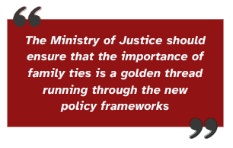
LORD FARMER REVIEW

Related Strategies, Polices and Procedures
The Families and Significant Others Strategy is supported by several other strategies, policies and procedures including:

Lord Farmer Recommendations
HMIP Expectations
Public Protection Manual
Providing Visits and Services to Visitors
Strengthening Prisoners Family Ties Policy Framework
Management of Security at Visits
Searching Policy Framework
Incentives and Earned Privileges Scheme
Local Searching Strategy
Local Safeguarding Strategy
Local Security Strategy
Assisted Prison Visitor Scheme
Local Reducing Reoffending Strategy

Contacting HMP Rye Hill


Visits Booking Line
You can contact the booking line on: 01788 523303
The Phone lines are open 09:00-12:00 and 13:00-16:30
You can also email direct on: ryehillvisits@uk.g4s.com


Emergency Contact
If you have an immediate or emergency concern about the welfare of a prisoner, you can contact HMP Rye Hill directly on 01788 523300 and request to speak to the Duty Manager or Duty Director. You will need to explain that your call is urgent and you are worried that a prisoner is at risk of immediate serious harm.

Safer Custody Helpline
If your concern is urgent but not life-threatening, please call the Safer Custody Helpline on 01788 523309. This is an answer machine service, however, it is checked regularly. You will need to leave a message explaining your concern along with your name and if you would like a member of the team to return your call. Please leave your contact details

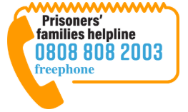
Prisoners families.org website
For information about safer custody concerns you can visit the Prisoners Families website at https://prisonersfamilies.org/ or contact the helpline on 0808 808 2003. The line is open 09:00-20:00 Monday to Friday and 10:00-15:00 Saturday and Sunday.
The website also allows for a Safer Custody Form to be completed that will be received by HMP Rye Hill’s safer custody team to respond to. You will not be able to book visits using this service

Writing to the Director
Families and Significant Others can also consider writing to the Director regarding concerns relating to the person they know in prison. This letter should be addressed as FAO The Director, HMP Rye Hill, Willoughby, Nr Rugby, CV23 8SZ. Letters will be responded to within 28 days.

Getting to HMP Rye Hill

HMP Rye Hill Prison address is: HMP Rye Hill, Willoughby, Nr Rugby, Warwickshire, CV23 8SZ

The closest railway station is Rugby which is about 7 miles from Rye Hill. For train enquiries please visit: www.nationalrail.co.uk
There are not currently any buses which travel to Rye Hill. Please visit www.warwickshire.gov.uk/buses to plan your route

Some local taxi companies for your reference are:
- People Express - 01788 546666 - https://www.peopleexpress.co.uk/
- Dial-a-Cab - 01788 570202 - https://www.rugbytaxi.co.uk/
- Compass Cabs - 01788 222222 - http://www.compasscabsrugby.co.uk/

The prison has a free visitor car park adjacent to the visitors centre. We are currently undergoing some building work which has affected the number of spaces available. We apologise for any inconvenience

The last entry for visits is 15:30. Entry will not be permitted into the visits hall past this time

Your Visit an HMP Rye Hill
All prisoners at HMP Rye Hill can receive visits, however, some may be subject to public protection restrictions.
Prisoners will request their visitors be added onto their CMS prior to booking their visit. Only visitors listed on the visit will be permitted entry on the day.

Visiting Times

 | Mon | Tues | Wed | Thurs | Fri | Sat | Sun
Social |  |  | 1330-1630 | 1330-1630 | 1330-1630 | 0900-1115  1330-1630 | 0900-1115  1330-1630
Official |  |  | 1400-1600 | 0900-1130  1400-1600 | 0900-1130  1400-1600
Purple |  |  | 0900-1040  1330-1840 | 0900-1040  1330-1840 | 0900-1040  1330-1655 | 0900-1040  1330-1655 | 0900-1040  1330-1655
Identification
Prior to your visit you will be asked to provide the appropriate ID. Ideally photographic ID should be used. Acceptable forms of photo ID are:
- Passport, including foreign passports, and time expired passports where the photograph is still recognisable.
- EC identity card
- Driving licence
- Benefits book
- Senior citizen’s public transport pass issued by a local authority.
- Employer’s or student ID card but only if this clearly shows the name of the visitor and the employer or educational establishment, and has a photograph or signature which can be compared with the visitor’s appearance or signature, and if the employer or educational establishment named on the card is known to exist.
If you are unable to produce one of the above, staff may accept combinations of two or more of the following:
- Birth/marriage certificate
- Rail or bus pass with photo
- Cheque book or credit/debit card (counts as one, do not accept as two)
- Employer’s pass or ID or student ID card not acceptable under paragraph 2
- Young person’s ‘proof of age’ card
- Trade Union or National Students’ union membership Card
- Library card, if it has a signature that can be compared with the visitor’s signature
- Rent book
- Foreign identity or resident’s card (other than EC ID cards acceptable in their own right)
- Expired documents from the above lists that appear satisfactory in other ways
For children under 18 years acceptable ID are:
- Birth Certificate, Medical Card or Passport
Please ensure you bring your ID with you every time you visit. If you do not have the appropriate ID or we have concerns regarding your identity you will be refused entry.

Dress Code
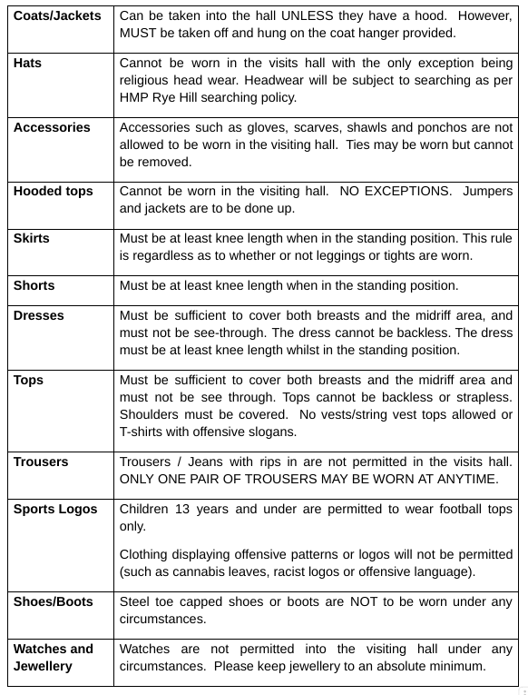
Behaviour
HMP Rye Hill will not tolerate abusive or inappropriate behaviour towards staff or prisoners. Inappropriate behaviour is defined as any behaviour that my present a risk to the security of the establishment of behaviour that is deemed indecent. All visitors and prisoners need to be aware that inappropriate physical interaction is prohibited and in some cases is a criminal act.
Examples of inappropriate behaviour in a public place (which the visits hall is) are:
- Prolonged intimate kissing
- Caressing of another person’s torso or lower region
- Physical exposure by either party of their chest, breasts or genitalia
Visitors Centre
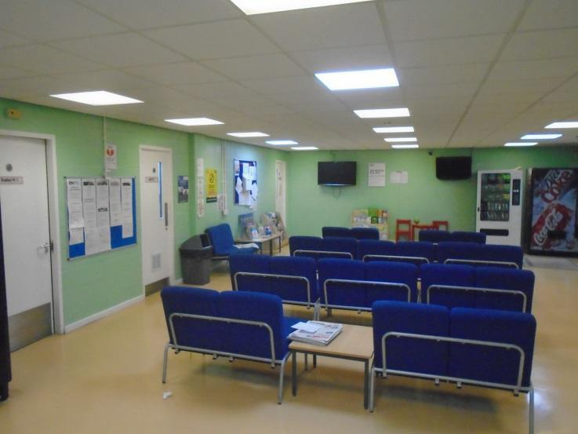
There is a dedicated visitors centre at HMP Rye Hill which is located directly outside and opposite the entrance to the prison. Within the centre there are a number of comfortable chairs within a large open plan waiting area. The environment is set out to be welcoming and keep families entertained whilst waiting. There is a T.V, a number of magazines, posters and leaflets, alongside an area for children with toys and activities. The centre has vending machines that provide refreshments and snacks for visitors. This facility is open before the visits session takes place to enable the visitors to have somewhere safe to wait should they arrive early for their session and lockers for personal items. The visitors’ perception of the centre will be reviewed annually as per visitors’ survey and updated if appropriate.
Entering the Prison
After booking in for your visit at the visitor’s centre you will be sent across to enter the prison. At least one visitor must be 18 or over at every visit. A maximus of 3 adults and 3 children are permitted to visit at one time.
All visitors entering the prison will receive a rub-down search, including children. All searches will be carried out sensitively, with respect and courtesy to all individuals. Children will be searched by female staff in view of their accompanying adults. All visitors' religious beliefs are respected. There is a private area available should religious headwear need to be removed as part of the search.
Before entering the establishment, you may encounter a drug dog which is trained to pick up the scent of drugs. If a person is identified as being in possession of drugs or any other prohibited item, they may be subject to closed visits, visit bans and the police informed. There are no exceptions to this search process but we will be sensitive and patient if visitors are nervous or anxious about this process.
The Visits Hall
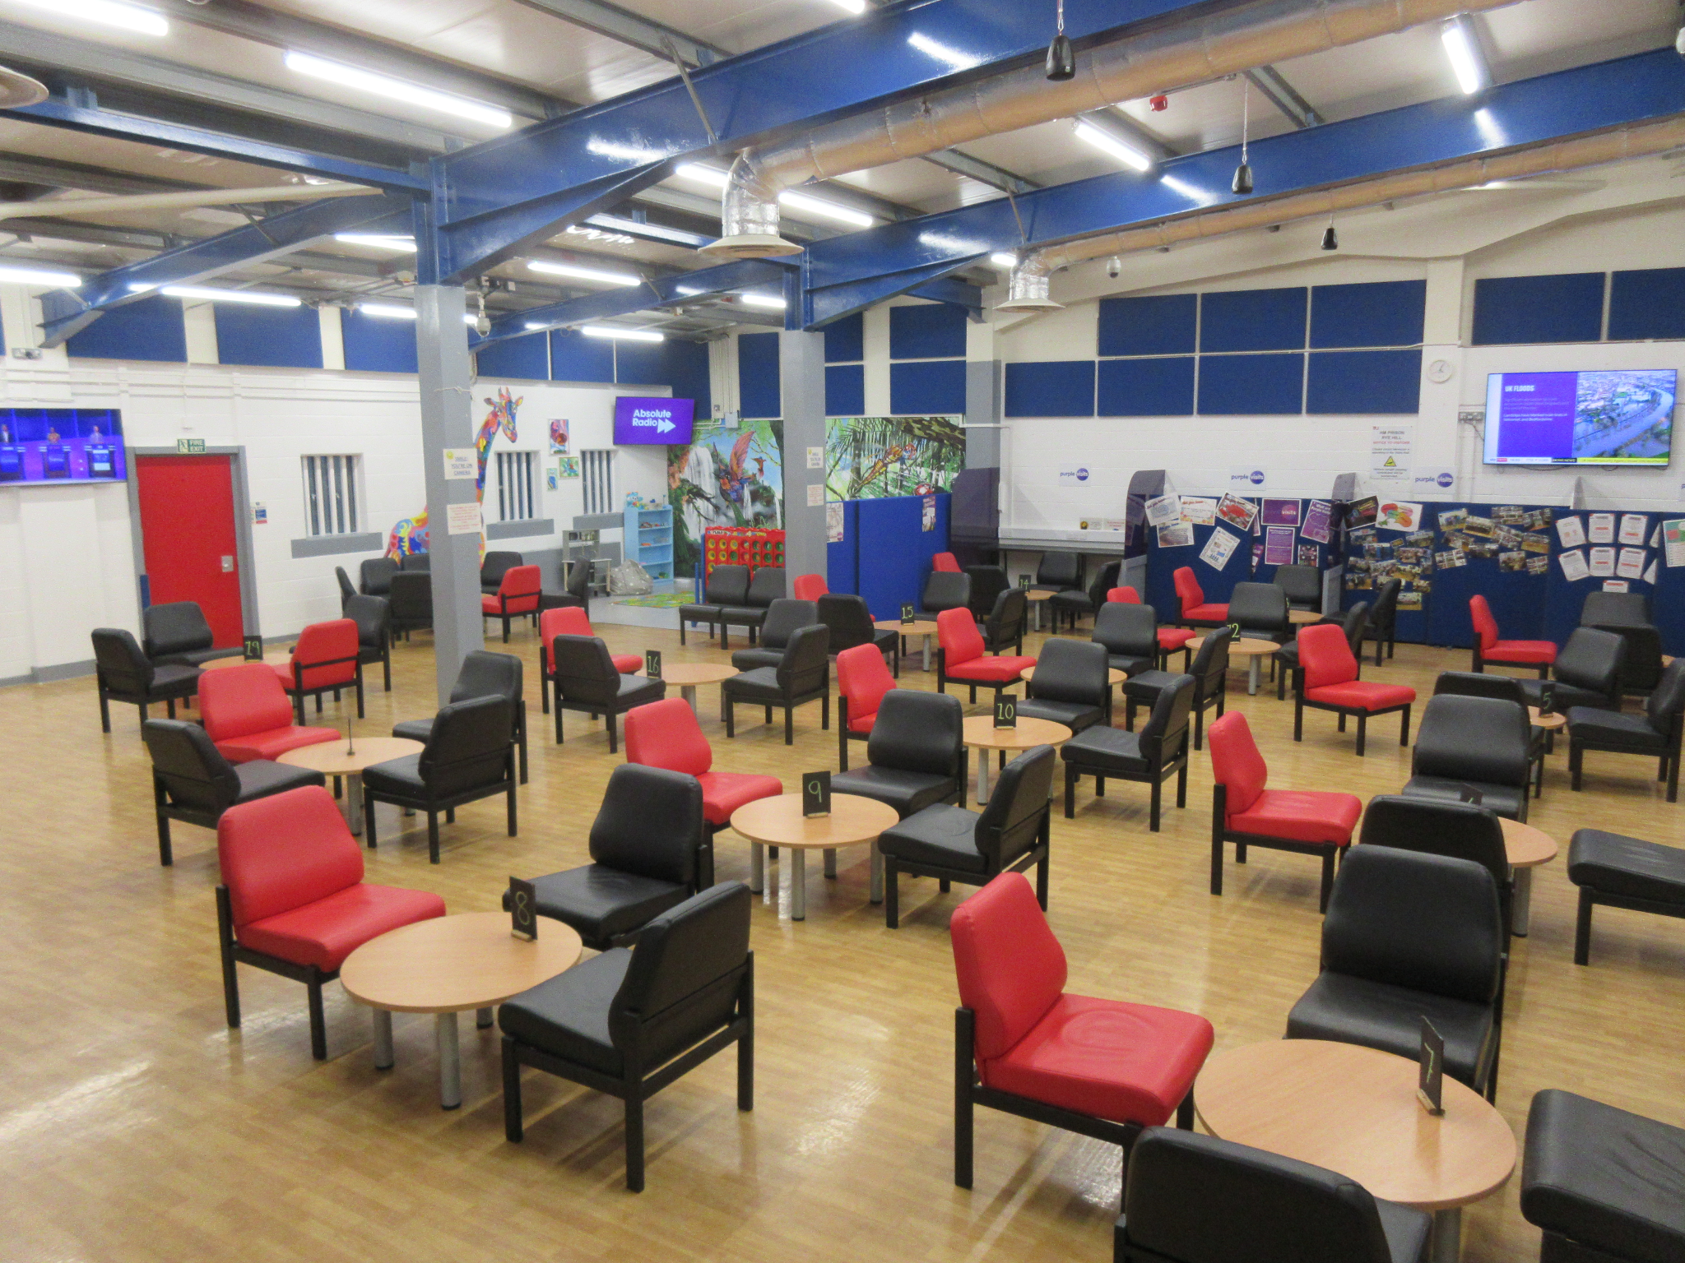
The Visits Hall is a large open plan area that is decorated with pictures and canvases from prisoners at HMP Rye Hill. They are used to create a safe and positive atmosphere within the hall. There are a number of ‘sound boards’ around the hall which assist in managing the acoustics, as when at full capacity, the hall can be loud. Music is played within the background to help create a positive atmosphere.
You will be allocated a table to sit at and your family member will join you at the table. When your visit has completed your family member will leave first before you exit the visit hall. Toilets are situated outside of the visit’s hall, therefore you will be required to be searched again before re-entering the room
The Visits Hall play area exists to provide an opportunity for children visiting prisoners to engage in play in sight of their parents, or by an appropriate accompanying adult. The area has a variety of activities available for children of all ages, including ‘big connect 4’ and other children’s toys. This will be reviewed annually as a result of the visitors’ survey.
The Visits Hall has refreshment facilities that are provided by ‘Aramark’. The refreshments provided (Tea/Coffee, cold drinks, sandwiches, snacks and confectionery) are open as sessions start to ensure that visitors are able to buy refreshments and this does not impact on the time they have on their visit. The refreshments offered are suitable for all including dietary requirements and cultural needs. Visitors are allowed to bring up to £50 in cash into the Visits Hall to purchase refreshments.
Children
All visitors under the age of 18 are regarded as children and must be accompanied on a visit by an adult. Children must be supervised at all times whilst visiting the establishment. If a child needs to use the toilet during a visit, they must be accompanied by an adult visitor.
Nappies and changing wipes are available in the visit’s toilets. Access to baby changing facilities is available
Drugs
The smuggling or drugs is a serious offence and therefore will be treated as such. If anyone is suspected of smuggling drugs they will either be placed on closed visits or have their visit terminated and the police informed.
If you are worried about drugs or are being pressured to smuggle drugs, please speak to an appropriate member of staff, or contact the prison directly.
Additional Support
Approximately 37% of the prisoner population at HMP Rye Hill access visits regularly. This is due to a number of contributing factors, such as the prison being located centrally within the country, and therefore the distance some visitors may have to travel; and the nature of the prisoners’ offences, meaning some families may not want to maintain ties. Furthermore, it is also important to consider that some families are not permitted to have such contact due to public protection or other legal issues. In order to promote family ties in such instances HMP Rye Hill offers additional support

Family Days
Family days are a great opportunity for prisoners and their families to engage in activities and spend quality time together as a family unit. Family days are available for all prisoners and their families to access regardless of their incentive level and they can apply for a place by putting in an application to the visits department. We aim to deliver a minimum of 12 family days throughout the year which will either be Adult or Children family days. Family days run on Mondays or Tuesdays from 10:30 until 15:00.
Children’s family days are focused on family members under the age of 18, who may not always get the opportunity to visit or feel uncomfortable in the normal social visits environment. Games and photos are part of the day and the opportunity to share a meal together.
Adult family days are focused on family members over the age of 18. They allow the opportunity for a more relaxed and comfortable visit. Games, quizzes and photos are part of the day alongside the opportunity to share a meal together.
For those prisoners who have little or no family contact we are also looking to add “community days” such as Lifer Days, Care Experienced Days, Veterans Days into the visits calendar which are designed to provide support and socialisation for those with limited access to normal domestic visits.

Post Programme Reviews
We recognise that prisoners' families and significant others are important in helping in the positive work to reduce risk and support rehabilitation. Key family members or significant others can be invited to a prisoners post programme review alongside their Programme Facilitator and Prison Offender Manager (POM) to discuss their progress and future needs.

Assisted Prison Visits
The Help With Prison Visits scheme (HWPV) provides a contribution towards prison visit costs for close relatives, partners or sole visitors. The visitor must be on a low income. Help is provided for English, Welsh and Scottish prisons. Limited help is available for Channel Island prisons.
Different rules apply to Northern Ireland prisons (ask at the prison you are visiting for information).
The minimum age to apply for help with visits is 18 years (16 years when visiting a prison in Scotland). Eligible children are included on the claim.
Claims are processed by Family Services in Birmingham, which is a part of His Majesty’s Prison and Probation Service.
To get help you must be listed on both the visitor and low income list below:
Visitor:
- Husband, Wife or Civil Partner
- Partner - living as a couple before the prisoner went into prison
- Parent or Grand-parent (includes step-parent or adoptive parent)
- Brother or Sister (includes half-sibling or step-sibling)
- Son or Daughter (includes step or adoptive)
- Next of Kin (as noted by the prisoner in prison records)
- Sole Visitor (only Social visitor in the four weeks before a visit claimed)
- Escort to a qualifying adult or child (see Escort Section)
Low income:
- Income Support
- Income - based Job Seekers Allowance
- Employment and Support Allowance (Income related)
- Universal Credit*
- Working Tax Credits (with Disability or Child Tax)*
- Child Tax Credits*
- Pension Credit
- Hold HC2 or HC3 Certificate
*An income limit applies to Universal Credit and Tax Credits (see Payment Rates Section)
If someone else claims benefits for you, make your claim online and we will contact you for further details if required.
The online application process allows you to upload your income details, receipts and visit confirmation. Payment is made into your bank account or cashed at a Post Office.
Information Booklet: https://www.gov.uk/government/publications/assisted-prison-visits-form/help-with-prison-visits-a-guide-to-claiming-help-with-the-cost-of-prison-visits#key-facts
Gov Website:
https://www.gov.uk/help-with-prison-visits


Ways to stay in touch with Prisoners at HMP Rye Hill

Telephone Contact
Prisoners have access to in cell phones to enable them to have more readily available contact with their families. This also enables prisoners who do not receive visits, or who have received less frequent visits, to have family contact, despite this not being physical contact. It is important to note that prisoners are able to exchange visiting orders for phone credit should they not have visits, thus continuing to promote the importance of staying in contact with family.

Email a Prisoner

Prisoners are able to access the ‘email a prisoner’ scheme in which their families can email in to the scheme online and their emails are then sent to them as part of the internal post. This enables families to send messages directly without delay, increasing the time between communications.

Letters
Letters should be addressed to: HMP Rye Hill, Onley Park, Willoughby, Nr Rugby, CV23 8SZ
Please ensure you include the prisoners full name and prison number on the envelope and their wing location if known.

Purple Visits
If you are unable to visit in person you can register to use Purple Visits Video Calling. They can be used anywhere in the world, calls are currently free, last 30 minutes and you can have up to 4 people on the call. Visitors can book the first 2 purple visits directly through the purple visits app per month and contact the visits booking line (details below) to book a third visit.
This app uses the latest facial recognition technology, which has been a work in progress to find the correct balance between security, safeguarding and the user's experiences. If the software sees someone unexpected or identifies anything that is inappropriate it will automatically pause the call.
Usual prison rules apply about appropriate dress and behaviour. Remember that all calls are recorded and monitored as they are happening and staff can terminate a call for inappropriate behaviour
For information of how to use this facility visit: www.purplevisits.com

Listening to Feedback
Feedback is important for us to understand the needs of prisoner and family visits at HMP Rye Hill. We hold family forums consisting of prisoners' friends and relatives with the agenda of understanding their needs and promoting family ties. This is chaired by the Head of Community Engagement, with a deputy chair which is the Visits Manager
We complete visitor surveys through the year to encompass the visitors’ experience of staff whilst visiting, the environment (in the Visitors Centre and Visits Hall), the activities offered and whether they’re appropriate, and the extra opportunities to develop their relationship with the prisoner. A large visitor survey is completed annually with smaller surveys running through the year to capture any potential issues highlighted
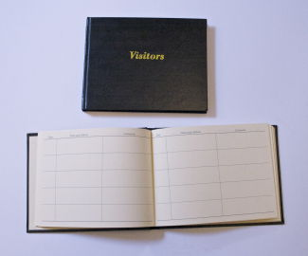
An annual survey is also available for prisoners to complete that encompasses their experience within the visits environment, staff, and their thoughts on how they are able to access visits.
The visits hall has a comments book that enables visitors to put their comments, whether positive or negative, for this to be used to improve visits. This is made available for all families & significant others to access and write in should they wish to.

