



Families and Significant

Others strategy

**Reviewed January 2025**

**Introduction**

This policy has been reviewed and updated following focus groups/feedback from prisoners, their families and significant others (FaSO).

The purpose of this FaSO strategy is to empower and enable prisoners to build and maintain strong family ties in order to reduce their reoffending and intergenerational offending. The Family Lead responsible for this is the Head of Reducing Re-Offending.

Family is an important construct in most people’s lives but for prisoners maintaining or building up good family ties is often key in motivating them to change and helping with their resettlement in the community. **Recovering Momentum on Families and Relationships in Prison after Covid an addendum to the Farmer Reviews (published December 2022)** talks about prisoners ‘*who receive family visits are 39% less likely to reoffend than those who do not. Among all other rehabilitation pathways, good quality contact with family and significant others is, statistically, the most effective way to cut crime*’. Although this is a little historic now, it still underpins our determination to improve and enhance our offer.

With this in mind, we want to build a strategy that is not only for prisoners but the whole family. The primary challenge facing imprisoned fathers is restricted contact with their children. It is important to recognise the diversity of families as they can be defined as either a blood relative, legal or significant person that a prisoner identifies as their next of kin. For prisoners who are care experienced or serving indeterminate sentences; families may include a statutory service, personal advisor, or friend. In most circumstances, whatever this ‘family’ looks like, their input is a strong protective factor and plays an integral role in inhibiting reoffending and supporting resettlement.

To embed the importance of our FaSO strategy, it is woven into all nine pathways’ annual reports written by respective pathway leads. These are implemented through our monthly Reducing Re-offending Meetings and through discussion, allow for all agencies working with the prison to have input and appreciation of the significance of the strategy.

At Sudbury, we have two Pact (Prison Advice and Care Trust) Family Engagement Workers in place to enhance and develop the service for all prisoners at Sudbury and to effectively meet the needs of a cohort of prisoners and their families going through Family Court or other acute challenges. As Sudbury is an Open category D prison, it’s important to acknowledge that prisoners and their families’ needs are likely to change as they move through various stages of their sentence.

Pact is a national charity that provides support to prisoners, people with convictions, and their families. They aim to support people to make a fresh start and minimise the harm that can be caused by imprisonment on people who have committed offences, their families and local communities.

For some prisoners’ families, they may be affected by a ‘hidden sentence’ whereby they feel they are being punished due to the prisoners’ sentence. Family members of incarcerated individuals are often referred to as “hidden victims” – victims of the criminal justice system who are neither acknowledged nor given a platform to be heard. As a rehabilitation prison, we strive to minimise the damaging effects imprisonment can have on families and in particular children. We must acknowledge these “hidden victims” and ensure the strategy considers the impact on the victims’ families alongside supporting them and the prisoner whilst they serve their sentence.

The work we do around this strategy will be dovetailed with the Lammy Review to ensure there is no disproportionate treatment or outcomes for prisoners from a minority group. Though the Lammy review outlines the need for us to review our Incentive scheme to ensure fairness for all, we will not penalise the family for the behaviour of prisoners in our care. As such, all prisoners are entitled to book visits equally, regardless of status.

We continue to work closely with the Offender Management Unit (OMU) who are identifying and supporting young adults with low levels of maturity to remove barriers to building relationships and improve their journey to resettlement. We recognise that there are other cohorts of prisoners who may need extra support, e.g. those who are foreign national, subject to an indeterminate sentence, victims or at risk of modern-day slavery, transgender and/or those who have negatively experienced the Care system as a child.

Pact is supported by prisoners with the skills to enhance this service. They are carefully selected and employed as ‘peer support workers’ to aid the Family Engagement Workers (Pact) with identifying needs, supporting peers and their families, driving communications and awareness through Induction, ‘Meet & Greet’ and with families and forums. All prisoners are given the opportunity to raise their views and shape the service provision by way of open forums held regularly throughout the year.

We encourage prisoners to involve their families and significant others in many of our internal processes; such as reaching out to families with information on Sudbury and contact information when they first arrive, attending their sentence planning board, working together as a family to develop family literacy (Homework Club, Storybook Dads, Share a Story, Angel tree and children’s free Book Exchange) and preparing the prisoners [and their families] for release and integrating back into the family (Couples Release Planning). We also encourage prisoners who are struggling emotionally and given extra support through Assessment, Care in Custody, Teamwork (ACCT) to involve appropriate FaSO members in this formal supportive measure.

We aim to respond to the needs identified by prisoners and their families & significant others. To establish these needs, we hold regular forums and surveys with our prisoners and their visitors. We also run a prison-wide ‘needs analysis’ survey every year to monitor for changes in our population’s needs and to ensure we are focussing on the relevant issues.

Family & significant other activities are open to all, subject to meeting the requirements of an individual risk assessment. We continue to work closely with the Safer Custody team to identify potentially isolated prisoners who may not have had contact from friends or family in a long period of time or consistently. Prisoners identified as having little, distant or no FaSO support are invited to attend Making Positive Connections. In this regular peer support group, supported by Pact and other agencies, prisoners are encouraged to take part in social activities that breakdown barriers and build community spirit. We also offer the Official Visitors scheme, led by chaplaincy.

**Partnerships**

This strategy takes a holistic approach to driving improved outcomes and we recognise we cannot do this work in isolation. We work collaboratively with internal/external departments, the prison’s key partnership agencies, charities, prisoner COMCIL (community council), staff, and visitors to deliver the family strategy. This allows us to embed the strategy within the prison, its culture and in all its dealings with families & significant others.

The Lead Family Engagement Worker holds a caseload of prisoners and will work with them to help build their family ties, strengthen relationships and signpost to relevant agencies. Part of the case work will involve referrals and working closely with agencies such as schools and social care to help meet the needs of the whole family. The Family Engagement Workers will work hard to identify prisoner’s needs and help provide strategic direction alongside prison offender managers. They will also recruit volunteers to come into the prison to support family provision. Blended courses are available from Pact and discussed in this strategy under the title “courses and family learning”.

To drive improvement the FaSO Lead meets regularly with regional prison professionals to share good practice. Pact will also be encouraged to share ideas and visit other prisons to build on their knowledge and help improve services at Sudbury. Local community partnerships are vital and Sudbury has links with a support group; University of the 3rd Age (U3A) in a local town for prisoners to access during their release on temporary licence (ROTL) if they don’t have families and Make Some Noise regularly attend extended visits to provide activities to breakdown barriers and ‘normalise’ playful interactions between children and their loved ones, (re)building relationships.

**Contract management**

To ensure the Pact provision meets the need of the prison, prisoners and their families, regular contract meetings are held between the Pact team and the Family Lead. These meetings discuss the casework contract, and the courses that Pact can offer to the prisoners to meet their needs. To support the contract, feedback from prisoners, staff, families & significant others are sought regularly throughout the year and used to review contract provisions.

**Performance and measurement**

Prisoners can communicate their needs via Pact casework, COMCIL (our prisoner community council), Family Peer Support Workers and Family forums. Annual visitor’s Surveys will also be collected and analysed, informing live action plans. Children’s feedback is specifically collected during some extended visits, to allow the whole family to feedback and influence our planning. The Lead Family Engagement Worker will record case work and produce monthly reports for Pact. The reports are shared with the Family Lead and Pact senior managers for quality assurance.

The Family Engagement Workers are based within the Through the Gate Hub alongside services such as Department for Work & Pensions, Employment Hub, Career Information, Advice & Guidance, Pre-release team, Momentic, Reconnect, St Giles’ Trust, Prison Employment Lead, ID & Banking Administrator, Strategic Housing Specialist, Citizen’s Advice and NACRO. All these services are freely accessible to prisoners within the Open environment at Sudbury giving prisoners the tools and support they need to enable a positive return to the community, thus reducing re-offending and intergenerational offending and we believe this strategy will support this.

**Digital technology and communication gateways**

Communication between families and prisoners is an important aspect of building relationships so we have a variety of different methods of communication.

A safety voicemail facility is available for prisoners and visitors to report safer custody concerns, anonymously if they wish, to a dedicated number at HMP & YOI Sudbury. The telephone number is checked four times a day: **01283 584109.** This number has also been added to all prisoners’ phone accounts so they can call anonymously to raise private concerns within the prison at any time, day or night. ***If your concern is time-critical, please call 01283 584000 and ask to speak to the Orderly Officer directly.***

All prisoners have a Personal Identification Number (PIN) to use the phones to call people that have been approved by the prison. Prisoners must use their own money to pay for regular phone calls.

All staff are aware of the actions they need to take if an urgent call or message is left on the Safer Custody helpline. Issues are dealt with sensitively and we can call family members back if they leave their contact details and their loved-one consents to this. Staff log their actions on the internal records to ensure everyone is made aware and notify the Safer Custody team, Duty Manager and other relevant staff.

Sudbury runs the ‘email-a-prisoner’ scheme which allows prisoners to receive and reply to emails. See [www.emailaprisoner.com](http://www.emailaprisoner.com) for more details.

We also have prison voicemail calls which enable prisoners to swap voicemail messages and speak to approved contacts all on the same landline call. Contacts must have prison voicemail account. See [www.prisonvoicemail.com](http://www.prisonvoicemail.com) for further information.

Pact have a helpline for families and prisoners to phone for advice. There is also a facility on this website to raise a concern about a prisoner and this is also fed through to our Safety team – see the ‘Worried about a prisoner?’ button on the Pact website.

The helpline number is **0808 808 3444.** Pact’s website, Twitter(X) and Facebook pages have useful information for families. The website also has useful information about visits at Sudbury**. Pact’s website address is: www.prisonadvice.org.uk**

**Prisoners with a care experience**

We recognise that we have a cohort of prisoners who are care experienced and may have additional needs. All prisoners who have already disclosed their care experience history are highlighted on arrival to their prison offender manager to ensure they are offered the support they need. It is important to identify this cohort as soon as they feel ready to disclose to us and we encourage engagement so we can properly signpost and assist them. Prisoners who are care experienced may wish to have their personal advisor or significant others visit them and we accommodate most requests to encourage building connections. They may also be eligible for specialist funding or external support for release. The Head of Offender Management Delivery is the lead for this cohort and the contact for families is via email to [**OMU.Sudbury@justice.gov.uk**](mailto:OMU.Sudbury@justice.gov.uk)

**Visits**

Sudbury prison is situated in South Derbyshire and can be reached by public transport or by car. The closest mainline railway stations to the prison are at Tutbury and Uttoxeter which are served by Derby, Stoke and Crewe stations. To complete the journey, you can either catch a bus or a taxi from the train station. By car the prison is situated at the junction of the A50 and A515 to Ashbourne. Sudbury is easily accessible from M1 at Derby and M6 at Newcastle under Lyme.

There is free parking at the prison and a signposted visitors’ car park close to the Gate Lodge. The car park has ample disabled parking spaces and is within close proximity to the Secret Diner (a prison-run, public café) which can be used by visitors. We ask that visitors park considerately and ensure when they park vehicles on the drive there is enough access for emergency vehicles to pass in case of an emergency.

All visitors, including children, will need identification (ID). **Adults will require a photo ID; passport, driving licence, ID card or a citizen card.** Visitors should also bring with them the prisoner’s name, prison number and date of birth. The Visits Hall is large and offers bright and comfortable furniture. The walls are bright and filled with child friendly displays and notices.

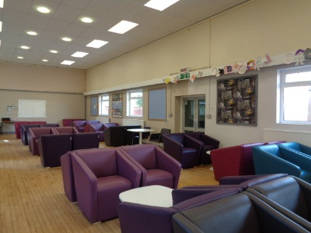 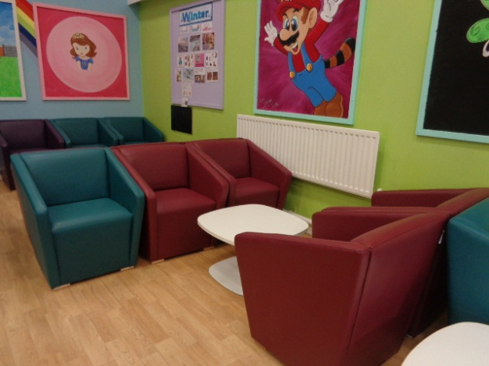

For prisoners who don’t receive regular social visits, the chaplaincy offers an official visitor scheme. Pact team run a group for those who may be socially isolated called Making Positive Connections.

**Kids Club**

Once a month, we have ‘Kid’s Club’ on a Saturday morning. This extended visit was designed following feedback from prisoners and their families. The idea behind Kid’s Club is that we focus on the children’s experience of visiting Sudbury. To improve their experience, we have designed this session for children and their carers over an extended period of two hours. We have the charity ‘Make Some Noise’ attending to run fun activities that encourage prisoners to break down barriers and play with their children, giving their carers a well-earned break. The visits are aimed at children under-12-year-old, but not exclusively, so that those attending know there’ll be lots of children of a similar age. We provide components for a simple breakfast so that the children can choose their food to prepare and eat with Dad/Uncle/Granddad etc. as a family. Families are not restricted to the number of children visiting, as such we have a cap on the overall numbers instead. Families can move around inside the visit’s hall and/or outside in the designated outdoor garden space during their visit, if weather allows, for a more natural experience for children, affording a greater sense of normality.



**FaSO days**

Sudbury offer FaSO days regularly throughout the year and have different themes which are highlighted on notice boards throughout the prison and on social media for families. During a FaSO day there are activities and toys available, and prisoners are actively encouraged to play with their children. Currently we have ‘Make Some Noise’ coming in to support our FaSO Days by providing music/drums/activities to encourage interactive play for families. Everyone is invited to eat a freely provided lunch together as the day runs from 10.00 – 15.00hrs.

FaSO days not only offer the opportunity for families to spend time together, but the visit also gives families the opportunity to talk to and meet staff such as the prison offender managers, initial point of contact Officers, Family Engagement Workers, Family Lead and professionals from other agencies. Prior to the visit, prisoners will have the opportunity to talk to staff about any concerns and prisoners can stay behind at the end for a debrief should they wish to do so. If a family member wishes to talk to a particular member of staff, they can ask a member of staff on the day, ring a contact number within this strategy, or email [**FaSO.Sudbury@justice.gov.uk**](mailto:FaSO.Sudbury@justice.gov.uk)**.** Visitors should note, Pact support is offered equally to both prisoners and their FaSO.

Photographs will be taken at FaSO day where consent is given. This is a vital part of the FaSO day as many family members treasure these photos, especially if they do not access regular social visits due to travel distance or other commitments. Prisoners are encouraged to apply whether they are accessing ROTLs or not, as we understand that it is a big commitment for many families to travel to the prison for the FaSO days.



**Video Calls**

Sudbury currently offer secure video calls on a Friday, Saturday, and Sunday. There are 10 sessions per day. Each slot is booked for a 30-minute visit and is freely available to all prisoners and their families or significant others. They can be booked by the prisoner submitting a General Application form to the Visits Co-ordinator or their family member can register online and book their own slots directly at www.prisonvideo.com. Video calls are held in the Legal Visits facility via the IO Phone Hub app. On Fridays at 18.30hrs we offer an hour-long session titled ‘Homework Club’ aimed specifically at prisoners wishing to support children with their homework. To support this session we have a bookcase full of curricula textbooks, stationery and reading books. Further books can be ordered through the library so that prisoners can aid learning and support reading skills.

Times are as follows:

09.00 – 09.30 09.45 – 10.15

10.30 – 11.00 14.00 – 14.30

14.45 – 15.15 15.30 – 16.00

17.00 – 17.30 17.45 – 18.15

18.30 – 19.00 (except on Fridays 18.30-19.30hrs - Homework Club)

19.15 – 19.45 (except on Fridays 18.30-19.30hrs - Homework Club)

*If times/days change we will inform prisoners and families.

**The Secret Diner**

Families and the general public can take advantage of Sudbury’s Secret Diner which offers a relaxing space and use of facilities including refreshments such as Costa coffee, at a reasonable price, before or after visits. The Secret Diner is beneficial to breaking down barriers for those who are anxious about visiting a prison as it allows for a more normal, relaxed environment. It is open to all members of the public and provides allocated work for prisoners who are developing qualifications in catering and barista skills.

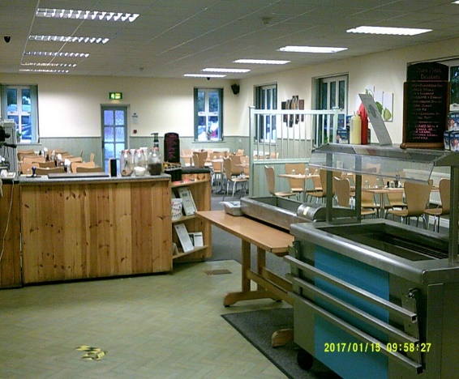 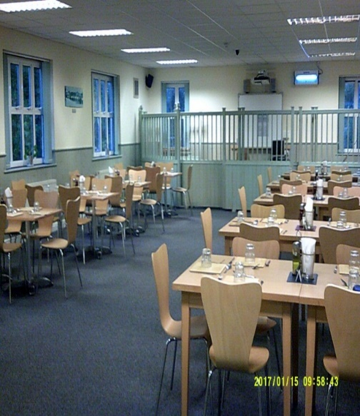

**Courses and family learning**

Family learning is very important in helping to reduce re-offending and in building prisoners and their families’ self-confidence. Prisoners who are given the opportunity to maintain healthy relationships can develop skills to improve the quality of these relationships during family learning. Helping families to build positive relationships will ultimately have positive outcomes for all involved and reduce the risk of intergenerational crime and other unintentional negative effects that imprisonment may cause. Pact have many courses available for prisoners to complete.

**Couples Release Planning**

This is a new initiative for prisoners who are working toward their first temporary release on licence to see their FaSO. Subject to risk assessment, this will be held in the Secret Diner as a neutral space for partners and prisoners to meet to talk about their upcoming release and what this means for them as a couple, or their friendship and/or family. This will be semi-structured to encourage communication with refreshments being provided. Pact staff will also be on hand to support the meeting.

**Our family literacy focus**

* To encourage reading within families, the library is currently offering a Share-a-Story project with the generous support of Give-a-Book. A selection of children’s books is available for prisoners to choose from. They keep a copy, and a copy is sent to their child for them to share over the phone in Homework Club or during other Video calls.
* For older children, the library stocks a selection of children and young adult books that prisoners can read at the same time as their children, to have a shared connection.
* A selection of free children’s books, kindly donated by visitors and the prison reading group are available in the Visits Waiting room for children to use, take and freely exchange to encourage reading and make children feel welcome.
* Toys are often donated in the Visits waiting room by families and these are used to replenish stock within the visits hall and to entertain children waiting to come in for their visit.
* Storybook Dads (a recording of the book being read by Dad/Uncle/brother/Granddad) is also offered by the library.

**Safeguarding**

The prison works as part of a multi-agency team to meet the needs of prisoners. Working as a team, we keep safeguarding as a priority. As this is an Open Category-D prison, this may be an ideal opportunity for prisoners and their families to access professional support and have their needs recognised by professionals. All safeguarding services have an ethos that is deeply based on working confidentially, with safeguarding children always at the forefront. All staff undertake safeguarding training and can signpost for advice. See **Annex B**

**Induction and support**

Sudbury work hard to involve family and significant others. When prisoners arrive at Sudbury, they are based on an Induction Dormitory. During their induction period they will have an induction talk on all the different functions of the prison, including Pact. They will be asked to provide an email address for their main FaSO contact. We will use this to send information about Sudbury and encourage families to get in touch to establish a line of communication, if happy to do so.

When prison staff have concerns that a prisoner is struggling to cope then they will use an ACCT document to ensure the appropriate support is offered consistently by staff on duty. An ACCT document is an individualised assessment for a prisoner experiencing low mood, poor mental health or at risk of self-harm and/or suicide. Family will only be informed and updated if requested and consent has been given by the prisoner. However, we will always encourage this as we know most families or significant others offer protective factors and are experts on their loved-one’s needs. Sudbury offer a Samaritan-trained ‘listener’ scheme which consists of prisoner volunteers and a Samaritan’s phone to access Samaritans directly, if the prisoner chooses to engage with them. This can be requested from safer custody or the residential team.

**Developing innovation and practice**

From feedback received from surveys, forums and other performance measurements, a live reducing reoffending action plan has been created and is reviewed monthly as part of the Reducing Re-Offending meeting. The Children and Families lead is open to all suggestions for initiatives or improvements and can be contacted via the [FaSO.Sudbury@justice.gov.uk](mailto:FaSO.Sudbury@justice.gov.uk) functional mailbox.

**Conclusion**

This strategy continues to evolve through feedback from prisoners, charities, families, and the support of key prison functions. We aim to leverage our Open environment to help prisoners prepare for release by fostering strong FaSO connections. By integrating the “golden thread” of family support throughout the prisoner’s journey, we can better equip both prisoners and their FaSO for a successful transition back into normal life. Providing the necessary tools for a positive start is essential for reducing reoffending and breaking the cycle of intergenerational offending. We firmly believe that this approach plays a critical role in unlocking prisoners’ potential.

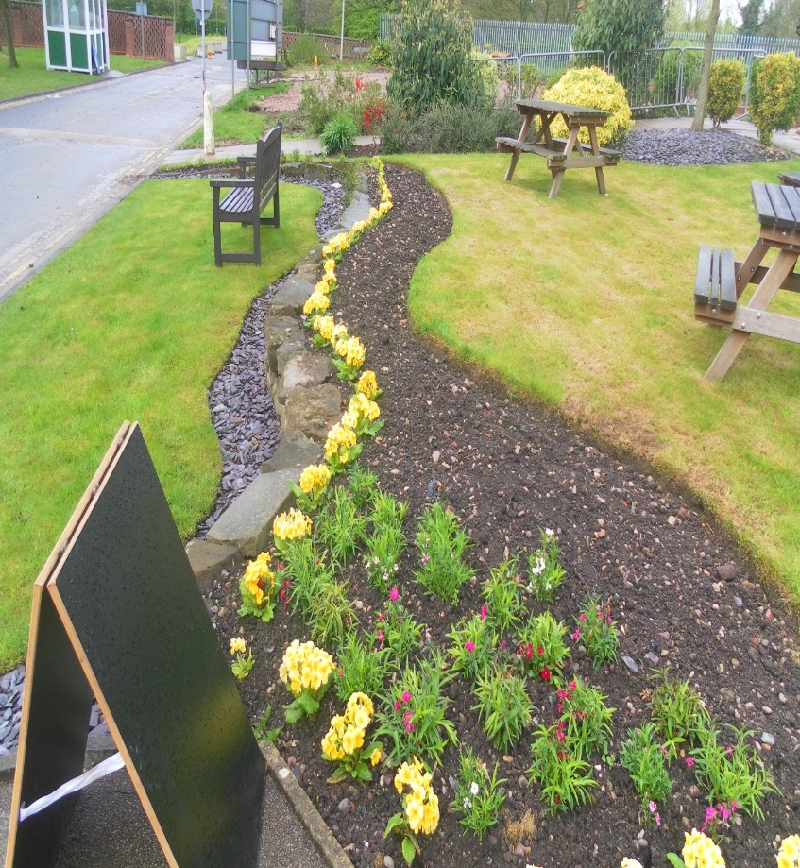

**Annex A**

If you require any advice or guidance in these areas, please email the relevant mailbox.

|  |  |  |
| --- | --- | --- |
| **Strategic Housing Specialist**  [PreReleaseTeam-Sudbury@justice.gov.uk](mailto:PreReleaseTeam-Sudbury@justice.gov.uk) | **Substance Misuse Team**  [DrugsTreatment.Sudbury@justice.gov.uk](mailto:DrugsTreatment.Sudbury@justice.gov.uk) | **Offender Management Unit**  [OMU.Sudbury@justice.gov.uk](mailto:OMU.Sudbury@justice.gov.uk) |
| **Head of Education, Skills & Work**  [Resettlement.Sudbury@justice.gov.uk](mailto:Resettlement.Sudbury@justice.gov.uk) | **Senior Probation Officer**  **Pre-release team**  [PreReleaseTeam-Sudbury@justice.gov.uk](mailto:PreReleaseTeam-Sudbury@justice.gov.uk) | PATHWAY 8  DOMESTIC ABUSE  Image result for domestic violence icons    **Senior Probation Officer**  **Pre-release team**  [PreReleaseTeam-Sudbury@justice.gov.uk](mailto:PreReleaseTeam-Sudbury@justice.gov.uk) |
| **Deputy Healthcare Manager**  [HealthcareSudbury@justice.gov.uk](mailto:HealthcareSudbury@justice.gov.uk) | **Head of Reducing Reoffending**  [FaSO.Sudbury@justice.gov.uk](mailto:FaSO.Sudbury@justice.gov.uk) | PATHWAY 9  SEX WORKERS  Image result for sex workers icons  **Senior Probation Officer**  **Pre-release team**  [PreReleaseTeam-Sudbury@justice.gov.uk](mailto:PreReleaseTeam-Sudbury@justice.gov.uk) |

**Useful contact numbers:**

Urgent Concerns - 01283 584000 and ask for the Orderly Officer (Direct line)

Safer Custody Hotline - 01283 584109 (answerphone; checked 4 times a day)

Family Engagement Worker – 01283 584134 (Direct line)

Drug Support Unit (SMS) - 01283 584181 (Direct line)

CM Corden – Families and Significant Others Custodial Manager - 01283 584000 (switchboard)

CM Torrington – Families and Significant Others Custodial Manager – 01283 584000 (switchboard)

Vicki McLean – Families and Significant Other Lead & Head of RRO - 01283 584000 (switchboard)

**Annex B**

**Adult safeguarding in prison – Referral process**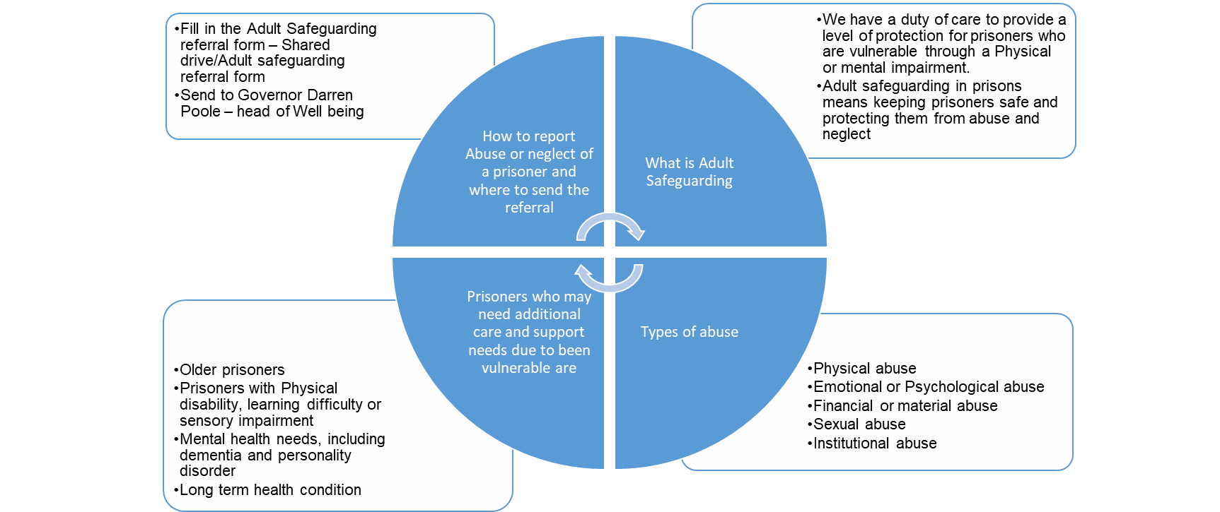

**Child safeguarding in prison – Referral process**

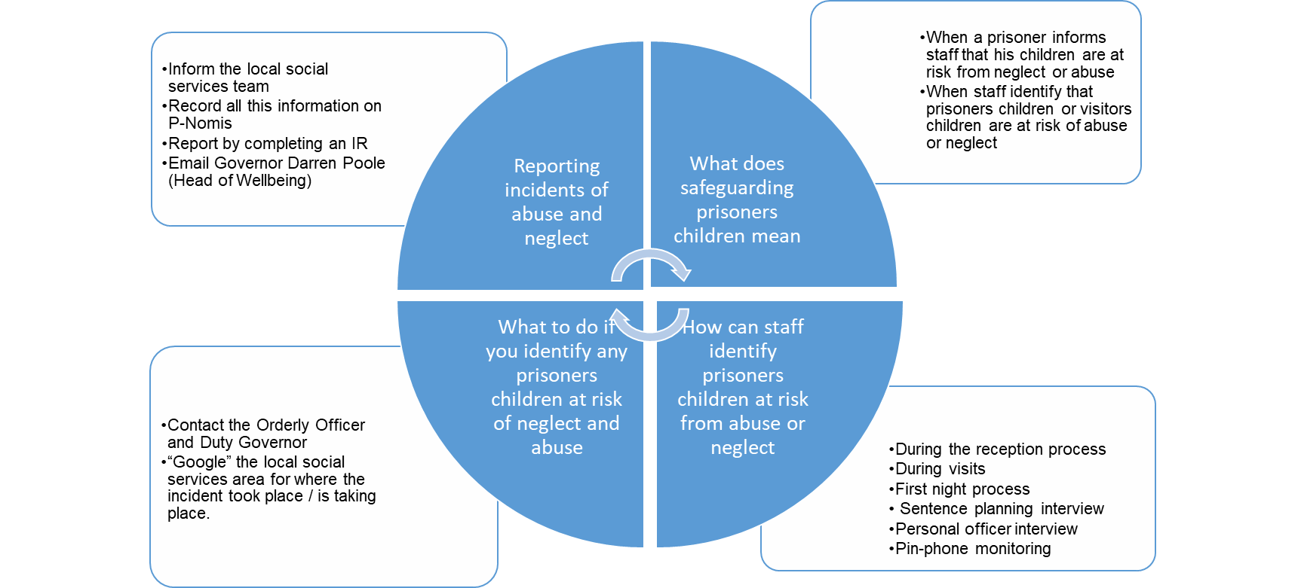

Equalities Analysis:

