

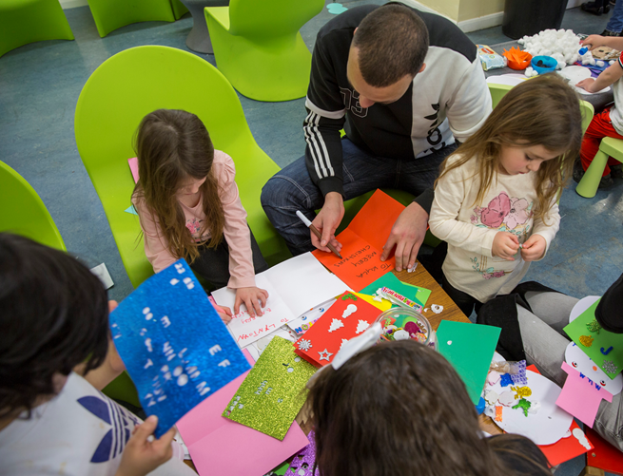
FAMILY AND SIGNIFICANT OTHERS STRATEGY

December 2024 to 2025
Governor Dom Ceglowski Signed

Director James Lucas Signed

INDEX

No: Page:

- Introduction 3

- Lord Farmers Report 4

- Coldingley’s Family Offer 4

- Visitor Centre and Domestic Visits 5

- Working in Partnership 6

- Contract Management 8

- Extended Visits and Family Learning 9

- Public protection 9

- Safer Custody 10

- Digital and Technology – Communications Systems 11

- Developing Best Practice 12

- Care Leavers 14

- Annex A 15

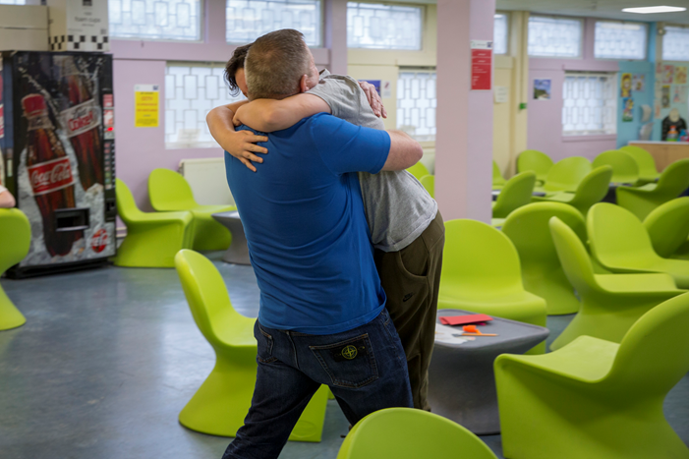

Introduction

- In August 2016 Lord Farmer published a report, The Importance of Strengthening Prisoners Family Ties to Prevent Re-offending and Reduce Intergenerational Crime. The report made 19 recommendations, which put family and significant others at the heart of prison reform. It advocates supporting efforts between prisoners and their families to improve relationships, and that ‘family should be the golden thread’ running through prison processes.

- This strategy has been developed as a result of Lord Farmers report, and it contains what Coldingley delivers currently, what we are striving to achieve going forwards and how we will measure our success and review our performance. This policy is a live and dynamic strategy that will evolve as we continue as a community to innovate and look at introducing the best of current practices from across the estate.

- HMP Coldingley is striving to develop a community whereby we all - staff, prisoners and their families - work with each other in partnership to help improve safety, reduce reoffending and reduce the risk of intergenerational crime. We will continue with this community based approach of working with prisoners, their families and third sector organisations to strive to develop our services even further; delivering first class work to assist prisoners to develop meaningful and constructive relationships with their family or significant other.

- HMP Coldingley is committed to providing the means for the men under our care to build and maintain positive relationships and strong family ties. Supporting family links is a key means by which we can prevent reoffending and reduce the likelihood of intergenerational crime.

- For the purpose of this strategy, Family is defined as either a blood relative, legal or significant persons that a prisoner identifies as their next of kin.

- For care-leavers this maybe someone that provides a statutory service, friend or associate. Many of those in custody will have experienced non- traditional upbringings, with a range of adults having cared for them, and similarly those in custody with children may have other arrangements outside of a traditional family arrangement. HMP Coldingley is committed to supporting all family arrangements where such provide a constructive and supportive relationship for the prisoner and family.

- HMP Coldingley does however recognise that not all family relationships are positive. Family members maybe either the direct or indirect victims of the prisoners offence, for example domestic abuse. These individuals have the right to be protected from the perpetrators and in cases, permission will be sought from the victim and any relevant partner agencies before any contact is made.
It is estimated that there are 200,000 children each year affected by parental imprisonment; as an establishment HMP Coldingley has a statutory duty to make arrangements to safeguard and promote the welfare of children, therefore contact must be in the best interest of the child.

Lord Farmers Report

- This strategy meets the requirements from Lord Farmers Report which gave nineteen recommendations that put family and significant others at the heart of prison reform.

- Lord Farmer spoke of a ‘local family offer’ recommending all establishments deliver and develop provision in the following areas, and that these are reflected in their local policy, and that the minimum should incorporate:

- Visitors’ waiting room.
- Staffing Structure - to ensure family work is an operational priority.
- Extended Visits – to enable supportive relationships to flourish.
- Family Learning – to equip prisoners to maintain and improve relationships.
- Gateway Communication System – to demonstrate how the establishment have responsive communication systems in place for families.

- The aim of this strategy is to encourage prisoners to maintain good relationships and re-establish ties with their family and friends in an environment that is safe and decent. Maintaining social contacts is a fundamental part of prisoner’s time in custody, and this contact is proven to assist both rehabilitation and reintegration into the community. Putting family at the core of our business as such Coldingley will achieve Lord Farmer’s objective by having our own Coldingley Family Offer.

Coldingley’s Family Offer

- Visitors waiting area and Domestic Visits
- Working in Partnership
- Contract Management (Pact)
- Extended Visits and Family Learning
- Safer Custody
- Digital and Technology - communication systems
- Developing Innovation and Best Practice
- Care Leavers

Visitors’ Centre and Domestic Visits

- The Visitors’ waiting area at HMP Coldingley is open from 8am and closes after visits are finished at 5pm.

- The current Coldingley Visitor waiting area is limited in terms of provision, affording a seated area, small play area and toilets and baby changing facility. It has been redecorated and the children’s area refreshed. There is water dispenser available.

As a means of improving our services here at Coldingley we will commit to the following:

- Hold two visitor surveys per year, these will be produced by both prison and Pact management, and the results and outcomes will be published for staff, prisoners and families.
- There will be a meet and greet table for departments to send representatives to meet visitors on allocated days.
- Run twice yearly ‘critical friend’ exercises. Staff not employed at Coldingley will walk through the visits process during a normal visits and feedback so we can embed best practice and address any identified weaknesses. Dates for October May 2023 and Sept 2023.
- Establish a prisoner focus group; allowing ideas and suggestions to be made regarding prisoners perception of visits and improvements they would like to be made to enhance the family experience. This focus group will also look at all current work streams that relate to strengthening family bonds.

Domestic visits take place at the following times:

Days | Times
Monday | 14:00 to 16:00
Tuesday | No Visits
Wednesday | 14:00 to 16:00
Thursday | 14:00 to 16:00
Friday | 14:00 to 16:00
Sat PM | 14:00 to 16:00
Sun AM | 09.00 to 11.00
Sun PM | 14:00 to 16:00

- It is recognised that there are difficulties when visiting a prison; with visiting often involving a great deal of time, effort, and expense. Visiting can be an emotional experience, both positively and negatively; for example, families enjoying seeing their loved one, but due to the length of visits saying ‘goodbye’ can be distressing. Visits can be particularly difficult for children, with our necessary processes and rules often confusing. This is compounded by long journeys, sometimes on public transport that interrupt dinner and bedtime routines; this can leave children tired, irritable and sometimes confused, which can impact on their performance at school the next day. Stigma for the children of prisoners can be manifested in being bullied by classmates in school. Longer term, the children of prisoners are three times more likely to engage in anti-social behaviour or offending behaviour than their peers who do not have a parent in prison.

- To reduce some of these issues we will invest in staff awareness and continue to do our utmost to make visiting Coldingley a more positive experience.

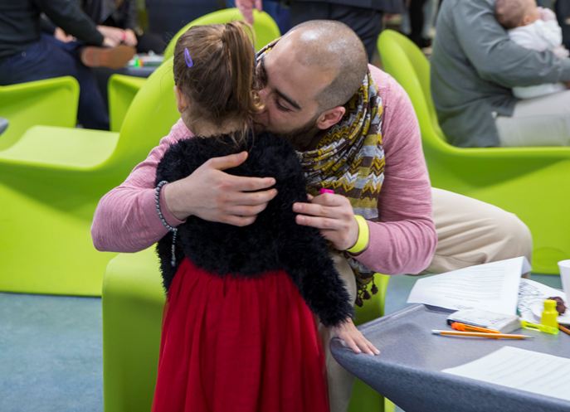

Working in Partnership

- In order to provide the very best service we can here at Coldingley we will continue to work with all departments within the prison, service providers, prisoners’ families and significant others.
- Pact (Prison Advice and Care Trust) now deliver family services at Coldingley and they continue to give support to families and significant others. The PACT team, operating in close partnership with operational staff at Coldingley, offer first class services these include:
- Family Days (Children, Toddler, Adult and Lifer Days), 12 days per year.
- Supervised Play
- Family Room
- AL-NON and other fellowship meetings, family support services from the Forward trust
- PACT Caseworker
- Monthly partnership meetings are held to look at the work that has been completed during the month, address any issues, plan for the coming weeks and discuss ways to innovate and improve services. In addition, quarterly contract meetings are held in order to monitor targets and service delivery agreements.
- The Coldingley partnership between Pact and the Family lead are excited to be looking at expanding what can be delivered; several innovations are being investigated, and whilst some maybe aspirational at this stage, it evidences our commitment to being a field leader, these include:
- Expand children-based theme visits, with fun academic learning and bonding activities.
- In-cell packs, additional themed workshops relating Father’s Day, world book day, etc
- In addition to Pact, we also use emailaprisoner.com, prisoner voicemail, Storybook Dads.
- Working with local MASH ( Multi-agency safeguarding hubs) to raise any concerns relating to prisoners and families.

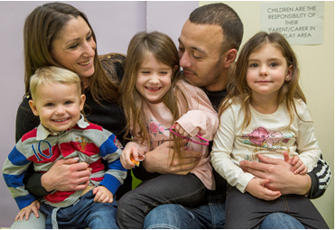
Contract Management

- The Joint heads of operations are the Lead for the family and significant others and the operations SO overseas visits in particular family days.

- Contract management meetings with our service provider Pact will take place quarterly. As cited above they are held to review contract and service delivery, any operational issues, discuss best practice that could be introduced at Coldingley and review how we are attaining the standards that Lord Farmer has made clear.
- Local partnership meeting with PACT to be held monthly, to measure trends and outcomes for the family strategy.
- There is a Memorandum of Understanding in addition to the contract between the prison and Pact, and Pact representatives attend Coldingley Resettlement Meeting, IRMM and Safer Custody meeting.
- Visitor surveys and prisoner forums are an excellent way of measuring our success, and this will be strengthened by managers attending the monthly meet and greet events in the Visitor Centre.
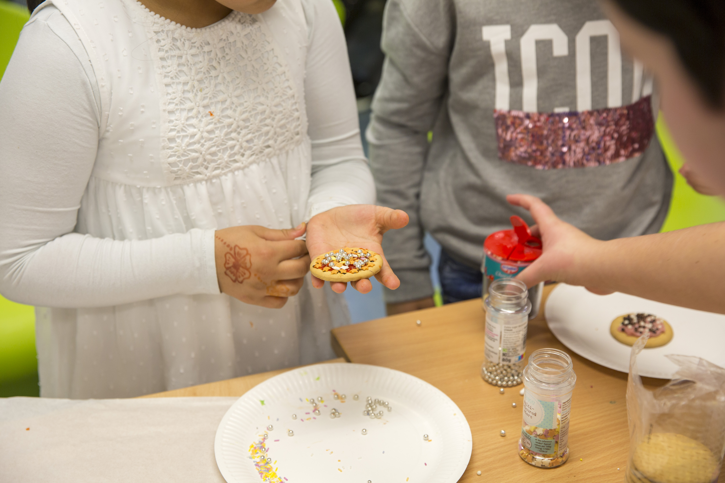

Extended Visits and Family Learning

Coldingley runs at present 12 family days, in 2025 these comprised of:

- 7 Children’s Days
- 3 Lifer/IPP Days
- 1 indeterminate sentence 10 yrs. +
- 1 Adult/Teenager Day

- The format and length of the days has recently changed, and now run from 10:30 to 15:30. Children days are broken down into distinct sections to allow optimum engagement, fun and bonding. A period is spent in the visits hall where interactive games and arts and crafts are available, and a period is spent in the gymnasium where fathers and their children play ‘potted sports’ with a certificate presented to all. An informal buffet lunch is provided, and photographs are taken to commemorate the day.

- Children days are scheduled during the holidays and are themed, Easter, Halloween and Christmas for example. It is hoped that going forwards funding can be secured to involve other organisations to assist in making the Family Day even better, such as inviting the Science Museum, local professional sports clubs etc to add the day’s activities, providing learning, quality family time and creating positive new memories.

- There is a team of Officers who work closely with Pact in helping organise and supervise the Family Days. The team is dynamic and meet regularly to ensure that the Family Days are safe, decent, and secure; the means of improving and innovating Family Days are also discussed.


Safer Custody

- It is important to ensure that all family and significant other details are recorded on reception into HMP Coldingley; equally, it is important that Key Workers ensure that these details are kept up to date. Key workers will ensure that NOMIS is accurate in regard to this information at least twice a year during their contact meetings; management checks will confirm this work is being delivered.

- There are some prisoners in our community who do not have family or significant others, and as a result do not have visits or contact with the outside. These individuals are at risk of becoming isolated, and it is critical that these individuals are identified and then made known to the family support worker in Pact, OMU and to the Safer Custody team. In addition to Pact, discussions will take place with the Chaplaincy team to establish if the individual could engage with an Official Prison Visitor. New bridge foundation.

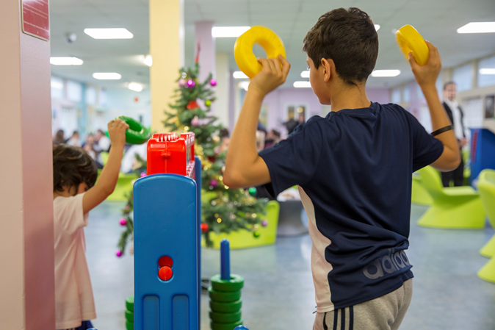

- It is so important to try and engage with families and significant others when their loved ones are in crisis this can be achieved with the help of Pact and consent of the individual prisoner.

- When prisoners are in crisis, they find it hard at times to talk to loved ones and engage with family and significant others within an Assessment Care in Custody Teamwork (ACCT) document review. By agreeing with us and when required we would like to invite a family or significant others to attend these reviews it can be a positive tool in which you can show your support to your loved one’s it will assist with this process and help keep everyone safe.

- The Family Engagement Worker will be encouraged to attend all ACCT reviews were applicable by the case manager.

Public Protection and Measures
- It is our duty to raise any public protection issues with other agencies, relating to safeguarding any individual that lives or is visiting HMP Coldingley.
- The reporting process is documented in our adult safeguarding policy and visits policy.
- All staff must complete the online training regarding safeguarding.
- Senior officers brief all staff prior to the commencement of visits including any safeguarding concerns,

Digital and Technology – Communication systems

In an emergency
Call 01483 344 300 if you think a prisoner is at immediate risk of harm. Ask for the Orderly Officer and explain that your concern is an emergency.

- There may be times when families or significant others feel that their loved one may be in trouble or is just not them self; maybe they are acting out of character. If you ever feel this may be the case than share your concern with us we are here to help. There is a dedicated safer custody emergency line which is checked at various times each and every day to ensure that any messages left are dealt with immediately. So you can feel confident that we are here and will listen.

- Video calling, which is booked locally by prisoners or families, which are limited to one call per month, this is currently.

- HMP Coldingley Dedicated Confidential Number is: 0800 496 1475.

- If you are concerned about a loved one for any reason don’t let him suffer in silence we are here to help call the number above and we will assist and look after him.

- There is an additional gateway to communication and a direct line to Pact for families and significant others to contact the prison during the working day in relation to family matters or advice, this number is for you to talk to staff if you are concerned about self-harm or the mental health of your loved ones.

- Pact Prisoners’ Families Helpline: 0808 808 2003 Opening times 10:00 to 1700 Monday to Friday

- At Coldingley we currently have the following technological services which help to maintain contact with families and significant others:

- E-mail a Prisoner: www.emailaprisoner.com.
- Prison voicemail: www.prisonvoicemail.com
- Storybook Dads
- HMP Coldingley twitter account

- We also want both visitors and prisoners as service users to feed into how we can innovate using technology, and we will welcome suggestions through surveys, forums and meet and greet sessions.

- In order to better understand the needs of our population we monitor the number of calls that are made, we review when and how often wing based telephony is used; this data will be interrogated in Family Strategy Meetings.

- We will continue to monitor the booking system for visits and understand how this is received by visitors to the prison. It is important to support anyone who is identified as not being able to use technology and offer support; this could be due to poor literacy, not familiar or comfortable with technology etc. We will be introducing a dedicated helpline to assist soon.

- Data will be collated, analysed and published on a quarterly basis and this will help inform our strategy; the following will be reviewed:

- Number of failed visits per quarter
- Number of family visits held and the numbers who did not arrive.
- The usage of use for E-mail a prisoner.
- The usage of Prison Voicemail
- The use of Prison Visitors

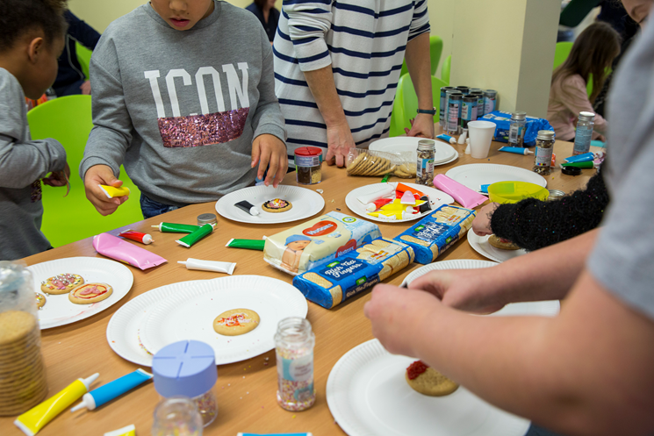

Developing Best Practice

- As part of informing this strategy a meeting was held with a number of key stakeholders, with Senior Managers from Prison Services, Resettlement, National Probation Services, OMU, Healthcare, Substance Misuse Services, the Library and Pact all in attendance. This is held on the third Tuesday of each month, called the family pathway meeting.

- This meeting is focused on Coldingley’s vision and aspiration of becoming a site of best practice with fully integrated family services, and all departments actively and knowingly contributing to putting families at the heart of our business.

- We will hold regular monthly meetings with these stakeholders to discuss progress and measure our success.

- We will aim to hold surgeries to provide more family engagement and give information on the IPP sentence for families of prisoners subject to this sentence.

- In the short to medium term, we want to deliver the following:

- Making better use of the visitors’ waiting room and visits hall by:

- Having third sector organisations on hand in the Visitors’ Centre that can offer support to family members who themselves may have substance or alcohol misuse issues.

- Hold pre-release visits when required to provide families with support and information on the continuing journey to stopping recidivism.

- Ensure that family and significant others are invited and included where possible in our review processes: ACCT, Substance Misuse Case Conferences and other multi-disciplinary meetings.

- Identify those that are isolated and encourage engagement with Pact and the Prison Visitor Scheme.

- Through Key Workers, NPS and OMU identify dysfunctional family relationships and incorporate this into sentence planning; also to review all known passes made on visits to see how influential these individuals are in the prisoner’s life.

- PACT Group work in a suitable environment.

- Family room, that is away from the visits hall and decorated and furnished in a child friendly fashion to enable whole family working.

- As stated at the start of this document, this is a live and dynamic strategy, that will be reviewed at each quarterly meeting, and where we identify new ways of innovating and achieving results these will be incorporated into this document.

Care Leavers

- At Coldingley we identify Care Leavers through initial Reception, NOMIS, and Key Worker interviews.

- Transition to adulthood is a difficult time for many young people, but it can be especially so for young adults who have been in care. Unlike many young people, care leavers often do not have the emotional, financial and personal support of parents and other family members.


- When compared to the general population care leavers are less likely to be in education, employment or training. Over a third of 19-year-old care leavers are not in education, employment or training; more likely to be attempting to live independently; and more likely to have a criminal conviction. Care leavers have been estimated to make up 27% of the adult prison population, despite the fact that less than 1% of under 18s enter local authority care annually.

- Any prisoner aged between 21-25 years of age who have been in the care of the local authority (Care leavers) is entitled to a personal advisor support from the local authority and anyone who requires this can obtain the information from Pact or Safer Custody Department who will be happy to contact the Local Authority. We will ensure that anyone who is a care leaver will be offered the support from the local authority.

- Young care leavers may face particular obstacles in desisting from offending and making an effective transition to adulthood.

Annex A
Available support/information for Children and families and professionals working with them

- Pact (Prison Advice and Care Trust) www.prisonadvice.org.uk
A national charity that provides support to prisoners, people with convictions and their families through a range of services, including a national helpline, digital information services, casework, play, groupwork, mentoring and befriending programmes.

- Pact Prisoners’ Families Helpline: 0808 808 2003

- Family Lives www.familylives.org.uk
A national family support charity providing help and support in all aspects of family life.

- AFFECT – AFFECT provides services for the families of serious offenders and offers support groups to families in the south of England. www.affect.org.uk

- Inside Time – www.insidetime.org.uk – this website gives visiting and other advice

- Prisoners’ Family Voices is a web-based community which gives family members the opportunity to talk to each other.
http://prisonersfamiliesvoices.blogspot.com

- Offenders’ Families Helpline 0808 808 2003 info@prisonersfamilieshelpline.org.uk
www.prisonersfamilieshelpline.org.uk

- Prisoners’ Families and Friends Service 0808 808 2003 info@pffs.org.uk
www.pffs.org.uk

- SHARP (Support Help and Advice for Relatives of Prisoners) 01743 245365 for free

- Prison voicemail prisonvoicemail.com

- NICCO National Information Centre on Children of Offenders is a one-stop information and advice service to support all professionals (working with children and families of prisoners) and all families of prisoners, bringing together useful information in one place.
www.nicco.org.uk

- HMP Coldingley 01483344300

Acknowledgements:
All images: Copyright Pact/Andy Aitchison

