

HMP/YOI Bedford

Families & Significant Others

Strategy 2025/26



Document Summary

Author(s) | Joshua Grange, Activities CM
Date | April 2025
Version | 1:1
Status | Complete

Document Review & Approval to be reviewed annually

Reviewed by | Position | Date

Date | Author | Amendment Summary
Document Amendment Details



Families and Significant Others play a critical role in supporting prisoners; positive relationships have been identified as a protective factor in keeping prisoners safe and well and in desistance from crime. For this reason, we are promoting strong families and significant others ties as an important aspect of prison reform. We also recognise that prisoners who did not receive regular visits are disproportionately more likely to engage in self harm and violence, so we are making efforts to engage this group in social activities using the visits facilities and resources.
Our strategy outlines the key actions we will take, working with our partners, to maintain and encourage positive family and significant other ties.

Our strategy includes the Equality Act 2010 protected characteristics and is aligned to the Ministry of Justice’s Outcome Delivery Plan and HMPPS Business Strategy, as it will help to improve the safety and security of our prison, reduce reoffending and ultimately protect the public. It is dynamic and will be reviewed on a regular basis to ensure it remains effective as we look after and prepare our prisoners for life on release.

In developing this strategy, we have been mindful of the Prison Reform White Paper, ‘Public protection, Safety and Order, Reform and Preparing for life after prison, The Farmer Report 2017, The Lammy Review 2017 and HM Inspectorate’s Expectations.

This strategy provides clarity and direction and takes account of the views of our partners, especially those of our prisoners and the people who care about them.

S Bott
Governor

Introduction

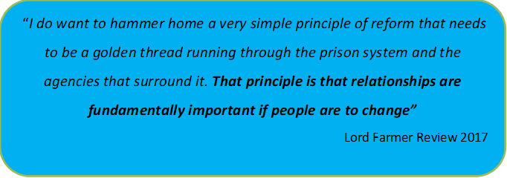

HMP/YOI Bedford and all those who form part of our prison team, have a part to play to provide prisoners with the opportunity to change. The Families and Significant Others Strategy (FaSO) underpins the approach within our establishment. Therefore, you are urged and encouraged to read this strategy, understand how it works, and to apply it appropriately throughout your work.

This strategy has been developed with Prisoner’s and Families at its core and relates directly to the Lord Farmer Recommendations. The FaSO strategy is supported by the 7 Reducing Reoffending Pathways, which in isolation, or collaboratively, provide a sound framework of support during a prisoner’s time in custody. The aim of the strategy is to provide prisoners with the opportunity to build, support and maintain strong family ties to reduce reoffending and reduce offending.

Aim:

We will provide a strategy enabling positive outcomes and interactions for children and families with individuals in our care, by enabling support for individuals’ relationships outside the prison to help prevent reoffending. We will offer an improved range of interventions at HMP/YOI Bedford to improve family ties. This approach aligns itself with the Joint Thematic Review by Ofsted and HMIP (2014) which concluded, ‘An offender’s family or significant other are the most effective resettlement agency’.

Outcomes:

The Head of Reducing Reoffending will drive a whole prison approach to look at achieving the following outcomes because of delivering this strategy:

Promoting and developing family support and maintaining family ties will be used as a key tool to improve the outcomes for all prisoners.

This policy supports the maintenance and development of prisoners’ relationships with family, significant others, and friends, by using a range of methods and interventions. Supporting prisoners’ relationships outside of prison is considered to help prevent reoffending and reduce intergenerational crime. Prisoners, their family and significant others, all internal and external staff, and service providers are encouraged to work in partnership and share good practice, to enhance opportunities for prisoners to develop or enhance positive relationships:

• The skills and abilities they need to make real choices about their
future
• The motivation to make positive choices rather than negative ones
• Links with close social structures to support improvement in outcomes
such as employment, education etc., that enable them to make use of
those choices

Developing positive staff-prisoner relationships and the recognition of the importance of how important families and significant others can be in influencing prisoners and supporting a life of desistance will be used as a key tool with which to reach out to all prisoners.

We understand the complex nature of family relationships from those families who are in our custody. Experiences are mixed and complex, and no families’ experiences are the same. Staff, Prisoners and Family members should all recognise that family experiences are not always positive and rewarding but can be negative or traumatic. Every family is different. Staff, Invisible Walls and Key Stakeholders will make every available effort to engage with prisoners in a way that offers them an opportunity to fully engage in all aspects of prison life. This will help to develop a sense of community within HMPYOI Bedford as well as maintain a safe and secure environment for all.

Lord Farmer Report

The Importance of Strengthening Prisoners’ Family Ties to Prevent Re-offending and Reduce Intergenerational Crime
https://www.gov.uk/government/uploads/system/uploads/attachment_data/file/642244/farmer-review-report.pdf

The Farmer report was published on 10 August 2017 and made 19 Recommendations that put family and significant others at the heart of prison reform. It supports efforts to improve the relationships between prisoners and their families or significant others and the services that are provided.

According to the Lord Farmer report, ‘Family should be the ‘golden thread’ running through the processes of all prisons, as well as in the implementation of standards presented in the Prison Reform White Paper - Public protection, Safety and Order, Reform and Preparing for life after prison.
Lord Farmer’s report referred to a ‘local family offer’ recommending that all establishments deliver and develop provision in the following areas and that these are reflected in their local strategies which should be a minimum offer:
- Visitor Centre/Visitor Reception Services
- Staffing structure to ensure family work represents as an operational priority.
- Extended Visits
- Family Learning – to equip prisoners to maintain and improve relationships.
- “Gateway” communications system – to demonstrate how the establishment have responsive communication systems in place for families.

Future Visit’s Improvement Plans
- To maintain regular Family and Significant other forums. This will give you an opportunity to speak directly with a member of the Senior Management Team.
- To improve facilities for children within the visit’s hall and the visitors’ centre. Reinvesting profits from the Café, maintaining and updating regularly Activities, and toys offered.
- We will invite Families into the prison to celebrate positive event, such as, passing a specific course, becoming a graduate, for example, STRIDE and ZMT Graduations.
- We will form a Calendar of events incorporating Children dedicated visits. As well as those that do not have family of significant others that can attend visits, including those from a Care leaver, Veterans in custody, or foreign national background without family in the UK.
- We will develop our Safeguarding concerns, equip our staff, and ensure key working forms an essential part of our strategy.
- To help create a more relaxing environment during Children and all day Family visits. To Review dedicated Family teams supporting Visits.
- Dedicated Breastfeeding area on Table 6. With Maternity bags and clothes provided. Review the Baby changing area also to provide better support.
- Wellbeing Groups to support those in Vulnerable key areas, Care Experienced, Foreign Nationals, as well as those whom may not be able to receive a visit from Family or significant others.
- Work to commence the Invisible Walls Schoolzone project which includes training sessions at HMP Bedford for teachers from local schools. These sessions aim to raise awareness of the effect of imprisonment on children and families, help teachers to identify children who may be affected and provides resources that teachers can use when working with these children. Those attending this training will experience the whole visit process which gives them an understanding of what it is like for children when visiting a prison.
- Additional Interim Family Forums to take place between the Quarterly SMT set. Advertised in advance so all families can see Prior.
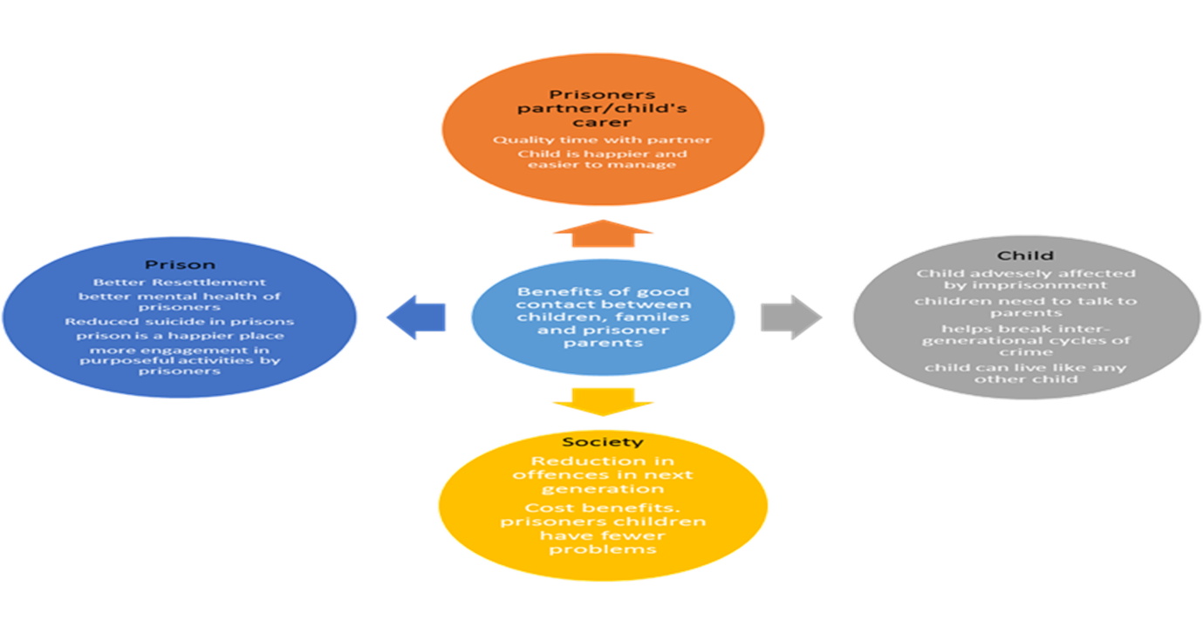
How to Contact us:
Address:
HMP/YOI Bedford, St Loyes Street, Bedford, MK401HG
General Phone Number:
01234 373000
Visits Booking Line (Social/Video Visits)
0345 646 2277

We are also on Twitter

Twitter Account @HMPBedford
About HMP/YOI Bedford:
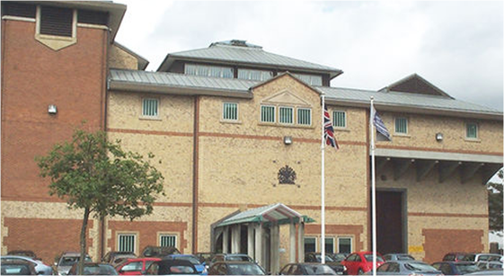
Brief History: HMP Bedford is a category B reception and resettlement prison for young adult and adult men. It has stood on its current site in the centre of Bedford since the early 19th century. It was enlarged in 1849 and in the early 1990s a new gate lodge, house block and health care centre were added. It mainly accepts prisoners from the local crown and magistrates’ courts.

HMP Bedford Families Provider:
The families provider for HMP Bedford is “Invisible Walls”. The team provide a warm welcome in our visitors centre as well as staffing the Café and Children’s play area. The IW Team also provide a wide range of interventions to the prisoners. They can be e-mailed directly on invisiblewallsbedford@uk.g4s.com.

The visits Café provides hot and cold drinks and snacks. All profits made from the Café is fed back into the families provision to provide extra Family visits during the year, updating the children’s play area and other services relevant to enhancing the family experience.

Getting to Bedford Prison:

HMP/YOI Bedford is a Category B Local Prison situated in Bedford town centre on St Loyes Street.
Find Bedford Prison on a map
Bedford railway station is a 15-minute walk, or taxis are available at the station. The bus station is a 3-minute walk.

To plan your journey by public transport:
- use National Rail Enquiries
- use Traveline for local bus times
There is no visitor car parking available at Bedford Prison. There are car parks in the town centre a short walk away.
There is disabled access to the visitor’s centre and the prison. If possible, please let staff know of any additional needs before you arrive.

Your Visit:

You can book your visit by telephone. There is also online booking visit service Visit someone in prison - GOV.UK
Social Visit Booking line: 0345 646 2277
Monday to Friday, 9am to 12.30pm

Email: socialvisits.bedford@justice.gov.uk
Try to give at least 2 working days’ notice when booking a visit.

Visit Days

Wednesday & Thursday 14:15 to 15:45

Saturday & Sunday 14.15 to 15:45

Family Visit Days

Family visit days will take place every 1 months at HMP/YOI Bedford as part of the prisons’ FaSO strategy and wider reducing reoffending strategy. They are designed to help prisoners and their families cope with the pressures that long term separation may have on the relationships between family units in particular the relationship between the children and their father. They will give a better quality of interaction between prisoners and their children. To help develop closer bonds with their children and help realise how criminality impacts upon them both.

PRISONER ELIGIBILITY.

In order to ensure that prisoners and their families are able to enjoy the day in a relaxed atmosphere there is a criteria that the prisoners must meet, this will be made to clear to them on their application.
VISITOR ELIGIBILITY.

The relaxed regime of family visit days will allow prisoners to develop and maintain closer relationships with their children, grandchildren or nieces / nephews. There must be a credible relationship to the child/children; however, each application will be judged on its own individual merit. That said the children of prisoners will always be given priority. Therefore, all prisoners attending the family visit day should have children visit otherwise there is no difference to a normal social visit. The visitors visiting with children should be:

- Wife.
- Mother of Prisoners’ children.
- Mother / Father.
- Stepfather / Mother.
- Brother / Sister.
- Legal guardian.
- Court appointed appropriate adult.
- Social worker.

One adult and any number of children under the age of 18 can attend a Family Visit. Each visit table can hold a maximum of 5 people All under 18-year-olds, are classed at children.
Entering Bedford Prison
All visitors, of any age must prove their identity before entering the prison. Read the list of acceptable forms of ID for all visitors..
When you arrive at Bedford Prison, you will need to check in at the visitors’ centre. There are strict controls on what you can take into Bedford Prison. You will have to leave most of the things you have with you in a locker (you need a £1 coin) or with security. This includes pushchairs and car seats.
Once inside the gate area you will be searched by a member of staff. There will also be a sniffer dog. You will be asked again if you are carrying any unauthorised articles before you enter the visits hall.
Visitors should dress sensibly. You may be turned away if you are wearing items like vests, low-cut tops, high-cut shorts or dresses, or clothing with offensive slogans.
You will be told the rules by an officer at the start of your visit. If you break the rules, your visit could be cancelled, and you could be banned from visiting again.

APPLICATION TO ATTEND.

Prisoners can apply to Invisible Walls Families provider via application to take part in a planned family visit day. They will receive a response approximately 2 weeks prior to the event. All applications must contain the following information:

- Names, addresses and phone numbers of all adults.
- Relationship to the prisoner.
- Names and addresses of all children.
- Relationship to the prisoner.

TIMINGS

Family visit days run from approximately 10:00 hours to 15:00 hours

ACTIVITIES.

“Invisible Walls” will provide a range of fun family-based activities throughout the day allowing prisoners and their loved ones to create fun pieces of art that can be kept as a memento.

HMP/YOI Bedford is providing secure video calls within the prison. This will ensure family relationships and ties are maintained. The current cost to the prisoners is free, however, they are limited to once a month.

- Each prisoner can have up to 4 people on the call. All persons must be at the same location and the call will commence on one device. The age of the main registered caller must be over 18 years.

- Video calls will start promptly at the allocated time.

- Video Call will last for 30 minutes.

Calls are monitored for safeguarding purposes and possible intelligence.

PROCESS OF ORGANISING A VIDEO CALL

- Family members and friends need to download the Prison Video app from Google Play or Apple Store, create an account in the app. You are then required to verify your identity and the identity of any additional people who want to be on the account. Details of the prisoner you want to have a video call with are also required.
- The family member or friend approves (or rejects) the arranged video call using the Purple Visits app once notified.
- If the video call is accepted, the status of the video call is updated on Purple Visits Web portal to ‘approved calls’. Prison staff will be notified.
- If any unauthorised person enters the Video call, it will be automatically terminated at source, this will be the same principle for any illicit behaviour.

EMERGENCY CONTACT
If you have a concern that there is an imminent risk of danger to a person in our care and you wish to speak to a member of staff to raise this concern, then you can call the switchboard:
01234 373000
The member of staff answering the phone will not be able to discuss the prisoner in our care; however, they will immediately pass your concern onto a senior member of staff to action. We aim to address any issues raised on the call immediately and will let you know what the outcome is.

If you are concerned about the safety or wellbeing of any person in our care at HMP/YOI Bedford but there is no immediate threat or danger, then you can leave a message for the Safer Custody Team on:
01234 373069
This service is checked numerous times a day and any concerns raised will be followed up by a member of our safety Team.
Staff Structure:
Our staff structure demonstrates HMP/YOI Bedford’s commitment to ensuring that Family ties are maintained and utilised to their full extent. HMP/YOI Bedford’s Senior Leadership Team have nominated a specific person to coordinate the FaSO policy, along with a Custodial Manager (CM) who will act as the Single Point of Contact (SPOC) for the FaSO Policy.

The Pathway lead & owner for the Families & Significant Others Strategy is Governor Susan Brady, who is also the Head of Reducing Reoffending. Joshua Grange is the Custodial Manager and SPOC for the FaSO policy.
Reducing Reoffending Pathways:
Reducing Reoffending has seven pathways that contribute to achieving the key principles that underpin this strategy. The following describes some of the work currently undertaken to support prisoners in achieving better outcomes in relation to contact with families and significant others.
Our partners from the Probation Resettlement Team, Prison Offender Managers, Community Offender Mangers, and community partners work collaboratively to support those being released to their families or the care of significant others.
We work with a whole range of partners to deliver our commitment to providing relevant and meaningful education, training, and employment opportunities for prisoners in our care. We recognise the value in supporting academic, practical and personal development which contribute to securing employment, increasing self-worth and the personal confidence of individuals. Such shifts in motivation and successful outcomes contribute to developing and securing improved relationships.
We have a fully integrated healthcare provision, that provides clinics for prisoners that are the same equivalent to those experienced in the community.
Our Integrated Substance Misuse and Mental Health Service is provided by our partners Supporting Change. They have good links with corporate carers, the local authorities and are working to make contact with families and significant others to support prisoners with their recovery, offer reassurance and support to prisoners and their families and provide clinical advice and guidance where necessary.
Our Resettlement partners have trained caseworkers that provide support, advice and guidance regarding finance, benefits and issues relating to debt. HMP Bedford will recruit its own Finance, Benefit & Debt person to enhance the service already provided. Where necessary, or appropriate, contact will be made with families and significant others to further support the prisoner’s transition from custody to the community.
The purpose of Lord Farmer’s review was in recognition of this pathway and the very reason as to why we have been asked to create a strategy. We have partners who will be working with prisoners to help develop their parenting skills and act as independent advocates where necessary, to help mend broken relationships and work together to secure more positive relationships moving forwards. As part of our strategy, we will be securing additional partners and expertise to help and support Bedford with developing this further. This is something we have identified as a priority.

There are specific modules within accredited interventions that focus primarily on the development of positive relationships and allow the prisoner to develop skills to recognise the value of meaningful relationships and how to maintain these in order to achieve his pro social goals and aspirations.

Support and Information for Children, Families and Significant Others Affected by Imprisonment and Professionals working with them
- AFFECT – AFFECT provides services for the families of serious prisoners and offers support groups to families in the south of England. www.affect.org.uk

- Assisted Prison Visits Unit (APVU) – help with the cost of prison visits https://www.gov.uk/help-with-prison-visits

- Barnardo’s - www.barnardos.org.uk

- Family Lives www.familylives.org.uk– Family lives, works for the benefit of prisoners' and prisoners' families by representing the views of families and those who work with them. The Prisoners Families Helpline will be open Monday - Friday, 9.00 am to 8.00 pm, and Sat-Sun from 10.00 am to 3.00 pm. The website will be available 24 hours a day, seven days a week. Families calling outside helpline hours will be provided with Family Lives' helpline - 0808 800 2222

- Families Outside www.familiesoutside.org.uk 0800 254 0088 the free helpline is an independent support service for families and friends affected by imprisonment. They aim to help with any questions or concerns you may have.

- Email a Prisoner - www.emailaprisoner.com

- Inside Time – https://insidetime.org– this website gives visiting and other advice.

- NICCO National Information Centre on Children of Prisoners is a one-stop information and advice service to support all professionals (working with children and families of prisoners) and all families of prisoners, bringing together useful information in one place. www.nicco.org.uk

- Pact (Prison Advice and Care Trust) – www.prisonadvice.org.uk A national charity that provides support to prisoners, people with convictions and their families through a range of services, including a national helpline, digital information services, casework, play, group work, mentoring and befriending programmes. (Pact Prisoners’ Families Helpline: 0808 808 3444)

- POPS - www.partnersofprisoners.co.uk they aim to provide a variety of services to support anyone who has a link with someone in prison, prisoners and other agencies. POPS provides assistance to these groups for the purpose of enabling them to cope with the stress of arrest, sentence, imprisonment and release.
- Prisoners’ Family Voices is a web-based community which gives family members the opportunity to talk to each other. http://prisonersfamiliesvoices.blogspot.com

- Prison voicemail – www.prisonvoicemail.com

- Prisoners’ Families Helpline 0808 808 2003 info@prisonersfamilieshelpline.org.uk
  - www.prisonersfamilieshelpline.org.uk The National Prisoners’ Families Helpline can support you if a family member is in contact with the criminal justice system. They provide advice and information on all aspects from what happens on arrest, visiting a prison to preparing for release.

- SHARP (Support Help and Advice for Relatives of Prisoners)- 01743 245365 for free
- G4S Family Support – G4S are our new Family Services provider. Their details will be uploaded shortly.

APPENDICIES
Appendix A – HMIP Expectations Document
https://www.justiceinspectorates.gov.uk/hmiprisons/inspections/hmp-bedford-7/

Appendix B - Working with Care Experienced People (Care Leavers) (18-25) in custody and community
https://www.gov.uk/guidance/care-leavers-in-prison-and-probation
Appendix C - Rehabilitative Culture
https://www.gov.uk/guidance/rehabilitative-culture-in-prisons

Appendix D – Families & Significant Others Self-Assessment Document
2022/23

