HMYOI WETHERBY
Family and Significant Others Strategy
January 2026

Head of Reducing Re-offending
Governor Simon Asher

Family Champion
CM (Custodial Manager) Padderatz
To review June 2026

Contents

How to contact us | 2
Equality statement | 2
Contents | 4+5
Introduction to HMYOI Wetherby | 5
Directions | 6
The Visitors Centre | 8
The Visitors Hall | 9
Family visiting times | 11
How to book your visit | 11
Attending for a visit | 12
Ways to keep in touch | 14
Video Visits | 15
Assessment on induction | 17
Social work team | 17
Keppel Park run | 18
The Resettlement and Offender Management Department | 18
In2Out | 18
Psychology and Interventions | 19
Family therapy | 19
ROTL (Release on temporary license) | 20
Themed/supported/pet visits | 21
Chaplaincy Team | 23
Time for Dads | 24
Storybook Dads | 24
The Youth Council | 25
Barnardo’s Advocacy Service | 25
New bridge befriending scheme | 26
Levels of Restrictions for Child Contact | 27
Further reading | 27

How to contact us:
By telephone:
HMYOI Wetherby 01937- 544200 (Emergency only)
Safeguards at risk hotline 0800 -4961000 (24hour safeguards answer machine) We have a Safeguards at Risk Hotline which allows family and friends of those in our care to express any concerns that they may have, this is monitored daily, and action is taken if required. We also have community concern forms in the visitor's centre and the visits hall for families to complete and return to us should they want to raise a concern.
If the matter is deemed as life threatening, please call 01937 544200 (this extension is manned 24 hours)
By post:
HMYOI Wetherby
York Road
Wetherby
LS22 5ED

Family events e mail, this is for family queries and supported and pet visits.
Familyevents.wetherby@justice.gov.uk

Or at the ministry of justice prison finder website:
http://www.justice.gov.uk/contacts/prison-finder/wetherby

HMPPS (Her Majesty s Prison & Probation Service) (Her Majesty s Prisons and Probation Service) Equality Statement
At HMYOI Wetherby, we are committed to fairness and equality of opportunity for all. We will deliver our services fairly and respond to identified individual needs. Our staff, young people and visitors will display respectful and decent behaviour, and discrimination, harassment and victimisation will not be tolerated. We recognise that such instances can, however, occur and we will ensure that processes are in place for the reporting, monitoring, and appropriate challenge of such incidents to take prompt and appropriate action.

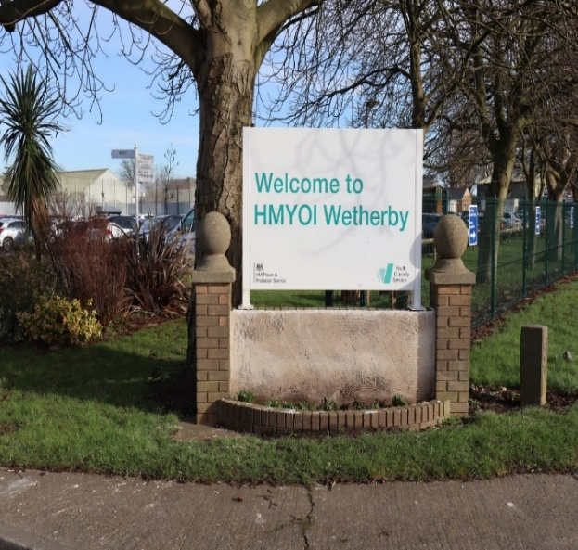

Introduction
HM YOI (Young Offender Institute) Wetherby is committed to support the children in our care to develop meaningful and constructive relationships with their families and carers or significant person who is identified as their next of kin and transforming Wetherby into a place of safety and reform and we recognise the need to provide those in custody with stable environments, as well as opportunities to change their behaviour and turn away from a life of crime. It is vital that family or carers are part of a child’s journey whilst in custody with research showing people in custody who receive visits from a family member, carer or significant other who is a protective factor in their life are less likely to reoffend as they play a key role in this.
Positive family relationships are likely to contribute to good order within an establishment.
Children being separated from their family and friends can be one of the most difficult situations to cope with when in custody and can trigger so many additional emotions and responses making progression whilst in custody onto a successful transition even more challenging.

Why Family Connections Matter
Being in custody can feel isolating, but staying in touch with family can:
- Boost emotional wellbeing
- Support rehabilitation and positive behaviour
- Help maintain identity and belonging
- Prepare for life after release


Family Strategy

Families play a vital role in the successful reintegration of the children back into their communities. Problems arising for individuals in the areas of siblings, children and families are often complex and inter-related. Therefore, it is important that we maintain and develop family relationships and community support to help offenders reduce their likelihood of reoffending. By providing support, encouragement and guidance, these young people will have a higher chance of positive outcomes when resettling into their own community and/or society in general.

Children are stigmatised for their offence, and their families often are too. Families are seen as guilty by association even though they are legally innocent and generally were not involved in the offence. This stigma is sometimes referred to as stigma by association. This stigma makes the imprisonment even more difficult for family members, and it can also mean that families are treated negatively by other members of their community, or face negative treatment from colleagues, peers, the media and even friends and family.

Directions to HMYOI Wetherby
HMYOI Wetherby (York Road, Wetherby, LS22 5ED) is situated approximately 1 mile from Wetherby town Centre. It lies opposite the Racecourse on B1224 York Road.
Bus:

From Leeds:
Buses operate on the “First Leeds Bus Company” 98 & 99 Service between City Square Leeds (outside main railway station) and the Centre of Wetherby. Buses run approximately every 30 minutes. From the Centre of Wetherby there is a 1-mile walk, short taxi ride, and/or York bus service.
From York:
Buses operate on the “Harrogate & District Bus Company” 79 Service between York Railway Station and Wetherby. There is a bus stop outside the establishment. The buses operate one every hour.
Train:


The nearest railway station to Wetherby is either Leeds, Harrogate or York. and public transport will be required to get you here.

Car:

HMYOI Wetherby lies just off the A1, opposite the Racecourse. When travelling from the north or south if you exit the A1 at the junction sign posted B1224 York, and head towards York. You will find the establishment on the left-hand side.

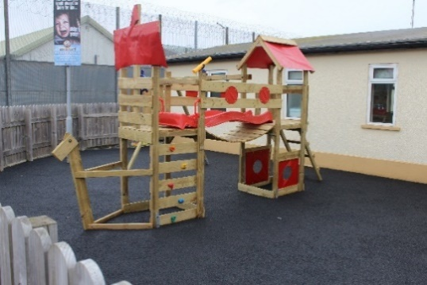
The Visitors Centre at Wetherby provides the first point of contact for friends, families and significant others who are visiting the children in our care. When you arrive at the visitors centre you will be and given an identification (ID) badge on a lanyard with a locker key attached which you need to display. A maximum of £10 per adult visitor in coins will be allowed into the establishment which will be carried in a transparent plastic bag which we will provide. There is a children’s playground that visitors with children can supervise their children playing in the fresh air whilst waiting for visits to commence and this will help alleviate any stress that the children may be feeling prior to entering the visits hall. We provide parking outside of the visits centre and some disabled parking bays to assist with ease of access. We have produced a helpful guide for children visiting HMYOI Wetherby, these guides have child friendly information about the visit and some fun ideas for games to play in the visit's hall with the person that you are visiting, these can be found in the visitors’ centre.

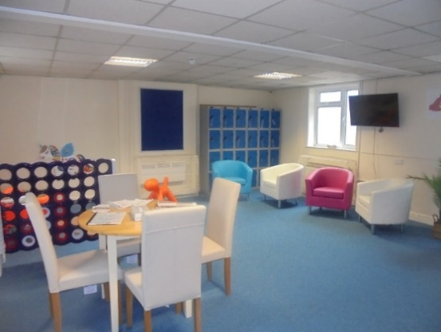
The visitor’s centre is a place to relax prior to your visit and get a hot drink from the vending machine. Staff in the visitor’s centre can assist in any queries you may have, and you can help yourself to the information booklets that are available and includes useful tips on how to maintain communication.
The Visitors Hall
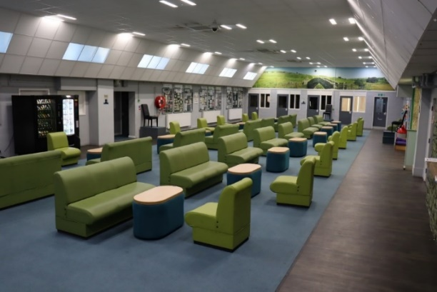
The visits hall is staffed by Prison Officers who are there to ensure that everyone enjoys their visit and to maintain security and decency, staff will be able to answer any questions that you may have. For visits to remain a positive environment visitors will be searched prior to visits as per Prison rules and in accordance with the local security strategy (LSS).
Any visitor who is deemed to be abusive or threatening will also have the visit declined or terminated and asked to leave.
We understand that visiting can be particularly difficult for children and confusing rules restricting how they can interact with the imprisoned family member, families often must travel long distances to a prison and often reliant on public transport, visiting times may not be compatible with teatime and bedtime routines, leaving children irritable or tired which may impact on school performance the following day.
There are often particular difficulties associated with prison visiting. Visiting often involves great deal of time, effort (both physical and emotional) and expense. Visiting can be quite an emotional experience, with both positive and negative feelings in the mix: for example, families usually enjoy seeing their imprisoned loved one, but due to the brevity of the visit saying ‘goodbye’ comes quickly, which can be distressing.

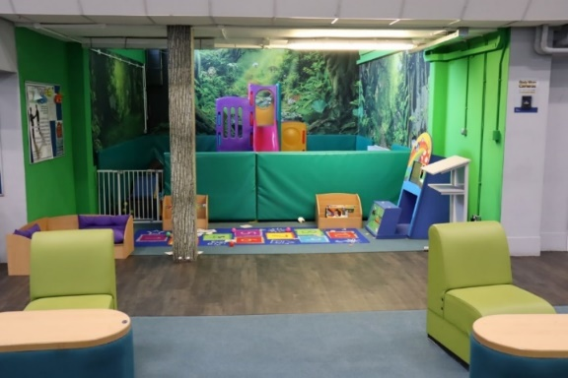
Our facilities include

- Vending machines for refreshments
- Play facilities for young children (Adult supervision required)
- Baby change provision
- Gender neutral, disability compliant toilet facility
- Full disability access to all areas of the visit's hall
- Pushchairs (Please ask a visits officer)
- Mother and baby room for breastfeeding
- First aid kit
- Board games to play on visits
Visitor consultation
Every quarter a Governor from our senior management team hold a Visitor consultation event on a Saturday or Sunday in the visits Centre they meet and greet the visiting Families and take notes of any concerns, questions, or ideas they may have.
We also have a visitor's questionnaire to complete these can be found in the visit's hall or the outside visitors centre and your feedback helps us to improve your visiting experience.

Family visiting times.

Monday | Keppel, Napier, Benbow and Collingwood unit | 17:45-19:15
Tuesday | Drake unit | 17:45-19:15
Wednesday | Exmouth unit | 17:45-19:15
Thursday | Frobisher unit | 17:45-19:15
Friday | Themed and supported visits. | Family themed visits
Saturday | A.M Frobisher unit  PM Drake unit | 09:30-11:00  14:00-15:30
Sunday | A.M Exmouth unit  P.M Keppel, Napier, Benbow and Collingwood unit | 09:30-11:00  14:00-15:30

Un- sentenced children (Remand) are entitled to one visit per week. Sentenced children are entitled to three visits per month (2 x weekends, 1 x midweek)
In a small number of cases, maintaining family ties may not be appropriate, possibly due to the risk of harm that a Child in our care poses to the family. Safeguarding children and supporting victims will always be a priority for HMYOI Wetherby.
How to book your visit

Visits must be booked 48hours in advance (minimum) i.e. For a Saturday visit this must be booked by Wednesday.
You can only visit a young person in Wetherby if they want you to visit them and they have added you to their visitors list and once you have been approved your identity will be checked on arrival to make sure, you’re on the visitor list.

Attending for a Visit
HM Prison & YOI Wetherby provides a Visitors Centre outside of the secure establishment, adjacent to the prison gate. Visitors are required to attend the Visitors’ Centre to book in ahead of the visit. The centre is a facility provided solely for visitor use and opens ahead of visiting times to facilitate visitor arrival. Visitors must bring the required forms of identification with them to assist with the booking-in process.
- Visitors may identify themselves using one of the following:
- Passport, including foreign passports, and time expired passports where the photograph is still recognisable.
- C identity card.
- Driving licence.
- Benefits book.

- Senior citizen’s public transport photo pass issued by local authority.

- Employer’s or student ID card but only if this clearly shows the name of the visitor and the employer or educational establishment and has a photograph or signature which can be compared with the visitor’s appearance or signature, and/or the Foreign National’s identity card.

If the visitor is unable to produce one of the above, staff may accept combinations of two or more of the following.

- Birth/marriage certificate.
- Cheque book or credit/debit card (counts as one: do not accept as two
- Employer’s pass or ID or student ID card which does not fit the criteria set out above.
- Young person’s ‘proof of age’ card.
- Trade union or National Students’ Union membership card.
- Rent book.
- Foreign identity or residents’ card (other than EC (Early Conciliation) ID cards acceptable in their own right
expired documents from the above lists that appear satisfactory in other ways and
- ID card from a recognised Prison Visitors’ Organisation.
- Citizen Card.

Visitors may be refused entry to the prison for being intoxicated or unruly or for carrying contraband or failing to provide acceptable identification.
Visitors must leave all belongings either within their vehicle or in the lockers which are provided. The visitor must retain the key to the locker for the duration of the visit. Information about custody generally, support services locally or nationally, as well as details and instructions about our local policy and procedures are available in the Visitors’ Centre. Information regarding what to expect and how to raise an issue or complaint is clearly displayed in the Visitors’ Centre, care. Risks or other issues to young people will be addressed by the establishment, in confidence, and always with the young person’s well-being central to these considerations. A Safeguards hotline number is also displayed for visitors who feel more comfortable in raising these matters while they are away from the establishment.
The centre aims to be a friendly and welcoming environment. On arrival at the visits centre, visitors must book in at the desk therein.
Take note of the fact that they are not permitted to take anything into the prison for young
people.
It is the prison’s policy to contact the police on every occasion that a visitor attempts to pass an item on to a young person. (Referral of Prohibited Items Offences to the Police)
When notified, visitors will proceed through to the main prison gate where they will be logged in,
then on to the visits area where they will be searched in line with the Domestic Visitors on Entry
risk assessment, before being admitted to the Visits Hall. A refusal by a visitor to be searched.
result in the visit being refused.

On entering the visits area, they will identify themselves to the visits staff, who will direct them to a designated table.
Passive drug and mobile phone detection dogs are often used in the visit's entry area. These dogs are trained specifically for this role and are entirely safe to be around. Visitors are required to agree to being searched by dogs, a refusal will result in the visit being declined by the prison.
Upon indication of a concern by the dog, the visitor will be required to undergo a further search; any refusal will result in the visit being declined by the prison. A positive indication by a passive search dog will result in an offer of a closed visit or the visitor being refused entry for the visit.
Visits are monitored with the use of Closed Circuit Television (CCTV) cameras which are operated by a trained member of staff, as well as by officers in the Visits Hall. Visits may be closely observed if there is reason to believe that a security risk exists by the visit taking place or if the camera operator or other member of staff notes unusual or suspicious behaviour. Recordings from this footage will be made available to the police in any prosecution.

Entry to visits is regarded as acceptance and understanding that monitoring by CCTV will take place.
If a visitor arrives without the relevant booking reference (having pre-booked a visit) the Visitors’ Centre staff will contact the Duty Manager who will decide whether entry into the Visits Hall will be authorised.
Failure to bring appropriate identification will jeopardise the visit taking place, and failure to bring the booking reference details will certainly delay the start of the visit.
We can issue claim packs for help with prison visits. All new Applications for assistance should be made online at www.gov.uk/help-with-prison-visits
Staff in the visit's hall can help you with completing the help with prison visits paperwork to claim expenses and stamp the form for you to claim for the visit.
Ways to keep in touch

Letters & Cards
- Write regularly—share updates, feelings, and encouragement.
- Include drawings, photos (if allowed), or news from home.
- Keep it positive and supportive.

Email a child in custody at Wetherby
Please log on to our website www.emailaprisoner.com

We know what it’s like to constantly write letters but now you have the option to send your message by email directly from your computer to the prison. Whether from home, work, college, or an internet café on the other side of the world – your thoughts can be emailed at a time to suit you. Depending on the time of day you send your message which can now include up to 4 photos, prison staff will print it and pass your message to the young person, hopefully the same or the following day. You can now request a reply by ticking a box when sending your message and your recipient can hand write a reply which will be sent back to you by email.

How it works

Once logged in to our secure website your message will be encrypted then, reformatted by our secure sophisticated software, and redirected to the prison of choice. Officers now seal the message (for privacy on the units) and deliver to the recipient, ASAP.
Please be advised our system does not provide a direct email service to your recipient. Our service is simply a different way of delivering.

Video Calls / Virtual Visits
- If available, these can help maintain face-to-face contact.
- Dress appropriately and find a quiet space.
- Treat it like a real visit—be present and respectful.
The times that we currently offer video visit calls are as below
Saturday and Sunday 09:15hrs until 16:00hrs
Monday to Thursday 14:15hrs until 19:15hrs
Friday 14:15hrs until 17:00hrs

Prison Video app user guide

What you will need to make a secure video call
- Mobile phone or tablet device
- An internet connection
- The Prison Video app installed on your phone or tablet.
- An account created in the Prison Video app.
- Passport, driving licence or other government-issued photo ID for each participant over the age of 18.
- A face photo of each participant, including children, will need to be uploaded using the app.

Step 1: Download and install the app.
- Download the Prison Video app from Google Play or the Apple App Store (or equivalent app stores outside the UK)
- Install the app on your phone or tablet.
- Allow notifications if prompted. You can check if notifications are enabled within the settings for the Prison Video app on your phone or tablet.
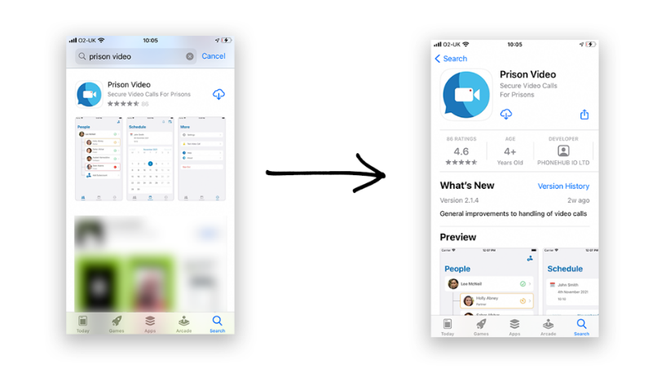

Step 2: Create an account in the app for yourself.
Complete the following fields on your screen:
- Enter your name, address, and date of birth.
- Take a picture of your driving licence, passport, or other government-issued photo ID.
- Take a photo of your face.
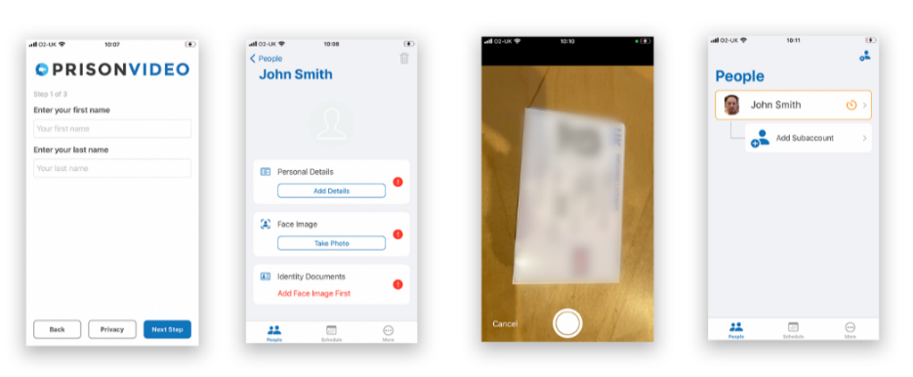

Step 3: Add any additional participants.
- Add details of any people who want to take part in secure video calls with you.
- Upload a clear photo of each participant’s face.
- Upload a photo of ID for people over the age of 18 only, unless the prison specifically asks you to provide anything else.
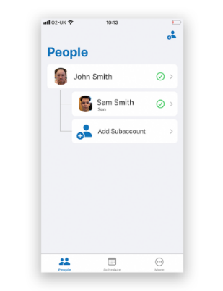

Step 4: Book a call. Prison staff will either invite you to book a secure video call, or you will be able to request a call, depending on the booking system the prison is operating.
You will receive a notification when your secure video call has been scheduled. (Remember, notifications from Prison Video should be enabled or allowed on your phone or tablet device).
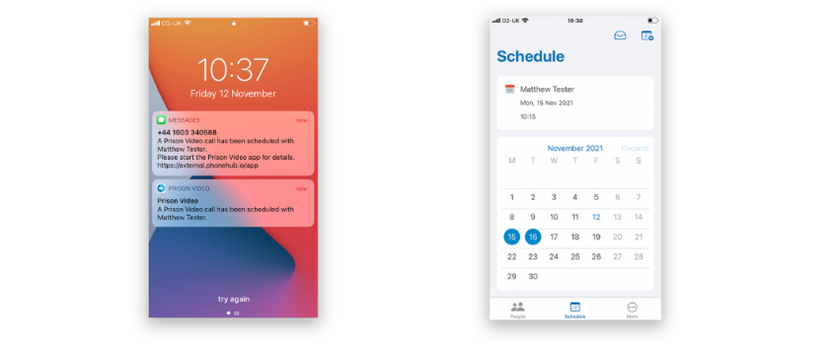

Step 5: Get set up for the secure video call.
- Check your internet connection. Wi-Fi is recommended, but you can also use 3G or 4G mobile data.
- Open the Prison Video app on your phone or tablet device.

Step 6: Have the secure video call.
The call will start when your family member or significant other has connected at the other end, so please be patient. You will be notified when the call starts.
Once you receive a notification to join the call you will need to agree to the rules and allow any required permissions. You will then be able to see and hear each other.
Email support@prisonvideo.com

Assessment on induction
The induction team completes an induction assessment on every child who comes into custody within the first week, they will explain the services we provide, including the visits booking process, how the telephones work, receiving and spending money, receiving clothing and property, letter writing, communication with family, friends and significant others and the various family interventions and support that we offer.
Wetherby’s Social Work Team Wetherby’s Social Work Team is a fully embedded, integrated service which, in the first instance works side by side with the Resettlement HUB and Safeguarding Department. Their role is to support the establishment and its functions in identifying initial and ongoing needs of the children which could hamper positive outcomes for them and their families. The Social Work Team ensure all children in care are identified at their initial screenings. In addition, they support financial support for children, leaving care support and rights, assist in relation to accommodation for release and escalate if required. If a young adult is transferred to the adult estate the social work team, ensure the receiving establishment is made aware that they are a care leaver.
The social work team also offer support for pre-birth assessments or if a social worker is involved in a child’s life they can link up to the child’s social worker and the dad whilst he is here at Wetherby.
The Social Work team advise and support the Safeguarding department re child protection matters.
CAMHS (Child & Adolescent Mental Health Service) is a team in the YOI. We all have different job titles, but all support young people with their mental or emotional health. We will work with any young person who wants to work with us.
We do one-to-one work with young people here, and young people can see a range of different people depending on the help that they might need. We also support the operational staff in thinking about and caring for the young people here.

We know that the families and friends of the young people here love and care about them. We know that mental health care and support is much better when it involves the people who are important to a young person, and we are working on plans to make this happen. We want to be able to share important information with you, learn from you, and for you to know what you can expect from our service.


Park Run
Keppel Park run takes place occasionally on a Saturday morning at 9am in the grounds of the Keppel Unit Young people and staff members can walk, jog, run a 5Km route or volunteer to take part.


Families can follow the results as they are published on the parkrun website each week, family members can also take part in the community at the same time as their child is completing Keppel parkrun. It offers a shared interest between family members where they can encourage each other to take part.

The Resettlement and Offender Management Department offer advice to young people with family related queries. Remand and sentence planning meetings provide the forum to explore individual need, and any concerns can be referred to the relevant agencies for support. Resettlement practitioners can also provide family liaison-based work for those wanting to establish contact with family members or rebuild previous links. Resettlement practitioners can also liaise with Public Protection colleagues for any Child Protection queries. One of the key roles of the Resettlement practitioners is to identify the influence the relationship between the child and their parent, guardian or carer has on the child’s behaviour. It may be that this relationship needs to be nurtured however at times these relationships can be extremely negative and detrimental on a young person’s responses and behaviour therefore a more complex approach may be needed to achieve positive outcomes for the young person.

The Official Prison Visitors (OPVs) provide support to those young people that have little or no family contact. They can also support those that do have family contact but require further support whilst in custody. The OPV (Official Prison Visitors) volunteers coordinate their visits through the Chaplaincy Team. The OPV volunteers are a diverse group of individuals with many different skills and attributes that provide great support to those they are visiting.
In addition to the OPV scheme, Wetherby are fortunate enough to have the support of the local charity In2Out. This is a service which children self-refer to and provides ongoing practical and emotional support during their time in Wetherby and when transitioning back into the community. The charity offers support in the areas of accommodation, employment, general personal skills in relation to independent living and this support continues well on into resettlement and beyond. This ‘mentoring style’ contact has proven to be very successful in reducing the risk of children’s re-offending when they leave custody. The charity tends to work more with children who do not have any family they can rely on support from however on many occasions, In2Out have helped re-build fractured relationships between children and their families producing positive outcomes for all.
Psychology and Interventions
Psychology and Programmes try where possible, to inform children’s families and significant others that they have been selected and will be completing either a 1-1 or group intervention. Facilitators will keep those who wish to be involved, updated in their child’s progress, and informed about their completion of interventions. It has proven helpful with children’s motivation and engagement throughout an intervention. On the completion of group interventions, Psychology and Programmes hold a celebration event in which families and significant others are invited to attend to celebrate the success of completers. During this event, children are presented with certificates and encouraged to show their families and significant others of the great work they have completed.

Family therapy


When your child comes into custody your family life can change for everyone in the family. Brothers and sisters. Fathers and mothers. Grandparents. Significant others. Sometimes it’s hard to keep your child at the centre of family life when they are in custody, especially if they have a long sentence. Sometimes, it’s as harder for the brothers and sisters and parents at home to come to terms with the Court verdict and sentence, as it is for the child you have here in Wetherby.

Family Therapy can be useful in helping everyone in a family better understand what has happened, and what needs to happen next. Sometimes it helps to help to have a professional involved in your family life if communication between family members has become difficult or even if it seems impossible. If you are interested in Family Therapy, please contact
Familyevents.wetherby@justice.gov.uk
`Those eligible can apply for a ROTL (release on temporary licence) which allows them to spend a day in the community with their family which supports relationships and family ties and enables those who have proven that they are well behaved, trusted and progressing positively. ROTL can be granted based upon risk assessments and eligibility. When a child completes a successful ROTL it also opens other gateways of opportunity like

- Early released.
- Home detention curfew
- Parole
- Employment
We have regular Themed/ supported visits, the aim is to encourage, strengthen and maintain positive relationships whilst in custody as per Lord Farmers report that “Family should be the golden thread”.

The themed visits are open for all the young people in our care regardless of incentive level and location within the establishment the themed visits are generally conducted in the visit’s hall or on the young persons residential unit and in Summer they may be held next to the on-site fishing pond. Themed visits are characterised by a more relaxed interaction and fewer restrictions than a normal social visit allowing the young people to get up, interact and play with their siblings/children and this is seen as a vital opportunity for shared family time in a more normalised environment. We encourage positive interactions and provide light refreshments for the visit. We encourage play through board games and the children’s play area and offer the opportunity to have your photo taken, a disclaimer will need to be signed prohibiting the use of the photos on social media. We also offer bespoke visits which is a need driven visit which may be due to the visit/meeting being sensitive and the crowded visits hall may not be suitable, the young person’s resettlement practitioner can advise of these.
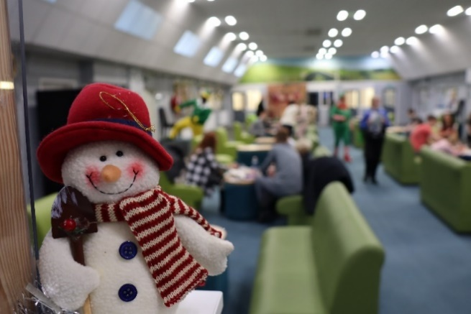

Comments from families who have attended the themed visits.

“The visit was lovely, it’s a nice, relaxed atmosphere for siblings. It really helped them relax and play with ####., That’s the first visit in 3 years his sisters got to play with #### in that way. As a mum to much younger siblings, their brother serving such a long sentence it’s so important to me to keep their bond strong. That’s hard without the opportunities given with events like these. Normal visits don’t accommodate #### interacting with his sisters the way these visits do. Given both #### and his sisters have a range of additional needs, face to face visits that include the freedom to get up move around and be able to touch & climb on him without worry is crucial, it’s how they all connect and communicate so thank you for the opportunity for them all to have that freedom”.

I asked his eldest sister who is 9 on what she thought about the visit, she said “we had so much fun making the cookies, I loved we could run about and jump on #### I like the things hung on the walls & they were dressed like elf’s & #### wore his clothes so it felt like home. It didn't make me sad.”

Feedback from a young person after his themed visit.
“It was brilliant. I couldn’t ask for anything better than being able to have photos and play with my little brother”

We have also introduced pet visits; these are provided on request and if the pet fits the criteria and the young person who is with us in Wetherby is well-behaved and on enhanced gold level then the pet visits can be arranged.
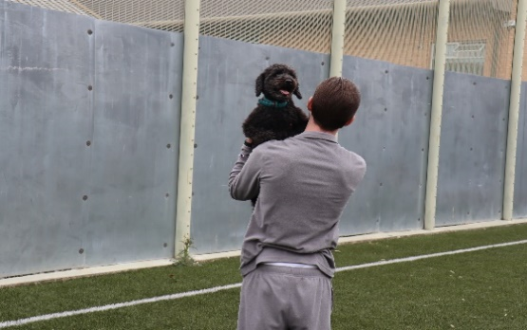

Feedback from a family member after a pet dog visit.
“Thank you so much, made us both a bit emotional. Honestly it meant so much to us.”

It is estimated that 200,000 children each year are affected by a parental imprisonment.
We also facilitate when appropriate inter-prison phone calls for children in custody who have parents and family members in custody ensuring that contact is maintained.


Monthly supported visits which are bespoke and facilitated on a need only basis and recommendations will come from the young person’s resettlement practitioner.

Family newsletters


We send out quarterly family newsletters to the young person’s next of kin, this is a great way of keeping up to date with the latest developments and projects that we have involving the young people in Wetherby, if you would like to request a copy of the newsletter, please e mail
Familyevents.wetherby@justice.gov.uk


The Chaplaincy Team
Offers pastoral support and care to all children throughout their time in custody. Statutory duties performed by Chaplaincy include seeing all new receptions within 24 hours of arrival and visiting the Healthcare and CSU every day to support prisoners who are isolated from the normal regime of the prison. The Chaplaincy Team provide teaching and discussion sessions which cover the beliefs and worship of the different faiths and look at reinforcing appropriate behaviour and thinking. The team offers one to one support, advice, and encouragement. The Chaplaincy Team are responsible for verifying and informing a child when news of a bereavement or serious illness of a relative is known, with ongoing support offered where appropriate. Chaplains are responsible for the pastoral care of all children in our care of any faith and none and fulfil the right of all children to observe their religion and participate in corporate worship. Chaplaincy also offers help and advice to staff that may have questions about the principles and sensitivities of a child’s faith. The chaplaincy team also provide through the Mothers Union a bag for new mothers that include baby wipes etc. and these can be handed out on visits by the new dad.



Within this team they also operates the Time for Dads course which is an accredited programme under the CARE (Collaborative Approach to Risk and Emotion) for the family’s positive parenting programme which promotes the well-being and responsibilities required for our young fathers or fathers-to-be to be successful in sharing the upbringing of their children, this course has a celebration event at the end where family members can come too.


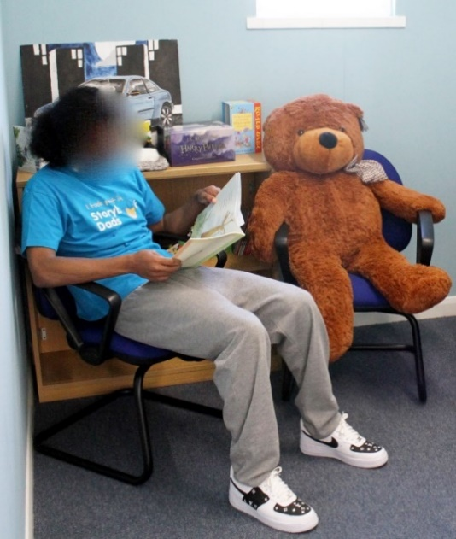
In addition to the Time for Dads we run the Storybook Dads facility within the library. This is an opportunity for young fathers or children in our care who have young siblings to be able to record themselves reading bedtime stories which can then be played to their child/siblings at home and reinforces their presence in the child’s life. This is recognised as an additional positive influence on both the young person and their siblings and proves to be a popular service.

We have now introduced Storybook Dads DVDs which is run by the establishment and the young person is filmed reading a story book which is then sent to the child to be watched and enjoyed with their Daddy/Sibling reading to them on a DVD.
We issue all the young people with a tee shirt to say that they have taken part in story book dads and send a teddy bear to the receiving child/sibling with the story book.
This service is free.

The Youth Council sits bi-monthly and addresses every aspect of a child’s time within Wetherby. Within these children raise any concerns or make suggestions as to where and how we might be able to improve on current provision in relation to family support and contact. This is then discussed further with the Heads of Functions within Wetherby and an action Plan developed.


For all those young people in Wetherby who feel that perhaps their voice is not being heard clearly enough, Barnardo’s; Your Rights, Your Voice can provide them with an advocate to help them raise their concerns. Their issue could relate to their stay at Wetherby, or it could be an external concern, for example, something to do with their YOT (Youth Offending Teams) or Social Services, ROTL/Early Release, or immigration issues. The independent children’s rights and advocacy service is there to support and empower the young person in promoting their wishes and feelings to those professionals involved in their care and treatment.

New bridge befriending scheme

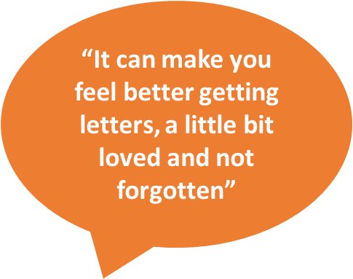
We have introduced a befriending scheme for those in our care who are 17 years and 6 months old and older who will be transitioning into adult estates and would like to have a friendship with security through letters and eventually visits and phone calls. The support is sometimes more attractive to those who are vulnerable and isolated or have limited or no contact with people in the world.
Some young people here don’t have much contact outside but all of us need someone to talk to - someone we can trust, who doesn’t put labels on us, who talks straight, stays in touch and doesn’t make promises they can’t keep. New Bridge befrienders will support the boys while they are here and as they move to adult prison.
The befrienders aren’t attached to Wetherby but to the child and that’s why they can continue to be the child’s volunteer as they move on.

Safeguarding children is a priority and depending on the level of risk level a person in custody poses to children, will determine the level of contact they can have with children whilst in custody. The management of these restrictions can involve mail and telephone PIN (Personal Identification Number) monitoring and monitoring of contact with children during visits. This is detailed below

Levels of Restrictions for Child Contact
Level One | Full restrictions apply. No contact with any child permitted All correspondence and telephone calls may be monitored subject to a risk assessment being carried out and regularly reviewed.
Level Two | Contact permitted with named child only via written correspondence. All correspondence and telephone calls may be monitored subject to a risk assessment being carried out and regularly reviewed.
Level Three | Contact permitted with named child only via written correspondence and telephone calls. Correspondence and telephone calls may be monitored subject to a risk assessment being carried out and regularly reviewed.
Level Four | No restrictions necessary, contact permitted with named child only via correspondence, telephone calls and visits. The prisoner may be allowed access to family visits with the permission of the Governing Governor following a further, individual risk assessment. Routine monitoring of correspondence, telephone calls, general observations in the visits area. This level of contact applies only to those children that the prisoner has permission to have contact with. All other children will be subject to Level One restrictions.

Further reading
- AFFECT – AFFECT provides services for the families of serious offenders and offers support groups to families in the south of England. www.affect.org.uk
- Prisoners’ Families and Friends Service 0808 808 3444 info@pffs.org.uk
www.pffs.org.uk
- SHARP (Support Help and Advice for Relatives of Prisoners) (Support Help and Advice for Relatives of Prisoners) 01743 245365 for free

POP’s
Tel 0161 702 1000
- www.partnersofprisoners.co.uk
- NICCO https://www.nicco.org.uk/
NICCO is a one-stop information and advice service to support all professionals (working with children and families of prisoners) and all families of prisoners, bringing together useful information in one place.

