


HMP/YOI Deerbolt

Family and Significant Others Strategy.

Version 2.3 — January 2026



Document details
Version | 2.2
Date published | 01/01/2025
Date for review | 01/01/2027
Document author | Head of Operations
Document owner | Head of Operations

Document version history
Version | Pages updated | Changes | Author
0.1 | All | First Draft | SH (HoRR)
1.0 | All | 2023 Publication | SH (HoRR)
1.1 | 7 | Revision | SH (HoRR)
1.2 | 6-7, 9-13, 16-18 | Review Draft | ALB (HoRR)
2.0 | Images | 2024 Publication | ALB (HoRR)
2.1 | 1-3, 5, 7-9, 11-14 | Revision | AB (HoOPS)
2.2 | All | Annual Review | AB (HoOPS)
2.3 | All | Annual Review | AB (Head of Ops)

Contents
1 Documents contents 2-3
2 Purpose and scope 4
3 Introduction and staffing 5
4 Diversity and Inclusion 6
5 Understanding the needs 7-8
6 Performance and Assurance 9-10
7 Facilities 11-13
9 Family days and enrichment activities 14
10 Father’s Pathway 14
11 Care experienced support 15
12 Building Positive Relationships (BPR) and Community Days 16
13 Role of a Keyworker 16-17
14 Reading opportunities 18
15 Offending behaviour courses 18
16 Safeguarding 19
17 Information, support and resources 20-21

Purpose & Scope

This strategy has been written in consultation with Nepacs, our Family Contract provider. We work together with Nepacs, to provide a quality service that aims to make a difference. The current contract commenced in October 2022 and will run for 5 years.
Purpose
The purpose of this strategy is to provide staff, prisoners and prisoners family and significant others with an overview of what Deerbolt currently provides and our future aspirations.
Scope
- Strengthening Prisoners’ Family Ties Policy Framework
- Visits Activities
- Services for Visitors
- Services for prisoners without contact with family and significant others
- Family Engagement & Advice
- Governance structure

Out of Scope
- Visits Policy
- ROTL Policy
- Security Policy
- Public Protection Policy

Introduction

“Family relationships are the golden thread to reducing reoffending”

The Lord Farmer report, published in 2016, suggests that ‘Family should be the ‘golden thread’ running through the processes of all prisons. Family and significant relationships are considered as a key means by which we can prevent reoffending and reduce the likelihood of intergenerational crime.
Staffing
The Family and Significant Others team is overseen by the Head of Reducing Reoffending and supported by:
- Family and Significant others lead (HoOps)
- A Custodial Manager championing support for Families and Prison Visits (Operations Custodial Manager)
- Nepacs Contract Management team
- Nepacs Family Support Worker (not currently in post)
- Nepacs Care Leavers Support Worker
- Nepacs visits team
- Waythrough
- A Safer Custody Officer
- The Deerbolt Catering team
- Gym Staff
- The Offender Management Team
- The Security and Operations Team (who operate the visits facility)
- The Chaplaincy Team
- The Mental Health Team

Diversity & Inclusion

At Deerbolt:
- We believe that a diverse prison community is a better prison community.
- We believe that making sure people feel included is good for individuals and good for our prison.
- We believe that people should be able to be themselves in our prison, celebrated for their uniqueness.
- We believe in the importance of being open to learning how we can do better.

We have signed up to the HMPPS Diversity and Inclusion Statement and are working toward making sure that we deliver this commitment:

“HMPPS is committed to Diversity and Inclusion for all. We treat our staff with respect and ensure equality of opportunity. We deliver our services fairly and respond to individual needs. We insist on respectful and decent behaviour from staff, prisoners, children, people on probation, and others with whom we work. We do not tolerate discrimination, harassment or bullying and we take prompt and appropriate action whenever we discover them. This is underpinned by our adherence to the
Public Sector Equalities Duties as outlined in the Equality Act 2010.”

Understanding the needs

As a family strategy team we will be dynamic, assessing and responding to the changing needs of the current prisoner population.

Needs Analysis
We will conduct an annual needs analysis, using a variety of data sources including:
OASys/Sentence Plans, whole prison surveys, local family data & visitor’s voice data. We will work with the psychology team to review the recommendations and plan provision for the year ahead.

Visitors Voice
Quarterly visitors voice sessions take place in the visitors’ centre which is chaired by Head of Operations (Families and Significant other lead) or a representative and facilitated by Nepacs.

“Visitors' Voice groups bring together families and loved ones of prisoners to have their say on how visits are run and how Nepacs and the prisons can improve the visit experience and support for families. These help in the running of our Visitors
Centres and other support services.”
Any feedback from visitors will be discussed at the monthly Nepacs meetings and any areas for improvement will be addressed and fed into the visits action plan, this is reviewed bi-monthly and any issues raised to SLT via monthly HoOps reports.
Children’s views and opinions are also greatly valued, Nepacs play workers will gather this information in a child appropriate forum with the consent of the children’s parents.

Focus Groups & Prisoner Consultative Committee Feedback
Monthly Prisoner Consultative Committee meetings are held by the Residential team; prisoners are free to raise any issues they may have or suggestions for improvements. Staff may also attend the meetings to discuss specific topics to gain feedback, or separate focus groups may be organised.

Performance & Assurance

The family strategy team are dedicated to providing a service which meets the
highest of standards. Below are some of the ways in which we hold ourselves to
account and provide assurance to the Governor that the service that we provide to
prisoners, their
family’s and significant others meet the requirements of the
Strengthening Prisoners’ Family Ties Policy Framework.

•

Governance Meetings

The prison will ensure that quarterly contract management meetings are held with
the current provider to ensure that the contract is being adhered to.

•

Yearly Self
-
Assessment

The prison service have

introduced a self
-
assessment performance measure, this
will feed into the overall performance of the prison.

“Establishments will need to complete a self
-
assessment measure, answering a
range of questions covering family and significant other work. The measure is
designed to encourage a proactive approach to family and significant other work,
and an establishment
t will score well if it is able to evidence proactivity in response to
the range of questions within the measure.”

Regular performance updates will be fed into monthly senior leadership team’s (SLT)
Performance and Assurance meeting by the Head of Operations.

Assurance Framework

The Custodial Manager (who is our Family and Significant Others Champion) will maintain responsibility for ensuring that assurance checks are carried out, this will be updated on our assurance framework which is reviewed quarterly.

HMIP
The prison is subject to inspections by HM Inspectorate of Prisons and Deerbolt was last visited by HMIP in December 2024. Recommendations from the published HMIP report are taken into consideration in the Family & Significant Others action plan. The action plan from the most recent report is yet to be published at the time of this review. There were no concerns raised within the draft report for FaSO provisions.
The Families and Significant Others Lead will ensure that any expectations are considered in the relevant pathway of the monthly Reducing Reoffending Meetings and if appropriate are added to the visits action plan. Below is a link to the prison services expectations for male closed establishments.
Men’s prison Expectations (justiceinspectorates.gov.uk)

IMB
The IMB complete yearly reviews and within their reports they assess our current family provision, access to visits and decency within this area. These reports can be accessed via the internet on www.imb.org.uk.
FaSO strategic action plan
Attached below is our current visits action plan, please note this is continually under review and new actions added when required. Any issues raised are escalated through the SLT via HoOps reports each month.

Facilities

The Visitors Centre

The first stop for visitors is the visitors
Centre which is run by NEPACS and offer a warm welcome and a child friendly play area

- Ample car parking spaces with designated disabled parking spaces
- Secure lockers for visitors
- Comfortable seating
- Tea bar facility offering affordable cold drinks and snacks • Toilet and baby change facilities

The Visitors Centre

A purpose-built area for visitors to check in with prison staff as well as an area used by Nepacs to deliver a meet and greet service for new visitors.
The space is also used to provide information and signposting to various support services including, but not limited to debt advice, employment and skills, children’s services, drug/alcohol support, women’s services housing, health, and wellbeing.
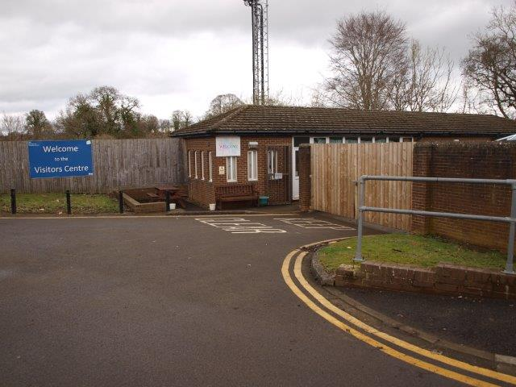
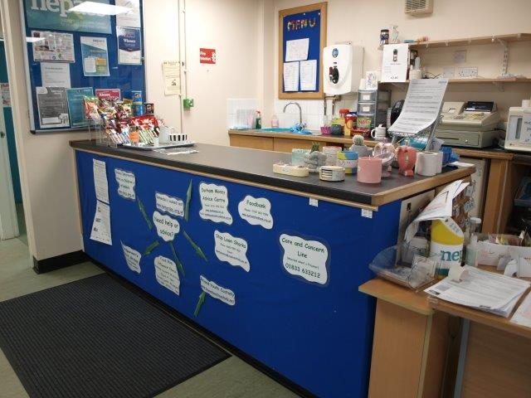
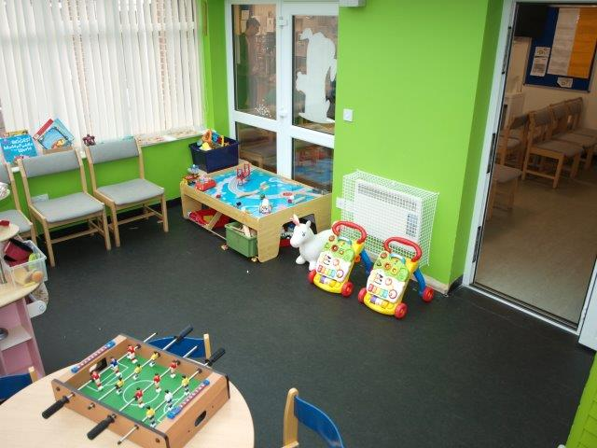

Visits Hall

The visits hall at Deerbolt includes:

- Comfortable, family friendly seats and tables, bean bags for smaller children also.
- Legal Visits rooms
- Closed visits booths
- Tea bar facility offering hot/cold drinks and snacks
- Toilet and baby change facilities with a dedicated accessible toilet (available in main gate area and Visits centre)
- Phone hub – video calling facility (this is now located within the main education department and not within the visits hall)

Family Days and enrichment activities.
There are 12 extra family visits sessions planned throughout the year, these generally during the main school holidays with the remainder to support alternative family days.
Prisoners can apply for these visits through an applications system. These events have:
- Sports / play / craft activities
- Snacks/refreshments provided
- Family photograph opportunities
- Themed fun days
Seasonal events also take place such as Christmas, Easter and School summer holidays. These include photo’s for family to take home with them and one for the prisoner.
The gym staff, safer custody, catering team and library staff come together to organise the family days with Nepacs, working hard to ensure that prisoners and their visitors can make positive memories and strengthen meaningful relationships.

Fathers pathway Plan
We are developing a father’s pathway for those men in our care who are Dads, this will include supporting them to build and maintain positive relationships with their children, this is currently through events such as family days, storey book dads, Angel tree project and parenting classes.
Enrichment Activities
Nepacs will work with prisoners and their visitors to assess what types of enrichment activities are in demand, the offering will change depending on the needs identified.
This may include homework clubs, baby and toddler soft play sessions, child free visits for couples or prisoners and their parents/grandparents. We are very keen that family enrichment activities do not focus only on children, prisoners may need to build or maintain relationships with parents, extended family, or significant others.
We will support prisoners and their families that have neurodiversity needs by exploring the use of quiet time visits, sensory play activities etc., to help them to maximise time with family.
Cultural diversity will be embedded with a calendar of cultural and religious celebrations to be observed with the support of the Chaplaincy team and the Residential function.
Care experienced support.
Personal Advisors have a statutory responsibility to visit / contact their young adult on a regular basis in the community. In prison the guidance states that Personal Advisors should also visit on a regular basis and this pattern of visits should be agreed in the Pathway Plan, up until the age of 21. If the young person requests support after age 21, frequency of contact will be agreed between the Personal Advisor and young person, according to need. It is important that we support and facilitate these visits.
Often it may be that their Personal Advisor is the only person who does visit them.
A prison visit protocol will enable flexibility for these visits taking place which will encourage flexibility for Personal Advisors to visit as a domestic visitor as well as a professional visitor and for the use of video calling to maintain contact. A family day session has been identified within the annual calendar to ensure those who are care experienced are supported with equal opportunity.
Building Positive Relationships (BPR) and Community Days
HMP Deerbolt now have prisoners acting as BPR Mentors, a peer support role that interacts with other prisoners to ascertain what type of support they can offer and make referrals to the Family and Significant Other Champion.
We will work with referred individuals to identify Significant Others in their lives who they may be able to build positive relationships with to support their time in prison ad on release.
The BPR mentors will support the Family Strategy Team to run quarterly Community Days in the visits room, where those prisoners who do not get regularly supported by visits can engage with professional services and agencies working in support of our Families and Significant Others pathway, socialise with peers in a similar situation and benefit from some of our visits services.

The Role of the Keyworker
The aim of the key worker role is to promote staff-prisoner relationships that are rehabilitative and constructive. This is to foster positive prisoner behaviour through staff example (pro-social modelling), dynamic security, fairness, decency and guidance. Key workers will empower prisoners to address their needs.
Key workers will help prisoners by undertaking certain tasks, including:
- Support prisoners to understand and come to terms with their sentence.
- Provide a link with their Offender Manager.
- Provide support to access services such as FaSO, activities, Waythrough, MH.
- Help prisoners to settle within the establishment, potentially by introducing them to others, explaining the daily regime and the system of incentives and privileges.
- Encourage them to build or maintain links with their families.
- Manage anxieties of the cohort that could otherwise be exacerbated by prison processes or a lack of updated information.
- Regularly engaging with prisoners to ensure wellbeing and escalating any areas of concern such as bullying, radicalisation or grooming, as appropriate.
- Talking to prisoners about their short, medium or long-term plans and how to make amends for past offending.
- Recognising and reinforcing positive behaviours to increase levels of maturity using the Choices and Changes resource package if applicable.
• Encourage activity to aid resettlement such as education or work experiences.

Reading Opportunities
Reading with children is a way in which families can bond, we therefor offer:
- Story Book Dads – the library team help prisoners to record a bedtime story which can be sent to their family in either CD or DVD format.
- Children’s Books are available on request via the Nepacs family support worker for prisoners to use to in their room, reading to their child over the telephone.
- Books are donated for children to be presented with on family days and Durham County Council Library Service promote family reading.

The Shannon Trust, peer led, reading programme is offered to prisoners who cannot read.

Offender behaviour courses.

Prison Offender Management (POMs) provide support for our prisoners and encourage family ties and engagement whilst also communicating directly with community probation services. In addition they.

- Complete all relevant safeguarding referrals

- Encourage and monitor family ties as key targets within sentence plans

Families are encouraged to attend the end of programme graduation events for those completing the Building Choices programme.

Safeguarding
Adult safeguarding in prisons means keeping prisoners safe and protecting them from abuse and neglect. This is underpinned by six key principles.

- Empowerment – Presumption of person led decisions and informed consent.
- Prevention – It is better to take action before harm occurs.
- Proportionality – Proportionate and least intrusive response appropriate to the risk presented.
- Protection – Support and representation for those in greatest need.
- Partnership – Local solutions through services working with their communities. Communities have a part to play in preventing, detecting and reporting neglect and abuse.
- Accountability – Accountability and transparency in delivering adult safeguarding

All staff have a common law duty of care to prisoners that includes taking appropriate action to protect them. Prisons have a range of processes in place to ensure that this duty is met. These also ensure that prisoners who are unable to protect themselves because of care and support needs are provided with a level of protection that is equivalent to that provided in the community. Definitions of abuse and neglect are based on those used in the Care and Support Statutory Guidance issued by the Department of Health in October 2014. Staff should direct any concerns they have to our safeguarding leads and submit an IR.

Abuse is any act, or failure to act, which results in a significant breach of a prisoner’s human rights, civil liberties, bodily integrity, dignity or general wellbeing, whether intended or inadvertent; including sexual relationships or financial transactions to which a person has not or cannot validly consent, or which are deliberately exploitative.
Our Safeguarding leads at HMP Deerbolt are Head of OMU Delivery (Senior Probation Officer) and Head of Safety, Equality and Inclusion, who can be contacted via:
SafeDecentSecureDeerbolt@justice.gov.uk or 01833 633200.
Information, support and resources.

For further information please see PSI 16-2015 Adult Safeguarding in prison Information and support
This series of short videos has been developed in partnership with prisoners and their families. It explores the different aspects of prison life and the support your loved one can access during their time in custody. These videos are copyrighted by prisoners’ family helpline:
These videos are also available in other languages:
Please click the link to access the following seven videos -
- Prison Environment
- Staying in touch
- Healthcare
- Prison life
- Key staff
- First night in custody
- Education and employment
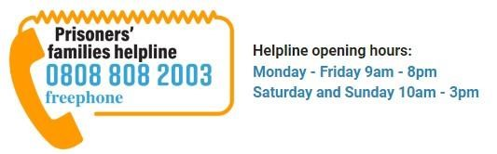
Prisoners' Families Helpline (prisonersfamilies.org)
The following link will take you to HMP/YOI Deerbolt website which provides useful information on the establishment:
Deerbolt Prison - GOV.UK (www.gov.uk)

In an emergency
If you think a prisoner is at immediate risk, please call the switchboard on 01833 633200 and ask for the Orderly Officer, then explain that your concern is an

emergency.

Concern and keep safe hotline

If you have concerns about the safety or wellbeing of a prisoner at HMP
/
YOI
Deerbolt that are not an immediate concern, call the safer custody hotline.

Telephone:
01833 633212

Find out about call charge
s

If you wish, you can leave your own details and a contact number so the prison can
give you feedback, if appropriate.

Booking a visit

You can

b
ook your visit online
e
.

You can book your visit by telephone.

Booking line
: 01833 633349

-

Monday to Friday,
9
:00
AM
–

12:00
PM

Find out about call charge
s

Getting to HMP
/YOI

Deerbolt

Find HM Prison Deerbolt - Google Maps
The closest railway station is Darlington. From there you can get a taxi or take the bus. To plan your journey by public transport use:
- National Rail Enquiries
- Traveline for local bus times
There is a free visitors car park. There is also a disabled visitors car park. A Blue badge must be displayed if parking in the designated zone.

