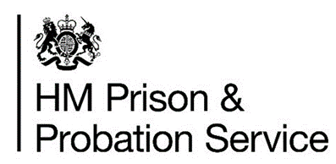

HMP/YOI DOWNVIEW

Families and significant others strategy

2025-2026


Reviewed - November 2025
Next review – November 2026

An easy read version of this strategy is available in the Visitors centre, and this strategy can be translated into a specific language upon request.

Version Control Page

Document Summary

Author(s) | Richard silvester (Head of Reducing Reoffending, HMP/YOI Downview)

Date
Version | 1.0
Status | Final - live

Document Review & Approval

Reviewed by | Position | Date
Richard Silvester | horr
Zoe Kottler | HORR | 22.11.2024
Keiran Mungroo | Head of OpERATIONS | 22.11.2024
KEIRAN MUNGROO | HEAD OF OPERATIONS

Document Amendment Details

Date | Author | Amendment Summary

Information Asset Assurance

In line with PSO 9015 (Information Assurance) this document has been registered as an Information Asset.

Date registered | Name of Local Information Manager receiving asset | Asset security level (restricted, confidential etc)

Contents
Foreword 3
Assessment of need 4
Our Family Offer 7
- Visitors Centre/Reception services 8
- Social visits 9
- Working in partnership 14
- Extended visits and Family learning 16
- Departmental support / Gateway communication 17
- Developing innovation and best practice 22
- Care experienced/leavers 23
- Safeguarding 24
Overcoming separation 26
- Digital and technology – communication systems 26
- Visits assistance 27
- Inter prison 27
Governance and delivery 29
Family and Significant others objectives 30

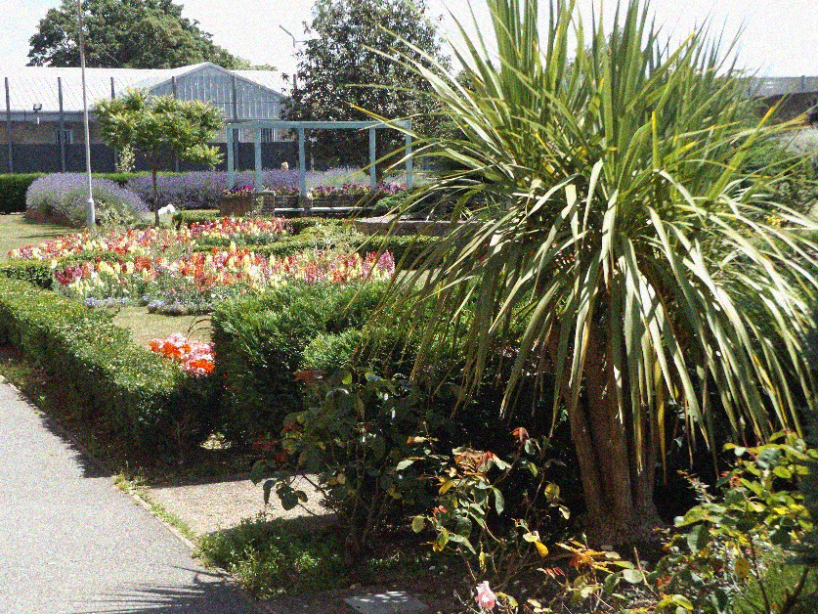

Foreword

HMP Downview is committed to offering a wide range of opportunities that meet the different needs of the people in our care. We use data and feedback from prisoners to shape our education, work, and emotional support services. Our aim is to build a positive environment where people feel motivated to grow and prepare for life after prison—focusing on learning, emotional wellbeing, and financial independence.
We support women as they return to their communities in a safe and lasting way.
We work with expert partners and outside organisations to help protect family ties, avoid harmful behaviours, and improve key areas like housing and jobs.
We understand that every woman is different, so the support we offer is tailored to each person while staying fair for all.
This strategy follows the ideas in Lord Farmer’s report (Ministry of Justice, June 2019), which says:
“Healthy, supportive relationships are not just a ‘nice to have’... They are utterly indispensable if she is to turn away from criminality and contribute positively to society.”
We believe strong relationships—especially with family—can help reduce reoffending and build safer communities. We want staff, prisoners, and families to work together to improve safety and break cycles of crime.
In this strategy, family means anyone the prisoner sees as their next of kin—whether that’s a relative, legal guardian, close friend, or support worker. Many people in custody have had non-traditional upbringings, and some have children in different care arrangements. We support all types of family structures, as long as they offer positive and caring relationships.
This is a flexible and evolving strategy. It shows what we’re doing now, what we hope to achieve, and how we’ll measure progress. We’re always looking for new ideas and best practices to improve how we support our community.

Assessment of need

HMIP
HMP/YOI Downview was inspected by Her Majesty’s Inspectorate of Prisons (HMIP).
The report published in August 2021 states,
“Support to help women maintain contact with their family had been limited during the pandemic, affecting the well-being of many women. There was now a promising family strategy, but no action plan. Women valued the in-cell phones, which had recently been installed. However, family days and group-work sessions were not available due to COVID19 restrictions and the Prison Advice and Care Trust family engagement worker provided a very limited service. Social visits had restarted but uptake was low. The video calling facility was reasonably well used.
The report recommended that the prison provide enough support to help women build and maintain strong relationships with their children, families, and other important people in their lives.
The report noted:
- Support to help women maintain or develop positive relationships with their children and families had been severely limited over the previous 18 months. Many women we spoke to reported that long periods of time without contact with their loved ones had adversely affected their well-being. The prison had introduced a promising family strategy but there was no action plan to drive improvement. (See key concern and recommendation)
- Women did not have in-cell telephony for most of the pandemic – it had only been installed in June 2021. Prisoners valued the fact that there were no time restrictions on the use of phones in their cells and in our survey, 98% reported that they were able to use the phone every day.
- Almost half the population surveyed (47%) said they had a child under the age of 18. This figure was even higher (66%) in the prison’s own needs analysis, where 31% of women said they had caring responsibilities for children. However, family days and group-work sessions were no longer available, and the service provided by the Prison Advice and Care Trust had been reduced throughout the pandemic. Despite some remote work being provided, provision to help women stay in contact with family was not always readily available. The family practitioner from the Forward Trust provided a good level of one-to-one support and advocacy.
- In the previous month, only 7% of prisoners said they had been able to see family or friends more than once during a social visit. At the time of the inspection, social visits had recently restarted, but uptake was low – the visiting experience had been badly affected by COVID-19 restrictions. Only 27 prisoners had had a social visit in May 2021, compared to an average of 204 prisoners each month before the pandemic. Visits took place for two hours on a Thursday and Saturday afternoon, and on a Sunday morning. Some women used the photography service from the Max Spielmann workshop, to have photos taken of themselves and their visitors, which could later be purchased.
- Video calling was reasonably well used compared to other Womens prisons and central data found that in the month before our inspection, 124 calls were made by 72 individuals (33% of the population). Women reported that the technology sometimes froze, compromising the quality of the call.
Findings from this HMP/YOI Downview Inspection report and the HMIP Expectations have informed discussions with our partnership organisations and our local action plan.

MQPL – Managing quality of prison life
Our most recent MQPL survey was completed in November 2021. The key findings of the survey were:
• Compared to the other female prisons, Downview experienced the largest improvement in perceptions regarding ‘Family Contact’ which can be attributed to the very large improvement in responses concerning the frequency and length of telephone calls. It should be noted that in cell telephony was installed at Downview in June 2021.
• Current perceptions pertaining to ‘Family Contact’ at Downview in 2021 were not notably different to those held at Drake Hall or Send but were slightly higher than the average female closed prison with a local function.
• Participants shared that in-cell telephony had provided less restrictive phone access and afforded them privacy to speak with family and friends. Participants also wrote positively about the enjoyment they gained from seeing their family either through video calls or social visits. It was also noted by some that the establishment was close to their home area which was of benefit to maintaining family ties. Not unusually for an MQPL survey, there was also some negative commentary regarding ‘Family Contact’ such as missing people and the associated difficulties with living away from family.
• Whilst social visits were described as “good”, participants expressed frustration as they did not always run-on time, which was particularly annoying if visitors had travelled a long way.
- There were also some comments about family members having difficulty accessing the video call technology due to the incorrect documentation.

SERVICE USER CONSULTATION
To inform the strategy HMP/YOI Downview strives to consult with their women in prison and families in different forms. This helps us to take an evidence-based approach to our strategy and work towards objectives that will have the biggest impact. We last surveyed our population in November 2022. Some of our findings are highlighted below. The Anna Freud project also carried out an evaluation of Pact’s Visiting Mum project at HMP Downview and its impact on prisoners and their children. (Annex C)
Our family and significant others service provider PACT are also contracted to survey our women and their visitors twice annually. As a live document the results of these surveys will be updated to this document and any actions arising added to the strategies objectives.

66% of women in Downview have children


31% of women with children have care responsibilities




66% of Women feel they are able to maintain adequate contact with the families and significant others. This is an increase from 50% on the previous survey. Most contact is made with children via telephone and letter.

Our family offer

Lord Farmer spoke of a ‘local family offer’ recommending all establishments deliver and develop provision in the following areas, and that these are reflected in their local policy, and that the minimum should incorporate:

  - Visitors’ Centre/Visitor Reception Services
  - Staffing Structure - to ensure family work is an operational priority
  - Extended Visits – to enable supportive relationships to flourish
  - Family Learning – to equip prisoners to maintain and improve relationships
  - Gateway Communication System – to demonstrate how the establishment have responsive communication systems in place for families.

The goal of this strategy is to help women in our care keep strong connections with their family and friends and rebuild relationships where needed—all within a safe, respectful environment that supports personal growth. Staying in touch with loved ones is a vital part of a woman’s time in custody, and research shows it plays a key role in both rehabilitation and successful reintegration into the community.
At HMP Downview, we place family at the heart of what we do. To meet the aims set out in Lord Farmer’s report, we go beyond the basic recommendations by offering a stronger, more supportive family-focused approach.

HMP/YOI DOWNview family offer

Visitors’ centre/visitor reception services
The Visitors’ Centre is open from 12:30-14:30 and 16:00-17:30 on Thursday, Saturday and Sunday each week. Visiting hours are 14:15-16:15 The area is furnished with tables and seating as well as a children’s play area and refreshments. There is a small outside play area which is currently being updated. There are also children’s table activities and toys for children to interact with while they await their visit.
The Visitors’ Centre is staffed by our family services provider PACT and they are able to offer support and advice to visitors prior to and immediately after a visit. Between the hours of 14:45-16:00 these staff are available in the Visits Hall to provide support and advice to families as well as any early departures. We understand that visiting a prison can be daunting and visitors may be nervous. This allows a period of time to relax following what may have been a long journey and settle any nerves. Equally following the visit emotions may be heightened and this offers the opportunity to decompress, it is also another chance to seek answers to any questions that may have come up during the visit.
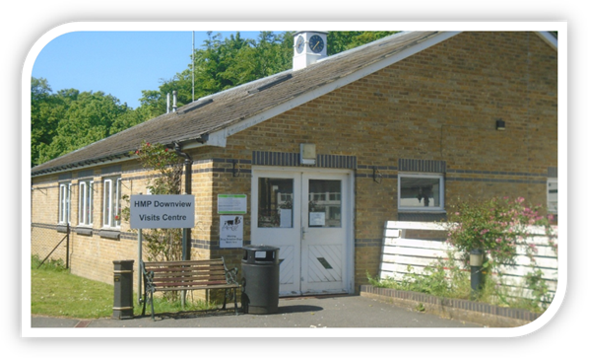

Social visits
Social visits are held on Thursdays, Saturdays and Sundays starting at 14:15 and ending at 16:15. To prevent unnecessary disruptions to visits we do have a cut-off point of 14:45 for those that may be running late. Anyone arriving after these times will unfortunately be denied entry. This is due to our security requirements to ensure that visits are conducted in a safe and enjoyable manner and to help prevent the ingress of unauthorised items such as drugs. This enables us to maintain a safe environment for our staff and your loved ones.
The social visits hall is furnished with tables and chairs in which to facilitate the visit as well as a children’s play area and a tea bar for refreshments. There is also a Family Room which can be requested prior to your visit. The Family Room is well equipped with children’s toys, books, soft furniture and table-based activities and offers a discrete space away from the main Visits Hall. The application process for access to the Family Room is detailed in Annex A – Family Room Policy.
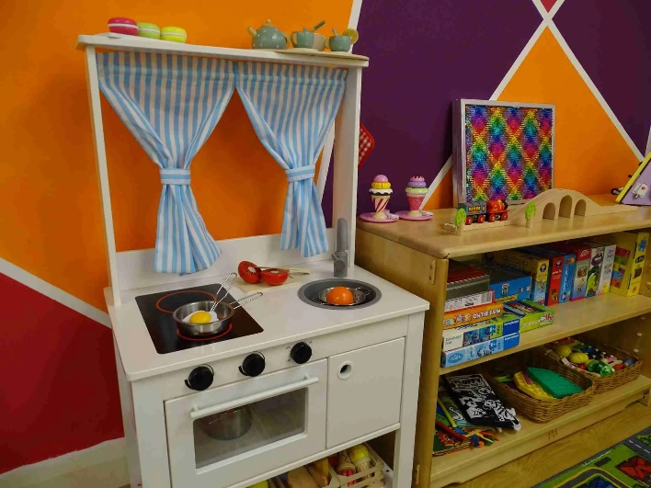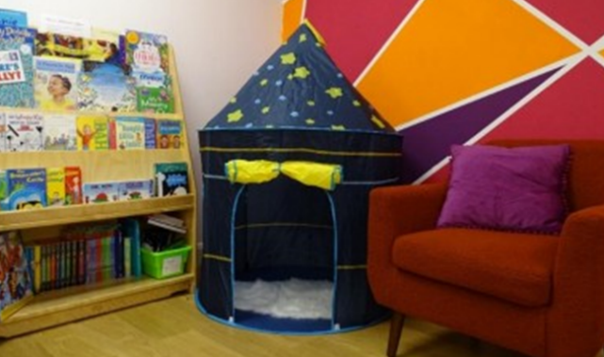
Family room –
refurbished by Change Grow Live

There are several other ways to contact someone in prison if you are unable to visit them. You can:
- leave a voice message using the Prison Voicemail Service
- send them an email using the email a prisoner service
- write to them
- Secure video calling is available at this prison. Family and friends need to download the ‘Prison Video’ app, create an account, register all visitors, and add the prisoner to their contact list.
You can also contact the Prisoners’ Families Helpline on 0808 808 2003.

Book and plan your visit to Downview
To visit someone in Downview you must:
- be on that person’s visitor list
- book your visit in advance
- have the the required ID with you when you go
At least one visitor must be 18 or older at every visit.
There may be a limit to the number of visits a person can have. You can check this with Downview.
Contact Downview if you have any questions about visiting.

Help with the cost of your visit
If you get certain benefits or have an NHS health certificate, you might be able to get help with the costs of your visit, including:
- travel to Downview
- somewhere to stay overnight
- meals

How to book family and friends visits
You can book your visit by telephone. There is no online booking service available.
Booking line: 0300 303 0633
The booking line is open: Monday to Friday, 9:15am to 4pm
Find out about call charges
Visiting times:
- Thursday, Saturday and Sunday: 2:15pm to 4:15pm

Getting to Downview
Find Downview on a map
The closest railway stations are Belmont and Sutton.
To plan your journey by public transport:
- use Transport for London journey planner
- use National Rail enquiries
There is a large visitor’s car park with ample parking, including spaces for Blue Badge holders.
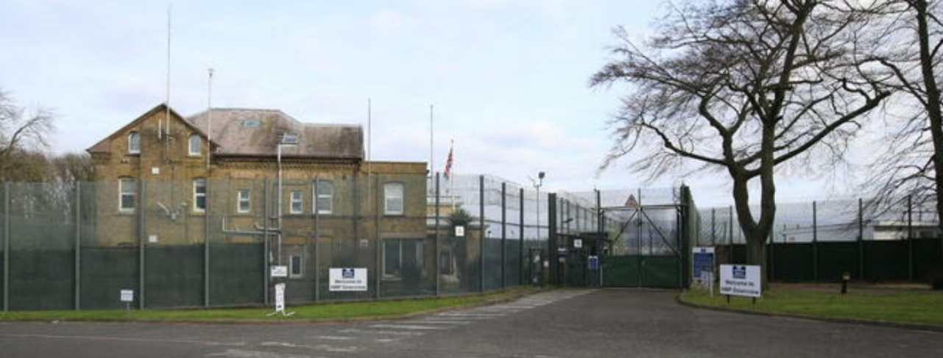

Entering Downview
When you first arrive at Downview, head to the visitor’s centre (directly opposite the prison) to sign in. The staff will direct you from there.
All visitors aged 16 and older need to bring one of the following types of photo ID:
- passport
- driving licence
- benefit book
- senior citizen’s public transport pass
- annual public transport season ticket (with photo card)
- employer ID card (if it shows the name of the visitor and the employer)
- European Community identity card
All visitors will be given a rub-down search, including children. You may be checked by a security dog. These dogs are passive and detect drugs using their sense of smell. You will also have to go through a metal detecting portal unless you have a doctor’s note. This is similar to airport security.
There are some restrictions on what you can take into the prison. You will be provided with your own locker if required to place any items in. You will also not be permitted to bring in items such as pushchairs and car seats (we have a pushchair, high chair and changing facilities for use within the visits hall), these will need to remain in your vehicle or in the visits centre. Visitors attending with young babies are allowed to bring in one bottle of milk and/or baby food. Additional milk and nappies are provided within the Visits Hall free of charge if needed.
Snacks and refreshments can be purchased from the Tea Bar in the Visits Hall. The Tea Bar is cash only. Visitors can only purchase snacks and refreshments for themselves, other people they are visiting with and the prisoner they have come to see. It is not allowed to purchase or give food and drink to a prisoner you are not visiting, even if you know them.
The rules of visitation will be explained by a member of staff at the start of your visit. If you break the rules, your visit could be cancelled, and you could be banned from visiting again. It is our aim to ensure visits are not disrupted and are enjoyable for all.

Who can visit an adult prisonER
To visit someone in an adult prison, you must be:
- aged 18 or over, or under 18 accompanied by an eligible adult (see Visiting an adult prison, YOI or STC in a group)
- a partner, parent, sibling, child, foster-parent, grandparent, carer or significant other of the person you are visiting, or an individual on whom the person in prison relies on for emotional support.

Visiting an adult prison, YOI or STC in a group
Only visitors named on a Visiting Order will be allowed to enter the prison. (See next section to find out about Visiting Orders). Although you can bring to the visit any number of children who are related to the prisoner, the presence of fixed furniture or other restrictions might make seating arrangements extremely difficult. For this reason, if there are more than three people of any age visiting at the same time, please ensure that you alert prison staff when booking your visit. This is so that arrangements can be made to accommodate them. Visitors under the age of 18 years must be accompanied by an adult. However, in exceptional circumstances and with prior agreement, Governors may allow young people between the ages of 16 and 18 years to visit on their own.
A children’s play area is usually open and supported by a children’s play worker. Mothers can access this area with their Children. Children and visitors can bring toys, books and colouring material back to the table. You can also follow @HMPPS on Twitter and read our rolling update page for the latest updates.

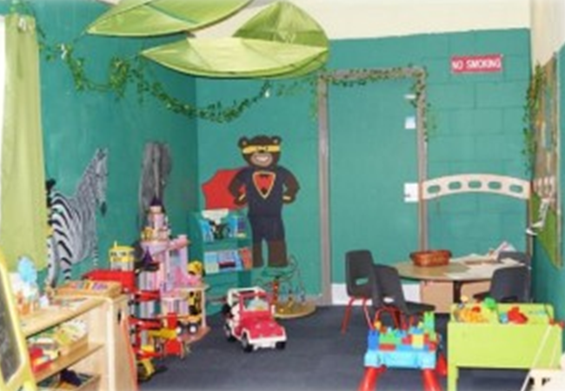
Refurbished Family and Visitors’ Centre (above) and refurbished Visits play area (below) by Pact.
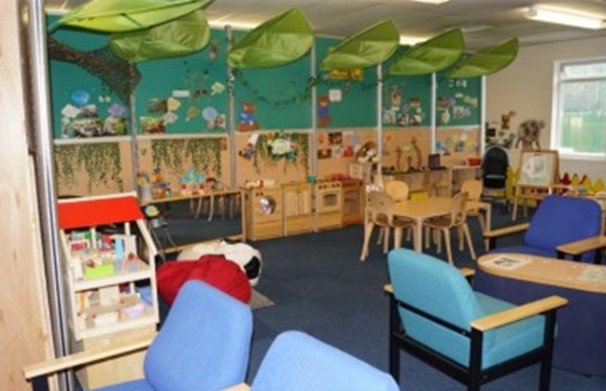

Working in partnership
In order to provide the highest service standard we can, we are committed to utilising a ‘whole prison approach’ to families and significant others work. As such we are committed to working with both statutory and voluntary service providers as well as the families and significant others our women hold important relationships with.

Pact – Our Family Services Provider
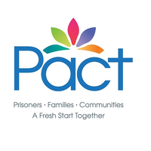
The Prison Advice and Care Trust (Pact), based at HMP/YOI Downview, is a national charity that provides support to women in prison, and their families. They aim to support people to make a fresh start, and minimise the harm that can be caused by imprisonment on people who have committed offences, on families and on communities.
In October 2022 Pact were successful in a bid to provide family services to HMP/YOI Downview.
The PACT team at Downview are a small team of staff who carry caseloads varying from healthcare related support to resettlement casework, and support for those women who have been released into the community.
More information on Pacts service at Downview can be found at https://www.prisonadvice.org.uk/hmp-downview
Pact are contracted to deliver the following services;
- Visits meet and greet.
- Visits centre and visits room refreshments (delivery of service only).
- Family support staff do an integrated role and also act as Children’s play workers in both visitor’s centre and visits room.
- Visits enrichment activity – inclusive of special visits, themed visits, homework club.
- Family visit days – Delivery of family focussed days to promote the development of children and build positive family relationships. Alternative days such as adult days.
- Work with local parishes and agencies to ensure children receive presents during the festive period.
- Storybook mums
- Services for prisoners without contact with family and significant others, running monthly wellbeing groups, offering crafts and refreshments. A befriending team offers external support to families too.
- Family engagement and advice.
- Family learning.

Pact can also be contacted on the Family helpline.
Details are below:
Prisoners Family Helpline: 0808 808 2003
Monday – Friday
9:00am – 8:00pm
Saturdays and Sunday
10:00am – 3:00pm.
New PACT Family Resettlement Support Service
PACT is trialing a new family support service at HMP Downview. Residents with between 4-12 weeks left to serve on their sentence are eligible for support with any family issues that they are facing. As part of this service, PACT can offer support for a number of different circumstances. These include:
- Supporting those who are returning to live with children in the family home - PACT can help to rebuild and strengthen family relationships and assist in making the return to the family home as smooth as possible.
- Supporting those who have parental responsibility for their children but will not be living with them - PACT can assist with strengthening relationships with family and children and help support you with making custody arrangements that benefit both you and your children.
- Supporting with other forms of contact with children such as letterbox arrangements
- Support with other relationship concerns, with adult children /parents /partner /other family members.
This support can continue post release, and PACT will aim to contact all of our resettlement service users post-release, whether that be in person, by phone or video call.
PACT also run family forums, mediation and have staff trained in using a trauma informed approach. They also provide support through family court, initiating contact, liaising with social services as well as help writing letters and welfare grants too.

Please do speak to a PACT member of staff if you have a family member who you think would benefit from the service.

The Forward Trust
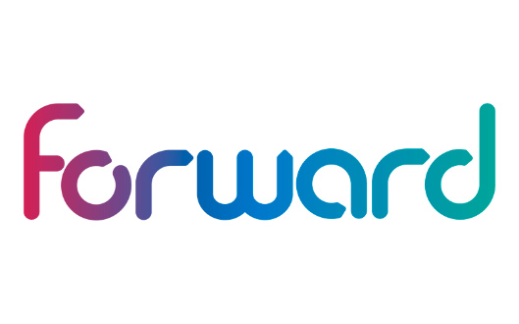
Forward Trust have a Family Worker who works closely with the Family Support Coordinator at their Head Office. The Family Worker will be responsible for delivering family work interventions to our service users alongside PACT. Duties include providing advice, support, signposting and guidance to families/carer, coordinating and developing family/carer work with an emphasis on supporting families/carers, identifying service users' needs, working closely with the prison and local agencies, providing pathways for clients and families to increase their engagement in family life, improving their health and well-being and reduce re-offending and carry out one-to-one and run the Family Ties Workshop. This focuses on parental responsibility, maintaining contact, and healthy relationships.

Forward Trust work alongside NACRO who provide the following workshops; Dealing with child removal, Healthy relationships and Family life among others.

Not beyond redemption
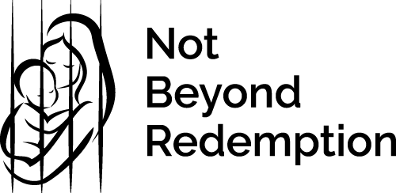
Not Beyond Redemption (NBR) provide free Family Law advice and representation to mothers in prison, or who have left prison, to assist in re-establishing and regenerating the fundamental relationship between mother and child.
At Downview this is provided through a monthly surgery with NBR’s assisting Lawyers team. Referrals are made by the family services provider.

extended visits and family learning
At HMP Downview we run extended visits often referred to as ‘family days’. These allow an opportunity for families and significant others to spend an extended period of time together and take part in activities that wouldn’t ordinarily be available on a visit. We are committed to delivering these alongside family learning provision to aid reintegration into families and the building of positive relationships. Our aim is to develop a plan to provide the opportunity for our women to have independent life experiences with family such as cooking a meal for their children. We intend to run a minimum of 12 extended visits per year including both child and adult specific days. We aim to host child focused family days during the school holidays to maximise attendance and prevent disruption of learning. Family days generally run between the hours of 1000 and 1600 and include refreshments. Downview and its partners seek to source and provide age appropriate activities for families to enjoy and interact with the loved ones. These are held either in our visits hall or gymnasium hall.

departmental support / gateway communication

Reducing Reoffending
The Head of Reducing Reoffending is Zoe Kottler, and she is responsible for the delivery of Family Services and this strategy. The Reducing Reoffending department oversee the interventions and services that support women in prison in improving their futures. In collaboration with other departments and partner agencies we aim to identify each resident’s individual needs and provide opportunities and support for them progress into crime free lives on release. This includes, Education and Skills development, Offending Behaviour Programmes, Employability and Work Experience, Family Services, Resettlement, Finance and Debt, Substance Misuse, Domestic Violence, Physical health, Wellbeing and regime delivery.
Our ambition is to a lead a joined-up approach to family engagement ensuring that its importance is recognised in everything we do. The delivery of family services is jointly managed along with Keiran Mungroo, Head of Operations. The impact of family and significant other support and engagement cannot be understated whether it is to support resettlement, promote wellbeing and safe behaviours or encourage learning.
Day to day operational oversight of family services delivery is carried out by a designated Custodial Manager, and Family and Significant Others champion, Ian Keetley
The key responsibilities of the Families lead are:
- Single point of contact for and oversight of the establishments Family Offer.
- Ensuring the establishments Families and Significant Others Strategy is fit for purpose.
- Local lead for completion of the Family and Significant Others performance measure.
- Contract management for family service providers.

Chaplaincy
Chaplains see women in prison in their induction interview, visits to landings, places of work and in response to request for pastoral care. In these conversations, family related issues/concerns are frequently raised and where appropriate, action is taken. The Chaplaincy is also regularly contacted by family members with regard to a variety of family issues including the serious illness or death of family members, as well as with concerns and/or requests for details regarding their relatives in custody. Chaplains respond to queries and concerns raised in these encounters in accordance with local prison policy. Actions taken includes referral to other departments such as Safer Custody and Health Care and signposting to partner agencies for example those offering counselling.
Sycamore Tree, Understanding Loss and Forgiveness, ID Essence suite of programmes, Flourish and Making Connections, faith studies/services provide the opportunity to work intensely with individuals in ways that can contribute to/enhance resettlement.
Chaplains regularly attend Visits, Family Days and the Visitor Centre and engage with both women in prison and their families; Chaplains also participate in strategic meetings in support of women in prison and their families.
Moving-on a through the gate escort scheme provided by Chaplaincy using volunteers is integral to the through the gate support that Downview offers. Making Connection a National Council for Voluntary Organisations approved resettlement programme that is offered in the near future will enhance effective resettlement in the community by working intensely with women in prison before and after release.
Regular checks to identify those who have not received visits for a period of time enables the offer of appropriate support to individuals which can contribute to the rebuilding of family ties. In addition the OPV –Official Prison Visitors scheme, where volunteers visit women in prison in the normal visits setting which is offered through the Chaplaincy can contributes to the rebuilding family ties and resettlement. Chaplaincy also facilitate access to a Family Tracing Service offered by the Salvation Army.
The Chaplaincy Team will endeavour to respond to queries as soon as we are able.
Contact details are as follows:
Telephone: 0208 196 6314 –Please leave message on voicemail as appropriate
Team Email: chaplaincy.downview@justice.gov.uk

Safer Custody
It is important to ensure that all family and significant other’s details are recorded on transfer into HMP Downview; equally, it is important that these details are kept up to date.
The prison service recognises how important maintaining family ties is.
Maintaining contact with family’s and significant other’s relationships during any custodial sentence is recognised as one of the key support processes that help to maintain the wellbeing of the women in our care. It also helps with their mental health, reducing the risk of self-harm and any possible negative behaviour. Having the support of families and friends has such a positive effect. Giving hope for a brighter future.
There are some prisoners in our community who do not have family or significant others, and as a result do not have visits or contact with the outside. These individuals are at risk of becoming isolated, and it is critical that these individuals are identified and then made known to the family support worker with the Forward Trust, or Prison Offender Manager (POM) also to the Safer Custody team. In addition, discussions will take place with the Chaplaincy team to establish if the individual could engage with an Official Prison Visitor.
It is so important to try and engage with families and significant others when their loved ones are in any crisis.
It is not uncommon for us to utilise family contact for women in prison who may be suffering from suicidal thoughts or patterns of self-harm, or even those who demonstrate high levels of violence to see if having family input can have a positive impact on an individual’s behaviour. Prisoners in crisis can find it hard at times engage within an Assessment Care in Custody Teamwork (ACCT) document review. This is a document with the purpose of keeping them safe and supporting them through a period of crisis. By agreeing with us and when required we would like to invite a family or significant others to attend these reviews. It can be a positive tool in which you can show your support to your loved one and will assist with this process and help keep everyone safe.
We promote the use of Listeners and Samaritans within prison for those who find things tough and we also have a hotline (02081966370) for concerned members of the family to contact and raise their concerns. Families can also write to the Governor if they feel strongly about any issues that may arise and these letters will be responded to by an appropriate manager. As well as writing and phoning, there is an email service available whereby concerned family members can make contact with the Safer Custody team, this email address is SaferCustody.Downview@justice.gov.uk and is monitored by the Safer Custody administration team.
We will continue to promote the input of families within individual’s patterns of behaviour and thought processes as we believe this can only have a positive impact on an individual’s time at HMP Downview.

offender management
Downview offers the opportunity for suitably assessed women in prison to spend time with their family in the community using Release on Temporary Licence (ROTL). There are several different forms of ROTL that allow temporary release for up to one day (Resettlement Day Release or RDR), overnight (Resettlement Overnight Release or ROR), for childcare purposes (Childcare Resettlement Leave or CRL) or in exceptional circumstances (Special Purpose Leave or SPL).
Women in prison can apply for ROTL if in open conditions or at any point in sentence if applying for Childcare Resettlement Leave (CRL). This will be discussed with their Prison Offender Manager who can advise about the process, timescales and any information that may be needed. A series of checks will then be conducted to ensure that it is safe for the individual to be released on ROTL. Once this process has been completed, then the resident will be supported to use the time productively, including helping them to maintain or rebuild their family ties in a more normal environment than a prison visits room. Initially this will be for a shorter period but over time can progress to overnight stays at the family home if this is assessed as suitable.
More information about ROTL, its purpose and the processes around it can be found at:
https://assets.publishing.service.gov.uk/government/uploads/system/uploads/attachment_data/file/863600/rotl-pf.pdf

Equalities
The Equalities Team promotes diversity and inclusion in everything we do in Downview. The team manages all complaints regarding any allegations of discrimination and ensures that every allegation is investigated correctly using a form known as a DIRF (Discrimination Incident Reporting Form) We also organise regular events to celebrate diversity including religious festivals, cultural celebrations, and international recognition days such as International Women’s Day.
Pregnancy and Maternity are defined as a protective characteristic with Senior Leadership oversight and as such there is additional safeguarding against discrimination on these grounds.

Pregnancy and Mother and baby Liaison Officers (PMBLO)
HMP Downview has a dedicated lead for Perinatal & Women’s Health. Her name is Jana Smith.
Prisoners who have been pregnant in the two years before arriving at HMP Downview or have a child two years or under in the community are identified as being on the perinatal pathway. HMP Downview has two dedicated PMBLOs available for women to talk to or request information from. When a perinatal woman arrives in HMP Downview, she is referred to a PMBLO who will visit her while she is on the Early Days In Custody (EDIC) unit. Women on the perinatal pathway are eligible for additional support through Pregnancy and Mother Baby Liaison Officers (PMBLOs). This is a signposting and support service for perinatal needs including mental health, bereavement services, applications for Mother and Baby Units, visits, breastfeeding, and aiding perinatal women during their time in HMP Downview.
If a woman has a child under 18 months old in the community, they are eligible to apply for a position on a Mother and Baby Unit where they can reside in a specialised unit built for mother and children to nurture their bond and child development. For more information about MBUs, you can request to speak to a PMBLO.

Healthcare
We always seek where possible to include family members and/or carers views and concerns when planning care and treatment for women in prison at HMP Downview. We will ask for a person’s consent, and respect and uphold an individuals’ legal right to medical in confidence, before any communication with family and carers and where this consent is given, we may seek to include views and input with care and treatment planning, ACCT reviews and where an individual may require external healthcare facilities.
We also encourage families and carers to complete our Families and Friends survey, which can be found here:

https://www.oc-meridian.com/cnwl/completion/custom/default.aspx?slid=71&did


developing innovation and best practice
We are always striving to improve our offer and as such have a number of processes in place to review how we are doing, encourage innovation and identify best practice. These include the following commitments:
  - Hold two visitor surveys per year, these will be produced by leaders across the establishment services, and the results and outcomes will be published for staff, prisoners and families. Families will be able to view these displayed within the visitors centre.
  - Quarterly meet the Deputy Governor and/or Head of Reducing Reoffending and Head of Operations, surgeries in the Visitor Centre or Visits Hall.
  - Maintain Visits as an agenda item on the Downview forum (a prisoner consultative committee) allowing ideas and suggestions to be made regarding prisoners perception of visits and improvements they would like to be made to enhance the family experience. This focus group will also look at all current work streams that relate to strengthening family bonds.
  - Maintain effective communication with other establishments Family and Significant other leads to discuss best practice and new opportunities.


care experienced/leavers
Care leavers and care experienced women in prison are those women who have spent any amount of time in the care of a local authority. The national figure indicates that up to at least 25% of women have had some experience of being in care at some point in their lives. The majority of these women will have experienced trauma. Our local strategy indicates the reported figure to be less than the actual figure.
Families support our women in prison in many practical ways. The survey and information from our partners highlighted one in three women return to live with family or friends after release. As Care Leavers are less likely to have family contact we know they are more likely to services around securing accommodation. The Community Rehabilitation Company will work with our Offender Management Unit to identify care leavers and address accommodation needs.
HMP/YOI Downview has a separate Care Leaver’s strategy and the lead for Care Leavers in the prison is the Head of Offender Management (HOMD) undertaking work to identify this group and will run specific focus groups to engage and understand how we can support them. Initiatives included on our action plan aimed at improving services to this group are;
Family days or extended visits for adults where care experienced women in prison can maintain positive relationships. 18% of women in prison report regular contact with someone who is not a partner or family member.
The majority of women in prison deem a family member or partner as the most important person in their lives and a smaller but significant group recognise a professional/significant other (for example a social worker, foster parent or legal representative) as an important person in their lives. We know contact with others has a significant impact on the well-being of our women in prison.
Our women in prison have reported many aspects of their lives have negatively affected their relationships. These may include factors such as; substance misuse, financial and health concerns before custody. We also recognise in most cases these issues continue to be a factor impacting on their relationships.
The initial experience of prison, for many visitors will be during their loved ones’ current sentence, as the majority of women in prison reported to us that this is their first prison sentence. The information we provide must not assume a prior level of knowledge therefore, we must prepare visitors with the practical details they need for a smooth visit.
Family days or extended visits for adults where care experienced women in prison can maintain positive relationships. 18% of women in prison report regular contact with someone who is not a partner or family member.
The Personal Advisor for Care Leavers can attend all visits sessions, and contact will be made with them to advise them of such following the initial interview process.

Safeguarding

Child safeguarding
The Child Protection lead for HMP Downview is the Head of Offender Management Delivery based within the OMU team. The lead has oversight of child protection cases held by the Prison Offender Managers (POMs) and acts as a point of contact for any staff member who has a concern relating to a child. Part of this role includes referring concerns to local multi-agency safeguarding hubs (MASH) and liaison with Social Workers. If a prisoner is identified as potentially posing a risk to children, a rigorous assessment process takes place in conjunction with children’s services to determine what level of contact (if any) with children should be allowed. Restrictions in place are monitored by the public protection team and security, some women in prison are subject to mail and phone monitoring to ensure they are complying with the restrictions placed upon them.

The Child Protection Lead forms part of Surrey Safeguarding Children Partnership (SSCP) and works collaboratively with its members to ensure child protection measures are adhered to within the prison. Every two years the SSCP invites its statutory partners such as Her Majesties Prison and Probation Service (HMPPS) to participate in audit, against the statutory requirements within Section 11 (S11) of the Children Act 2004. This audit was completed in November 2020 and the actions will form part of the Families and Significant Others Action Plan.

Adult safeguarding
Adult safeguarding in prisons means keeping prisoners safe and protecting them from abuse and neglect.

HMP Downview promotes the welfare of all prisoners, particularly vulnerable adults at risk, and protects them from all kinds of harm and neglect. Prisoners, particularly adults at risk, are provided with a safe and secure environment which protects them from harm and neglect. They receive safe and effective care and support. Indicators
• The risks to prisoners are recognised and there are guidance and procedures to help reduce and prevent harm or abuse from occurring.
• When abuse is alleged or suspected to have occurred, prompt and appropriate action is taken to protect the prisoner.
• An individual care plan is in place to address a prisoner’s assessed needs.
• Care plans are thorough and reviewed regularly, involving staff from a range of disciplines.
• Up to date government and local guidance about safeguarding adults is accessible and safeguarding procedures are known and used by all staff, including how to make referrals.
• The safeguarding policy and any prison codes of conduct are informed by the underlying five principles of the Mental Capacity Act 2005: ‐ a presumption of capacity ‐ the right for individuals to be supported to make their own decisions ‐ that individuals must retain the right to make what might be seen as unwise decisions ‐ best interests ‐ least restrictive intervention.
• Where possible, access to advocates and/or appropriate adults is in place to aid prisoners’ capacity to understand and consent.
• The prison training to staff of their duty to raise legitimate concerns about the conduct of an individual in relation to the treatment and management of prisoners.
• Staff feel confident and safe to raise concerns.
• Staff are aware of their personal and professional responsibility to protect adults at risk and undergo appropriate training.
• Staff are subject to recruitment and vetting procedures which comply with necessary legislation.

overcoming separation

Supporting relationships

Digital and technology – communication systems

- Prison Visits Video Calling – You can book and take part in a secure video call with a family member or friend in prison. Video calls last 30 minutes and can have up to 4 people on the call talking to a prisoner. All callers must be on the prisoner’s visitor list and the ‘main caller’ must be over 18. People under 18 can be on the video call, as long as they are on the prisoner’s visitor list. Every adult prisoner and young person in custody is offered one free 30-minute video call per month. The governor may allow additional calls for wellbeing reasons and in exceptional circumstances. More information is available at Secure video calls with prisoners - GOV.UK (www.gov.uk)

- Money to Prisoners Portal - The Money to Prisoners Portal, is the easiest way for prisoners to receive money from their friends and family. For families and friends who wish to send money to a prisoner, they should search “money to prisoner” online, or go to gov.uk Send money to someone in prison - GOV.UK (www.gov.uk). They will need to have the prisoner number and date of birth of the prisoner they wish to send money to.

- In-Cell Telephony – Downview has successfully installed a phone in every one of its cells meaning every woman has the facility to contact their family friends at any time they wish, phone credit allowing.

- Email a prisoner – HMP Downview allows access to the ‘Email a prisoner’ service. This can be accessed through www.emailaprisoner.com. Information on how up an account and the costs of messages is available on the website. Your message will be printed by the establishment and delivered to the recipient.

- Additional Pin credit requests – In the event of an emergency prisoners are able to apply to purchase additional pin credit outside of the weekly canteen ordering process.

- In an emergency Call 0208196 6300 if you think a prisoner is at immediate risk of harm. Ask for the Orderly Officer and explain that your concern is an emergency

Visits assistance
- Accumulated visits - Accumulated visits may be of particular interest to those whose families are located some distance from the establishment; in other countries or for those families who might be ineligible for financial assistance under the Assisted Prison Visits Scheme. A prisoner is eligible to apply for accumulated visits six months after transfer from the local prison to which he/she was sent on conviction, though earlier transfer may be possible in appropriate cases with the consent of the Governor. Prisoners may apply for further accumulated visits every six months, provided they have a minimum of six months to serve.
- Claim for help with prison visits - If you visit a family member, partner or someone who does not get other visitors you might be able to get help paying for:
  - travel to the prison
  - overnight accommodation
  - meals
You can apply to get help paying for visits that you:
  - have made in the last 28 days
  - want to make in the next 28 days
You must be getting certain benefits or have a health certificate to get help.
If you take a child with you or someone to help you (for example because you’re disabled) you might also be able to get help paying for their visit.
This can be applied for at Get help with the cost of prison visits - GOV.UK (www.gov.uk)

Inter-Prison

- Inter-prison visits – Visits may be allowed, on application, between close relatives (defined as a spouse/partner (including a person - whether of the same or different sex - with whom the prisoner was living as a couple in an established relationship immediately prior to imprisonment) parent, child, brother, sister (including half - or step - brothers and sisters), civil partner, fiancé or fiancée (provided that the Governor is satisfied that a bona fide engagement to marry exists), or a person who has been acting in loco parentis to an prisoner, or a person to whom the prisoner has been in loco parentis)- when both parties are prisoners at separate establishments. Prisoners may apply for inter-prison visits by submitting a general application to the Security Department explaining the details of why an inter-prison visit is being requested. All applications will be dealt with on merit, and if refused a reason provided in writing. Applications for inter-prison visits will only be considered once prisoners have spent a minimum of one month at Downview. In some circumstances, an inter-prison visit by video-link facility may be considered. Further details on Inter-prison visits may be found in HMPS Intranet - PSI 2011/16 - Providing Visits and Services to Visitors – Paragraphs 5.13 – 5.15.
- Inter-prison phone calls – Calls between family members within the prison estate are facilitated through inter-prison phone calls. These are by application and are screened by our Offender Management Unit and Security department. Where approved these are organised between establishments and carried out using the applying prisoners pin phone account.

Governance and delivery

Contract management (pact)
Through effective contract management we will ensure that our women in prison and their families are receiving the best possible service that meets their individual needs. In addition to responding to resident and visitor feedback we use the following assurance methods to meet our family offer:
- Quarterly performance reporting – Pact report to the Reducing Reoffending team with quarterly KPI data, trends, highlights and issues relating to the delivery of family services. We use this opportunity to both work collaboratively on future service improvements and ensure that current provision meets our high expectations.
- Local assurance – The Head of Reducing Reoffending is responsible for monitoring performance reports. The Head of Reducing Reoffending addresses any concerns and provides further assurance to the Governing Governor.
- Agenda item on monthly Reducing Reoffending Strategy meeting ensuring effective partnership work between other departments and stakeholders within HMP/YOI Downview.
- Specific Family and Significant Others monthly meeting with stakeholders to drive local action plan.

- Womens estate regional and local contract review meetings.

Family and significant others objectives/Action plan
Our objectives informed by our analysis of need and family offer are listed below. Our objectives will be monitored through the Family and Significant others meeting and reported through the Reducing Reoffending Strategic meeting and remain live as we progress.
HMIP 2021
- “Key recommendation: The prison should ensure that women receive sufficient support to help them maintain and develop positive relationships with their children, family members and other people significant to them.
In 2022 the Family and Significant Others contract was retendered. Using data and information gathered on the need of our women the Head of Reducing Reoffending developed a new high-level specification to better meet this need. The new contract went live in October 2022 and see’s a significantly improved and better resourced model then previously. This includes a FTE Family Engagement Manager, 2 x FTE Family Engagement Workers and a PT Therapeutic playworker delivering case work support to the women. This is expected to be fully mobilized by January 2023. The Forward trust also provide a FTE Family Engagement Worker for substance misuse affected cases. In addition, Not beyond Redemption provide free family legal support through monthly surgeries with their assistant lawyers team.

- “Almost half the population surveyed (47%) said they had a child under the age of 18. This figure was even higher (66%) in the prison’s own needs analysis, where 31% of women said they had caring responsibilities for children. However, family days and group-work sessions were no longer available, and the service provided by the Prison Advice and Care Trust had been reduced throughout the pandemic. Despite some remote work being provided, provision to help women stay in contact with family was not always readily available (see key concern and recommendation 1.35). The family practitioner from the Forward Trust provided a good level of one-to-one support and advocacy.”

PACT service has returned to onsite, face to face support and is better resourced to meet the needs of the women. Family days are being delivered and are contracted to be delivered at a minimum frequency of 12 per year. Group work session are limited through the family services provider however 1:1 work books are provided as our family/relationship courses by other providers.

- In the previous month, only 7% of prisoners said they had been able to see family or friends more than once during a social visit. At the time of the inspection, social visits had recently restarted, but uptake was low – the visiting experience had been badly affected by COVID-19 restrictions. Only 27 prisoners had had a social visit in May 2021, compared to an average of 204 prisoners each month before the pandemic. Visits took place for two hours on a Thursday and Saturday afternoon, and on a Sunday morning. Some women used the photography service from the Max Spielmann workshop, to have Report on an unannounced inspection of HMP & YOI Downview 27 photos taken of themselves and their visitors, which could later be purchased (see paragraph 1.41).

Visits were restricted nationally due to the Covid-19 pandemic. Visits are now running as normal on a Thursday, Saturday and Sunday in the afternoon. Sunday morning was moved to the afternoon due to low up take of the morning session. There is sufficient capacity for all women to have access visits. That said on 31/12/2022 there were 61 women at Downview that had not had a visit since their reception. This equated to 25% of the population. 75% (184) have accessed visits at Downview.

- Video calling was reasonably well used compared to other women’s prisons and central data found that in the month before our inspection, 124 calls were made by 72 individuals (33% of the population). Women reported that the technology sometimes froze, compromising the quality of the call.

