

HMP Wymott
Family & Significant Other’s Strategy
2026-27

VERSION CONTROL AND COMPLIANCE:

Date of Draft Copy: Date: __12__/___12__/_2025____

Date of Final Copy: Date: _09___/__02___/____2026_

Agreed at SLT: Date: __09__/__02___/__2026___

Date of Publication: Date: __09__/_02____/__2026___

This Strategy document is due for review: ……December 2026…………………… (Annual review)

STRATEGY AGREED BY:

_________________Kerrie Mclaughlin Date: _09___/__02___/__2026___
Head of Reducing Reoffending

_________________Anne Double Date: __09__/___02__/_2026____
(Head of Education, Skills & Work)
_________________Mahala McGuffie Date: _09___/__02___/__2026___
(Governor – HMP Wymott)

HMP Wymott Partnerships
______________________________________________________________________________


Education






_________________________________________________________________________________________


Industries








________________________________________________________________________________________

Library and Reading



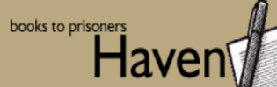




_____________________________________________________________________________________




CIAG and Resettlement
_____________________________________________________________________________________

HMP Wymott Partnerships
Healthcare


_____________________________________________________________________________________

Families and Visitors
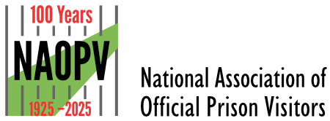









_____________________________________________________________________________________
Safety






Contents

Executive summary 3
HMP Wymott vision and our values 3-5

Working in partnerships 6

POPs - Our family service provider 8

Our key priorities and aspirations moving forward 9
Prisoner support and keeping in touch 10
Diversity, inclusion and belonging 14
Visits 17
Video call visits 19
Families and Significant Others days 20
Experience of care 22
Useful links and information 23

Executive Summary
Family & Significant Others Strategy 2026
HMP Wymott recognises the critical role that families and significant others play in rehabilitation, reducing reoffending, and supporting the wellbeing of those in custody. This 2026 Strategy sets out our ambitions, priorities, and delivery model for strengthening family relationships, increasing meaningful contact, and ensuring all prisoners regardless of background, circumstance or need can access support to build and maintain positive connections.

Our Vision
Grounded in Wymott’s values of Accountability, Compassion, Honesty, Integrity, Empowerment, Vision and Excellence, this strategy places families at the heart of our rehabilitative culture. By working collaboratively with partners, staff and prisoners, we aim to provide inclusive, safe and compassionate opportunities for relationships to thrive.

Strategic Priorities
Aligned with our SAR priorities, this strategy focuses on:
- Strengthening staff–prisoner relationships
- Developing prisoner-focused interventions
- Upskilling and professionalising staff
- Enhancing safety and resilience
- Maintaining and improving infrastructure
These priorities support the wider goal of ensuring that every prisoner can sustain meaningful family and social bonds throughout their sentence.

Partnership Working
We work closely with specialist organisations including POPS (our Family Service provider), Red Rose Recovery, New Bridge, Practice Plus, the Chaplaincy team and other voluntary and community groups. These partnerships enhance access to support, advocacy, activities, and emotional connection for both prisoners and their loved ones.

Key Achievements and Ongoing Developments
- Strong external recognition: HMIP (Dec 2023) identified children and families work at HMP Wymott as a notable area of good practice.
- Expansion of Family Forums and engagement mechanisms.
- Successful delivery of Family Days and themed events.
- In-cell telephony improving accessibility and privacy for daily contact.
- Increased support for those who do not receive visits, including PAT dogs, befriending services and social events.
- Enhanced provision for older adults, disabled men and those on the Haven unit.
- Continued growth in inclusive practice, including targeted support for foreign nationals, transgender prisoners, those with mobility needs and care-experienced individuals.

Visits and Digital Contact
HMP Wymott provides:
- Two social visits per month (plus one enhanced visit).
- Monthly video call opportunities, with priority for those facing distance, ill-health or mobility challenges.
- Upgraded visitor facilities, child-friendly spaces, and improved booking systems.
- New initiatives such as “Send a Selfie”, Raising Readers, and expanded children’s library spaces.

Survey feedback (April & October 2025) highlights the need for:
- More timely start of visits
- Increased awareness of Family Forums
- Continued stabilisation and improvement of video call technology
A dedicated Visits Team is being introduced to address these issues.

Diversity, Inclusion and Belonging
The population at HMP Wymott is diverse, including foreign nationals, older adults, transgender prisoners, ethnic minority groups, and individuals with care experience. This strategy embeds inclusive practice throughout all family services, ensuring:
- Accessible visiting arrangements
- Interpreter provision where required
- Inclusive search procedures
- Awareness events celebrating diversity
- Tailored support for care-experienced people

Resettlement and Safety
Family contact is integral to safety, wellbeing and resettlement. This strategy supports:
- Involvement of families during ACCT and CSIP processes
- Early and structured resettlement planning
- Collaboration between key workers, POMs and external agencies
- Access to safe channels for families to raise concerns
- Use of technology (including Zoom) for bereavement and important family events

Aims for 2026
Throughout 2026, HMP Wymott commits to:
- Delivering at least 12 Family and Significant Other Days
- Improving visit punctuality and visitor experience
- Enhancing communication via social media and centres
- Continuing Family Forums on a 2–3 month cycle
- Strengthening provision for those who do not receive family contact
- Monitoring and improving digital visitation quality
- Increasing inclusivity and removing barriers to engagement

Values

Together we can Achieve great things
- Accountability
- Compassion
- Honesty
- Integrity
- Empowerment
- Vision
- Excellence
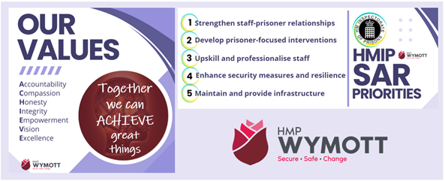

Our SAR Priorities

To strengthen staff – prisoner relationships
To develop prisoner-focused interventions
To upskill and professionalise staff
To enhance security measures and resilience
To maintain and provide infrastructure

SAR Priority | What this strategy delivers
Strengthen staff–prisoner relationships | Forums, keyworkers, engagement
Develop prisoner interventions | Family days, reading schemes
Upskill staff | Training initiatives
Safety & resilience | ACCT/CSIP family involvement
Infrastructure | Visits hall ongoing improvements

Working in partnerships

HMP Wymott aims to encourage prisoners to maintain family ties and to build better relationships with families and significant others to help reduce re-offending and reduce intergenerational offending. Good relationships between family members not only lead to a reduction in reoffending but also to the healthy development of any children in the family unit. At HMP Wymott we work in partnerships with other agencies such as POPs (Partners of Prisoners), Mothers union, Newbridge, Red Rose Recovery and Practice plus group to deliver findings of this review to support prisoners, their children, their families, and significant others and are actively working to improve and develop a family centered focus to the services we provide.
.

Family Significant others and Reading
Wymott has a reading strategy that is at the heart of education skills and work and family and significant other pathways. Reading for purpose, pleasure and rehabilitation is at the core of Wymott’s ethos
Family engagement plays a vital role in supporting rehabilitation, maintaining positive family relationships, and promoting a culture of reading that extends beyond the prison walls. Our partnership work with the Family Liaison Team ensures that reading remains at the heart of Family Days, domestic visits, and activity within the Family Visits Centre. This approach provides meaningful opportunities for children and their parents to connect through access to high-quality, age-appropriate books, shared stories, and literacy-based activities.
Our Family development Worker ensures that reading is embedded across all domestic visits and Family Days and that this engagement extends beyond visits, creating continuity between families and the wider community. An example of this is the promotion of Raising Readers: Share a Story, a parent-and-child reading initiative at HMP Wymott. Through this scheme, prisoners are able to send new, age-appropriate books to their child or children. Parents also receive a free copy, enabling them to enjoy the book together over the phone or during video visits.
During domestic visits, book-themed tabletop activities are available, including activity packs and reading- and writing-focused tasks. These include letter-writing activities themed around texts such as My Dad’s a Superhero, encouraging creativity, literacy, and emotional connection.
For every visit, whether domestic or family-focused, the ages of children attending are checked to ensure that appropriate books are available for them to access and, where possible, take away. This is delivered in liaison with the Give a Book charity. In addition, bilingual books are available through our links with Lancashire County Council Libraries.
Reading areas are provided in both the visits hall and the Family Visits Centre, equipped with beanbags and a wide variety of books and text types. Families are also encouraged to send books into the prison for prisoners, with all items monitored and supported through the Family Liaison Worker.
Family Days frequently include reading-focused events. Recent sessions have featured Rogan Mills, a local storyteller from Chorley. His interactive storytelling sessions, funded through the Tea Bar budget, have been highly valued by families and have encouraged both parents and children to experience reading as an enjoyable, shared activity.
We work closely with BookTrust, who supply children’s reading packs to support early literacy and ensure that children visiting the prison have access to high-quality books. Our Raising Readers scheme further strengthens these connections by providing matching books to both parent and child, enabling them to read together during visits, phone calls, or video visits. Books are exchanged at each visit, promoting continuity, shared interests, and positive communication between families.
The establishment also benefits from the Storybook Dads programme, which allows prisoners to record stories that are sent home to their children. Storybook Dads also provide activity packs and reward charts so that both parent and child can track progress together. This helps fathers feel meaningfully involved in their child’s learning, development, and home routines.
To further enhance the experience for children visiting the prison, a children’s library has been introduced in the Visitors’ Centre. This space enables children to choose and exchange books at each visit, creating a welcoming and familiar environment and helping them distinguish between social visits and Family Day events. A dedicated reading corner in the visits hall also provides a calm, engaging space for shared reading during visits.
Through the support of Give a Book and in partnership with BookTrust, we receive donations of books for every Family Day. These contributions allow us to sustain existing schemes, expand reading opportunities, and ensure that each family attending has access to high-quality books to take home. Any surplus stock is reinvested into wider reading initiatives, supporting consistent access to reading materials across the establishment.
Together, these initiatives ensure that reading is not only a rehabilitative tool for the individual, but also a meaningful bridge between prisoners and their families- strengthening relationships, supporting child development, and promoting positive engagement with learning for the whole family.

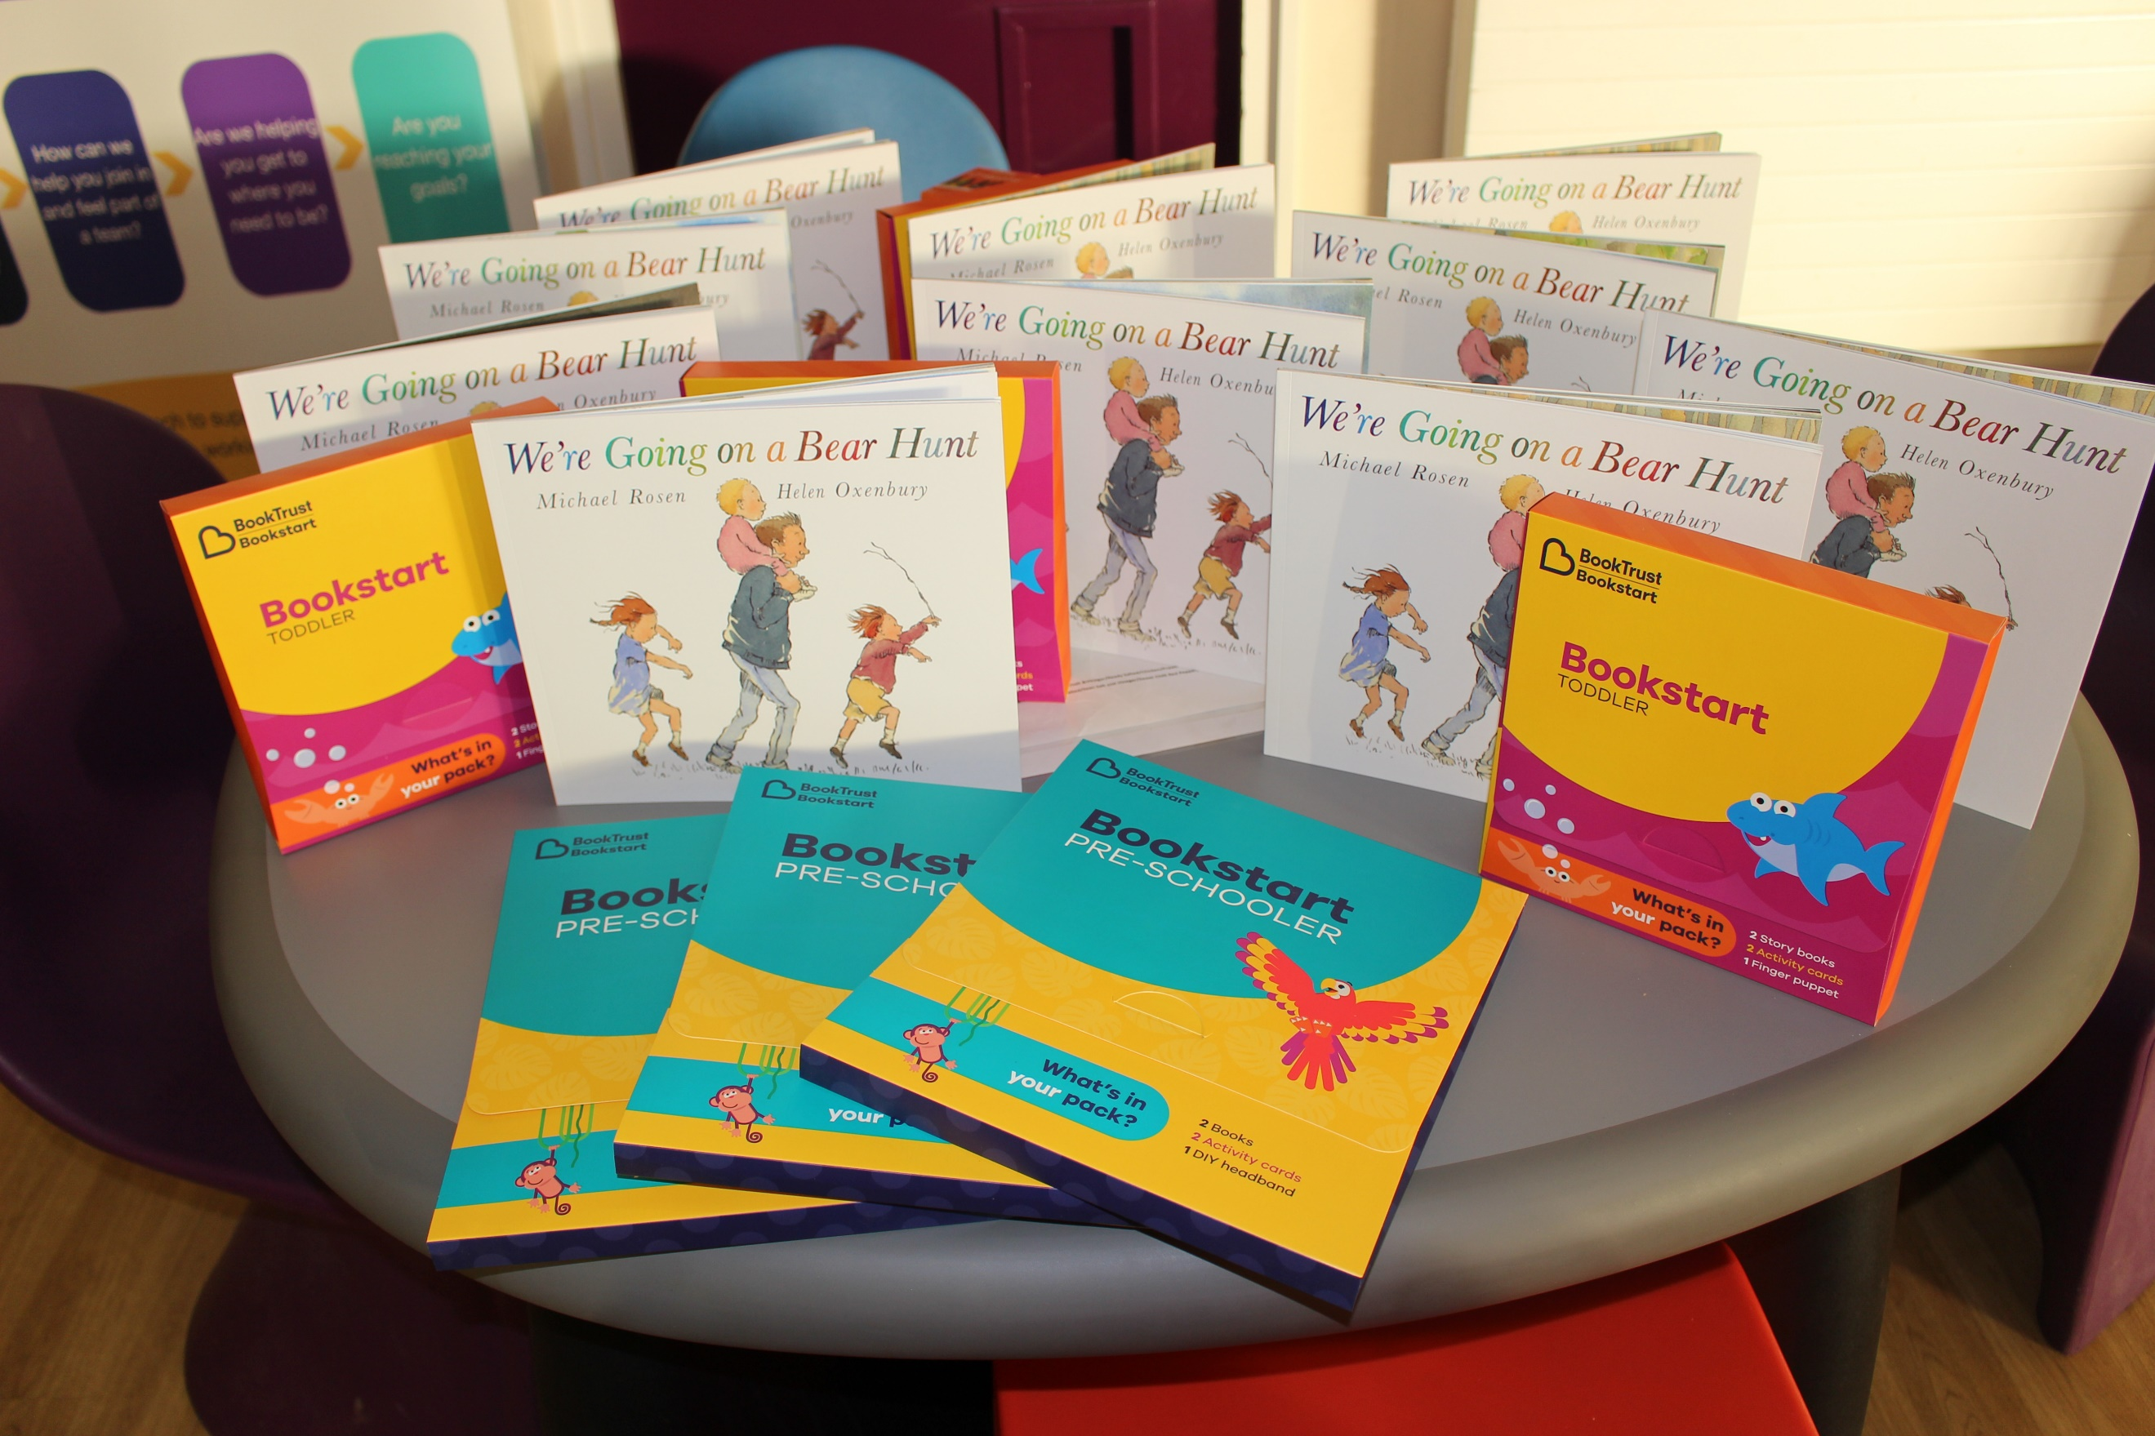
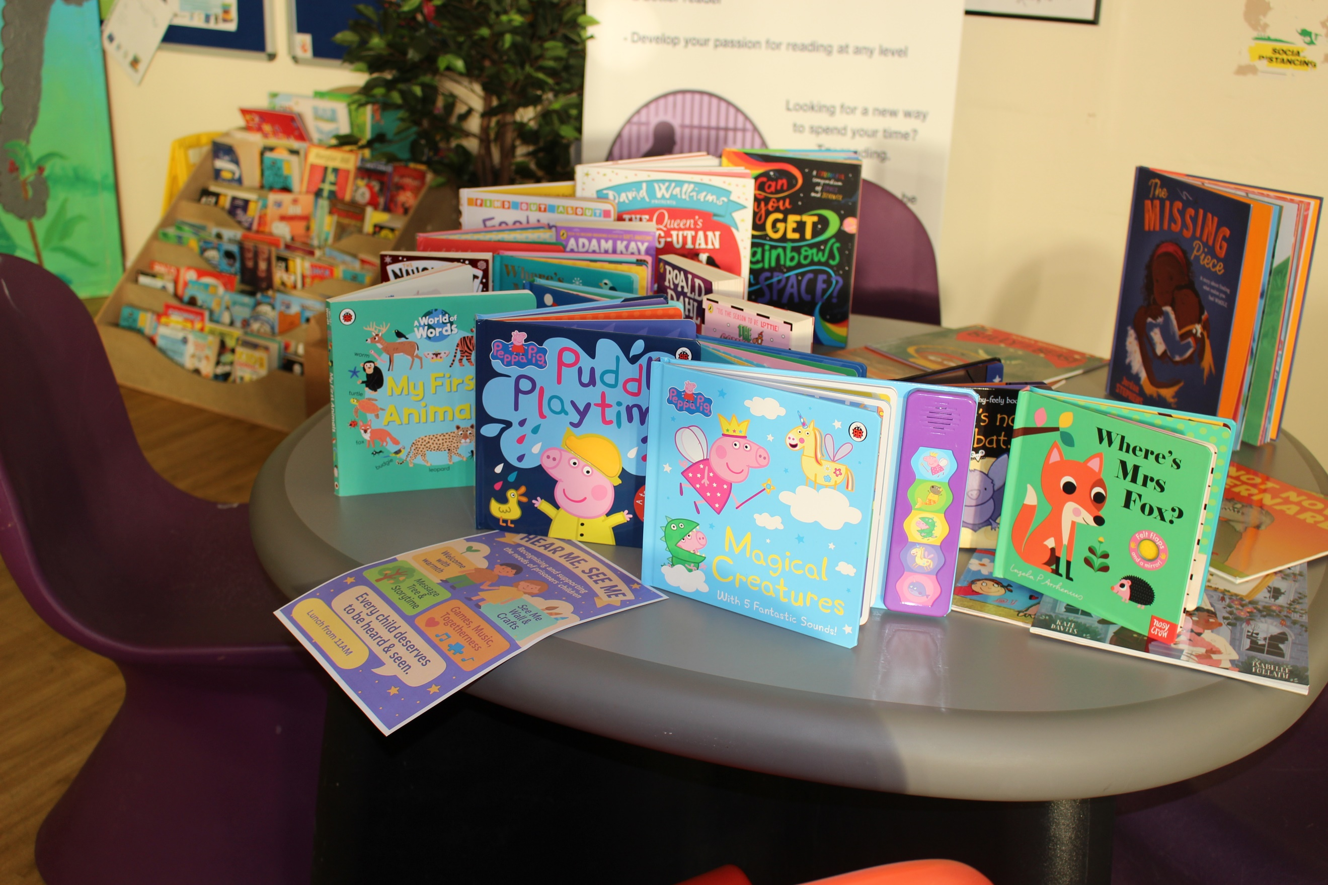

Our Family Service provider
POPS (Partners of Prisoners & Families Support Group), is a user-led organisation, supporting families through their contact with the criminal justice system as a result of a loved one’s conviction. We aim to help individuals overcome stigma, understand their identity, build self-confidence/skills and contribute to a more cohesive society. POPS’ work:
- strengthens and rebuilds family ties
- creates safe spaces for families and under-represented communities to speak out about the issues affecting them
- increases public awareness of the impact of the criminal justice system on family life
- builds strong links with communities
- advocates for changes in public policy and commissioning
POPS provides a range of prison-based and community-focused services, including:
- Court-based family support
- Family Support Services delivered at 15 prisons across the North-West and Yorkshire
- ‘Through the Gate’ support for people in prison and their families across Merseyside and Greater Manchester
- Community-based support for women through the Farida Women’s Centre (Oldham)
- Community-based support for men on probation through the Welfare Programme (Oldham & Manchester)
- Prison and community-based education programme’s including POPS’ Fresh Start for Families’ course
- Awareness training for professionals
- Community-based interventions for prisoners from BAME backgrounds
- Advocacy and support for under-represented communities.

POPS are committed to building a continuum of care to support families at every step of their journey through the criminal justice system.

Our key priorities and aspirations moving forward

- Continuing to hold Family Forums held in partnership with POPS, focusing on awareness to families of their existence.
- A range of Family Days facilitated by partners and stakeholders for a range of prisoner groups.
- Visits and support for prisoners who do not get family visits, in partnership with Red Rose Recovery
- Utilising Pets as Therapy (PAT) dog visits for prisoners who are identified as socially isolated
- ‘Send a selfie’ scheme to enable prisoners to reassure their family members when appropriate and photographs during visits for prisoners’ birthdays
- Engagement with community events and activities (e.g., Charity fund-raising activities)
- Continue to encourage reading between prisoners and their children by using the recently introduced children’s library, and a continuing development of the “Raising Readers” scheme
- We are currently working with the Education Department to develop a ‘Reading Connects Us’ Family and Visits Hall Focus Display, celebrating the National Year of Reading. This will be artwork centred on reading as a shared experience between prisoners and their families. Artwork prompts may include: Reading to a child; a letter written about a book; a memory of being read to or an imagined future moment of reading together.
- We are also developing a staff and prisoner book club, with plans to extend this to families to create a Community Book Club. This will involve all participants reading the same texts as part of an eight-book challenge.
- In addition, we are exploring the introduction of a Saturday Homework and Reading Group, which will support prisoners to engage with and assist their children’s reading and homework monthly.

Lord Farmer published his report on Prisoners Families in August 2017. In his summary he said… ‘The Ministry of Justice’s own research shows that for a prisoner who receives visits from a family member the odds of reoffending are 39% lower than for those who do not. Yet the clearest finding from my work – and the conclusion of Her Majesty’s Inspectorates of Prison and Probation and others – is that there is an unacceptable inconsistency of respect for the role families can play in boosting rehabilitation and assisting in resettlement across the prison estate.’
HMP Wymott has made great strides over the last few years with an excellent relationship with our family service provider and our dedicated Family Services Development worker. We aim to offer visits when possible, and to communicate openly with families and significant others and to offer assurance. We are aware that efforts to facilitate positive family relationships help to foster hope, maintain wellbeing, and encourage change. We believe that our family support work is a priority as it underpins other aspects of our support for prisoners.
Our Family Services team continuously look to improve the experience of families visiting Wymott, those supporting their families in prison and those prisoners for whom there are no immediate family support in place. We have held several successful events for prisoners who don’t receive visits, and a regular schedule for others is in place.
The latest HMIP inspection of Wymott in December 2023 found that our children and families work was strong, the report also highlighted that our program of family events was notable positive practice.

Prisoner support and keeping in touch

Aim | To ensure that every prisoner at HMP Wymott has access to the services they need to in relation to families and significant others.  To ensure all prisoners, whatever their struggles, are given the opportunity to receive support from their loved ones during the ACCT (Assessment, care in custody and teamwork) and moving forward the CSIP (Challenge, support, and intervention plan) processes.  Plans for resettlement are delivered at an early stage to ensure all prisoners receive the support they need for release. We also hold resettlement boards with prisoners prior to release.
HMP Wymott as an establishment understands and recognises the power and influence that family relationships have in reducing the risks of re-offending. As part of induction the establishment aims to empower men to take advantage of the support and initiatives that are in place to strengthen and build family ties.  A prisoners resettlement journey begins on arrival and continues through their sentence. Regular communication with identified key workers, the Offender Management Unit for sentence planning and an identified Prison Offender Manager all work in collaboration to identify outstanding resettlement needs and to allow them to plan their time at HMP Wymott constructively. |  | Background
Needs Data | The current population at HMP Wymott is a total of 1169 at time of writing.  We have recently received feedback from the prisoner and visitor family and significant others survey which was completed in April 2025 and October 2025.  All prisoner’s resettlement needs are discussed prior to the prisoner leaving Wymott. This meeting takes place 12 weeks, 8 weeks and 4 weeks prior to discharge.  The visitors survey identified that Wymott needs to continue to raise the awareness of the family forums. There is also still some work to do on visits starting on time 21% of respondents felt they didn’t. The prisoner’s survey was lower only 16% said visits didn’t start on time, and responses had declined slightly since the last survey.  The prisoners survey highlighted the issues with video visits, but these are now resolved although October results raised some issues with the quality of these visits.
- In collaboration with the Safer Living Team any prisoner currently being supported by the ACCT (Assessment, Care in Custody and Teamwork) process is given the opportunity to receive additional support from their family and significant others.  If you have a concern that there is an imminent risk of danger to a person in our care and you wish to speak to a member of staff to raise this concern, then you can call the switchboard:  01772 442000 or out of hours 01772 442020  The member of staff answering the phone will not be able to discuss the person in our care with you, but they will immediately pass your concern onto a senior member of staff to action. We aim to address any issues raised on the call immediately and will let you know what the outcome is.  If you are concerned about the safety or wellbeing of any person in our care at HMP Wymott but there is no immediate threat or danger, then you can leave an answerphone message for the Safer Custody Team on:  0800 496 1481  This voicemail service is checked numerous times a day.  - Weekly Safety Intervention meetings are held to discuss individual cases of those supported by short term and long-term ACCTs, those subjected to CSIP referrals and those identified as having complex needs, who require unique and tailored intervention.  - Family engagement and support is developing well, and we regularly hold Family Forum along with our POPs partners. The Family Forums will continue and usually take place every 2-3 months and POPS have provided the dates for the next 12 monthly period.  - The Haven unit consists of a 60-bed residential unit for elderly and disabled prisoners with complex health, social care and emotional needs. All staff who work on that unit are trained in dementia and palliative care awareness. This unit is closely linked to the Cameo Hub (Come Along and meet Each Other) and this provides additional opportunities for prisoners residing on the Haven unit to connect with some prisoners from other areas and be involved with organisations such as The Samaritans, The Shannon Trust and Pride in Prison.  - In cell telephony is installed at HMP Wymott. This provides most prisoners with an in-cell telephone, which works exactly like a prison wing PIN phone, only providing far more privacy and a wider timeframe for usage. This enables prisoners at Wymott to now contact their friends and loved ones between the hours of 07.00 and 22.30hrs. This will give a wider opportunity to make calls before prisoners and their loved ones leave for work and/or during the evening to speak with children before bedtime, or once parents have settled down to relax for the evening. Any additional lockdowns due to concerted indiscipline will no longer cease the opportunity for prisoners to keep in regular touch with families and significant others, as they are able to do this from the comfort of their own cell.  - Prisoners and their loved ones can access the emailaprisoner.com service.  - A postage paid letter, and envelope is afforded to every prisoner each Monday and there is no limit on any prisoner who wishes to send out any additional letters, provided they pay for the postage.  - During the initial induction programme prisoners will undertake a walkthrough of what is available to meet their needs. This will be regularly reviewed by the resettlement team. Through the gate meetings are held 12 twelve weeks prior to discharge, 8 weeks prior and 4 weeks prior to discharge. All outstanding resettlement needs are discussed, and support put in place as required.  - Achieve will be aware of those individuals and address any outstanding resettlement needs whilst working collaboratively with key workers, prison offender managers and community offender managers to prepare them for release. Achieve now conduct individual prisoner learning plans for each prisoner who arrives on Induction.  - Keyworkers support prisoners through their sentence. They are the bridge between the prisoner, their Prison Offender Manager and other areas internal and external to the prison. A keyworker provides support and guidance to the prisoner and liaises with the POMs to support them with their sentence plan and rehabilitation. |  | How We Deliver

Diversity, inclusion and belonging

Aim | To ensure that every prisoner at HMP Wymott has equality of opportunity. To ensure that no individual is disadvantaged or excluded whilst working, visiting, or residing at HMP Wymott.  To promote and encourage a culture where diversity, inclusion and belonging thrive.
Diversity is the range of human differences, including but not limited to race, ethnicity, gender, gender identity or expression, sexual orientation, age, social background, physical ability, or attributes, religious or ethical values system, national origin, caring responsibilities, and political beliefs.  Inclusion is the deliberate act of welcoming and celebrating diversity and creating an environment where all different kinds of people can thrive and succeed, regardless of their background or identity, and where barriers to that are addressed. |  | Background
Needs Data | There are currently 42 Foreign Nationals at HMP Wymott.  There are currently over 364 prisoners residing at HMP Wymott, over the age of 50.  There are currently 3 transgender prisoners residing at HMP Wymott.  There are currently 224 ethnic minority prisoners residing at HMP Wymott.  There are currently 86 prisoners with care experience residing at Wymott. (6 who meet the criteria for support)
- We recognise that in the case of foreign nationals, some of their families may live abroad. This can hinder and restrict regular access to face-to-face visits which could further restrict regular family contact. To accommodate this barrier, additional video call visits, in replacement of the domestic visiting orders, will be provided and if those individual family members visit the UK, an additional visiting order will be offered. If there is no request for video call visits, then additional phone credit will be afforded in replacement of any visiting order.  - The Offender Management Unit holds planned Foreign National surgeries. The last one was held on 1st October 2025 with a representative from the UKBA. This will give all the foreign national prisoners the platform to voice their concerns and be heard.  - Any prisoner that identifies his family or significant others to not speak any English will be highlighted prior to any visit and we will ensure those individuals are guided through the visits process, prior to and on their arrival, using an interpreter.  - Any elderly or disabled visitor is encouraged to highlight their individual needs to the visits booking team and we endeavour to accommodate them in several ways such as, the use of a hearing loop during their visit or the use of the stair lift when entering or leaving the visits hall. We have contingency plans in place if for any reason the stair lift fails to ensure all our elderly or disabled visitors can access the visits hall. Visitors’ co-operation is paramount during this time to enable us to be inclusive of everyone that visits HMP Wymott.  - We have several transgender individuals. In consultation with the Head of Security and Diversity, Equalities, and Inclusion manager, search guides have been created. These are intended to offer guidance to both staff and transgender individuals.  - We hold several events throughout the year to provide awareness and inclusion for both staff and prisoners. As an example, in 2025 we have held Interfaith Awareness and Trans Awareness Weeks. South Asian Heritage Month, Black history month, Pride in Prisons and Probations events and Gypsy, Roma & Traveler month. We celebrated International Women’s Day. MS Teams often organise events such as the Disability Advocacy and Wellbeing Network for staff whilst Diversity and Inclusion training continues.  . |  | How We Deliver

Visits

Aim | To give every prisoner at HMP Wymott the opportunity to receive regular visits or maintain family and significant others contact via either social visit, video calls and family days. To receive regular feedback through the Family Forums and the Prisoner Council meetings to maintain the services we provide and to act upon any negative feedback as soon as it is received. To ensure our procedures are adapted to give every prisoner the opportunity to maintain family ties and to create new ideas on how to deliver family and significant other days.
Due to logistics and criteria of the prisoners received into our care HMP Wymott is afforded two separate visits halls. One hall consisting of 19 tables and a hall consisting of 16 tables. Sandwiched between the two is the To Go Shop Canteen that serves hot and cold food Monday to Friday. Legal visits take place in the halls. We have 3 private booths in each hall, and these are mainly for video visits and can also be used for legal visits. We can offer 3 video visits in each hall per day.  Currently at HMP Wymott prisoners are allowed 2 visits per month with an additional privilege visit for those on Enhanced incentive level. They are also allowed 1 video visit per month, and priority is given to those whose family do not travel due to distance, health and so on. |  | Background
Needs Data | Visitor/Prisoner survey -  Visitors told us in April that Visit start times and organisation of visits, require some more attention. There has been slight decline in responses to this, and this area still requires further work as more than a quarter of respondents felt visits did not start on time in October; decline compared to April. Overall Visitors felt the visits hall/centre and toilets were clean and decent, although prisoners were happy with food in the tea bar with and only 3% of respondents felt that prices too high. 10% of respondents were unaware of the family forum. We will ensure we widen our advertising of these and explore the areas highlighted as negative in the family forum. The family forum has highlighted that they have sometimes long wait times for food.
- The results of the prisoner and visitors survey which was completed in April and October 2025 regarding timeliness of visits will be addressed by the introduction in the coming months of a dedicated pool of staff who will become the visits team.  - The goody bag scheme introduced following the prisoner consultative meeting continues to be popular but can cause queues. To address this, we have had a meeting with our 2go shop provider and will trial a new system in the coming weeks.  - We have a quiet area afforded to both visits’ halls which, at request, we offer to those who may be delivering or have recently been made aware of upsetting news. This area is also afforded to any new father who may be meeting their child for the first time. The Family Development worker can also offer the opportunity to have a photograph taken to be sent later to the family or significant others.  - We identify those that do not receive visits and encourage the Newbridge be-friending services along with arranging PAT therapy dog sessions and visits from The Samaritans and Official Prison Visitors. We have developed social events for prisoners who do not receive visits and had some very successful events. With the help of the ND manager, we continue to widen that offer and more of these events are scheduled for 2026.  - New Bridge creates links between people in prison and the community. New Bridge befriends people in prison in England and Wales through a network of volunteers who write to and visit them. They offer support to a prisoner for the life of their sentence and even if they are transferred to another establishment, they maintain the contact and support.  - We have a scheduled calendar arrangement for the PAT dogs who visit HMP Wymott. They attend and visit many different areas of prison, each time providing support to prisoners by helping them to explore different ways of expressing and processing emotions. Dogs also provide a sense of connection to the 'outside world’.  - In collaboration with the family service provider, we endeavour to keep visitors up to date with new information relating to visits and issues such as property via social media platforms. A positive and child-friendly environment has been created within our visitors’ center, and the redecoration of the main gate area provides a more welcoming and friendly environment. We have introduced a children’s library within the visitors’ center and a reading corner inside the visitors’ hall.  - Using the Family Forum platform and results from the visitors survey we will regularly review the amenities and provisions afforded on visits, to ensure we are decent and inclusive of everyone.  - Both visitor halls were re-furnished during 2022 with new tables and chairs. This was to ensure the tables are the correct height for eating a hot meal at, and for those with mobility issues, who had previously struggled with the lower chairs. They are also much easier to clean, therefore providing a more hygienic environment. Following feedback and based on usage data we have increased the capacity in one of our visits hall by 3 extra tables to 19 allowing more visits to take place.  - During domestic visits, table-top activity packs are available. These promote reading and writing through letter-writing activities and the ‘Dad’s My Hero’ theme. Families also send books in for prisoners, and this is monitored by the Family Development Worker  - The FDW also gathers the ages of children attending visits and uses the ‘Give a Book’ scheme to make sure there are suitable books available for children to take home.  - LCC provides bilingual texts and there is a reading area on both sides of the visits hall, stocked with appropriate material that is refreshed regularly.  You can book your visit by telephone. Booking line: 01772 442234  Monday to Friday, 9.00am to 3.00pm  Or online: www.prisonvisits.service.gov.uk  For visiting times and further information please contact Gov.UK/prison visits website or the Visits booking line. |  | How We Deliver

Video call visits
Aim | HMP Wymott will continue to provide the opportunity for prisoners to have video calls with their families and significant others. Our aim is to ensure all those who require this service will be afforded it and we will ask for feedback on the service and how improvements can be made. We aim to ensure we have the most up to date technology to be able to provide connection consistency.
HMP Wymott, we continue to offer video call visits. These are now held in private booths in the visits hall, and we have the capacity for 3 visits each day except Friday and they run at the same time as normal visits. This service is of benefit to those families who may not always be able to visit HMP Wymott, due to ill health or mobility issues, or those who would ordinarily have to travel a long distance to visit. All prisoners can use this technology to keep in contact with families and significant others.  Prisoners can access 1 video call visit per month however we do take into consideration those who do not receive social visits, and these will take priority.  The chaplaincy department also provides a zoom service for prisoners who are unable to attend a loved one’s funeral, and this has been used on several occasions. |  | Background
Needs Data | We have 6 laptops which ensure that our technology is up to date.  The survey results for video visits in April were mixed. Many respondents choose not to use this facility and therefore do not comment. Of the responses it was noted that the video visits system was temporarily down due to complicated technical issues, and there was an improvement in this response in the following survey but October shows increase in negative responses for booking and quality of video visits, which we will keep an eye on.
- Regular monitoring of video call visits to ensure the visit is not interrupted by being offline or buffering.  - We will continue to monitor this service and receive feedback via the prisoner rep forums, family forums and the PCC and look at ways to improve the service where necessary.  - Continue to use the chaplaincy department technology for prisoners to view and be part of important events such as funerals if they are not deemed suitable to attend in person.  - Our FDW has developed a ‘Raising Readers: Shared Story’ scheme, which involves sending books to children to share with their dads during phone calls or video visits.  To book a video call, visit you will need to download the Prison Video app, create an account, register all visitors and add the prisoner to your contact list. |  | How We Deliver

Family and Significant Other Days

Aim | HMP Wymott will aim to provide an enjoyable and wide-ranging schedule of days when families and significant others will be invited to spend quality time with their loved ones, with a more relaxed environment.
Regular Family Days are held at HMP Wymott. These consist of celebrating success days, whereupon those who have successfully completed courses would have the opportunity to invite their family to an awards ceremony. Other days to involve themselves in group activities or have an extended visit for their family to join them for lunch were also organised. |  | Background
Needs  Data | The Ministry of Justice’s own research shows that for a prisoner who receives visits from a family member the odds of reoffending are 39% lower than for those who do not.
- Full 2026 family days schedule is in use which provides a full range of Family and Significant other Days arranged. Within the POPS contract we aim to complete 12 in a year.  - We continue to request regular feedback from surveys, prisoner council meetings and family forums to ensure no one is placed at a disadvantage to anyone else.  - Work in collaboration with the Family Service provider to provide a wide-ranging programme of activities on different Family Days.  - To be inclusive of all families and significant others, regardless of their employment status or personal responsibilities and provide differing days and times for family days.  - To invite families and significant others following the completion of the programme, to discuss and share experiences of behaviour changes and attitudes with each other.  - Inviting external stakeholders to attend the Family Days who can offer support and guidance to the prisoners and their families and significant others.  - As a training prison our next challenge is to try and utilise family and significant other connections to hopefully encourage prisoners to take part in purposeful activity. |  | How We Deliver

Experience of Care

Aim | HMP Wymott is committed to supporting all prisoners in our custody, including those who are identified as Care Experienced People.  HMP Wymott has a duty to – where possible - identify Care Experienced People in our custody and determine which Care Experienced People qualify for additional services and support by way of further education and funding for courses which they may require prior to release from custody.
The Care Leavers’ Association identifies all Care Experienced People as 18 to 25 years of age.  The definition of a Care Experienced Person is as follows:  “A Care Leaver is defined as a person aged 25 or under, who has been looked after by a Local Authority for at least 13 weeks since the age of 14; and who was looked after by the Local Authority at school-leaving age or after that date.” |  | Background
Needs Data | Currently we have 9 men who fit the criteria of under 25 having been in care for 13 weeks or more, which spans their 16th birthday.  86 prisoners in total have registered as being care experienced.  We have two Staff Care Experienced Champion and two prisoner representatives
- As part of the first night and induction process all prisoners arriving at Wymott will be asked to complete the Diversity and Inclusion Questionnaire. As part of this process prisoners can disclose if they are a Care Experienced individual. It should be noted that disclosure is on a voluntary basis and that prisoners may choose not to disclose that they are a Care Experienced individual.  - All prisoners also receive a leaflet, during the induction process, which provides information on whether they qualify as a Care Experienced individual, what they may be entitled to, and who they need to contact for further information.  - In cases where a prisoner is identified as a Care Experienced individual who qualifies for additional support, the Offender Management Unit (OMU) is notified. If a prisoner is identified as a Care Experienced individual, in collaboration with the safer living department the prisoner’s local authority are contacted for additional information and to offer pre-release support.  - A Personal Advisor will be allocated to every Care Experienced individual who will create a Pathway Plan to outline the necessary support for that Care Experienced Person.  - HMP Wymott are in contact with Lancashire County Council to work in conjunction with them regarding any identified Care Experienced person. A SPOC has been appointed from OMU, and the plan is to run focus groups and invite members of Lancashire County Council to take care of experienced support workers to provide support and to advertise for prisoner champions. |  | How We Deliv er

Useful links and information

HMP Wymott visits booking line – 01772 442234 Monday to Friday 9am to 3pm
HMP Wymott Family Development worker contact D Goodier Wymott.families@justice.gov.uk
HMP Wymott Family Development and families and significant others champion contact D Goodier -Wymott.families@justice.gov.uk
HMP Wymott Safeguarding line – 0800 496 1481
HMP Wymott & out of hours emergency line 01772 442000
Vistors Centre 01772 442109

 Emailaprisoner.com service

 www.gov.uk/guidance/wymott-prison

 Inside Time – www.insidetime.org.uk

 POPs twitter - @POPSFamilies

 POPs Facebook – HMP Wymott

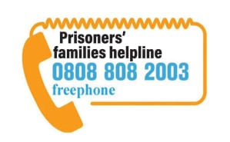 Prisoners’ Families Helpline - 0808 808 2003 info@prisonersfamilieshelpline.org.uk www.prisonersfamilieshelpline.org.uk
 Prisoners’ Families and Friends Service - 0808 808 3444 info@pffs.org.uk www.pffs.org.uk

